Lesson Plan
Lecturer : Somchay Makesavanh
Subject : General English
Time : 120 minutes
Unit 2 : Been there, done that!
Topic : Present Simple Vs. Present Continuous
Vocabulary of travel and sports
Prepositions
Learning objectives:
- Students (Ss) will be able to practice using Present Simple Vs. Present Continuous.
- Ss will be able to learn of adding -ing rule.
- Ss will be able to learn new vocabulary about travel and sports.
- Ss will be able to learn prepositions.
Learning outcomes:
- Ss can understand deeply using present simple and present continuous.
- Ss can identify of adding -ing rule.
- Ss know more vocabulary about travel and sports.
- Ss understand in using propositions.

Content | Teacher’s activities | Students’ activities | Teaching aids
I. Greeting (3’)  Collecting homework (5’) | - T says ‘Good morning everyone’ to Ss  - T check attendance  - write some verbs from the last homework on the white board and ask questions.  Example:  What is the Simple Past and Participle of these verbs?  Buy, catch, draw, fall, keep, make, ride, send, sleep, speak | - Ss say ‘Good morning teacher’  - Ss react.  - Ss follow and say out the Simple Past and Participle of each verb loudly. | Name list sheet
II. Introduction (7’) | - write the topics on the board  - introduce the topics  - point the topics and read; then, ask Ss to repeat. | - make a copy.  - listen and take note.  - look and read the topics. | White board  Marker
III. Procedure  Activity 1: Present Simple and Present Continuous (45’) | - motivate Ss to review the use of Present Simple and Present Continuous Tense.  - explain the verb form of Present Continuous Tense.  - write the rule of adding -ing to the base verb.  - write 45 verbs on the white board.  - ask Ss to add -ing to the verbs.  - check the answer for the whole class.  - write the answers on the white board. | - play attention to listen to the teacher and take note into their notebook.  - practice to add -ing to the verbs.  - share the answer together.  - do the correction whether there are some mistake. | Hand out  White board  Marker  Projector
- Adding _ing rule:
Rule 1: For words that end in a silent (not pronounced) -e,drop the -e and add -ing.
Example: smile → smiling
Rule 2: For one-syllable words that end in consonant-vowel-consonant (except x and w), double the last
letter and add -ing.
Examples: sit → sitting
run → running
Rule 3: For most other words (including words that end in -y), add -ing with no changes.
Examples: rain → raining
send → sending

Exercise 1:
Practicing to use these rules to add -ing to the following words:
1. shave _____________ 16. hope ________________ 31. save _______________
2. comb _____________ 17. Jump ________________ 32. tap _______________
3. make _____________ 18. Joke ________________ 33. carry _______________
4. feed _____________ 19. marry ________________ 34. buy _______________
5. do _____________ 20. Put ________________ 35. sew _______________
6. empty _____________ 21. say ________________ 36. eat _______________
7. jog _____________ 22. talk ________________ 37. write ________________
8. take _____________ 23. stop ________________ 38. dream ________________
9. vacuum _____________ 24. type ________________ 39. cut ________________
10. go _____________ 25. use ________________ 40. roar _________________
11. sleep _____________ 26. worry ________________ 41. snap _________________
12. wax _____________ 27. look ________________ 42. dig _________________
13. change _____________ 28. bat ________________ 43. bury _________________
14. fry _____________ 29. dance ________________ 44. see _________________
15. get ______________ 30. hurry ________________ 45. skate _________________

Exercise 2:
Put in the verbs in brackets in Simple Present or Present Continuous Tense.
- Andy sometimes _________________ comics. (to read)
- We never __________________ TV in the morning. (to watch)
- Listen! Sandy _________________ in the bathroom. (to sing)
- My sister usually ________________ in the kitchen. (to help)
- My mother ____________________ breakfast now. (to make)
- They often _________________ the bathroom. (to clean)
- Look! The boys __________________ home. (to come)
- Every day his grandfather _______________ for a walk. (to go)
- I _________________ with my friend at the moment. (to chat)
- Cats ________________ mice. (to eat)

Activity 2: Vocabulary ‘travel and sport’ (30’) | - ask Ss to open the textbook into page, 16.  - explain the direction to do the exercise.  - ask Ss to say out the answers.  - write the answer on the white board.  - read the new words and ask Ss to repeat. | - open the textbook into page, 16.  - listen and start to do the exercise.  - say out the answers.  - make a copy.  - listen and repeat after the teacher. | Textbook  White board  maker
Exercise 1:
Tick the verbs which go with each form of transport.

 | car | bus | bike | train | plane | ship/ferry
get into/out of
Get on/off
Take off
Land
Ride
Drive
Catch
Miss
Board
park

Exercise 2: complete the table below with the nouns in the box. Some can go into more than one column.

runway  crash helmet  traffic lights  service station  tyres  port  traffic jam  customs  porter  charter flight | platform  harbour  life jacket  season ticket  track  one-way street  timetable  deck  cabin  cycle lane | seat belt  carriage  ticket collector  trolley  horn  check-in desk  hand luggage  tunnel  aisle seat  cargo

car | bus | bike
train | plane | Ship/ferry

Activity 3: Prepositions of movement (20’)  Complete the text with prepositions from the box. Use each preposition at least once. | - introduce about preposition.  - give example.  - After that, write the new words from the text on board.  - discuss with Ss about new words.  - ask Ss to read the text carefully and complete by using preposition from the box.  - check the answers.  - read the text to Ss.  - lead Ss to translate the text into Lao language. | - listen and make a copy.  - share the ideas.  - listen and complete the text.  - share the answers.  - listen to the teacher.  - try to translate into Lao language together.
- Introduction to Prepositions:
Prepositions are short words that show time, place direction, etc.
Example:
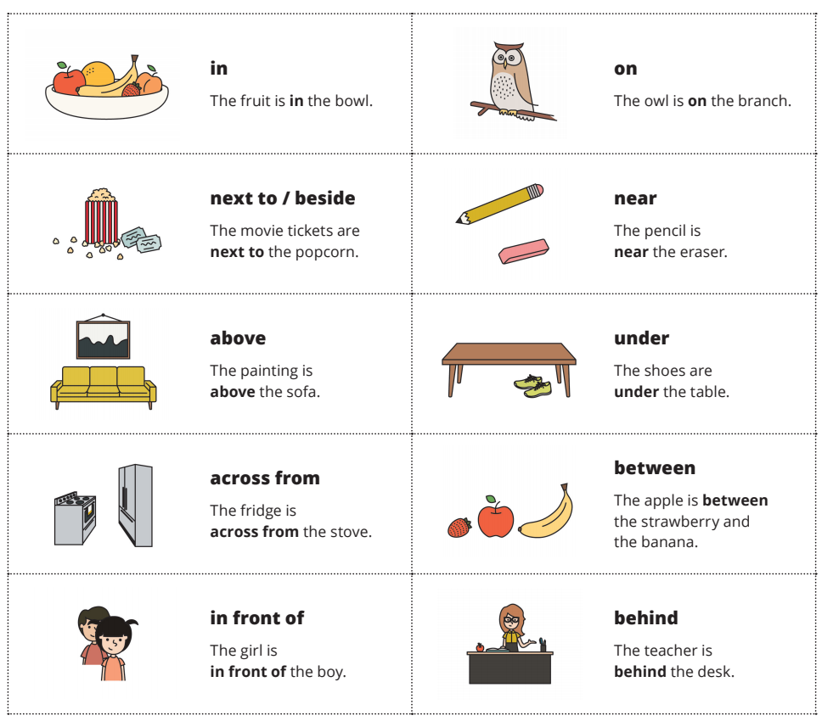

Exercise:
Complete the text with prepositions from the box. Use each preposition at least once.

across against on onto
along in off into
up out of over through
past to towards at

Joe’s journey
across town
Joe’s plane landed on time (1) ___________ Heathrow airport. He had exactly one hour to get (2) __________ the airport and (3) __________ the centre of London to catch his train (4) _____________ Manchester. He hurried (5) ___________ Customs and passport control and then raced (6) ____________ the taxi sign at the exit. Unfortunately, at that moment, the strap on his rucksack broke and it fell (7) ____________ his back and (8) ____________ the ground. Dirty socks, shirts, and underpants spilt all (9) ______________ the airport floor. Joe was so embarrassed! He stuffed everything back (10) ____________ his rucksack and, pushing his way (11) ___________ the crowds of people, finally made it (12) _____________ the taxi rank. He jumped (13) ____________ the nearest taxi, shouting ‘Euston Station, quickly, please!’ the taxi set off at such speed that Joe was thrown forward, hitting his face (14) ___________ the glass partition. The taxi sped on and finally arrived (15) ____________ the city centre, and inevitably, the middle of a traffic jam! It would be quicker to walk. Joe paid the driver, leapt (16) ___________ the taxi and ran (17) ___________ the pavement, (18) ___________ all the brightly-lit shop windows. At last he could see the station opposite, but it was difficult to get (19) ___________ the road because of all the traffic. He reached the station just as his train was leaving. He jumped (20) ___________ the barrier, raced (21) _________ the platform and leapt (22) ____________ the train with seconds to spare. He sighed with relief-he would be home in time for Christmas.

IV. Conclusion: (5’)  Summary the lessons have learned. | - conclude and write some of the main points on board.  - invite questions  - answer questions | - listen and take note  - ask questions  - take note | White board  Marker
V. Giving homework: (5’)  Practicing to remember some of common irregular verb forms. | - pass hand out to Ss  - ask Ss to do at home  - inform Ss that they have to hand in their homework for the next class.  - if Ss have some questions from doing homework, allow them to ask for the next class. | - keep the hand to do at home.  - Ss finish homework and bring it to class.  - take note some questions which need to be ask. | Hand out


