TUTORIAL PLAN

Cross cultural negotiation and decision making

Tutorial at a glance
Lecture recap
True False
Profile of negotiators
Nigeria and USA negotiation
Video discussion
Role Play
Reserved activity : debate

Activity 1. Lecture recap (30 min)

- What are the attitudes towards conflict by different cultures?
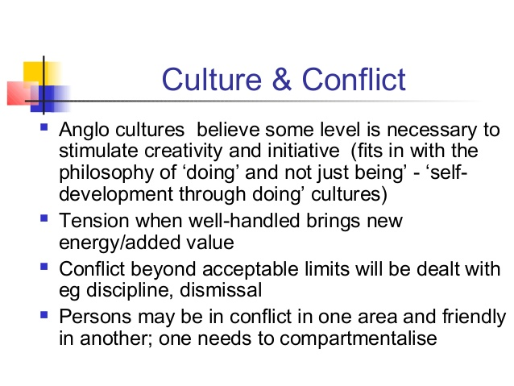
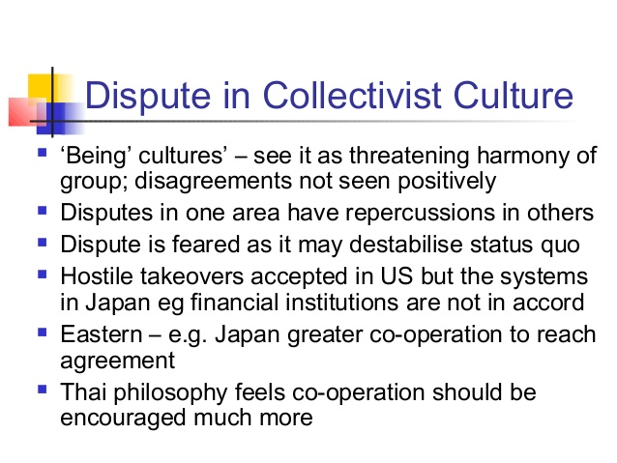
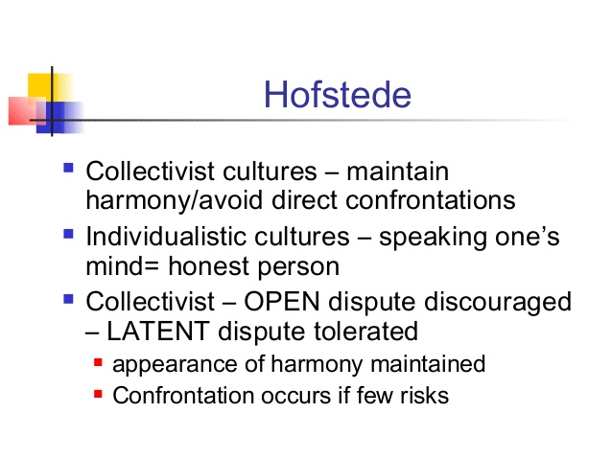
- How do cultures tolerate towards the conflict?
High Power Distance—latent conflict is normal between ranks, peers do not trust each other
Small power distance—harmony between powerful and powerless, peers are willing to cooperate
High Uncertainty Avoidance cultures consider disputes undesirable, conflict is emotionally disapproved
Low uncertainty avoidance –conflict is natural. Competition may be fierce, but afterwards the opponents easily reconcile.
Masculine cultures resolve dispute by fighting them
Feminine cultures resolve by compromise and negotiation
- What are the negotiation stages?
- What is the role of culture in:
- negotiation
- conflict
- What are the influential factors towards the negotiation process?
- Place
- Time
- Person/people
- Reason
- The way to negotiate
- True or False exercise

- The stages of negotiation are seldom very distinct from one another, but tend to blend together . T/F
- The Japanese ordinarily do not like long, detailed negotiating sessions. T/F
- Japanese negotiators are not likely to spend much time with non-task sounding activities. T/F
- Japanese negotiators are generally uncomfortable with straightforward eye contact. T/F
- Russian are effusive and emotional negotiators who believe "time is money." T/F
- Arabs tend to have a casual approach to deadlines and frequently lack authority to finalize deals T/F
- Passive listening is generally preferred over active listening in good negotiating strategy. T/F
- Chinese negotiators are apt to ask numerous questions, delving specifically and repeatedly into the details.
- Americans take contracts very seriously, Russians often renege their contracts.
- Chinese negotiators join negotiation in order to negotiate the relationship

- True
- False
- False
- True
- False
- True
- False
- True
- True
- True

Activity 2. Matching task on profiles of negotiators: American, Indian and Arab
Time: 20 min
Materials: pieces of paper with profiles and characteristics

- Divide the students into 3 groups as American negotiators, Arab negotiators and Indian negotiators. Their task is to choose the most suitable characteristics of the particular nation’s negotiation styles (below right answers are provided). The following mixture the profiles should be distributed to the groups:
American + Indian
American + Arab
American + Indian (for students’ handouts look at different file).

Profile of an American Negotiator
- Respects the “opponents”
- States his or her position as clearly as possible
- Has a good sense of timing and is consistent
- Makes the other party reveal his or her position while keeping his or her own position hidden as long as possible
- Is fully briefed about the negotiated issues.
Profile of an Indian Negotiator
- Is humble and trusts the opponent
- Is able to withdraw, use silence, and learn from within
- Appeals to the other party’s spiritual identity
- Goes beyond logical reasoning and trusts his or her instinct as well as faith
- Learns from the opponent and avoids the use of secrets
Profile of an Arab Negotiator
- Protects all the parties’ honor, self-respect, and dignity
- Avoids direct confrontation between opponents
- Does not put the parties involved in a situation where they have to show weakness or admit defeat
- Is creative enough to come up with honorable solutions for all parties
- Is respected and trusted by all.
Indian
- Seeks solutions that will please all the parties involved
- Respects the other party
- Neither uses violence nor insults
- Is ready to change his or her mind and differ with himself or herself at the risk of being seen as inconsistent and unpredictable
- Exercises self-control (the weapons of the satyagraha are within them)
American
- Knows when to compromise
- Takes a firm stand at the beginning of the negotiation
- Refuses to make concessions beforehand
- Keeps a maximum of options open before negotiation
- Operates in good faith
Arab
- Can keep secrets and in so doing gains the confidence of the negotiating parties
- Controls his temper and emotions
- Can use conference as mediating devices
- Understands the impact of Islam on the opponents who believe that they possess the truth, follow the Right Path, and are going to ‘win’ because their cause is just
- Can keep secrets and by doing so gains the confidence of negotiating partners

Activity 3. USA and Nigeria
Time: 25 min
Materials: handouts
Negotiator ́s Profile
Countries: USA & Nigeria
A US computer software company has recently heard from a Nigerian manufacturing company. The Nigerian company has expressed interest in one of its software programs. The Nigerian company has invited the US company to Nigeria to demonstrate its software. The US company has been very successful domestically, but this will be the first time it has ever ventured into the international business world. The company would like to expand and begin to build status in the international community. Being successful with this negotiation would help the company very much. The top managers have come together to plan a business strategy for the Nigerian business trip. They must also decide who is the most appropriate person to send to Nigeria to represent the company. The person chosen must be a highly competent negotiator, able to persuade the Nigerians that the company ́s software is the best in the market and exactly what the Nigerian company needs. Therefore, they must think very carefully about the qualities of the person they send.

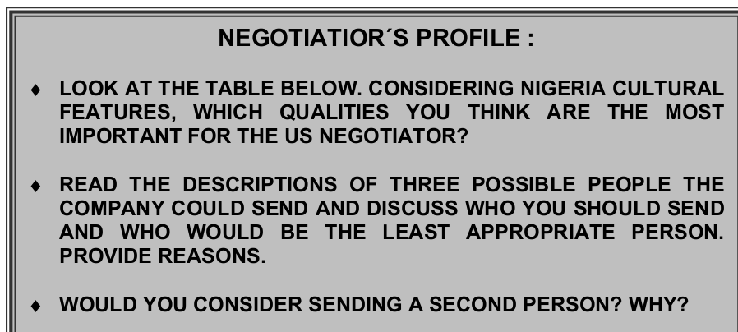
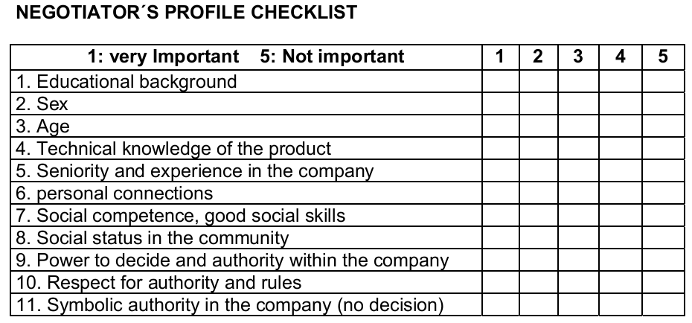
1: very important 3: not important
1. | Age | +
2. | Egalitarianism |  |  | +
3. | Relationships | +
4. | Loyalty to company
5. | Gender in business (senior position) | +
6. | Dress code | +
7. | Technical knowledge of the product
8. | Respect for authority and rule | +
9. | Seniority and experience in the company | +
10. | Risk taking |  | +
11 | Patience | +
http://www.worldbusinessculture.com/Nigerian-Business-Negotiation.html

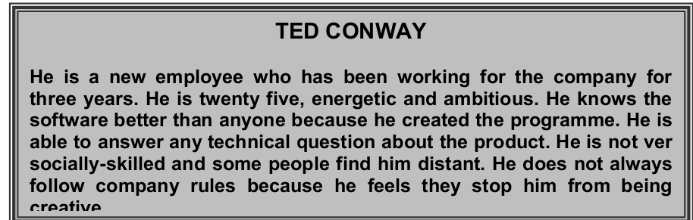
What about Nigeria?
If we explore the Nigerian culture through the lens of the 6-D Model©, we can get a good overview of the deep drivers of its culture relative to other world cultures.
Power Distance
This dimension deals with the fact that all individuals in societies are not equal – it expresses the attitude of the culture towards these inequalities amongst us. Power Distance is defined as the extent to which the less powerful members of institutions and organisations within a country expect and accept that power is distributed unequally.
Nigeria scores high on this dimension (score of 80) which means that people accept a hierarchical order in which everybody has a place and which needs no further justification. Hierarchy in an organization is seen as reflecting inherent inequalities, centralization is popular, subordinates expect to be told what to do and the ideal boss is a benevolent autocrat
Individualism
The fundamental issue addressed by this dimension is the degree of interdependence a society maintains among its members. It has to do with whether people´s self-image is defined in terms of “I” or “We”. In Individualist societies people are supposed to look after themselves and their direct family only. In Collectivist societies people belong to ‘in groups’ that take care of them in exchange for loyalty.
Nigeria, with a score of 30 is considered a collectivistic society. This is manifest in a close long-term commitment to the member 'group', be that a family, extended family, or extended relationships. Loyalty in a collectivist culture is paramount, and over-rides most other societal rules and regulations. The society fosters strong relationships where everyone takes responsibility for fellow members of their group. In collectivist societies offence leads to shame and loss of face, employer/employee relationships are perceived in moral terms (like a family link), hiring and promotion decisions take account of the employee’s in-group, management is the management of groups.
Masculinity
A high score (Masculine) on this dimension indicates that the society will be driven by competition, achievement and success, with success being defined by the winner / best in field – a value system that starts in school and continues throughout organisational life.
A low score (Feminine) on the dimension means that the dominant values in society are caring for others and quality of life. A Feminine society is one where quality of life is the sign of success and standing out from the crowd is not admirable. The fundamental issue here is what motivates people, wanting to be the best (Masculine) or liking what you do (Feminine).
Nigeria scores 60 on this dimension and is thus a Masculine society. In Masculine countries people “live in order to work”, managers are expected to be decisive and assertive, the emphasis is on equity, competition and performance and conflicts are resolved by fighting them out.
Uncertainty Avoidance
The dimension Uncertainty Avoidance has to do with the way that a society deals with the fact that the future can never be known: should we try to control the future or just let it happen? This ambiguity brings with it anxiety and different cultures have learnt to deal with this anxiety in different ways. The extent to which the members of a culture feel threatened by ambiguous or unknown situations and have created beliefs and institutions that try to avoid these is reflected in the score on Uncertainty Avoidance.
Nigeria receives an intermediate score of 55 on this dimension, which does not show a clear preference.
Long Term Orientation
This dimension describes how every society has to maintain some links with its own past while dealing with the challenges of the present and future, and societies prioritise these two existential goals differently. Normative societies. which score low on this dimension, for example, prefer to maintain time-honoured traditions and norms while viewing societal change with suspicion. Those with a culture which scores high, on the other hand, take a more pragmatic approach: they encourage thrift and efforts in modern education as a way to prepare for the future.
Nigeria scores very low (13) on this dimension, meaning that its culture is normative instead of pragmatic. People in such societies have a strong concern with establishing the absolute Truth; they are normative in their thinking. They exhibit great respect for traditions, a relatively small propensity to save for the future, and a focus on achieving quick results.
Indulgence
One challenge that confronts humanity, now and in the past, is the degree to which small children are socialized. Without socialization we do not become “human”. This dimension is defined as the extent to which people try to control their desires and impulses, based on the way they were raised. Relatively weak control is called “Indulgence” and relatively strong control is called “Restraint”. Cultures can, therefore, be described as Indulgent or Restrained.
With a very high score of 84, Nigerian culture is said to be one of Indulgence. People in societies classified by a high score in Indulgence generally exhibit a willingness to realise their impulses and desires with regard to enjoying life and having fun. They possess a positive attitude and have a tendency towards optimism. In addition, they place a higher degree of importance on leisure time, act as they please and spend money as they wish.
Retrieved from: https://geert-hofstede.com/nigeria.html

Activity 4. Video Discussion 15 min.
- What are two ways of negotiation mentioned in the video?
Answer: Distributive: Win-Lose
Integrative: Win-Win
- Differentiate ‘Distributive’ and ‘Integrative’ Negotiations.
Distribuative:
- Emphasizes individual games
- Resources are viewed as limited
- Avoid sharing and misrepresent information
- Second party is accepted as ‘enemy’

Integrative:
- Emphasize joint game
- The goal is ‘to expand the pie’ rather than ‘hurrying to own the piece of it’.
- Openly share information
- Other parties are partners
- What is meant by ‘separating people from problem’ in integrative negotiations? Even if the reason of the problem is people, the problem needs solving with possible ways rather than blaming the parties.
- What do you understand by ‘focus on interest not positions’? Sometimes people occupy the positions that do not reflect their ultimate interest. So one should be interested in why the people are asking certain things, not who is asking this
- Explain the tip ‘Invent options for mutual gain’. Every issue has more than one solution. So the resolution should be gained by brainstorming all the options and solutions.
- What is your understanding of the tip ‘using objective criteria’? Instead of making the negotiation process concentration should be given to the measures of success.
Activity 5. Debate 30 min
The statement is the topic and question of the debate:
Conflict is necessary in organizations and it can improve performance.
The group is divided into ‘Yes’ and ‘No’ groups. The groups should discuss the statement and provide justification for their arguments. You might change the the debate statement as ‘Conflict is necessary in current business environment in Uzbekistan so it would improve performance’

