Advanced Web Based Application Development

Lecture 1

Introduction to Web-Based Applications and Scripting

Dr. Obuhuma James

Description
This topic aims at introducing you to concepts of scripting for web applications. It looks at scripting by exploring the two categories of scripting. The differences and example languages per category are broadly covered.

Learning Outcomes
By the end of this topic, you will be able to:
- Understand the concepts of scripting and how it fits in the world of web-based applications.
- Understand the two broad categories of scripting: client-side and server-side scripting.
- Appreciate the role of both client-side and server-side scripting.

Overview of Web-Based Application Languages
A web-based application is a type of application that can run on a web browser. Such applications are normally developed in such a manner that allows the inbuilt browser capabilities to execute them without requiring extra plugins or enhancements to the browser. In their normal state, web browsers have inbuilt capabilities to execute Markup Languages like HTML, Cascading Stylesheets, some scripts like JavaScript, among others. Hence, most HTML files contain HTML tags, text, and scripts. Web-based application languages are either known as markup or scripting languages.

Markup Languages
Markup languages are those languages that are used to create webpages. These languages are considered as fundamental building blocks for any webpage. The work of a markup language is to create the structure and layout and to oversee the appearance of the web page. Prior to attending the advanced web class, you should have interacted with various markup languages.
Several markup languages exist. The most used language is HTML. As you are aware, HTML stands for Hypertext Markup Language. Files within HTML are saved with a .htm or .html file extensions. HTML uses tags that are used to add content to a webpage, enhance its appearance and create the general layout of the webpage. The current version of HTML in use is HTML5.
Other markup languages include: Extensible Markup Language (XML) and Extensible Hypertext Markup Language (XHTML). XML is a set of rules that dictate how data is exchanged online while XHTML is a combination of XML and HTML. Basically, XHTML is a HTML version that incorporates the guidelines found in XML.

Scripting Languages
While markup languages are run directly on the browser, scripting languages tend to be executed as they are run and will mostly run on the server side. While markup languages are building blocks, scripting languages add a dynamic aspect to the webpage. In turn the page is considered interactive.
Several scripting languages exist. JavaScript is one of the most common of scripting languages. Prior to this class you have probably interacted with JavaScript. The main role of JavaScript is to allow interactive content on a website.
Additional scripting languages include VBScript which stands for Visual Basic Scripting Edition. The functionality of VBScript is like JavaScript. PHP which stands for Hypertext Preprocessor and Perl which stands for Practical Extraction and Report Language are additional scripting languages.

Introduction to Scripting for Web-Based Applications
Scripts are pieces of code written in a scripting language for a specific purpose. A scripting language is a lightweight programming language. Such languages are normally categorized as either client-side or server-side scripting depending on which side of the client-server architecture the script is executed from. The client-server architecture outlined in Figure 1, shows the two parts that form the model, namely, the client-side and the server-side.

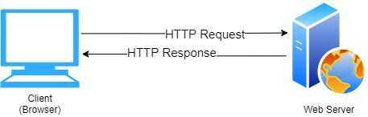
Figure 1: Client-Server Architecture

According to the model, the client is a computer program, commonly the web browser running on the local user’s computer, smartphone, or other devices. On the other hand, the server is a web server program. Communication between the client and the server mostly relies on the Hypertext Transfer Protocol (HTTP). Operations may be performed on either side of the model depending on their nature. For instance, operations may be executed on the client-side when they require access to information or functionalities available on the client but not on the server, when the user needs to observe the processes or provide input, or when the server lacks the processing power to perform operations timely for all the clients under its control. Additionally, if operations can be performed by the client, without sending data over the network, they may take less time, use less bandwidth, and incur a lesser security risk. Conversely, operations may be performed on the server when they cannot be executed by the client, or the data and process require privacy as a security measure. These and many more reasons led to the separation of client-side scripting from server-side scripting.

Client-side Scripting
Client-side scripting is about "programming" the behaviour of the client, the browser. It is also called browser scripting since the scripts execute directly on the web browser. Several client-side scripting languages exist, including, JavaScript, VB Script, among others. HTML, CSS and JavaScript are common computer languages categorized as client-side in the context of the worldwide web.
JavaScript, often abbreviated as JS, is one of the most famous client-side scripting languages of the web. JavaScript conforms to the ECMAScript specification as a high-level, often just-in-time compiled, and multi-paradigm language. It has curly-bracket syntax, dynamic typing, prototype-based object orientation, and first-class functions. Alongside HTML and CSS, JavaScript is one of the core technologies of the World Wide Web. It adds interactivity to web pages, making it an essential component of web applications. JavaScript is used in billions of web pages to add functionality, validate forms, communicate with the server, and much more. Thus, many web browsers have a dedicated JavaScript engine to execute scripts made using JavaScript. In a nutshell,
- JavaScript is a client-side scripting language.
- A JavaScript consists of lines of executable computer codes.
- A JavaScript is usually embedded directly into HTML pages.
- JavaScript was designed to add interactivity to HTML pages.
- JavaScript is free for public use without requiring a license.
- Web browsers have inbuilt capabilities to execute JavaScript.
JavaScript has many notable capabilities, including:
- JavaScript gives HTML designers a programming tool.
- JavaScript is a scripting language with a very simple syntax. Almost anyone can put small "snippets" of code into their HTML pages.
- JavaScript can react to events.
- JavaScript can be set to execute when something happens, like when a page has finished loading or when a user clicks on an HTML element.
- JavaScript can be used to validate user data.
- JavaScript can be used to validate form data before it is submitted to a server. This saves the server from extra processing.
- JavaScript can be used to detect the visitor's browser and load another page specifically designed for that browser.
- JavaScript can be used to create cookies.
- JavaScript can be used to store and retrieve information on the visitor's computer.
- JavaScript can read, write, or modify HTML elements.
- JavaScript can read and change the content of an HTML element.
- JavaScript uses the HTML DOM to access the elements of a web page.
It is worth noting that despite some notable similarities between JavaScript and Java, including language name, syntax, and respective standard libraries, the two languages are distinct and differ in design to a large extend.

Server-side Scripting
Server-side scripting is about "programming" the behaviour of the server, in this case, the webserver. It is also called server scripting since the scripts execute directly on the webserver. Normally, when a browser requests an HTML file, the server returns the file. However, if the file contains a server-side script, the script is executed on the server first before the file is returned to the browser as plain HTML. Hence, the browser that displays the file does not need to support scripting at all, it only displays results generated by the server-side script. Several server-side scripting languages exist, including, ASP, PHP, Nodejs, Ruby, among others. ASP.Net and PHP are amongst the most famous server-side scripting languages in use. This course will focus on PHP as an open-source, cross-platform server-side scripting language.
PHP stands for Hypertext Preprocessor. It is a general-purpose scripting language especially suited for web development. PHP was created by a Danish-Canadian programmer Rasmus Lerdorf in 1994. Currently, the PHP Group produces the PHP reference implementation. In a nutshell,
- PHP is a server-side scripting language.
- PHP is free and widely used.
- The latest stable release is PHP 7.
- The current version of PHP available is 8.0.3. This was released on March 4th 2021.
- A community exists for PHP queries - https://www.php.net/
- The community offers downloads, documentation, and other resources for PHP support.
PHP has many notable capabilities, including:
- It can dynamically edit, change, or add any content to a web page.
- It responds to user queries or data submitted from HTML forms.
- It can access any data or databases and return the result to a browser.
- It can customize a web page to make it more useful for individual users.
- It provides security since the server code cannot be viewed from a browser.

Differences Between Client-side and Server-side Scripting
Client-side Scripting | Server-side Scripting
Program the behaviour of the browser | Program the behaviour of the server
Scripts are executed directly on the browser | Scripts are executed on the server with results sent to the browser
Source code is visible to users via the browser | Source code cannot be accessed from the browser since the server output is rendered as data in HTML format on the web page
Reduces the load on the server | May create a higher load on the server
Data security is not provided | Data security is provided
Examples include JavaScript, VB Scripts, among others | Examples include PHP, ASP, Python, Ruby, among others

Genealogy of Programming Languages
Scripting languages are often featured in the genealogy of programming languages even though they are commonly perceived to be lightweight programming languages in nature. For instance, Figure 2 outlines the genealogy of common programming languages, spanning from 1957 to 2015 [1].
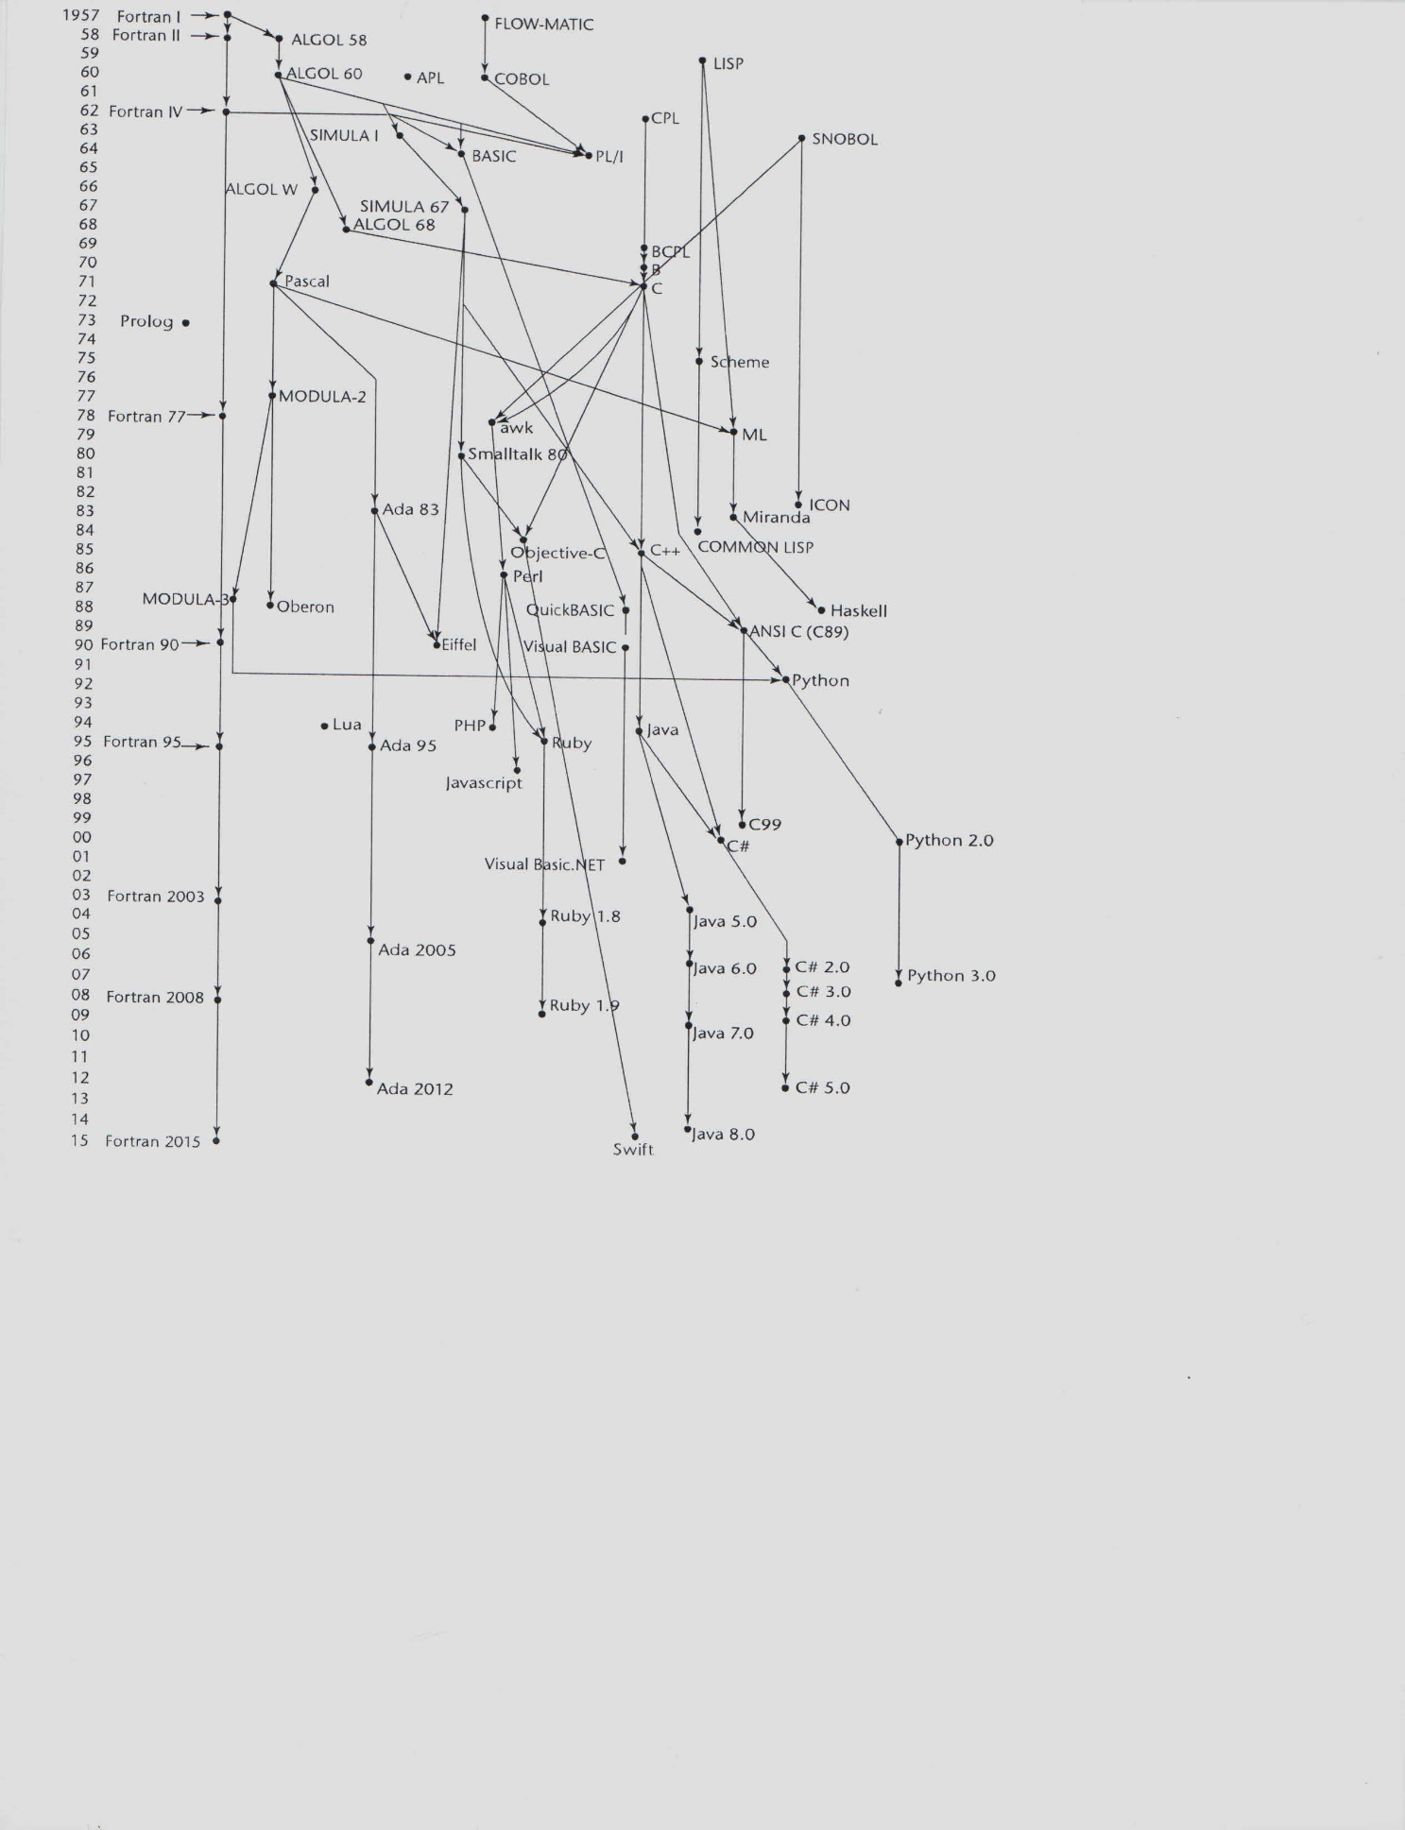
Figure 2: The Genealogy of Programming Languages [1]

Both JavaScript and PHP can be traced in genealogy in the years 1997 and 1994 respectively. To date, both JavaScript and PHP are still finding many applications in web-based applications. It is however worth noting that they both have competitors in the market. This, therefore, leaves developers with choices to make depending on their needs, preferences, capabilities, ease of use, proficiency, among other factors considered in deciding the language to use.

Summary
The topic has introduced the concept of scripting by exploring the two categories of scripting and their capabilities. Examples of scripting languages per category are also outlined. From this point onwards, we should now be able to dive into PHP as the main language to be used in this course.

Check Points
- Describe the concept behind scripting.
- Differentiate between the two categories of scripting languages.
- State any four examples of scripting languages per scripting languages category.
- Discuss the roles and capabilities of client-side scripts.
- Discuss the roles and capabilities of server-side scripts.

Learning Resources

Core Textbooks
- Brooks, D.R., 2017. Programming in HTML and PHP. Switzerland: Springer.
- Gosselin, D., Kokoska, D. and Easterbrooks, R., 2010. PHP Programming with MySQL: The Web Technologies Series. Cengage Learning.

Other Resources
- Sebesta, R.W., 2016. Concepts of programming languages. Pearson Education, Edinburgh Gate.

References
- Sebesta, R.W., 2016. Concepts of programming languages. Pearson Education, Edinburgh Gate.

