Advanced Web Based Application Development

Lecture 2

Introduction to Server-side Scripting Using PHP

Dr. Obuhuma James

Description
This topic aims at introducing you to server-side scripting with a focus on the Hypertext Preprocessor (PHP) for web applications. It gives a brief introduction to PHP, the syntax for PHP files, how to write, save, and execute PHP files. The topic further outlines how PHP scripts can be embedded into HTML files with clarity on how execution occurs in such cases.

Learning Outcomes
By the end of this topic, you will be able to:
- Understand the concepts of server-side scripting.
- Write, save, and execute a simple standalone PHP script.
- Setup XAMPP as an execution environment for PHP scripts.
- Embed PHP scripts into HTML, save and execute such files.

Introduction to PHP
PHP is a server-side scripting language that has gained fame in the current world of web-based applications, spanning from 1994. As an open-source server-side programming language, PHP tries to fill the gap that static HTML pages fail to address. This is achieved through the introduction of dynamism in web pages. According to [3], PHP provides a way to solve computational problems by breaking them into discrete steps that can be carried out in a top-down approach. It is hence capable of performing the following tasks:
- Manage input and output.
- Give room for manipulation of values in a symbolic manner that is independent of a particular computer stores information internally.
- Perform arithmetic operations on numbers.
- Perform operations on characters and strings of characters.
- Facilitate decision-making based on comparing values.
- Perform repetitive calculations.

PHP Script Syntax
A script in this case refers to a set of PHP statements aimed at accomplishing some given task. PHP scripts are written within code blocks that may be achieved in four different formats. These are [2]:
- The standard PHP script delimiter
<?php
Statements;
?>
- The <script> element
<script language=”php”>
Statements;
</script>
- Short PHP script delimiter
<?
Statements;
?>
- ASP-style script delimiter
<%
Statements;
%>
The choice of style to use is sometimes influenced by preferences of the programmer. However, it is worth noting that the short PHP delimiter and ASP-style delimiter options may be enabled and disabled from the php.ini configuration file. On the other hand, the <script> element option must have the language attribute set to value “php”. This unit will use the standard PHP script delimiter style in all its examples for consistency purposes.

Creating and Saving PHP Scripts
PHP scripts can be written using any basic text editor like notepad or any specialised text editor like notepad++, sublime text, Dreamweaver, among others. The scripts should be saved in a file with a .php extension. For instance, consider a simple script that will display “Hello World”. The following code could be used.
<?php
Echo “Hello World”;
?>

Note that:
- Either echo or print can be used to print the message “Hello World”. Both are output functions.
- The statement “Hello World” in this case is a literal string that must be displayed as is. Such literal strings can be enclosed in single or double quotation marks. Brackets could also enclose the quotation marks and the literal strings. For instance, each of the following approaches is valid:

echo “Hello World”;
echo ‘Hello World’;
echo (“Hello World”);
echo (‘Hello World’);
- Each statement in PHP must be terminated by a semicolon.
- PHP is case insensitive. Hence, the word echo, Echo, and ECHO are interpreted the same.
Supposing we want to save the file with a filename “hello”, then we should save it as “hello.php”.

Displaying Script Results
As the server executes scripts, any data that is meant for display on a webpage is created by an echo or print statement. It is the choice of the programmer to use whichever statement for the purpose. This is clearly explained in the previous section in the “Hello World” example.

Case Sensitivity
PHP is case insensitive. This means that code can be written in lower case, upper case or even a mix of lower and upper case. However, for better and ease of reading, it is good practice to use one case throughout the script.

Executing PHP Scripts
To execute a PHP script, a webserver must be set up with the appropriate services running on the server. The PHP script files must then be saved in a specific location on the webserver and accessed appropriately on the browser.

Setting up the Webserver
PHP scripts execute in a webserver. The most common webservers are Apache and Internet Information Services (IIS) webservers. Apache is a software foundation that develops and provides open-source software that is meant to run webservers. HTTP is Apache’s primary product that is the most popular HTTP server in use today. IIS on the other hand is a software pack developed by Microsoft to provide their Windows operating system with the ability to host internet services. IIS is second only to HTTP as the most used HTTP server in the world.
The Apache webserver is free, hence, very popular. This is very advantageous to those who are just trying out web publishing and are still unsure about it. Apache is part of the XAMPP software suite. XAMPP is a collection of open-source software suited for web publishing requirements from the OS down to the scripting language. Apart from being free, the open-source community is always a suitable source of support for users who have the time and patience to seek for answers to tough questions and support.
Conversely, IIS is a Microsoft product, hence, designed to only run on the Microsoft Windows Operating System. IIS comes as a free product that rides on the Microsoft Windows Operating Systems license. Using IIS comes with the advantage that most people are already familiar with the Windows Operating System, making IIS much easier to learn for Windows users. IIS is also supported by the .NET Framework released by Microsoft. This automatically means guaranteed support by Microsoft. It is worth noting that ASPX scripts, a competitor of PHP scripts, is exclusive to IIS.
PHP scripts can run on either Apache or IIS webservers, provided that the PHP execution engine is installed and configured correctly. This course will use the Apache webserver that comes as part of the XAMPP package. The initial X in XAMPP represents the operating systems that XAMPP operates on i.e., Linux, Windows, and Mac OS X; A represents the Apache webserver; M is MySQL (or MariaDB), as relational Database Management System (DBMS) in XAMPP; while the double Ps represent Perl and PHP as scripting languages in XAMPP. Additionally, XAMPP contains more useful tools, which vary depending on the operating system. These tools include Mercury, a mail server; phpMyAdmin, a database administration environment, Webalizer, a web analytics software solution; OpenSSL, an end to end Security Socket Layer; FileZilla or ProFTPd, File Transfer Protocol servers; and the XAMPP Control Panel, for monitoring and regulating the operation of other components of XAMPP.
XAMPP is the most popular PHP development environment that is completely free and easy to install. It is an Apache distribution that currently contains MariaDB, PHP, and Perl. Visit Apache friends website, https://www.apachefriends.org to download and install the XAMPP version of your choice, based on your operating system. However, all demonstrations for this unit will be on the Windows Operating System. On the same website, you will find a YouTube video with steps on how to install and configure XAMPP for Windows operating system. The same video could be accessed via https://youtu.be/h6DEDm7C37A. The following is a snapshot of the set of the steps followed to help kickstart your installation after downloading the executable installation file.
- Run the executable file by double-clicking on it. This results in the following window. Click “Yes” to proceed.
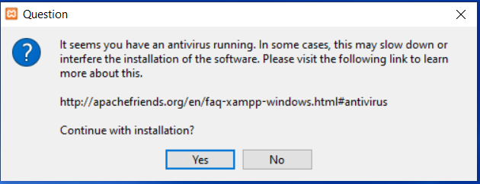
Figure 1. Antivirus Status
- A warning pops up relating to User Account Controls (UAC). Click “Ok” to proceed.
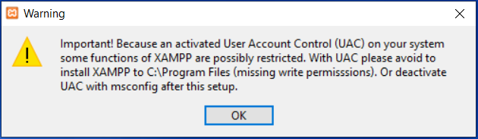
Figure 2. User Account Control Status

- The installation wizard will now be ready to start the installation process. Click “Next” to proceed.
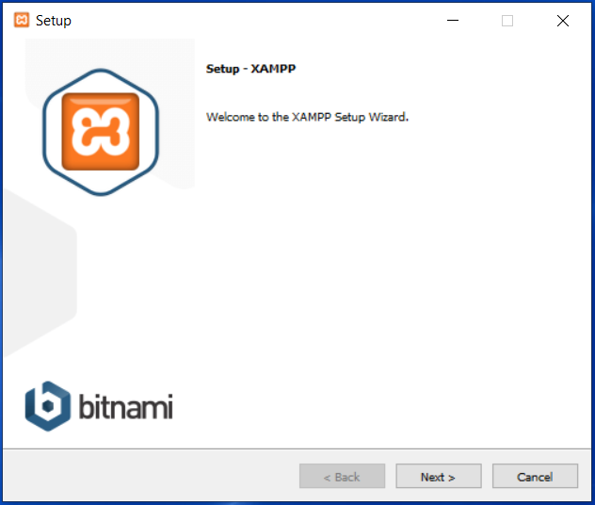
Figure 3. XAMPP Setup Wizard Launch
- When prompted to select components to install, leave the default selections or be sure to select MySQL, PHP and phpMyAdmin, in case they are not checked. Click “Next” to proceed.
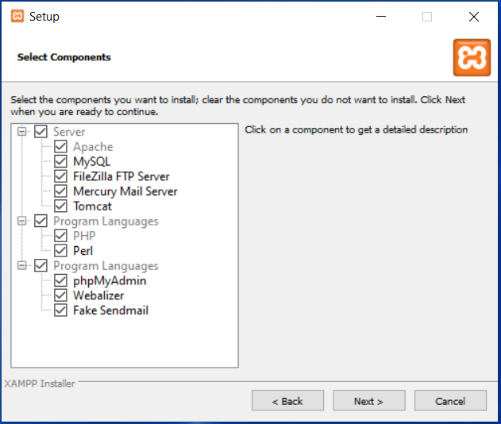
Figure 4. Choice of Installation Components
- Select the installation folder, language, and whether you want to learn more from Bitnami respectively as you click “Next” to proceed. This will take you to a point where the installation will get ready. Also, click “Next” to start the installation.
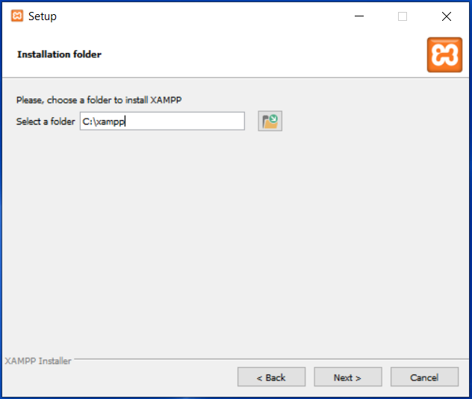
Figure 5. XAMPP Installation Folder
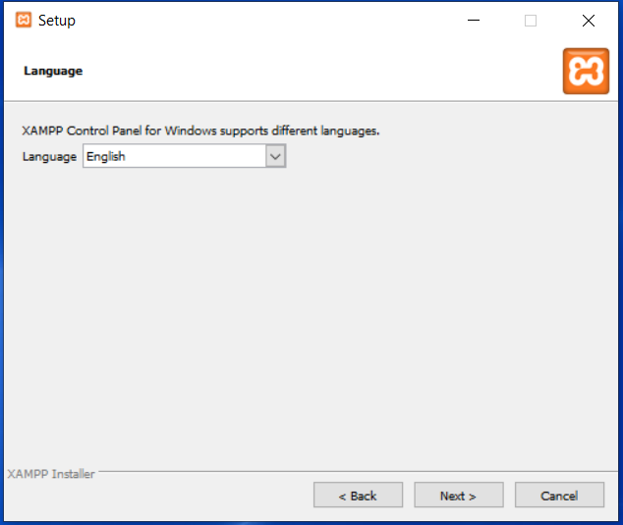
Figure 6. XAMPP Language
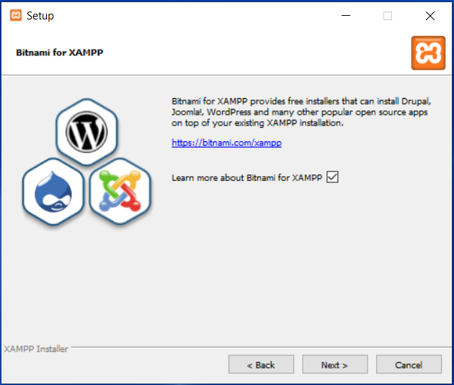
Figure 7. Learn More About Bitnami for XAMPP
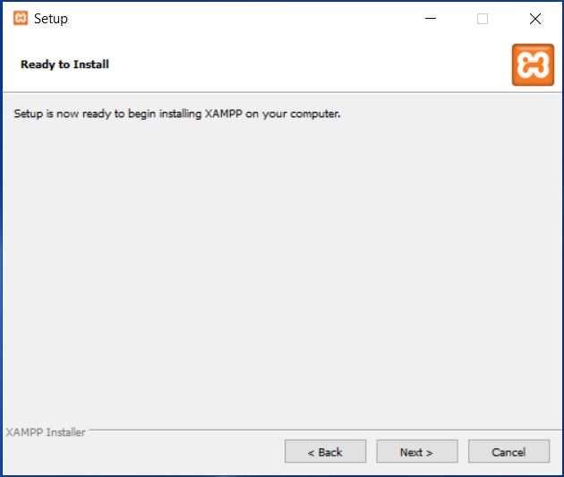
Figure 8. Setup Ready to Install XAMPP
- The installation will start, with a progress indicator showing the estimated percentage of the installation. This may take a couple of minutes until the installation is completed.
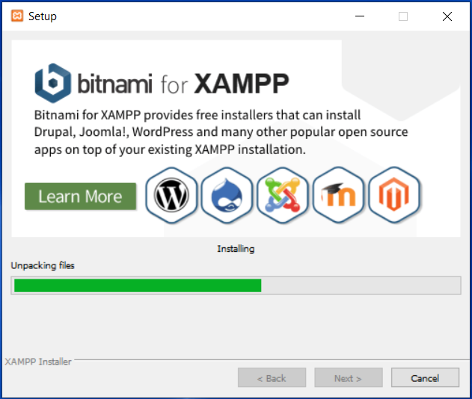
Figure 9. Installation in Progress

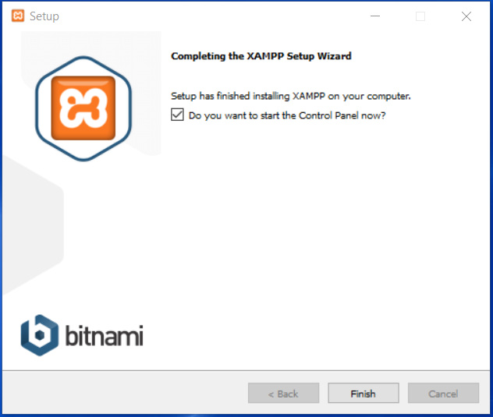
Figure 10. Completion of the XAMPP Setup Wizard
- Click “Finish” to launch the XAMPP Control Panel.
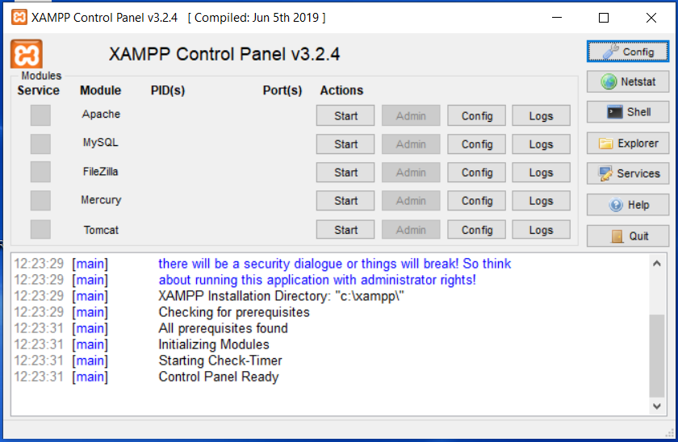
Figure 11. XAMPP Control Panel
- The XAMPP Control Panel will show you various services available at your disposal. You can start, stop, configure, and view logs for any of the services. For the sake of this course, we are only interested in Apache and MySql. Be sure to start the two services. This will highlight them in colour green, an indicator that they are started and running correctly. Any other colour will be an indicator that the services are not running or are being interfered with by other services that may be using the same ports. You will also be able to see the service status with a timestamp at the bottom for your information.
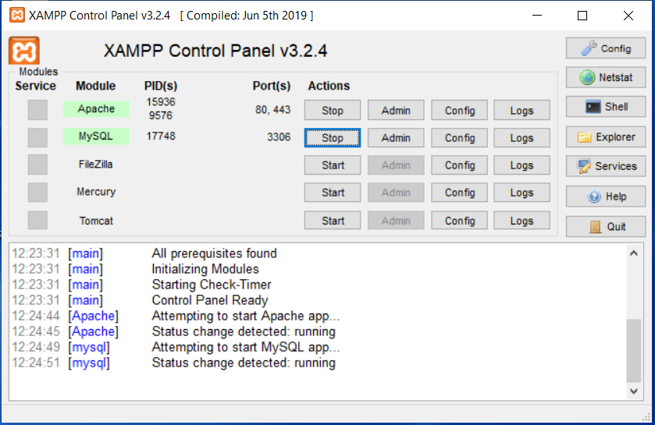
Figure 12. XAMPP Control Panel with Apache and MySQL Services Started
Up to this point, all will be set up and ready for execution of PHP scripts. The XAMPP Control Panel icon will remain on the system tray for ease of access when needed.

Running PHP Scripts on the Browser
In reference to XAMPP installed on a Windows OS, based on the installation location folder that was selected during installation, a subfolder called htdocs will be part of the subfolders in the main installation folder. All PHP scripts must be loaded in this folder. The following screenshots, labeled as Figure 13 – 15, show examples of the folders and where PHP scripts should be saved.
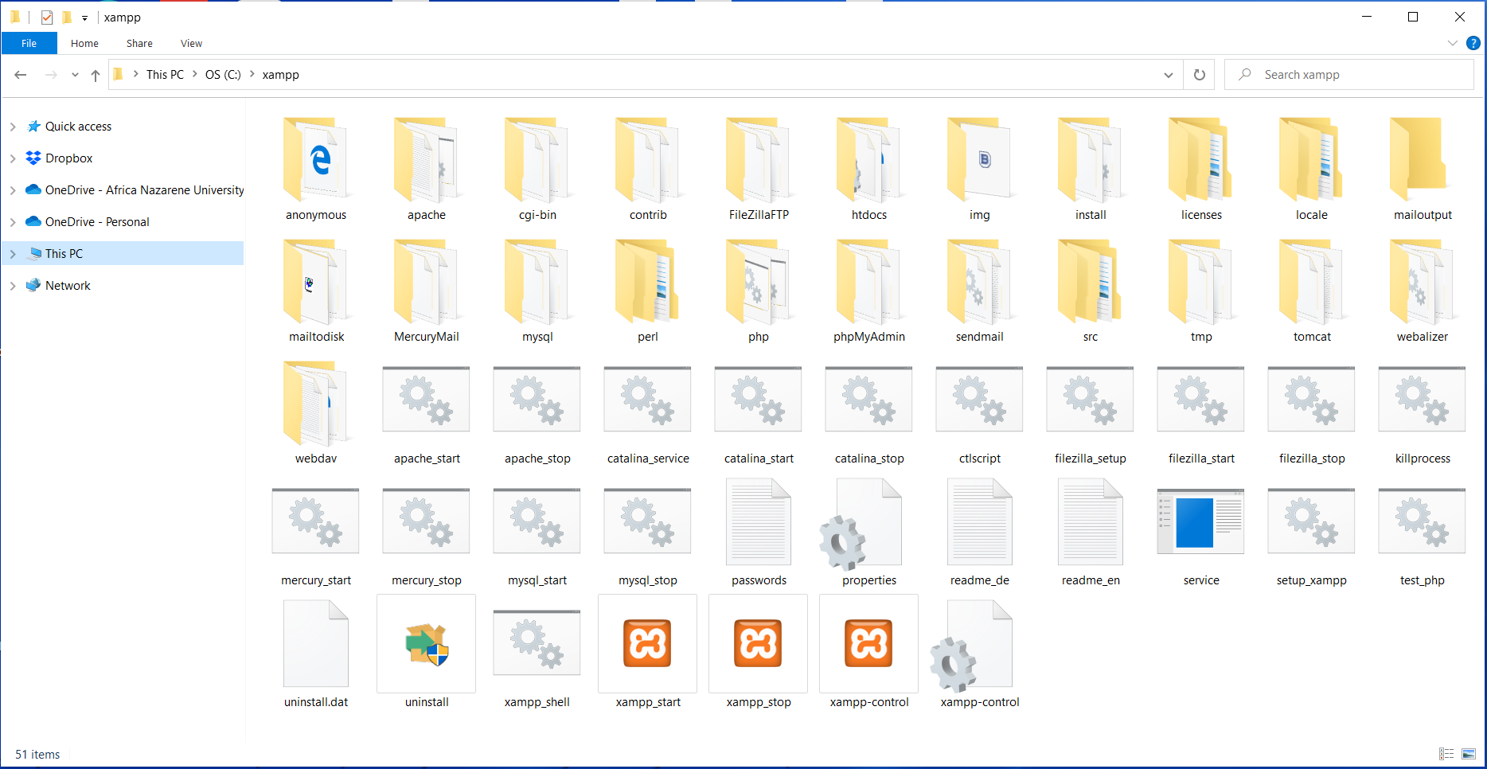
Figure 13. The Set of Default Files and Folders in the XAMPP Folder

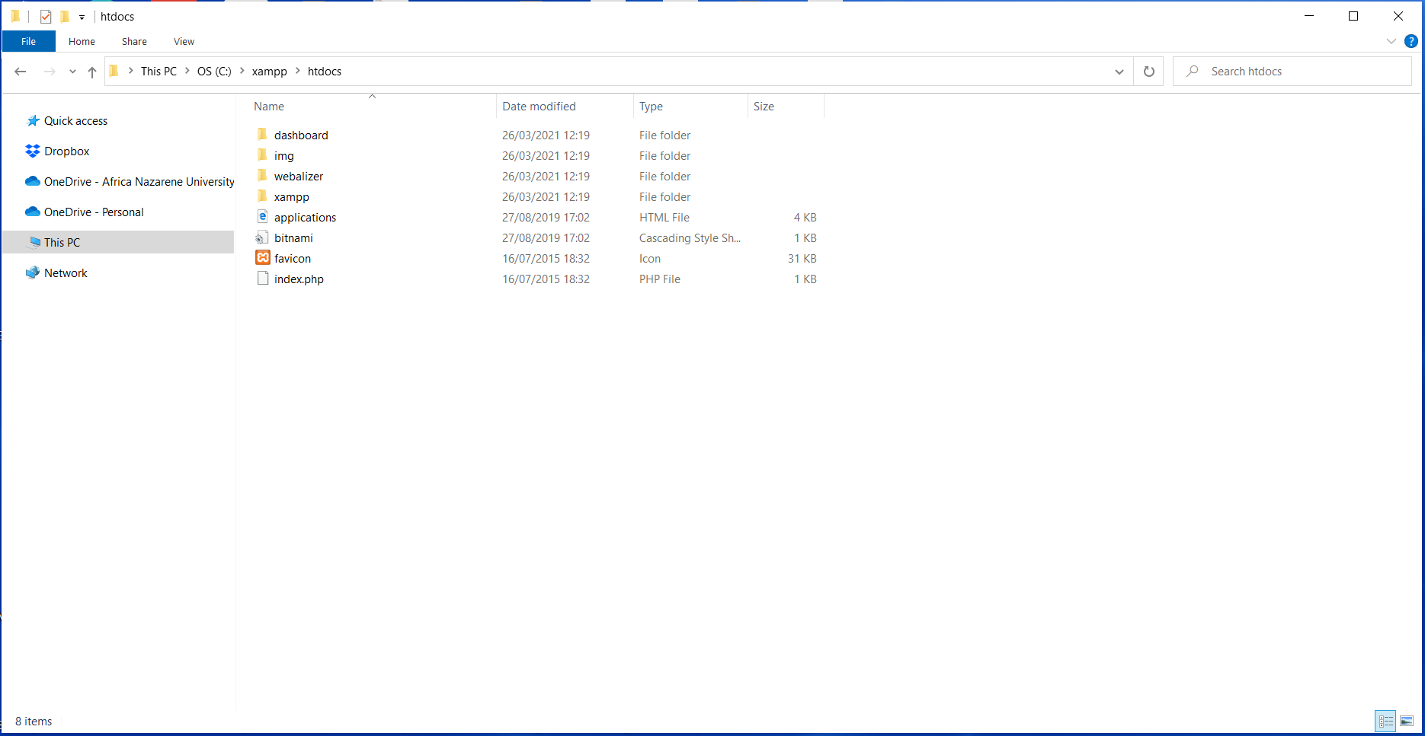
Figure 14. Default Contents of the htdocs Folder
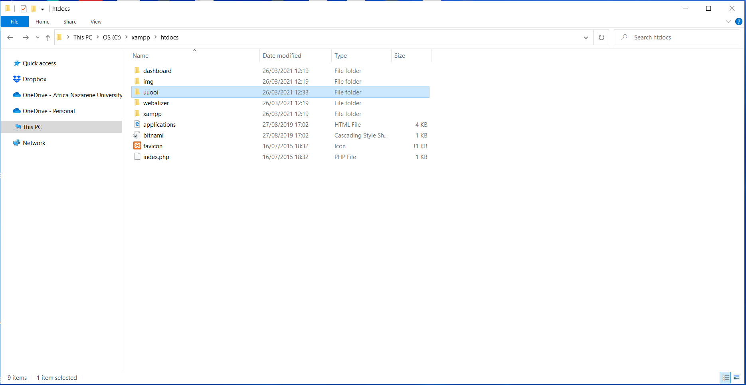
Figure 15. The Working Folder for the Course “uuooi”
PHP script files must be run directly from a client, in this case, a web browser. This means that we cannot open the files directly by double-clicking on them or right-clicking and selecting open as we do for other files. This is because server-side scripts must be executed from the server first before the results are sent to the client for display. Figure 16 – 22 outlines steps on how to run PHP scripts from the web browser as a client.
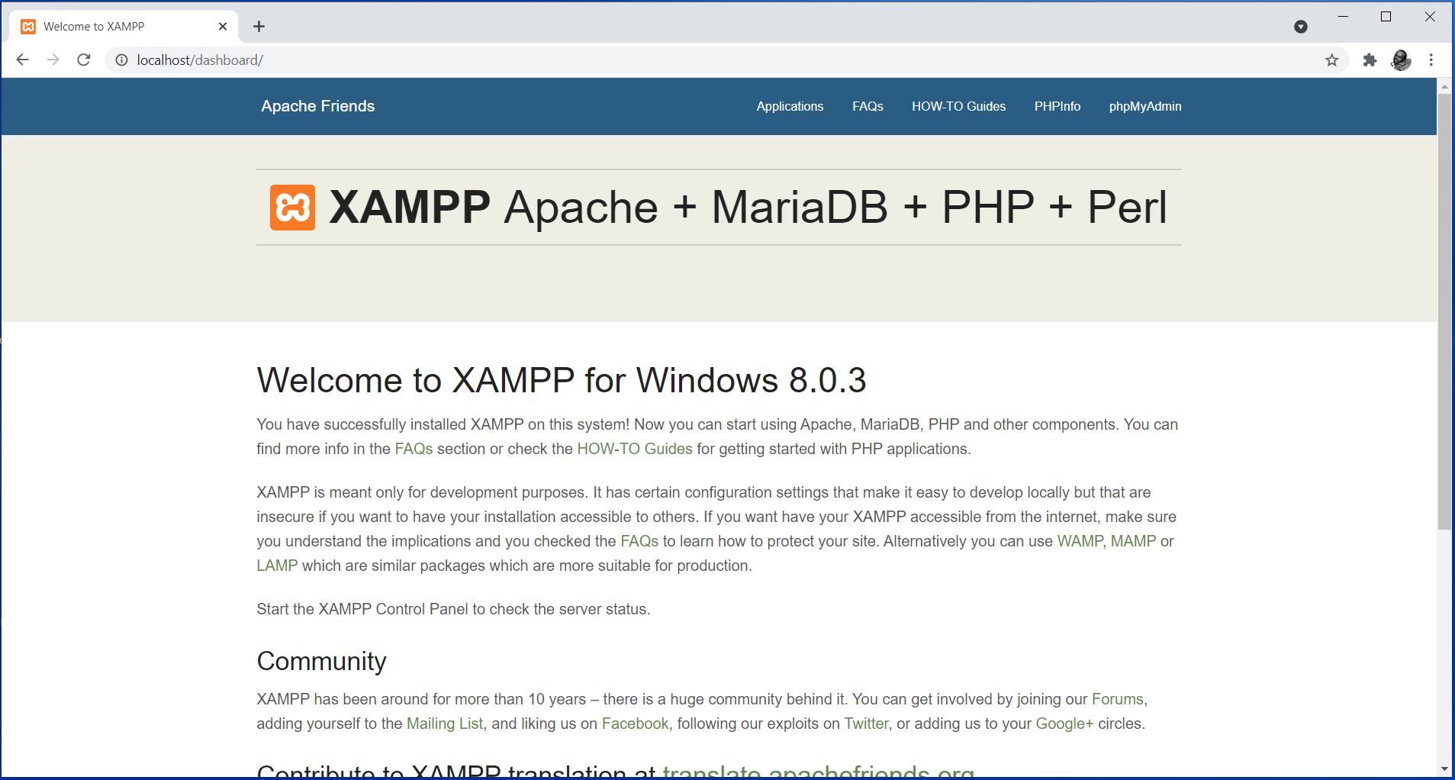
Figure 16. Option 1: Opening the Webserver from the Browser (Using http://localhost)
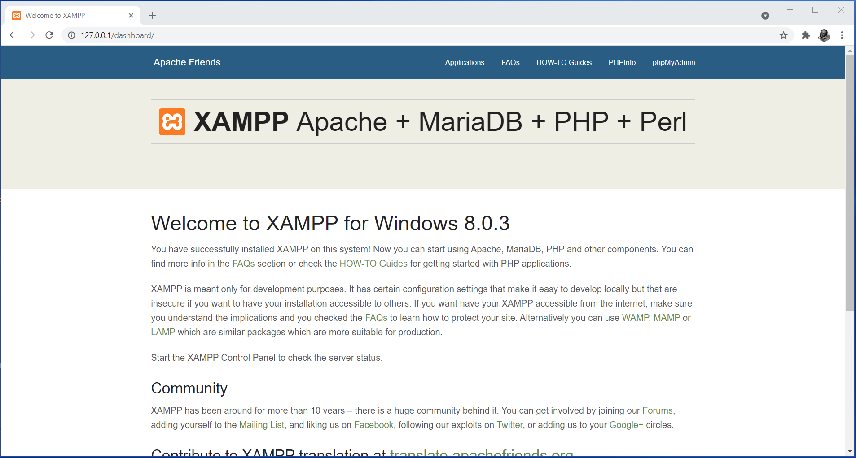
Figure 17. Option 2: Opening the Webserver from the Browser (Using http://127.0.0.1)
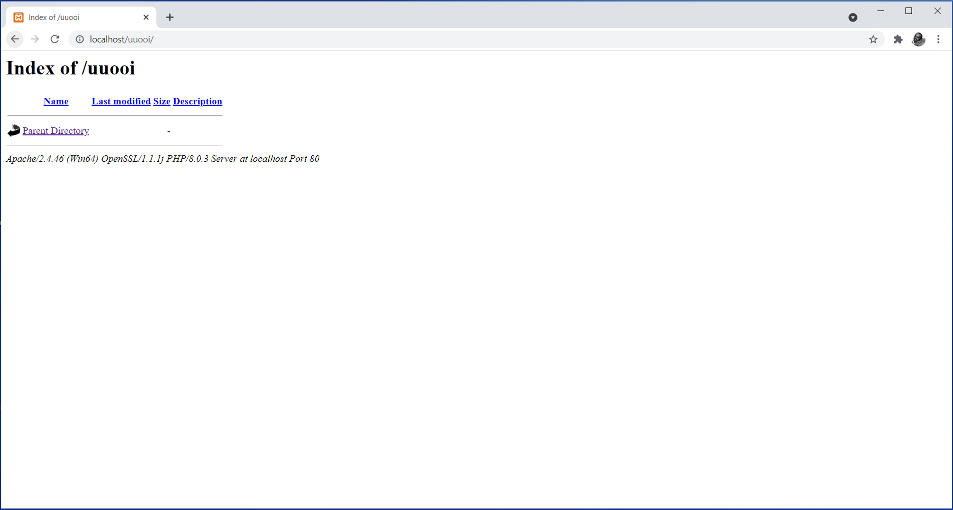
Figure 18. Accessing the uuooi Directory
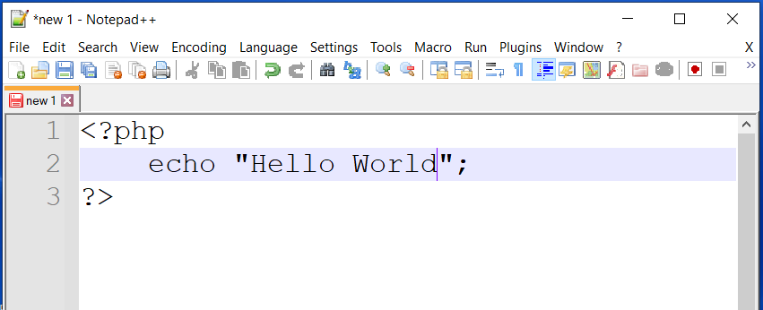
Figure 19. Writing a “Hello Word” Script in a Text Editor
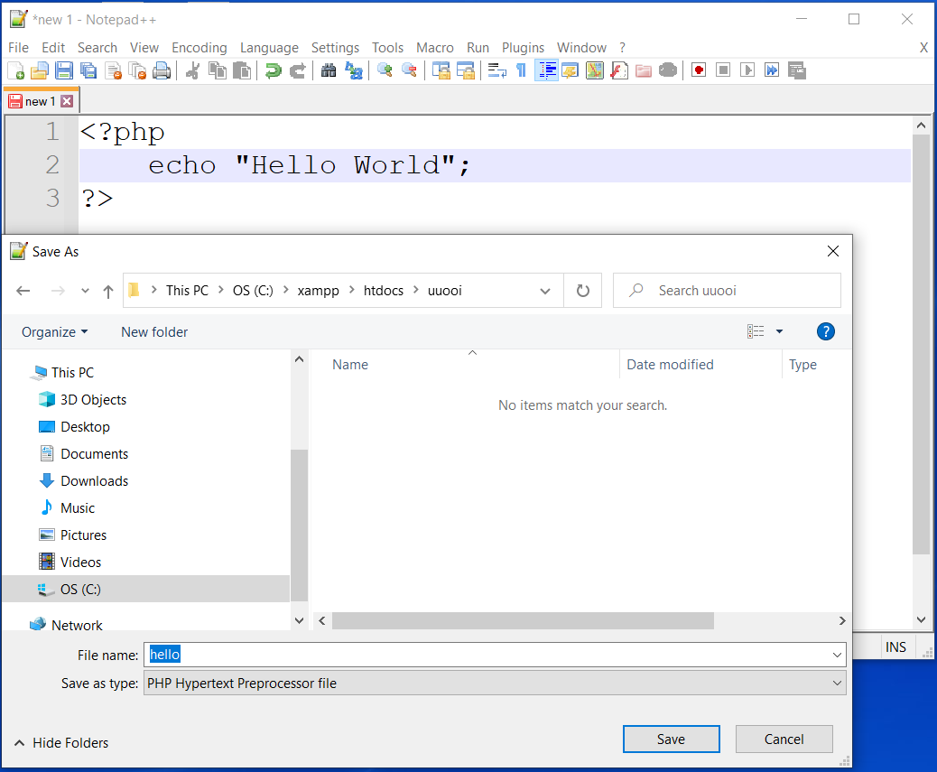
Figure 20. Saving the “Hello World” Script in the uuooi Folder
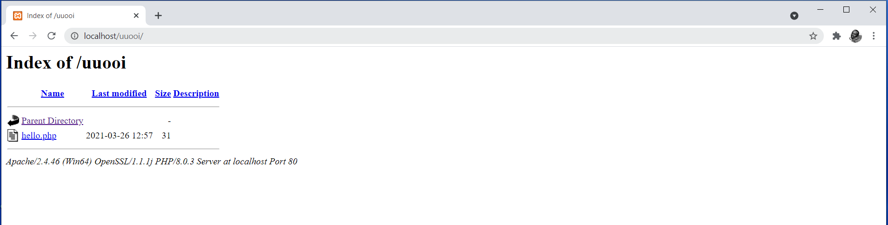
Figure 21. Accessing the uuooi Directory on the Browser with Files in it
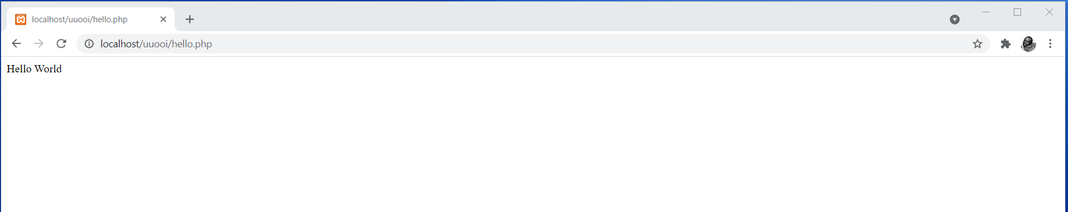
Figure 22. The Executed hello.php Script on the Browser
The example demonstrating how to write, save, and execute a PHP script is a clear indicator that by now the webserver is well set up and configured.

PHP Comments
Comments are normally crucial for the developer. They help in documenting the code, and for facilitation of troubleshooting. Commenting on a line or segment of code makes the interpreter skip the line(s) from execution. Hence, the regions with comments do not appear on the output displayed on the browser. There are two ways to include comments in PHP code.
- Single line comments
Single line comments are applied to one line at a time. The line being commented precedes with double forward slashes “//”. For instance, the following is an example of how three lines could be commented.
//line one commented out
//line two commented out
….
//line n commented out

- Multiple line comments
Multiple line comments are applied to more than one line at a time, or better say a block of code. The lines being commented precedes with a single forward slash followed by an asterisk “/*” and closed with an asterisk followed by a single forward slash “*/”. For instance, the following is an example of how three lines could be commented together.
/* line one commented out.
line two commented out.
….
line n commented out. */

The following example shows a PHP script and its output. The script is demonstrating scenarios for both single line and multiple line comments. The script also has some regions without comments.

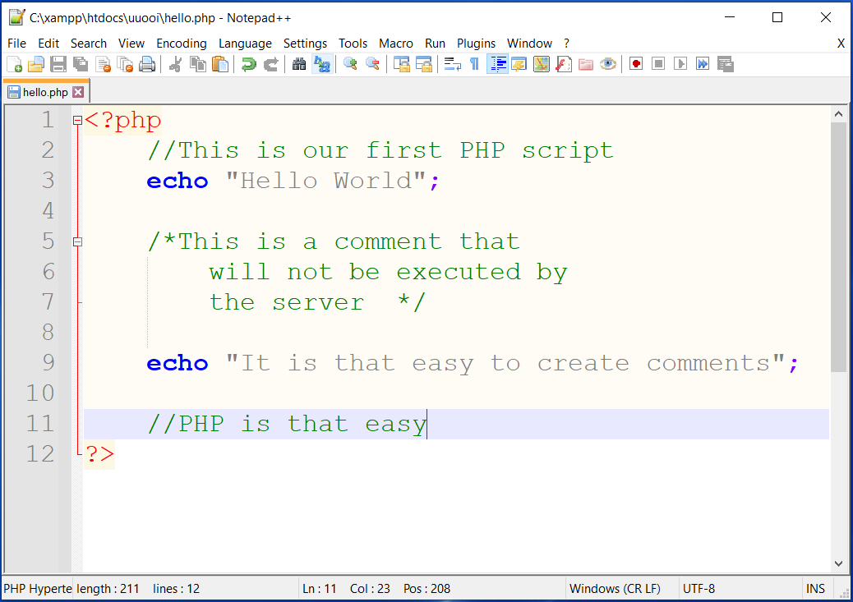
Figure 23. Adding Comments in PHP Scripts
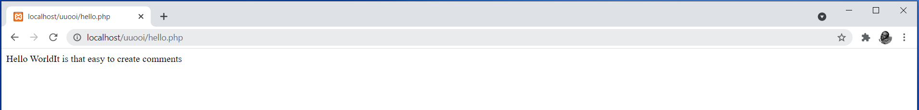
Figure 24. Executed Script Omitting Comments
Notice the fact that all the lines with comments have been ignored by the server and the client as evident in the output on the browser.

Embedding PHP into HTML
PHP codes, just like JavaScript codes, can be embedded into HTML documents. As a result, both PHP and JavaScript are sometimes referred to as embedded languages. The codes are normally typed directly into HTML webpages as separate sections embracing the syntax rules for the respective scripting language. The following example shows a PHP script embedded into HTML.
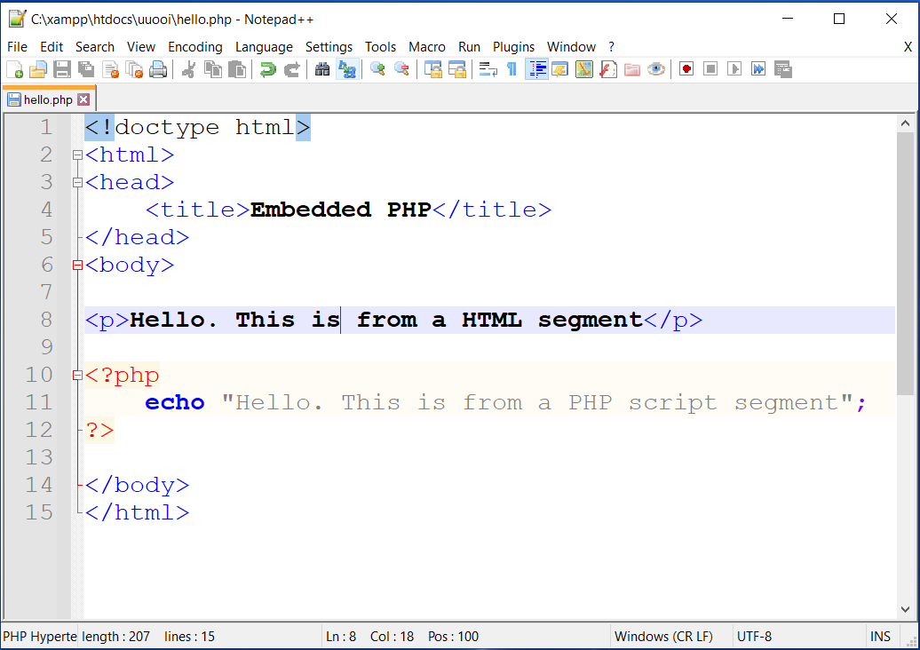
Figure 25. Embedding PHP Scripts in HTML
Notice the two code segments i.e. an HTML segment and a PHP script segment. It is worth pointing out that the moment a PHP script is embedded in an HTML document, then the file must be saved as .php. This is because the server must execute the PHP segment first before the page gets to the client for execution of the HTML segments. The output for the above example code is as follows.
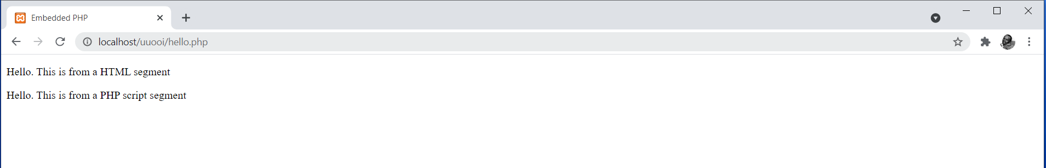
Figure 26. Output of Embedding PHP in HTML
It is worth noting that the PHP script code segments can be positioned before the beginning of the HTML segment, within the body of the HTML segment, or at the very end of the HTML segment.

Multiple Code Blocks
Multiple PHP script segments can also be embedded in one HTML webpage as outlined in the following example. This will only work if each segment has an independent opening and closing as per PHP syntax rules.
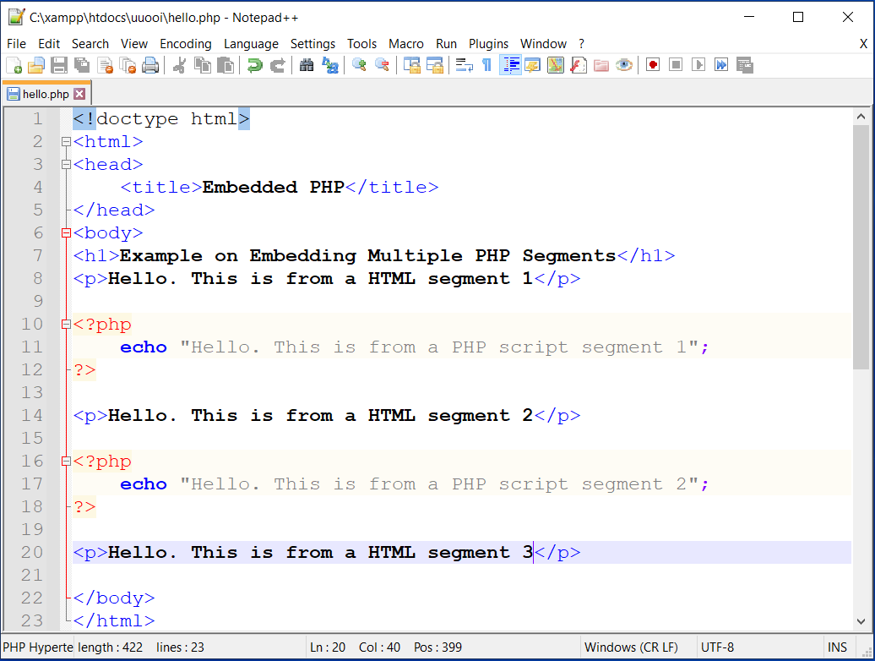
Figure 27. Embedding Multiple PHP Code Blocks in HTML
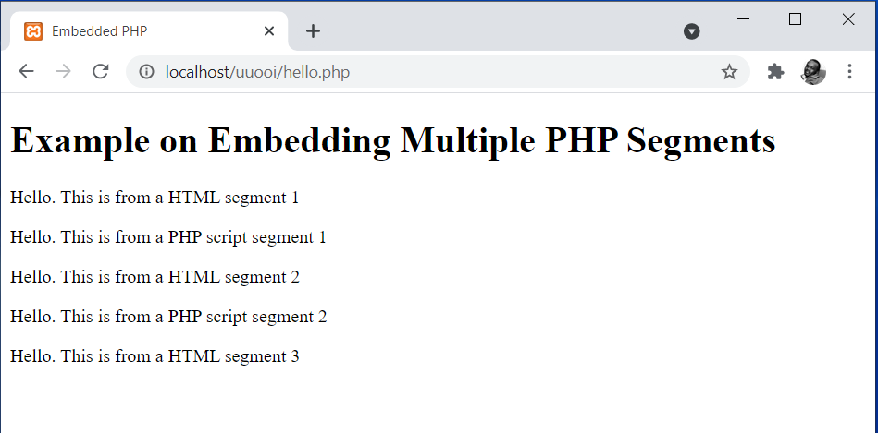
Figure 28. Output of Embedding Multiple PHP Code Blocks in HTML

Incorporating HTML Elements in PHP
HTML tags can also be embedded directly into PHP scripts in cases where specific effects have to be applied to text or any other objects being defined in PHP scripts. All the HTML and PHP rules must be followed appropriately in such cases. This is as shown in the example below.
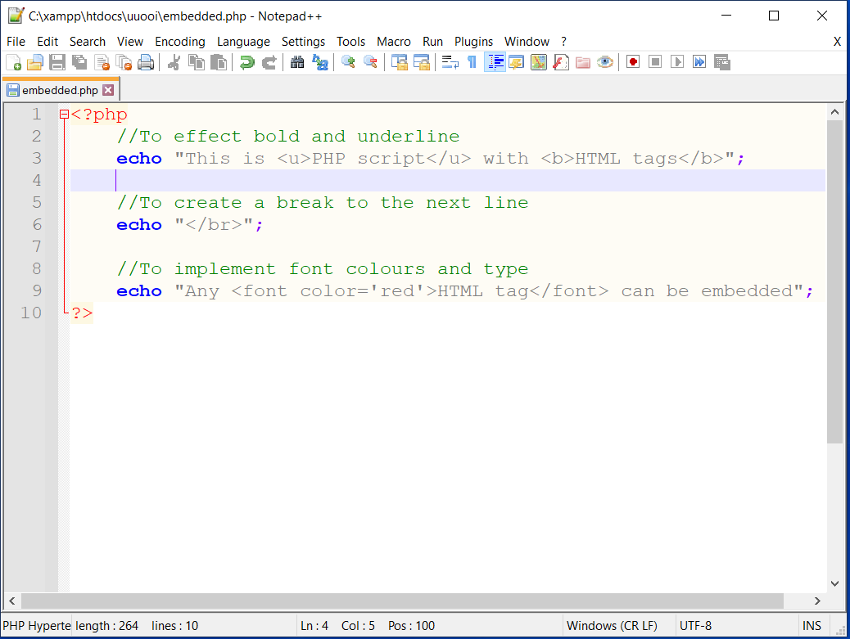
Figure 29. Incorporating HTML Elements in PHP
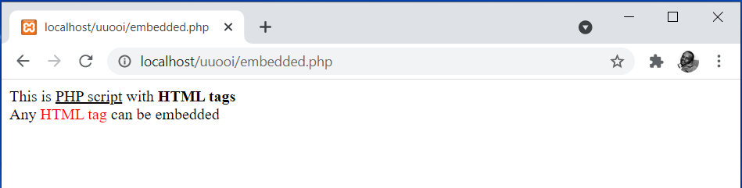
Figure 30. Output of Incorporating HTML Elements in PHP

Take note of how the selected examples of HTML tags have been embedded into PHP scripts. The same approach could be applied to any other HTML tags.

Summary
The topic has laid a foundation to PHP by outlining concepts of server-side scripting; how to write, save, and execute a simple standalone PHP script; the process of setting up XAMPP as an execution environment for PHP scripts; and how to embed PHP scripts into HTML and HTML tags into PHP scripts. From this point onwards, we should be good to proceed into deep PHP programming for web-based applications.

Check Points
- Describe the concepts behind scripting.
- Describe the components of XAMPP that make it critical for server-side scripting.
- Describe the process of installing XAMPP on a Windows OS.
- Demonstrate how HTML tags can be embedded into PHP scripts.
- Demonstrate how PHP scripts can be embedded into HTML web pages.

Learning Resources

Core Textbooks
- Brooks, D.R., 2017. Programming in HTML and PHP. Switzerland: Springer.
- Gosselin, D., Kokoska, D. and Easterbrooks, R., 2010. PHP Programming with MySQL: The Web Technologies Series. Cengage Learning.

Other Resources
- https://www.w3schools.com/php/DEFAULT.asp
- https://www.tutorialspoint.com/php/index.htm

References
- Brooks, D.R., 2017. Programming in HTML and PHP. Switzerland: Springer.
- Gosselin, D., Kokoska, D. and Easterbrooks, R., 2010. PHP Programming with MySQL: The Web Technologies Series. Cengage Learning.

