Advanced Web Based Application Development

Lecture 4

PHP Expressions and Operators

Dr. Obuhuma James

Description
This topic aims at exploring how computations can be performed in PHP. This will be achieved through exposing you to expressions and operators. Different types of operators used in expressions covered together with examples of how they can be applied in practice. The various types of operators covered include arithmetic operators, assignment operators, comparison operators, conditional operators, logical operators.

Learning Outcomes
By the end of this topic, you will be able to:
- Understand the relationship between expressions and operators.
- Distinguish the various types of operators and apply them in practice.

Introduction
Programming is founded on some element of mathematics. Hence, knowledge on how mathematical expressions are formulated and executed is paramount. The fact that expressions are made up of operands and operations to be performed on them, there is always a need for programmers to understand the different types of operations that can be perform on data in a program. This topic thus focuses on exploring the relationship between expressions and operators. It further covers the different types of operators commonly used in programming.

Expressions
Variables and data become more useful when used in an expression. An expression is a literal value or variable that be evaluated by the PHP scripting engine to produce a result. Expressions are created using operands and operators, where operands are the values to be worked on while operators are symbols that signify the operation to be performed on the operands.

Operators
Operators are a critical part of expressions. They can broadly be grouped into two types, namely, binary, or unary. Binary operators are signified by the presence of an operand before and after an operator while unary operators require only a single operand before or after the operator.
Operators can be further grouped into four main categories, namely, arithmetic, assignment, comparison, and logical operators. The categorization depends on the nature of operations performed by various operators forming the category as follows:
- Arithmetic operators – perform mathematical operations.
- Assignment operators – map or assign values to variables.
- Comparison operators – performs comparison of operands and returns a Boolean value.
- Logical operators – perform Boolean operations on Boolean operands.

Arithmetic Operators
Arithmetic operators are used to perform mathematical operations. The main arithmetic operations are addition, subtraction, multiplication, and division. In addition to the four, is the modulus operation. Table 1 summarizes the five operation with an indication of the symbols used to represent each one of them. These operations are all represented by bonary arithmetic operators.
Table 1: Binary Arithmetic Operators
Operation | Symbol | Description
Addition | + | Adds values for two operands
Subtraction | - | Subtracts the value of the right operand from that in the left operand
Multiplication | * | Multiplies values for two operands
Division | / | Divides the value of the left operand by that of the right operand
Modulus | % | Returns the remainder of dividing the value of the left operand by that of the right operand

Example Usage of Binary Arithmetic Operators
<?php
$x = 10;
$y = 6;
echo "Let x = " . $x . " and y = " . $y . "<br />";
echo "x + y = " . $x + $y . "<br />"; //the result will be value 16
echo "x - y = " . $x - $y . "<br />"; // the result will be value 4
echo "x * y = " . $x * $y . "<br />"; // the result will be value 60
echo "x / y = " . $x / $y . "<br />"; // the result will be value 1.6666666666667
echo "x % y = " . $x % $y; // the result will be value 4
?>

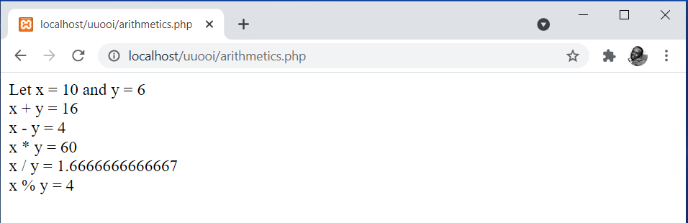
Figure 1. Output for Binary Arithmetic Operators Example

The output in Figure 1 clearly aligns to the descriptions per operation as earlier outlined in Table 1.

In the same line, PHP supports two main unary arithmetic operators, the increment and decrement operators. Table 2 summarises the operation with an indication of the symbols used to represent each one of them.
Table 2: Unary Arithmetic Operators
Operation | Symbol | Description
Increment | ++ | Increments the value of an operand by 1
Decrement | -- | Decrements the value of an operand by 1

The two operators can be applied as prefix operators, where the symbols appear before a variable or as postfix operators, where the symbols appear after a variable. Either option has its own meaning and impact after the execution of the statement.

Example Usage of Unary Arithmetic Operators
<?php
$x = 10;
echo "Let x = " . $x . "<br />";
echo "x++ = " . $x++ . "<br />";
echo "New x = " . $x . "<br />";
echo "<br />";
$x = 10;
echo "Let x = " . $x . "<br />";
echo "++x = " . ++$x . "<br />";
echo "New x = " . $x . "<br />";
echo "<br />";
$x = 10;
echo "Let x = " . $x . "<br />";
echo "x-- = " . $x-- . "<br />";
echo "New x = " . $x . "<br />";
echo "<br />";
$x = 10;
echo "Let x = " . $x . "<br />";
echo "--x = " . --$x . "<br />";
echo "New x = " . $x . "<br />";
?>

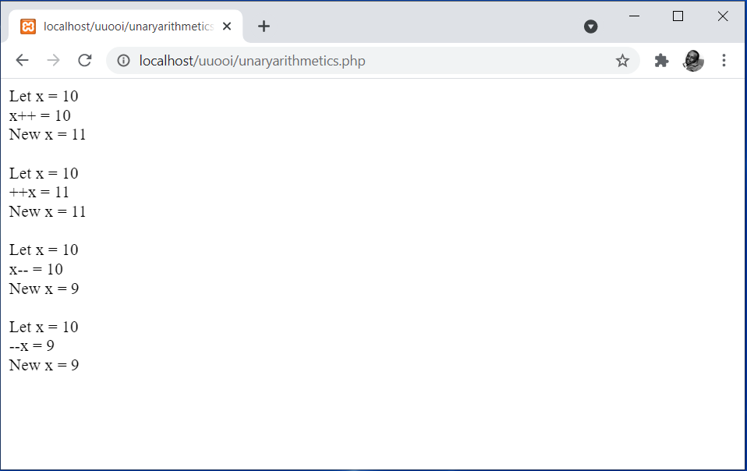
Figure 2. Output for Unary Arithmetic Operators Example

Based on the results, it is evident that when a prefix operator is used for incrementing, the value of the operand is increased by 1 before it is returned. On the other hand, when a postfix is used, the value of the operand is increased by 1 after it is returned. The same logic applies to prefix and postfix decrement.

Assignment Operators
The assignment operator, signified by an equal sign (=), maps or assigns a value to a variable. This could be an initial value to a new variable or a new value to an existing variable. This has already been demonstrated through almost all examples covered so far.

Example Usage of the Assignment Operator
<?php
$x = 20; //assigns the value ‘20’ to variable ‘x’
$name = “John Does”; //assigns the string ‘John Doe’ to variable ‘name’
$y = 10 + 4; //assigns the resulting value after evaluating 10+4 to variable ‘y’
?>

It is worth noting that an identifier should never appear on the right-hand side of an assignment operator unless it has previously been declared and assigned an appropriate value [1].
Most programming languages, including PHP support shorthand arithmetic/assignment operator that are also referred to us compound assignment operators. These operators facilitate performance of mathematical operations on variables and literal values in an expression then assigns new values to the operand on the left-hand side. Table 3 summarizes such operations with an indication of the symbols used to represent each one of them.

Table 3: Assignment and Compound Assignment Operators
Operation | Symbol | Description
Assignment | = | Assigns the value on the right-hand side of the operator to the variable on the left-hand side
Compound addition assignment | += | Adds the value on the right-hand side to that on the left-hand side of the operator then assigns the new values to the variable on the left-hand side
Compound subtraction assignment | -= | Subtracts the value on the right-hand side from that on the left-hand side of the operator then assigns the new values to the variable on the left-hand side
Compound multiplication assignment | *= | Multiplies the value on the right-hand side with that on the left-hand side of the operator then assigns the new values to the variable on the left-hand side
Compound division assignment | /= | Divides the value on the left-hand side by that on the right-hand side of the operator then assigns the new values to the variable on the left-hand side
Compound modulus assignment | %= | Divides the value on the left-hand side by that on the right-hand side of the operator then assigns the remainder to the variable on the left-hand side

Moreover, concatenation of values can also be achieved using the “.=” compound operator, such that the value on the right-hand side of the operator is concatenated to that on the left-hand side then the new value is assigned to the variable on the left-hand side.

Example Usage of Compound Assignment Operators
<?php
$x = 10;
echo "Let x = " . $x . "<br />";
$x+=5;
echo "x+=5 <br />";
echo "New x = " . $x . "<br />";
echo "<br />";

$x = 10;
echo "Let x = " . $x . "<br />";
$x-=5;
echo "x-=5 <br />";
echo "New x = " . $x . "<br />";
echo "<br />";

$x = 10;
echo "Let x = " . $x . "<br />";
$x*=5;
echo "x*=5 <br />";
echo "New x = " . $x . "<br />";
echo "<br />";

$x = 10;
echo "Let x = " . $x . "<br />";
$x/=5;
echo "x/=5 <br />";
echo "New x = " . $x . "<br />";
echo "<br />";

$x = 10;
echo "Let x = " . $x . "<br />";
$x%=5;
echo "x%=5 <br />";
echo "New x = " . $x . "<br />";
echo "<br />";

$x = 10;
echo "Let x = " . $x . "<br />";
$x.=5;
echo "x.=5 <br />";
echo "New x = " . $x . "<br />";
echo "<br />";
?>

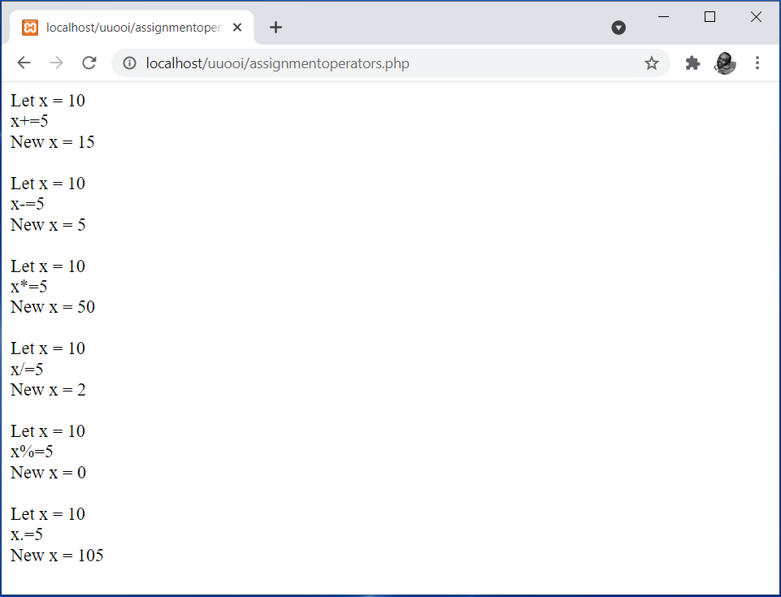
Figure 3. Output for Compound Assignment Operators Example

The output of the example clearly aligns to the descriptions per operation as earlier outlined in Table 3.

Comparison and Conditional Operators
Comparison operators determine how a given operand relates to another. The output of a comparison is a TRUE or FALSE, Boolean value, signifying the status of the comparison. Table 4 summarises comparison operations with an indication of the symbols used to represent each one of them.

Table 4: Comparison Operators
Operation | Symbol | Description
Equal | == | Returns TRUE if the values on the left-hand side are equal to those on the right-hand side
Strict equal | === | Returns TRUE if the values on the left-hand side are equal and of the same data type to those on the right-hand side
Not equal | != or <> | Returns TRUE if the values on the left-hand side are not equal to those on the right-hand side
Strict not equal | !== | Returns TRUE if the values on the left-hand side are not equal or not of the same data type to those on the right-hand side
Greater than | > | Returns TRUE if the values on the left-hand side are greater than those on the right-hand side
Less than | < | Returns TRUE if the values on the left-hand side are less than those on the right-hand side
Greater than or equal to | >= | Returns TRUE if the values on the left-hand side are greater than or equal to those on the right-hand side
Less than or equal to | <= | Returns TRUE if the values on the left-hand side are less than or equal to those on the right-hand side

Comparison operators are sometimes used with conditional operators [2], where the conditional operator executes one of two expressions based on results of a conditional expression.
Syntax
conditional_expression ? expression1 : expression2;

Expression1 is executed if the conditional expression returns TRUE, otherwise, expression2 is executed.

Example Usage of a Conditional Operator
<?php
$temperature = 10;
($temperature >= 20) ? $output = "It is a hot day" : $output = "It is a cold day";
echo $output;
?>
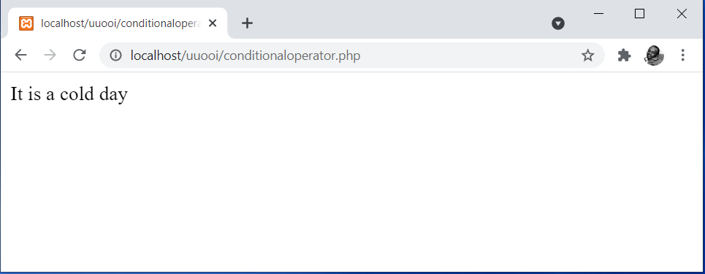
Figure 4. Output for a Conditional Operator Example

The output clearly aligns to the descriptions of the operation of conditional operators, where in this case, the conditional expression returned FALSE, resulting to execution of the second expression.

Logical Operators
Logical operators are used to compare two Boolean values for equality, where Boolean values are signified by a TRUE or FALSE value. Table 5 summarises logical operation with an indication of the symbols used to represent each one of them.
Table 5: Logical Operators
Operation | Symbol | Description
Logical AND | && or AND | Returns TRUE if both outcomes for the left-hand side and the right-hand side are TRUE, otherwise it returns FALSE.
Logical OR | || or OR | Returns TRUE if either outcome for the left-hand side or the right-hand side is TRUE, otherwise it returns FALSE.
Logical Exclusive Or | XOR | Returns TRUE if only one outcome for either the left-hand side or the right-hand side is TRUE, otherwise it returns FALSE.
Logical NOT | ! | Returns TRUE if an expression is FALSE and returns FALSE if an expression is TRUE.

It is worth noting that comparison and logical operators are mostly used by conditional statements and looping statements. Hence, examples of their usage will be demonstrated in the subsequent topic, as we get to control structures.

Summary
The topic covered concepts behind the use of expressions and operators. Expressions are composed of operands and the operation to be performed. Such operations are signified by operators. The operators covered were categorized as arithmetic, assignment, comparison and logical. Example usage of the various operators has been demonstrated throughout the topic. It is worth pointing out that the topic only focused on key operators that are commonly used in programming. It is hence recommended that learners should explore other operators-related aspects not covered in this topic on their own. These may include special operators, type casting, operator precedence, among others.

Check Points
- Describe the composition of expressions as used in PHP.
- Discuss the various categories of operators.
- Differentiate between unary and binary arithmetic operators.
- Describe the different types of arithmetic operations.
- Describe the different types of comparison operations.
- Describe the different types of logical operations.
- Differentiate between the assignment operator and compound assignment operators.

Learning Resources

Core Textbooks
- Brooks, D.R., 2017. Programming in HTML and PHP. Switzerland: Springer.
- Gosselin, D., Kokoska, D. and Easterbrooks, R., 2010. PHP Programming with MySQL: The Web Technologies Series. Cengage Learning.

Other Resources
- https://www.w3schools.com/php/DEFAULT.asp
- https://www.tutorialspoint.com/php/index.htm

References
- Brooks, D.R., 2017. Programming in HTML and PHP. Switzerland: Springer.
- Gosselin, D., Kokoska, D. and Easterbrooks, R., 2010. PHP Programming with MySQL: The Web Technologies Series. Cengage Learning.

