Advanced Web Based Application Development

Lecture 6

Control Structures

Dr. Obuhuma James

Description
This topic aims at exploring control structures that define the way statements are to be executed in each program. This will be looked at from two perspectives, namely, branching, and looping control structures. The two approaches define other forms of execution in addition to the normal sequential (linear) fashion of execution. Examples of standard statements will be discussed and demonstrated in each case.

Learning Outcomes
By the end of this topic, you will be able to:
- Describe the three main approaches of execution, namely, sequential, branching, and looping.
- Practically implement branching and looping control structures.
- Apply comparison and logical operators in real-world programming.

Introduction
The form of execution of statements covered so far has been purely a linear fashion of execution. This means that statements are executed in the order in which they appear in the program, in a top-down manner. This topic introduces branching and looping concepts that allow execution to deviate from sequential (linear) to any order that a programmer wishes to use. Branching and looping are somehow universal since they cut across relatively all programming languages.

Branching
Branching is a control structure that allows for the order of execution to take one of two options available based on the outcome of a given conditional expression. It is also known as decision-making. The conditional expression returns a Boolean value that can be either TRUE or FALSE as a determinant of the direction to be taken as shown in Figure 1.

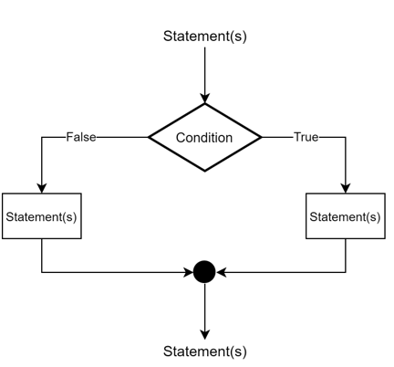
Figure 1. The Concept of Branching Control Structure

There are three statements that can be used to implement branching in PHP, just like in other programming languages. These are the if statement, the if … else statement and the switch statement.

If Statement
The if statement contains a condition that evaluates to a TRUE or FALSE Boolean value. In case the condition returns a TRUE, then the statements in the if segment are executed. Otherwise, if a FALSE value is returned, then the program does not get into the if segment, it instead proceeds execution of any other statements coming after the if statement segment.

Syntax
if(condition){
Statement(s) to be executed of condition is TRUE;
}

Example
Consider the following simple example of a PHP script that checks whether the temperature value provided is greater or equal to 20 for it to execute or fail to execute the if segment of the script.

<?php
$temperature = 30;

if($temperature >= 20){
echo "It is a hot day"; //executed if and only if the temperature is >=20
}
echo "<br />";
echo "Execution proceeds to other statements";
?>

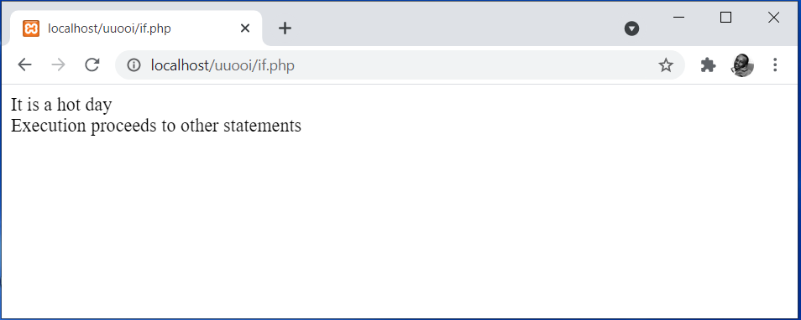
Figure 2. Output of the If Statement Example

Notice that since the set temperature value 30 is greater than 20, the condition returns a TRUE. This makes the script to jump into the if statement block and execute the statement that displays “It is a hot day”. After which, the script proceeds to sequentially execute any other statements coming after the if statement segment. If the set temperature could have been less than 20, the output could have omitted the statement “It is a hot day”.

If … else Statement
The if … else statement extends the standard if statement by including an else part. The else segment comes immediately after the if segment, such that it is only executed if and only if the condition returns FALSE.

Syntax
if(condition){
Statement(s) to be executed if condition is TRUE;
}else{
Statement(s) to be executed if condition is FALSE;
}

Example
Consider the enhanced example of the PHP script that checks whether the temperature value provided is greater or equal to 20. This time round, the script will either jump into the if segment or else segment depending on the outcome of the condition.
<?php
$temperature = 15;

if($temperature >= 20){
echo "It is a hot day"; //executed if and only if the temperature is >=20
}else{
echo "It is a cold day"; //executed if and only if the temperature is <20
}

echo "<br />";
echo "Execution proceeds to other statements";
?>

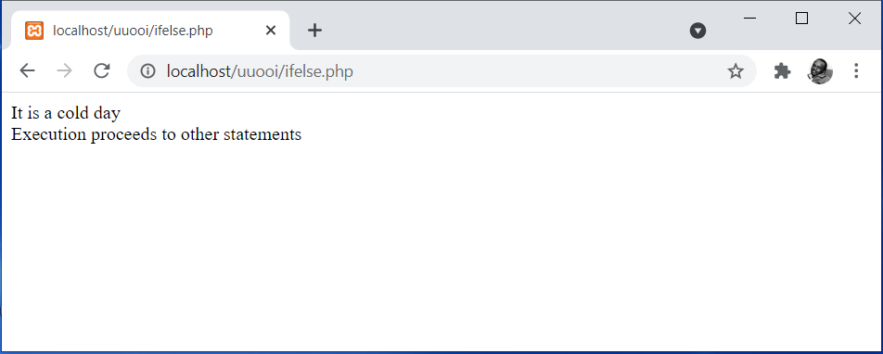
Figure 3. Output of the If … else Statement Example

Notice that since the set temperature value 15 is less than 20, the condition returns a FALSE. This makes the script to jump into the else part of the if … else statement and execute the statement that displays “It is a cold day”. After which, the program proceeds to sequentially execute any other statements coming after the if … else statement segment. If the set temperature could have been greater than 20, the output could have been as explained in the previous if statement example.

Nesting if … else Statements
The if … else statement allows nesting, where several if … else statements are stacked together to test several conditions. Such a statement is commonly referred to as the nested if … else.

Syntax
if(condition_1){
Statement(s) to be executed if current condition is TRUE;
}elseif(condition_2){
Statement(s) to be executed if current condition is TRUE;
} elseif(condition_3){
Statement(s) to be executed if current condition is TRUE;
}
…

elseif(condition_n){
Statement(s) to be executed if current condition is TRUE;
}else{
Statement(s) to be executed if no condition is TRUE;
}

Example
Consider a script that checks a numeric value matching a day of week and displays the correct day of week, such that:
1 – Sunday
2 – Monday
3 – Tuesday
4 – Wednesday
5 – Thursday
6 – Friday
7 – Saturday

<?php
$today = 4;

if($today == 1){
echo "Today is a Sunday";
}elseif($today == 2){
echo "Today is a Monday";
}elseif($today == 3){
echo "Today is a Tuesday";
}elseif($today == 4){
echo "Today is a Wednesday";
}elseif($today == 5){
echo "Today is a Thursday";
}elseif(today == 6){
echo "Today is a Friday";
}elseif($today == 7){
echo "Today is a Saturday";
}else{
echo "No match found";
}

echo "<br />";
echo "Execution proceeds to other statements";
?>

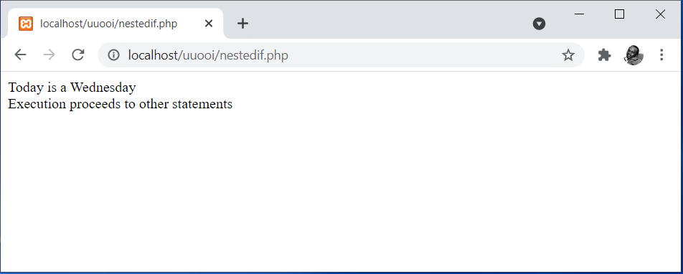
Figure 4. Output of the Nested If … else Statement Example

Notice that since the variable $today has been set to value 4, only condition 4 returns a TRUE. This makes the script to jump into that segment and execute the statement that displays “Today is a Wednesday”. After which, the program proceeds to sequentially execute any other statements coming after the nested if … else statement segment. If none of the conditions could have returned a TRUE, then the else part of the nested if … else segment could have been executed. Note that the else part comes at the very end of the nested if … else statement to take care of such scenarios.
A nested if … else statement works in a similar manner to that of a switch statement. The next subsection on the switch statement will hence use a similar example to show the relationship between the two statements.

Switch Statement
The switch statement is best suited for scenarios with many options. It starts with a switch kind of function that determines the value to be searched for. The value may be supplied directly or may be a result of an expression. The value can be a string, character, or numeric value. The switch body contains as many case segments as the number of possible options to be tested. Each case has a value that is tested against the value being searched for. A break statement exists in each case segment to allow the execution to get out of the switch statement upon successful execution of all statements in that segment. At the very end of the cases, is a default segment that is executed if and only if no matching case is found. It is very important to ensure that the break statement is present in each case segment. Otherwise, the default segment will be executed in addition to the matching case since the execution will still be in the switch statement.

Syntax
switch(expression/value){
case value_1:{
Statement(s) to be executed if the value matches;
break;
}
case value_2:{
Statement(s) to be executed if the value matches;
break;
}
case value_3:{
Statement(s) to be executed if the value matches;
break;
}
…
case value_n:{
Statement(s) to be executed if the value matches;
break;
}
default:{
Statement(s) to be executed if the value matches;
}
}

Example
The following is a similar implementation for a script matching numeric values to days of week using the switch statement.
<?php
$today = 4;

switch($today){
case 1:{
echo "Today is a Sunday";
break;
}
case 2:{
echo "Today is a Monday";
break;
}
case 3:{
echo "Today is a Tuesday";
break;
}
case 4:{
echo "Today is a Wednesday";
break;
}
case 5:{
echo "Today is a Thursday";
break;
}
case 6:{
echo "Today is a Friday";
break;
}
case 7:{
echo "Today is a Saturday";
break;
}
default:{
echo "No match found";
}
}

echo "<br />";
echo "Execution proceeds to other statements";
?>

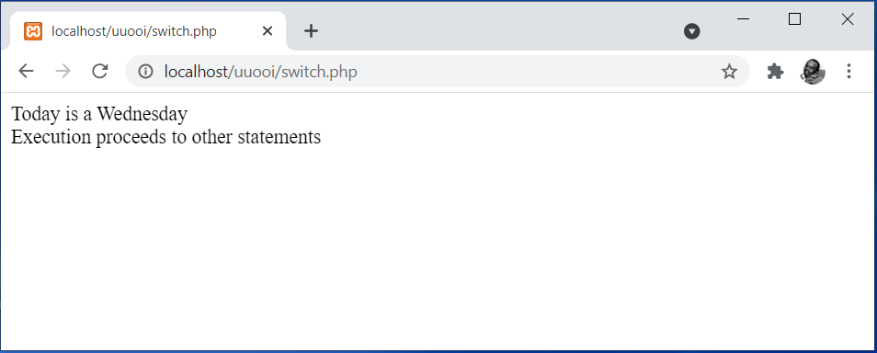
Figure 5. Output of the Switch Statement Example
Notice that since the variable, $today, has been set to value 4, only the case requiring value 4 matches. This makes the script to jump into that segment and execute the statement that displays “Today is a Wednesday”. After which, the script breaks from the segment allowing the program to proceed sequentially by executing any other statements coming after the switch statement segment. If none of the cases could have been found matching, then the default segment could have been executed. Note that the default part comes at the very end to take care of such scenarios.

Looping
Looping is a control structure that allows for the order of execution to take one of two options available based on the outcome of a given condition. Unlike for the case of branching, looping allows repetitive execution if the condition holds. Hence, looping control structures are also referred to as repetition. The conditional expression returns a Boolean value that can be either TRUE or FALSE as a determinant of the direction to be taken as shown in Figure xx.
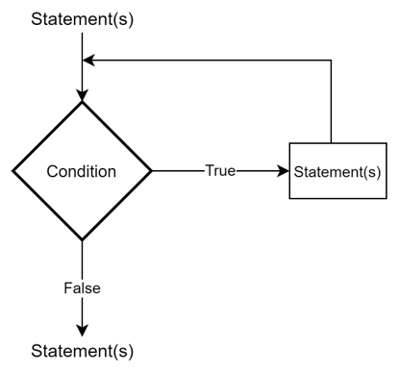
Figure 6. The Concept of Looping Control Structure

There are four statements that can be used to implement looping in PHP, just like in other programming languages. These are the for loop, while loop, do … while loop, and foreach loop.

For Loop
The for loop is made up of three critical parameters, namely, an initialization, a condition, and a loop counter. The initialization is used to define and initialize a variable whose value serves as the starting point for loop execution. The variable is then used in the conditional expression to set a condition that will be used to determine the number of times the loop executes and the stopping point. Moreover, the same variable is used in the loop counter where it gets updated every time an execution cycle occurs. The updated value for the variable is what is subjected to the conditional expression every time a check is made to determine the next move.

Syntax
for(initialization; condition; loopcounter){
Statement(s) to be executed of condition is TRUE;
}

Example
Consider the following simple example of a PHP script that prints numbers 1 to 5 in a vertical manner.
<?php
for($i=1; $i<=5; $i++){
echo $i;
echo "<br />";
}
?>

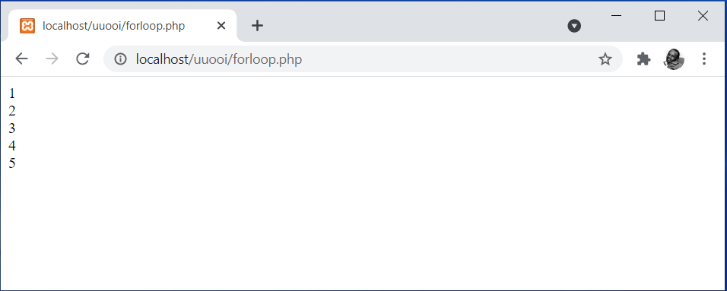
Figure 5. Output of the For Loop Example

Note that whatever is echoed is what is to be displayed every time the loop executes. Hence, in this case, the variable $i is what is displayed. Since the variable gets updated upon every execution cycle, in this case, an increment by 1, the script ends up printing 1 – 5.

While Loop
The while loop is made up of three critical parameters, namely, an initialization, a condition, and a loop counter, just like the case of the for loop. The initialization is used to defines and initialize a variable whose value serves as the starting point for loop execution. The variable is then used in the conditional expression to set a condition that will be used to determine the number of times the loop executes and the stopping point. Moreover, the same variable is used in the loop counter where it gets updated every time an execution cycle occurs. The updated value for the variable is what is subjected to the conditional expression every time a check is made to determine the next move. The while loop defines and initializes the initialization variable before the loop starts. This approach is similar to the do … while, but it is completely done differently in the for loop.
Syntax
Initialization;
while(condition){
Statement(s) to be executed of condition is TRUE;
Loopcounter;
}

Example
The following example will print numbers 1 to 5 in a similar manner as was done by the for loop described in the previous subsection.
<?php
$i=1;

while($i<=5){
echo $i;
echo "<br />";
$i++;
}
?>

Do … while Loop
The do … while loop is made up of three critical parameters, namely, an initialization, a condition, and a loop counter, just like for the case of the for loop and the while loop. The initialization is used to define and initialize a variable whose value serves as the starting point for loop execution. The variable is then used in the conditional expression to set a condition that will be used to determine the number of times the loop executes and the stopping point. Moreover, the same variable is used in the loop counter where it gets updated every time an execution cycle occurs. The updated value for the variable is what is subjected to the conditional expression every time a check is made to determine the next move. The unique approach used by the do … while loop compared to the other loops is the fact that the condition is tested at the end after execution of the statements in the loop’s body.

Syntax
Initialization;
do{
Statement(s) to be executed of condition is TRUE;
Loopcounter;
} while(condition)

Example
The following example will print numbers 1 to 5 in a similar manner as was done by the for loop and while loop described in the previous subsection.
<?php
$i=1;

do{
echo $i;
echo "<br />";
$i++;
}while($i<=5)
?>

Foreach Loop
The foreach is used to loop through elements in an array [1]. For each iteration of a foreach loop, the loop moves to the next element in an array. Unlike the previous looping statements, the foreach loop does not require a loop counter. However, an array expression must be specified within a set of parentheses following the foreach keyword.

Syntax
foreach(array_name as variable_name){
Statement(s) to be executed;
}
There are two critical variables required in the foreach loop. The first variable should refer to an existing array while the second variable should be a new variable created to hold array elements each time the loop executes.

Example
Consider the array of continents that we created in topic 3. The following example demonstrates how the foreach loop can be used to access and display the three continents stored to the array.
<?php
$continents = array("Africa", "Asia", "Europe");

foreach($continents as $continentname){
echo $continentname;
echo "<br />";
}
?>

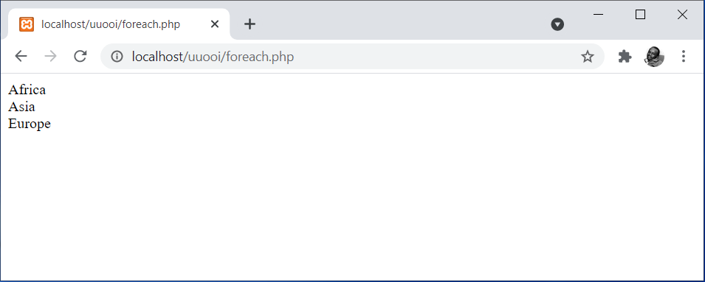
Figure 6. Output of the Foreach Loop Example
The output is a clear indicator that the foreach loop was able to iterate through the array elements. The $continents variables in the loop acted as a reference to the array while the $continentname variable was used to hold array element names each time the loop was iteratively executed. The loop can be enhanced to access indices for the various array elements. In which case, a third variable must be added to variables specified in the parentheses after the foreach keyword as outlined in the following modified syntax.

Syntax
foreach(array_name as variable_index => variable_name){
Statement(s) to be executed;
}

Example
Consider the following enhancement to the previous example to allow the array indices to be accessed and displayed.
<?php
$continents = array("Africa", "Asia", "Europe");

foreach($continents as $continentindex => $continentname){
echo "The continent at index " . $continentindex . " is " . $continentname;
echo "<br />";
}
?>

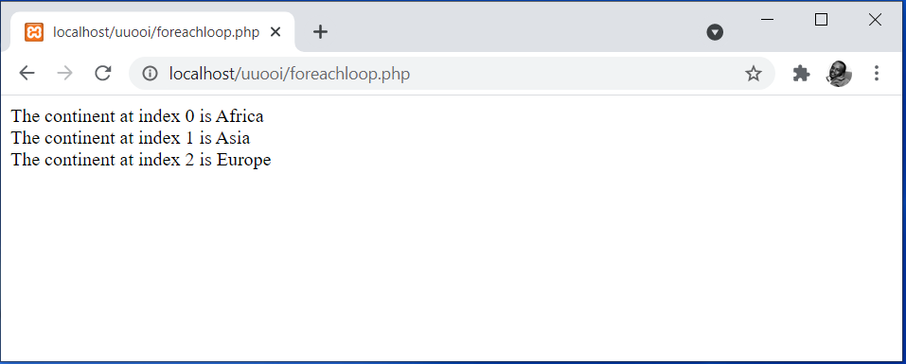
Figure 7. Output of the Foreach Loop with Array Indices Example
Notice the fact that the output now includes the index for each array element. This was made possible by including the $continentindex variable in the enhanced version of the foreach loop.
The for loop, while loop or do … while loop could be used to access and display array elements and their indices as achieved by the foreach loop. For instance, the following example demonstrates how a while loop can be used to perform a similar implementation for accessing and displaying array elements.
<?php
$continents = array("Africa", "Asia", "Europe");

$i=0;

while($i<=2){
echo "The continent at index " . $i . " is " . $continents[$i];
echo "<br />";
$i++;
}
?>

Application of Comparison and Logical Operators
The conditional expressions used in branching and looping statements can be made up of both comparison operators and logical operators. Under all circumstances, the outcome of the evaluation of the conditional expression should be a Boolean value that is either a TRUE or FALSE. All the examples demonstrated in previous subsections have employed the use of comparison operators like equals (==) and greater than or equals to (>=). Logical operators are normally applicable in cases where two or more conditions are to be tested at once. For instance, consider the temperature script example used to demonstrate the if statement. Supposing we wish to check for temperatures falling between some range, say 20 to 40, then a logical AND operator will be applied as follows.

<?php
$temperature = 30;

if(($temperature > 20) && (temperature < 40)){
echo "It is a hot day"; //executed if and only if the temperature is >=20
}
echo "<br />";
echo "Execution proceeds to other statements";
?>

Any other logical operator can be applied in a more or less similar manner based on conditions to be tested.

Summary
The topic covered control structures as mechanisms for defining the order of execution of statements in a program. This has been looked at in two broad categories, namely, branching and looping. Under branching, the if statement, if … else statement and the switch statement have been fully described and demonstrated. Similarly, under looping, the for loop, while loop, do … while loop and the foreach loop have been fully described and demonstrated. The application of both comparison and logical operators has been demonstrated discussed with some demonstration.

Check Points
- Discuss the reason behind the existence of different control structures.
- Differentiate between branching and looping control structures.
- Describe circumstances under which the nested if … else and switch statements are applicable.
- Demonstrate how the for loop and do … while loops can be used to access and display array elements.
- Describe why the foreach loop is unique from other looping approaches.

Learning Resources

Core Textbooks
- Brooks, D.R., 2017. Programming in HTML and PHP. Switzerland: Springer.
- Gosselin, D., Kokoska, D. and Easterbrooks, R., 2010. PHP Programming with MySQL: The Web Technologies Series. Cengage Learning.

Other Resources
- https://www.w3schools.com/php/DEFAULT.asp
- https://www.tutorialspoint.com/php/index.htm

References
- Brooks, D.R., 2017. Programming in HTML and PHP. Switzerland: Springer.
- Gosselin, D., Kokoska, D. and Easterbrooks, R., 2010. PHP Programming with MySQL: The Web Technologies Series. Cengage Learning.

