Advanced Web Based Application Development

Lecture 7

PHP-MySQL Database Connectivity

Dr. Obuhuma James

Description
This topic aims at introducing you to PHP connectivity to MySQL databases. It will explore the foundations of MySQL databases, with a focus on relational databases. Mechanisms to connect to MySQL databases using PHP scripts will be clearly covered.

Learning Outcomes
By the end of this topic, you will be able to:
- Understand how to access the phpMyAdmin web application.
- Determine default database access privileges and create new user accounts using phpMyAdmin.
- Establish and close connections to a MySQL database engine using PHP.

Introduction
One of the capabilities of PHP scripts is to access databases and its data and to return the result to a browser. The process involved in achieving this requires a clear understanding of the use of Structured Query Language (SQL) statements in creating databases and tables. Furthermore, an understanding of how Data Manipulation Language (DML) statements are used to insert, update, select and delete records in a relational database is also critical. This topic will start by introducing the phpMyAdmin web interface that is part of XAMPP and its importance in PHP-MySQL database connectivity. PHP functions for establishing connectivity to MySQL databases will then be explored. Finally, the need for closing connections and the PHP functions for performing that will be covered.

MySQL Database
A database is a collection of data and set of rules that organize the data. There are different types of databases, including hierarchical databases, network databases, relational databases, object-oriented databases, nosql databases, among others. Despite the existence of the many types of databases, the most commonly used type of databases is the relational database model, in which data is organized as a collection of tables, also referred to as relations. A table is a set of unique attributes or columns. Each row (or record) of a relation is called a tuple. To manage and control data in a database, a Database Management System (DBMS) is essential. Examples of common DBMSs include, MySQL, Oracle, DB2, MS-SQL server among others. All these DBMSs are SQL based. PHP supports Open Database Connectivity (ODBC) compliant databases including Oracle, Informix, PostgreSQL, and MySQL [2]. In some instances, PHP also allows direct connection to some databases without going through ODBC. This course will use MariaDB, a fork of the MySQL database to demonstrate concepts of PHP to database connectivity, use of PHP in creating and deletion of databases and tables and in inserting, updating, selecting, and deleting data in the database. Direct connectivity to the database will be used, without going through ODBC. The choice of DBMS to use for the demonstration is because MariaDB comes as part of XAMPP which is the main package used throughout this course. PHP’s MySQLi Extension will be used in the entire course to interface between PHP and the MySQL database. Other API options that may be used are the MySQL Extension or the PHP Data Objects (PDO). It is worth mentioning that MySQLi Extension is an improved version of the MySQL Extension, supported by PHP 5 and later versions [2]. Each of the three API options has its own pros and cons that have to be considered by programmers on a case-by-case basis.

XAMPP Control Panel
To be able to use the MySQL engine, the MySQL service must be started and running on your computer. The XAMPP control panel is essential for effecting this. The XAMPP control panel can be opened from the start menu, among the programs on the list. Figure 1 shows how the control panel looks like when opened.
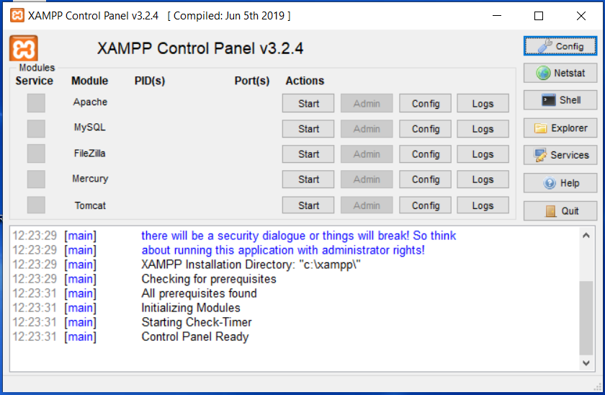
Figure 1. XAMPP Control Panel

The XAMPP Control Panel will show you various services available at your disposal. You can start, stop, configure, and view logs for any of the services. For the sake of this course, we are only interested in Apache and MySQL. Be sure to the two services. This will highlight them in colour green, an indicator that they are started and running. Any other colour will be an indicator that the services are not running or are being interfered with. You will be able to see the service status with a timestamp at the bottom for your information. This topic onwards will require both Apache and MySQL to be started and running. Figure 2 show how they should appear in the XAMPP control panel when they are up and running.
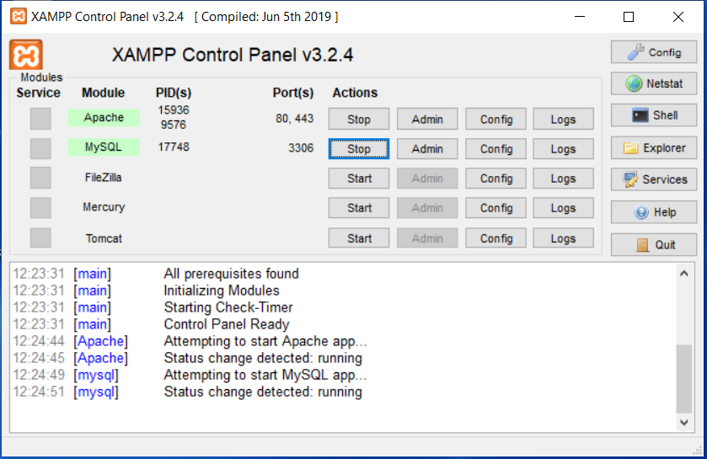
Figure 2. XAMPP Control Panel with Apache and MySQL Services Running

Once open, the XAMPP Control Panel icon will remain on the system tray for ease of access when necessary.

phpMyAdmin
The next step is to be familiar with the MySQL database, how to create a database and tables even before we get to PHP scripts for interacting with the database engine. Part of the XAMPP package is the phpMyAdmin, a web application used to manage the database engine in XAMPP.

Opening and Using phpMyAdmin
The phpMyAdmin web application can be opened and used through the browser. Start by opening http://localhost to access the interface shown in Figure 3.
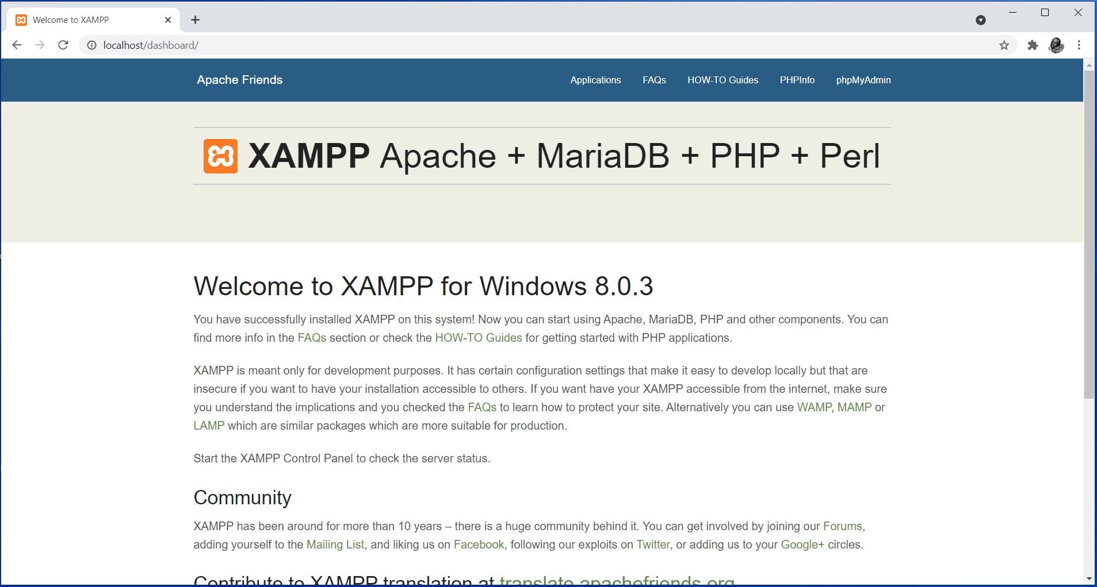
Figure 3. Opening the Webserver from the Browser (Using http://localhost or http://127.0.0.1)

Part of the main menu items is a link to the phpMyAdmin application. Clicking on it gets you to the phpMyAdmin interface shown in Figure 4.
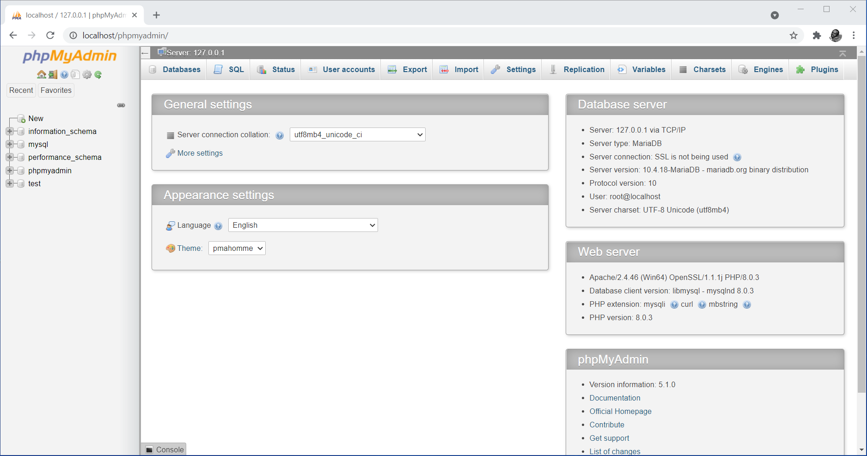
Figure 4. Default phpMyAdmin Page

The default phpMyAdmin web interface shows details for the database server, the webserver, and phpMyAdmin. These details include database host name and protocol, server type, server version, user; webserver version, database client version, PHP extension and version; and the phpMyAdmin version information plus links to documentations and other information.

Connecting to MySQL Database
To establish a connection to the database engine, the mysqli_connect() function is used. The function takes three critical parameters, namely, the host, username, and password. The host parameter represents server name or IP address for the server hosting the database. The username and password parameters represent the login credentials used to login to the database engine.
Syntax
Mysqli_connect(host, username, password);

By default, the username for a MySQL database that comes as part of XAMPP is set “root” with no password set. Since we are running the server on the localhost, the host in this case becomes “localhost” or IP address “127.0.0.1”. This is as evident in Figure 5 that is accessible upon clicking on the privileges tab with the default MySQL database active.
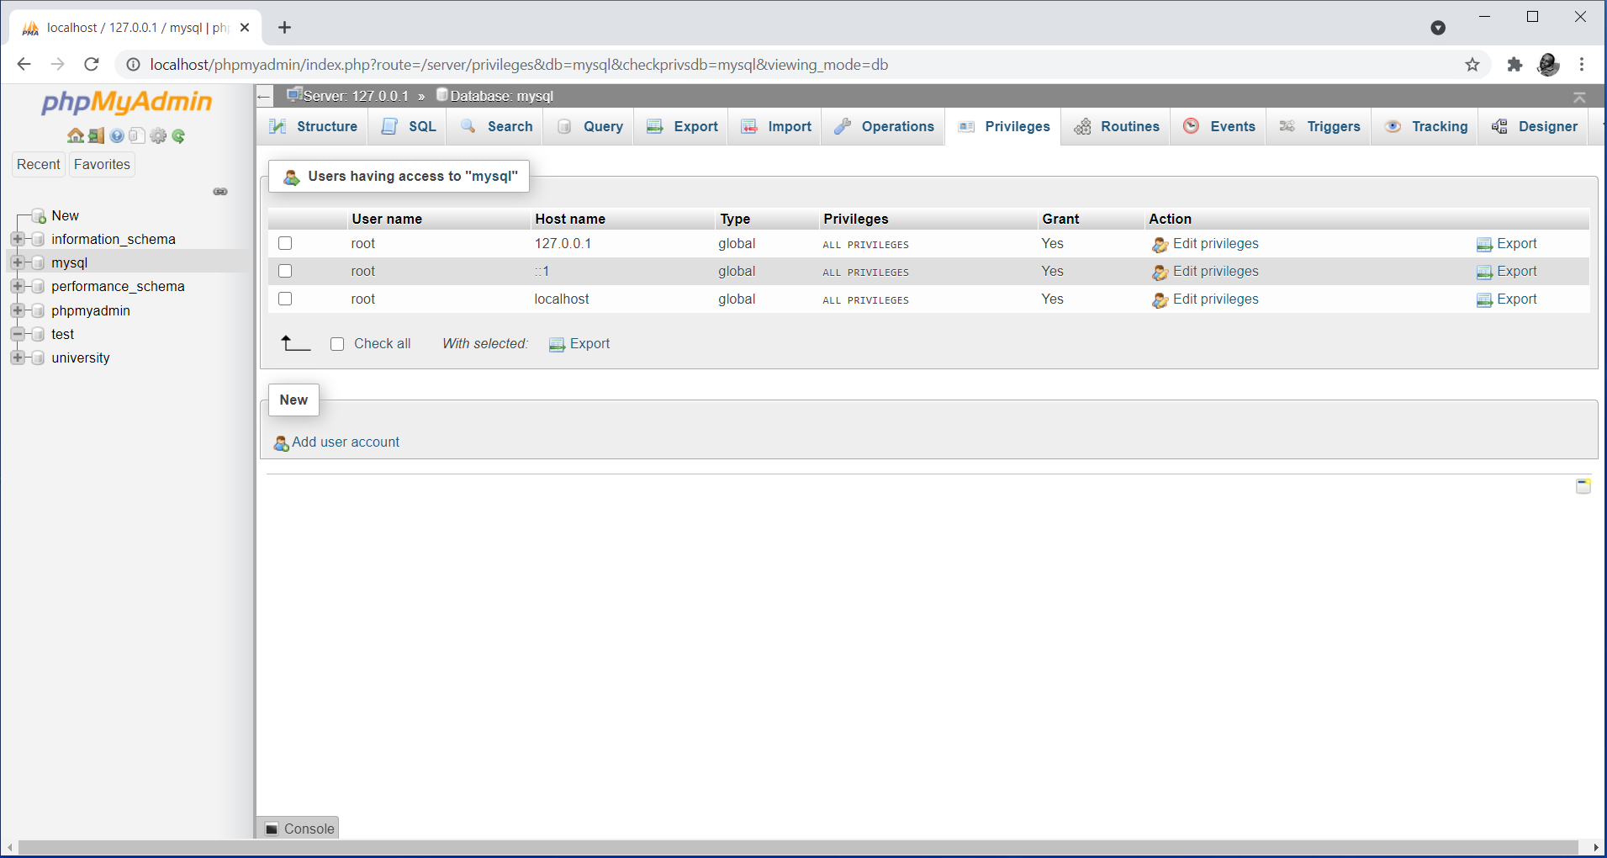
Figure 5. Default Details for Accessing the MySQL Database under XAMPP

It is also possible to specify a different user account in case you don’t wish to use the default “root” account. This can be accomplished by clicking on the user accounts tab which opens the window shown in Figure 6.
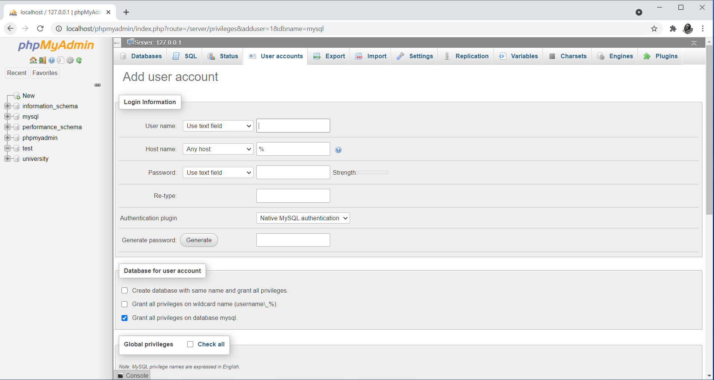
Figure 6. Creating a New Database User Account

Such an approach will allow you to specify a username, host name and password. Furthermore, at the bottom of the interface, you will be able to choose privileges that you wish to assign to the new account as shown in Figure 7.
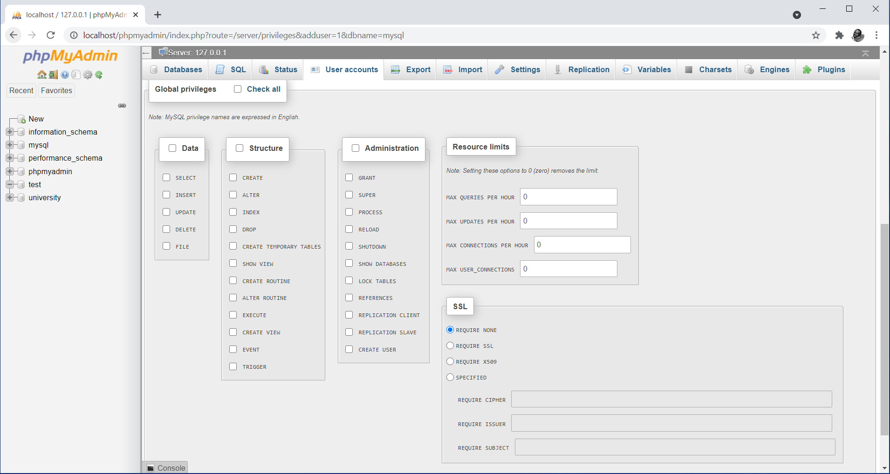
Figure 7. Granting Access Privileges to a New User Account

This course will use default settings such that the host name, username, and password will be set to localhost, root, with the password left blank, respectively. Thus, the following will be our replacements in the mysqli_connect() function

<?php
//establish connection to the database server
mysqli_connect("localhost","root","");
?>

The most appropriate way in programming is to employ mechanisms that can allow for visualization of processes. In this regard, it would be appropriate in enhance the connection to help display success or fail messages whenever the connection is successful or not successful. PHP provides an “or die()” kind of function that can be appended to the mysqli_connect() function to capture failed connections. For instance, the following enhancement to the mysqli_connect() function will see a display of the statement "Connection to the database engine failed" in case either or all of the parameters are incorrect.

<?php
//establish connection to the database server
mysqli_connect("localhost","root","") or die("Connection to the database engine failed");
?>

The only disadvantage with this approach is the fact that we will not be able to see anything on the browser upon successful connections. Thus, the following approach using the if … else statement would work better.

<?php
//establish connection to the database server
$connect = mysqli_connect("localhost","root","");

if(!$connect){
echo "Connection to the database engine failed";
}else{
echo "Connection to the database engine successful";
}
?>

Notice the fact that for ease of operation, the connection string has been assigned to a variable called $connect. This comes handy because the variable can be used afterwards in all cases that require reference to the connection string. For instance, in the above example, the variable has been used in the if … else statement to test whether the connection is successful or not. Figure 8 shows the actual output upon execution of the script.
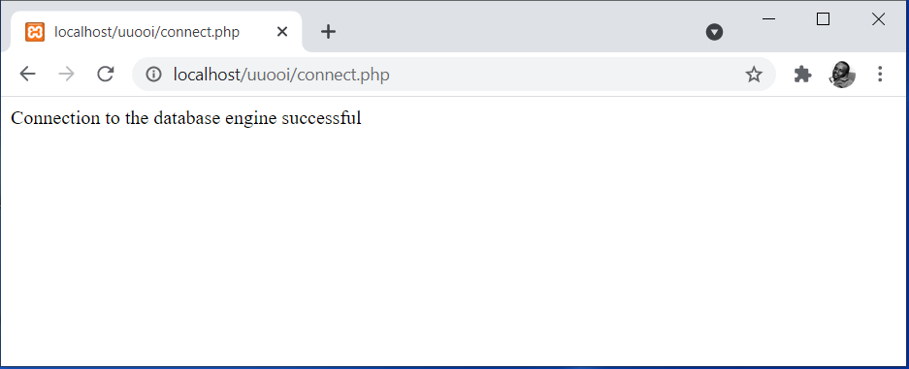
Figure 8. Output for Executing the PHP-MySQL Connectivity Script

Closing Connection to MySQL Database
Once connection has been successfully established, any operations targeting to use that database engine can now be performed. For instance, we can use PHP to execute SQL statements to create or delete databases and tables; insert, update, select or delete data in the database. These statements must be placed right after the statements that established a connection to the database engine. After all statements have been included in the script, the connection to the database must be closed to avoid execution of any other database related statements that are not part of the script. This is more of a security measure. The mysqli_close() function is used to close the connection. The function takes the connection string as a parameter.

Syntax
mysqli_close(connection_string);

In the case of our example, the connection string is represented by a variable called $connect. Hence, the following will serve as a close to our connections.

mysqli_close($connect);

The following script thus serves as a full example demonstrating how to establish a connection to the database engine, where to place any PHP statements targeting to use the database engine, and how to close the connection to the database engine.

<?php
//establish connection to the database server
$connect = mysqli_connect("localhost","root","");

if(!$connect){
echo "Connection to the database engine failed";
}else{
echo "Connection to the database engine successful";
}

//place here any PHP statements targeting to use the database engine

mysqli_close($connect);
?>

Summary
The topic is a starting point for PHP to Database interactions. It has set a foundation on how to directly connect to a MySQL database engine using PHP’s MySQLi Extensions. PHP functions for establishing and closing connections with the database have been demonstrated with clear examples. Additionally, the role of the XAMPP control panel and phpMyAdmin has come out clearly through this topic.

Check Points
- Describe how to start, monitor, and stop services using the XAMPP control panel.
- Demonstrate the process of establishing connection to a MySQL database using PHP.
- Describe the need for closing connections with the database in a PHP script.
- Discuss the functions and capabilities of phpMyAdmin in administration of MySQL databases.
- Describe the difference between ODBC compliant and non-ODBC compliant database.

Learning Resources

Core Textbooks
- Brooks, D.R., 2017. Programming in HTML and PHP. Switzerland: Springer.
- Gosselin, D., Kokoska, D. and Easterbrooks, R., 2010. PHP Programming with MySQL: The Web Technologies Series. Cengage Learning.

Other Resources
- https://www.w3schools.com/php/DEFAULT.asp
- https://www.tutorialspoint.com/php/index.htm

References
- Brooks, D.R., 2017. Programming in HTML and PHP. Switzerland: Springer.
- Gosselin, D., Kokoska, D. and Easterbrooks, R., 2010. PHP Programming with MySQL: The Web Technologies Series. Cengage Learning.

