Advanced Web Based Application Development

Lecture 8

Inserting and Manipulating Data in a MySQL Database

Dr. Obuhuma James

Description
This topic aims at exploring how PHP scripts can be used to create and delete MySQL databases and tables; insert data into the database; and manipulate data in the database. The topic will also expose you to the process of processing form data and inserting it into the database.

Learning Outcomes
By the end of this topic, you will be able to:
- Understand how to use phpMyAdmin to create MySQL databases and tables.
- Create and delete databases and tables using PHP scripts.
- Insert data into the database and manipulate any data in the database.

Introduction
The power of server-side scripting languages is in their capability to create dynamic, database driven application. Such applications give room for free flow of data into and out of the database. To implement this functionality, server-side scripts like PHP must be execute SQL statements categorized as Data Manipulation Languages (DMLs). These statements provide mechanisms for inserting, updating, selecting, and deleting data. This topic will explore how PHP can execute DMLs for inserting and manipulating data in the database. To achieve these, the first step entails creating a database and tables that will hold the data. The topic will hence cover the process for creating the two.

Creating Databases and Tables Using phpMyAdmin
Creating databases and tables can be achieved in two different ways. The first approach that is best suited for many users is using the phpMyAdmin web application. The second approach entails executing SQL statements via PHP scripts. This section covers the first approach.
As earlier introduced in previous topics, it is important to ensure that the XAMPP Control Panel icon is running with Apache and MySQL services running as shown in Figure 1. This may be on the system tray.

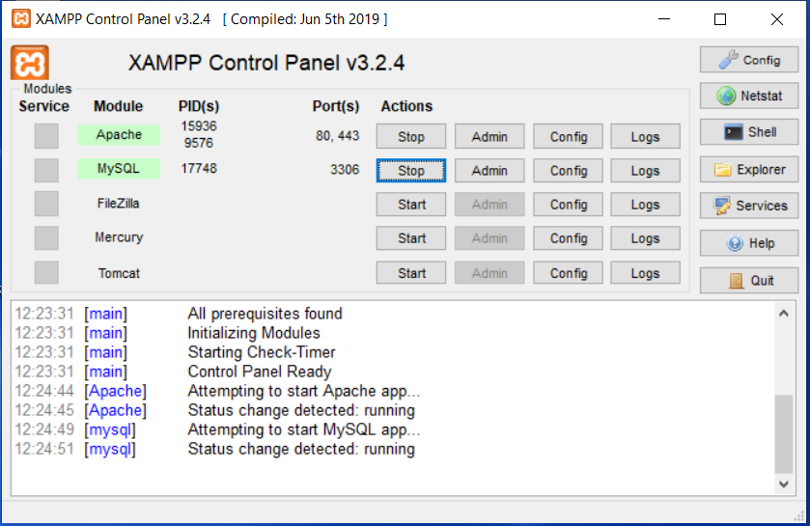
Figure 1. Apache and MySQL Services Running

The next step is to be familiar with the MySQL database, how to create a database and tables even before we get to PHP scripts for interacting with the database engine. Part of the XAMPP package is the phpMyAdmin, a web application used to manage the database engine in XAMPP.
The phpMyAdmin web application can be opened and used through the browser. Start by opening http://localhost to access the interface shown in Figure 2.
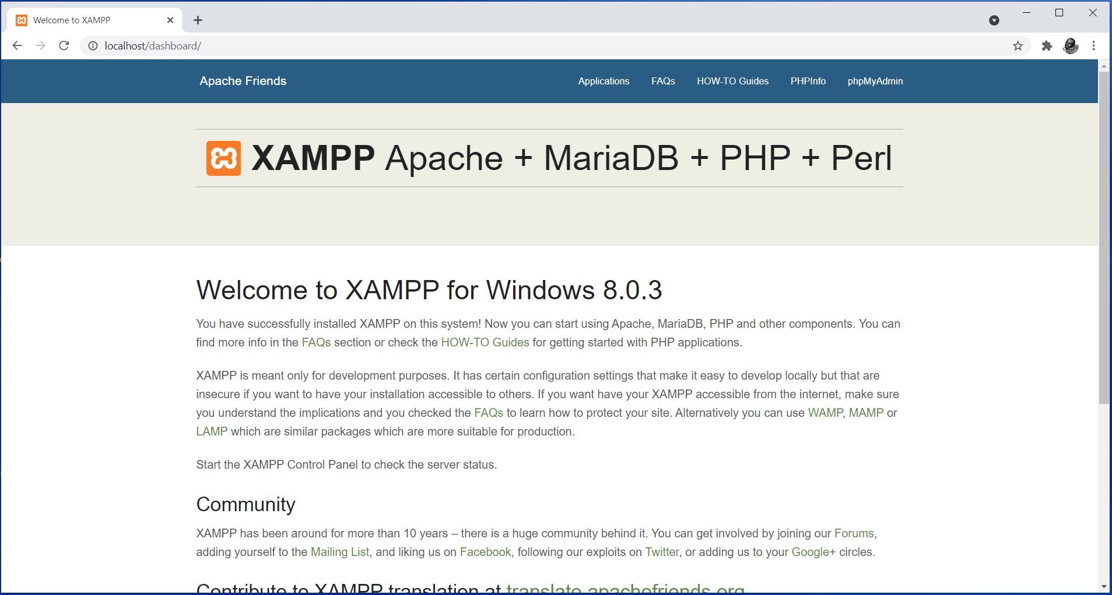
Figure 2. Opening the Webserver from the Browser (Using http://localhost)

Part of the main menu items is a link to the phpMyAdmin application. Clicking on it to get to the phpMyAdmin interface shown in Figure 3.
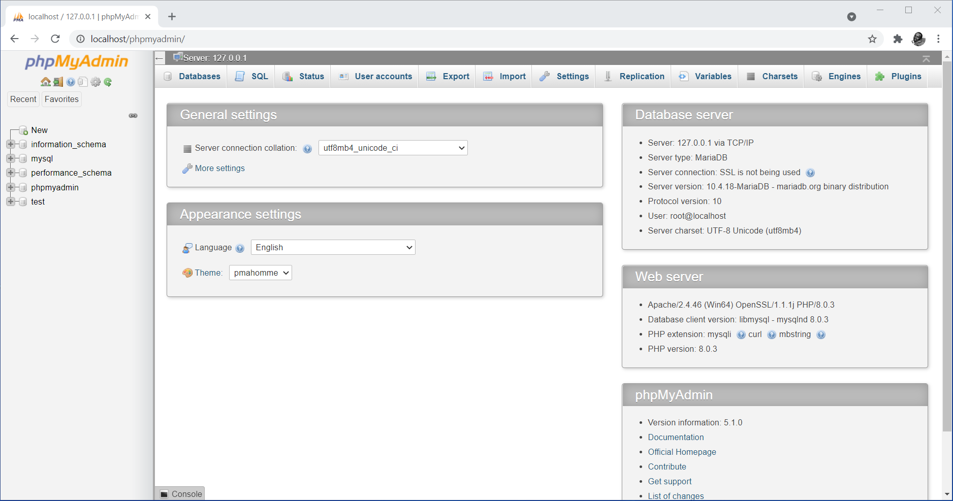
Figure 3. Homepage for phpMyAdmin Web Interface

For the sake of this topic, we will create a database called “University” and a table called “Students”. The table will have four fields, namely, AdmNo, Name, Age, Program. The admno represents the student admission number which will act as the primary key in this table. From the phpMyAdmin web interface, we start by creating the database by clicking on the Databases tab, specify the database name then clicking create as outlined in Figure 4.
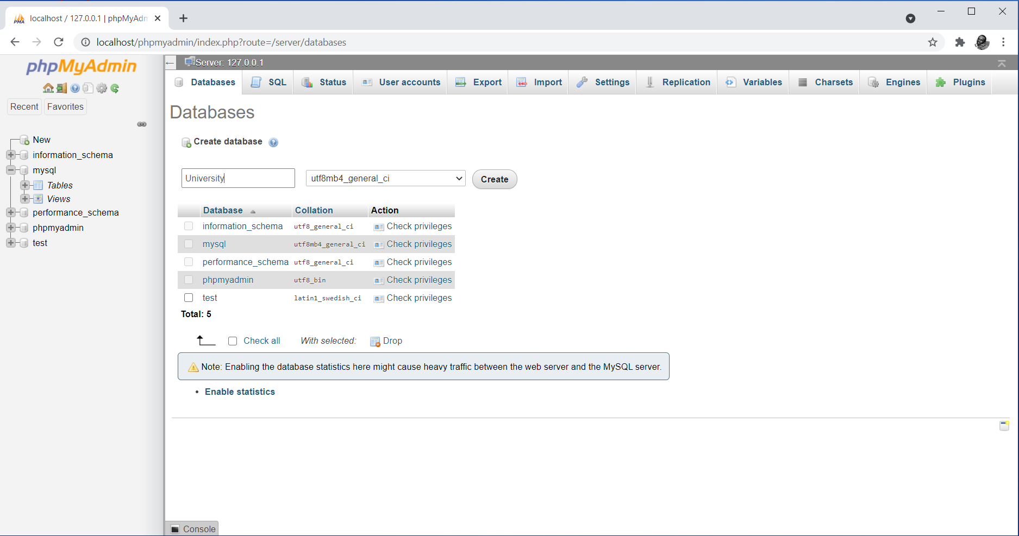
Figure 4. Interface for Creating a Database in phpMyAdmin

Upon clicking the create button, the database gets created and ready for creation of tables. You end up being redirected to the following interface that will allow you to specify a table name and desired number of columns to define the table as shown in Figure 5.
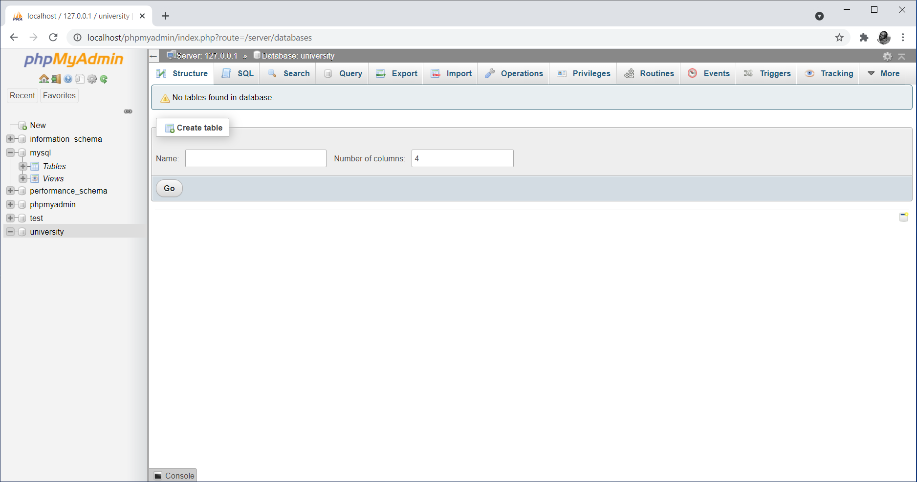
Figure 5. Interface for Initiating Creation of Tables in phpMyAdmin

For the sake of this topic, we will set the table name to “Students” with 4 columns then click the Go button to proceed. This lands you on the following interface that requires you to specify the four column names and their properties. This is as shown in Figure 6.
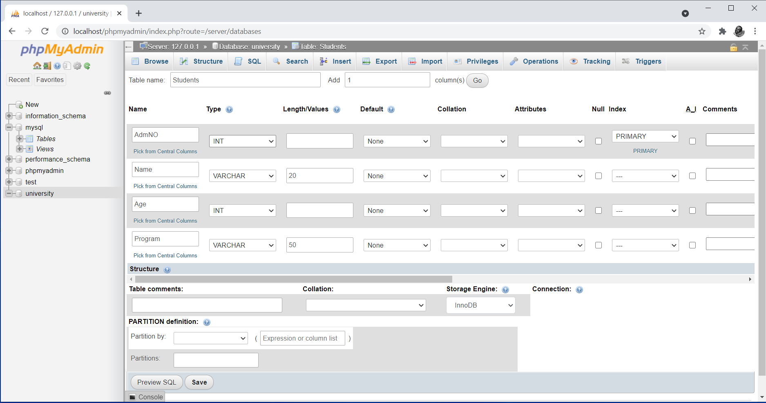
Figure 6. Interface for Specifying Table Field and their Properties in phpMyAdmin

Set the column names as indicated in the interface in Figure 6. Be sure to set the index for AdmNo to primary. This will make the field to act as the primary key for the table. Click the Save button to effect table creation. This will land you to the interface shown in Figure 7.
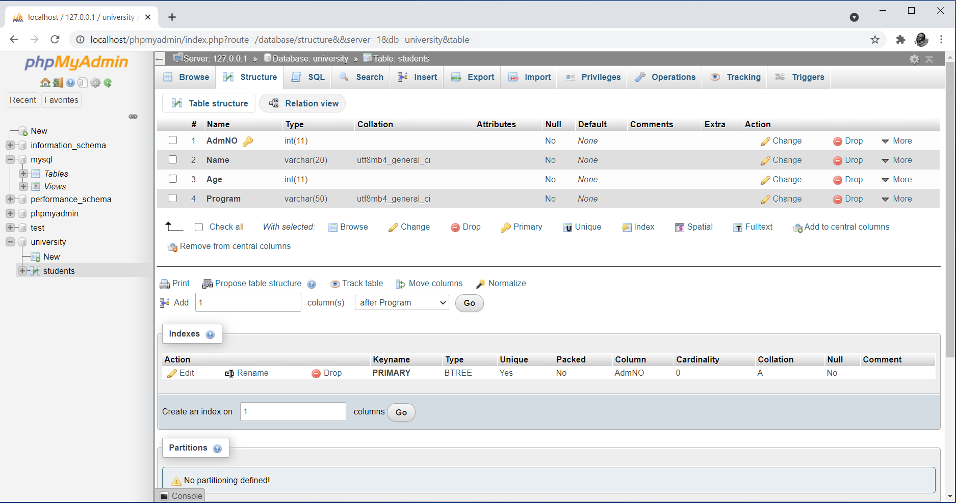
Figure 7. Structures of a Table in phpMyAdmin

Up to this point, the database and table are ready for use. Any changes or modification can be performed with ease from the phpMyAdmin GUI. For the sake of this topic, all is set for us to proceed to writing PHP scripts to connect to the database and insert and manipulate data in the database table.
The same task of creating databases and tables described above can be achieved through writing and executing SQL statements through the query browser that comes as part of the phpMyAdmin web application. The query browser can be opened by clicking the SQL tab on the main menu for the phpMyAdmin web interface.
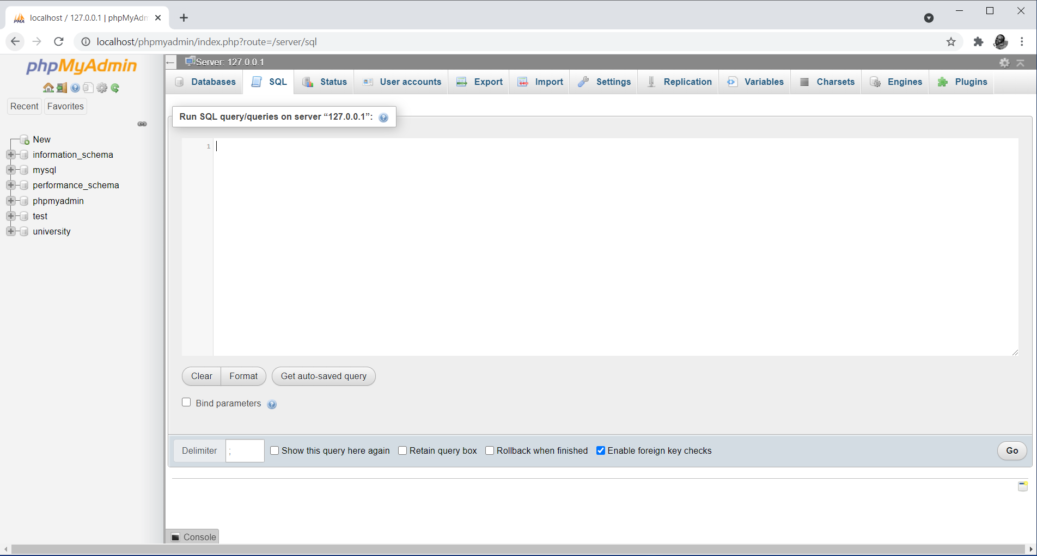
Figure 8. Query Browser in phpMyAdmin

The query browser option is used by user that are good in writing and executing SQL queries. Upon writing any valid SQL query, clicking on the Go button at the bottom right end of the interface triggers execution of the query.

Removing Databases and Tables Using phpMyAdmin
To remove a database, you can use the operations tab with the database or table selected. A link leading to the removal process will appear on the interface. Following the link opens a confirmation prompt with the OK button finishing the operation. It is worth noting that the processing of removing a database or table is called dropping. Figure 9 to 12 show the steps for dropping the table and database that we created in the previous subsection.
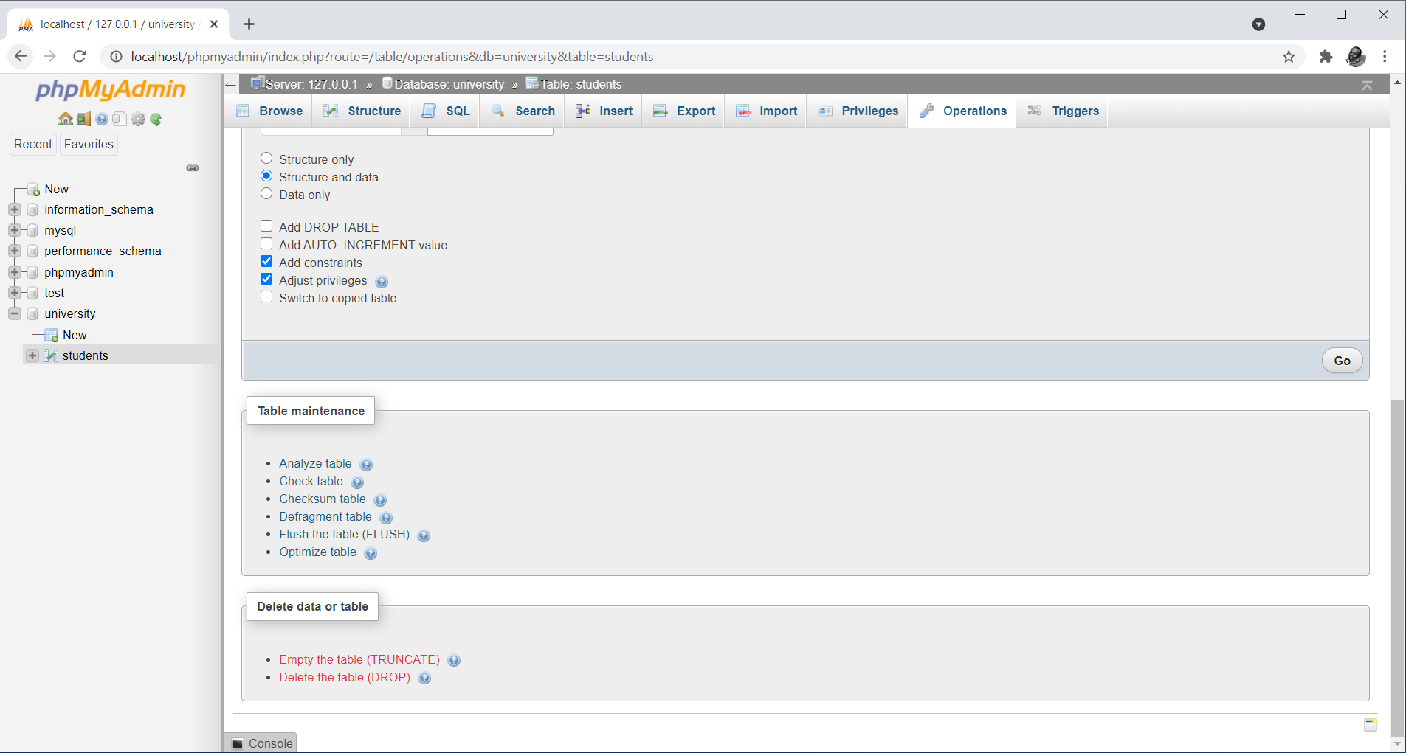
Figure 9. Opening the Operation Tab with Table Students Selected

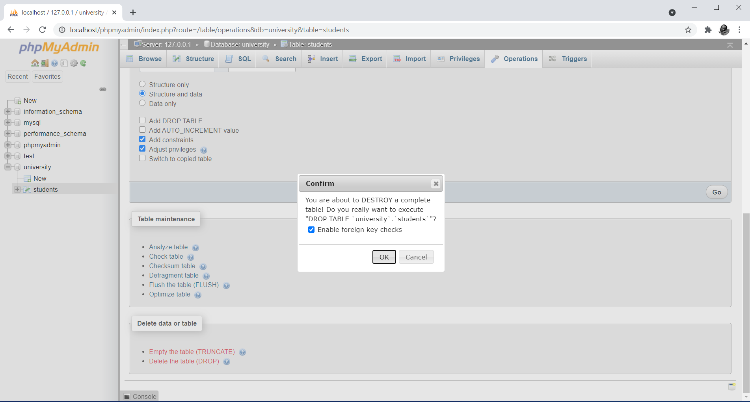
Figure 10. Confirmation Prompt Upon Following the Delete Table Link

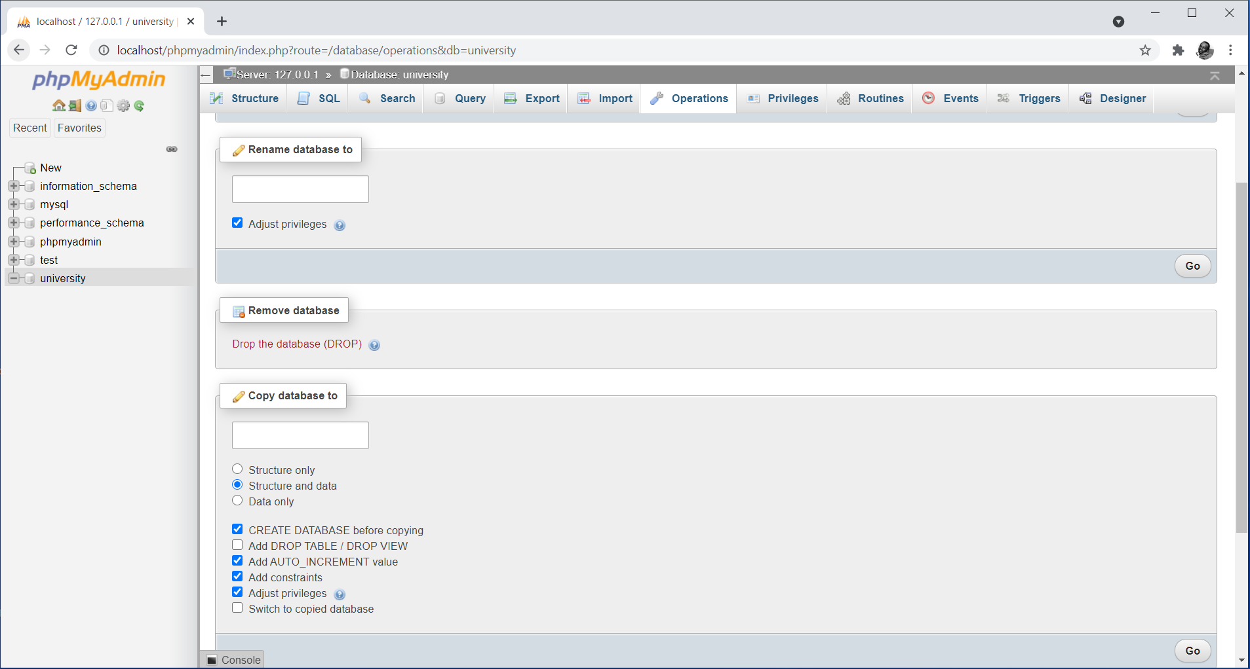
Figure 11. Opening the Operation Tab with Database University Selected

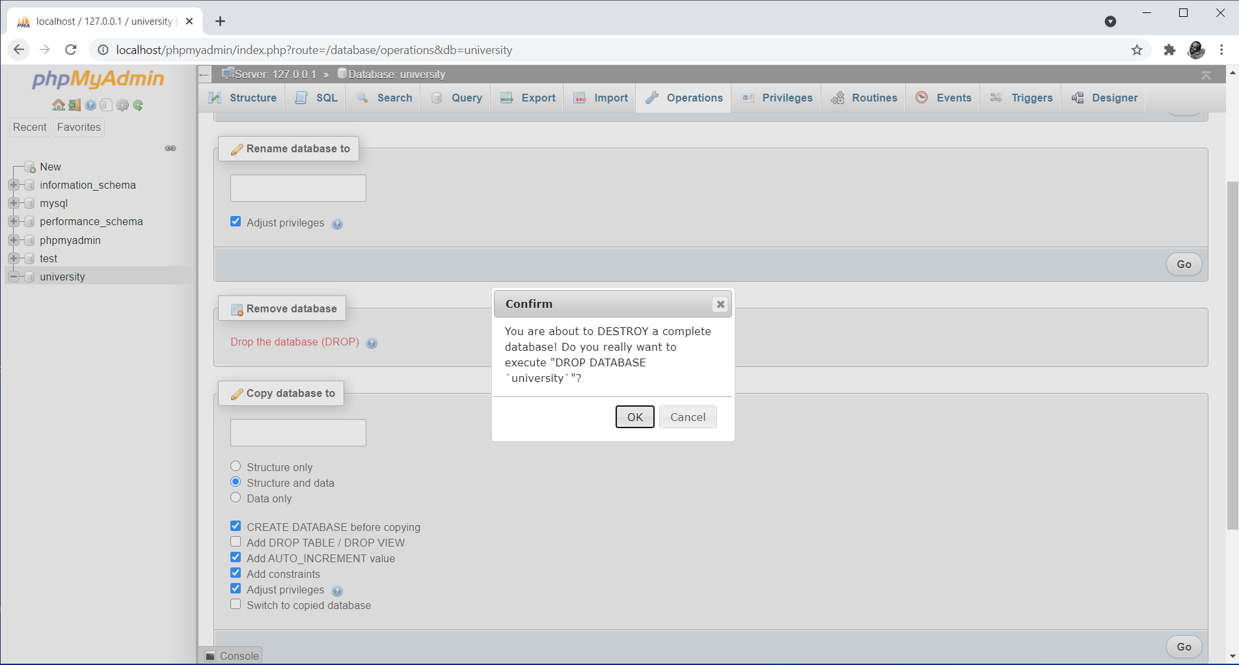
Figure 12. Confirmation Prompt Upon Following the Drop Database Link

The same can be achieved by executing the following SQL statements in the query browser of the phpMyAdmin.
- drop table Students;
- drop database University;

Creating Databases and Tables Using PHP Scripts
PHP provides a mysqli_query() function for executing SQL queries. The mysqli_query() function is the workhorse of PHP connectivity with MySQL with almost every SQL query send to MySQL from PHP scripts being executed by the function [2]. Such queries may be used to accomplish any task including creating and removing databases and their objects, inserting, updating, retrieving, removing data for the database. The mysqli_query() function takes two parameters, namely, the database connection string and a valid SQL query. It returns a Boolean value TRUE or FALSE depending on the outcome of the execution of the SQL query. This is the case only for SQL statements that do not return information from the database. In cases of statements that return information from the database like the select statement, the function returns a result pointer that represents query results [2]. This will be explained in detail in the next topic. As earlier discussed, the “or die()” function can be appended to the mysqli_query() function to capture and report instances the SQL query fails to execute. The if … else statement could still be applicable in this case to achieve the same functionality.

Syntax
mysqli_query(connection_string, sql_query);

Replacing the sql_query parameter with any valid SQL statement will see the statement executed upon execution of the function. For instance, to create a database called University, the SQL statement “create database University” should be provided as the sql_query parameter. The function must come after the function for establishing a connection to the database has been defined in the PHP script and tested to ensure that it is connecting successfully to the MySQL database server.

Example
The following PHP script creates a database called University.
<?php
//establish connection to the database server
$connect = mysqli_connect("localhost","root","");

if(!$connect){
echo "Connection to the database engine failed";
}else{
echo "Connection to the database engine successful";
}

//create a database called University
mysqli_query($connect, "create database University");

//close connection to the database server
mysqli_close($connect);
?>

Notice the fact that the first part of the script establishes a connection to the database server. This has been applied as covered in the last topic. The connection string assigned to variable $connect has been supplied as the first parameter in the mysqli_query() function.

Once a database has been created, it is now ready for use. Such a database must be selected to make it active in any PHP script that desires to utilize it. This is achieved using the mysqli_select_db() function. The function returns a Boolean value TRUE or FALSE upon execution.

Syntax
mysqli_select_db(connection_string, database_name);

Example
The following example establishes a connection to the MySQL database server, then selects a database called “University” for use within the script.
<?php
//establish connection to the database server
$connect = mysqli_connect("localhost","root","");

if(!$connect){
echo "Connection to the database engine failed";
}else{
echo "Connection to the database engine successful";
}

//select a database called University for use within the script
mysqli_select_db($connect,"University") or die("Database not found");

//close connection to the database server
mysqli_close($connect);
?>

The “or die()” function appended to the mysqli_query() function helps to capture and report attempts to access databases that do not exist. From this point onwards, any SQL statement executed will affect database “University” that is active for use within the script.

To create a table in a database, the following syntax should inform the structure of SQL statements that should be supplied as sql_query parameters.

create table table_name (column_name1 datatype, column_name2 datatype, … column_namen datatype, primary key(column_namex), [any_constraints]);

For instance, to create a table called Students, the SQL statement “create table Students (AdmNo int, Name varchar(20), Age int, Program varchar(50), primary key(AdmNo))” should be provided as the sql_query parameter. The function must come after the function for selecting the database called “University” has been defined in the PHP script. This is as shown in the following example.

<?php
//establish connection to the database server
$connect = mysqli_connect("localhost","root","");

if(!$connect){
echo "Connection to the database engine failed";
}else{
echo "Connection to the database engine successful";
}

//select a database called University for use within the script
mysqli_select_db($connect,"University");

//creating a table called Students in the University database
mysqli_query($connect, "create table Students (AdmNo int, Name varchar(20), Age int, Program varchar(50), primary key(AdmNo))");

//close connection to the database server
mysqli_close($connect);
?>

Removing Databases and Tables Using PHP Scripts
The “drop database database_name” SQL statement syntax is used to remove a database from the database server, where database_name represents the name of an existing database. For instance, to remove a database called University, the SQL statement “drop database University” should be provided as the sql_query parameter for the mysqli_query() function. The function must come after the function for establishing a connection to the database has been defined in the PHP script and tested to ensure that it is connecting successfully to the MySQL database server. This is as shown in the following example.

<?php
//establish connection to the database server
$connect = mysqli_connect("localhost","root","");

if(!$connect){
echo "Connection to the database engine failed";
}else{
echo "Connection to the database engine successful";
}

//remove a database called University
mysqli_query($connect, "drop database University");

//close connection to the database server
mysqli_close($connect);
?>

Similarly, the “drop table table_name” SQL statement syntax is used to remove a table from a database, where table_name represents the name of an existing table in a database. For instance, to remove a table called Students from the University database, the SQL statement “drop table Students” should be provided as the sql_query parameter for the mysqli_query() function. The function must come after the function for selecting the database called University has been defined in the PHP script. This is as shown in the following example.

<?php
//establish connection to the database server
$connect = mysqli_connect("localhost","root","");

if(!$connect){
echo "Connection to the database engine failed";
}else{
echo "Connection to the database engine successful";
}

//select a database called University for use within the script
mysqli_select_db($connect,"University");

//remove a table called Students from the University database
mysqli_query($connect, "drop table Students");

//close connection to the database server
mysqli_close($connect);
?>

Inserting Data into MySQL Tables Using PHP Scripts
To insert data into a table in a database, the following syntax should inform the structure of SQL statements that should be supplied as sql_query parameters.
insert into table_name (column_name1, column_name2, … column_namen) values (value1, value2, … valuen);

For instance, to insert a sample record into the Students table, the SQL statement “insert into Students (AdmNo, Name, Age, Program) values (100, ‘John Doe’, 20, ‘Computer Science’)” should be provided as the sql_query parameter. The function must come after the function for selecting the database called “University” has been defined in the PHP script. This is as shown in the following example.

<?php
//establish connection to the database server
$connect = mysqli_connect("localhost","root","");

if(!$connect){
echo "Connection to the database engine failed";
}else{
echo "Connection to the database engine successful";
}

//select a database called University for use within the script
mysqli_select_db($connect,"University");

//creating a table called Students in the University database
mysqli_query($connect, "insert into Students (AdmNo,Name,Age,Program) values (100,'John Doe',20,'Computer Science')");

//close connection to the database server
mysqli_close($connect);
?>

Processing Form Data Destined to the Database
Part of the capabilities of PHP mentioned in topic one was the fact that PHP is used to process form data. In this case, the $_POST[] function is used to receive form data which is then passed as a value to the insert statement. The form should be defined in such a manner that the attributes of the form tag should be defined as follows:
- method = “POST”
- action = “php_script_name.php”
The method value “GET” can also be used. However, this will mean a change in the way the data is received by the PHP script.

The following HTML code creates a form that could be used to capture students details to be stored in the Students tables.

<!doctype html5>
<html>
<head>
<title>Students Details</title>
</head>
<body>
<form method="POST" action="processformdata.php">
Admission Number <input type="text" name="admno" /><br />
Student Name <input type="text" name="name" /><br />
Age <input type="text" name="age"><br />
Program <input type="text" name="program" /><br />
<input type="submit" value="Add Student" />
<input type="reset" value="Refresh" />
</form>
</body>
</html>

Note the following critical aspects of the HTML form code:
- The method attribute of the form tag has been set to “POST”.
- The action attribute of the form tag has been set to "processformdata.php". This means that the PHP file for processing form data must be saved with the filename.
- Each input element of the form has a unique name attribute value that is useful at the point of receiving respective element data in the PHP script.

The following PHP script saved as "processformdata.php" will be used to receive form data, process the data, then send it to the database.
<?php
//establish connection to the database server
$connect = mysqli_connect("localhost","root","");

if(!$connect){
echo "Connection to the database engine failed";
}else{
echo "Connection to the database engine successful";
}

//select a database called University for use within the script
mysqli_select_db($connect,"University");

//receive form data as you store in variables
$admno = $_POST['admno'];
$name = $_POST['name'];
$age = $_POST['age'];
$program = $_POST['program'];

//creating a table called Students in the University database
mysqli_query($connect, "insert into Students (AdmNo,Name,Age,Program) values ('$admno','$name','$age','$program')") or die("Could not insert the data in the database");

//close connection to the database server
mysqli_close($connect);
?>

Note the following critical aspects of the PHP script code:
- A connection to the MySQL database server must be established first.
- The database must be selected to make it active for use within the script.
- Based on the script code, the $_POST[] is used to receive data from each form input element then assign the data to a variable for subsequent use in the script.
- The value assigned in the $_POST[] must match the value for the name attribute of the input element of the form.
- The variables that have been assigned the data received from each input element of the form has to be mapped appropriately in the SQL query meant to insert the data in the database upon it execution.

Manipulating Data in MySQL Tables Using PHP Scripts
The mysqli_query() function can also be used to manipulate data in the database as desired by the programmer. In such cases, the update SQL statement taking up the following syntax can successfully be executed by the function.
Update table_name set column_namex=new_value where condition;
The WHERE clause in the update statement is used to help focus on the exact record to be updated. This acts as a form of filtering based on the condition provided in the statement. For instance, suppose we want to change the program for John Doe from Computer Science to Education, we would need to execute the following PHP script containing the update statement with the WHERE clause focusing on the name of the student.
<?php
//establish connection to the database server
$connect = mysqli_connect("localhost","root","");

if(!$connect){
echo "Connection to the database engine failed";
}else{
echo "Connection to the database engine successful";
}

//select a database called University for use within the script
mysqli_select_db($connect,"University");

//update the program for John Doe from Computer Science to Education
mysqli_query($connect, "update Students set Program='Education' where Name='John Doe'") or die("Could not update the data in the database");

//close connection to the database server
mysqli_close($connect);
?>

Using the same approach, SQL statements to remove data (records) from the database can be executed. The syntax for such statements is as follows.
Delete from table_name where condition;
The WHERE clause in the delete statement applies in a similar manner as described for the update statement. It is worth mentioning that the WHERE clause works the same across any SQL statement. For instance, suppose we want to remove the record for John Doe from the database, we would need to execute a PHP script containing the following delete SQL statement with the WHERE clause focusing on the name of the student.
<?php
//establish connection to the database server
$connect = mysqli_connect("localhost","root","");

if(!$connect){
echo "Connection to the database engine failed";
}else{
echo "Connection to the database engine successful";
}

//select a database called University for use within the script
mysqli_select_db($connect,"University");

//remove the record for John Doe from the database
mysqli_query($connect, "delete from Students where Name='John Doe'") or die("Could not delete the record from the database");

//close connection to the database server
mysqli_close($connect);
?>

Reporting MySQL Errors in PHP
PHP offers two functions to support in reporting any errors that may occur in case execution of a function related to PHP-MySQL database connectivity. The first one is the mysqli_error() function can be used to return a string with a description of the error that has occurred. The second one is the mysqli_errno() function can be used to return the numerical code of the error that has occurred. The following example shows how the mysqli_error() function can be used to report the error that may occur if the SQL statement supplied un the mysqli_query() function fails to return a Boolean TRUE value.
mysqli_query($connect, "delete from Students where Name='John Doe'") or die(mysqli_error());
The same approach could be applied to any other function. Similarly, the mysqli_errno() function can be used in the same manner.

Summary
The topic has explored critical aspects of executing SQL statements using PHP. The statements covered so far were limited to creating and removing databases and tables, inserting and manipulating data in the database and deleting data from the database. A number of functions have been introduced including the mysqli_select_db(), mysqli_query(), mysqli_error() and mysqli_errno() functions. The mysqli_query() functions dominates as the main function for executing relatively all valid SQL statements supplied to it.

Check Points
- Describe the process of creating and removing databases and tables using phpMyAdmin.
- Demonstrate the process of creating and removing databases and tables using PHP scripts.
- Demonstrate how form data can be inserted in the database.
- Demonstrate how data in the database can be manipulated or records removed.
- Describe the process of error reporting in PHP-MySQL scripting.

Learning Resources

Core Textbooks
- Brooks, D.R., 2017. Programming in HTML and PHP. Switzerland: Springer.
- Gosselin, D., Kokoska, D. and Easterbrooks, R., 2010. PHP Programming with MySQL: The Web Technologies Series. Cengage Learning.

Other Resources
- https://www.w3schools.com/php/DEFAULT.asp
- https://www.tutorialspoint.com/php/index.htm

References
- Brooks, D.R., 2017. Programming in HTML and PHP. Switzerland: Springer.
- Gosselin, D., Kokoska, D. and Easterbrooks, R., 2010. PHP Programming with MySQL: The Web Technologies Series. Cengage Learning.

