Advanced Web Based Application Development

Lecture 9

Retrieving and Displaying Data from a MySQL Database

Dr. Obuhuma James

Description
This topic is a continuation of aspects covered in the last two topics. The focus will be on utilization of the data stored in the database by retrieving and displaying on the browser so far by exploring how PHP scripts can be used to retrieve data from MySQL databases. The topic will hence explore the use of the select Data Manipulation Language statement.

Learning Outcomes
By the end of this topic, you will be able to:
- Understand how to use phpMyAdmin to view data in a MySQL database table.
- Retrieve data from the database using PHP as you display on the browser.
- Combine HTML elements and PHP scripts to tabulate data retrieved from the database.

Introduction
As earlier mentioned, the power of server-side scripting languages is in their capability to create dynamic, database driven application. Such applications give room for free flow of data into and out of the database. To implement this functionality, server-side scripts like PHP must be execute SQL statements categorized as Data Manipulation Languages (DMLs). These statements provide mechanisms for inserting, updating, selecting, and deleting data. This topic will explore how PHP can execute DMLs for retrieving data from the database. For better display of the data, tables will be employed in a process that will require combining of PHP scripts with HTML elements.

Retrieving Data from the Database Using phpMyAdmin
The phpMyAdmin provides room for viewing data stored in the database. For the sake of this topic, we will demonstrate the concept by accessing data stored in the “University” database in the “Students” table that were created in the previous topic. It is worth recalling that the has four fields, namely, AdmNo, Name, Age, Program. From the phpMyAdmin web interface, we start by selecting table “Students” on the left menu under database “University”. This results in the appearance of the Browser tab on the main menu. Clicking on the Browser menu opens up a window that displays content of the Students table as shown in Figure 1.
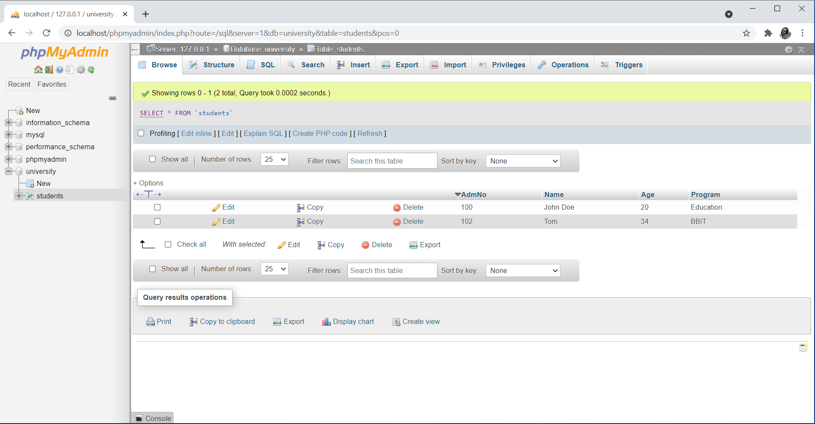
Figure 1. Accessing Table Data Upon Visiting the Browser Tab in phpMyAdmin

Notice the details for the two records in the database as shown in the browser view of the table.
The second approach entails writing and executing valid SQL statements through the query browser. As earlier discussed, the query browser is accessed through clicking the SQL tab of the phpMyAdmin main menu. To execute an SQL statement in the query browser, the correct table must be selected. This makes the table to be active for execution of SQL statements over it. Figure 2 shows a query browser open with the Students table active for SQL statements execution over it.
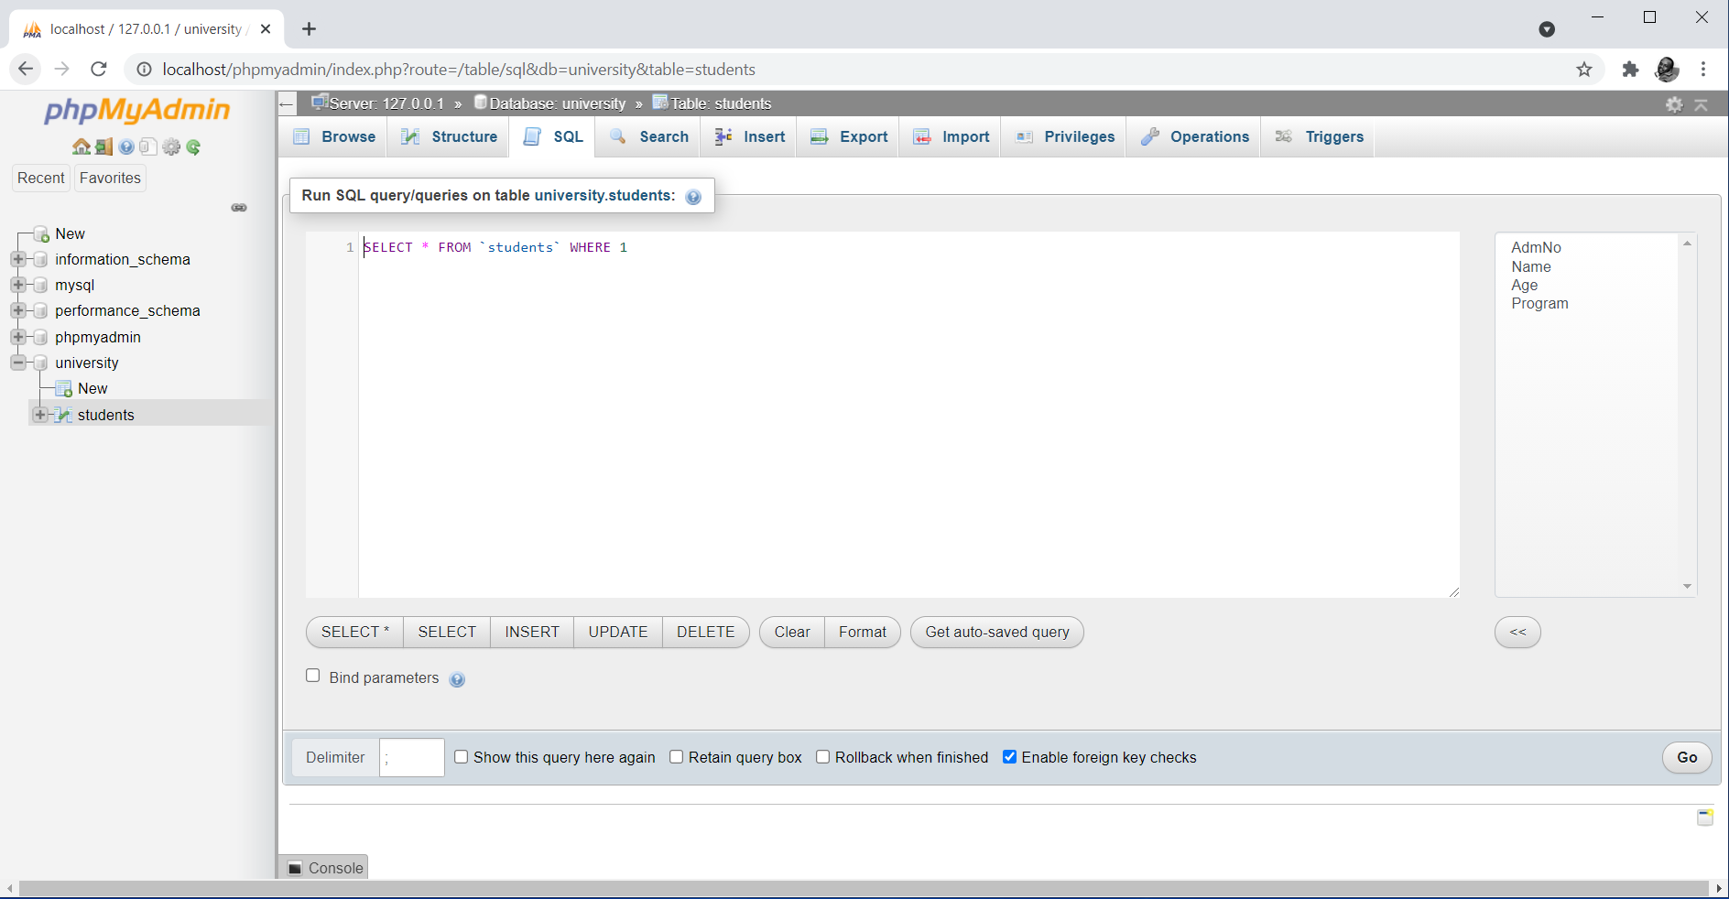
Figure 2. Query Browser Open for Execution of SQL Statements in phpMyAdmin
Notice the inform right above the query browser textarea that indicates the active database and table. This is quite critical in ensuring that the correct table is selected. With a table selected, by default, the query browser will contain a select SQL statement that executes upon clicking the Go button at the bottom right corner. Clicking the Go button leads to the display of the data in the table as shown in Figure 3. Any other SQL statement can be written in the textarea for subsequent execution.
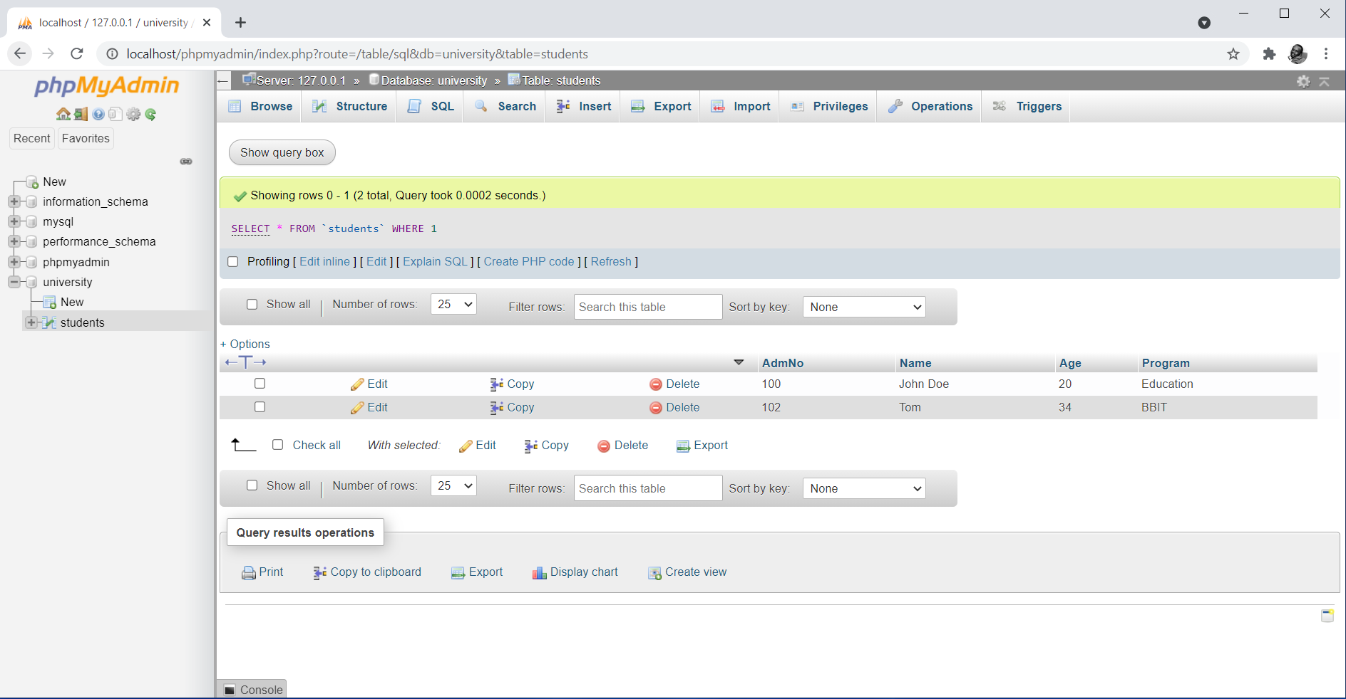
Figure 3. Accessing Table Data Upon Execution of the Select SQL Statement in phpMyAdmin

Retrieving Data from the Database Using PHP Scripts
The select SQL statement is used to retrieve data from the database for display on the browser.
Syntax
Select [* | column_name(s)] from table_name;

Where the * is used if the intention is to retrieve records for all the columns that make up the table. In case you want to only retrieve data for specific columns, then the desired column names are listed separated by commas. For example, supposing we want to retrieve data for all columns in table Students, then the SQL statement supplied as the sql_query parameter of the mysqli_query() function should be “Select * from Students”. Otherwise, if say we want to only retrieve records containing student registration number and name, then the SQL statement should be “Select AdmNo, Name from Students”.
Unlike other SQL statements covered, executing the mysqli_query() function with the SQL statement alone, does not display the data. This is because once the function is executed, query results are generated awaiting further instructions on how to utilize them. If the query executes successfully, the function returns a results pointer that represents the query results [2], otherwise, it returns a Boolean value FALSE. The results pointer acts as a special type of variable referring to the current selected row in the list of records returned by the MySQL, called a resultset [2]. In summary, the result pointer helps in tracking the actual point where the script is in a resultset [2]. The best approach is to assign the result pointer to a variable that will be used in the script to access the resultset at the point of utilization of the data. This will be demonstrated in subsequent examples.
Extra mechanisms are required to make sense of the results held in the variables that the result pointer is assigned to. PHP provides several functions that can be used in this case. These are mysqli_data_seek(), mysqli_fetch_array(), mysqli_fetch_assoc(), mysqli_fetch_lengths(), and the mysqli_fetch_row() functions. This topic will demonstrate the application of the mysqli_fetch_array() and the mysqli_fetch_row() functions in access and display of data in the resultset. Each function works together with a looping control structure. The loop helps in facilitating extraction of data row by row as data for all columns for a given row is fetched. The loop stops once all the rows have been exhausted.
The mysqli_fetch_array() function returns the fields in the current row of a resultset into an indexed array, associative array, or both, and moves the result pointer to the next row [2]. The function takes two parameters as shown in the following function syntax.
mysqli_fetch_array(resultset, MYSQLI_ASSOC/MYSQLI_NUM/MYSQLI_BOTH)

Example
Consider the following example that retrieves all the records in the Students table. The script then facilitates display of the data on the browser. In this example, the use of the mysqli_fetch_array() function is demonstrated together with a WHILE loop.

<?php
//establish connection to the database server
$connect = mysqli_connect("localhost","root","");

if(!$connect){
echo "Connection to the database engine failed";
}

//select a database called University for use within the script
mysqli_select_db($connect,"University");

//generate a resultset with all records in a table called Students
$results = mysqli_query($connect, "select * from Students");

while($row=mysqli_fetch_array($results, MYSQLI_ASSOC)){
echo $row['AdmNo'] . " " . $row['Name'] . " " . $row['Age'] . " " . $row['Program'] . "<br />";
}

//close connection to the database server
mysqli_close($connect);
?>

The result pointer that points to the resultset achieved after executing the select SQL statement is assigned to a variable called $results. The variable is then used as a parameter in the mysqli_fetch_array() function forming the conditional statement for the while loop. A new variable $row is created that holds data for each row as you get into the loop. Inside the loop, the $row variable is used to point to specific column names as array indexes whose values are to be displayed. Notice the fact that the <br /> is an HTML element used to cause the display to jump to the next line after retrieving and displaying a given record. This makes each record to be display in its own line. The output of the script is as shown in Figure 4.

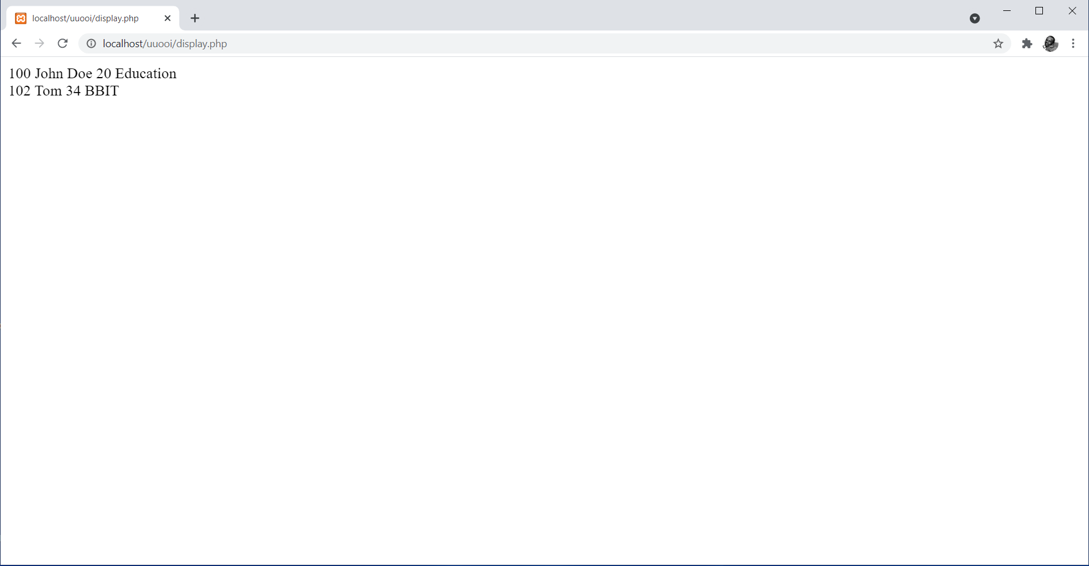
Figure 4. Output of Retrieving and Displaying Data using the mysqli_fetch_array() Function

The same results in the above example can be achieved using the mysqli_fetch_row() function that returns the fields in the current row of a resultset into an indexed array and moves the result pointer to the next row [2]. The function takes one parameter, only the resultset, as shown in the following function syntax. It however checks whether the outcome is TRUE or FALSE as will be seen in the example that follows next.
mysqli_fetch_array(resultset)

Example
Consider the following example that repeats what was done in the previous example. The script however uses the mysqli_fetch_row() function.

<?php
//establish connection to the database server
$connect = mysqli_connect("localhost","root","");

if(!$connect){
echo "Connection to the database engine failed";
}

//select a database called University for use within the script
mysqli_select_db($connect,"University");

//generate a resultset with all records in a table called Students
$results = mysqli_query($connect, "select * from Students");

while(($row=mysqli_fetch_row($results))!=FALSE){
echo $row[0] . " " . $row[1] . " " . $row[2] . " " . $row[3] . "<br />";
}

//close connection to the database server
mysqli_close($connect);
?>

The result pointer that points to the resultset achieved after executing the select SQL statement is assigned to a variable called $results. The variable is then used as a parameter in the mysqli_fetch_row() function forming the conditional statement for the while loop. A new variable $row is created that holds data for each row as you get into the loop. Inside the loop, the $row variable is used to point to specific indexes of columns whose values are to be displayed. Notice the fact that the <br /> is an HTML element used to cause the display to jump to the next line after retrieving and displaying a given record. This makes each record to be display in its own line. The output of the script is as shown in Figure 5, which is exactly similar to that shown in Figure 4.

Figure 5. Output of Retrieving and Displaying Data using the mysqli_fetch_row() Function

In summary, it is the programmers choice on whether to use the mysqli_fetch_array() function or the mysqli_fetch_row() function.

Displaying Data in a Tabular Format
Display of results demonstrated in the previous examples can be improved to achieve better tabulation of the results. This is best done by embedding HTML elements in PHP, or better say embedding PHP scripts in HTML. Recall these concepts as covered in topic 1 of the course. The following example script is an enhancement of the previous script that retrieves all the records in the Students table. This time round the script then facilitates display of the data on the browser in a proper tabular form.

<!doctype html>
<html>
<head>
<title>Tabular Display of Data</title>
<head>
<body>
<?php
//establish connection to the database server
$connect = mysqli_connect("localhost","root","");

if(!$connect){
echo "Connection to the database engine failed";
}

//select a database called University for use within the script
mysqli_select_db($connect,"University");

//remove a table called Students from the University database
$results = mysqli_query($connect, "select * from Students");
?>

<!-- Retrieve and display data in tabular format -->
<table border="1">
<tr>
<th>Admission No</th>
<th>Name</th>
<th>Age</th>
<th>Program</th>
</tr>

<?php
while($row=mysqli_fetch_array($results, MYSQLI_ASSOC)){
?>

<tr>
<td> <?php echo $row['AdmNo']; ?> </td>
<td> <?php echo $row['Name']; ?> </td>
<td> <?php echo $row['Age']; ?> </td>
<td> <?php echo $row['Program']; ?> </td>
</tr>

<?php
}
?>
</table>
<?php
//close connection to the database server
mysqli_close($connect);
?>
</body>
</html>

Notice the way a HTML table elements and PHP scripts have been mixed within one script. In this case, HTML elements are laying out how the data is to be displayed as PHP scripts are determining the data to be displayed. Figure 6 shows a well tabulated output, as an improved presentation of data on the browser.

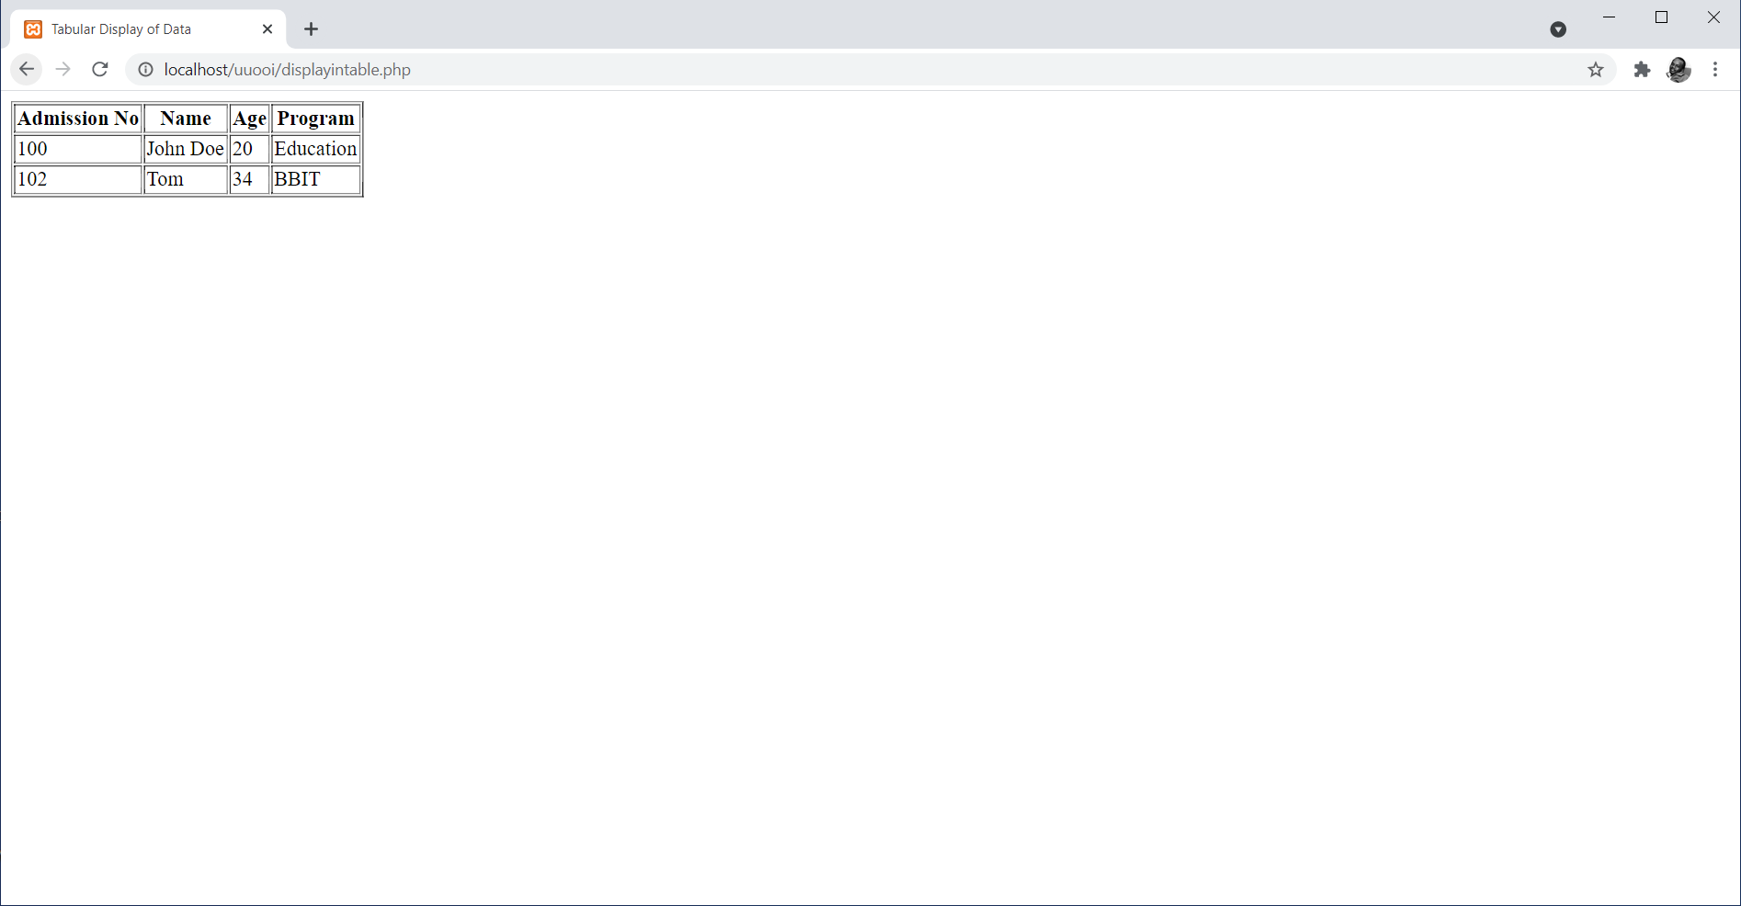
Figure 6. Retrieving and Displaying Data in a Tabular Form

Summary
The topic has extended what the concept of PHP-MySQL database connectivity by exposing you on how to retrieve data from the database. Furthermore, it has demonstrated how the retrieved data can be displayed on the browser. The topic was limited to a select statement used to retrieve all records without any form of filtering. A number of PHP functions have been introduced including the mysqli_fetch_array() and mysqli_fetch_row() functions. The concept of the use of result pointer to resultset has been fully explored. The topic has also demonstrated the concept of embedding PHP scripts into HTML.

Check Points
- Describe the process of retrieving data from the database using phpMyAdmin.
- Demonstrate the process of retrieving data from the database using PHP scripts.
- Describe the use of result pointers and resultsets in PHP scripts.
- Differentiate between mysqli_fetch_array() and mysqli_fetch_row() as used in PHP.
- Describe the need for use of both HTML elements and PHP scripts with respect to retrieval and display of data in the database.

Learning Resources

Core Textbooks
- Brooks, D.R., 2017. Programming in HTML and PHP. Switzerland: Springer.
- Gosselin, D., Kokoska, D. and Easterbrooks, R., 2010. PHP Programming with MySQL: The Web Technologies Series. Cengage Learning.

Other Resources
- https://www.w3schools.com/php/DEFAULT.asp
- https://www.tutorialspoint.com/php/index.htm

References
- Brooks, D.R., 2017. Programming in HTML and PHP. Switzerland: Springer.
- Gosselin, D., Kokoska, D. and Easterbrooks, R., 2010. PHP Programming with MySQL: The Web Technologies Series. Cengage Learning.

