Advanced Web Based Application Development

Lecture 10

Executing Advanced SQL Queries Using PHP

Dr. Obuhuma James

Description
This topic finalizes on PHP-MySQL database connectivity by exploring how some selected advanced SQL queries can be used to advance use of data in the database. The focus will be on appropriate utilization of the data stored in the database by retrieving and displaying on the browser based on specific conditions. The topic will also explore the aspect of multi-table querying using PHP scripts. In summary, the topic aims to explore the application of filtering and multi-table querying as used by the select statement.

Learning Outcomes
By the end of this topic, you will be able to:
- Understand how to use phpMyAdmin to filter data being extracted from a MySQL database table.
- Retrieve filtered data from the database using PHP scripts.
- Perform multi-table querying using PHP scripts.

Introduction
As earlier mentioned, the power of server-side scripting languages is in their capability to create dynamic, database driven application. Such applications give room for free flow of data into and out of the database. The last two topics introduced database connectivity aspects, with the previous topic dwelling more on retrieval and display of data in the database. This topic will advance what has been covered by exploring the execution of queries that support multi-table querying and conditional statements that embrace filtering of data.

Data Filtering and Multi-table Querying Using phpMyAdmin
The phpMyAdmin provides room for execution of advanced SQL queries for any given task. For the sake of this topic, we will demonstrate the concept by accessing data stored in the “Students” table under the “University” database that were created and used in previous topics. By now, we are all familiar about the use of the query browser which will be used in this subsection.

Data Filtering in phpMyAdmin
Data filtering in SQL is achieved using a WHERE clause. The WHERE clause is normally appended on insert, update, select or delete data manipulation language statements to provide conditions under which the statement must execute. This was partially introduced in previous topics when the update and delete statements were covered. The WHERE clause is heavily used by the select statement to determine the data to be retrieved from the database. The syntax of the select with a WHERE clause is as follows.

Select [* | column_name(s)] from table_name where condition;

Consider Figure 1 showing a query browser with a select statement that is aimed to retrieve students whose age is greater than 20.
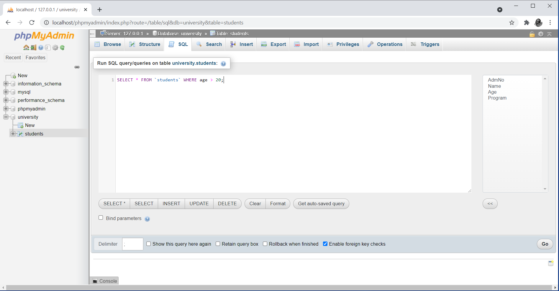
Figure 1. Data Filtering in phpMyAdmin

Notice the condition created by the WHERE clause that allows for filtering of data being retrieved to a specific age group. Execution of the statement only retrieves one student whose age is greater than 20 as shown in Figure 2.

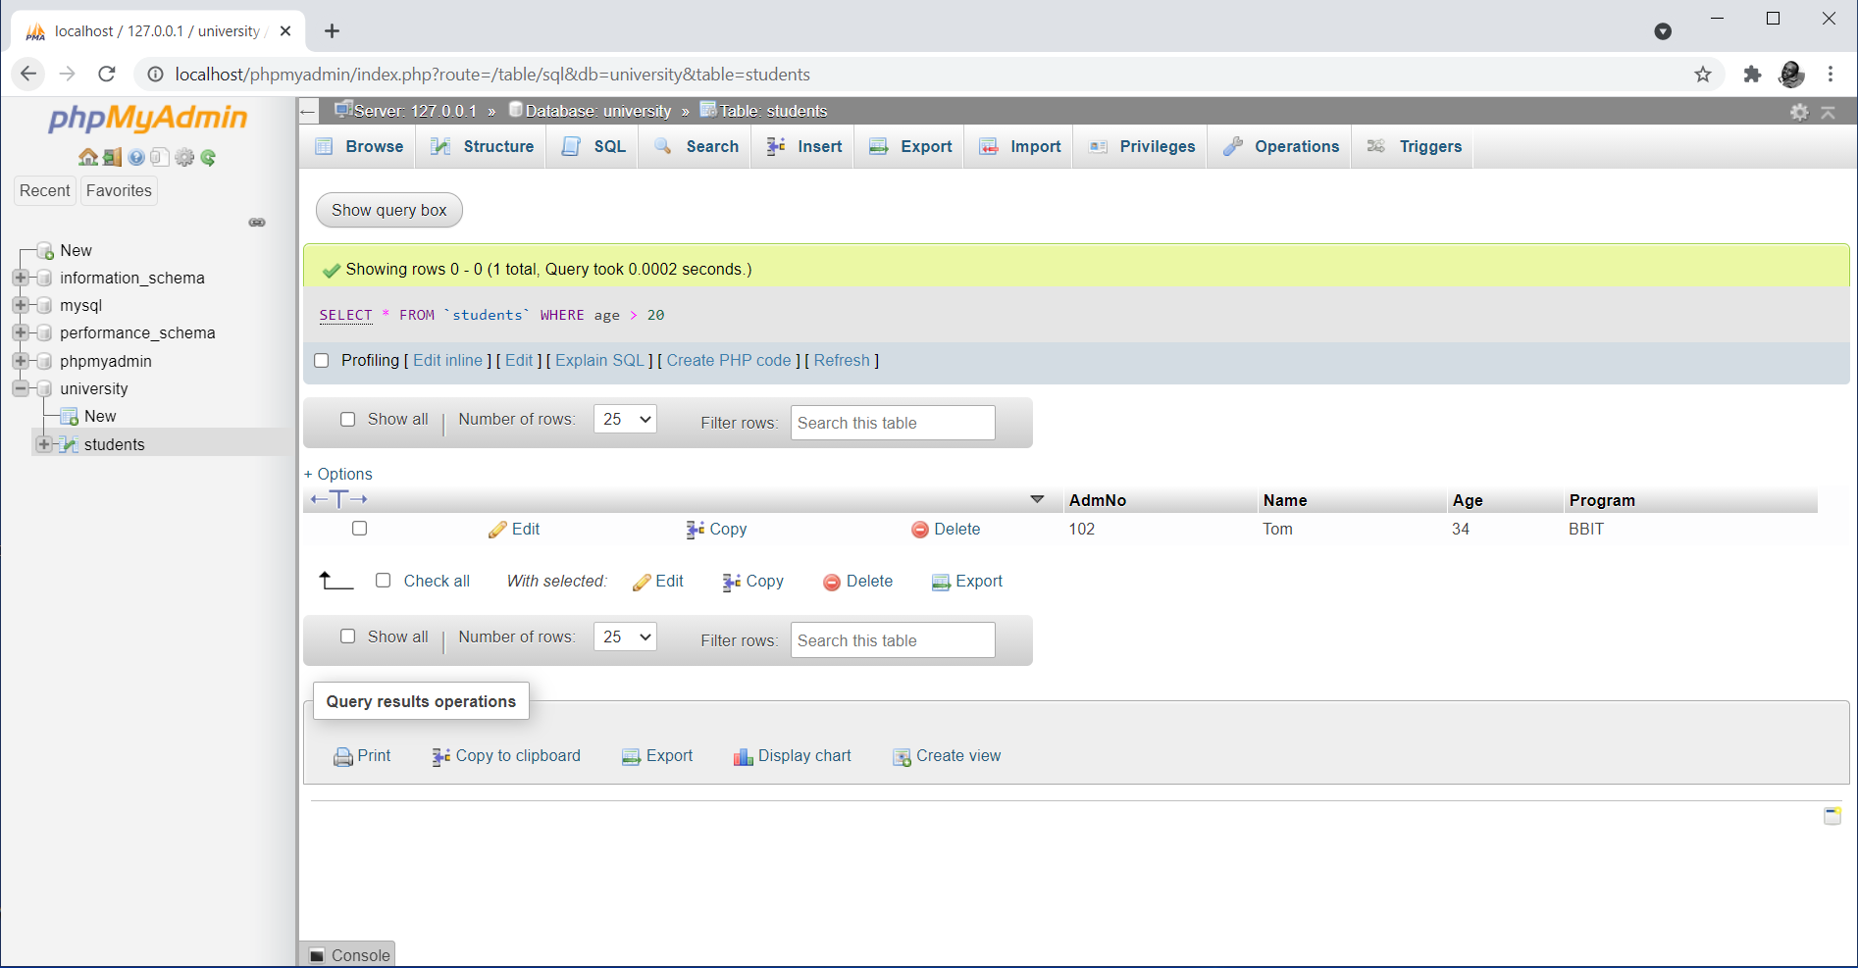
Figure 2. Output of Data Filtering in phpMyAdmin

Any other cases that require data filtering will entail supplying an appropriate condition using the WHERE clause as demonstrated in the above example. Conditions should be formulated using valid column names and values accompanied by appropriate comparison and conditional operators, like those covered in topic 4 on PHP Expressions and Operators.

Multi-table Querying in phpMyAdmin
The Structure Query Language (SQL) provides capabilities for querying more than one table at a time. In which case, the SQL statement must be written in such a manner that it gets to access data from any table. The use of the WHERE clause applies in this case, optionally supported by the concepts of JOINs. This topic will do a simple demonstration of how data can be retrieved from two tables using a single SQL query. To start the process, we will create two more table in the same database, namely, Departments and Programs. The two will hold details of all departments and programs in the University. This will hence require us to delete the initial program field in the Students table and replace it with the Program Identity field as a foreign key linking it to the Programs table. On the other hand, the Department Identification field will relate the Programs and Departments tables. The resulting relationship is as shown in the database designer view in Figure 3.

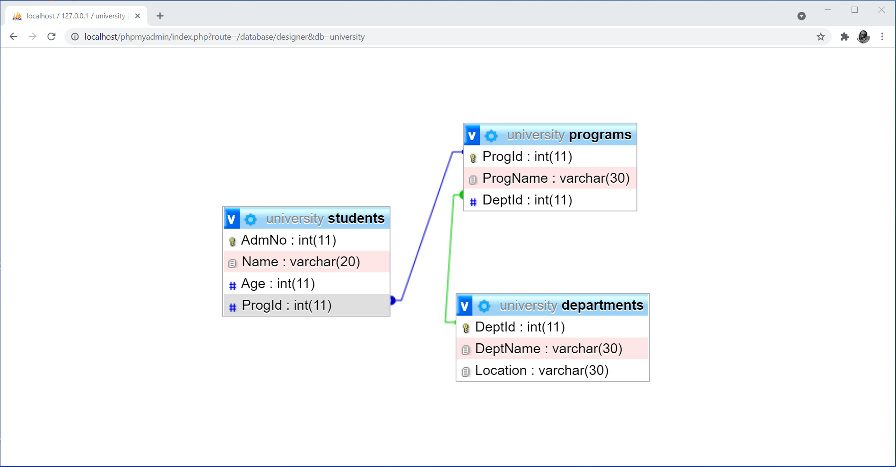
Figure 3. Database Designer View in phpMyAdmin

Figure 3 shows the designer view for the database with the third normal form enforced appropriately. To make the process of multi-table querying more real, we will ensure that each table contains at least three records as shown in Table 1 – 3.

Table 1. Departments Table
DeptId | DeptName | Location
1 | Computer Science | Rongai
2 | Business | Rongai
3 | Education | Nairobi

Table 2. Programs Table
ProgId | ProgName | DeptId
100 | Computer Science | 1
101 | BBIT | 1
102 | BCOM | 2

Table 3. Students Table
AdmNo | Name | Age | ProgId
100 | John Doe | 20 | 100
102 | Tom | 34 | 100
103 | Amos | 19 | 102
104 | Jane | 18 | 101

Notice the way proper entity and referential integrity has been enforced though key fields. At this point, we can now be able to perform multi-table querying. The following is the syntax for the first approach to multi-table SQL querying without use of JOINS.

Syntax
Select [table_name.column_name(s)] from table_name_1, table_name_2, … table_name_n where condition;

Note that the number of fields and tables depends on the data required for retrieval. Furthermore, the condition should be formulated in such a manner that it binds the tables based on key field that established the relationship. The following syntax defines another approach to multi-table SQL querying using JOINS.

Syntax
SELECT [table_name.column_name(s)] FROM table_name_1 JOIN table_name_2 ON condition;

Note that the term JOIN may be replaced with LEFT JOIN or RIGHT JOIN depending on the direction you want the data to be pulled from. Furthermore, the condition should be formulated in such a manner that it binds the tables based on key field that established the relationship.

Examples
The following SQL statement will display student details with the program name and department name included.

SELECT students.AdmNo,students.Name,programs.ProgName,departments.DeptName FROM students LEFT JOIN programs ON students.ProgId=programs.ProgId JOIN departments ON departments.DeptId=programs.DeptId;

Notice the fact that the query targets to retrieve data all the three different tables using JOINs. The output of the query in phpMyAdmin is as shown in Figure 4.
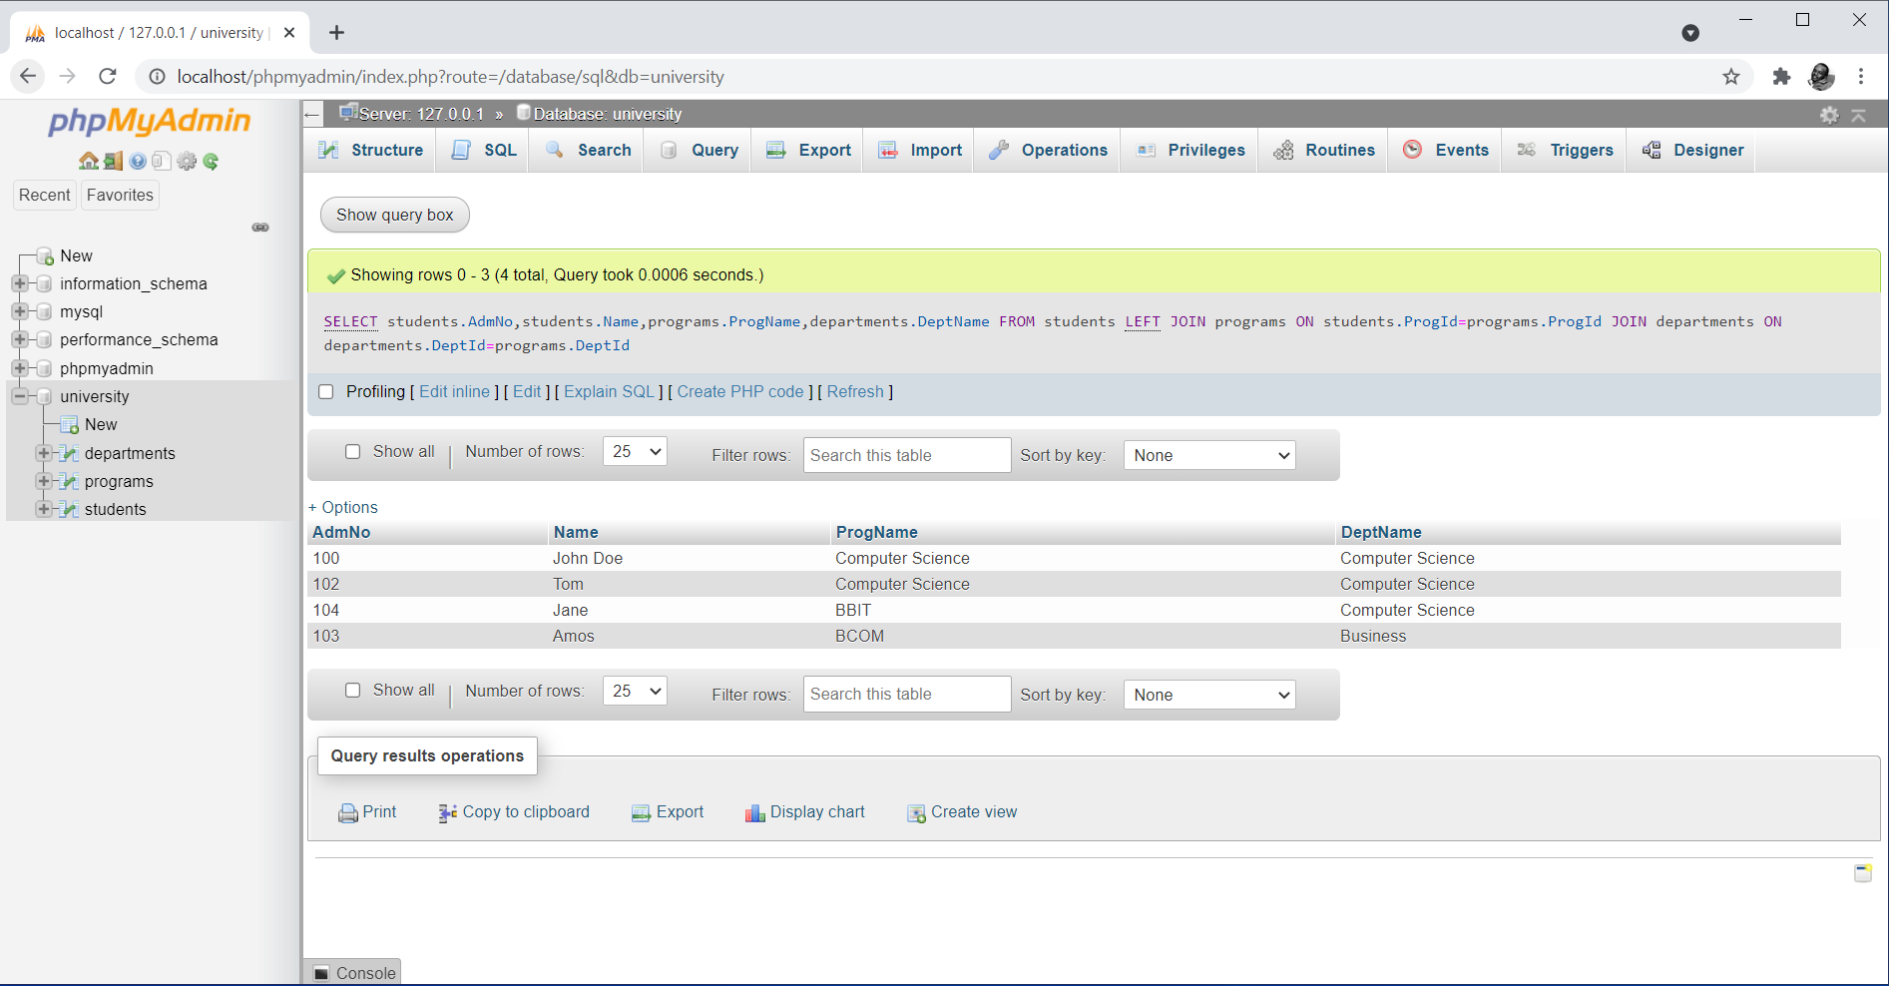
Figure 4. Output of Multi-table Querying in phpMyAdmin

Notice the way the use of JOINs over the key fields has enabled program names and department names to be matched correctly per student. Using a similar approach, any form of multi-table querying can be done.

Data Filtering Using PHP
The select SQL statement as used in PHP scripts to retrieve data from the database for display on the browser can also support filtering. As long as a valid statement is supplied to the mysqli_query() function, the desired data will be retrieved from the database. The syntax for data filtering SQL statements using the WHERE clause is as discussed in the previous section. The following example demonstrates a PHP script with a query containing a WHERE clause aimed at retrieving students whose age is greater than 20.

<!doctype html>
<html>
<head>
<title>Data Filtering</title>
<head>
<body>
<?php
//establish connection to the database server
$connect = mysqli_connect("localhost","root","");

if(!$connect){
echo "Connection to the database engine failed";
}

//select a database called University for use within the script
mysqli_select_db($connect,"University");

//generate a resultset with filtered records from a table called Students
$results = mysqli_query($connect, "select * from Students where age > 20");
?>

<!-- Retrieve and display data in tabular format -->
<table border="1">
<tr>
<th>Admission No</th>
<th>Name</th>
<th>Age</th>
<th>Program</th>
</tr>

<?php
while($row=mysqli_fetch_array($results, MYSQLI_ASSOC)){
?>

<tr>
<td> <?php echo $row['AdmNo']; ?> </td>
<td> <?php echo $row['Name']; ?> </td>
<td> <?php echo $row['Age']; ?> </td>
<td> <?php echo $row['Program']; ?> </td>
</tr>
<?php
}
?>
</table>
<?php
//close connection to the database server
mysqli_close($connect);
?>
</body>
</html>

The script generates a resultset containing data filtered to only records where the age of the student is greater than 20. The output of the script is as shown in Figure 3.

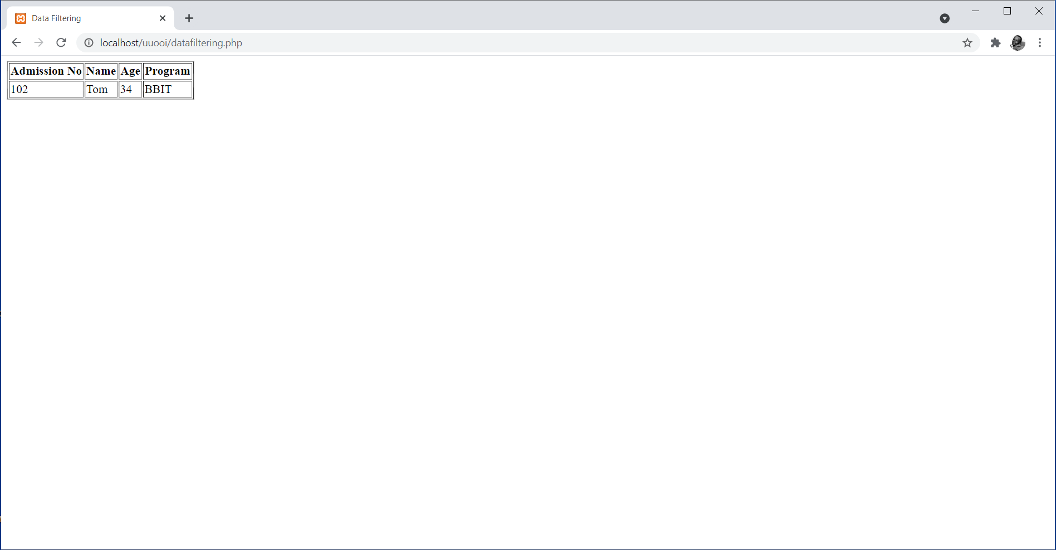
Figure 3. Output of Data Filtering using a PHP Script

Multi-table Querying Using PHP
The select SQL statement as used in PHP scripts to retrieve data from the database for display on the browser can also support multi-table querying. As long as a valid statement is supplied to the mysqli_query() function, the desired data will be retrieved from the database. The syntax for multi-table querying using JOINs is as discussed in the previous section. The following example demonstrates a PHP script with a query aimed at retrieving and displaying student details with program names and department names.

<!doctype html>
<html>
<head>
<title>Multi-table Querying</title>
<head>
<body>
<?php
//establish connection to the database server
$connect = mysqli_connect("localhost","root","");

if(!$connect){
echo "Connection to the database engine failed";
}

//select a database called University for use within the script
mysqli_select_db($connect,"University");

//generate a resultset with data from multiple tables
$results = mysqli_query($connect, "SELECT students.AdmNo,students.Name,programs.ProgName,departments.DeptName FROM students LEFT JOIN programs ON students.ProgId=programs.ProgId JOIN departments ON departments.DeptId=programs.DeptId");
?>

<!-- Retrieve and display data in tabular format -->
<table border="1">
<tr>
<th>Admission No</th>
<th>Name</th>
<th>Program</th>
<th>Department</th>
</tr>

<?php
while($row=mysqli_fetch_array($results, MYSQLI_ASSOC)){
?>

<tr>
<td> <?php echo $row['AdmNo']; ?> </td>
<td> <?php echo $row['Name']; ?> </td>
<td> <?php echo $row['ProgName']; ?> </td>
<td> <?php echo $row['DeptName']; ?> </td>
</tr>

<?php
}
?>
</table>
<?php
//close connection to the database server
mysqli_close($connect);
?>
</body>
</html>

The script generates a resultset containing data consolidated from three tables using JOINs. The output of the script is as shown in Figure 4.

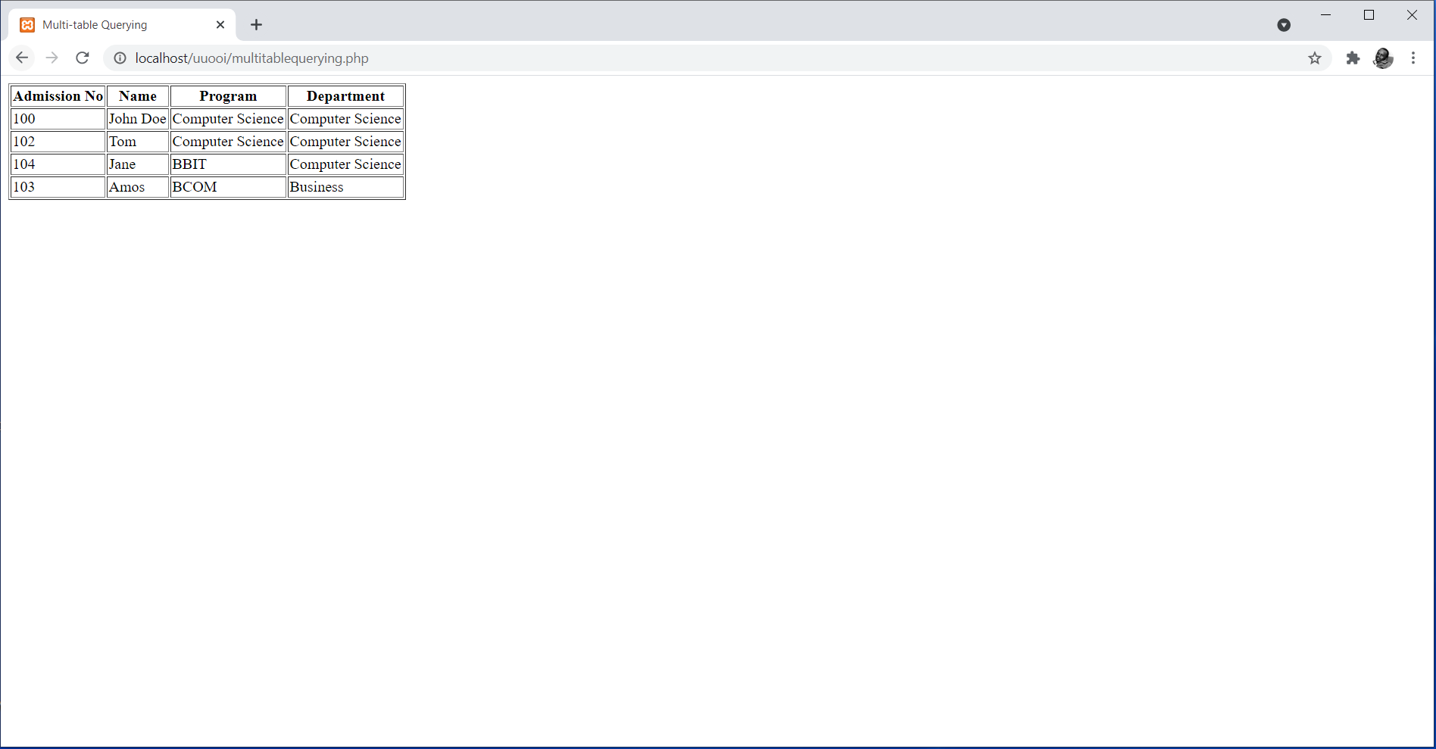
Figure 4. Output of Multi-table Querying using a PHP Script

It is worth noting that the concept of data filtering and multi-table querying can be combined to generate a query that retrieve data from multiple tables with a specific condition as defined by the WHERE clause.

Other Advanced Data Retrieval Concepts
In the same manner as described in previous subsections, other advanced data retrieval related SQL clauses are applicable. These include:
- GROUP BY – used for grouping data based on some unique field data.
- ORDER BY – used for sorting in either ascending or descending order.
In addition, functions can also be included in SQL statements and executed appropriately. Such functions include sum(), product(), average(), count(), among other functions. As long as the SQL statement is properly defined for its intended purpose, the PHP myqli_query() function will execute it successfully to generate a resultset that can be used as desired.

Summary
The topic has exposed you to some advanced concepts of SQL querying with an inclination to retrieval of data from the database. The demonstrations in the topic have been limited to data filtering and multi-table querying. In summary, it is upon the programmer to determine the desired output then craft a valid SQL query for the same which is supplied in the mysqli_query() function for generation of filtered data from either a single table or a set of tables. The resulting resultset can then be used as needed.

Check Points
- Describe the process of data filtering using phpMyAdmin.
- Demonstrate the process of data filtering using PHP scripts.
- Describe the process of multi-table querying using phpMyAdmin.
- Demonstrate the process of multi-table querying using PHP scripts.
- Describe the use of other advanced data retrieval concepts, like the ORDER BY clause, GROUP BY clause and functions, in PHP scripts.

Learning Resources

Core Textbooks
- Brooks, D.R., 2017. Programming in HTML and PHP. Switzerland: Springer.
- Gosselin, D., Kokoska, D. and Easterbrooks, R., 2010. PHP Programming with MySQL: The Web Technologies Series. Cengage Learning.

Other Resources
- https://www.w3schools.com/php/DEFAULT.asp
- https://www.tutorialspoint.com/php/index.htm

References
- Brooks, D.R., 2017. Programming in HTML and PHP. Switzerland: Springer.
- Gosselin, D., Kokoska, D. and Easterbrooks, R., 2010. PHP Programming with MySQL: The Web Technologies Series. Cengage Learning.

