Advanced Web Based Application Development

Lecture 11

Managing State Information Using PHP

Dr. Obuhuma James

Description
This topic takes a different perspective for PHP scripting by exploring how state information can be managed on a web page. State information is critical for many different roles including determination of visitors on a given web page, transfer of data from one page to the other, among other functions. The topic hence explores four ways to manage state information, namely, use of hidden form fields, query strings, cookies, and sessions.

Learning Outcomes
By the end of this topic, you will be able to:
- Understand the need for management of state information on a web page.
- Describe the use of different forms of state information management.
- Use PHP to create, maintain, and destroy sessions for systems requiring login and logout.

Introduction
State information helps in accomplishment of different tasks on web applications, some of which include determination of visitors on a web page [2], transfer of data from one page to the other, among other tasks. Detection of visitors on a website was highlighted as one of the capabilities of PHP scripts in the first topic. State information can be managed using different approaches. These includes use of hidden form fields, query strings, cookies, or sessions. This topic will demonstrate how each of the four approaches can be used to manage state information in a web-based application. Pros and cons for each approach will also be outlined.

State Information Management
In its original design, HTTP was stateless [2], hence, web browsers stored no data on any pages visited for any given website. Such an approach made webservers to process requests for web pages much faster since remembrance of any unique client requirements was not a necessity [2]. Likewise, web browsers required no special information to load a particular web page from the webserver [2]. Even though the stateless design was more efficient in terms of time, it had its own cons. The main con was the fact that since the web server could not remember individual user information, every visit to a web page was treated as a new session to the browser, even if the browser just opened a different web page on the same webserver [2]. The approach hence resulted to a major limitation on interactivity with a website. This and many more cons led to a need for mechanisms to manage state information.

This topic focuses on one example of state information management that allows for establishment of user identity, maintaining the identity throughout the period when the user is visiting different pages of the website, and finally destroying the identity when the user opts to end the session. This example is best suited for systems that require critical access control management. Function level access controls can comfortably be taken care of depending on the user identity and role assigned to such users.

PHP offers four tools for managing state information for web-based applications. These are hidden form fields, query strings, cookies, and sessions. The following subsections will explore each of these with an example of how it can be applied in real-life.

Hidden Form Fields
HTML form fields are created using different elements including the <input>, <radio>, <checkbox> elements, among others. The <input> element is the most widely used since its type attribute gives room for definition of different kinds of data allowable in the field. These type values include text, password, email, color, range, hidden, among others. The syntax for the <input> element is as follow.

<input type="hidden" value="userdefined" name="userdefined" />

Setting the type attribute to value “hidden” makes the field not to appear on the browser. Data values specified in such a field are however part of the data submitted upon clicking of the submit button. For instance, consider the following form with three <input> element fields. Notice the fact that the type attribute for the last element is set to value “hidden”, hence, the field is not displayed on the browser as shown in Figure 1.

<!doctype html>
<html>
<head>
<title>Hidden Form Fields</title>
</head>
<body>

<form method="POST" action="validate.php">
Username<input type="text" name="username" /><br />
Password<input type="password" name="password" /><br />
<input type="hidden" value="admin" name="role" /><br />
<input type="submit" value="Login" />
</form>

</body>
</html>
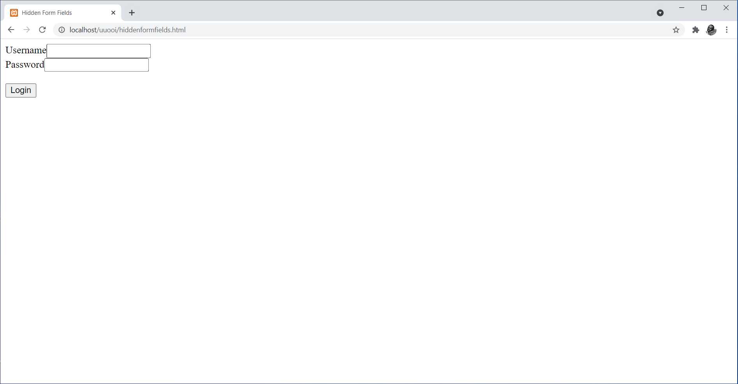
Figure 1. HTML Form on the Browser with Hidden Form Fields

According to Figure 1, the role field is not displayed on the browser since its type was set to value “hidden”. However, upon clicking of the submit button, the value “admin” will be part of the data submitted to the “validate.php” script under form name “role”. This means that either the $_GET[] or $_POST[] autoglobal can be used to access the value for the field despite the fact that it was not provided by the user on the browser.

In general, hidden form fields allow programmers to get a way to pass form values from one PHP script to another since they are submitted along with other form fields without user intervention [2]. However, hidden form fields pose a security challenge because users can view their values on the browser by right clicking on the page then selecting “view page source”. For instance, Figure 2 shown the page source for the form in Figure 1.

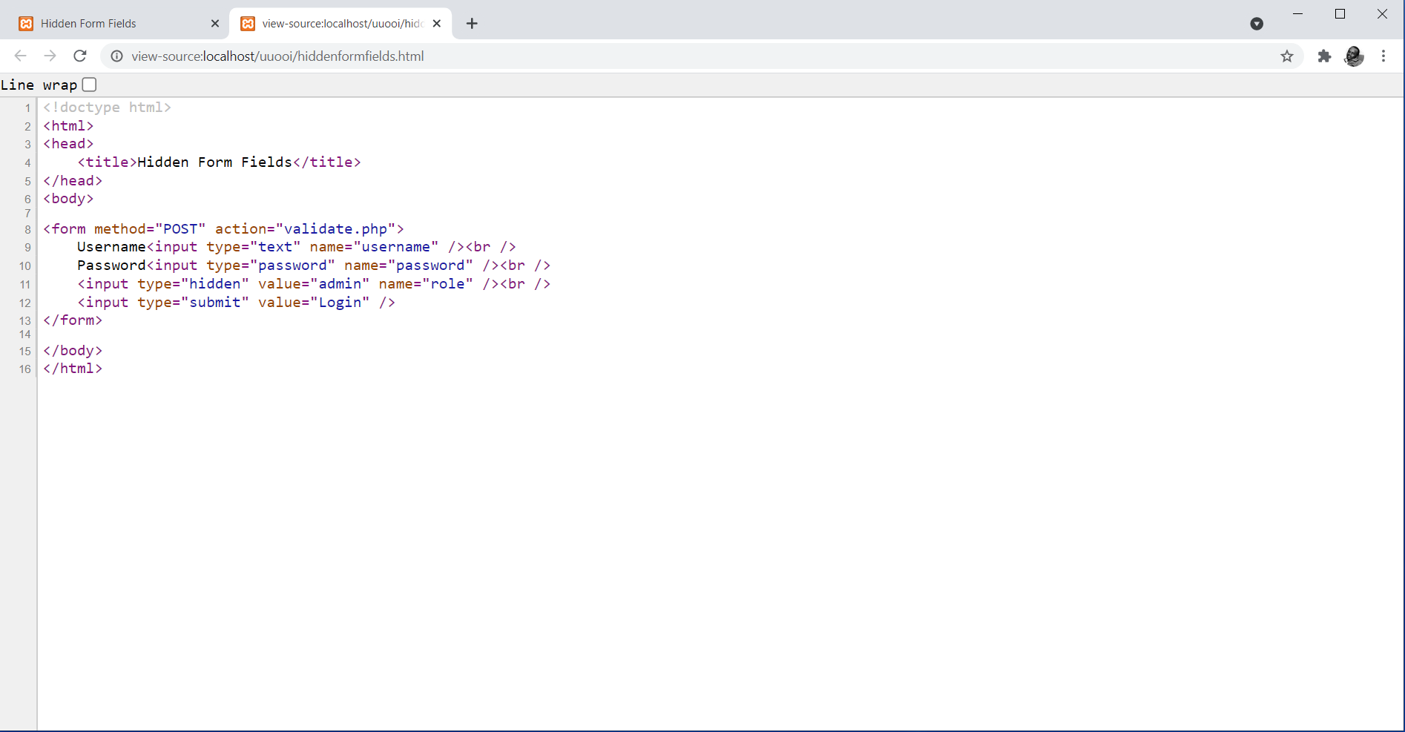
Figure 2. Page Source for the Form in Figure 1

The page source as accessed from the browser provides all the HTML data for the form including the values assigned to the hidden form field. It is thus not advisable to pass sensitive data through hidden form fields since this can be a better catchment area for hackers.

Query Strings
Query strings can offer a mechanism for preservation of information on a user’s visit to a web page. A query string is a set of name/value pairs normally appended at the end of a URL [2]. A query string is usually expressed as a single text string containing one or more pieces of information to be passed over to another page or script. To create a query string, a question mark (?) is added at the end of the URL followed by the name/value pair(s) as shown in the following syntax.

<a href=”targetpage.php?name_1=value_1&name_2=value_2 … &name_n=value_n>Link Text</a>

For example, consider the following example that creates a link called “Query String Example”. The link targets a PHP script called “querystring.php” with three name/value pairs containing name, id and age values.

<!doctype html>
<html>
<head>
<title>Query String</title>
</head>
<body>

<a href="querystring.php?name=james&id=35265454&age=52">Query String Example</a>

</body>
</html>

The following code shows how a PHP script called “querystring.php” that was the target for the query string in the previous HTML code would be used to read data supplied in the query string.

<?php
echo "The received name is " . $_GET['name'] . "<br />";
echo "The received name is " . $_GET['id'] . "<br />";
echo "The received name is " . $_GET['age'] . "<br />";
?>

Notice how the $_GET[] autoglobal is used to receive query string values using the names that each value was assigned to. Figure 3 shows the output achieved upon clicking on the “Query String Example” link.

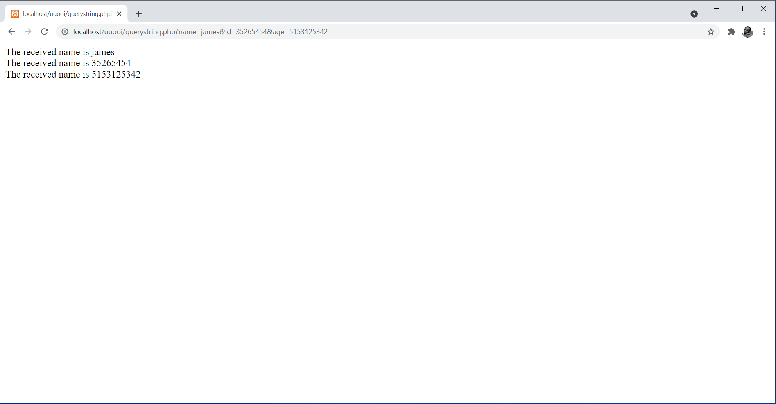
Figure 3. Output of the querystring.php Script

This example is a clear indicator that query strings can be used to preserve and transfer information from a web page to a script. Such information can then be used as desired in the new location. Just like the case of hidden form fields, query strings also pose a security challenge. Notice the fact that the address in the address bar of the querystring.php script shown in Figure 3 includes the full query string name/value pairs. This become part of the data cached by the web browser and can be accessed later in the history of pages visited on the browser. It is hence not advisable to pass sensitive data through query strings since this can be a better catchment area for hackers.

Cookies
The use of cookies is another methodology for storage and management of state information. Unlike hidden form fields and query strings that only hold information during an active browser session, cookies allow for both temporary and permanent storage of state information. Hence, nearly all modern browsers support use of cookies that can be either temporary or persistent [2]. Temporary cookies hold data only during an active browser session. Conversely, persistent cookies allow for permanent storage of state information. Such information is stored in a text file on a client computer [2]. The choice of type of cookie to use depends on the programmer’s need i.e. whether information is required beyond an active browser session or not.
Creating Cookies
The setcookie() function is used to create cookies in PHP using the following syntax

setcookie(name [, value, expires, path, domain, secure])

The name argument is mandatory while the value, expires, path, domain, and secure arguments are optional [2]. However, if they must be there, then they have to be specified in the order in which they appear in the syntax. The setcookie() function must be called before sending the browser any output, before including any white space or HTML elements, or output from the echo or print statement [2]. Cookies give users room to accept or reject them. Either way, if the setcookie() function runs successfully, it returns a Boolean value TRUE.

The name argument of the setcookie() function works hand in hand with the value argument for effective functioning of the cookie. For instance, the following example creates a cookie named username and assigns a value “jdoe” to it.

<?php
setcookie("username", "jdoe");
?>

<!doctype html>
<html>
<head>
<title>Creating Cookies</title>
</head>
<body>

<p>Example of a cookie</p>

</body>
</html>

Multiple setcookie() functions can be specified in cases where more than one cookie is to be specified. For instance, the following example can be used to specify three cookies for one session.

<?php
setcookie("username", "jdoe");
setcookie("country", "Kenya");
setcookie("county", "Kajiado");
?>

Cookie values can also be stored in indexed or associative arrays. This can be accomplished by appending array operators ([]) and an index or key to the cookie name within the setcookie() function [2]. The following example demonstrates creation of an indexed cookie array called origin[] containing three cookie values used in the previous example.

<?php
setcookie("origin[0]", "jdoe");
setcookie("origin[1]", "Kenya");
setcookie("origin[3]", "Kajiado");
?>

Similarly, the following examples demonstrates creation of an associative version of the origin[] cookie array.

<?php
setcookie("origin[‘username’]", "jdoe");
setcookie("origin[‘country’]", "Kenya");
setcookie("origin[‘county’]", "Kajiado");
?>

The expires argument is used in cases where a cookie is expected to persist beyond an active browser session. This is specified using the time() function followed by positive or negative integer value signifying time in seconds. The path argument specifies the availability of the cookie to other web pages on a webserver. A forward slash “/” is used to signify availability of a cookie to all directories on a webserver, otherwise, a specific subdirectory name may be stated within two forward slashes. The domain argument gives room for specification of a domain that permits sharing of cookies across multiple webservers in the domain. The secure argument is used to indicate whether a cookie is to be transmitted across a secure internet connection using HTTPS or any other secure protocol. The argument is specified using a 0 or 1 to signify FALSE or TRUE. The following example demonstrates creation of a cookie with all arguments specified.

<?php
setcookie("username", "jdoe", time()+10, "/sales/", ".doe.com", 1);
?>

The example creates a cookie called “username” set to value “jdoe”. The cookies is set to expire after 10 seconds upon terminations of an active browser session. It is limited within the “sales” subdirectory across servers within the “.doe.com” domain. The cookie is to be transmitted only in a secure internet connection.

Reading Cookies
Cookies available to the active browser are automatically assigned to the $_COOKIE[] PHP autoglobal array [2]. Hence, specifying the cookie name as a key for the $_COOKIE[] array allows access to the cookie. For instance, the following example will access the cookie created in the previous example then display the value assigned to the cookie name.

<?php
echo $_COOKIE['username'];
?>

It is worth noting that cookies stored in indexed or associative arrays are stored in two-dimensional arrays within the $_COOKIE[] autoglobal. Hence, multidimensional arrays should be used to read cookie values.

Deleting Cookies
Temporary cookies are automatically deleted when an active browser session comes to an end. Conversely, persistent cookies rely on the time assigned to the expires argument of the setcookie() function to get deleted. PHP allows for deletion of persistent cookies before expiry of the set time. In such cases, the value argument of the setcookie() function should be set to an empty string with the new expiry time value set to a past time [2]. This is achieved by subtracting any number of seconds from the time() function. The following examples causes the username cookie set in the previous example to expire.

<?php
setcookie("username", "", time()-10);
?>

Limitations of Cookies
It is worth noting that individual browsers can limit the number of cookies each server (or domain) can store on a user’s computer or total number of cookies stored on a user’s computer [2]. Browsers may start discarding older cookies upon exceeding of limits. Furthermore, there are a number of security issues associated with saving state information in cookies on a client computer [2]. For instance, ensuring security of every client computer running PHP scripts may be a challenge, hence rendering sensitive data stored in cookies vulnerable. Many clients configure browsers not to accept cookies, which in return also disables any cookie preservation code in PHP scripts [2].

Sessions
A session is basically a period of activity when a PHP script stores state information on a webserver. The use of sessions offers a more secure way of storing state information compared to cookies since they store state information on the webserver as opposed to storage on client computers [2]. As such, if the webserver is secured appropriately, then session information will also be secure. Sessions store state information only during active browser sessions. They can hence be compared to the concept used in temporary cookies as described in the previous subsection. Maintenance of state information using sessions does not require cookies to be enabled on the browser. This makes them much easier to use and as such increases on reliability. The use of cookies outdoes the use of sessions in cases where state information is to be stored permanently, thus the need for persistent cookies.

Creating Sessions
The PHP session_start() function is used to either start a new session or continue an existing one. Starting a new session generates a unique random alphanumeric string that acts as a session identifier. Additionally, this triggers a text file to be created on the webserver with the same name as the session identifier, preceded by sess_ [2]. Session files have no extension. The file is used to store any variables generated by the session. By default, PHP session files are stored in the “tmp” subfolder in XAMPP. The location can however be changed in the php.ini configuration file under the session.save_path directive. In cases where the cookies are enabled on the browser, the session identifier is assigned to a temporary cookie called PHPSESSID [2]. PHP offers a session_id() function that can be used in cases where a programmer needs to retrieve a session identifier for use within the script. Such usage may include passing the identifier to other pages using query strings or hidden form field among other usage. It is however worth remembering that session identifiers are part of sensitive data that must be handled with care.

Just like for the case of cookies, the session_start() function must be called before sending the browser any output, before including any white space or HTML elements, or output from the echo or print statement [2]. However, the function does not take any parameters like the setcookie() function does. If the session_start() function runs successfully, it returns a Boolean value TRUE, otherwise, it returns FALSE.

Working with Session Variables
Session state information is stored in the $_SESSION[] autoglobal. Whenever the session_start() function is invoked, a new $_SESSION[] autoglobal is initialized or any variables in the current session are retrieved into the $_SESSION[] autoglobal. The latter refers to an already started session based on an existing session identifier. For instance, the following example script starts a session then declares and initializes three variables in the session.

<?php
session_start();
$_SESSION['username'] = "jdoe";
$_SESSION['country'] = "Kenya";
$_SESSION['county'] = "Kajiado";
?>

<!doctype html>
<html>
<head>
<title>Creating Sessions</title>
</head>
<body>

<p>Creating session with variables example</p>

</body>
</html>

It is always good practice to put checks on all pages requiring sessions such that a verification is first made to determine whether a session is already initiated or not. The isset() function is applicable in such cases. For instance, suppose we want to check on another page whether the session variable for username is already set on the browser, the following code could be used.

<?php
/*check if session is set then read the session variable otherwise,
redirect back to login page */
session_start();
if (!isset($_SESSION['username'])){
header('location: login.php');
}else{
echo "You are logged in as " . $_SESSION['username']
. " with session id " . session_id() . "<br />";
}

//provide a link for logout
echo "<a href=logout.php>Logout</a>";
?>

The example script checks if the sessions is already set. If yes, it reads and prints the session with variable name “username” and its session identifier. Otherwise, it redirects the user back to the login page, in this case, login.php. The last line of the script provides a link to the logout script, in this case, logout.php, meant to destroy the session and its variables.

Deleting Sessions
Under normal circumstances, a session automatically ends when an active browser session terminates. However, programmers sometimes give provision for users to terminate sessions at will, for instance through a logout process. In such cases, the session and its variables need to be destroyed. The following steps are critical in the process of deleting of sessions [2]:
- Provide a call to execute the session_start() function as usual.
- Reinitialize the $_SESSION[] autoglobal using the array() construct.
- Delete the session using session_destroy() function.
In reference to the above stated steps, the following script could be used to perform a logout process for a web-based application that has a session that was established and is running following successful a login process. The script could be executed behind scenes whenever a user clicks a logout button or link.

<?php
//gather all session variables in an array
session_start();
$_SESSION = array();

//destroy all session variables then redirect to the login page
session_destroy();
header('location: login.php');
?>

Notice the fact that the script starts by initiating the session_start() function aimed at checking whether a session is already initialized. This is followed by the execution of the array() construct to gather all active session variables and assign them to the $_SESSION[] autoglobal. The session_destroy() function then destroys the entire session with its variables. The last line redirects the user to the login page, in this case login.php as a sign that no session is active.

Although sessions are perceived to be much more secure than cookies for state information management, it is worth noting that poor management of sessions can become a vulnerability to the web application. This will be covered in the next topic on “Web-based Application Security Risks with their Countermeasures”.

Summary
The topic has exposed you to the various techniques used to manage state information in web-based applications. This is a critical aspect of web-based application development. Four state information management mechanisms have been explored, namely, hidden form fields, query strings, cookies, and sessions. Each of the four mechanisms has its own advantages and disadvantages. Hence, each of them is best suited for different applications. For instance, hidden form fields and query strings are best suited in transferring information from one web page to another within a website. On the other hand, cookies and sessions are critical in initiating and maintaining sessions on an active browser session.

Check Points
- Describe the concept behind management of state information.
- Briefly describe the pros and cons of hidden form fields, query strings, cookies and sessions as used in management of state information.
- Using an example, differentiate between the process of passing values using hidden form fields from that of using query strings.
- Using an example, demonstrate the process of managing states using cookies.
- Using an example, demonstrate the process of managing states using sessions.

Learning Resources

Core Textbooks
- Brooks, D.R., 2017. Programming in HTML and PHP. Switzerland: Springer.
- Gosselin, D., Kokoska, D. and Easterbrooks, R., 2010. PHP Programming with MySQL: The Web Technologies Series. Cengage Learning.

Other Resources
- https://www.w3schools.com/php/DEFAULT.asp
- https://www.tutorialspoint.com/php/index.htm

References
- Brooks, D.R., 2017. Programming in HTML and PHP. Switzerland: Springer.
- Gosselin, D., Kokoska, D. and Easterbrooks, R., 2010. PHP Programming with MySQL: The Web Technologies Series. Cengage Learning.

