Tarqatma materiallar
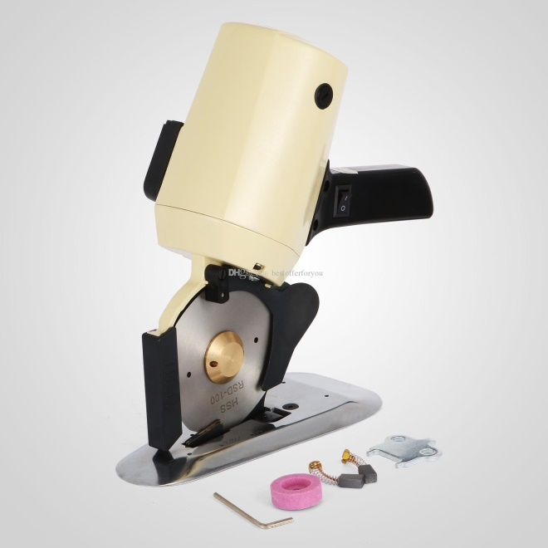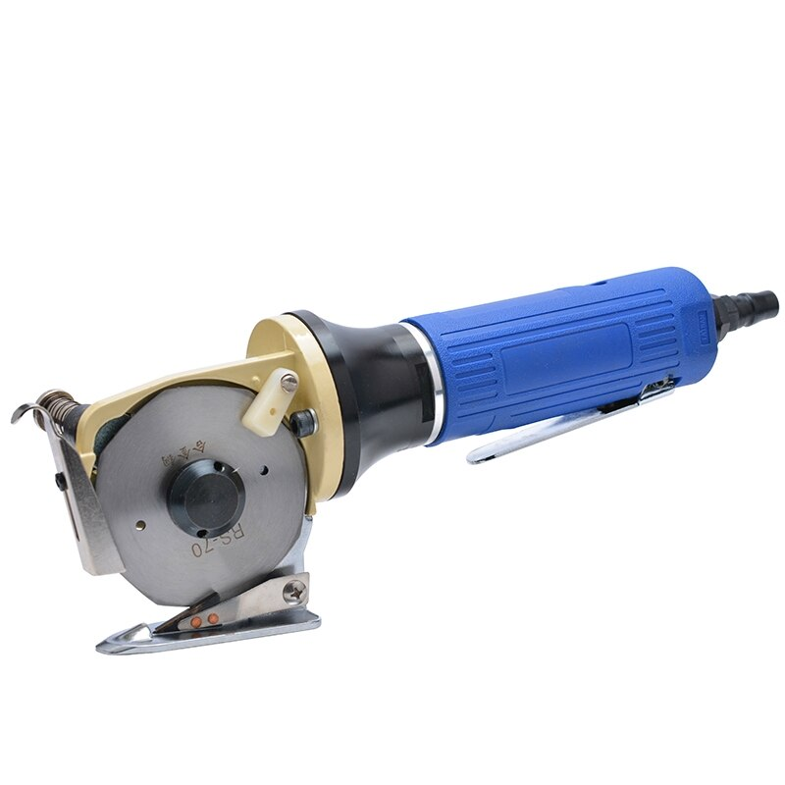
Diskli mato qirqish mashinasi
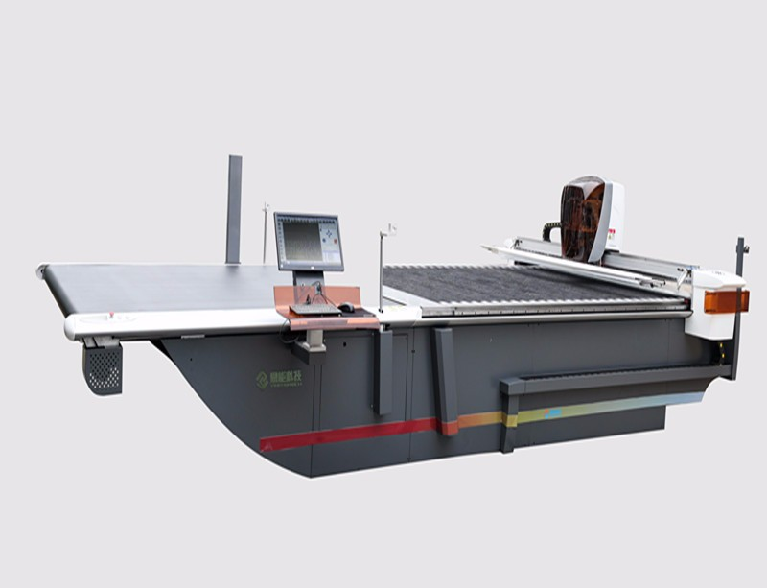
Avtomat mato qirqish mashinasi

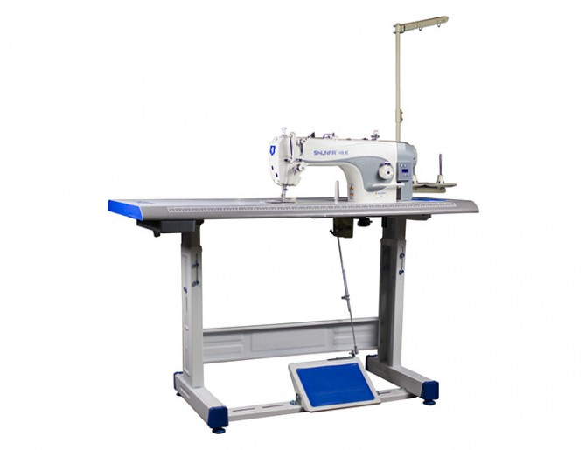
To’gri baxya tikuvchi universal mashina
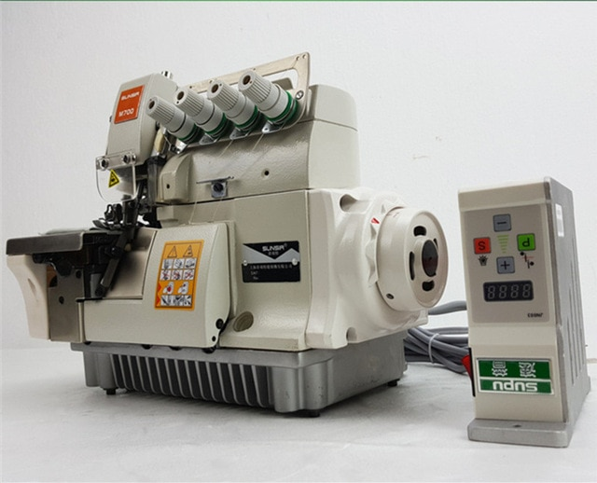
Yo’rmalash mashinasi

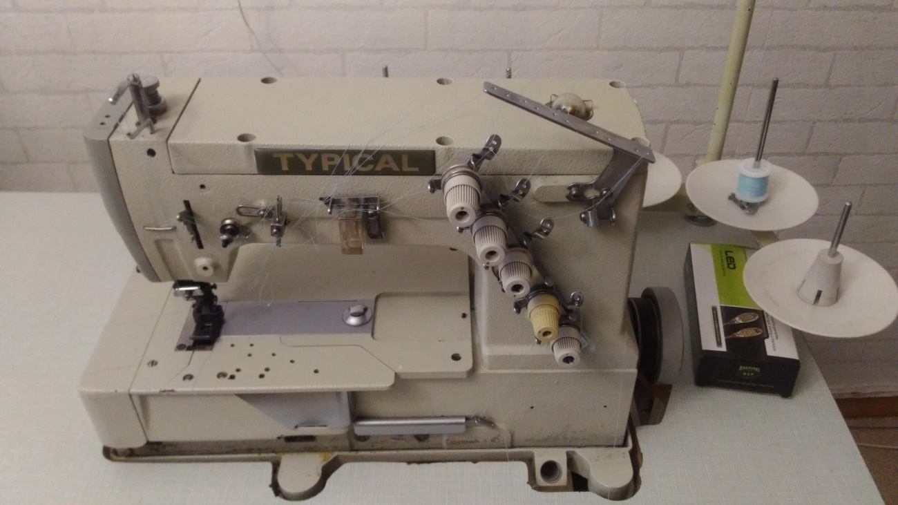
Yo’rmab tikish mashinasi
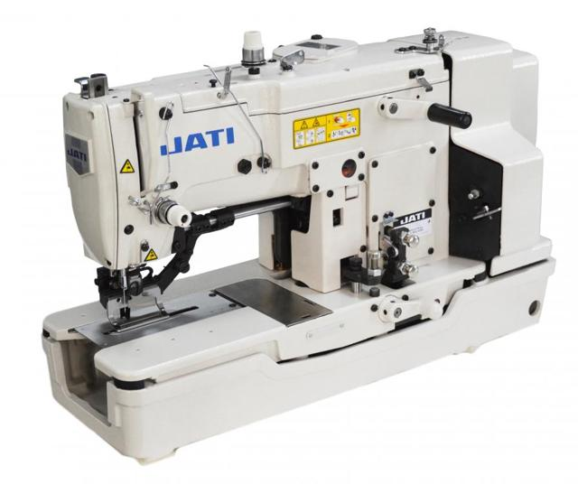
Izma ochish mashinasi

