Lesson 5:

Establishing Credibility


https://www.freepik.com/premium-photo/hand-writing-establish-credibility-with-red-marker-isolated-white-background-business-technology-internet-concept-stock-image_11644460.htm

Lecturer: M. Kurbonov
Establishing Credibility
So, now we know that technical writing is about explaining, illustrating, or instructing on a particular subject, whether that's a policy recommendation or a kitchen appliance. But what does that mean in terms of your role as a writer? How does your voice differ from that of an academic or creative writer, for example?
It is important to remember that technical writing is, primarily, functional. Opposed to creative writing, or even academic writing, you may assume that the technical writing style is less chic style or complex. Functional writing, however, does not necessarily clash with style. Style has often been confused with pretension when it comes to writing, and overcomplicated and obscure vocabulary are sometimes mixed up with actually good writing.
Contemporary attitudes towards writing, however, increasingly privilege clarity. As Lester Faigley puts it (2011), "Too often long sentences reflect wandering thoughts that the writer did not bother to go back and sort out" (p. 154). The influence of "business-speak" in society has more or less shifted the consensual requirements of "good writing" towards clarity and conciseness (Lanham, 2006). This applies not only to technical writing but is an overarching societal attitude towards writing.
Whether privileging clarity over flourish in writing is a good or a clarity don't necessarily have to be at odds with one another, but it is clear that technical writing demands a certain utilitarian tone. Many people, however, forget that this is legitimately a stylistic requirement.
Really, style isn't about writing in only one way that is stylish — there are many different valid styles. Style is about finding the appropriate tone for the purpose of your writing and using suitable language for your target audience. In this way, the stylistic requirements of technical writing are no lesser than those of any other type of writing. The list below details the most prominent stylistic requirements of technical writing.
Objectivity
Technical writing may seem like it doesn't leave much space for subjective involvement. But whatever you are writing, it's important to remember that you are an individual with a subjective perspective, opinions, tastes, preferences, and values.
"Does objectivity matter that much when I'm writing a professional email or a report?", you might be wondering. Well, it does. Imagine an employee is asked to write a report about the fish population in their local river. The said employee is a climate change denier and writes the report with no mention of how rising temperatures in the local area's river have caused a large proportion of fish to migrate further North. This omission obviously has a dramatic impact on the content of the report!
There are things you can do to strive for objectivity in your technical writing:
- Present balanced views. Reporting the full extent of nuanced positions on a matter ensures you are not oversimplifying your writing or supporting a biased stance. (Smyth, 1996)
- Don't leave information out. Even if part of the data doesn't confirm your position or is not coherent with the overall trend in the data, always include it. Leaving important information out only weakens your writing and makes it easily refutable.
- Don't get too personal. Using the passive tense and the third person is one way to avoid saying "I", and it might help you steer away from including anecdotal personal experiences, which do not actually help your writing.
- Always support your claims with evidence. Presenting supporting facts forces you to address other possible views and contrasting position, which overall helps you to avoid focusing on your personal stance.
- Reference properly! This advice is of course tied to evidence, which should always come from a reputable source. We'll elaborate more on citation and referencing later in this chapter.
Sound reasoning
Part of establishing credibility as a writer is expressing yourself coherently, demonstrating a grasp on sound reasoning. A sound argument is an argument which does not present any logical flaws - i.e., an argument that does not contradict itself. This isn't always as easy as it seems!
Faulty arguments, which are often used as kinds of tricks to convince audiences, are called fallacies. Since the birth of rhetoric-- the art of persuasion- fallacies have been used in the political and judicial arenas to mislead and divert audiences' attention. Other obvious places you might read or hear a lot of fallacies are the news, or in advertising. A study conducted by the argumentation scholar Walton (2010) suggests that the reason why we are susceptible to fallacious arguments is because our brains use "heuristics", mental shortcuts, which sometimes lead us to jump to conclusions. These mental shortcuts may hold beliefs such as "If it is an expert opinion, defer to it. If there is no reason to think it is false, accept it as true." (Walton, 2010, p.2).
Although these shortcuts can be helpful in decision-making situations, it's important to try and avoid falling prey to these argumentative pitfalls in your technical writing. Being aware of possible fallacies is already a big step towards avoiding repeating them yourself. Luckily for us, common types of fallacies have been well-documented and commented on! Here is a list of faulty arguments you want to avoid in your technical writing:
Argumentum ad verecundiam (Appeal to authority)
Example:
"Many doctors and scientists believe that a bowl of Special K cereal for breakfast everyday provides all the essential nutrients needed for an average adult."
This argument is not fallacious, in the sense that it does not contain a logical contradiction. However, you can see how an argument which rests solely on an unknown number of mysterious sources' opinion is not very strong. The above argument really is fallacious in the sense that sources are not named (and for all we know, they could be made up!). Another version of this type of fallacy is to present as evidence a claim b> someone who is not an authority or expert on a matter (e.g. My friend Rebecca believes that a bowl of Special K cereal for breakfast everyday provides all the essential nutrients needed for an average adult).
Slippery slope
A slippery slope argument infers a chain of negative consequences from a single premise. Because of the escalation in the negative consequences, the aim of a slippery slope argument is to demonstrate that the premise should be rejected.
Example (Stanford Encyclopedia of Philosophy, 2020):
"You have decided not to go to college;
If you don't go to college, you won't get a degree;
If you don't get a degree, you won't get a good job;
If you don't get a good job, you won't be able to enjoy life;
But you should be able to enjoy life;
So, you should go to college."
Enoch (2001) argues that slippery slope arguments often turn against themselves; although some slippery slope arguments may not always be entirely fallacious, distinguishing between valid inferences and invalid ones is a tricky business. It's a lot easier to avoid slippery slopes altogether!
Argumentum ad hominem (Argument against the person)
The ad hominem fallacy designates portraying your argumentative opponent negatively, in order to dismiss their point. By attacking "ad hominem" (Latin for "the person"), you target the arguer, rather than their actual stance.
Example:
"Ms. Clark's position on juvenile delinquency should be ignored, since she was herself arrested for public intoxication as a teenager."
This argument attacks the figure of Ms. Clark rather than her actual position on juvenile delinquency-- which might be a very interesting stance! Another way to use the ad hominem fallacy (Stanford Encyclopedia of Philosophy, 2020) is to suggest that the arguer is defending their position out of self-interest, or that the arguer does not follow their own stance. These are all strategies to discredit the argumentative opponent.
Post hoc ergo propter hoc (after this, therefore because of this)
This type of fallacy infers causation from temporal succession; in other words, this form of argument establishes causality between two events which occurred in succession. It is a version of "because event 2 occurred after event 1, event 1 caused event 2."
Example:
"In country X, unemployment decreased in June, because the government reduced the payroll tax in January."
Just because event 2 (decrease of unemployment) happened after event 1 (government reduced payroll tax), it cannot be soundly inferred that event 1 caused event 2. There could be many other causes for the falling rates in unemployment.
Peititio principii (begging the question):
This type of fallacy is also called a circular argument. Its a form of argument where the premise is logically equivalent to the conclusion; in other words, it's the logical equivalent to a dog chasing after its own tail.
The Stanford Encyclopedia of Philosophy cites Whately's (1875 II §13) example:
"to allow everyman an unbounded freedom of speech must
always be, on the whole, advantageous to the State; for it is
highly conducive to the interest of the Community, that each
individual should enjoy a liberty perfectly unlimited, of
expressing his sentiments."
As you can see, this sentence is completely tautological (it repeats itself). Whately doesn't demonstrate anything, but only repeats his premise as the conclusion of his argument.
Straw man argument
The straw man argument is a variation of the fallacy known as ignoratio elenchi, or irrelevant conclusion. Essentially, this consists in building a "straw man" of the opponent arguer's claim, distorting and simplifying their stance, in order to refute it more easily.
Arguer 1: Veganism could help reduce carbon emissions.
Arguer 2 (straw man): Veganism could solve all of the world's problems.
Because the straw man version of the argument is easy to refute (it's easy to prove that veganism wouldn't solve every problem across the planet), arguer 2 creates the impression that arguer l's position is ludicrous and untenable.
The bottom line
All these Latin names and technical terms may seem like a lot but knowing these fallacies can help you avoid recreating them in your own writing!
Referencing
While you might think of referencing as the boring to-do chore at the bottom of your list, it is actually extremely important. Similar to using argumentative devices properly, referencing is a big part of being an intellectually honest writer. By citing precisely and accurately, you are essentially crediting other people for their hard work.
If you write on a laptop, using referencing software is a huge help. When you are writing, it's easy to lose track of your source of information...which always leaves you in a kerfuffle at the very last minute, when you are trying to clean up your piece.
Referencing software-systems you can easily download on your PC or MAC include:
- Zotero
- EndNote
- RefWorks
- Mendeley
- Citationsy
By using some of this software, you can keep track of your sources as you go along writing. However, whether you are entering references manually or with software, knowing common citation styles is important.
The lists below demonstrate the use of the APA citation system
Avoiding the waffle
Key to technical writing is making sense to as many people as possible. Have you ever come across an instruction manual that goes on a tangent about the historical origins of the screwdriver or an email that finishes with "thanking you kindly and grateful this morning"? The answer, hopefully, is no.
Technical writing avoids the waffle and is defined by the widespread use of plain language. Unlike academic or creative writing, the use of plain language in technical writing seeks to make a point as clearly and concisely as possible. It helps avoid confusion and misunderstandings among its readership.
What is plain language?
Professor Robert Eagleson (Anastasia, 2020), an expert in modern English language, describes plain language as displaying the following characteristics:
- Clarity: the most understandable words are used in the shortest amount of space possible.
- Message-focused: the topic should take pride of place and should not be distracted through language.
- Unpretentious: obscure words and convoluted sentences are a no-no.
- Professional: simple language should be used, but it should be appropriate - no uses of slang or "baby talk".
How to write using plain language
Owing to its simple nature, there is a fairly straightforward way of using plain language. As mentioned, forms of technical writing vary widely, and a more extensive guide on how to write in different formats will come in the later sections of this book. However, there are some key basics which can provide you with a good foundation to begin with (Anastasia, 2020):
- Important messages come at the beginning.
- Convey one message in one sentence - no need for repetition.
- Sentences should be short (typically no more than 25 words).
- Use paragraphs - separate sections by an idea.
- Short words are better. Why use "demonstration" when you could use "show"?
- Avoid jargon. Check if necessary and remove or replace.
- Use the active, rather than passive, voice; you pick up the apple - not the apple was picked up by you.
STRUCTURE
Once you’ve planned and scheduled your project, the next step is to determine the internal structure of your deliverables. This is also known as information architecture. Structure usually takes its form in an outline, or table of contents. The table of contents is the backbone of your document, providing a structure for you to populate with text and diagrams later on.
The initial table of contents can be as simple as an outline jotted down on your notepad, or a basic indented list to reflect the different levels of headings in your structure. You won’t always need a table of contents - some documents (e.g. newsletters or short wiki articles, work instructions) may simply not have enough depth of structure to require one. Alternatively, you may be using a template that has structure built-in, allowing you to simply fill in the blanks with text.
When developing a structure, it’s important to review it formally and informally with your stakeholders and subject matter experts (you’ll probably need to do this several times). They will provide valuable feedback that you should use to fine-tune the structure until you’re confident in it.
Use heading styles to generate a table of contents
When working on a new document, I always use my word processor’s built-in heading styles (heading 1, heading 2, etc.) to create structure. This allows me to easily navigate the document; automatically generate a table of contents; and create internal links within my document to headings, which will update dynamically as I add to the document. This simple technique, which is embedded in many tools and technologies, should be in every writer’s toolkit. If you don’t know how to use heading styles, learn how! It might surprise you to learn that this technique doesn’t just apply to writers. Web designers use the same technique to create structured websites and web pages, and graphic designers use the same technique to embed structure within designed documents.
Create table of contents (if required)
There are a number of different approaches to structuring technical documents. I’m going to describe four of the common approaches here. In practice (particularly with longer documents), you’ll probably find yourself using a mix of these approaches to create your table of contents. The approaches are: narrative, process-based, library, and system-based structures. Some of these are more naturally suited to one type of document than others, as the following diagram demonstrates.
To arrive at a suitable structure for your document, you’ll need to develop an understanding of the audience’s needs, aka the user experience (UX): How will users interact with the product, process or procedure? Does their interaction follow a predictable journey? Does the structure you’ve chosen align with this journey? Will the users have some proficiency already, or are they complete novices? Put yourself in their shoes, using the audience profiles you created in your Documentation Plan
While you’re developing your structure, it helps to have access to people who fit your audience’s profile so you can work through and test your various approaches with them. You will also need to develop at least a basic level of competence with the product, process or procedure you’re documenting. There are many ways of doing this: analyzing existing information, holding workshops with stakeholders to map out possible structures, interviewing key subject matter experts, or (as is often the case) simply jumping in and trying out whatever it is you’re documenting.
Don’t discount your intuition - often, after a bit of hands-on experimentation, a potential structure will start to take shape in your mind. This can provide you with a basis for your first stab at a table of contents.
Finding someone who matches your audience profile can be a different story. For internally focused documents such as procedures, processes and operations manuals, you’ll often have ready access to the audience. The audience for this type of documentation is frequently an archetypal new starter: a new, untrained employee who has basic proficiency with common office software and hardware, but no specialized knowledge of the company’s unique software, hardware and processes.
For externally focused documents, such as user guides and other product documentation, gaining access to customers (or potential customers) can be problematic: what if you’re documenting a product that hasn’t been released to market? The last thing you’d want to do is spill the beans about a new product ahead of the official launch date.
If talking to your actual audience isn’t possible, develop a mental picture instead. Talk to the engineers and product managers about the audience, as they may have already performed their own customer research. Some companies devote extensive resources to analyzing and profiling their customers, developing named personas (‘What would Jennifer [a persona] do in this instance?’) to represent and personify their key customer types.
If possible, find a suitable proxy for your audience from within the company who fits the profile in most respects. These audience proxies will come in handy later on when you need to road-test your documentation.
As you progress through the Write and Review steps, you’ll discover that your first table of contents is really just a guide as to how the final structure will turn out. It’s enough to get you started, but don’t be surprised if structure evolves significantly during writing.
Use your first encounter to put yourself into the audience’s shoes
When you start work on a new technical documentation project, you’ll often have one thing in common with your audience: no prior expert knowledge of the product, system or process. You may feel a sense of information overload (this is common) on your first encounter with whatever it is you’re documenting. Remind yourself that this is probably the same experience that your audience members will go through on their first time, and use this as an opportunity to place yourself in their shoes.
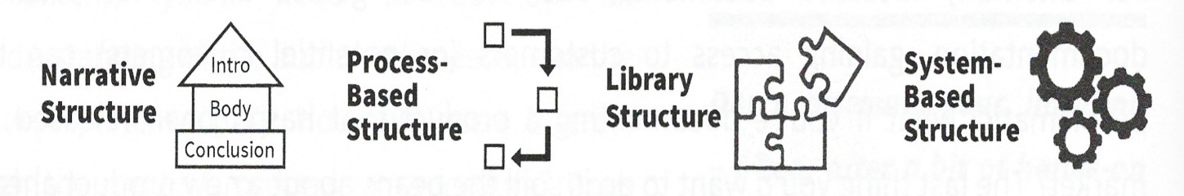
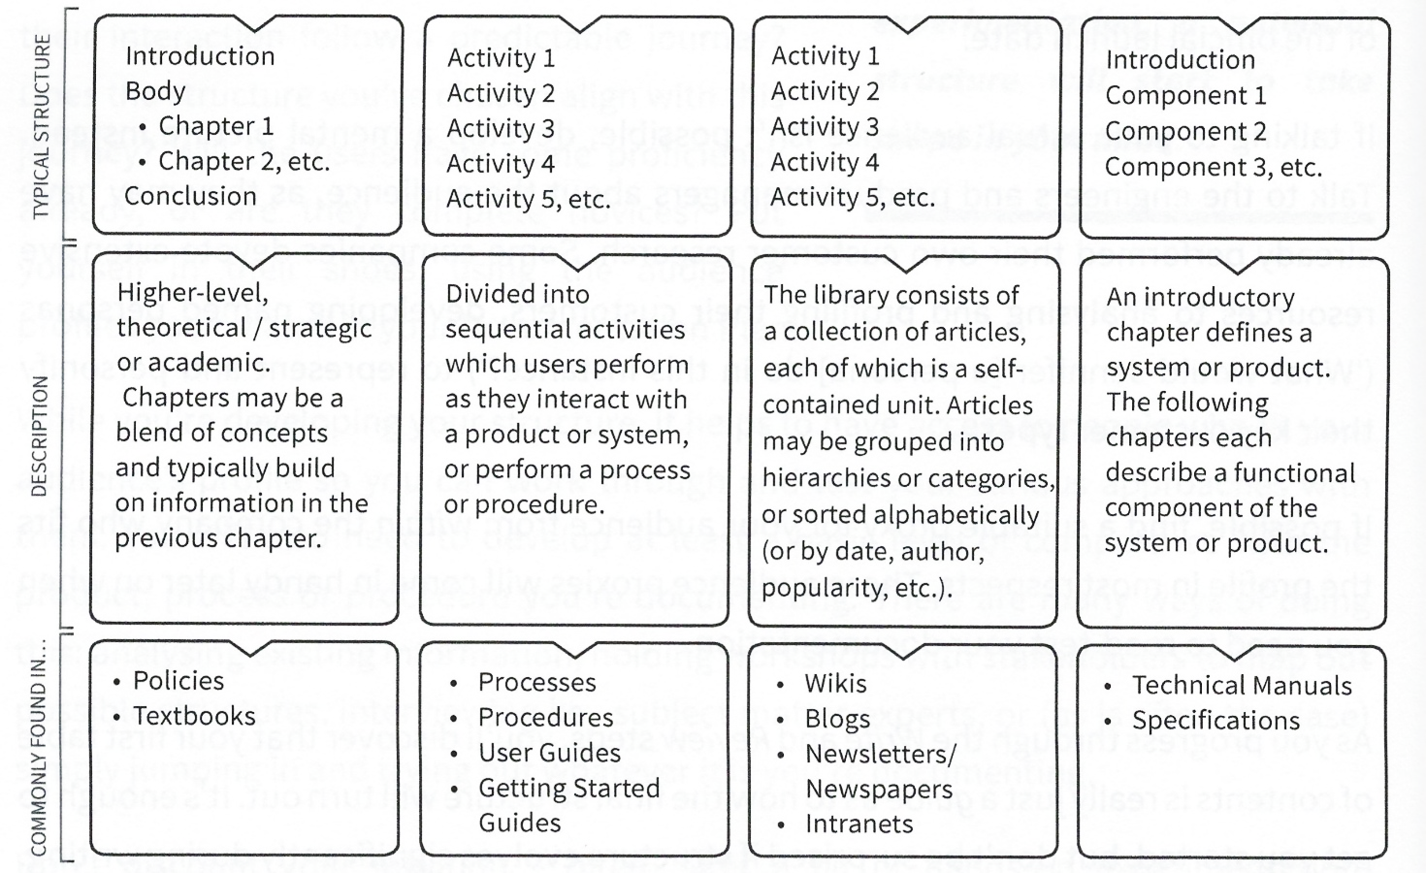
Narrative structure
The narrative structure begins with an introduction; is followed by the body, which covers all the main topics; and ends with a conclusion, which wraps everything up in a summary. Typically, topics build upon one another in a sequential way: to understand chapter two, you must first read chapter one, and so on.
This structure lends itself well to longer documents that are more conceptual, such as academic papers, reports, essays and textbooks. It’s a very common structure, but much less common in technical documentation-with the exception of introductions or overviews, which are very commonly found at the beginning of processes, procedures and chapters of user guides.
Process-based structure
In process-based structures, the document architecture is mapped to an underlying process, sequence of activities or use cases. As you’d expect, this type of structure is fundamental to process and procedure documentation. It’s also commonly found in user guides. In fact, process-based documentation is becoming extremely popular these days. This is due to a combination of factors: the wide uptake of process analysis in the information technology world (it’s integral to the software development life cycle); the increasing use of standards such as the quality management standard, ISO 9001, which mandates a process based approach; and the rise of systems thinking and engineering.
Simply put, when so many products and systems are designed using a process-based approach, it makes sense for the documentation to follow a similar pattern. Understanding process-based structures and the accompanying jargon is a must-have skill for technical writers these days.
Systems thinking / engineering
A way of thinking that looks at how systems work and interact with each other.
System
A set of interacting components which together make up an integrated whole. For example, a company is a system made up of components such as people, teams, processes, software, etc.
What is a process?
A process is a set of activities or tasks performed to accomplish an objective, i.e. to get something done! Processes typically have a trigger, which initiates the process, and a corresponding result, or output. The output from the previous process becomes the trigger, or input, for the next process.
Processes may contain sub-processes or lower-level activities. For example, the process ‘purchase goods and services’ might consist of a number of lower-level activities such as ‘get quote from vendor, "create purchase order,’ ‘approve purchase order,’ etc.
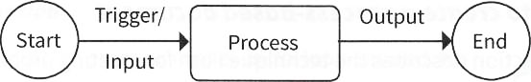
ISO 9001, the quality management standard
ISO 9001 is generally regarded as the international standard for quality management. It’s published by the International Organization for Standardization and is well-recognized around the world. It sets out certain requirements that companies must meet to ensure the quality of their work is up to scratch. These are very wide-ranging, but in terms of documentation, they include the following requirements: keep written policies, procedures and records; establish formal document control (records of who approved what, version control, etc.) and conform to a process-based approach when documenting procedures.
Standards are different to laws in that it’s not against the law to not follow a standard. However, your company may need to show they comply with a standard if they want to work with particular clients, typically government departments or large companies. To prove they comply with the standard, companies may be audited periodically by an accredited auditor. The auditor may identify any areas that need improvement, such as shortcomings in the document management system, and may or may not issue a certificate of compliance.
How to create a process-based document
This section describes the technique I use for creating process-based documentation. I use a four-step approach, as shown in the following diagram. The result is a robust process model that can be mapped to a table of contents in a document:
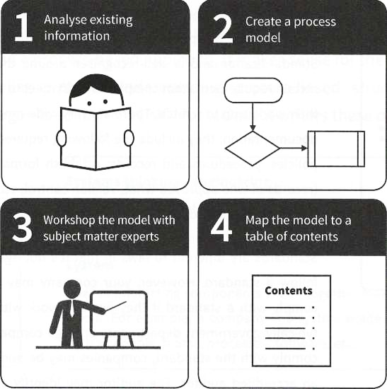
There are a multitude of different techniques for creating process models, such as Business Process Modelling and Notation (BPMN) and the numerous proprietary versions that work with particular tools. Depending on your documentation requirements, you may need to do a little research to find out which technique works best for you.
Analyze existing information
The first step in creating your process model is to look around for information which may contain pre-existing processes. These may guide you in your own process modelling or simply be repurposed into your model.
Engineers often start designing a product by defining the process a user takes to interact with it. This is common in software design, where the processes are called use cases and are contained in requirements documents, or specifications. These documents may also define the characteristics of the future software users, i.e. your audience.
As you can imagine, these documents are excellent starting points for your own process models (even if it takes a little head scratching before you can decipher them). Although they may not be directly translatable into documentation, they provide a wealth of insight into the thinking and assumptions behind the product design and the user base. At the very least, once you familiarize yourself with this information, the engineering team will appreciate that you’ve taken the time to understand the thought processes they went through in designing the product. Learning about your company’s products, techniques, and customer types increases your value to the company and earns respect from technical subject matter experts.
Create a process model
The next step is to create a process model which you can use as the basis of your document’s table of contents. Start your model at the top level: a number of boxes (ideally less than half a dozen) with terms inside them which capture the entire process from start to finish. This might seem a little abstract, but that’s okay for now. Depending on what you’re modelling (e.g. the workflow of several departments vs. a single team) you may need a number of high-level models.
Once you have the high-level process defined, create the next level of your process model. Each box in the high-level process should equate to another set of sub-processes, or activities, in the next level (as per the following diagram).
Avoid the temptation to create numerous additional process levels, as this will create a very complicated model. If I’m mapping, say, the workflow of a department or business function, I’ll generally stick to only two levels - high level and detailed. The next level of detail is where the written text comes in: instead of drawing boxes, you will write out these steps as text.
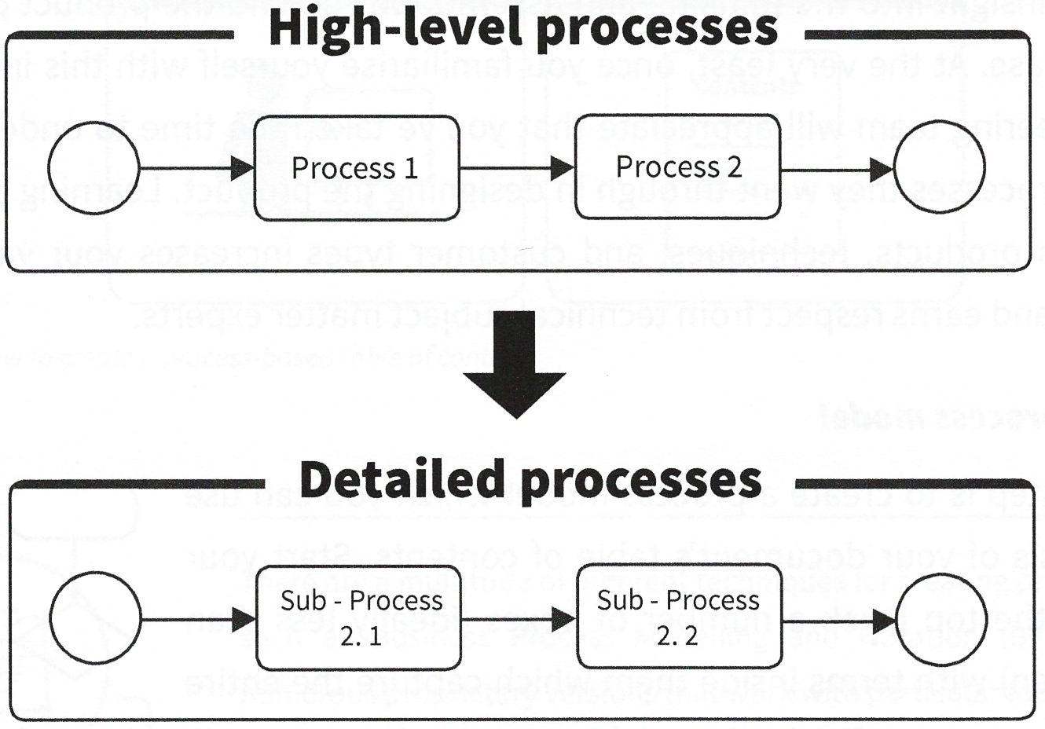
Here’s an example of how this works in practice, using the Technical Writing Process as an example:
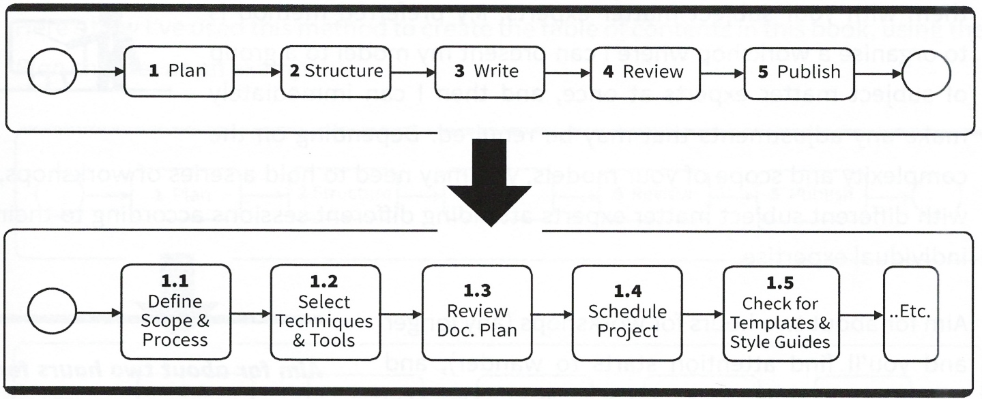
Use a verb-noun structure in your process boxes
It’s common practice when developing processes to use a verb-noun structure in the process box text. For example:
- Install [verb] software [noun]
- Add new user account
- Create report
- Update settings
And so on. If you look at the table of contents of this book, you’ll notice that I’ve used the verb-noun approach to define the headings (at least in the process-based chapters).
Grammatically, this is known as the imperative mood. For those who are military minded, you will know that an imperative is a command. This is the effect of the verb-noun structure: to create a command to the user which leaves very little room for ambiguity!
Workshop with subject matter experts
Once you have your models mapped out, it’s time to review them with your subject matter experts. My preferred method is to organize a workshop where I can present my model to a group of subject matter experts at once, and then I can immediately make any adjustments that may be required. Depending on the complexity and scope of your models, you may need to hold a series of workshops, with different subject matter experts attending different sessions according to their individual expertise.
Aim for about two hours for workshops (any longer and you’ll find attention starts to wander), and make sure you have a whiteboard or computer handy to capture any changes, notes or actions. If you need to schedule longer workshops (e.g. half- or all-day sessions to bring together geographically scattered subject matter experts), make sure you have plenty of breaks. Long workshops can be very draining, both for yourself and the workshop participants.
Map the model to the table of contents
Once you’ve finalized the process model, map it to a table of contents. This is quite a simple process, where the different levels of your process model map to the corresponding levels in your table of contents:
Process Level 1 → Heading 1
Process Level 2 → Heading 2, etc.
You’ll probably find that you need to add additional elements of structure into your document in order to make it complete, for example an introductory or ‘about’ chapter or overview.
Library structure
In the library structure, content is viewed as a set of independent articles or documents that can stand on their own. This allows a dip-in-dip-out style of reading, which is great for wikis, blogs and news, intranets, or anywhere else that your documentation will be accessible by a web browser or a search engine. Usually, articles have a loose structure which categorizes, or tags, them into buckets of similar articles using metadata – classifying information such as topic, author and date. Articles are frequently cross-referenced to one another using hyperlinks.
An online newspaper is an example of a library structure. Think about how your favorite paper organizes articles into categories such as world and local news, business, environment, and sports rather than a strict sequential order - that’s an example of the library structure in action. Usually, you’ll be able to sort and filter articles using other metadata such as the author’s name, date published, etc. This allows the reader to pick and choose articles they’re most interested in rather than following a predefined path set by the author from article 1 to article 2.
Company wikis and intranets are another common example of the library structure, with articles grouped by department, project, topic, author and so on. Many corporate intranets these days allow users to post ad hoc content as blog posts, further adding to the overall collection.
The library structure is a great approach for content hosted on a website or intranet, as it allows the audience to access information via keyword searches, browse metadata categories, and sort and filter articles as desired. It’s also an excellent approach if the intention is to accumulate the collection over time, with a host of different authors contributing content. As with all libraries, it’s important that articles are curated as the collection grows - screening for quality, adherence to templates, and correctness of metadata are essential to maintain a credible and authoritative collection.
Here are a few hints for working with a library structure:
- Naming: Pay careful attention to the titles and abstracts of articles. Titles and abstracts will appear in search results, so they need to accurately and concisely describe the nature and purpose of the article. Avoid the temptation to invent new terminology or use jargon - stick to established terms that are well-recognized within the industry or company.
- Tagging: Organize and tag articles into logical categories that make sense to the audience, not just yourself. This allows the audience to refine and filter their searches as well as browse categories for relevant articles.
- Breadcrumbs: Use a breadcrumb trail that positions the article within the library hierarchy. This allows the audience to navigate back to the parent article or category.
Metadata
Data about data. For example, when you take a photo with a digital camera, the camera will commonly capture metadata such as the date and time the photo was taken, the brand and model of camera used, the firmware version of the camera software, even perhaps the geographical location the picture was taken in.
Tagging
A way of adding metadata (e.g. keywords) to text. It’s often used for categorization (e.g. tagging a blog post in order to file it under a particular category).
Breadcrumb
A navigation tool used in websites, e.g. About Us > Executive Team > Ken’s Bio. Breadcrumbs (or breadcrumb trails) enable website users to navigate and locate themselves in the website’s hierarchy of pages.
System-based structure
Another common approach is system-based structure, found in technical manuals and specifications documents. In this structure, the first chapter introduces the system or product being documented, for example: ‘This manual defines how the XYZ automobile works.’ The following chapter may provide a functional diagram of all of the components of the automobile. Each subsequent chapter may then describe one of these components in detail (e.g. engine, battery, radiator, etc.).
The chapters are equal in importance, but their order isn’t necessarily significant. Together, they build up a complete picture of the system or product introduced in chapter one.
As you can probably guess, this type of structure tends to be more commonly found at the technical or mechanical end of the documentation spectrum, where what makes up the system is more important to the audience than how people interact with it.
Review table of contents with subject matter experts / stakeholders
Regardless of the combination of structural approaches you choose, your table of contents should be reviewed by your subject matter experts and stakeholders. Your table of contents may not require formal approval, but at least make sure there is agreement that your structure is sufficiently developed to proceed.
The process of review provides valuable feedback which you should use to fine-tune the table of contents. You’ll most likely need several rounds of informal review before you’re confident with your structure. If you have the opportunity (and it’s appropriate to do so), run the structure past your target audience or someone who shares similar characteristics with its profile.
A review of the table of contents at this stage ensures that there is in-principal agreement to the general shape of the document before the project goes ahead, which reduces the chance that you’ll have to rework your structure later on. By the time you get to the writing stage, you don’t want to have to fundamentally alter your approach.
Of course, this doesn’t mean that your table of contents can’t change over time. It should and will naturally evolve as you continue to write and refine the draft.

References:
- Technical Writing, Serena Henning, JP Publishing, LLC, 2020
- Technical Writing Process, Kieran Morgan, Better on Publications, 2015
- Spring into Technical Writing for Engineers and Scientists, Barry J. Rosenberg, Pearson Education, Inc, 2005
- Technical Writing A-Z, Trever M. Young, Asme Press, 2009

