Lesson 7:

APPLYING FOR JOBS


https://www.elevationrecruitmentgroup.com/careers-advice/5-ways-to-make-yourself-noticed-when-applying-for-jobs

Lecturer: M. Kurbonov

Applying for Jobs
Job applications are stressful. The process of filling in application forms, rewriting your resume, and coming up with a solid cover letter is difficult enough by itself; on top of that, a concomitant rejection can be a tough blow to take. Of course, the more optimistic perspective is that job applications constitute an important step towards finding the right career path for you. Getting there, however, can be difficult at the best of times. The struggle to pin down an ideal job, for example, is often framed as a failure on the applicant's part. Many job searchers may experience depression (New York Times, 2019) when they do not find a job shortly after starting their search, accompanied by a sense of shame and defeat.
It's important to remember, then, that struggling to find work is hardly due to personal failure, but to an increasingly competitive job market. The growing use of application tracking systems has complicated job searching for applicants (Forbes, 2015), as many potentially well-suited candidates can be eliminated through keyword-tracking software.
Additionally, levels of higher education among populations continues to increase every year in the United States and in many countries around the world. The U.S. Census Bureau recently recorded the highest ever number of education levels among Americans: more than one third (33.4%) of the adult population in the U.S. held a bachelor's degree or higher in 2016 (U.S Census Bureau, 2017).
These factors, therefore, have created an unprecedented competitive climate in job markets. The average number of applications for any given job in the U.S. is 118 (Forbes, 2013), and for corporate employment, goes up to 250 (Glassdoor, 2015) per single job.
Although these figures may seem like a pretty dreary picture for jobseekers, remember, they also serve as a reassurance: increasing competitiveness for jobs does not mean that you are less valuable as a candidate. Rather, it has created a climate where learning to highlight your skills effectively is all the more important.
Ultimately, you should always remind yourself of the golden rule of job hunting: rejection is not a reflection of your abilities, but due to the lack of compatibility between applicant and hirer. Finding the right job isn't just about being able to do the tasks, it's about being comfortable in your workspace, believing in the values of your organization, and sharing the sensibility of your co-workers. If you don't get hired that one time, it's not because you couldn't do the job, it's because you and that particular job were probably incompatible in the first place.
Before you start applying
Before you start your job hunt, it is useful to identify and list your skills. This is a good base for your cover letter, which will have to go beyond listing your achievements. A cover letter (more on this later) should articulate your accomplishments in relation to the job that you are applying for, highlighting commonalities in the nature of the work or its objectives.
First, list the skills required by the job in one column. Then, try and relate a past achievement or experience to this. Your table could look something like this:

Skills required for the job...  - Communication  - Written communication  - Verbal communication & listening  - Leadership  - Delegating tasks  - Managing workload  - Listening to others  - Teamwork  - Supporting others  - Setting up shared goals  - Organizing  - Prioritizing  - Dealing with pressure  - Time management  - IT skills  - Using the Internet, email, calendar applications  - Familiarity with software packages | Your experiences demonstrating these skills...  - Writing essays, writing for a student newspaper, writing reports  - Making presentations, oral reports, teaching  - Endeavors you have started, membership to student club, or committees, etc.  - Balancing two part-time jobs, or job and studying.  - Mentoring program, tutoring.  - Volunteering projects  - Being a member of any team (club, society, etc.)  - Delivering a project on tight deadline  - Organizing an event  - University coursework or schoolwork or experience at other job  - Experience using social media for a project  - Demonstrated use of Microsoft, Outlook etc.

CVs and Resumes
What are CVs and Resumes?
Curriculum vitae, Latin for the "course of one's life", commonly referred to as "CVs" by the Brits... you've probably guessed, we're talking about resumes. Whatever you might call them, resumes or CVs are anxiety-inducing. Simply put, CVs are a written summary of your skills, education, and work experience. They are essential to pretty much any job search and are often the difference in whether you are considered for a role.
Stressing over how to best convey your career profile in such a dry and drab document is a challenge, but the following chapter will help you get started on writing a solid version of your resume!
Layout and design
The most difficult part about writing a CV is often just taking the first step. Where do you start? And on top of that, the crippling fear of having nothing to write down on that page doesn't make things any easier. The best approach to getting over the initial fear is to try and come up with a basic skeleton of your education and work experience, which you can build on later for each new job application.
The basic sections in a CV are:
- Education
- Work experience
- Additional experience
- Languages and other skills
- Interests/Awards
Non-academic CVs usually run over one or two pages (academic CVs are usually longer and provide details about publications, conferences etc.). Whether you choose to format your CV on one or two pages should depend on the details in the job description. A shorter one-page CV should simply be a more condensed version of the longer one - this may force you to keep only the most relevant information on your resume!
How to organize each section
Each section (education, work experience etc.) can be broken down either in a chronological or a skills-based manner. A chronological structure, perhaps the most common, means your most recent experience will be featured at the top of each section, and the least recent one at the bottom. A skills-based structure is used only when the applicant has years of experience working in the same sector as the job applied for.
What not to include
- Pictures. Not of your dog, not of your graduation ceremony, and not even an ID pic! According to Graduateland.com, 80% of US employers will not consider your resume if it includes a profile photo. Although it depends on the country where you are applying, it's a rule of thumb that you should usually not include a picture of yourself, as hiring decisions are not meant to be made under the influence of gender, ethnicity, or appearance (though these can sometimes be inferred from your other information, such as your name).
- Your nationality. There is no need to specify your nationality on your resume unless it is explicitly requested by the job description.
- Different colors. Just stick to black and white paper. Although it might seem boring, it does look more professional and it is always a safe choice.
- Eccentric fonts. You want to stand out, but you don't want to stand out for the wrong reasons! The point is to draw the hiring manager's attention with your achievements and suitability for the position, not your brilliant display of varied font use. Stick to Arial or Times New Roman in a font between 10 and 12.
The "I have no experience" anxiety
Many things can count as experience on a resume. Just because you haven't had done an internship at J.P. Morgan doesn't mean you haven't done anything valuable. If you're worrying about a lack of experience to include on your resume, keep in mind the following:
- A big part of starting a new job is learning! Employers don't expect you to know everything already.
- You can demonstrate your skills and competences through other kinds of experiences than full-time positions or internships. Unpaid voluntary work can also testify to your skills and personality, as well as any kind of entrepreneurial, organizational endeavors!
- If you're applying for your first job, remember everyone has to start somewhere. It's O.K. to be starting out-- just keep that in mind when you are searching for jobs. Try and aim for entry-level positions which don't require previous experience.
Tailoring to the job
Once you have a standard resume listing all of your achievements, you will have to sort through the most relevant elements, and perhaps get rid of the less relevant ones, based on each position you are applying for. You shouldn't send out the exact same resume for each job application but try your best to personalize it each time. Although this might seem like a big waste of time, it does significantly increase your chances of catching the hiring manager's attention. It's certainly a better strategy to send out 5 personalized CV for 5 different positions than one standard CV to 10 different positions.
How to ensure relevance:
- Choose your words carefully. Read the job description closely-- the job ad asks the question "can you do this job?", and your resume and cover letter should be the answer to that question. So, it makes sense to pick up on key words in the job description and include them in your resume.
- Make a checklist of all the criteria for the job. Make sure you have illustrated each requested competency with something on your CV. This will show you are already paying attention to the requirements of the job, and that you are well-suited to the role.
- Check out the organization's website. Try and figure out who they are and what they're looking for: this can help you find the right words to resonate with the organization's message. This is a way to try to speak their language.
- Present information in a positive light, but don't exaggerate! Use active verbs like "organized" or "achieved" and steer away from derogatory or vague vocabulary. Don't overemphasize your past roles, however, otherwise this will probably show during an interview.
- Use spell check and always formulate short, straightforward sentences. A resume especially has no space for rambling! Aside from showing your brilliant synthesis skills, simple sentences just make it easier for the hiring manager to read your resume. Resumes can be quite cramped, so short sentences just save everybody involved from a migraine.
The heading
The heading of your resume should contain your name and contact information, usually presented in the following manner:
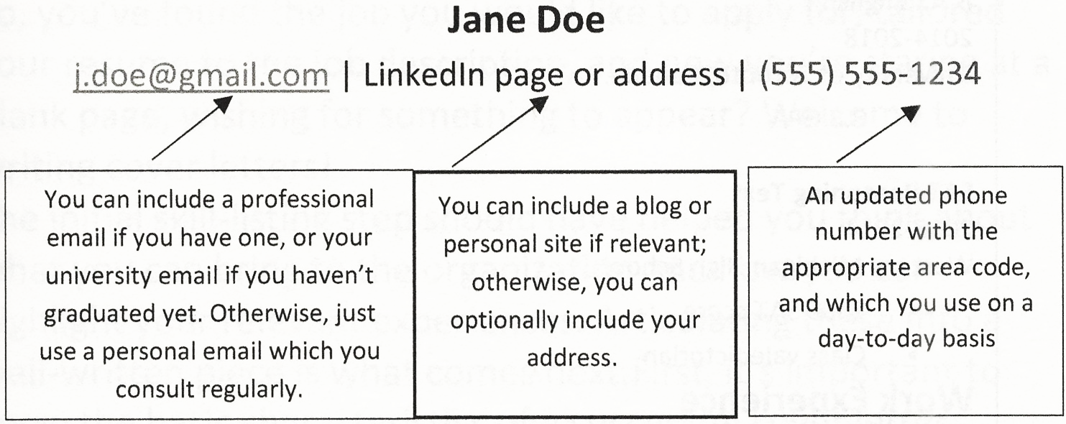
Example
The following page displays a standard CV example. You will most likely want to adapt this to your own preferences, but the layout and format of this template is a certainly a good place to start!
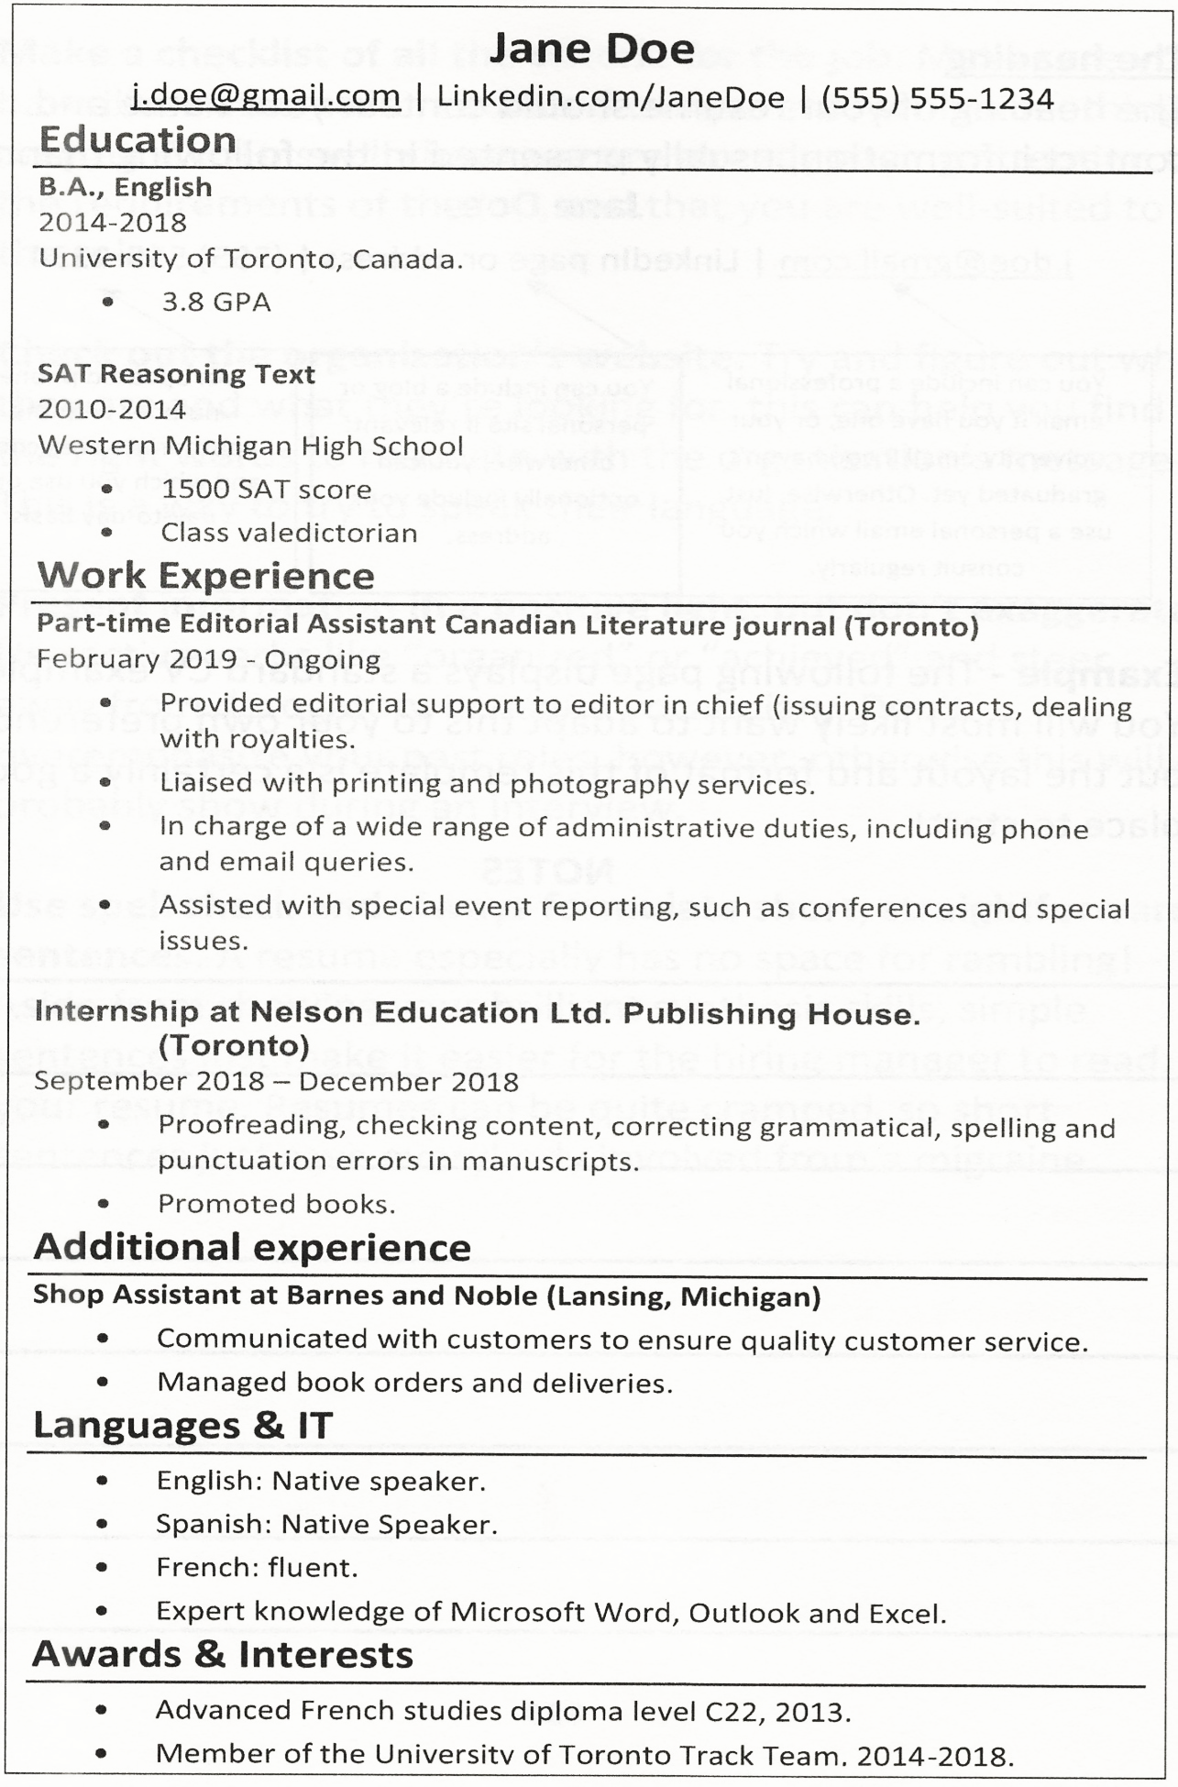
Cover letters
How to write a cover letter
So, you've found the job you would like to apply for, tailored your resume to the job description, and now you're staring at a blank page, wishing for something to appear? Welcome to writing cover letters!
The initial skill-listing step should have helped you think about what you can bring to the organization and how you can highlight your relevant experiences. Articulating these into a well-written piece is what comes next. First, it's important to know the basic characteristics of a successful cover letter:
- Brevity. Unless explicitly specified, a cover letter should not be longer than one A4 page, or about 400 words. Short sentences, which do not exceed 14 words (LSE Careers, 2020) are preferable, and the style should be sharp and logical.
- Formal greetings. As a form of business correspondence, cover letters should always use a formal tone. This means cover letters usually begin with "Dear [Title and Last Name]". It is always best to know who will read your letter so that you can name them, and to end with "Your sincerely". If you do not know who to address the letter to, you may use "Dear Sir/Madam" or "Dear Hiring Manager", and end with "Yours faithfully".
- Positive and enthusiastic language. Use the active voice rather than the passive (i.e., "I created" as opposed to "was created") and include action words, such as "accomplish" and "undertake".
Cover letters should also include:
- Your name and contact information (phone number, email, and address) in the right-hand corner. It's also customary to include the organization's address on the left.
- A logical structure. How exactly you structure your letter is up to you, as there is no set formula for cover letters. Essentially, what matters is that it makes sense. One way to structure your letter is to divide it into two "why this job" and "why you" paragraphs (The University of Oxford Careers Service, 2020).
- Correct spelling and grammar. As usual, always use spell check when writing your cover letter, and make sure that you proofread it several times. Grammatical and spelling mistakes create a negative impression - to be extra safe, get someone else to double check your letter if you can.
- Relevant facts about the organization. Show that you actually want to work there by including facts that you have researched. This shows that you are committed, and familiar with the organization's profile and values.
Demonstrating relevance
Remember, getting a job is all about compatibility; the main concern is to ensure that your cover letter portrays you as well- suited to the role. The obvious thing not to do is to write a generic, nondescript cover letter and send it to multiple organizations. Every cover letter you send should be a unique response to a specific job advertisement.
Furthermore, your cover letter shouldn't simply repeat the information on your resume: its purpose is to clearly state why you are drawn to the position, and what value you can bring to the role.
A straightforward way of applying this advice is to use the STAR method. This approach ensures that your cover letter develops your experience in a relevant manner and is not superficially listed. STAR stands for Situation, Task, Action, Result: it provides a framework through which to detail your past experience (University of Oxford, 2020).
The spirit of the STAR approach is the idea of detailing experience, rather than shoving a multitude of loosely related achievements into your cover letter.
- Situation: Describe the situation you were in
- Task: clearly outline the task you had to accomplish
- Action: Elaborate on the actions you took
- Results: What results came out of this experience?
Example:
Superficial achievement description:
As the editor of The Red Panda Times, I undertook several projects to broaden our readership and develop the newspaper's online presence.
Improved STAR method:
As the editor for my college newspaper, The Red Panda Times, I was in charge of sourcing innovative content and ensuring the representation of the university's varied student body in The Red Panda's publications. I considerably developed the newspaper's online presence and organized a monthly outreach event to recruit contributors and increase circulation. This resulted in a 25% increase in readership of The Red Panda Times, and in the addition of fifteen new regular contributors to our team.
Structuring a cover letter (Yale University, 2020).
- Paragraph 1/ Why this job? Getting the reader's attention:
- State who you are and why you are writing.
- Draw in the reader by providing a reason why you are interested in the role.
- Include information about the organization that you have gathered through research. This is a way to prove you know the organization and serves as evidence of your genuine interest in it.
The point of the first paragraph is to get your audience to keep reading. Catch their attention by using compelling reasons and language and try to think about what might resonate with them.
- Paragraph 2/ Why you?
- Evidence how you are suited to this position by drawing links between the required skills and your past experience.
- Without repeating your resume, focus on one or two achievements related to the tasks of the role.
- Detail one or two examples, using the STAR method, which demonstrate how your profile fits with the organization's culture and objectives.
This paragraph should constitute the argumentative chunk of your letter. Here, you should focus on providing evidence and supporting your case with one or two detailed examples, rather than a long list of unrelated accomplishments.
- Paragraph 3/ Conclusion
- Reemphasize your interest in the position.
- Briefly wrap up your letter with a summary of why you are a good fit for this job.
- End the letter by thanking the reader for their time and consideration.
The last paragraph should effectively summarize what you can bring to the company or organization, and end on a positive note.
Example: The following is a sample cover letter
Darlene Simson
333 High Street
Kansas City, MO 34175 (111) 304-2222
d.simson@gmail.com

June 26, 2019

Hiring Manager
39 West Press
123 Summer Lane
Kansas City, MO 35467
Dear Ms. Blake,

I am writing to express my strong interest in the new editor position at 39 West Press. My combination of experience in freelance journalism and editing has made me an excellent fit for this role.
I am particularly drawn to this position because of 39 West Press' unique and inspiring publishing profile. I have always been a passionate writer, in fiction as well as nonfiction. Producing quality critical discourse on socio-political matters was the main focus of my college newspaper. This objective is evidently upheld by 39 West Press' publications, alongside a constant preoccupation with artistic and literary value. Your recent publication of the book of poems, It's a Woman's World (2019) demonstrates your commitment to promoting a diverse range of experiences and voices. This publishing culture echoes my own priorities as a writer and editor.
Having worked as an editor, an editorial assistant, and a freelance journalist, I am highly familiar with the full range of typical editorial duties. Producing quality writing on a tight deadline was the cornerstone of my freelancing job. As an editorial assistant for The Kansas City Star, I perfected my research and fact-checking sills. Finally, as the editor in chief for my college newspaper, I focused on shifting the editorial line to a more progressive and critical style. By organizing monthly outreach events and distributing the newspaper throughout various societies and clubs at the university, I succeeded in considerably diversifying our contributors' profiles and our overall content. My initiative resulted in the inclusion of a poem and art section, and a 15% increase in readership.
In light of my editing and writing experience, I believe I am an excellent fit for the editor role at 39 West Press. I am committed to broaden the world of publishing to include a wider variety of voices and would be honored to be a part of your editorial team. Thank you for your time and consideration, and please feel free to contact me for any further information.

Yours sincerely,

Darlene Simson

Useful language (London School of Economics, 2020)
Leadership
• coordinated • implemented • established • managed • led • directed • supervised • delegated • coached • allocated
Research
• analyzed • investigated • determined • experimented • surveyed • solved • synthesized
Communication
• trained • negotiated • influenced • consulted • presented • persuaded • interacted • advised • addressed
Organization
• streamlined • scheduled • encouraged • expanded • resolved • budgeted • (re)organized • prepared • administered
Interpersonal:
• collaborated • facilitated • mediated • consulted • liaised
Taking initiative:
• initiated • created • designed • established • launched • set up • conceived • implemented
Achievements:
• promoted • launched • developed • redefined • simplified • persevered • enhanced • accelerated • improved • completed • produced • secured • increased • doubled

Here some more examples:

Title: Donations Officer
Role: To plan, develop and implement donations campaigns to Charity X, and expand the existing portfolio of potential donors.

Duties:
- Solicit donors, including public figures, able to make contributions and appearances to support Charity X' cause.
- Develop strategies to meet annual revenue goals.
- Maintain positive relations with contributors.
- Reach out to volunteers and liaise with the volunteering department.

- To whom it may concern,
I am writing because I want to apply to the Donations Officer position at Charity X. I created a donation campaign for the charity group ABC at university, so the Donations Officer role should suit me well. I also want to continue working in fundraising, to keep improving my skills.
Here is what I have accomplished as student leader of the MSF donation campaign:
- Exceeded donation goals
- Expanded the donor and contributor base
- Recruited dozens of new volunteers
- Organized ABC days at the university to raise awareness
- Dear Hiring Manager,
It is my pleasure to apply to the Donations Officer position at Charity X. My considerable experience in the charity sector, combined with my dedication to your cause, position me as very well-suited to this role.
As the donation's leader for the charity group ABC, I have significantly developed my communication and leadership skills, as well as my ability to build lasting positive relationships with donors. By organizing monthly outreach events across my campus and the surrounding town, I succeeded in dramatically broadening ABC's donor portfolio. This resulted in a 3% excess in donation goals and the addition of twenty new volunteers to the donations program.

E-Mail
Many e-mail messages—even those sent by one brilliant engineer to another brilliant engineer—are unintelligible. This chapter focuses on writing effective e-mail messages.
Pickford Paradox of E-Mail
Mary Pickford—talented, intelligent, and charming—was a Hollywood superstar during the silent film era. After the advent of “talkies,” Pickford noted that talkies were artistically inferior to silent movies. Therefore, in her opinion, silent films should have come after motion pictures with sound. Critics referred to her idea as the Pickford Paradox.
As a scientist or engineer, you might be thinking that the Pickford Paradox is ridiculous. After all, when would a lower-bandwidth medium (silent films) be superior to a higher-bandwidth medium (talkies)?
The strange answer is that we are living through a Pickford Paradox of our own right now. The bandwidth of a telephone call far outstrips that of an e-mail, and yet, corporate employees now communicate more through e-mail than through the telephone. Imagine if e-mail had been invented in the nineteenth-century and the telephone in the 1970s. If that had happened, we would probably still be amazed by the power of the telephone.
Even more fascinating, the effective bandwidth of many e-mail messages is exactly zero. That's because many e-mail messages are so poorly written that no information actually gets communicated.
Tom researched some software tools and then used Microsoft Word to compose the following short, formal document:
Recommendations for Performance-Analysis Tools
Sam asked me to investigate various performance-analysis tools and recommend the one I thought was best suited for our department's needs. This short document explains my methodology and recommendations.
Methodology
I downloaded evaluation copies of the following three performance-analysis tools:
- Kaneval Eval v8.2 (made by Dexco Unlimited)
- Perf Burner v3.1 (made by Dexco Unlimited)
- PerfRomance v5.0 (made by Carambola Software)
I used all three tools to evaluate our latest software release, going through the documentation and trying out various features.
Recommendations
I strongly recommend PerfRomance v5.0 over the two Dexco Unlimited products for the following reasons:
- PerfRomance is the easiest product to learn.
- PerfRomance generates the clearest reports. (I've attached some comparable reports.)
- PerfRomance has the lowest cost.
In a parallel universe, Sam researched the same software tools. However, instead of writing up his recommendation as a formal document, he composed the following e-mail:
To: EngTeam
Subject: Recommendations
PerfRomance was very clean compared to the other two.
– Sam

Sam’s e-mail message is, admittedly, concise, but the message is fuzzy. Furthermore, Sam’s message doesn’t contain any supporting detail. Engineers are critical thinkers who require substantiation of any claims.
Something strange happens to people when they compose e-mail. Even if an engineer brings great discipline to the art of writing formal documents, that same discipline usually vanishes in the writing of e-mail. When composing e-mail, people get very sloppy. Many busy people write e-mail as a stream-of-consciousness exercise, just blasting out messages. Some of my own e-mail messages have as much coherence (and I’m a professional writer) as the chaotic brain pattern I experience just before falling asleep.
People have much lower expectations from e-mail than from formal documents. Consequently, many people write e-mail to those low expectations, forfeiting all the knowledge they have about good writing. The first rule of writing work-related e-mail is, therefore, as follows:
Use the same discipline in writing e-mail as you do when writing formal documents.
The preceding rule will sound trite until you give it a try. The same discipline includes running e-mail through a spell-checker, capitalizing normally, and even putting the pronoun I in uppercase.
Note that I’m only talking about work-related information. I’m not saying that messages like the following deserve any discipline at all:
To: EngTeam
Subject: Lunch
Lunch at Mary Chung's at noon today?
-- Sam

Before Hitting the Send Button...
If I were king of the world and the world had fallen into serious economic collapse, I would institute the following rule, which 1 believe would increase gross world product immensely:
You may not send any e-mail until you have first reread it.
When rereading your e-mail, always ask yourself the following question:
Will the recipient(s) understand this message?
For example, suppose Sam (based in London) sends out the following message to Nicole (based in San Francisco), who has just joined the project:
To: Nicole
Subject: status reports
status report needed by end of day tomorrow

At first glance, the preceding e-mail message seems innocuous enough. However, poor Nicole will probably not understand this message for the following reasons:
- Like many e-mail messages, this message is written in passive voice. In fact, the sole sentence is missing a pronoun altogether. Consequently, Nicole cannot be quite sure whether she needs to produce the status report or Sam needs her input on his own status report.
- Since she just joined the project, Nicole probably has no idea what kind of status report is required. Sam should send Nicole a status report template or an example status report.
- The phrase end of day is ambiguous. Sam’s end of day (in London) comes quite a few hours prior to Nicole’s.
- Engineers and scientists have an extremely low tolerance for empty bureaucratic exercises. Since Sam does not explain the purpose of the status reports, Nicole might not put the appropriate amount of effort into producing them.
- This message is missing uppercase letters and punctuation. I’m not a literary scholar, but I’m reasonable certain that most of the best writers’ start sentences with an uppercase letter and end them with a period.
As is often the case with e-mail, Sam’s original message omitted critical details and lacked any sort of empathy with the recipient. A brief moment of reflection on Sam’s part would have solved the problem. Sam would do better to send the following e-mail instead:
To: Nicole
Subject: Please send me a status report
Please write a status report and send it to me by 10:00 am (your time) Thursday, Nov. 30. Your status report should contain the following two sections:
- "What I Accomplished This Month"
- "What I Plan to Accomplish Next Month"
For each section, provide a bulleted list containing three or four items. I like brevity, so try to keep each item down to a sentence or two. I've attached a sample status report.
Everyone in my group writes a status report on the last working day of every month. I use these status reports to produce a monthly status report for my own manager. In addition, I store all your monthly status reports and use items from them in your annual salary review.
If you have any questions, don't hesitate to send me an e-mail or call me.
--Sam
After the First Miscommunication...
When composing e-mail, people are often blunt. They type things in e-mail that they would never say in person. People are much wiser (or more cowardly) in face-to-face or telephone meetings than they are while composing e-mail. Therefore, before hitting the Send button, ask yourself the following question:
Would you feel comfortable saying the text in this e-mail message in a face-to-face meeting with the recipients?
The preceding question is a reasonable starting point for e-mail sensitivity; however, you really have to take it a step further. After all, in face-to-face meetings, listeners attune to a whole range of social cues, including body language, facial expressions, and vocal inflections. In a face-to-face meeting, attendees know whether you are being sarcastic, but e-mail recipients might easily miss the sarcasm.
Emoticons
Emoticons are graphics that come in either of the following two forms:
- new-fangled graphic icons, such as the following which are quite popular in instant messaging: 😊
- old-fashioned collections of punctuation marks, such as :)
The oft-stated purpose of emoticons is to provide emotional context for instant messaging and e-mail messages, since words alone allegedly cannot do the trick. For example, notice how the following emoticons defuse a potentially sticky situation:
You're an idiot. :) You have no idea what you're talking about. :)
Your experimental design is juvenile. :)
My initial response to emoticons was that writers have somehow managed to convey emotional context through words alone for several millennia. (Astonishingly, the works of Tolstoy, Shakespeare, and Cervantes do not contain a single smiley face.) I now realize that emoticons can be a valuable means of expression in e-mail and instant messaging if all recipients share a common understanding of their meaning. Note that many older readers are not well versed in emoticons and may find them annoying and confusing.
Do not place emoticons in any formal or legal written communication,
Miscommunication in e-mail often generates rage. For example, consider the following e-mail message, which does not successfully convey the intended idea:
To: EngTeam
From: Quincy (QA Manager)
Subject: Performance Testing on Project Sea Grape
I ran performance tests on Project Sea Grape over the last week. I found performance at the expected levels, except for the Batch Processing Module.
The preceding message angered Tim, who wrote the Batch Processing Module. He was not only angry, but he was embarrassed because Quincy had sent out the e-mail message to the entire engineering team. Tim responded in the following way:
To: Quincy
CC: EngTeams
From: Tim
Subject: RE: Performance Testing on Project Sea Grape
There is nothing wrong with the performance of the Batch Processing Module. In fact, it outperforms earlier releases by a factor of three. How did you test it? Do you have any previous experience writing tests on Batch Processing Modules?
In typical work environments, Quincy and Tim would get into a rapidly escalating e-mail war, with each side accusing the other of greater and greater ignorance. However, Quincy is not a typical engineer. Instead, he obeyed the following principle:
After the first miscommunication, stop sending e-mail. Use other media instead.
Quincy called Tim on the telephone to apologize. Quincy had meant that the Batch Processing Module performed far better than expected. Tim was relieved. Quincy then sent out a clarification to the entire EngTeam mailing list.
Scientists and engineers are more sensitive than stereotypes suggest.
Summary of E-Mail
When reviewing an e-mail message, just prior to clicking the Send button, ask yourself the following questions:
- Will the recipient(s) understand what you are trying to communicate?
- Does your e-mail message contain a relevant subject line? A good subject line not only makes sense initially but will continue to make sense in a few months. Note that many people now use their e-mail system as a sort of database management system for their work life.
- Have you edited the e-mail message?
- Are you sending this message to the appropriate recipients? Are you sending it to anyone who will be annoyed by receiving irrelevant e-mail? Are you excluding recipients who will feel left out if they learn that you didn’t send them a message?
- Is the e-mail the right length? Recipients are often annoyed (and will ignore) lengthy e-mail. Conversely, make sure the e-mail is long enough to cover what it needs to.
- Could a recipient misunderstand your e-mail and get angry?
- What is your emotional state? If you are responding angrily to something, consider handling the situation in person or via the telephone instead of through e-mail.
- If you are sending e-mail to people in another culture, examine the message for the following:
- Does your e-mail message contain slang that recipients in other cultures will not understand? In this case, jargon is okay, but slang is not.
- Could this e-mail message offend someone, even inadvertently, in another culture?
- If English is a second or third language to the recipients, does your e-mail contain long, complex sentences? Your message should contain short, simple sentences.
Are you requiring that a recipient respond through e-mail? A recipient who is relatively unfamiliar with English might feel embarrassed to respond in written English to a large mailing list. Consider allowing the recipient to send an e-mail message directly to you, and then tactfully indicate that you will edit any grammatical or spelling problems before transmitting the edited message to the mailing list.

References:
- Technical Writing, Serena Henning, JP Publishing, LLC, 2020
- Technical Writing Process, Kieran Morgan, Better on Publications, 2015
- Spring into Technical Writing for Engineers and Scientists, Barry J. Rosenberg, Pearson Education, Inc, 2005
- Technical Writing A-Z, Trever M. Young, Asme Press, 2009

