Lesson 11:

HOW TO WEB WRITE


https://www.searchenginejournal.com/writing-for-web-capitalization-rules/355790/

Lecturer: M. Kurbonov

How to Web Write
What is web writing?
A website content writer is somewhat newer to the field of technical writing but is fast becoming an increasingly sought after and lucrative profession. In short, web content writers specialize in producing writing for websites. This could be writing articles for a vegan lifestyle site, producing informative content for a hedge fund firm, or creating overviews on national population statistics. In summary, web content writers are all over the place.
Despite this, there are clearly defined forms of web content to consider, as well as distinctly different writing styles. Different forms of web content include (Gotter, 2017):
- Blogs
- Longform content
- Case studies
- White papers
- eBooks
- Infographics
- Template and checklist downloads
The varied character of web writing also means that it must be highly attuned to target audiences, especially for businesses looking to attract consumers. Web writers, therefore, have to adapt their style and content to cater to specific online audiences. One important way to do this is through the use of SEOs.
The SEO mystery
What is SEO?
Many people have heard the term SEO thrown around, but don't fully understand what it means. In fact, without elaboration, it can seem like nonsense computer-speak. But, not to fear! Search Engine Optimization is a lot easier to grasp than it sounds.
In a nutshell, SEO is the practice of increasing the quantity and quality of traffic to a website through "organic search engine results" (Moz, 2020). Put simply, it is the practice of attracting more people, who are genuinely interested in your website, without using paid advertisements-- that's the organic part. Drawing an audience organically, therefore, means that you are getting unpaid traffic through search engine results pages (SERPs) (Moz, 2020). This is clearly desirable for any organization hoping to up visitors to their site.
But how does it work? Results pages on search engines such as Google don't just magically appear. They are organized by a variety of factors; SEO is the process of optimizing this organization to your website's advantage. Explaining the algorithms at play here could fill an entire book and are held secret by many big tech companies. In brief, search engines will scan (or "crawl") different websites to deliver the most relevant results -- largely determined by particular phrases and keywords (Sherman, 2019).
How to practice SEO
Now we know how it works, how do we actually practice SEO (Sherman, 2019)?
- Improve your content
The most important factor to the success of your site is focussing on your content. This is the backbone of your website - no amount of graphic fluff can distract from a poorly written piece.
- Create high quality content.
The more quality content, the better. An abundance of relevant pieces will propel you up the search engine ranks, and good quality work will keep your audience engaged and sticking around for longer. Make sure to diversify your content and ensure that it is well-written and topical, in order to avoid it going stale.
- Include key words and phrases.
Another SEO technique is to use key words and phrases generously across your site. These are the words or phrases that you would expect a user to deploy in their initial search. Create content around these key words and phrases and make sure to use them throughout your work - but use them wisely! Including 10 or so keywords can suffocate and unfocus your piece. Instead, it is better to build your content around one or two keywords to ensure that your piece is focused and relevant.
- Keep it new.
To optimize your results, you need to keep things rolling. Relying on old and outdated content is a sure way to keep your numbers low. However, you don't always need to keep purging out entirely new content. Updating posts with re-writes and new information or statistics will also increase your search engine ranking.
- Make technical adjustments
Once you've got good quality content down, you need to think about how to organise it. SEO moves beyond the purely written stuff - it's also the presentation.
- Tag your title.
This is the HTML element which is the clickable headline for your page (Moz, 2020). Include keywords relating to the topic of your content as well as your organization’s name. For example, the title of a guide on how to grow tomatoes may be "Kuma Kitchens: Top 10 Tips to Growing Fresh and Juicy Tomatoes".
- Include subheadings!
Sub-headings break up your work into easily digestible chunks and encourage a visitor to read on. These can be tagged using H2 and H3 tags. Whilst H2 tags act as your main subheadings, H3 tags act as subheadings for your H2s. Like your title, remember to include keywords and relevant information.
- Write a meta description.
This is another HTML element which appears under your title tag in search engines. It is highly influential to whether a potential visitor clicks on your site (Moz, 2020), and is what appears when someone shares your page. This should include a brief description of your content and key words. Think about it as a teaser to your site. For example, an online food magazine may want to include a description such as "Cook with style. 100% plant-based and seasonal recipes available on our online catalogue".
- Include internal links.
Adding hyperlinks within your content to other relevant pages on your site can also optimize your engine search results. For example, if your website is explaining how to make a caramelized onion and goats cheese tart, you may want to provide a link to your "Top 10 tips for caramelizing onions" page.
There are a number of other strategies which you can deploy for SEO, but these move beyond the scope of creating content. For example, the layout of your website and its visual appeal will highly impact whether a user stays on.
Blog writing
What is blog writing?
A blog is a website that focuses on written content. This can range from lifestyle to news blogs - key is their personal take. Blogs, then, usually write through a first-person perspective, emphasize personal experiences and include a comments section where they can interact with their readers. This is especially important to its success; having a steady and loyal readership base ensures a consistent flow of user traffic (Chow, 2020).
Now, you may be thinking - how is this related to technical writing? Blogs are quite unusual in the technical writing category due to their uncharacteristic personal style. However, blog writing is an important and widespread style of web writing. As Biggs and White (2011) put it, "blogging at its most basic level is the keeping of an online journal" (p.39). The term comes from the combination of web and log, or a log of a piece of information online (Biggs & White, 2011).
Anyone can have a blog, but being a blogger takes a lot of dedication and hard work. Keeping a blog alive, with active readers, and innovative content, is considerably difficult. The following section provides useful tips on how to blog successfully.
If you're thinking about starting a blog, you should start by asking yourself what you would like to write about. The main questions to contemplate are:
- What do you know about?
- What are you passionate about?
The more specific your focus is, and the more informed you are on your topic, the easier it will be to target a well-defined audience and appeal to regular readers. It is also useful to research existing blogs on your area of interest. Knowing what is already on the web can help you define what you can bring with your blog.
How to get started
There are many websites for new blog starters, which will host your page on their servers for free. These include WordPress, TumblR, LiveJournal, or Blogger and many others. Using these services is certainly the easiest way to create a blog without having to learn the basics of HTML code. By utilizing these, you also avoid needing to register a domain, and self-host your website. These platforms allow you to choose a theme and customize your blog.
The other important step, intuitively, is to choose a title. Choose something which resonates with you and your readers, and with keywords that search engines can easily pick up (remember SEO!).
Finally, once you're all set up, remember the most important requirement of holding a successful blog: regularity. Posting consistently (Biggs & White, 2011) is the only way to effectively build a faithful reader base with an appetite for more.
Web Sites
The Internet is big. Really big. Important, too. Search engines have helped something or other immeasurably. The Internet has caused a fundamental change in yada, yada. In the time it took you to read this paragraph, 24 new Web sites were blah, blah, blah...
Having satisfied the legal requirements for all technical books published since 1994, can now move on to the subject of this chapter, which is how to present technical and scientific information over the Web. This is not a chapter about HTML, JavaScript, or servlets. Rather, this is a chapter about designing and implementing Web sites that effectively convey technical or scientific information. Nevertheless, a little familiarity with basic HTML will come in handy as you read this chapter.
Is creating content for the Web different from creating content in a traditional paper manual? Well, clearly the Web and paper are different media. After all, the Web provides hyperlinks, which make it easy for users to bounce around like dust specks in Brownian motion. Furthermore, the Web offers multimedia, so Web sites can explain concepts through speech or music or animation.
In some ways, paper documentation has recently begun to act more and more like Web sites. For example, consider this very book you are now reading. Note how the book is chunked into bite-sized morsels, roughly the length of proper Web pages. Further note that you don’t have to read this book linearly (from page 1 straight through to page n) to get something out of it. You can bounce around randomly as you would when browse a Web site.
Television and the Internet have made us a society of information nibbiers. There is no reason to editorialize against it, and the wise Web developer doesn’t try to fight it. The wise Web developer simply embraces the notion that readers have Attention Deficit Hyperactivity Disorder.
Plans
A good plan improves your chances of Web success. This chunk provides some planning suggestions.
Define the Site’s Purpose
Your plan should begin by identifying the purpose of the Web site, as in the following statement:
Web Site Purpose
This Web site will distribute recent scientific research on citrus trees and fruit to professional citrus farmers in Florida.

Define Your Audience
As with any form of communication, begin by defining your audience. I recommend that you begin planning your Web site by filling out an audience definition chart similar to the one shown in Table 1. Supplement that table by supplying answers to the following additional topics for Web sites:
- How will users find your Web site? Typically, visitors will find your Web site through a search engine and from hyperlinks in a related Web site. If you expect visitors to find your Web site through a search engine, what keywords should trigger a search engine hit on your Web site?
- What Web sites will visitors hit after visiting your Web site? Perhaps your Web site will direct visitors to other Web sites, or perhaps a search engine will direct them.
View your Web site as one piece in your target audience’s information jigsaw puzzle. Understand what piece your Web site will provide and what pieces other Web sites will provide.
Create a List of Pages
Your plan should contain a list of Web pages constituting your Web site. Many designers first create a list of topics and then herd these topics into Web pages. Other designers create a list of Web pages first and then figure out what information should be in each of them.
If your Web site will contain many Web pages, consider organizing Web pages hierarchically. The home page, of course, is at the top of the hierarchy. Just below the home page are the key secondary pages that you expect users to visit first. The secondary pages might lead users to tertiary pages, and so on. Table 1 helps organize the pages of a simple agricultural Web site.
TABLE 1. A Portion of a Web Page Planning Table for a Simple Agricultural Web Site
Parent Page | Web Page | Contents
Not applicable | Home page | Purpose and audience of site, navigator, search box, engaging picture, and About Us
Home page | Fertilizers | Summary table of various fertilizer categories, leading to tertiary pages
Home page | Grafts | Summary table of different grafting techniques, leading to tertiary pages
Home page | Infections | Summary table of various infections, leading to tertiary pages
Home page | Pesticides | Graphic of various pests, leading to tertiary pages
Fertilizers | Organic | Table of organic fertilizers and relative efficacy
Fertilizers | Inorganic | Table of inorganic fertilizers and relative efficacy
Infections | Citrus Canker | Summary of latest research; links to key sites
Infections | Nonbacterial | Table of nonbacterial infections

Pick the Right Web Technologies
Your plan should consider technological questions such as the following:
- What parts of your Web site will provide static information and what parts will be dynamically generated? Static content looks the same to every visitor on every visit. By contrast, dynamic content can vary per visit, based on factors such as who the visitor is (this is called personalization') or what the visitor wants to do.
- Who may access your Web site? Most technical Web sites provide free access to everyone, although some do restrict access for security or financial reasons.
- What technology will you use to evolve the Web site? If a Web site consists of only a few pages, then no supporting technology is necessary. However, as a Web site grows past even a small number of pages, maintaining the Web site becomes difficult. To untangle the mess, consider content-management software.
Home Page: Specify Purpose and Audience
The home page is the designated starting page for a Web site. It is the most important page at any Web site and the one you should devote the most time to implementing. This chunk and the two that follow provide guidance on building home pages.
The first order of business with any home page is to state clearly the purpose of the site and its audience. Unlike a commercial site, scientific and technical sites do not need a catchy slogan or a cute catchphrase. Instead, such sites should just blurt out the purpose and audience in the following three places:
- In the title of your home page. Use the HTML <T I TLE> tag to specify the title. The title appears in your browser’s title banner, in browser bookmarks, and in search engine results. Keep the title brief—no longer than eight words.
- In the top-level header on your home page. You typically specify the top-level header through an <H1> tag.
- In the opening body text of your home page. The opening body text is typically inside a <P> tag, but it might just as easily be inside a <TD> tag.
For example, the following HTML passage shows the start of an agricultural Web site:
<HTML>
<HEAD>
<TITLE>Latest Citrus-Growing Research for Farmers</TITLE>
</HEAD>
<B0DY>
<H1>Latest Citrus-Growing Research for Farmers</H1>
<P>This site details the latest agricultural research on growing oranges, lemons, and limes. We've built this site for professional citrus farmers, particularly those with agricultural degrees.</P>
…

The Title
Writing a good title is a difficult balancing act because a good title is simultaneously concise and precise. Somehow, you must capture the essence of your Web site in a bare minimum of words. As a rule of thumb, do not use more than eight words in a title. However, before congratulating yourself on the slimmest possible title, remember that a title that is too general is pretty worthless as well. For example, the following title is too general; based on the limited information it presents, the Web site could just as easily be for diabetics, doctors, or researchers:
<TITLE>Artificial Insulin Research</TITLE>
By contrast, the following title precisely identifies the audience:
<TITLE>Artificial Insulin Research for Type B Diabetic Patients</TITLE>

Title and Search Engines
When displaying matching Web sites, search engines display the exact title embedded in your <TITLE> tag. Consequently, a precise title attracts appropriate visitors to your site.
Home Pages: Engage the Reader’s Imagination
Surfing the Web is similar to cruising for a television show. In either case, potential viewers decide whether new content is worthwhile in a handful of seconds since alternative content is only a click away. (Rest assured that this great big World Wide Web almost certainly harbors other Web sites that cover similar territory to yours.) The moral: a good home page makes its case very quickly.
Presenting an eye-catching graphic is probably the best way to engage readers in a home page. The key is to pick a graphic that is appropriate for the audience. (See the next page for details.)
Another more devious mechanism—one only appropriate for lay sites—-is to pose a few mysteries that can only be answered by exploring the Web site. This mechanism is effective because intelligent readers have trouble passing up a challenge. For example, the portion of a home page shown in Figure 1 features questions about Saturn. Notice that each question on the home page is a hyperlink to the answer.
Do you know the answers to the following questions:
- How many rings does Saturn have?
- What are Saturn's rings made of?
- Do other planets have rings?
- Why is Saturn lighter than water?
FIGURE 1. Engage lay readers by posing questions on the home page.
You may scoff at this technique, thinking that it sounds a bit childish. However, this technique is effective because it gets users to leave the home page and start probing the site’s real content. Remember that this technique is inappropriate for a serious academic Web site.
Home Pages: Set the Tone
A well-constructed home page should provide obvious visual clues enabling visitors to identify the Web site’s tone immediately and to determine whether the site is appropriate for them. In essence, setting the tone is similar to defining the audience explicitly through text, although setting the tone acts at a more emotional level.
For example, consider home pages devoted to the planet Saturn. For a Web site aimed at a lay audience, the home page should feature a large, beautiful, color photo of the planet. By contrast, for a Web site aimed at planetary scientists, the home page might feature a graph or perhaps a map of magnetic fields on the surface.
A Site for Technical Practitioners
A serious Web site aimed at serious researchers requires a serious tone. The following home page guidelines help set that serious tone:
- Use common sans-serif fonts such as Arial or Verdana, which are usually the browser’s default fonts anyway. Never use exotic fonts. Render text in black on a white background.
- Provide an overtly technical illustration on the home page.
- Make sure that text on the home page contains at least some jargon.
- Provide a fairly high amount of information on the home page, although not to the point of clutter.
A Site for a Lay Audience
A technical or scientific Web site aimed at a lay audience requires a gentler, less-intimidating foyer than a site for technical practitioners. For example, the home page for a site that explains asbestos to a lay audience should not display an X-ray of a diseased lung. Many nonscientists find science intimidating or humbling. Therefore, your home page needs to provide a comforting environment, much like the waiting room of a doctor’s office. The following list provides a few guidelines for setting the tone:
- Provide some color.
- Provide a photograph that contains a person interacting with the target technology. (Ideally, the person should be smiling. If smiling is inappropriate for the subject matter, at least show the person in apparent mastery over the technology.)
- Do not use jargon.
- Provide plenty of white space in the design, giving the home page a relaxed, airy feel.
Page Templates
Most of the Web pages within a single large commercial Web site share the same layout. For example, although the Web site for the online edition of a large newspaper might contain thousands of pages, 90% of them might share the layout shown in Figure 2.
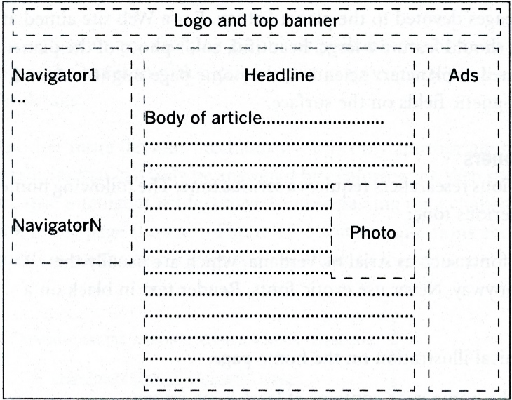
FIGURE 2. Layout of a typical online newspaper.
To implement a consistent layout such as the one shown in Figure 2, you must define a page template. A page template defines the layout elements of a class of Web pages. When a Web site uses page templates consistently, readers quickly learn where the content is, where the navigational aids are, and even where to avoid looking (at the ads, I suppose). A site without page templates forces visitors to regain their bearings whenever they step into a new Web page. A Web site composed without page templates is like a program whose graphical user interface changes with every use.
Page templates are not just for large, commercial Web sites. Even a modest, technical Web site with only a dozen Web pages should still rely on a page template. A simple page template, when applied to all pages in a Web site, will give a site a far more professional look.
You can use a variety of techniques to implement page templates. The most sophisticated page template mechanisms are built into enterprise content-management software. Such software enforces the use of page templates, making it impossible for renegade cowboys to create different-looking Web pages.

Navigators and Search Boxes
Each page in a Web site should provide a pathway to reach all other pages in your Web site. That is not to say that each page must provide a one-click link to every other page. (That much navigational baggage would crush any large Web site.) Nevertheless, each page should provide a clear pathway allowing readers to move to any other page in the Web site in just a few clicks. The most popular strategies for navigation within a Web site are as follows:
- navigators
- search boxes
Whichever method you choose, be consistent about their placement. For example, if a search box appears in the top-right corner of your home page, then that same search box should appear in the top-right corner of every page in your Web site. Don’t make readers hunt for navigational devices.
Navigators
A navigator is a list of multiple hyperlinks (and nothing but hyperlinks) that helps readers get to the desired page. For example, consider the simple navigator in the agricultural Web site shown in Figure 4.
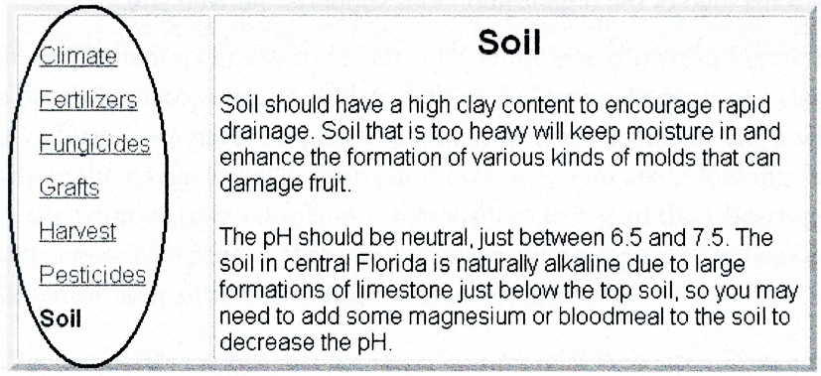
FIGURE 4. The left side of this Web page contains a simple navigator.
The navigator should clearly distinguish the current page. For example, since Sol 1 is the current page, notice that the navigator does not display a hyperlink for Soil.
Notice that the anchor text (for example, Climate, Fertilizers, and so on) for each hyperlink in Figure 4 is only one-word long. Your own navigator can contain more than one word, but one word is certainly the ideal.
The navigator for a simple Web site can contain a pointer to every page in the Web site. However, once a Web site contains more than 15 or so pages, a navigator with links to every page starts to become ungainly. (By the way, try to avoid forcing readers to scroll down to see a submerged part of the navigator.) To keep a navigator at a manageable size, consider a multilevel navigator. For example, if the reader clicks Climate, appropriate additional choices should appear, as shown in Figure 5.
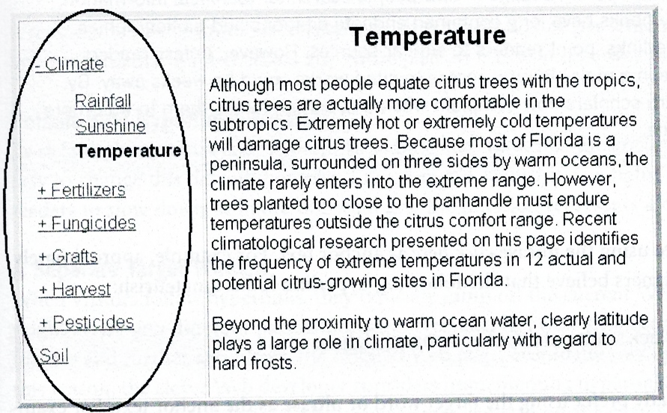
FIGURE 5. A two-level navigator, which is typically implemented through JavaScript.
Search Boxes
Instead of searching for the right hyperlink in a menu or navigator, users love to type text into a search box and let it find the right link. To be more precise, most readers start off loving search boxes but end up frustrated with them because of the spurious links they generate. Nevertheless, if you do implement a search box, make sure that you clearly define which site(s) will be searched. The simple phrase Search is no longer clear; it could mean Search this Site Only, Search the Entire Internet, or anything in between. By contrast, Figure 6 shows a well-defined search box.
Enter a phrase: Search This Web Site
diabetes research for doctors

FIGURE 6. An unambiguous search box.
Hyperlinks in Body Text
During the Web’s infancy, many users thought that hyperlinks were its coolest feature. Nowadays, Web users take this critical technology for granted. This chunk explores how to get the most out of hyperlinks within body text.
Hyperlinks Are Revolutionary
Hyperlinks represent a sea change in how people search for technical information. True, hard-copy books have long contained endnote citations and bibliographies, which, like hyperlinks, point readers to similar sources. However, unless readers happened to be in a major library, access to cited works could be weeks away. By contrast, modern scholars now complain when a hyperlink forces them to wait more than ten seconds.
Click Here
Web designers hate using the phrase click here as anchor text. For example, approximately 100% of Web designers believe that the following hyperlink looks amateurish:
To see Dr. Jill Black’s tutorial about eczema, click here.
Web designers greatly prefer using the target word or phrase as the anchor text. For example, the following example omits click here altogether:
Dr. Jill Black created a tutorial about eczema.

Once in a while, it is clearer to write a passage with click here than to adhere dogmatically to the click here prohibition. In fact, if your Web site’s target audience includes many relative newcomers to the Web (yes, this still happens), then click here is often the least ambiguous choice.
The Right Number of Hyperlinks in Text
Too many hyperlinks can confuse readers. For example, consider the following hyperlink- happy sentence:
Dr. Jill Black, a renowned dermatologist, created a tutorial about eczema, one of many common skin diseases that can be triggered through allergens or heredity.

The preceding sentence contains six hyperlinks, which is an overwhelming density. If readers followed every one of these, it could take them hours just to process that one sentence. In addition, since hyperlinks are usually rendered in the default blue color, the preceding black-and-blue mixture takes on a striped appearance that is somewhat difficult to read.
A reasonable rule of thumb is to keep hyperlinks down to one per sentence, although even one per sentence applied across any entire page of text would be way too many.
Default Blue Hyperlinks Are Best
By default, browsers render hyperlinks in blue and underline the anchor text. It is fairly easy to change this default; however, I recommend against it. Changing the default forces readers to slow down to figure out what graphic notation represents a hyperlink.
A Separate Target Window
When visitors follow hyperlinks, they typically jump off the current Web page. True, they might arrive at a different part of the same Web site, but they still lose context and drift further and further away from the original Web page, eventually waving it good-bye. For this reason, the clever Web developer considers implementing hyperlinks so that the target appears in a separate window. That way, visitors can stay on the current Web page while exploring other hyperlinks.
Be careful how you make additional browser windows appear, lest you trigger a pop-up blocker’s wrath.

Secondary Pages
As noted earlier, all secondary pages (that is, nonhome pages) should use a page template to present a consistent format. This chunk provides a few suggestions about those secondary pages.
Keep Content of Each Page Relatively Brief
Keep the amount of content on each Web page relatively brief. In the 1990s, a design axiom stated that users hate to scroll, so Web pages should be short enough to fit in a standard screen without a scrollbar. However, in the last few years, users have gradually become accustomed to vertical scrolling, and the design prohibition against vertical scrollbars has ended. Nevertheless, lengthy Web pages (beyond about four scrolled pages) are still frowned upon.
For example, suppose you must convert this book into a Web site. As a good Web developer, you would make a Web page out of each one- or two-page chunk rather than putting an entire chapter into a single Web page.
Associate Related Web Pages
Since content must be brief on each Web page, you need to find a way to associate related Web pages. Probably the best way to do this is through a navigator (described earlier in this chapter). In addition, you might provide See Al so hyperlinks at the bottom of each Web page. Since the Web is, by its nature, a random-access medium, you would generally not put Next buttons at the bottom of pages unless each page is truly meant to be read in a specific order. For example, it would be appropriate to put Next buttons at the bottom of tutorial pages.
Keep Content Narrow
Although users have become accustomed to scrolling vertically, most users despise scrolling horizontally. (Note that most modern mice provide a vertical scroll wheel but not a horizontal scroll wheel.) Furthermore, placing text in relatively narrow columns helps users read quickly. Therefore, the wise Web developer follows the same practice as most online newspapers and keeps body text between 350 and 500 pixels in width.
Graphics—particularly high-resolution photos—are often rather wide. Within a Web page, avoid displaying wide graphics that will force users to scroll horizontally. Instead, display a scaled-down version of the graphic and provide readers with a hyperlink that will pop the full version up in a separate window. (Beware of pop-up blocks, though.)
Text in Web Sites
Most of the rules established in Section 2 of this book also apply to Web pages. In other words, your Web content should consist of short, clear, active-voice sentences that use vocabulary appropriate for the target audience. However, creating content for the Web is not exactly like writing traditional documentation. When creating content for the Web, the wise writer considers the following differences:
- The “Tell ’em what you’re going to tell ’em... tell ’em... tell ’em what you told ’em” approach is less valuable in Web writing than in traditional writing. Web visitors frequently don’t have the patience to read introductions and seldom have the patience to read conclusions. Web visitors typically just want to dive straight into the entree, skipping the appetizers and dessert.
- You have a range of media at your disposal. Some kinds of information are more effectively presented through audio or video than through text. In fact, Web visitors tend to have less patience for straight text than do readers of hard-copy documentation.
- To handle a long block of text within a Web page, consider the following approach:
- Use subheads to divide the long block of text into units.
- Start the Web page with a bulleted list.
- Make each element in the bulleted list a hyperlink, pointing to subheads within the page. The Web page skeleton shown in Figure 7 illustrates this approach.
Citrus Canker Research
This page discusses recent research in citrus canker, which falls into the following categories:
- Quarantine
- Antibiotics
- Disease Spread
Quarantine
[Lengthy text goes here]
Antibiotics
[Lengthy text goes here]
Disease Spread
[Lengthy text goes here]
FIGURE 7. Handling large blocks of text through bulleted links and subheads.
On the Internet, the two most common document distribution formats are HTML and PDF. Table 2 compares and contrasts these two formats.

TABLE 2. Comparing PDF and HTML documents
Question | PDF | HTML
Can the user change an author's font choices? | No. The user must live with the author’s font choices. | Yes and no. The answer depends on how the author has set up the document.
Can the author embed fonts? | Yes. The author can optionally embed fonts within a PDF file to ensure that users can view the document properly. | No. The author cannot embed fonts within an HTML file. The author can, however, suggest alternate fonts to use if the author’s first choice of fonts is not available on the user's machine.
Does text rejustify when the user resizes a window? | No. When the user resizes the Acrobat Reader window, text does rejustify. | Yes (usually). When the user resizes the browser window, text not typically does rejustify.
Does font size change when the user resizes a window? | Yes. When the user resizes the Acrobat Reader window, virtual font size adjusts. Thus, fonts look relatively small when the viewing window is small. | No. When the user resizes the browser window, font size does not change.
Does this format use the concept of pages? | Yes. PDF uses the traditional physical page metaphor, just like a word processor. | No. A user can scroll almost infinitely down a lengthy document without encountering page breaks.
Do documents print well? | Yes. Printed pages look almost exactly as they do when printed directly from the author’s word processor. | No. Pages print in strange and uncontrollable ways. Sometimes information on wide lines doesn’t get printed at all.

PDF documents look awfully similar to a traditional book. PDF gives authors complete control over the layout of each page, just like WYSIWYG word processors. With HTML, the author hands over some of the formatting power to the browser and some to the end user. PDF is rigid; HTML is flexible.
Should You Distribute PDF or HTML?
In an ideal world, you would distribute documents in both PDF and HTML format. After all, some users prefer PDF and some prefer HTML. However, distributing in both formats is a lot of work.
Many users still prefer hard-copy documentation to soft-copy documentation. A few of these users have such a strong preference that they print out online documentation. Since the hard-copy version of PDF documents looks much better than the hard-copy version of HTML documents, score a point for PDF.
The average author typically converts a lengthy manual into a set of multiple HTML files; however, that same average author typically converts that same lengthy manual into a single PDF file. The PDF version often contains several orders of magnitude more bytes than one HTML file. Consequently, if your users access online documentation over a low-bandwidth network, HTML is a better choice.
Finally, some users read documents from devices (such as most cell phones) that cannot display PDF. However, a rather extraordinary collection of devices (not just traditional computers) can display some form of HTML.
Programs to Handle PDF
Adobe invented PDF; however, PDF is an open specification, and some other vendors have created software products for interacting with PDF. Nevertheless, the key software programs for interacting with PDF are still made by Adobe.
Acrobat Reader is a program that displays PDF files. It is freeware, available from www.adobe.com. Many modern computers preinstall Acrobat Reader. Furthermore, an Acrobat Reader plug-in lets users view PDF files directly in their browsers.
Acrobat Distiller is a program that converts documents to PDF. The full-strength version of Acrobat Distiller (generally marketed within a larger package called Acrobat Professional) lets authors convert just about any kind of document (including, ironically, HTML files) into PDF. Some word processors embed a reduced- strength version of Acrobat Distiller that enables conversion of only certain kinds of documents into PDF.
Adobe (and others) also make products that enable authors and others to edit PDF files. However, instead of editing the PDF file, it is generally far smarter to edit the source document, and then regenerate the PDF file.
Frequently Asked Questions (FAQs)
This chunk details frequently asked questions (FAQs), which are a staple of technical Web sites.
What is a FAQ?
A FAQ—as you probably know—consists of a bunch of questions and their answers. In addition to Web sites, newsgroup snobs love to use FAQs to intimidate newcomers. (Why didn’t you read the FAQ before posting that question?)
Why do many readers hate FAQs?
Most readers like the concept of FAQs; however, the actual FAQs often leave something to be desired. Usually, readers are angry because FAQs don’t contain their questions.
How should you create a FAQ?
The technique for creating a FAQ is simplicity itself—just do the following:
- Gather up a list of the most commonly asked questions.
- Provide answers for each of them.
- Organize groups of related questions into sections.
- Optionally, provide a search mechanism to help readers find the best-fit question.
How do you gather up a list of questions?
For product-related FAQs, just ask your customer-support organization, since they usually keep records of all the questions that customers ask. For science or general technology FAQs, questions posed on newsgroups and electronic bulletin boards often provide good sources of questions.
Can you make up your own questions?
Absolutely. Don’t rely completely on questions that others have already asked. Sometimes people are too embarrassed to ask questions that they think are too basic. You, the writer, should make up some of the questions. The best FAQs successfully anticipate readers’ questions.
What questions should you ask first?
The first question should always explain the purpose of the FAQ. The next few questions should summarize the product or technology. In essence, you should write an introduction in Q-and-A format.
Should you include every possible question in a FAQ?
No. A question asked only once does not constitute a frequently asked question. Don’t clutter the FAQ with arcane questions.
What is the key to answering questions?
Be concise; answer the question in a paragraph, if possible. Never write an answer longer than three paragraphs. If an answer can’t fit in three paragraphs, split the question into two or three narrower questions.
Don’t try to explain the whole world in each answer; create hyperlinks and cross-references to other related answers that might already have the goods.
What is the proper tone for answers?
Readers do not expect a formal tone in FAQs and will appreciate a casual, down-to-earth approach. Writers can often let their hair down in a FAQ.
Can you place graphics in answers?
Yes—readers love graphics.
Is humor okay in a FAQ?
Yes, but remember that it is notoriously difficult to create a response that everyone in a diverse audience will find humorous.
If grouping questions, how many questions should you place in each group?
Keep groups of questions fairly small (fewer than 10 questions). When groups of questions get too long, subdivide them into narrower categories.
How do you make a FAQ searchable?
Most large Web sites provide automated indexing, so a FAQ placed in such a Web site will automatically be searchable. If your FAQ does not have the benefit of automated indexing, consider placing the entire FAQ in one physical file. Readers can then invoke their browser’s Find menu to search for key words. The only problem with this approach is that a single file FAQ—particularly one with a lot of graphics—might take an annoyingly long time to download. To get around this problem, consider placing only the questions (not the answers) in one physical file. Then, place each answer in a separate file. Users can download the list of questions quickly, since the question file is usually relatively small and typically does not contain graphics.
Summary of Web Sites
The home page is the most important page in your technical Web site and the one that you should expend the most energy on. When reviewing your home page, ask yourself the following questions:
- Does the home page clearly explain the purpose of and audience for the site?
- Does the home page engage the reader’s imagination and encourage exploration?
- Does the home page establish the tone for the site?
- Does the home page provide a mechanism for navigating and searching the rest of the site?
When reviewing your secondary pages, ask yourself the following questions:
- Is the writing accurate, concise, and audience appropriate? Does the writing conform to the best practices highlighted in Section 2 of this book?
- Do the secondary pages share a common layout, enforced through page templates?
- Does each secondary page contain a descriptive top-level header and title?
- Is the body text on any secondary page longer than four scrollable pages? No secondary page should be longer than four pages. If you find a Web page that is too long, divide it into multiple pages.
- Are any pages too wide? Pages shouldn’t force users to scroll horizontally.
When reviewing your entire Web site, ask yourself the following questions:
- Does your Web site truly live up to the purpose and intended audience stated by the home page?
- Can visitors easily find their way around the different pages in your site?
- Can visitors find your site from a search engine?

References:
- Technical Writing, Serena Henning, JP Publishing, LLC, 2020
- Technical Writing Process, Kieran Morgan, Better on Publications, 2015
- Spring into Technical Writing for Engineers and Scientists, Barry J. Rosenberg, Pearson Education, Inc, 2005
- Technical Writing A-Z, Trever M. Young, Asme Press, 2009

