Lesson 12:

HOW TO USE AND INTERPRET GRAPHICS

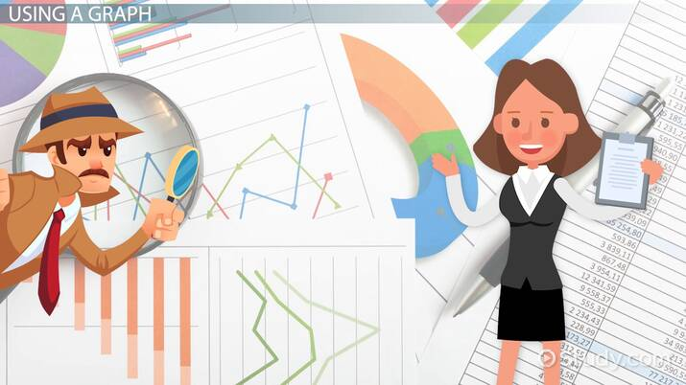
https://study.com/academy/lesson/how-to-interpret-information-from-graphs.html

Lecturer: M. Kurbonov

How to Use and Interpret Graphics
What are graphics?
The use of graphics is a crucial part of technical documentation (Parker, 2020) - providing a visual aid to oftentimes bland and lengthy text. This can help to break up your work, reiterate and emphasize a particular point and make complex information more digestible.
The type of graphic that you choose to illustrate your text is highly dependent on the information you wish to convey. For example, if you have written a business plan and want to show your future projections for financial growth, you would probably opt to display this information on a line graph (more on this later). Different types of graphics include:
- Tables
- Charts
- Graphs
- Infographics
How to use graphics?
Though the use of graphics may seem like a basic and straightforward process, there are a number of hidden considerations. Here are a few pointers to bear in mind (Parker, 2020):
- Keep it simple. What would be the point in an overly complicated and crowded graphic? Remember that illegible graphics can be very off putting to a reader.
- Use when necessary. It may be tempting to highlight every conclusion that you come to with an explanatory diagram, however, this may clutter your work. Central to using graphics is striking an important balance with your text. Only use them when they elevate your piece!
- Quality is key. Graphic designs should be clean and visually appealing.
- Choose your colors wisely. Does the color palette of your graphic fit with the rest of your work? What kind of message is this conveying? Too much red on your piece, for example, may send alarm bells to your reader. An overuse of luminous yellow may, similarly, be an eyesore. Think about the overall cohesion of your work.
Tables
Tables are used in technical writing, when presenting categorical information, such as textual or numerical. As one of the simplest forms of graphic, there are not many complications when creating a table. However, there are a few important formatting rules.
Remember that tables are organized in rows and columns, divided by headings, with a title placed at the top or on the first row. Additionally, the far-left column is left aligned whilst the remainder of the table is central.
When constructing a table, remember to (McMurrey, 2020):
- Prioritize the most important information. A mammoth 40 column table will probably take up too much space in your work and confuse your reader. Display the information that most closely supports your point.
- Refer to your table in the text. It would seem slightly disjointed to include a table without any explanation, especially when it is included to illustrate a point. Providing a short summary of the most important parts of your table will also help your reader's understanding.
- Don't put measurements in every box. If you are recording numerical data, such as that organized in dollars, there is no need to put a dollar sign in every box. Include this in the column or row heading.
- Include footnotes when necessary. If your table comes from a specific source, or you need to elaborate on a point, put this as a footnote at the bottom.
Example: The following table displays numerical data.
Table 1. Pet population in the U.S. by total number (million) from 2000 to 2020¹

Year | Cats | Dogs | Rabbits
2000 | 73 | 68 | 5
2010 | 86 | 83 | 6
2020 | 94 | 90 | 8

¹Source: This is an example and not an accurate estimation of the USpetpopulation.com
Charts and graphs
The difference between the data included in tables versus charts and graphs is not significant - in fact, you can usually opt for either when choosing a graphic. The main difference, however, is in the precision (MeMurrey, 2020). Whilst graphs give a better overall sense of trends, such as in an increasing U.S. cat population over time, they do not provide data in as much detail as a table. You should opt for using charts of graphs, then, when you want to emphasize an observable pattern in your data. Graphs and charts may seem quite daunting, but, really, they are quite simple to use if you have the correct software installed. Many office programmes have easy to understand graph and chart options that can be found in the insert tab.
When formatting a chart of a graph, make sure to include (McMurrey, 2020):
- Axis labels. Include these where applicable. What do your y and x axis (or each pie slice) represent? Remember, the y axis is the vertical part of your graph or chart and the x axis is the horizontal section. For example, your x axis may represent years whilst your y axis may indicate total number of pets (in millions).
- Figure titles. Place the title of your graph/chart underneath or on top. Make sure to cite the source if this is not original data.
- Keys. If you are presenting data from more than one category, then you will need a guide to which bits represent what. On a line graph, for example, a blue line may indicate "cats" and an orange line may indicate "dogs". Include this information in a box situated in an open space on your chart or graph.
- Information in the text. As with introducing a table in your work, it is essential that you reference any charts or graphs with more information in your text. Failure to do so may cause some confusion amongst your readers!
There are a number of different graphs and charts that you can draw from. Here are the most commonly used ones (NCES, 2020):
- Line graphs - Line graphs can demonstrate changes over longer and shorter periods of time. They are better to use than bar charts when there are smaller changes that you want to emphasize. They are also useful for comparing changes among different categories (i.e. cats and dogs) over the same amount of time.
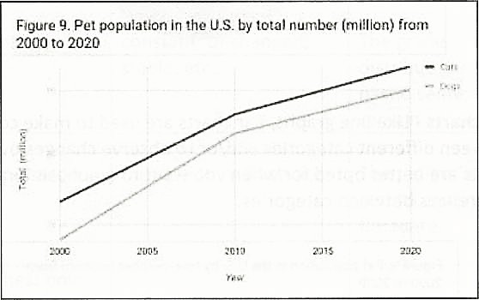
Figure 1. Pet population in the US by total number (million) from 2000 to 2020
- Pie charts - Pie charts do not show changes over time and are best at comparing different parts of a whole. For example, you may wish to show the total distribution of pets (percentage) in the U.S. in the year 2000 with a pie chart.
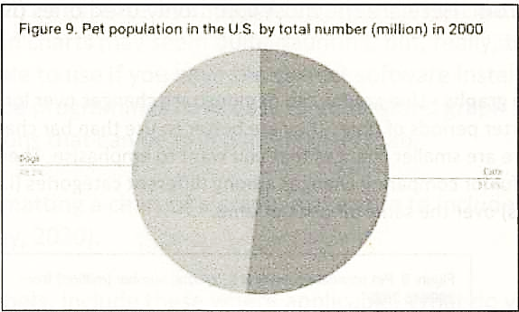
Figure 2. Pet population in the US by total number (million) in 2000
- Bar charts - Like line graphs, bar charts are used to make comparisons between different categories and/or to observe changes over time. Bar charts are better opted for when you want to emphasis large differences between categories.
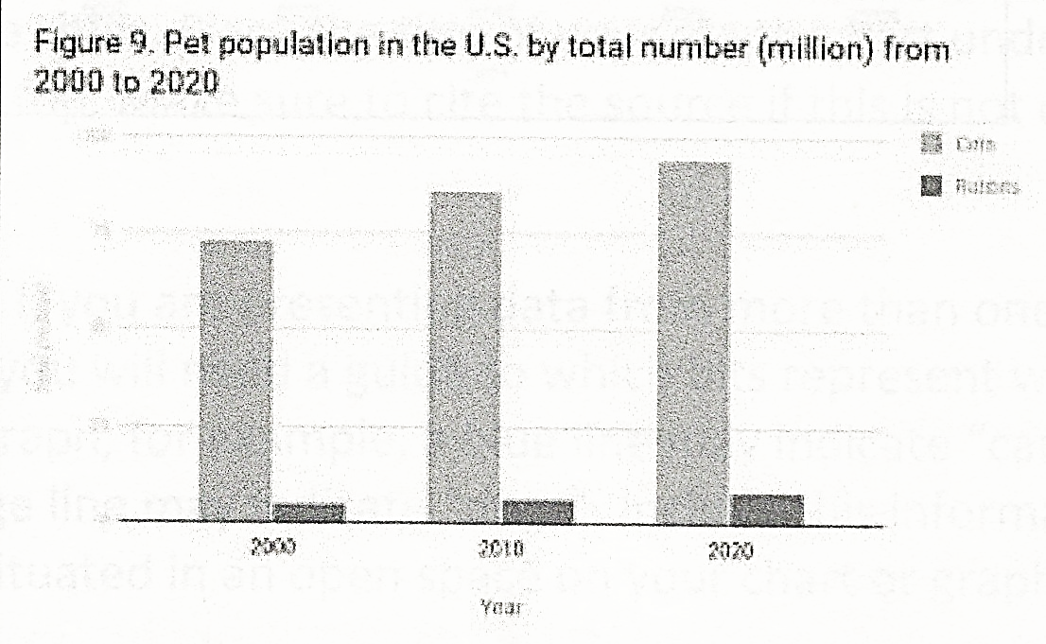
Figure 3. Pet population in the US by total number (million) from 2000 to 2020

USEFUL LANGUAGE
Introducing data | The chart shows, the graph displays, the table exhibits, etc....
Describing Trends | Kev Words | Example
Going up | increase; upward trend; rising; an improvement; a surge; etc... | There is an increase in employment numbers.
Going down | decrease; downward trend; decreasing; a decline; a slump; etc... | There is a decrease in sales for the month of March.
No Change | constant; unchanged; stable; etc... | The grade distributions for the past 6 semesters remain constant.
Frequent Change | fluctuation or fluctuate | The patient's lab results continue to fluctuate.
At the highest point | at the peak; peaking | This year's sales numbers peak in the month of August.
At the lowest point | at its low point; hit the lowest point; at its trough | The current unemployment numbers are at its lowest points since 1979.
Changes (in speed) | quickly, gradually, slowly, etc.... | The patient's temperature quickly rose due to an acute infection.
Changes (in degree) | significantly, substantially, dramatically, slightly, a little, slowly, etc... | The student's performance improved dramatically.
Comparison | whereas, in contrast, contrasting, in comparison, comparing, etc... | Whereas my morning class’s highest grade was a C, my afternoon class’s highest grade was an A+.

Infographics
Infographics are graphic representations of data, knowledge, or information. They can emphasize a particular point and make it more comprehensible. In fact, the use of infographics has been proven to enhance the ability of the human mind to digest information (Segue, 2014).
There are a wide variety of infographic forms to choose from, and hundreds of free templates online - you by no means, however, have to stick to one particular format. Types of infographics include:
- Geographic infographics. These are useful when providing information about a specific geographic area, using a map as the key visual. The information included can range from demographic data to top things to do in the area.
- Timeline infographics. This is the type of visual used when displaying the history of something, or when highlighting important dates and events. Use aids such as lines and photos to help emphasize your graphic.
- Statistical infographics. Detailing data results, survey information, or a specific argument can be a tiresome and waffly enterprise. Arranging these in statistical infographics helps put the emphasis on your findings without the need for long winded jargon. You may wish to include charts and graphs in this type of visual.
- Informational infographics. Use informational graphics when you want to elaborate on a concept or provide information on a particular topic. These are often split into distinct sections with headers. Include a number in your title to draw your audience in, such as "10 reasons to visit Oxford".
- Process infographics. Think about a standard flow chart - a step by step on a particular topic. This is the best type of infographic to use when providing an overview of a process.
- Comparison infographics. Use a comparison infographic to compare two or more items. You may want to split your graphic vertically or horizontally, with key information under your item title.
- Hierarchical infographics. When you want to rank information, you can opt for a hierarchical infographic. This could be in the form of a pyramid, with the "most..." at the top and the "least... "at the bottom.
- List infographics. These replace standard bullet points lists with visual representations.

Graphics
A picture is, of course, worth a thousand words. Unfortunately, creating professional looking graphics often takes substantially longer than writing a thousand professional-sounding words. Nevertheless, the effort is usually worth it. Effective technical communication engages readers, and nothing engages readers like beautiful photographs, lucid graphs, or exotic illustrations. Few people—if being truly honest with themselves—will deny that they like looking at pictures more than reading text. True, the same people might learn more from the text, but there is something satisfying and easy about pictures, while text requires effort.
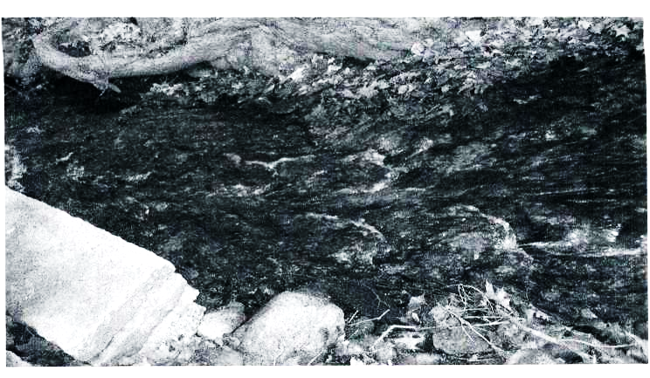
Figure-4. This picture is totally off topic, but you looked at it before you read the opening paragraph, simply because it is a picture.
Time Series
A time series is a two-dimensional graph in which the x-axis represents the passage of time. The y-axis could represent just about anything. For example, consider the time series in Figure 2, which plots temperature in Andijan over a 14-day period.
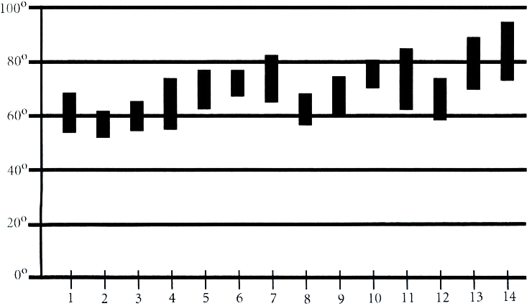
FIGURE 5. Daily extremes in Andijan from June 1 to June 14 (a faulty graph).
The preceding time series contains the following faults:
- The y-axis spans 100 degrees, yet the actual data only spans about 50 degrees. The compulsion to normalize graphs is very strong; however, starting the y-axis at zero wastes space, squishes data, and makes the graph less useful. Since so much space is wasted, it is harder to get an accurate read on individual data points.
- The guiding horizontal lines at 20° intervals are too thick and strong, taking the focus away from where it should be (on the data itself).
- The axes are only partially labeled. Without reading the caption, you can’t tell what month this represents.
- The reader gets little sense of how this data relates to the norm. Was this period cooler or warmer than normal?
Figure 6 improves upon Figure 5.
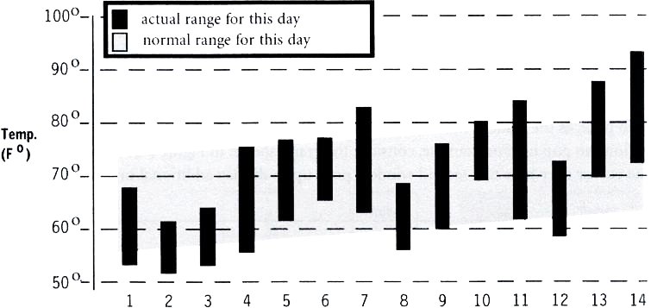
June 2021
FIGURE 6. Daily extremes in Andijan from June 1 to June 14 (better).
Figure 6 does a better job of illustrating detail but still does not help readers understand the aggregate. The detail obscures the big picture, making it difficult to determine whether temperatures were warmer or cooler than normal over this period. One simple solution is to add a textual summary announcing the deviation from the norm. An alternate solution is to add a second graph—such as the one shown in Figure 7—that focuses on the daily mean. By focusing on the mean, Figure 7 makes it easy to see various cool and warm periods and to realize that temperatures were above normal for the period.
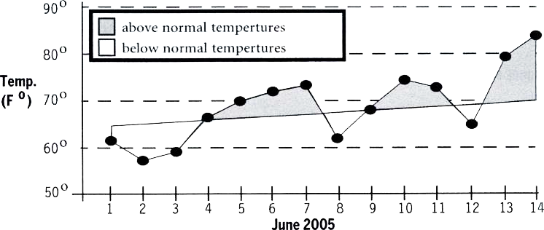
June 2021
FIGURE 7. Actual versus expected mean temperatures in Andijan from June 1 to June 14.
Extra Detail in Online Graphics
The best graphics not only present immediate information but also provide a way for interested readers to dive down to a greater level of detail. Achieving this multilayered presentation is quite difficult in hard-copy graphics but relatively easy in online graphics. In a Web page, as the reader’s mouse rolls over a region of the graph, further details about that region can pop up. For example, consider the graph shown in Figure 8. As a visitor rolls the cursor over June 6, a second window pops up to display additional information.
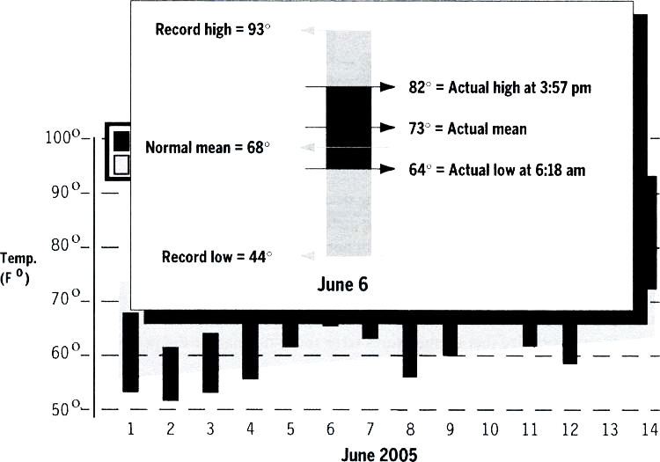
June 2021
FIGURE 8. Clicking on a date should provide details about that date.
It would have been possible for a single graph to represent all the information shown in the primary graph and the popup. However, the resulting graph would have been busy and cluttered. By separating the graphs, each graph stays relatively clean. Casual readers can view what they need, as can more serious viewers.
Before and After
In a before-and-after sequence, lay out the two graphics side by side, with the “before” graphic on the left and the “after” graphic on the right (unless you are writing a manual for an audience that reads text from right to left). For example, consider the before-and- after figure shown in Figure 9.
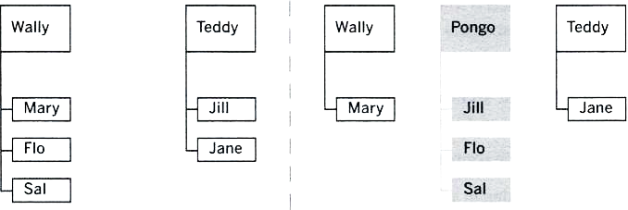
Before Pongo After Pongo
FIGURE 9. Walrus mating groups before and after introduction of Pongo.

Many technical communicators mistakenly provide only the “after” picture, leaving readers grasping for the change. The before-and-after sequence in Figure 10 is more powerful than either picture by itself.
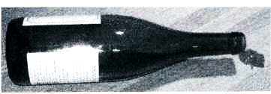 | 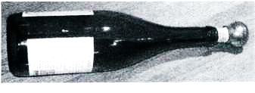
FIGURE 10. A wine bottle, before and after corking.

Callouts versus Embedded Text
Labeling the parts of a mechanical or biological unit is typically of great value to readers. To label the parts of a figure or photograph, rely on one of the following two mechanisms:
- callouts
- embedded labels
In a callout, the label is some distance away from the part. For example, Figure 11 contains four callouts. Most artists connect the label with the part by drawing a line segment. The keys to successful callouts are as follows:
- Keep the line segment short to avoid making the reader’s eyes traverse a lot of real estate to connect the label with the part.
- Don’t let line segments cross.
- When working in a color medium, render the line segments in a color that contrasts sharply with the figure.
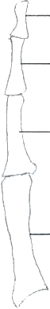 | Distal phalanx
 | Middle phalanx
 | Proximal phalanx
 | Metacarpal
FIGURE 11. Using callouts to label bones in the human little finger.
An embedded label is affixed to the part itself. In other words, the label is stamped directly on the part. Therefore, an embedded label has no need of a line segment to connect the part to the label. For example, Figure 12 contains three embedded labels.
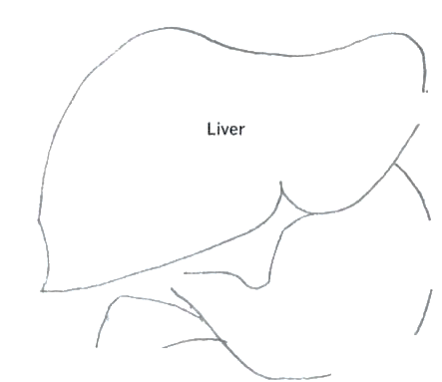
FIGURE 12. Using embedded labels to identify parts of the human digestive system.
An effective embedded label should not disturb the reader’s view of the part itself. In Figure 12, for example, the embedded labels are small enough that they do not interfere with the outline shapes of the digestive organs, although the “Pancreas” label is awfully close to the border.
Callouts versus Embedded Labels
Most professional graphic artists greatly prefer callouts over embedded labels. When the parts you are labelling are skinny, you have no choice but to use callouts. For example, you cannot fit embedded labels inside the bones of your little finger.
As a technical communicator, I’m less concerned about the sanctity of artwork than about communicating effectively. Therefore, I do not feel quite as negatively about embedded labels as most professional graphic artists. In some cases, I feel that callouts force readers’ eyes to work unnecessarily hard. For example, when a diagram contains many parts jumbled together like a jigsaw puzzle, it is easier to read embedded labels than to traverse a lengthy line segment to a callout label far, far away.
Graphics That Orient Readers
When walking in a highly touristed area, most people like to see the same map repeated every few blocks. The only thing that changes in these maps is the position of the blessedly comforting words You are here. You can use a similar mechanism to orient technical readers. Instead of a map, repeat the same block diagram at the start of each chapter in your book. In place of the magic words You are here, help readers get their bearings by highlighting the relevant section of the diagram.
For example, suppose your document contains an introductory chapter followed by three chapters, entitled “Canid,” “Coyote,” and “Gray Wolf.” In this case, consider placing Figure 10.
Gray Wolf | Coyote
Canid
FIGURE 13
In each chapter, repeat the preceding figure, but highlight the relevant topic. For example, place Figure 14 at the beginning of the “Coyote” chapter.
Gray Wolf | Coyote
Canid
FIGURE 14. The figure you place at the beginning of the “Coyote" chapter.
This method of presentation is simple to implement (after all, you only have to draw the picture once) and highly effective.
Screenshots
One way to document a graphical user interface (GUI) is to take screenshots of its menus. A screenshot is a “picture” of a portion of the image displayed on a computer monitor. For example, Figure 15 shows a screenshot. Most installation and administration manuals feature plenty of screenshots. In addition, online help often contains screenshots.

Display Choices
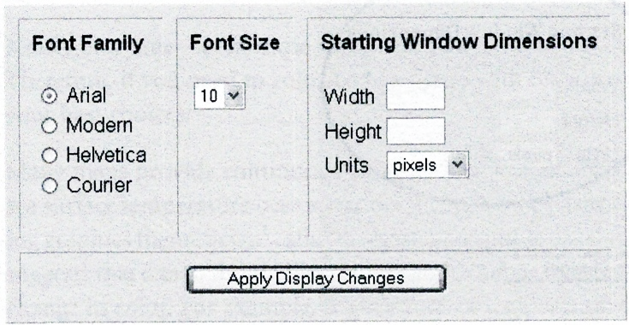
FIGURE 15. A sample screenshot.
Writers import screenshots into the documentation. Then, writers provide text explaining what the screenshot illustrates or what the reader should do when confronted with the menu in the screenshot.
Suppose a writer is documenting “Starting Window Dimensions.” Good screenshots focus readers’ attention on the current topic, so Figure 15 is not a great screenshot. After all, it not only shows “Starting Window Dimensions” but also irrelevant, distracting information about “Font Family” and “Font Size.” One way to reduce distractions is to eliminate them, leaving only the relevant portion of the screen, as shown in Figure 16.
The screenshot in Figure 16 is useful only if the reader knows the context (“Display Choices” screen) in which “Starting Window Dimensions” appears. A nice way to have your cake and eat it too is to take a screenshot of the entire screen and then highlight the relevant portion. For example, in Figure 17 a thick circle makes it easy for the reader to focus on the “Starting Window Dimensions” section.
Starting Window Dimensions
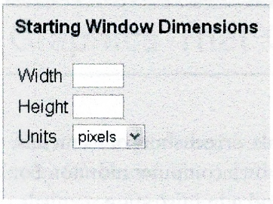
FIGURE 16. A subset of the full screen.
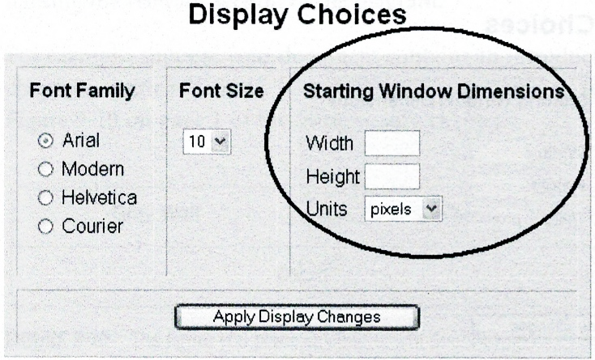
FIGURE 17. The full screenshot with the relevant section highlighted.
If you are producing screenshots for a color medium, render the highlighting shape (such as the circle in Figure 17) in a color that contrasts sharply with the underlying screenshot. For example, if the screenshot contains a lot of blue and no yellow, then highlighting with yellow will do a great job of catching a reader’s eye. If the screenshot is black and white only, then render the highlight shape in red.
The Cost of Screenshots
It is tempting to believe that documentation built around screenshots is cheaper to produce than documentation built primarily around text. In fact, screenshot documentation is more expensive to maintain because screens tend to change more frequently than the accompanying text. Even a tiny change to a screen means that you must reshoot it. (Readers get nervous when a screenshot does not exactly match the menu that readers see.) The worst-case scenario is when designers change the background color or background image or font of every screen, which forces the writer to reshoot every screenshot in the book.
Color Blindness
A significant percentage of men with European ancestry are color-blind. A tiny percentage of women with European ancestry are also color-blind, but the condition (like baldness) is primarily a male phenomenon. The wise technical communicator loves the power of color but understands that color-coding frustrates many readers.
Contrary to popular belief, color-blind individuals do not see the world in black and white. Instead, most color-blind individuals perceive green and red as pretty much the same color. All the subtle hues between green and red also blend into a single color.
Nearly everyone—even those categorized as color-blind—can distinguish blue from red. Therefore, if you need to color-code a figure with only two colors, red and blue would be your best choices.
Many maps provide continuous color-coding. For example, consider a map showing the sea surface temperature over a vast ocean. Such maps usually rely on a principle that a leading graphics theoretician1 calls “the least-perceptible difference.” This widely used principle suggests that a map should illustrate a subtle change in value with a subtle (but perceptible) change in color. For example, if a sea surface temperature of 72° is keyed as orange, then a sea surface of temperature of 73° should be keyed as a slightly redder shade of orange. This principle has great aesthetic appeal but is beyond frustrating to the color-blind. In fact, many people without color blindness find it difficult to distinguish close colors.
An alternate approach for continuous maps (and one that will also work in a black-and- white medium such as this book) is to rely on shading instead of color. For example, the continuous map shown in Figure 18 shows sea surface temperatures coded with shades of gray.
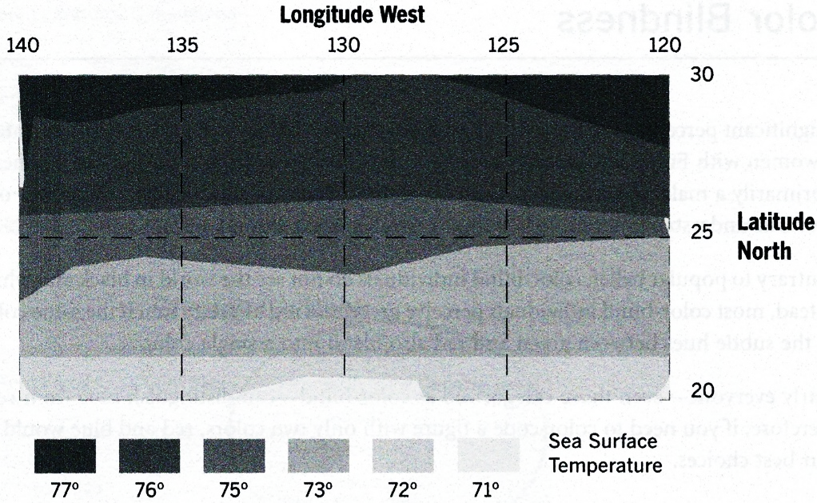
FIGURE 18. Sea surface temperatures in gray scale.
Many people find it difficult to distinguish between close shades of gray. Although Figure 19 is an aesthetic disaster, most people will find it easier to understand than Figure 18.
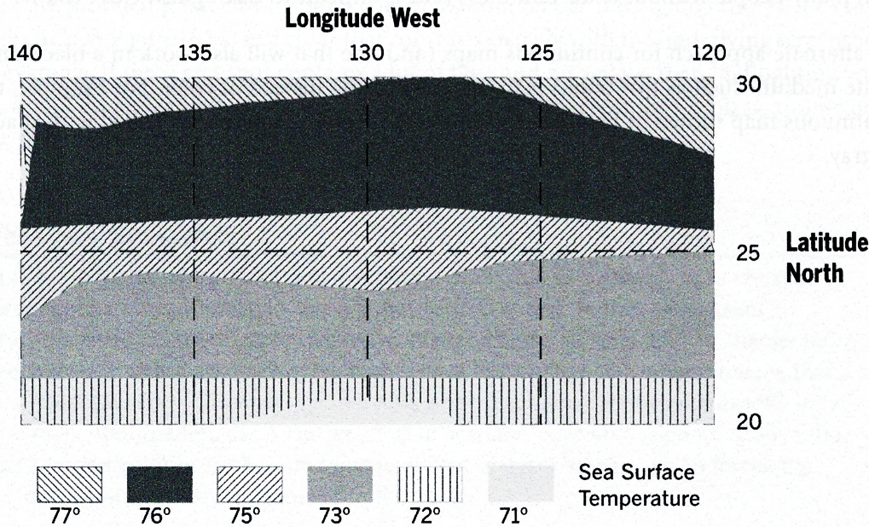
FIGURE 19. Sea surface temperatures in gray scale and various backgrounds.
Block Diagrams
Block diagrams typically consist of a set of rectangles (or other geometric shapes) with embedded labels. Artists visually connect the rectangles by stacking them to suggest a hierarchy or by shooting arrows from one rectangle to another.
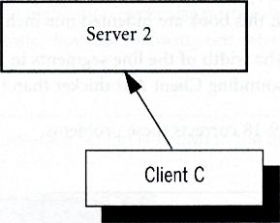
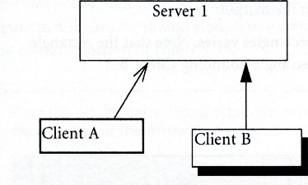
Block diagrams have become the bread-and-butter illustration of many engineers. Microsoft Visio makes it rather easy to draw block diagrams, but even with a powerful drawing package, many block diagrams still look pretty miserable. The key to creating professional-looking block diagrams is consistency; you have to be consistent both within a single graphic and among all the graphics in a document. To study this principle, consider the rather inconsistent graphic shown in Figure 20.
FIGURE 20. An inconsistence block diagram.
What’s wrong with this picture? Let me list the ways:
- The text is set in two different fonts. Notice that Client C is set in a different font than the text in other boxes. It is a good idea to use the same font family within a figure and throughout all the figures in a document. If you need to draw attention to text, then apply italics, bold, or color.
- The text alignment differs. Some of the text is left aligned (for example, Client B) but other text (for example, Client C) is centered. Even worse, some of the text is vertically aligned with the top of the box (for example, Server 1) while other text is vertically centered (for example, Server 2).
- The arrowheads differ. Needless to say, all the arrowheads in a document should have the same shape, size, and color.
- The arrows start and end from different sorts of places. If possible, arrows should all start from and end at the midpoint of a line segment; for example, the arrow connecting Client C and Server 2 connects nicely, but the arrow from Client A to Server 1 is lost in space.
- Some of the boxes are three-dimensional and others are two-dimensional. All the elements in graphics should typically have the same number of dimensions. However, if you do mix dimensions, at least render related elements (for example, all client boxes) in the same number of dimensions.
- The size of the rectangles varies without reason. There is no compelling reason why Client C is larger than Client A or Client B; all client boxes should be the same size and all server boxes should be the same size.
- The rectangles for related elements are not aligned. The three client boxes should align horizontally, as should the two server boxes.
- The left edge of the graphic is not left aligned. You should align graphics as closely as possible with the left edge of the body text on the page. In this book, for example, body text is indented one inch from the margin; therefore, the left edge of all figures in this book are indented one inch from the margin.
- The width of the line segments in the rectangles varies. Note that the rectangle bounding Client A is thicker than the rectangle bounding Client B.
Figure 21 corrects these problems.
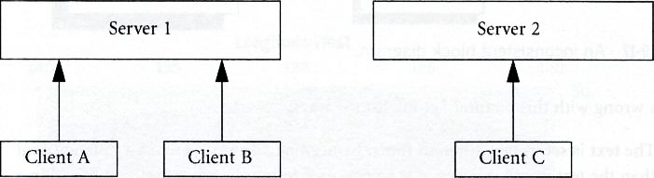
FIGURE 21. A consistent block diagram.
The consistency notes mentioned here are mere guidelines. Clever artists can sometimes break these rules and emerge with beautiful figures that still look perfectly professional.
Text That Supplements Figures
The text surrounding a figure should enhance the figure. (For that matter, the figure should enhance the text surrounding it.) This page provides a few principles regarding the prose near a figure.
Keep Illustrations Close to Text
Keep illustrations physically close to the text that introduces them. Don’t put the relevant illustration five pages later (except in a lab report where the illustrations, by custom, go at the end).
Focus Attention
The paragraph that precedes a figure should help focus the reader’s attention on the figure that will follow. In some cases, the paragraph should highlight a particular portion of the figure that the reader should study. For example, notice how the following text refers to the relevant portion of Figure 22.
Plug the printer cable into the parallel printer interface, which is shown in the lower right corner of the following figure:
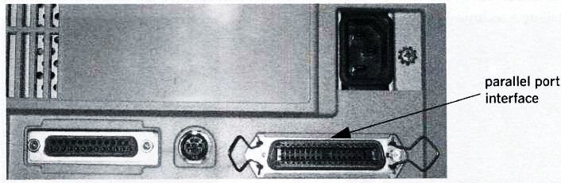
FIGURE 22. The text preceding a figure should introduce the figure.
Use Terminology Consistently
Use the exact same terminology within the figure and the text surrounding it. Failure to adhere to this subtle point has caused readers immeasurable pain. For example, notice the “parallel port interface” callout in Figure 22. If the paragraph preceding the figure had referred to this region as the “parallel interface” or the “printer interface,” you’d be surprised how many readers would wonder what you were referring to. Even a simple slip like referring to this region as the “Parallel Port Interface” (in uppercase) would trip up quite a few readers.
Technical Photography
Digital photography holds enormous value for technical communication. The following elements have recently come together to make technical photography highly desirable:
- High-resolution cameras and storage media have become relatively inexpensive.
- High-resolution color printing is inexpensive.
- High-bandwidth networks to transfer high-resolution photographs have become ubiquitous.
- Most end users now have programs that display digital photos.
Despite these advances, technical photography remains a challenging medium to master. The primary challenge is figuring out how to use technical photographs to enhance the technical story you are telling. Of course, some photographs are obvious. For example, if you are describing a certain airplane, displaying a photograph of the airplane is always a sound idea. However, suppose you are describing the aerodynamic performance of a new airplane wing. A photograph of the wing alone probably won’t be all that valuable.
I would urge you to consult a digital photography manual for details on aperture, shutter speed, and so on. In the next few pages, I only want to focus on a few common techniques for telling a technical story.
Layout: White Space
White space is the part of a printed page that contains no information. Since paper is usually white, white space literally refers to the white sections of the page, or the sections that do not contain ink. In a Web page, the white space is the background color. Thus, even if the background color is teal, teal blocks of the Web page are still termed white space.
A key principle of layout is as follows:
White space is good.

The corollary to this principle is as follows:
Clutter is bad.

In a technical manual, readers love white space. Cramming too much visual information into a small space makes readers nervous. White space is an island. White space is a place for the reader to rest before attacking the next topic.
When creating illustrations, always consider white space. For example, consider Figure 23, which suffers from a serious white space deficit.
DBMS (Database Management System) |  | JDBC (Java Database Connector) Driver |  | J2EE (Java 2 Enterprise Edition) Application Server
FIGURE 23. Not enough white space.
Just looking at Figure 23 makes me feel claustrophobic. This figure’s sins are as follows:
- White space is missing above the top of the figure and below its caption. Notice how scrunched the entire figure appears. Because of the absence of white space, some readers might not even notice the existence of the figure at all.
- The artist has placed too much text inside the three rectangles; the text is cluttered and hard to read. Notice how the text bumps up against the rectangles.
- The rectangles are too close to each other.
Figure 24 exaggerates white space somewhat to make a point. Notice that the text inside the rectangles has been stripped down to the essentials. (Text preceding or following this figure should expand the acronyms.)
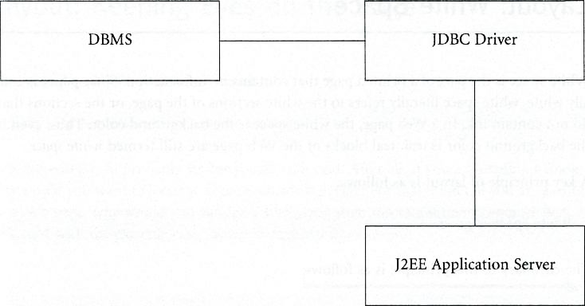
FIGURE 24. Rearranging the elements to enhance white space.
Note that it is not always appropriate to recast a horizontal drawing as a vertical drawing because a vertical drawing can imply a hierarchy.
QUANTUM LEAP
Many people center graphics halfway between the left margin and the right margin. However, most graphic artists prefer to lay graphics out flush with the left edge of their captions.
Summary of Graphics
When reviewing graphics in your document or Web site, ask yourself the following questions:
- Does the illustration supplement the body text? Does the body text surrounding the illustration help to explain the illustration? Does the body text use the same terminology as labels inside the illustration?
- Does the illustration contain a caption? By convention, the caption for an illustration is just below the illustration. Does the caption accurately convey the purpose of the illustration?
- If the illustration contains labels, are the labels consistent? For example, a single illustration should not mix callouts and embedded labels. Is the font consistent throughout the illustration?
- Is the illustration working too hard to cram in as much information as possible? An illustration is a little like a paragraph—when it starts to contain too much information, you should divide it in two.
- If this is a graph, are both axes clearly labeled? Are the units clearly labeled?
Have you optimized the presentation of your graphics by providing a proper layout? Do pointers push readers’ eyes off the page? Does the page contain enough white space, or does it look cluttered?
References:
- Technical Writing, Serena Henning, JP Publishing, LLC, 2020
- Technical Writing Process, Kieran Morgan, Better on Publications, 2015
- Spring into Technical Writing for Engineers and Scientists, Barry J. Rosenberg, Pearson Education, Inc, 2005
- Technical Writing A-Z, Trever M. Young, Asme Press, 2009

