Basic Mathematics
Lecture 2
Application of Venn diagrams
Lecturer: Kahenya, N.P

Introduction to Lecture 2
This lecture will focus on how to solve real-life problems involving the concept of set theory.
Intended learning outcomes
At the end of this lecture you will be able to;
- Solve real-life problems involving set theory.
- Apply Venn diagrams to solve problems.
References
These lecture notes should be complemented with relevant topics in (Antony & Robert, 2006; Kahenya, 2017; Spiegel & Robert, 2009; Seymour, 2020)
Introduction
The idea of Venn diagrams was introduced in Lecture 1. Venn diagrams are named after the English mathematician John Venn (1834 – 1923). Venn diagrams are used to show the relationship between finite sets. Venn diagrams can be applied to show relationships in real life situation. They can show relationship between family members, employees, components of a machine, animals in the park among other relationships in real life.
Sets and Venn diagrams
In a Venn diagram, a rectangle is normally used to represent the universal set while circles or ovals are used to represent the subsets. One can use Venn diagrams to solve problems involving set theory. Using Venn diagrams may be tedious and even complicated especially when the number of sets involved are many. The best option is to use the laws of algebra of set to solve such complicated problems.

Solving problems using the laws of the algebra of set
One can use the laws of set theory to solve problems involving sets. These laws were discussed in lecture 1. These are the laws of idempotent, associative, commutative, involution, De Morgan’s laws, among others.
Example 1: A survey was carried out on 60 students to determine how many had either a Samsung or a Techno or both smartphones. It was observed that: 23 students had a Samsung phone A, 35 students had a Techno phone B, and 7 students had both phones. Determine:
- The number of students who had a smartphone
- The number of students who had exactly one phone.
- The number of students who had neither the phone.
Solution: (i) The number of students who had smartphone i.e. $|A∪B|$. In our previous lecture 1 we know that; $\left|A∪B\right|=\left|A\right|+\left|B\right|-|A∩B|$. Hence we have;
$\left|A∪B\right|=\left|A\right|+\left|B\right|-\left|A∩B\right|=23+35-7=51 students$
- The number of students who had exactly one phone.
Those who had exactly a Samsung phone A i.e. $|A-B|$. We have . $\left|A-B\right|=\left|A\right|-|A∩B|$.
Hence we get; . $\left|A-B\right|=\left|A\right|-\left|A∩B\right|=23-7=16 students had a Samsung phone only.$
Those who had exactly a Techno phone B i.e.$\left|B-A\right|$. We have $\left|B-A\right|=\left|B\right|-|A∩B|$. Hence we get; $\left|B-A\right|=\left|B\right|-\left|A∩B\right|=35-7=28 students had only a Techno phone B$.
Therefore, we had 28 + 16 = 44 students who had exactly one of the phones.
- The number of students who had neither the phone. These are students who neither had a Samsung phone A nor a Techno phone B i.e. $|A^{c}∩B^{c}|$. Using De Morgan’s laws we have;
$$A^{c}∩B^{c}={\left(A∪B\right)}^{C}$$
Hence we have; $\left|A^{c}∩B^{c}\right|=\left|{\left(A∪B\right)}^{C}\right|=\left|ξ\right|-\left|A∪B\right|=60-51=9 students$.
Example 2: In a certain company it was observed that;
18 worked in the Finance F department,
11 worked in the Transport T department.
24 worked in the Cleaning C department.
7 in Finance and Transport department.
11 in Finance and Cleaning department.
5 in Transport and Cleaning department, and 2 worked in all three departments.
Find the number of persons who worked in at least one of the departments i.e. $|F∪T∪C|$
Solution: From lecture 1 we noted; $\left|A∪B∪C\right|=\left|A\right|+\left|B\right|+\left|C\right|-\left|A∩B\right|-\left|A∩C\right|+\left|B∩C\right|+|A∩B∩C|$. Hence;
$$\left|F∪T∪C\right|=\left|F\right|+\left|T\right|+\left|C\right|-\left|F∩T\right|-\left|F∩C\right|+\left|T∩C\right|+|F∩T∩C|$$
$=18+11+24-7-11-5+2=32 persons$.
Application of Venn diagrams
Example 1: A survey was carried in a picnic. It was noted that 17 people took Fanta F, 25 took coke C, and 28 took sprite S. 9 people took a Fanta and coke, 12 took a coke and sprite, and 7 took a Fanta and sprite. Suppose 51 people were in the survey and 5 people never took any of these three drinks. Use a Venn diagram to determine how many took all the three types of drinks i.e. $n(F∩C∩S)$.
Solution: One need to draw a Venn diagram to represent the above relationships. Let the number of people who tool all the three types of drinks to be $x i.e. n\left(F∩C∩S\right)=x.$ Starting from the middlemost region and then moving outwards one can easily label the other regions, as shown below.
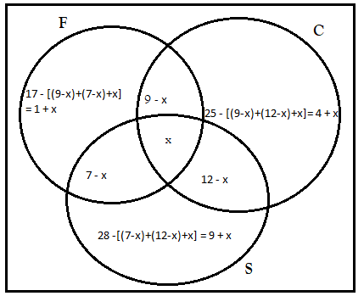
One end up with the following equation and solve for x.
$$51-5=46$$
$$=x+\left(9-x\right)+\left(12-x\right)+\left(7-x\right)+\left(1+x\right)+\left(4+x\right)+(9+x)$$
$46=x+42=>x=4$ people.
Example 2: The following table represent the number of people who ate 3 types of fruits. Suppose the total number of people was 21, use a Venn diagram to determine the number of people that ate;
- Oranges
- Orange or apple but not a mango
- Apple only Apple but not an orange
- All the three fruits

Type of Fruit | No. of people
Mango only | 3
Mango but not orange | 7
Mango and Apple | 5
Mango | 10
Orange and apple | 6
Apple | 12
The shaded part of the Venn diagram represents each row of the table above.
Row 1: Mango only – 3 people
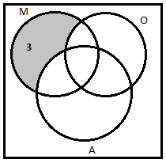
Row 2: Mango but not orange – 7 people
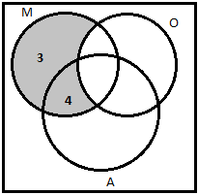

Row 3: Mango and Apples – 5 people
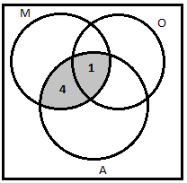
Row 4: Mango – 10 people.
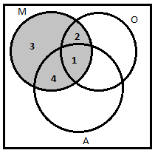
Row 5: Mango and Apple – 6 people.
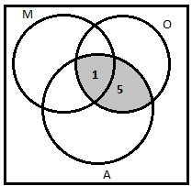
Row 6: Apple – 12 people.
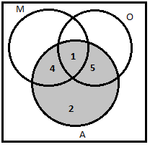

The six Venn diagrams above can be represented in one Venn diagram as shown below.
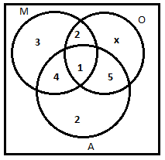
The number of people who ate Oranges only is x since it is not indicate in the Table. To get x we have; 21 – [3 + 2 + 1+ 4 + 5 + 2] = 4 people.
Solution:
- Oranges – 12 people (See shaded part)
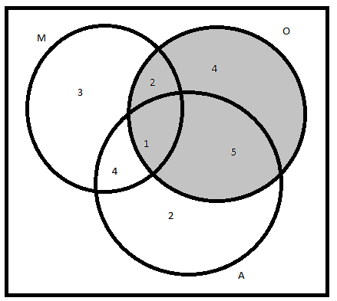
- Orange or apple but not a mango i.e. $\left|\left(O∪A\right)∩M^{C}\right|=11$ people (see shaded part).
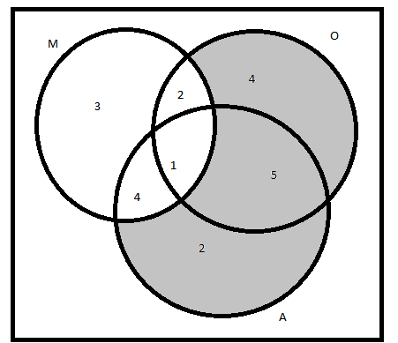

- Apple only – 2 people (see shaded part).
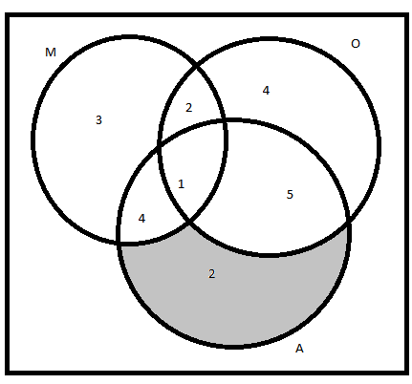
- Apple but not an orange – 6 people (see shaded part).
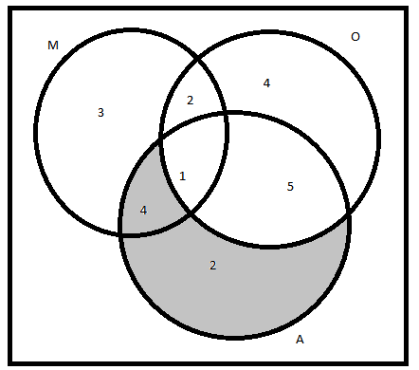
- All types of fruits i.e. $\left|M∩O∩A\right|=1$– person (see shaded part below).
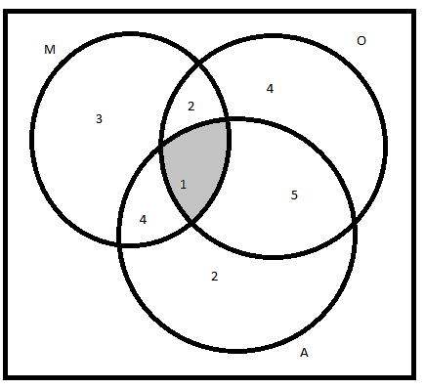

Exercise
- Represent the following non-empty sets in separate Venn diagram, by shading the appropriate region where applicable. The sets are subsets of the universal set $ξ$.
- $\left(P∪Q\right)∩R^{c}$
- $A⊃B$
- $X∩Y=∅$
- $A∩\left(B∪C\right)$
- $H^{c}$
- $\overset{̿}{X}$
- 90 people boarded a bus from the market. It was observed that; 40 had apples A, 63 had bananas B, and 13 had both fruits. Using laws of sets to determine the number of passengers had fruits A and B, exactly one on of the two fruits, and neither of the fruits.
- Study the Venn diagram below that represent the number of people in a party who consumed certain beverages i.e. Tea T, Soda S, Fresh juice F, and others. Use the information to attempt the following questions;
- Supposed 3 people did not honor the invitation to attend the party, find how many people were invited.
- How many people drunk all the drinks i.e. tea, soda, and fresh juice.
- How many people took at least one of the three drinks i.e. tea, soda, and fresh juice.
- How many too exactly one of the drinks i.e. tea, soda, and fresh juice.
- $n(T∪S)$
- $|\left(F∩S\right)∩T^{c}|$
- How many took both fresh juice and tea but not soda.
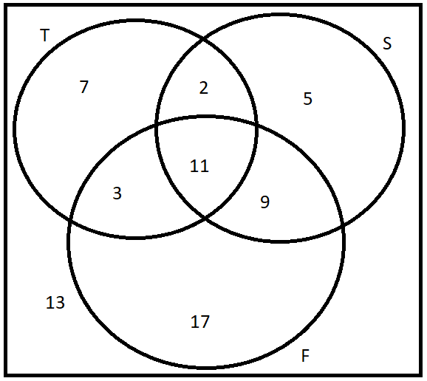
- In a class of 70 students, 43 uses a blue pen, 31 uses a black pen, and 11 uses both blue and black pens. Find the number of students who;
- Do not use a blue pen.
- Do not use a black pen.
- Uses a blue or black pen.
- Uses a blue pen but not a black pen.
- Uses exactly one of the two pens.
- Uses neither a blue nor a black pen.
- In a survey of a sample of 33 companies on what application is used for their virtual meetings, it was observed that:
14 uses Skype. 4 uses both Skype and GoogleMeet.
16 uses GoogleMeet. 10 uses both GoogleMeet and Teams.
17 uses Teams. 7 uses both Skype and Teams.
3 uses all the applications.
Use the information to determine number of companies that uses; (i) Skype only, (ii) Teams only, (iii) Skype and Teams but not GoogleMeet, (iv) only one of the application, (v) at least one of the application,(vi) none of the application.

Bibliography
Antony, C., & Robert, D. (2006). Foundation Maths. Prentice Hall.
Kahenya, P. (2017). Foundation Maths. LAP Lambert Academic Publishers.
Murray, S., & Robert, M. (2009). College Algebra. McGraw-Hill.
Seymour, L. (2020). Set Theory and Related Topics. McGraw-Hill.

