Basic Mathematics
Lecture 5
Solving linear systems: Graphical method and Cramer’s Rule
Lecturer: Kahenya, N.P

Introduction to Lecture 5
This lecture will focus on how to solve linear systems with 2 or 3 unknown using graphical method (for a system with two unknowns) and Cramer’s rule. It is a continuation of the previous lecture that discussed the elimination and substitution methods.
Intended learning outcomes
At the end of this lecture you will be able to;
- Solve linear systems using the graphical method and Cramer’s rule.
- Apply the methods to solve real-life problems.
References
These lecture notes should be complemented with relevant topics in (Antony & Robert, 2006; Kahenya, 2017; Spiegel & Robert, 2009)
Graphical Method (for equations with 2 unknowns)
The method requires plotting the graphs on a plane. The graphs of the two or more equations will;
- Intersect at a point (x, y). The value of x and y at the point of intersection is the solution to the linear systems. We say such system is consistent and has a unique solution.
- Parallel lines, implying that the equations are inconsistent and have no solutions.
- Coincident line or just a single line implying that the system is consistent but has infinitely many solutions.
There is free source software for drawing graphs e.g. Microsoft mathematics, Computer Algebra System CAS among others.

Example 1: Solve the following using graphical method; $\begin{matrix}2x+y=4 \\ 3x-2y=-1\end{matrix}$
Solution: If one is using a software one need to follow the right procedure to input the graph. Drawing the graph manually requires one first draw a table of values for both equations to assist in plotting the graphs.
$$x$$ | $$-1$$ | $$0$$ | 1 | $$2$$
$$y=4-2x$$ | $$2$$ | $$4$$ | $$2$$ | $$0$$
$$y=1.5x+0.5$$ | $$-1$$ | $$0.5$$ | $$2$$ | $$3.5$$

From the graph below it is clear that the two lines intersect at point (1, 2). Hence the solution to our system is unique i.e. x = 1 and y = 2.
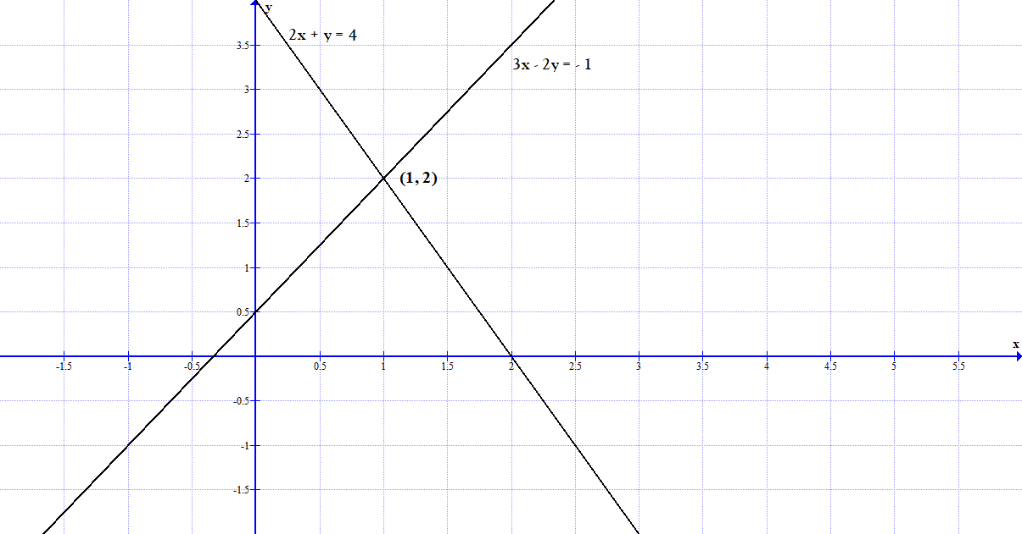
Example 2: Solve the following using graphical method; $\begin{matrix}4x+3y=6 \\ 8x+6y=24\end{matrix}$
Solution:
From the graph below it is clear that the two lines are parallel and therefore the systems is inconsistent i.e. no solution.
$$x$$ | $$-3$$ | $$0$$ | $$3$$
$$y=-\frac{4}{3}x+3$$ | $$7$$ | $$3$$ | $$-1$$
$$y=-\frac{4}{3}x+4$$ | $$8$$ | $$4$$ | $$0$$

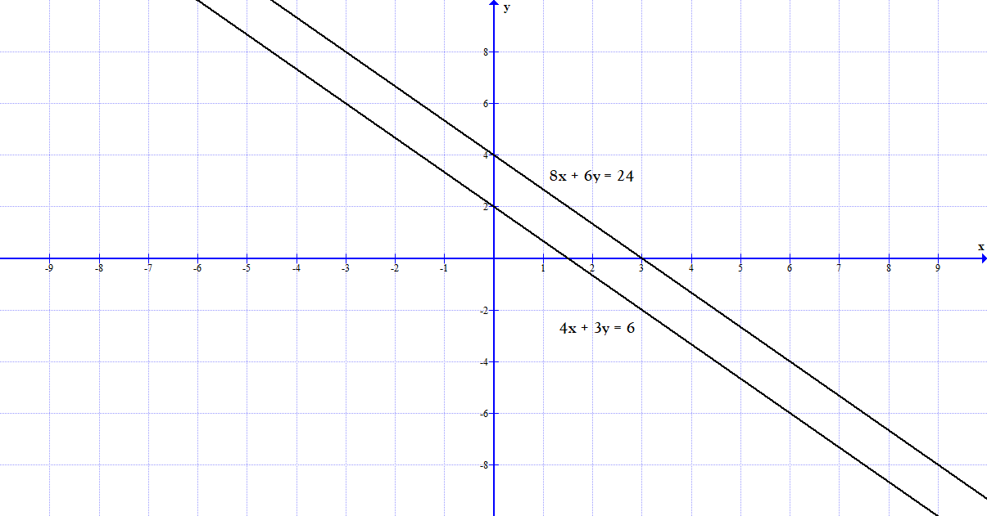
Example 3: Solve the following system; $\begin{matrix}4x+3y=6 \\ 8x+6y=12\end{matrix}$
Solution: From the graph we have only one line. The second line is a multiple of the first one. It implies that the system is consistent with infinitely many solutions.
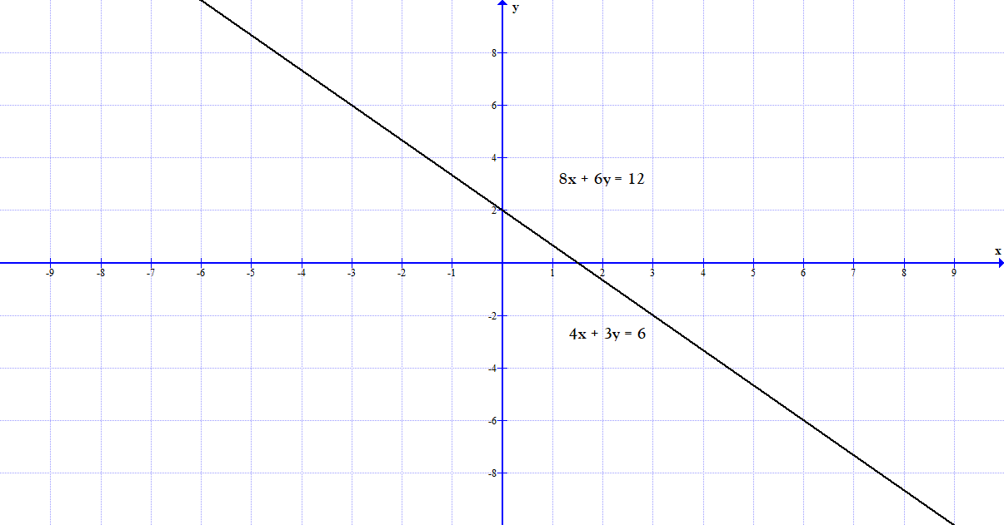
Cramer’s Rule
Cramer’s rule uses the determinant of a matrix. One can manually find the determinant of a square matrix of any order or use CAS.
Example 1: Find the determinant of a $2×2$ matrix $A=\left(\begin{matrix}-5 & -7 \\ 9 & 12\end{matrix}\right)$.
Solution: The determinant of matrix A i.e. det. A, is the product of the elements in the leading diagonal minus the product of the elements in the secondary diagonal. Hence in our case we have;
$$det. A=\left|\begin{matrix}-5 & -7 \\ 9 & 12\end{matrix}\right|=\left(-5×12\right)-\left(9×-7\right)=-60+63=3$$

Example 2: Find the determinant of a $3×3$ matrix $M=\left(\begin{matrix}2 & -3 & 5 \\ -4 & 0 & 1 \\ 3 & 2 & 1\end{matrix}\right)$
Solution: You can CAS, the Sarrus rule or the expansion method to find the determinant of a $3×3$ matrix.
Sarrus Rule
Step 1: Rewrite the matrix by repeating columns 1 and 2 in that order to have a $3×5$ matrix as shown below;
$$\det{M=\left|\begin{matrix}2 & -3 & 5 \\ -4 & 0 & 1 \\ 3 & 2 & 1\end{matrix}\right|=\left|\begin{matrix}2 & -3 & \begin{matrix}5 & 2 & -3\end{matrix} \\ -4 & 0 & \begin{matrix}1 & -4 & 0\end{matrix} \\ 3 & 2 & \begin{matrix}1 & 3 & 2\end{matrix}\end{matrix}\right|}$$
Step 2: Find the product of the elements in the diagonal running from top left element (i.e. elements 2, 0, and 1) as shown below. Repeat with the next two diagonals to get 0, -9, and -40. Add these products to get 0-9-40 = -49.
$$\det{M=\left|\begin{matrix}2 & -3 & \begin{matrix}5 & 2 & -3\end{matrix} \\ -4 & 0 & \begin{matrix}1 & -4 & 0\end{matrix} \\ 3 & 2 & \begin{matrix}1 & 3 & 2\end{matrix}\end{matrix}\right|}$$
Step 3: Find the product of the elements in the diagonal running from bottom left element (i.e. elements 3, 0, and 5) as shown below. Repeat with the next two diagonals to get 0, 4, and 12. Add these products to get 0 + 4 + 12 = 16.
$$\det{M=\left|\begin{matrix}2 & -3 & \begin{matrix}5 & 2 & -3\end{matrix} \\ -4 & 0 & \begin{matrix}1 & -4 & 0\end{matrix} \\ 3 & 2 & \begin{matrix}1 & 3 & 2\end{matrix}\end{matrix}\right|}$$
Step 4: Next is to get the determinant by subtracting what you got in step 3 from what you got in step 2 i.e.
$$\det{M=-49-16=-65}$$
Expansion method/Cofactor method
In the method consider the elements in the first row i.e. 2, -3, and 5. We multiply them with their cofactor (determinant of the matrix formed by the elements that are not in the row or column containing this element) i.e.
$det. M=2\left|\begin{matrix}0 & 1 \\ 2 & 1\end{matrix}\right|+3\left|\begin{matrix}-4 & 1 \\ 3 & 1\end{matrix}\right|+5\left|\begin{matrix}-4 & 0 \\ 3 & 2\end{matrix}\right|$
$=2\left(-2\right)+3\left(-7\right)+5\left(-8\right)$
$=-4-21-40$
$=-65$
Example 3: Solve the following system using the Cramer’s rule; $\begin{matrix}5x+7y=13 \\ 3x-2y=14\end{matrix}$
Solution: We need to write the system in matrix form i.e.
$$\left(\begin{matrix}5 & 7 \\ 3 & -2\end{matrix}\right)\left(\begin{matrix}x \\ y\end{matrix}\right)=\left(\begin{matrix}13 \\ 14\end{matrix}\right)$$
To get the variables we have;
$$x=\frac{Δx}{Δ}=\frac{\left|\begin{matrix}13 & 7 \\ 14 & -2\end{matrix}\right|}{\left|\begin{matrix}5 & 7 \\ 3 & -2\end{matrix}\right|}=\frac{-26-98}{-10-21}=\frac{-124}{-31}=4$$
Where $Δx$ is the determinant with respect to $x$. We replace the coefficients of $x$ with the constants; and $Δ$ is the determinant of the coefficients’ matrix.
$$y=\frac{Δy}{Δ}=\frac{\left|\begin{matrix}5 & 13 \\ 3 & 14\end{matrix}\right|}{\left|\begin{matrix}5 & 7 \\ 3 & -2\end{matrix}\right|}=\frac{70-39}{-10-21}=\frac{31}{-31}=-1$$
Where $Δy$ is the determinant with respect to $y$. We replace the coefficients of $y$ with the constants; and $Δ$ is the determinant of the coefficients’ matrix.
Hence our solution set is $\left\{x, y\right\}=\{4, -1\}$
Example 4: Solve the following system using Cramer’s rule; $\begin{matrix}5x+2y=9 \\ 10x+4y=20\end{matrix}$
Solution: We first rewrite the system in matric form i.e.,
$$\left(\begin{matrix}5 & 2 \\ 10 & 4\end{matrix}\right)\left(\begin{matrix}x \\ y\end{matrix}\right)=\left(\begin{matrix}9 \\ 20\end{matrix}\right)$$
We need to first find the determinant of the coefficient matrix i.e.
$\left|\begin{matrix}5 & 2 \\ 10 & 4\end{matrix}\right|=20-20=0$
$Δx=\left|\begin{matrix}9 & 2 \\ 20 & 4\end{matrix}\right|=36-40=-4$ $=>x=\frac{Δx}{Δ}=\frac{-4}{0}=∞$
This means the system has no solution. The two equations will form parallel lines when plotted on the plane.
Example 5: Solve the following system using the Cramer’s rule; $\begin{matrix}5x+2y=9 \\ 10x+4y=18\end{matrix}$
Solution: The system in matrix form is given as; $\left(\begin{matrix}5 & 2 \\ 10 & 4\end{matrix}\right)\left(\begin{matrix}x \\ y\end{matrix}\right)=\left(\begin{matrix}9 \\ 18\end{matrix}\right)$
We need to first find the determinant of the coefficient matrix i.e.
$\left|\begin{matrix}5 & 2 \\ 10 & 4\end{matrix}\right|=20-20=0$
Next, we find the determinant with respect to x, $Δx$ i.e.,
$Δx=\left|\begin{matrix}9 & 2 \\ 18 & 4\end{matrix}\right|=36-36=0$
$$=>x=\frac{Δx}{Δ}=\frac{0}{0}-indeterminate$$
This implies the system has many solutions. Note that the second equation is a multiple of the first equation. The two will form a coincident line.
Example 6: Solve the following system using Cramer’s rule; $\begin{matrix}x+y+z=6 \\ 2x-y-2z=-6 \\ x+3y-z=4\end{matrix}$
Solution: We first rewrite the system in matrix form i.e.
$$\left(\begin{matrix}1 & 1 & 1 \\ 2 & -1 & -2 \\ 1 & 3 & -1\end{matrix}\right)\left(\begin{matrix}x \\ y \\ z\end{matrix}\right)=\left(\begin{matrix}6 \\ -6 \\ 4\end{matrix}\right)$$
To get the variables we have;
$$x=\frac{Δx}{Δ}=\frac{\left|\begin{matrix}6 & 1 & 1 \\ -6 & -1 & -2 \\ 4 & 3 & -1\end{matrix}\right|}{\left|\begin{matrix}1 & 1 & 1 \\ 2 & -1 & -2 \\ 1 & 3 & -1\end{matrix}\right|}=\frac{14}{14}=1$$
Where $Δx$ is the determinant with respect to $x$. We replace the coefficients of $x$ with the constants; and $Δ$ is the determinant of the coefficients’ matrix.

$$y=\frac{Δy}{Δ}=\frac{\left|\begin{matrix}1 & 6 & 1 \\ 2 & -6 & -2 \\ 1 & 4 & -1\end{matrix}\right|}{\left|\begin{matrix}1 & 1 & 1 \\ 2 & -1 & -2 \\ 1 & 3 & -1\end{matrix}\right|}=\frac{28}{14}=2$$
Where $Δy$ is the determinant with respect to $y$. We replace the coefficients of $y$ with the constants; and $Δ$ is the determinant of the coefficients’ matrix.
$$z=\frac{Δz}{Δ}=\frac{\left|\begin{matrix}1 & 1 & 6 \\ 2 & -1 & -6 \\ 1 & 3 & 4\end{matrix}\right|}{\left|\begin{matrix}1 & 1 & 1 \\ 2 & -1 & -2 \\ 1 & 3 & -1\end{matrix}\right|}=\frac{42}{14}=3$$
Where $Δz$ is the determinant with respect to z. We replace the coefficients of $z$with the constants; and $Δ$ is the determinant of the coefficients’ matrix.
Hence our unique solution is; $\left\{x,y,z\right\}=\{1,2,3\}$

Exercise
- Find the determinant of the following matrices;
- $\left(\begin{matrix}3 & 1 \\ -2 & 5\end{matrix}\right)$
- $\left(\begin{matrix}5 & 3 \\ 10 & 6\end{matrix}\right)$
- $\left(\begin{matrix}2 & -3 & 4 \\ 1 & 2 & 7 \\ 3 & -2 & 5\end{matrix}\right)$
- $\left(\begin{matrix}5 & 2 & 2 \\ 0 & 1 & -3 \\ -1 & 8 & 2\end{matrix}\right)$
- $\left(\begin{matrix}0 & 0 & 1 \\ 0 & 1 & 0\end{matrix}\right)$
- Apply Cramer’s rule to solve the following systems;

- $\begin{matrix}7m+4p=130 \\ 11m+5p=185\end{matrix}$

- $\begin{matrix}x+y-z=1 \\ x-2y-3z=-16 \\ x+3y+z=15\end{matrix}$
- $\begin{matrix}3x+2y=15 \\ 5x-7y=-37\end{matrix}$

- $\begin{matrix}x+y-z=10 \\ x-2y-3z=-52 \\ x+3y+z=60\end{matrix}$

- Use graphical method to determine the solutions of the following systems;

- $\begin{matrix}5p+2q=11 \\ p-5q=-14\end{matrix}$

- $\begin{matrix}6s+5t=-6 \\ -3s+5t=3\end{matrix}$

- $\begin{matrix}5x+7y=19 \\ x-2y=-3\end{matrix}$

- $\begin{matrix}9α+β=6 \\ α-2β=7\end{matrix}$

Bibliography
Antony, C., & Robert, D. (2006). Foundation Maths. Prentice Hall.
Kahenya, P. (2017). Foundation Maths. LAP Lambert Academic Publishers.
Murray, S., & Robert, M. (2009). College Algebra. McGraw-Hill.

