Basic Mathematics
Lecture 8
Solving quadratic equations: Graphical method and Analytical solutions
Lecturer: Kahenya, N.P

Introduction to lecture 8
This lecture discusses how to solve quadratic equations using the graphical method and analytical solutions to quadratic functions. It is a continuation of the previous lectures that dealt with solving quadratic equations using the factorization method, completing the square method, and quadratic formula.
Intended learning outcomes
At the end of this lecture you will be able to;
- Solve quadratic equations using graphical method.
- Determine analytical solutions to quadratic functions.
References
These lecture notes should be complemented with relevant topics in (Antony & Robert, 2006; Kahenya, 2017; Spiegel &Robert, 2009; Seymour, 2020).

Graphical method
This method requires plotting a quadratic function $y=ax^{2}+bx+c$ to solve a quadratic equation $ax^{2}+bx+c=0$.
The method involving adding (or subtracting) the quadratic equation from the quadratic function and plotting the resultant linear graph.
The roots of the quadratic equation will be the values of x where the linear graph and the quadratic function intersect, otherwise the roots are complex (i.e., the case where the linear graph does not intersect the quadratic function).
Example 1: Plot the graph of $y=x^{2}+5x+6$ and use it to solve $x^{2}+5x+6=0$
Solution: To plot the graph $y=x^{2}+5x+6$ manually on a graph paper, one need the corresponding values of x and y. To get a smooth curve one need to have several points.
$$x$$ | -4 | -3 | -2 | -1 | 0 | 1
$$y$$ | 2 | 0 | 0 | 2 | 6 | 12

After plotting the graph, subtract the equation from the function and plot the resultant linear graph i.e.,
$$\begin{matrix}y=x^{2}+5x+6 \\ \underline{0=x^{2}+5x+6} \\ \underline{y=0 }\end{matrix}$$
The resultant linear graph is $y=0 \left(x-axis\right)$ note (in the graph below) it cuts the graph function at $x=-2 and x=-3$
Hence the roots of $x^{2}+5x+6=0$ are - 2 and – 3
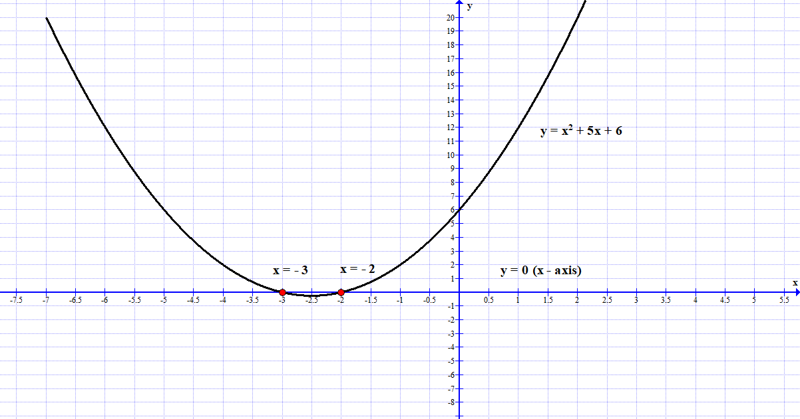
Example 2: Plot the graph of $y=x^{2}+5x+6$ and use it to solve $x^{2}+5x+4=0$
Solution: This is the same graph drawn in the Example 1 above. After plotting the graph, subtract the equation from the function and plot the resultant linear graph i.e.,
$$\begin{matrix}y=x^{2}+5x+6 \\ \underline{0=x^{2}+5x+4} \\ \underline{y=2 }\end{matrix}$$
The resultant linear graph is $y=2$ note (in the graph below) it cuts the graph function at;
$$x=-1 and x=-4$$
Hence the roots of $x^{2}+5x+4=0$ are - 1 and – 4.
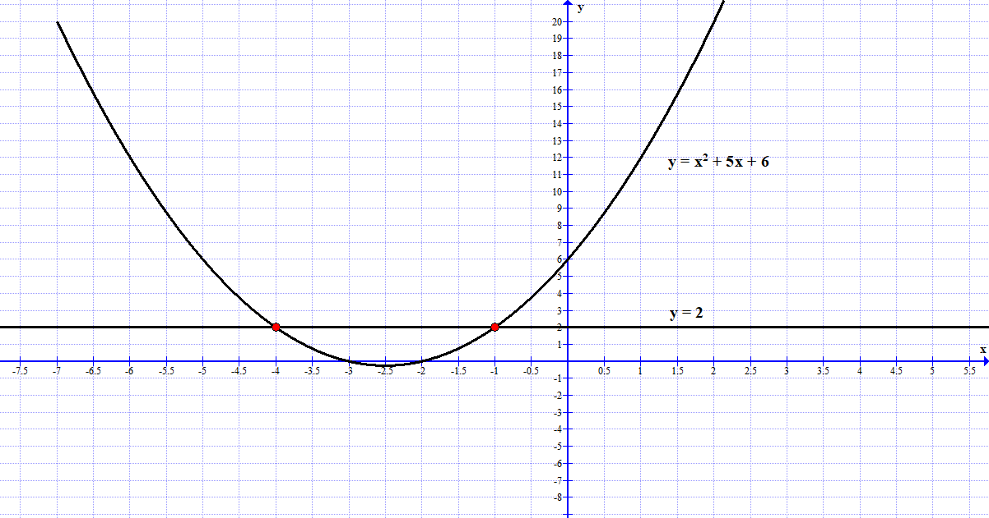
Example 3: Plot the graph of $y=x^{2}+5x+6$ and use it to solve $x^{2}+3x-4=0$
Solution: After plotting the graph, subtract the equation from the function and plot the resultant linear graph i.e.,
$$\begin{matrix}y=x^{2}+5x+6 \\ \underline{0=x^{2}+3x-4} \\ \underline{ y=2x+10 }\end{matrix}$$
The resultant linear graph is $y=2x+10$ note (in the graph below) it cuts the graph function at $x=1 and x=-4$
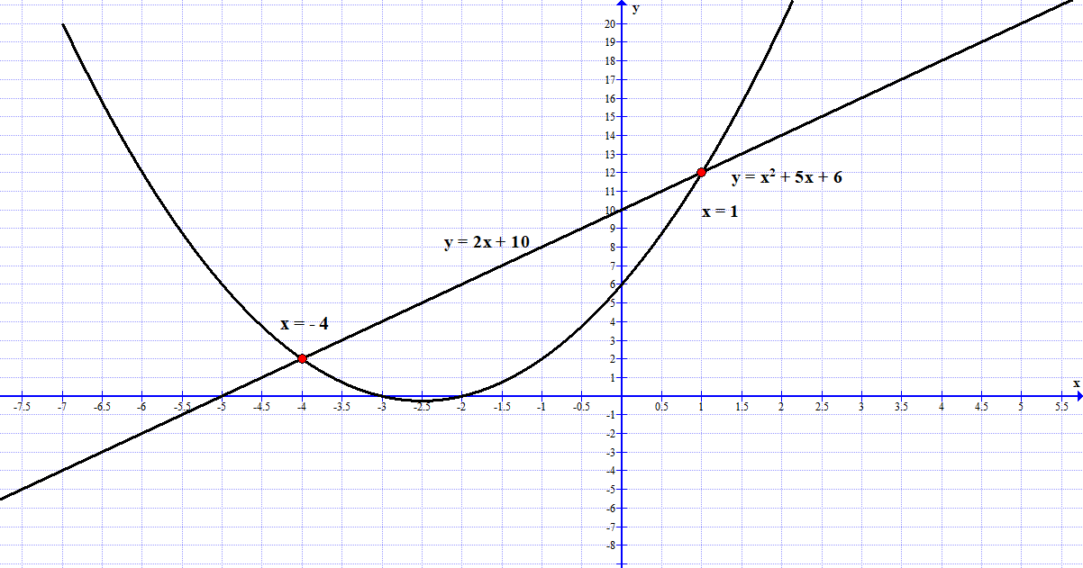

Example 4: Plot the graph of $y=x^{2}+5x+6$ and use it to solve $x^{2}+5x+9=0$
Solution: After plotting the graph, subtract the equation from the function and plot the resultant linear graph i.e.,
$$\begin{matrix}y=x^{2}+5x+6 \\ \underline{0=x^{2}+5x+9} \\ \underline{ y=-3 }\end{matrix}$$
The resultant linear graph is $y=-3$ note (in the graph below) it DOES NOT cut the graph function. Hence the roots of $x^{2}+5x+9=0$ are not real numbers but complex numbers.
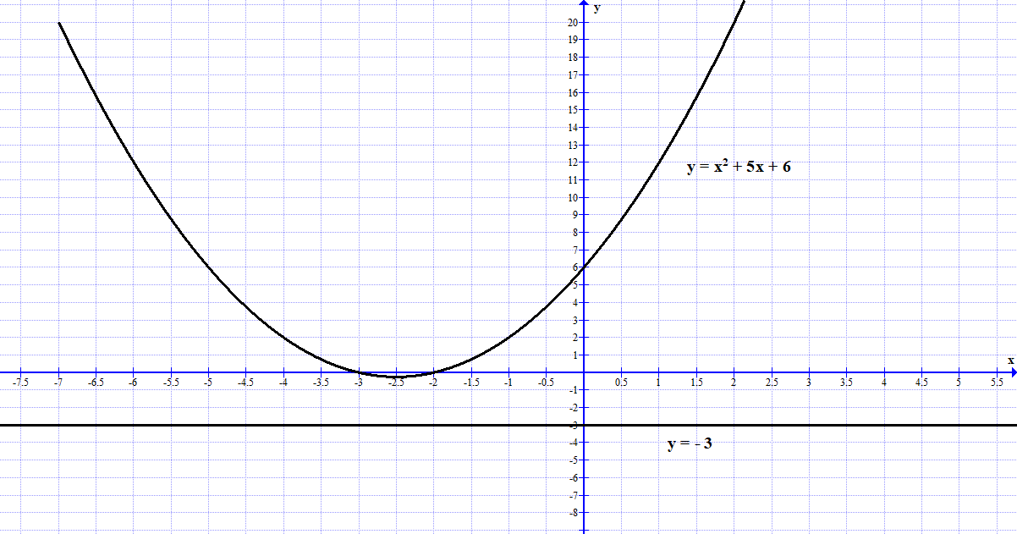Analytical solutions to quadratic functions
A quadratic function is a function of the form $y=ax^{2}+bx+c$ where a, b, and c are known constants, with $a≠0,$ and x and y are variables.
The objective of this lesson is to be able to investigate or analyze certain attributes of a quadratic function. These include;
- The x-intercepts
- The y intercepts
- The vertex
- The line of symmetry (line of axes) of the quadratic function
The graph of a quadratic function is an upright U or upside-down U, depending on the value of the coefficient $a$. The graph is called a parabola. If $a>0$ then the graph is an upright U but if $a<0$ then the graph is an upside-down U.
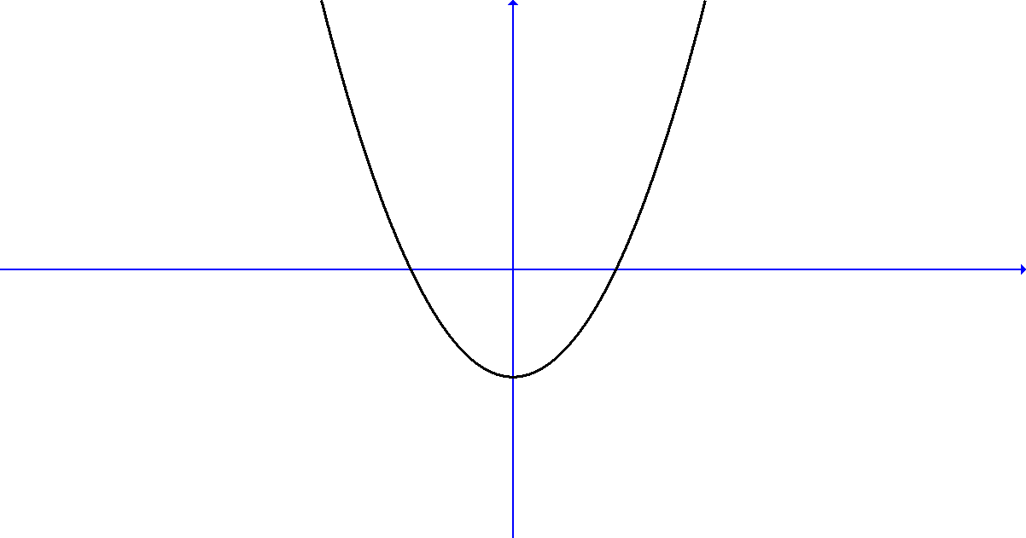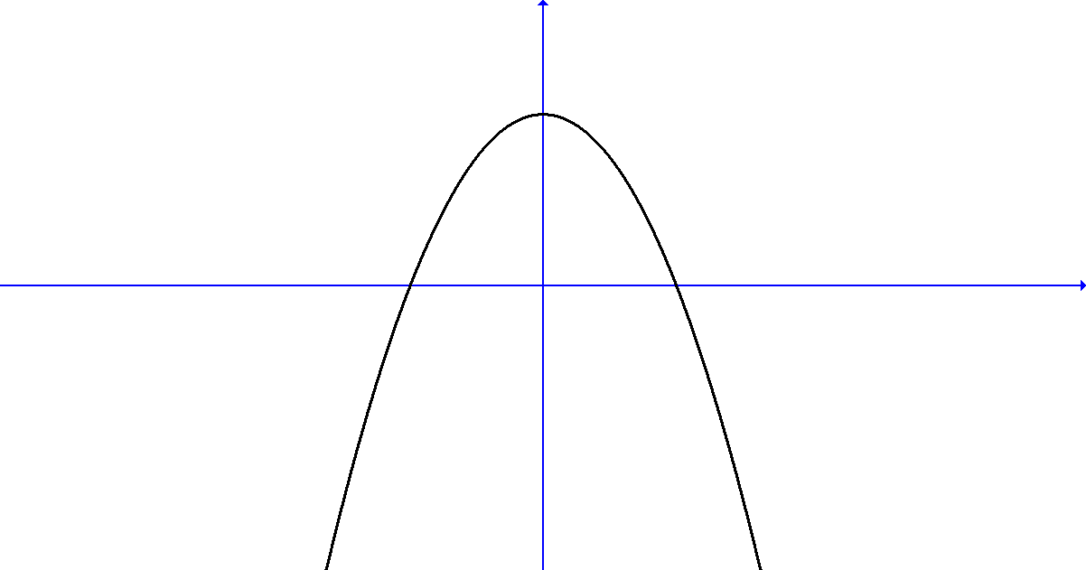
y-intercept: Given $y=ax^{2}+bx+c$ then the y-intercept is the point $(0,c)$. For example, given $y=2x^{2}+3x+5$ then the graph has an upright U shape, and the y-intercept is the point $\left(0,4\right).$
x-intercepts: Given the graph function $y=ax^{2}+bx+c$ then at the x-intercepts the value of
$y=0$. Hence to get the x-intercepts we need to solve the quadratic equation $ax^{2}+bx+c=0$.
Note that there are three options; the quadratic function may cut the x-axis at only one point, two points or never (see graphs below).
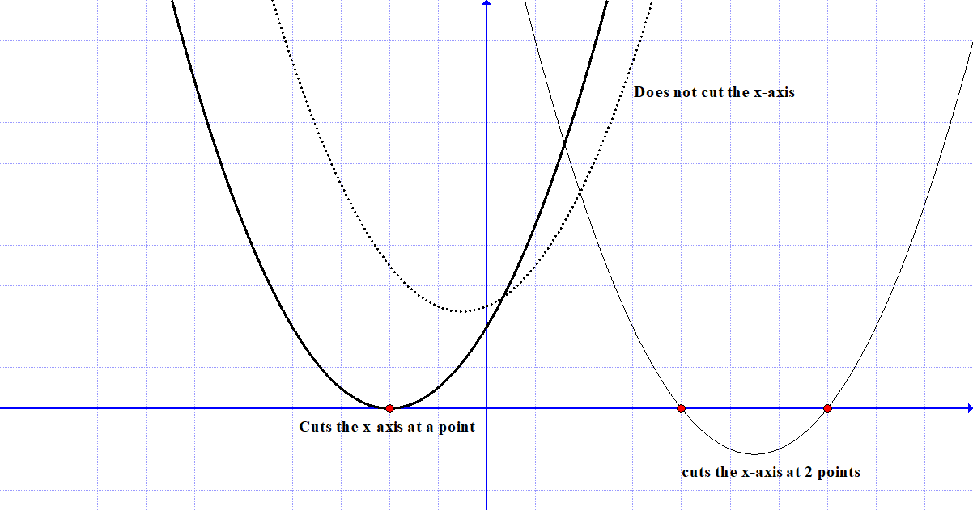
Example 1: Given $y=x^{2}-13x+40$ determine the y-intercept, and x-intercepts.
Solution: The y-intercept is the point $\left(0, 40\right)$.
To get the x-intercept, we solve the equation $x^{2}-13x+40=0$
$$x=\frac{13±\sqrt{{\left(-13\right)}^{2}-4×1×40}}{2}=\frac{13±3}{2}=\frac{16}{2}=8 or\frac{10}{2}=5$$
Hence the x-intercepts are the points: $\left(5,0\right)and (8,0)$.

Vertex:
The graph of quadratic function has only one turning point or vertex. The line of symmetry passes through the vertex.
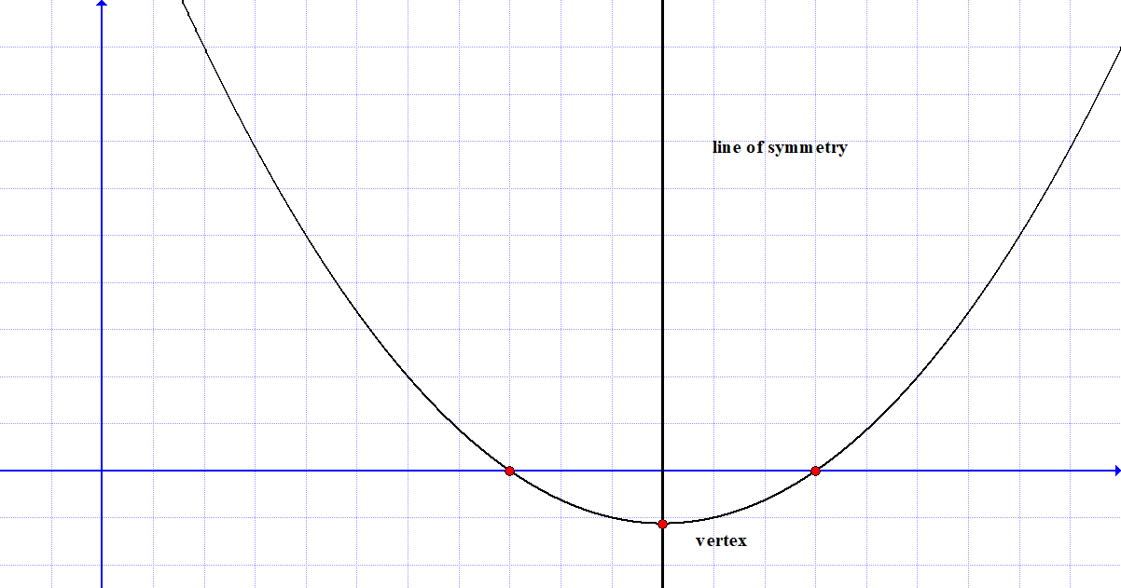
Note that if the vertex is point $(h,k)$ then the quadratic function $y=ax^{2}+bx+c$ can also be written as;
$$y=a{\left(x-h\right)}^{2}+k$$
This is called the vertex equation of a quadratic function while $y=ax^{2}+bx+c$ is the standard equation of a quadratic function.
The axis of symmetry will then be the line $x=h$
Definition: Given the standard form of the quadratic function $y=ax^{2}+bx+c$ then the x-coordinate of the vertex (h, k) is;
$$h=-\frac{b}{2a}$$
Then the axis of symmetry is given as;
$$x=-\frac{b}{2a}$$
the y-coordinate of the vertex is given as;
$$k=c-\frac{b^{2}}{4a}$$
Alternatively, since the vertex is the point (h, k) then;
$$k=f\left(h\right)=f\left(-\frac{b}{2a}\right)$$
Hence the vertex is given as;
$$\left(h,k\right)=\left(-\frac{b}{2a}, c-\frac{b^{2}}{4a}\right)$$
Example 1: Given the quadratic function $y=x^{2}-13x+40$ determine the vertex and the axis of symmetry.
Solution: Note that $a=1, b=-13, c=40$
Hence; $h=-\frac{b}{2a}=\frac{13}{2}=6.5$
$$k=f\left(-\frac{b}{2a}\right)=f\left(6.5\right)=-2.25$$
Alternatively,
$$k=c-\frac{b^{2}}{4a}=40-\left(\frac{169}{4}\right)=40-42.25=-2.25$$
The axis of symmetry is the line; $x=h=6.5$
Example 2: Given the standard quadratic function $y=x^{2}-13x+40$ convert it into the vertex form $y=a{\left(x-h\right)}^{2}+k$
Solution: $y=x^{2}-13x+40$, we add a k such that;
$$y=\left(x^{2}-13x+k \right)+40-k$$
Complete the square in the parenthesis, recall that $k={\left(\frac{b}{2}\right)}^{2}$hence we have;
$y=\left(x^{2}-13x+{\left(-\frac{13}{2}\right)}^{2} \right)+40-{\left(-\frac{13}{2}\right)}^{2}$
$$y={\left(x-\frac{13}{2}\right)}^{2}+40-42.25$$
$$y={\left(x-6.5\right)}^{2}+\left(-2.25\right)-Vertex form$$
Example 3: Given the function $y=4x^{2}+11x+7$ convert it into vertex form and hence determine the vertex and axis of symmetry.
Solution: We need to write the function in vertex form. We first divide everything by 4 to make the coefficient of $x^{2}=1$ i.e. $\frac{y}{4}=x^{2}+\frac{11}{4}x+\frac{7}{4}$
Then add a k to the RHS such that;
$\frac{y}{4}=\left(x^{2}+\frac{11}{4}x+k\right)+\frac{7}{4}-k$ , where $k={\left(\frac{b}{2}\right)}^{2}={\left(\frac{11}{8}\right)}^{2}$
$$\frac{y}{4}=\left(x^{2}+\frac{11}{4}x+{\left(\frac{11}{8}\right)}^{2}\right)+\frac{7}{4}-{\left(\frac{11}{8}\right)}^{2}$$
$$\frac{y}{4}={\left(x+\frac{11}{8}\right)}^{2}+\frac{7}{4}-\frac{121}{64}$$
$$\frac{y}{4}={\left(x+\frac{11}{8}\right)}^{2}+\left(-\frac{9}{64}\right)$$
$$y=4{\left(x+\frac{11}{8}\right)}^{2}-\frac{9}{16}$$
Hence our vertex $\left(h,k\right)=\left(-\frac{11}{8},-\frac{9}{16}\right)$.
We can check; $h=-\frac{b}{2a}=-\frac{11}{8}$ ; $k=c-\frac{b^{2}}{4a}=7-\frac{121}{16}=-\frac{9}{16}$
Exercise
- Determine the y-intercept, the x-intercepts, the vertex, axes of symmetry, and convert into vertex form the following functions;

- $y=x^{2}-7x+12$
- $y=x^{2}-11x+28$
- $y=x^{2}+x-12$
- $y=16x^{2}-8x-3$
- $y=x^{2}+x+1$
- $y=15x^{2}-8x+1$

- Plot the graph of $y=x^{2}-7x+12$ and hence use it to solve $x^{2}-7x+12=0$
- Plot the graph of $y=x^{2}+6x-16$ and hence use it to solve $x^{2}+6x-16=0$
- Plot the graph of $y=2x^{2}+7x-15$ and hence use it to solve $2x^{2}+7x-15=0$
- Plot the graph of $y=x^{2}+3x-4$ and hence use it to solve;
- $x^{2}+3x-4=0$
- $x^{2}+3x+4=0$
- $x^{2}+2x-8=0$

Bibliography
Antony, C., & Robert, D. (2006). Foundation Maths. Prentice Hall.
Kahenya, P. (2017). Foundation Maths. LAP Lambert Academic Publishers.
Murray, S., & Robert, M. (2009). College Algebra. McGraw-Hill.
Seymour, L. (2020). Set Theory and Related Topics. McGraw-Hill.

