Basic Mathematics
Lecture 12
Statistics: Measures of central tendency, and variation (Grouped data)
Lecturer: Kahenya, N.P

Introduction to lecture 12
This lecture introduces you to basic statistics. It discusses the measures of central tendency and measures of variation/spread/dispersion for grouped data.
Intended learning outcomes
At the end of this lecture you will be able to;
- Define measures of central tendency and measures of variation.
- Calculate measures of central tendency, and variation for grouped data.
References
These lecture notes should be complemented with relevant topics in (Antony & Robert, 2006; Kahenya, 2017; Upton & Cook, 2001).
Measures of central tendency (Grouped data)
In the previous lecture we dealt with ungrouped data set. In this lecture we shall find the arithmetic mean, mode, and median by calculation and by use of graphs. One can use a histogram to find the mode, while the median can be estimated from a cumulative frequencies curve (ogive).
Example 1: Consider the data set below and hence find the; Arithmetic mean, Arithmetic mean using the assumed mean A, Mode, Median, plot a histogram and estimate the mode, and plot a cumulative frequency curve and estimate the median.
Class | 10 – 14 | 15 – 19 | 20 – 24 | 25 – 29 | 30 – 34 | 35 – 39 | 40 – 44 | 45 – 49
$$f$$ | 2 | 5 | 7 | 9 | 14 | 8 | 6 | 1

Solution:
- To calculate the arithmetic mean we use the formula; $\overline{x}=\frac{∑fx}{∑f}$
In our case x will be the midpoints of the given classes. Hence, we need a table with the additional rows.
class | 10 – 14 | 15 – 19 | 20 – 24 | 25 – 29 | 30 – 34 | 35 – 39 | 40 – 44 | 45 - 49 | Total
$$f$$ | 2 | 5 | 7 | 9 | 14 | 8 | 6 | 1 | 52
$$x$$ | 12 | 17 | 22 | 27 | 32 | 37 | 42 | 47
$$fx$$ | 24 | 85 | 154 | 243 | 448 | 296 | 252 | 47 | 1549
$$\overline{x}=\frac{∑fx}{∑f}=\frac{1549}{52}≈29.79$$
- Arithmetic mean, using an assumed mean A
When one needs a quick mean or doesn’t have time to calculate one, one can take any class midpoint more so the one at the center (in case the data is normally distributed), and work with it to interpret the data set. This is called a working mean or an assumed mean A. To calculate the arithmetic mean using an assumed mean A we use the formula;
$$\overline{x}=A+\frac{∑fd}{∑f}, where d=x-A$$
We need some more rows for the values of d. We shall use A = 32 as our assumed mean, since it lies almost at the middle of the data set.
class | 10 – 14 | 15 – 19 | 20 – 24 | 25 – 29 | 30 – 34 | 35 – 39 | 40 – 44 | 45 - 49 | Total
$$f$$ | 2 | 5 | 7 | 9 | 14 | 8 | 6 | 1 | 52
$$x$$ | 12 | 17 | 22 | 27 | 32 | 37 | 42 | 47
$$d=x-A$$ | -20 | -15 | -10 | -5 | 0 | 5 | 10 | 15
$$fd$$ | -40 | -75 | -70 | -45 | 0 | 40 | 60 | 15 | -115

$$\overline{x}=A+\frac{∑fd}{∑f}=32+\frac{-115}{52}≈29.79$$

- Mode
Mode of grouped data is not as straight forward as for ungrouped data. In grouped data the mode can be any value in the class interval. Hence, we need a formula to calculate the mode.
$$M_{0}=l+\frac{f_{0}-f_{1}}{2f_{0}-f_{1}-f_{2}}×i$$
Where;
l – is the adjusted lower-class limit of the modal class (to get the modal class, find the modal frequency f₀ first).
f₀ – the modal frequency (the highest frequency in the data set)
f₁ – the frequency BEFORE f₀
f₂ – the frequency AFTER f₀
i – the class interval or class size
In our case, the modal frequency f₀ is 14. Hence, the modal class is class 30 – 34 i.e., our mode lies within this class. To improve on accuracy, we need to adjust the class i.e., 29.5 – 34. 5. Note that 30 is the lower-class limit and 34 is the upper-class limit. After adjusting the class, we have 29.5 as our adjusted lower-class limit (or lower-class boundary) and 34.5 as adjusted upper-class limit (or upper-class boundary). The class interval or class size $i$ is the difference between the adjusted lower-class limit and adjusted upper class limit. In our case;
$$i=34.5-29.5=5$$
We now have our values as;
$$l=29.5, f_{0}=14, f_{1}=9, f_{2}=8, i=5$$
$$M_{0}=l+\frac{f_{0}-f_{1}}{2f_{0}-f_{1}-f_{2}}×i=29.5+\frac{14-9}{2×14-9-8}×5=29.5+\frac{5}{11}×5≈31.77$$

- Median
We need to use a formula to find the median $M_{d}$ just like the mode,.
$$M_{d}=l+\frac{\frac{N}{2}-cf}{f}×i$$
Where;
l – adjusted lower-class limit of the median class
f – frequency of the median class
cf – the cumulative frequency BEFORE the median class
i – the class size or class interval
$\frac{N}{2}$ – the median position
The first step is to find the median position. We need to cumulate the frequency to identify the median position and hence the median class. Cumulative frequency (cf) column is like ranking the frequencies to identify the middlemost position.
Class | 10 – 14 | 15 – 19 | 20 – 24 | 25 – 29 | 30 – 34 | 35 – 39 | 40 – 44 | 45 – 49
F | 2 | 5 | 7 | 9 | 14 | 8 | 6 | 1
Cf | 2 | 7 | 14 | 23 | 37 | 45 | 51 | 52
The median position is 26.5th (since N = 52 which is an even number. Note that if the N is a very large number, we ignore the 0.5).
The 26.5th position is at cumulative frequency 37 (here we have positions 24 up to 37).
Hence our median class is class 30 – 34. Which means the l = 29.5. The cumulative frequency BEFORE the median class cf = 23
The median frequency f = 14.
Therefore; $M_{d}=l+\frac{\frac{N}{2}-cf}{f}×i=29.5+\frac{26.5-23}{14}×5=29.5+\frac{3.5}{14}×5=30.75$
Remark: The mean = 29. 79, mode = 31.77, and median = 30.75 lies almost in the same neighborhood. Since the three are measures of central tendency, and the data set is almost normally distributed.
- Mode using a histogram
Definition 1: A histogram is one way to represent grouped data. A histogram is a bar graph for continuous data set. A histogram can be used to get the mode of the data set.
Procedure of drawing a histogram:
A histogram is drawn by plotting the frequencies against the lower-class boundaries.
The size of the bar is proportional to the frequency i.e., the area of the bars represents the given frequency. Sometimes you may find grouped data with no uniform class intervals. Hence if for instance the class interval is doubled, then the frequency is halved.
Estimating the mode using a histogram
To estimate the mode, follow the steps below.
- Identify the highest bar. The mode is in this class.
- Draw a diagonal from the top-left corner of this bar, to touch the top-left corner of the bar opposite this corner.
- Draw a diagonal from the top right corner of this highest bar, to touch the top right corner of the bar opposite this corner.
- Drop a perpendicular from the point of intersection of these diagonals, to the horizontal axis.
- The mode is the point where the perpendicular touches the horizontal axis.

Example 1
Class | 10 – 14 | 15 – 19 | 20 – 24 | 25 – 29 | 30 – 34 | 35 – 39 | 40 – 44 | 45 – 49
f | 2 | 5 | 7 | 9 | 14 | 8 | 6 | 1
Lower class boundaries | 9.5 | 14.5 | 19.5 | 24.5 | 29.5 | 34.5 | 39.5 | 44.5

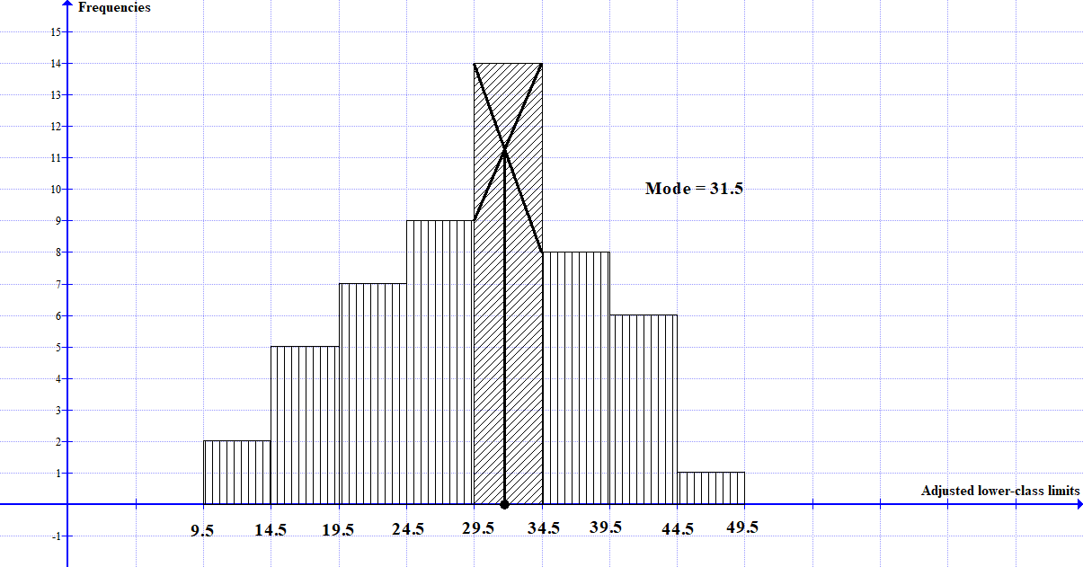
From the histogram the mode is approximately 31.5 (compare with calculated value of 31.77).
- Median using a cumulative frequencies curve
Definition: The cumulative frequencies curve is also referred to as an Ogive or an S- curve. If the data is normally distributed the curve makes a smooth letter S, hence the name S-curve.
To plot the cumulative frequencies curve, we plot the cumulative frequencies against the adjusted upper-class limits.
If the first class has non-zero frequency, then you need to add another class with zero frequency such that the ogive starts from zero.
Join the points to get a smooth curve. Note that in this example the median position is 26.5th.
Next, along the cumulative frequency axis identify the 26.5 point and then draw a line parallel to the horizontal axis. At the point of intersection with the ogive, drop a perpendicular to get the median. In our case about 31 (see Ogive below).
Class | 5 - 9 | 10 – 14 | 15 – 19 | 20 – 24 | 25 – 29 | 30 – 34 | 35 – 39 | 40 – 44 | 45 – 49
f | 0 | 2 | 5 | 7 | 9 | 14 | 8 | 6 | 1
cf | 0 | 2 | 7 | 14 | 23 | 37 | 45 | 51 | 52
Upper class boundaries | 9.5 | 14.5 | 19.5 | 24.5 | 29.5 | 34.5 | 39.5 | 44.5 | 49.5

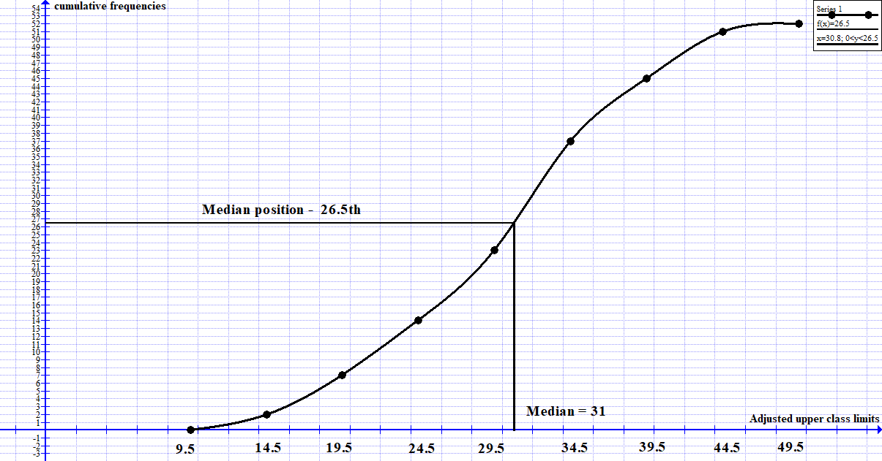

Measures of variation (grouped data)
Example 1: The performance in a math quiz for a group of students was recorded as below. Calculate the interquartile range, and the standard deviation.
Marks | 10 -19 | 20 - 29 | 30 – 39 | 40 – 49 | 50 – 59 | 60 – 69 | 70 – 79 | 80 – 89 | 90 - 99
No. of students | 1 | 2 | 7 | 10 | 14 | 6 | 5 | 3 | 2

Solution:
- The interquartile range
Marks | 10 -19 | 20 - 29 | 30 – 39 | 40 – 49 | 50 – 59 | 60 – 69 | 70 – 79 | 80 – 89 | 90 - 99
No. of students | 1 | 2 | 7 | 10 | 14 | 6 | 5 | 3 | 2
Cumulative freq. | 1 | 3 | 10 | 20 | 34 | 40 | 45 | 48 | 50
Recall that $IQR=Q_{3}-Q_{1}$. To find the third quartile we use the formula;
$$Q_{3}=l+\frac{\frac{3}{4}N-cf}{f}×i$$
This formula is similar with the formula for finding the median (median is the same as $Q_{2}$)
The third quartile is at position $\frac{3}{4}×50={37.5}^{th}$ position (at cumulative frequency 40). Hence, the 3rd quartile class is class 60 – 69, with a frequency f = 6.
Hence the adjusted lower-class limit l = 59.5
The cumulative frequency BEFORE the 3rd quartile class is 34. Class size is 10
Therefore, $Q_{3}=l+\frac{\frac{3}{4}N-cf}{f}×i=59.5+\frac{37.5-34}{6}×10=59.5+5.833≈65.33$
Next, to find the first quartile we use the formula;
$$Q_{1}=l+\frac{\frac{1}{4}N-cf}{f}×i$$
The first quartile is at position $\frac{1}{4}×50={12.5}^{th}$ position (at cumulative frequency 20). Hence, the 1st quartile class is class 40 – 49, with a frequency f = 10.
Hence the adjusted lower-class limit l = 39.5
The cumulative frequency BEFORE the 1st quartile class is 10. Class size is 10.
Therefore, $Q_{1}=l+\frac{\frac{1}{4}N-cf}{f}×i=39.5+\frac{12.5-10}{10}×10=39.5+2.5=42$
Therefore, $IQR=Q_{3}-Q_{1}=65.33-42=23.33$
- Standard deviation
To calculate the standard deviation, we use the formula;
$$σ=\sqrt{\frac{∑fx^{2}}{∑f}-{\overline{x}}^{2}}$$
We therefore need to find the mean $\overline{x}$, $x^{2}$, and $fx^{2}$ (a table will facilitate this working).
Marks | $$F$$ | $$x$$ | $$Fx$$ | $$x^{2}$$ | $$fx^{2}$$
10 – 19  20 – 29  30 – 39  40 – 49  50 – 59  60 – 69  70 – 79  80 – 89  90 – 99 | 1  2  7  10  14  6  5  3  2 | 14.5  24.5  34.5  44.5  54.5  64.5  74.5  84.5  94.5 | 14.5  49  241.5  445  763  387  372.5  253.5  189 | 210.25  600.25  1190.25  1980.25  2970.25  4160.25  5550.25  7140.25  8930.25 | 210.25  1200.5  8331.75  19802.5  41583.5  24961.5  27751.25  21420.75  17860.5
 | $$∑f=50$$ |  | $$∑fx=2715$$ |  | $$∑fx^{2}=163122.5$$
$$σ=\sqrt{\frac{∑fx^{2}}{∑f}-{\overline{x}}^{2}}=\sqrt{\frac{163122.5}{50}-{\left(\frac{2715}{50}\right)}^{2}}=\sqrt{3262.45-2948.49}=\sqrt{313.96}≈17.72$$
Exercise
- The marks obtained by a group of students in a quiz were recorded as below;
Marks | 1- 5 | 6 – 10 | 11 – 15 | 16 – 20 | 21 – 25 | 26 – 30 | 31 - 35
No. of students | 2 | 12 | 20 | 15 | 11 | 6 | 4
Calculate the interquartile range, quartile deviation, variance, and the standard deviation.
- Students’ performance in a certain math quiz was recorded as below;
Marks | 10 -19 | 20 - 29 | 30 – 39 | 40 – 49 | 50 – 59 | 60 – 69 | 70 – 79 | 80 – 89 | 90 - 99
No. of students | 10 | 13 | 16 | 19 | 27 | 21 | 15 | 11 | 8
Use the above data to find; Arithmetic mean, Arithmetic mean using an assumed mean, mode, median, mode using a histogram, and median using a cumulative frequencies curve

Bibliography
Antony, C., & Robert, D. (2006). Foundation Maths. Prentice Hall.
Kahenya, P. (2017). Foundation Maths. LAP Lambert Academic Publishers.
Upton, G., & Cook, I. (2001). Introduction to Statistics (2nd ed.). Oxford University Press.

