Seminar Plan
Recruitment and selection for international assignments

Tutorial at a glance
Lecture recap
Advantages and disadvantages of types of labor
Problem solving activities

Warm –up: Homework and summary of the last tutorial
Activity 1 Lecture recap. (15 min)
Questions
- What are four staffing policies on key positions at headquarters and subsidiaries?
    - Ethnocentric
Strategic decisions are made at headquarters
Limited subsidiary autonomy
Key positions in domestic and foreign operations are held by headquarters’ personnel; PCNs manage subsidiaries

    - Polycentric
Each subsidiary is a distinct national entity with some decision-making autonomy
HCNs manage subsidiaries who are seldom promoted to HQ positions
PCNs rarely transferred to subsidiary positions

    - Geocentric
A global approach - worldwide integration
View that each part of the organization makes a unique contribution
Nationality ignored in favour of ability:
Best person for the job
Colour of passport does not matter when it comes to rewards, promotion and development
    - Regiocentric
Reflects a regional strategy and structure
Regional autonomy in decision making
Staff move within the designated region, rather than globally
Staff transfers between regions are rar
- What are the types of international assignments?

- Short term
  - Up to 3 months
- Extended
  - Up to 1 year
- Long term
  - Varies from 1 to 5 years
  - The traditional expatriate assignment
- What are the roles of an expat in MNC host country?

- Agent of direct control
- Agent of socialization
- Network builder
- Boundary spanner
- Language node
- Transfer of competence and knowledge

Activity 2 Advantages and Disadvantages of PCN, TCN, HCN (25 min)

- Students are asked to brainstorm the advantages and disadvantages.
- Students present their ideas.
- Teacher refers to the table on the next page. We can print and give to students.

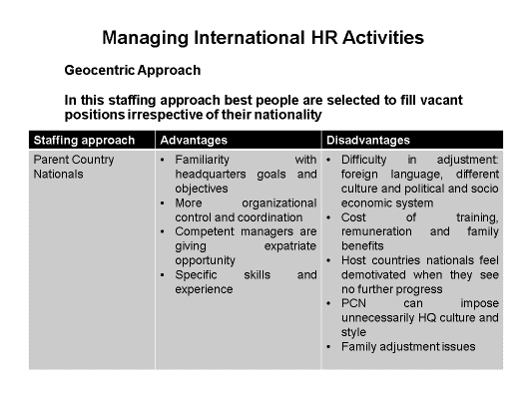
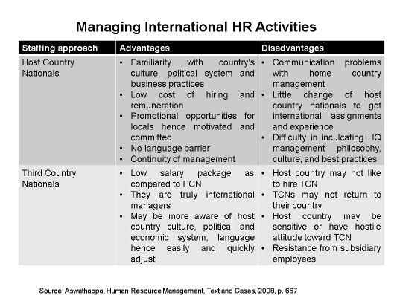

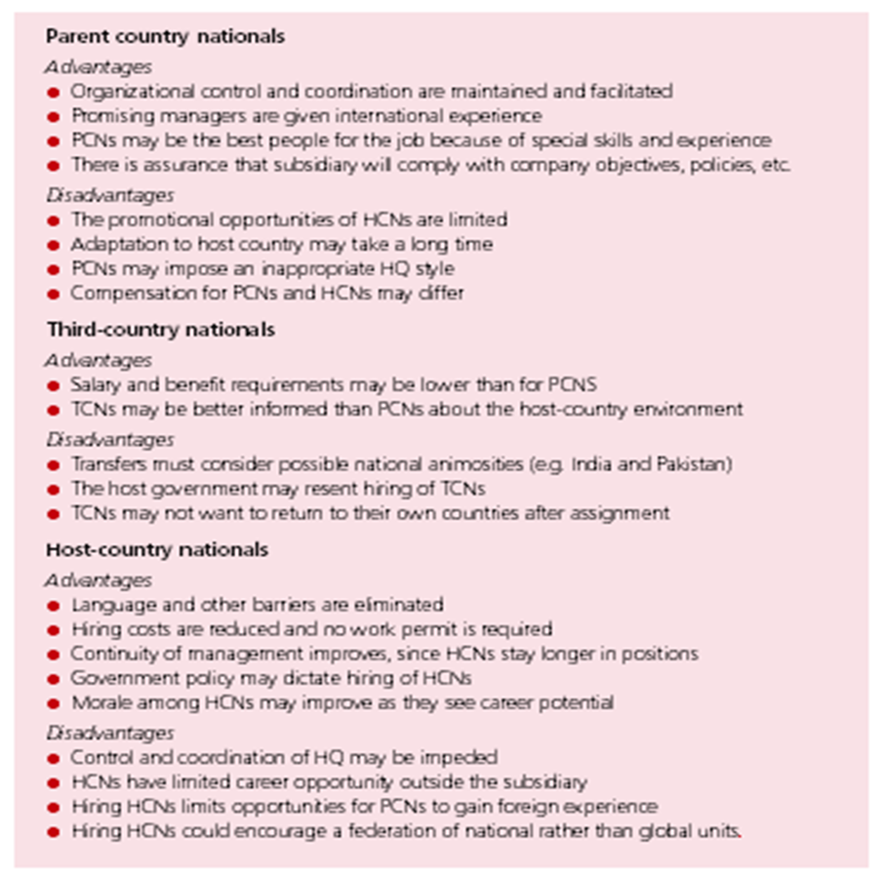

Activity 3 Controlling by Staffing Case studies

- Students are challenged to do problem solving case studies (Mead , p 400-402)

“What did you learn?”
Each student is asked to give one sentence summary of the new material

