1-Lectures. INTRODUCTION TO DIGITAL BUSINESS MODELS

Content
- What is the digital economy ?
- What is the digital transformation ?
- Benefits of digital economy
- Digital business models in the development of digitalization

What is the digital economy ?
The digital economy is an economy that is based on digital computing technologies, but is often perceived as conducting business through markets based on the internet and the World Wide Web. It is also known as the Internet Economy, New Economy, or Web Economy.

Digital economy and its benefits
The importance of the digital economy. The COVID-19 pandemic has accelerated the process of digital transformation and added urgency for Governments to respond. A key challenge is how to govern and harness the surge in digital data for the global good. It has been estimated that global Internet traffic in 2022 will exceed all the Internet traffic up to 2016. (António Guterres
Secretary-General United Nations)
Fundamentals of the digital economy. Don Tapscott first coined the term digital economy in his 1995 best-selling book The Digital Economy: Promise and Peril in the Age of Networked Intelligence. Nicholas Negroponte, founder of the Massachusetts Institute of Technology's Media Lab and author of the 1995 book Being Digital, has described the digital economy as using "bits instead of atoms."
The digital economy is an economy that is based on digital computing technologies, but is often perceived as conducting business through markets based on the internet and the World Wide Web. It is also known as the Internet Economy, New Economy, or Web Economy.

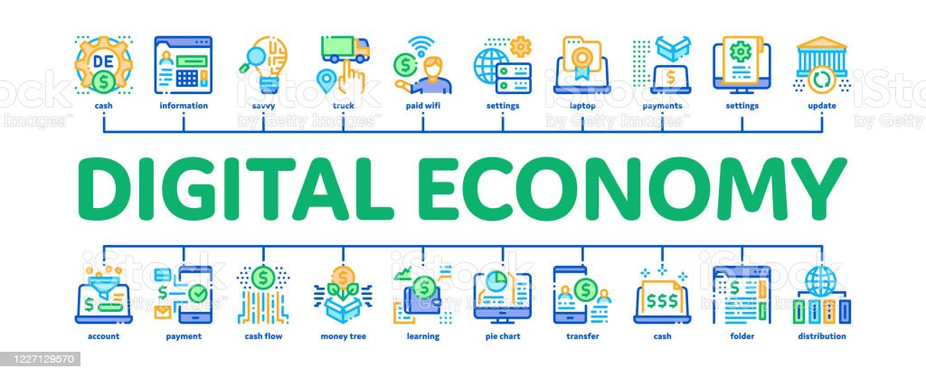
Source: https://www.istockphoto.com/vector/digital-economy-and-e-business-minimal-infographic-banner-vector-gm1227129570-361794272

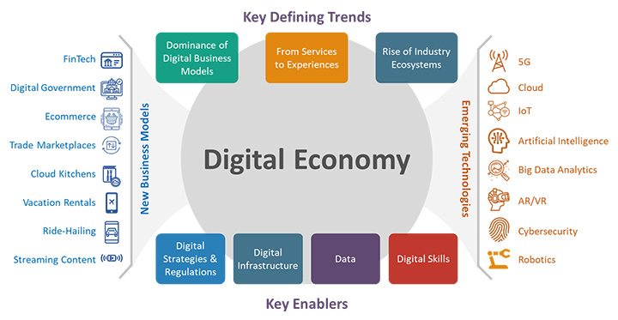
Source: https://e.huawei.com/br/eblog/industries/insights/2021/accelerating-digital-economy

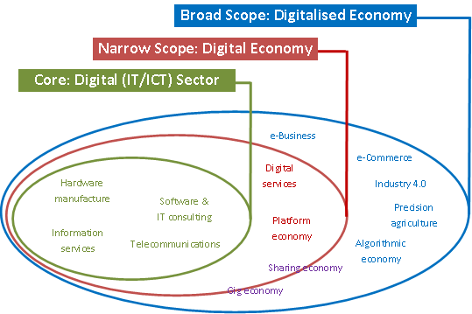
Source: https://diode.network/2017/07/10/defining-conceptualising-and-measuring-the-digital-economy/

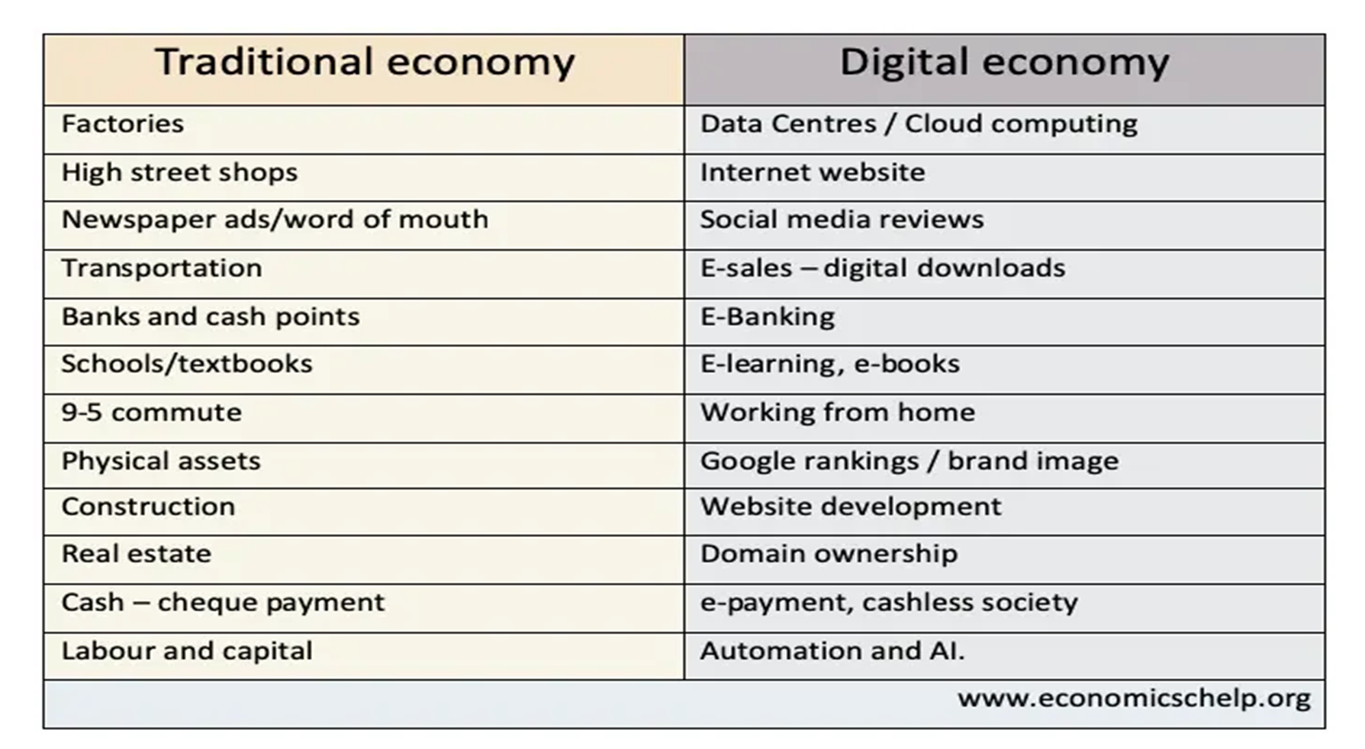
Digital technologies. The digital economy extends well beyond digitization and automation.Instead, this new paradigm harnesses multiple advanced technologies and new technology platforms. Those technologies and platforms include but aren't limited to: hyperconnectivity, the internet of things (IoT), big data, advanced analytics, wireless networks, mobile devices and social media. The digital economy uses these technologies, both individually and in concert, to rework traditional exchanges and enable new ones.
The penetration of digital technologies into our daily lives is expanding the usual scope of business, changing entire industries and opening up new markets. Large companies are waiting for the emergence of new players who can change the market with the help of new digital technologies. Each new technology and business model has the potential to explore new markets and deal serious blows to existing ones.
New digital technologies: artificial intelligence, big data, Internet of Things, smart city, cloud technologies, blockchain, cryptocurrency and more. high degree of automation; electronic document exchange; electronic integration; electronic databases; Availability of CRM (customer interaction system); Digital business models and processes. Digital transformation and other types.
What is the digital transformation ?
Digital transformation is the process of using digital technologies to create new - or modify existing - business processes, culture, and customer experiences to meet changing business and market requirements. This reimagining of business in the digital age is digital transformation (https://www.salesforce.com/products/platform/what-is-digital-transformation/).
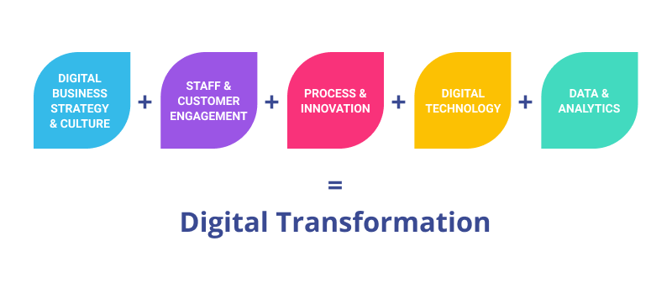
Source: https://www.revechat.com/blog/digital-transformation-examples
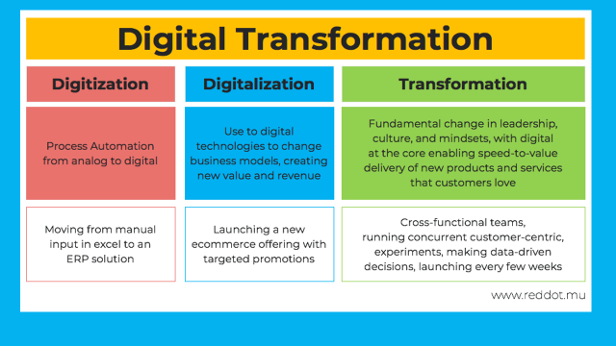
Source: https://www.reddot.mu
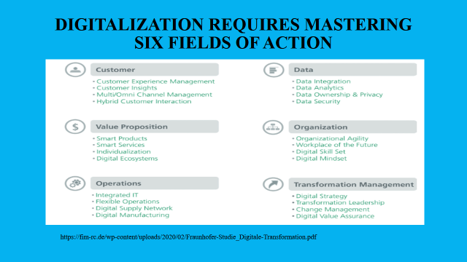
Digital transformation directions
  - Automation of operational and management workflows.
  - Make decisions based on BigData and predictive analytics.
  - Communication with customers, suppliers and staff.
  - Innovation in products, business models and operating models.
  - Risk and cybersecurity management
  - Creation of corporate culture

Key elements shaping the digital economy
The digital economy - is a system of economic, social and cultural communications based on the use of digital technologies. Sometimes it is also expressed in terms of the internet economy, the new economy, or the internet economy. (https://www.youtube.com/watch?v=6nkB5lnT0UI).
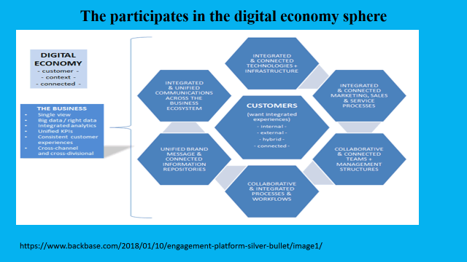
Benefits of digital economy
Advantages of the digital economy
Advantages of the digital economy:
- Greater information.
- Saves time.
- Reduced costs.
- Personalisation
- Lower barriers to entry.
- Creates significant data which can give new insights.
- Benefits for developing world.
- Enables people to work from home.

Greater information. The internet has enabled consumers to have greater information and choice. For example, it makes it easier to compare prices between firms. It also brings information to a person’s fingertips. This is particularly important for tourists going on holiday. Before the digital economy, it might not be possible to find the prices of hotels and bus timetables.
Saves time. Before if you needed office supplies, you would have to make a journey into town and purchase. Now, you can make an order over the internet and it will arrive the next day. This saves business labour costs.
Reduced costs. Firms can save on renting expensive buildings by running most of business through the internet. A digital economy enables firms to cut out an aspect of the retail chain and send personalised goods direct from factory or warehouse to people’s goods, rather than through shops. This enables lower costs and lower prices.
Personalisation. A digital economy allows greater personalisation than would be possible under traditional economy. For example, a traditional shop would only have room to stock a certain number of colours and sizes, but with the digital economy, a consumer can choose any preference and then the product can be custom-built e.g. 3D printer. For example, custom clothes that have particular sizes and colours to match individual preferences.
Lower barriers to entry. In some markets, aspects of the digital economy make it easier for new firms to enter. If an entrepreneur has an innovative idea that catches on, they can create a new product which challenges traditional firms. The digital economy has brought many new services which were inconceivable before, such as online home deliveries for grocery to dating apps.
Creates significant data which can give new insights. The mass production of data can help inform governments and charities about what is happening in the economy. For example, in tracking of COVID-19 spread, the use of an app on mobile phones may indicate where local hotspots emerge.
Benefits for developing world. The digital economy is opening up opportunities for the developing world. For example, computer programmers in India can easily underbid western counterparts, leading to new job opportunities and higher income in India.
Enables people to work from home. The digital economy has been a huge asset during the COVID lockdown. Without digital technologies, the decline in economic activity would have been even greater. The digital economy gives greater scope for people working from home and having greater flexibility in their hours (which may suit parents with children). Working from home can reduce contact and spread of a virus. It can also help reduce traffic congestion and pollution
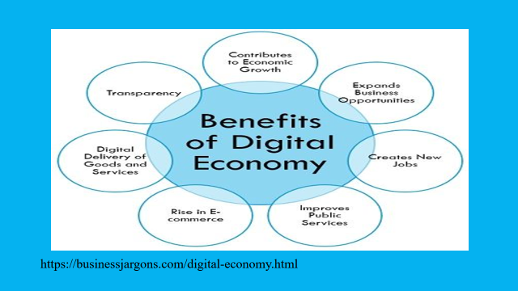

Digital business models in the development of digitalization
What is business model ?
• Provides insight into how the organization can benefit
• Describes the value the organization provides to various customers.
• reflects the ability of the organization and its partners to create, promote and communicate this value to customers;
• Indicates the sources of capital needed to generate sustainable income.
• It represents the method a company uses to create value and profit.
• will be linked to the company's competitive strategy
A digital business model is a model that aims to change several aspects and processes of a company or organize a new model with the help of digital technologies:
• relationships with clients;
• value proposition;
• income generation (monetization).
Digital business is a business project based on the interaction of people, companies and smart devices at the intersection of the physical and digital worlds. That is, interaction and complexity lie at the very basis here. Digital business is the creation of new business designs by blurring the digital and physical worlds. (https://www.gartner.com/en/information-echnology/glossary/digital-business).
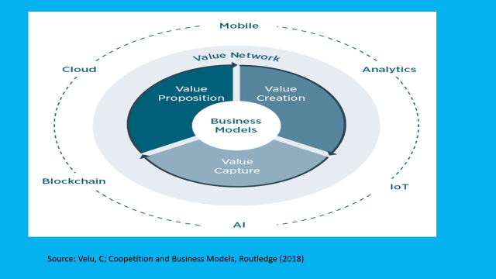

Digital business models are business models based on digital technologies
Radical business thinking (new customer benefits, new sources of profit)
Digital transformation of the business model:
• Activities (new products or services)
• Customer selection (new customer segments)
• Source of differentiation (creation of new values)
• production system (new production system, new ways of offering services)
• Organizational structure (new organizational structure)
• market access mechanism (new ways to distribute a product or service)
It doesn't have to be an entirely new product or service, it's about having a new way to offer that value.
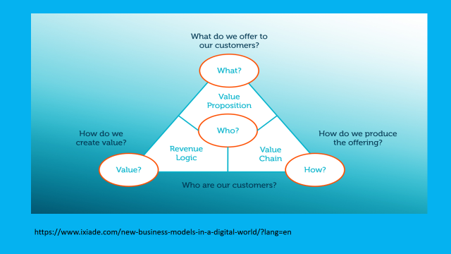

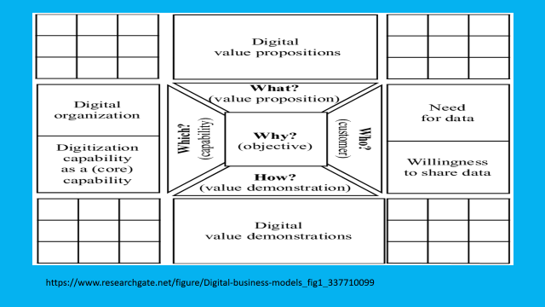

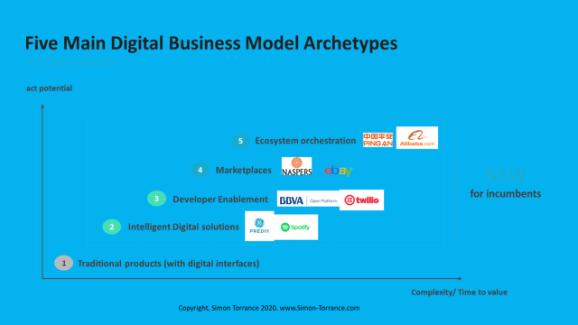

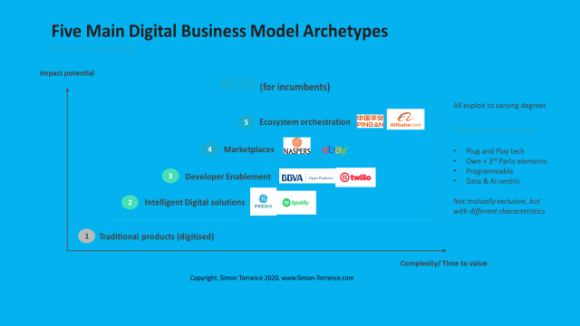

Reference
- Digital Business Models Concepts, Models, and the Alphabet Case Study Progress in IS Bernd W. Wirtz. Published by Springer (2019). ISBN 10: 3030130045 ISBN 13: 978303013004
- Electronic Business - Business Model Management : Concepts, Models, and the Alphabet Case Study.Wirtz, Bernd W.Published by Springer (2019).ISBN 10: 3030130045 ISBN 13: 9783030130046
- The Business Models Handbook: Templates, Theory and Case Studies Kindle Edition by Paul Hague (Author) Format: Kindle Edition. ASIN ‏ : ‎ B07LCRSFXG. Publisher: ‎ Kogan Page; 1st edition (January 3, 2019) Publication date ‏ : ‎ January 3, 2019. Language ‏ : ‎ English
- Data-Driven Business Models for the Digital Economy Paperback – April 21, 2020 by Rado Kotorov (Author) Publisher ‏ : ‎ Business Expert Press (April 21, 2020) Language ‏ : ‎ English, Paperback ‏ : ‎ 152 pages.ISBN-10 ‏ : ‎ 1951527801. ISBN-13 ‏ : ‎ 978-1951527808
- What's Your Digital Business Model?: Six Questions to Help You Build the Next-Generation Enterprise Hardcover – May 8, 2018. by Peter Weill (Author), Stephanie Woerner (Author). Publisher Harvard Business Review Press Year 2018. ISBN 9781633692718
- Digital Business Models. Perspectives on Monetisation. Adam Jabłoński, Marek Jabłoński. Publisher Taylor and Francis Year 2020.ISBN 9781000193657

https://unctad.org/webflyer/digital-economy-report-2021
https://www.techtarget.com/searchcio/definition/digital-economy
https://en.wikipedia.org › wiki › Digital_economy

