Mathematics for Science
Lecture 2
Polar Equations and Graphs
Lecturer: Kahenya, N.P

Introduction to lecture 2
This lecture will introduce the rectangular and polar coordinates systems.
Intended learning outcomes
At the end of this lecture you will be able to;
- Define rectangular and polar coordinates .
- Convert from one system to another.
- Plot graphs of polar equations.
References
These lecture notes should be complemented with relevant topics in (Kahenya, 2017; Stewart, 2012; Swokowski & Cole, 2009)

Definition 1: (Rectangular coordinates)
The rectangular plane is also referred to as the Cartesian plane or the $xy-plane$. Points on the plane are ordered pairs of x and y coordinates, representing the horizontal distance from the origin and the vertical distance from origin respectively. For example, point (3, 2) is a point 3 units along the horizontal axis, from the origin; and 2 units along the vertical axis, from the origin (0, 0).
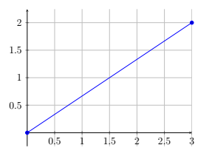

Definition 2: (Polar coordinates)
The Polar coordinates system is used to locate points on a plane. It is an ordered pair of $r$ distance from the origin or the pole, and $θ$, the angle between the polar axis and the point i.e. $P(r, θ)$. Consider the circle below with centre the origin
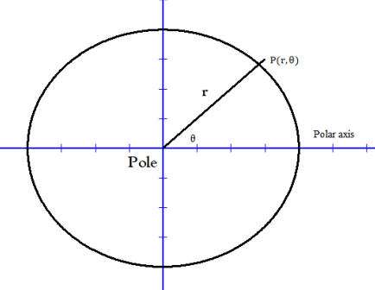
The origin is the pole. The horizontal axis is called the polar axis. The line OP = r, makes an angle $θ$ with polar axis. If r is the distance of point P from the pole, then the ordered pair $(r,θ)$ are the polar coordinates of point $P$ .
Remark
- One can use the polar coordinates graph to locate or identify polar coordinates of various points.
- $(r,θ)$ and $(-r,θ+π)$ denotes the same point e.g. $\left(7, {30}^{o}\right)=(-7, {210}^{0})$
- $r$is the directed distance.

Definition 3: (Polar and rectangular coordinates)
There is a relationship between the rectangular coordinates and the polar coordinates. One can convert from one system to another. Consider the diagram below that combines the two systems, point P(x, y) is the same as point $P(r,θ)$;
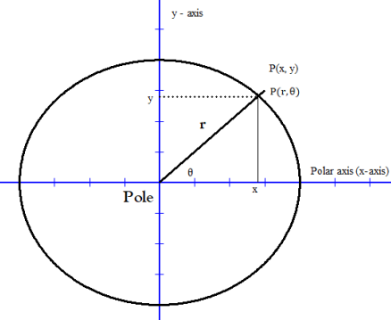
Applying the Pythagoras theorem we have; $x^{2}+y^{2}=r^{2}⋯(i)$
And by the basic trigonometric ratios ; $Sin θ=\frac{y}{r}⇒y=rSin θ⋯(ii)$
Again we have; $Cos θ=\frac{x}{r}⇒x=rCosθ⋯(iii)$. Note that $\tan{θ=\frac{y}{x}}$
Equations (i), (ii),and (iii) are used to convert coordinates from one system to another.

Example 1: Given the polar coordinates of a point $P(7,\frac{π}{3})$. Determine the rectangular coordinates of this point.
Solution: $P(r,θ)=P(7,\frac{π}{3})⇒r=7,θ=\frac{π}{3}$
But $x=rCosθ=7Cos\frac{π}{3}=7⋅\frac{1}{2}=3.5$
and $y=rSinθ=7 Sin\frac{π}{3}=7⋅\frac{\sqrt{3}}{2}=3.5\sqrt{3}$
$$∴P\left(x,y\right)=\left(3.5, 3.5\sqrt{3}\right)-Rectangular coordinates$$

Example 2: Convert into polar coordinates the rectangular coordinates (3, 5).
Solution: our $x=3, y=5$ but $r^{2}=x^{2}+y^{2}=>r^{2}=9+25=34∴r=\sqrt{34}$ units.
Also $\tan{θ=\frac{y}{x}=>θ=\tan^{-1}\left(\frac{y}{x}\right)=\tan^{-1}\left(\frac{5}{3}\right)}$
$$θ≈{59}^{0}$$
$$∴\left(3,5\right)=\left(\sqrt{34}, {59}^{0}\right)$$

Example 3: Convert to rectangular form the polar equation; $r=2Cosθ+3\sin{θ}$
Solution: Multiply both sides by $r$to get;
$$r^{2}=2rCosθ+3rSinθ \\ x^{2}+y^{2}=2x+3y \\ x^{2}-2x+y^{2}-3y=0$$

Example 4: Convert the equation $x^{2}+y^{2}=16$ into a polar equation.
Solution: It is given that $r^{2}=x^{2}+y^{2}∴we have r^{2}=16$ – polar equation.

Example 5: Convert the equation $3x-5y=9$ into a polar equation.
Solution: Recall that $x=r\cos{θ and y=rsin θ}$
Therefore we replace accordingly to get; $3rcosθ-5rsin θ=9$
$$3rcosθ-5rsin θ-9=0$$
Example 6: Convert to polar equation the rectangular equation $x^{2}+2xy+3y^{2}-2x+4y=7$
Solution: $r^{2}\cos^{2}{θ+2r^{2}\sin{θcosθ+3r^{2}\sin{θ-2rcosθ+4rsin θ-7=0}}}$

Definition 4: (Mod-arg form/polar coordinates of Complex numbers)
Consider the Argand diagram below.
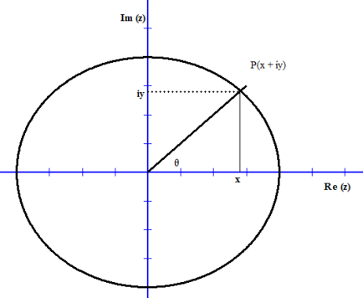
We can write the complex number $z=x+iy$ in terms of cosine and sine.
$$z=x+iy=r\cos{θ+irsin θ}=r \left(cosθ+isin θ\right)-polar coordinate form of z$$
Example 1: Find the modulus and the principal arg of $(5+2i)$.
Solution: It is clear that $x=5, y=2$. By definition $\left|z\right|=\sqrt{x^{2}+y^{2}}=\sqrt{5^{2}+2^{2}}=\sqrt{29}$ units. From lecture 1 we saw that $\arg{z=θ=>\tan{θ=\frac{2}{5}∴θ=\tan^{-1}\left(\frac{2}{5}\right)≈{21.8}^{0}}}$
Example 2: Express $(3+7i)$ in mod-arg form (polar coordinate form).
Solution: The complex number $(x+iy)$ in polar form is given by $r(cosθ+isin θ)$.
Our x = 3 and y = 7. Therefore;
$$r=\left|z\right|=\sqrt{\left(3^{2}+7^{2}\right)}=\sqrt{58}$$
$\tan{θ=\frac{7}{3}=>θ=\tan^{-1}\left(\frac{7}{3}\right)≈{66.8}^{0}}$ i.e. $\left(\sqrt{58},{66.8}^{0}\right)$
Note that; $z=\sqrt{58}(\cos{{66.8}^{0}+isin {66.8}^{0})}$

Definition 1: (Polar graphs) Polar graphs or curves are curves of the equations of the form $r=f\left(θ\right)$ or $F\left(r, θ\right)=0$ that consists of all points p that have at least a point $(r,θ)$ that satisfy the polar equation. Polar curves have nice and interesting shapes e.g. the butterfly curve, Limacons, Roses, Archimedean spiral (Mathcurve, n.d.) etc. shapes can be designed along polar curves while there are areas while the concept of polar curves are used design technologies.
Example 1: Sketch polar graph the graph of $r=3cosθ$
Solution: One can either draw the graph manually on a polar graph paper or use a graphing device or Integrated writing environments such as TexStudio (TexStudio, n.d.).
$$θ$$ | 0 | $${15}^{0}$$ | $$30^{0}$$ | $$45^{0}$$ | $$60^{0}$$ | $75^{0}$ | $$90^{0}$$ | $$105^{0}$$ | $$120^{0}$$ | $$135^{0}$$ | $$150^{0}$$ | $$165^{0}$$ | $$180^{0}$$
$$r=3 cosθ$$ | 3 | 2.9 | $$2.6$$ | 2.1 | 1.5 | 0.8 | 0 | -0.8 | -1.5 | -2.1 | -2.6 | -2.9 | -3

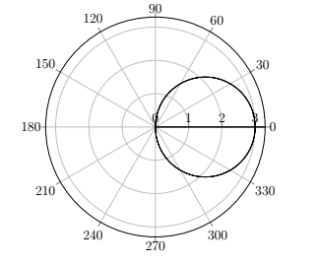

More polar graphs drawn using TexStudio©
$r=\sin{2θ}$ | $$r=1+sinθ$$
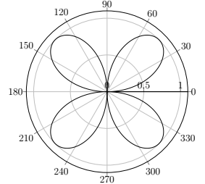 | 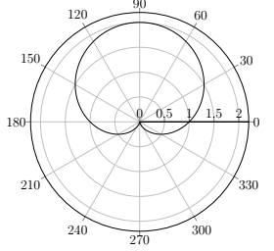
$$r=\sin^{2}\left(1.2θ\right)+\cos^{3}\left(6θ\right)$$ | $$r=1+3sinθ$$
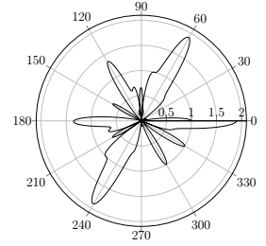 | 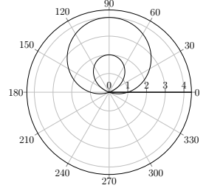
$$r=cos3θ+2\sin{3θ}$$ | $$r=1+2\sin{3θ}$$
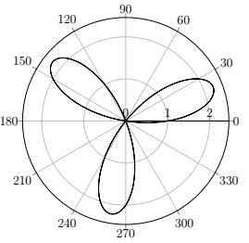 | 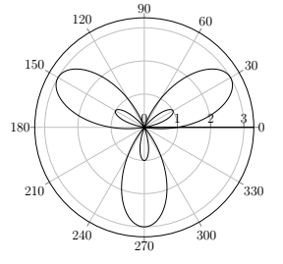

Exercise
  - Identify areas in real life where polar equations and/or graphs have been used.
  - Convert to rectangular equations the following polar equations
(i) $r=1-2\cos{θ}$ (ii) $r=2\cos{θ}$
(iii) $r=\tan{θ}$ (iv) $r=3\cos{2}θ$
(v) $2\cos{θ}-3\cos{θ}=r$ (vi) $r=6$
(vii) $r=3\sin{2}θ$ (viii) $r=2+2\cos{θ}$
  - Convert the following polar coordinates to rectangular coordinates
(i) $(2,π)$ (ii) $(4,\frac{π}{4})$
(iii) $(-5,\frac{π}{6})$ (iv) $(3,\frac{2}{3}π)$
  - Convert the following rectangular coordinates to polar coordinates (let $r>0$ and $0≤θ≤2π$)
(i) $(2,\sqrt{3})$ (ii) $(-2,4)$
(iii) $(0,-3)$ (iii) $(-3,-3)$
  - Convert the following rectangular equations to polar equations
(i) $2x-5y=8$ (ii) $x^{2}+y^{2}=25$
(iii) $y^{2}+2x=x^{3}$ (iv) $y=\frac{1}{3}x^{2}$
(v) $3x^{2}+2y-4=0$ (vi) $x+y+7x=7\sqrt{(x^{2}+y^{2})}$
  - Plot the graphs of the following polar equations

      - $r=2\cos{θ}$ for $0≤θ≤2π$
      - $r=2+2\cos{θ}$ for $0≤θ≤2π$
      - $r=1-2\cos{θ}$ for $0≤θ≤2π$
      - $r=4\cos{(}3θ)$ for $0≤θ≤π$
      - $r=\sin{3}θ$ for $0≤θ≤2π$
      - $r=\frac{θ}{π}$ for $θ≥0$

  - Plot the graphs below using a graphing device
    - $r=\sin^{2}\left(2.4θ\right)+\cos^{4}{(2.4θ)}$
    - $r=1+2\sin\left(\frac{θ}{2}\right)$ – Nephroid of Freeth
    - $r=e^{\sin{θ}}-2\cos\left(4θ\right)$ – butterfly curve
    - $r={\left|tanθ\right|}^{|cotθ|}$ - valentine curve

  - Find the distance between the following pairs of points ;
i) $P(1,4)$ and $Q(5,-3)$
ii) $X(-10,7)$ and $Y(17,2)$
iii) $A(9,-3)$ and $B(-2,9)$
  - Determine the distance and the midpoint of the following line segments given their endpoints;
(i) $(-2,10)$, $(5,-1)$
(ii) $(-8,-7)$, $(5,10)$
(iii) $(\frac{1}{2},1)$, $(-1,4)$

References
Kahenya, P. (2017). Foundation Maths. LAP Lambert Academic Publishers.
Mathcurve. (n.d.). Archmedean Spiral. Retrieved March 23, 2022, from https://mathcurve.com/courbes2d.gb/archimede/archimede.shtml
Stewart, J. (2012). Calculus (7th ed.). BROOKS/COLE Cengage Learning.
Swokowski, E., & Cole, J. A. (2009). Algebra and Trigonometry with Analytical Geometry. BROOKS/COLE Cengage Learning.
TexStudio. (n.d.). TexStudio. Retrieved March 23, 2022, from https://www.texstudio.org/

