Mathematics for Science
Lecture 4
Ellipses and Hyperbolas
Lecturer: Kahenya, N.P

Introduction to lecture 4
This lecture will introduce ellipses and hyperbolas. It is continuation of lecture 3 on circles and parabolas. Ellipse and hyperbolas are the other two conics. Ellipses occur naturally e.g. orbit of planets around the sun. Human made structures that apply the shapes of ellipses and hyperbola exists (CUEMATH, n.d.)
Intended learning outcomes
At the end of this lecture you will be able to;
- Define an ellipse and a hyperbola.
- Solve problems involving equations of ellipses and hyperbolas.
- Explain how ellipses and hyperbolas are used in real life.

Definition 1: (Ellipse) An ellipse is a locus or a path of all points $(x,y)$ on a plane whose sum of distances from two distinct fixed points, called the foci, is constant.
Proposition 1: Sum of distances from two distinct fixed points, called the foci, is constant.
Consider the diagram below, then $c^{2}=a^{2}-b^{2}$
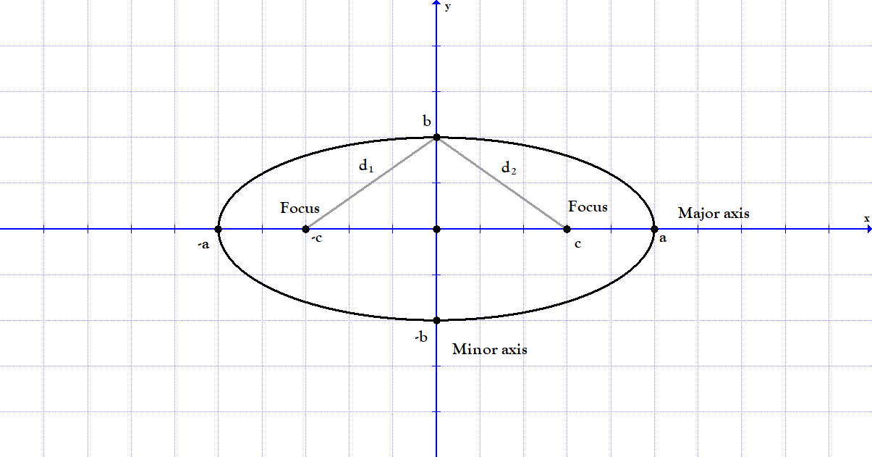
Proof: Let the distance between $-c$ and $b$, $\overline{\left(-c\right)b}=d_{1}$ and $\overline{bc}=d_{2}$. From the proposition the sum of the distances $d_{1}+d_{2}$is constant.
Again the sum of the distances from the y-intercept $\left(0,b\right)$to the foci is the same as the sum of the distances from the x-intercept $\left(a,0\right)$to the foci (i.e. $\left(-c,0\right)and (c,0))$. That is;
$$d_{1}+d_{2}=\left(a+c\right)+\left(a-c\right)$$
$$d_{1}+d_{2}=2a⋯(i)$$
Applying Pythagoras theorem we have;
$$\overline{\left(-c\right)b}=d_{1}=\sqrt{b^{2}+{\left(-c\right)}^{2}}⇒d_{1}=\sqrt{b^{2}+c^{2}}$$
$$\overline{bc}=d_{2}=\sqrt{b^{2}+c^{2}}⇒d_{2}=\sqrt{b^{2}+c^{2}}$$
Then equation can be written as; $\sqrt{b^{2}+c^{2}}$+ $\sqrt{b^{2}+c^{2}}=2a$
$$2\sqrt{b^{2}+c^{2}}=2a$$
$$\sqrt{b^{2}+c^{2}}=a$$
Squaring both sides to get; $b^{2}+c^{2}=a^{2}$
$$⇒c^{2}=a^{2}-b^{2}$$
Definition 2: (Equation of an ellipse) Given the general quadratic equation with two variables $x$ and $y$ i.e. $ax^{2}+bxy+cy^{2}+dx+ey+f=0$ where $a,b,c,d,e,f∈R$ with $a,b,$ and $c$ not all zero. Then if $b^{2}-4ac≤0$ we get the graph of an ellipse.
Note that if $b=0$ and $a=c$ we shall get a circle or the degenerate cases i.e. a point or the graph will be non-existent.
Example 1: Consider the equation $4x^{2}+7y^{2}-24=0$.
Solution: $a=4$, $b=0$, and $c=7$ hence the discriminant is;
$b^{2}-4ac=0-4⋅4⋅7=-112<0$.
The equation represents an ellipse.
Definition 3: (Standard equation of an ellipse) The standard equation of an ellipse with center the origin and x-intercept $a$ and the y-intercept $b$ (see diagram below) is given by;
$$\frac{x^{2}}{a^{2}}+\frac{y^{2}}{b^{2}}=1$$
Note that the ellipse has two axis; the major and minor axes. In the diagram above the major axis lies on the x-axis while the minor axis is on the y -axis. If $a^{2}>b^{2}$ then the major axis lies on the x-axis, otherwise it lies on the y-axis.

Definition 4: The standard equation of an ellipse centre $(h,k)$ is given by;
$$\frac{{\left(x-h\right)}^{2}}{a^{2}}+\frac{{\left(y-k\right)}^{2}}{b^{2}}=1$$
Example 1: Consider the ellipse in the diagram below. The ellipse is horizontal oriented. The centre of the ellipse is point $(h,k)$. The foci are the points $c1 and c2$ with $c1$ being the point $(h-c, k)$ and $c2$ being the point $(h+c,k)$.
The vertices of the ellipse are the points $V2 (h-a, k)$ and $V1(h+a,k)$.
The covertices of the ellipse are the points $v1(h, k+b)$ and $v2(h, k-b)$.
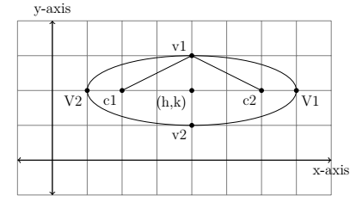
Source: (Kahenya, 2017)
Example 2: Given the ellipse $x^{2}+2y^{2}-16=0$ determine its centre, foci, the vertices, and the covertices.
Solution: we need to write the general equation in standard form;
$$x^{2}+2y^{2}=16$$
Note the equation represent an ellipse since $b^{2}-4ac<0 i.e. 0-4\left(1\right)2=-8<0$
Divide every term by 16 to get; $\frac{x^{2}}{16}+\frac{y^{2}}{8}=1⇒a=4 and b=2\sqrt{2}$
Consider $c^{2}=a^{2}-b^{2}⇒c^{2}=16-8=8∴c=2\sqrt{2}$
The centre is the origin. The foci are the points $±(2\sqrt{2},0)$
The vertices are the points $±(4,0)$
The covertices are the points $±\left(0,2\sqrt{2}\right)$
Example 3: Given the ellipse $x^{2}+4y^{2}-10x-32y-11=0$ determine its centre, foci, the vertices, and the covertices.
Solution: We need first to confirm if indeed it is an ellipse. The discriminant $b^{2}-4ac=0-4\left(1\right)4=-16<0$. The equation represents an ellipse.
Next we write it in standard form.
$$x^{2}-10x+k_{1}+4(y^{2}-8y+k_{2})=11+k_{1}+4k_{2}$$
$$x^{2}-10x+{\left(-\frac{10}{2}\right)}^{2}+4\left(y^{2}-8y+{\left(-\frac{8}{2}\right)}^{2}\right)=11+{\left(-\frac{10}{2}\right)}^{2}+4k_{2}$$
$${\left(x-5\right)}^{2}+{4\left(y-4\right)}^{2}=11+25+64=100$$
Divide every term by 100 to get;
$$\frac{{\left(x-5\right)}^{2}}{100}+\frac{{\left(y-4\right)}^{2}}{25}=1$$
Hence the centre of the ellipse is $\left(5,4\right)$
$a=10$ and $b=5$ then $c^{2}=a^{2}-b^{2}=100-25=75∴c=5\sqrt{3}$
Foci are the points $(5-5\sqrt{3}, 0)$ and $(5+5\sqrt{3})$
Vertices are the points $\left(15,4\right)$ and $(-5,4)$
Covertices are the points $\left(5,9\right)$ and $(5, -1)$

Definition 1: (Hyperbola) A hyperbola is a path of all set of points $(x,y)$ on a plane such that for any point on the path, the difference of the distances from two fixed points, the foci, is constant.
Definition 2: (Central Hyperbolas) These are hyperbolas with the centre as the origin and the vertices and foci on one axis. Such hyperbolas are symmetric.
Definition 3: (Equations of hyperbolas)
- Given the general quadratic equation with two variables $x$ and $y$ i.e. $ax^{2}+bxy+cy^{2}+dx+ey+f=0$ where $a,b,c,d,e,f∈R$ with $a,b,$ and $c$ not all zero. Then;
if $b^{2}-4ac>0$ we get the graph of a hyperbola or the degenerate case i.e. two intersecting lines.
- The standard equation of a central hyperbola (centre the origin) is given by;
$$\frac{x^{2}}{a^{2}}-\frac{y^{2}}{b^{2}}=1$$
$a-$distance from the centre to the vertex; $c-$ distance from the centre to the focus (see diagram below). The dotted lines are the asymptotes and $c^{2}=a^{2}+b^{2}$.
Exercise: Show that $c^{2}=a^{2}+b^{2}$
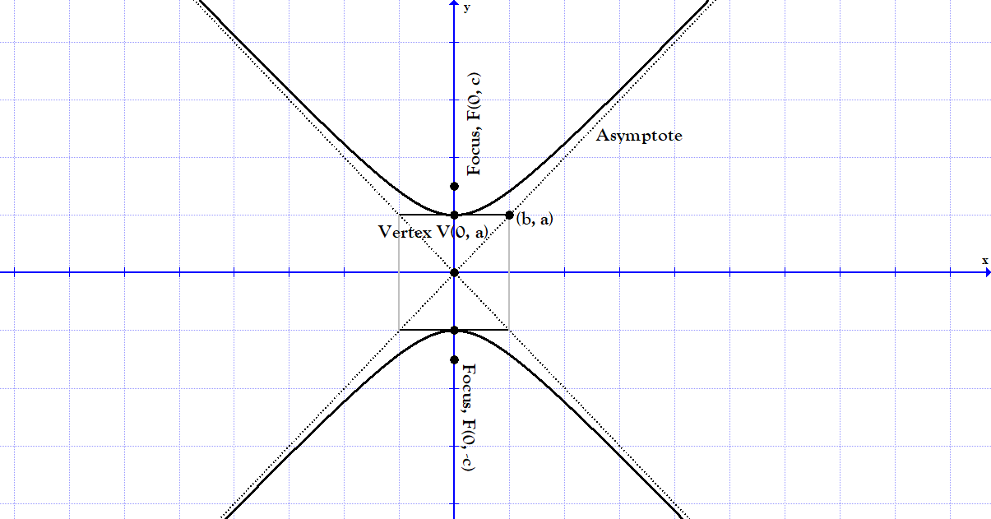
- The standard equation of a hyperbola with the centre at point $(h,k)$ is given by;
$$\frac{{\left(x-h\right)}^{2}}{a^{2}}-\frac{{\left(y-k\right)}^{2}}{b^{2}}=1$$
The vertices are points $\left(h+a,k\right)$ and $(h-a,k)$.
The foci are the points $(h+c, k)$ and $(h-c, k)$.
The asymptotes pass through the origin and the points $(h+a,k+b)$ and $(h+a, k-b)$.
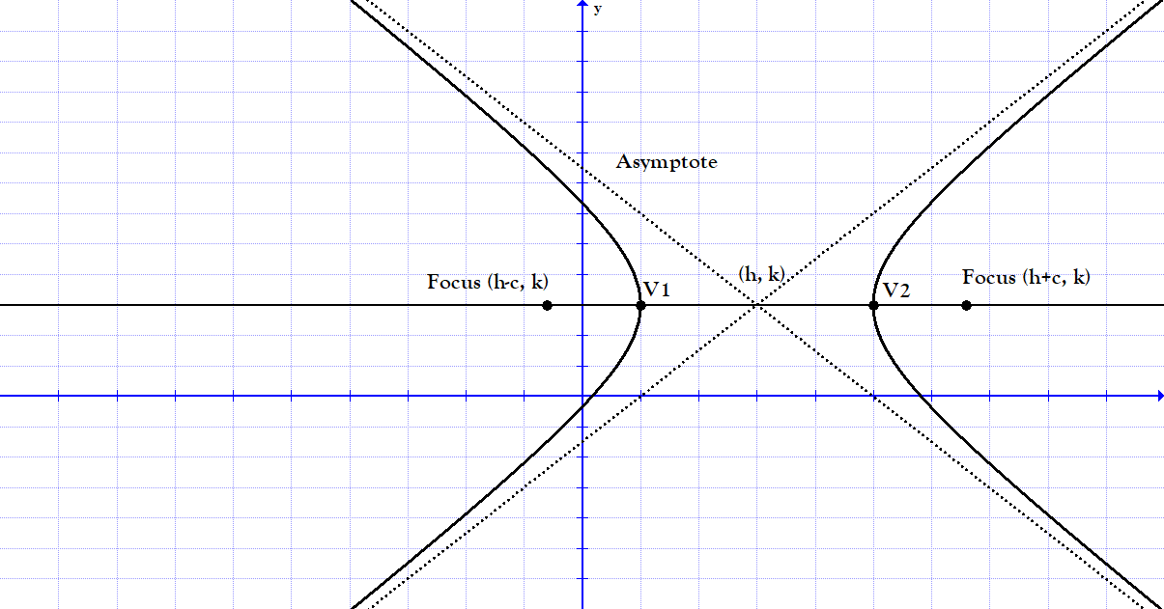
Proposition 1: Every hyperbola has two asymptotes.
Definition 4: (Eccentricity of a hyperbola) It is the ratio of the distance of the focus from the centre, and the distance of one vertex from the centre of the hyperbola.
Remark 1: The eccentricity $e$of a hyperbola is always greater than 1 i.e. $e>1$
Remark 2: In the diagram above, the distance of the focus from the centre is $c$ and the distance of the vertex from the centre is $a$. Therefore the eccentricity $e=\frac{c}{a}$
Example 1: Determine the standard equation of the hyperbola below and hence find the centre, foci, vertices, and eccentricity. $x^{2}-2y^{2}-4=0$
Solution: We need to write it in the form $\frac{x^{2}}{a^{2}}-\frac{y^{2}}{b^{2}}=1$. In our case; $x^{2}-2y^{2}=4$
Divide every term by 4 to get; $\frac{x^{2}}{4}-\frac{y^{2}}{2}=1⇒a=2, b=\sqrt{2}$. We know that $c^{2}=a^{2}+b^{2}∴c^{2}=4+2=6⇒c=\sqrt{6}$. Therefore; the centre of the hyperbola is the origin, the foci $±\left(c,0\right)$ are the points $±( \sqrt{6},0)$ and the vertices $±\left(a,0\right)$ are the points $±\left(2, 0\right).$The graph is symmetrical along the lines x = 0 and y = 0. The asymptotes pass through the points $±(a, b)$ and the origin. Hence $y=±\frac{\sqrt{2}}{2}x$. Eccentricity $e=\frac{c}{a}=\frac{\sqrt{6}}{2}$

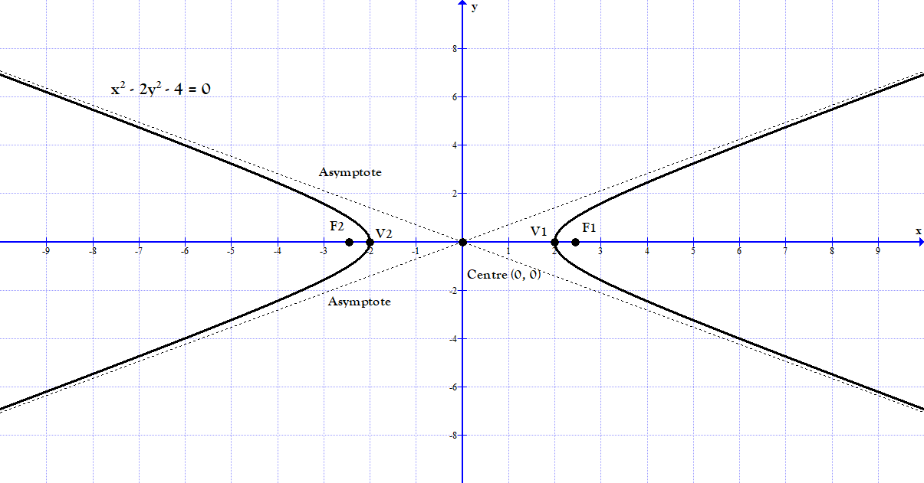

Example 2: Determine the standard equation of the hyperbola and hence find the center, foci, vertices, asymptotes, and eccentricity.
$$9x^{2}-18x-25y^{2}-50y-241=0$$
Solution: We need to write this in standard form;
$$9x^{2}-18x-25y^{2}-50y=241$$
$$9\left(x^{2}-2x\right)-25\left(y^{2}-2y\right)=241$$
$$9\left(x^{2}-2x+k_{1}\right)-25\left(y^{2}-2y+k_{2}\right)=241+k_{1}+k_{2}$$
$$9\left(x^{2}-2x+{\left(-\frac{2}{2}\right)}^{2}\right)-25\left(y^{2}+2y+{\left(\frac{2}{2}\right)}^{2}\right)=241+9{\left(-\frac{2}{2}\right)}^{2}-25{\left(\frac{2}{2}\right)}^{2}$$
$$9{\left(x-1\right)}^{2}-25{\left(y+1\right)}^{2}=241+9-25=225$$
$$9{\left(x-1\right)}^{2}-25{\left(y+1\right)}^{2}=225$$
Dividing every term by 225 to get;
$$\frac{{\left(x-1\right)}^{2}}{25}-\frac{{\left(y+1\right)}^{2}}{9}=1$$
The centre (h, k) of the hyperbola is the point (1, -1).
$$a=5, b=3⇒c^{2}=25+9=34∴c=\sqrt{34}$$
The vertices are points $\left(h+a,k\right)$ and $(h-a,k)$ i.e. (6, 1) and (-4,1)
The foci are the points $(h+c, k)$ and $(h-c, k)$ i.e. $(1+\sqrt{34}, -1)$ and$(1-\sqrt{34}, -1)$
Asymptotes are the lines $y=±\frac{b}{a}\left(x-h\right)+k⇒y=±\frac{3}{5}\left(x-1\right)-1$.
Eccentricity $e=\frac{c}{a}=\frac{\sqrt{34}}{5}$

Exercise
- Outline areas where ellipses and hyperbolas are applied.
- Given the following equations of ellipses, determine their centres, foci, covertices, and vertices
- $25x^{2}+16y^{2}=400$
- $25x^{2}-100x+36y^{2}+216y-476=0$
- $16x^{2}+32x+9y^{2}-36y-92=0$
- $4y^{2}+16y+9x^{2}+54x+61=0$
- Find the vertices, covertices, and the foci of the following ellipses
- $\frac{x^{2}}{9}+\frac{y^{2}}{16}=1$
- $\frac{x^{2}}{28}+\frac{y^{2}}{30}=1$
- $14x^{2}+36y^{2}=252$
- $4x^{2}+9y^{2}-36=0$
- Find the centre, vertices, eccentricity, foci, and asymptote of the following hyperbolas
- $\frac{x^{2}}{36}-\frac{y^{2}}{49}=1$
- $3x^{2}-7y^{2}-21=0$
- $\frac{1}{16}x^{2}-\frac{1}{25}y^{2}-\frac{1}{4}x+\frac{6}{25}y-1.11=0$
- $\frac{{\left(x-2\right)}^{2}}{49}-\frac{{\left(y+3\right)}^{2}}{121}=1$
References

Kahenya, P. (2017). Foundation Maths. LAP Lambert Academic Publishers.
Murray, S., & Robert, M. (2009). College Algebra. McGraw-Hill.
Stewart, J. (2012). Calculus (7th ed.). BROOKS/COLE Cengage Learning.
CUEMATH. (n.d.). Conics in Real Life. Retrieved March 23, 2022, from https://www.cuemath.com/learn/mathematics/conics-in-real-life/#P004
Lumen. (n.d.). Parabolas, Ellipses, and Hyperbolas. Retrieved March 23, 2022, from https://courses.lumenlearning.com/calculus2/chapter/parabolas-ellipses-and-hyperbolas

