Lesson 7:
RISK AND OPPORTUNITY MANAGEMENT.

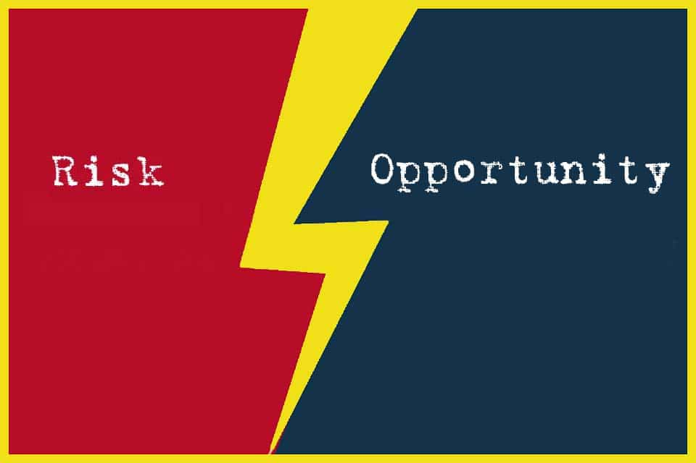
https://t2informatik.de/en/smartpedia/opportunity-management/

Lecturer: M. Kurbonov

RISK AND OPPORTUNITY MANAGEMENT
Some things can (and probably will) go wrong on your project; how can you still get the job done? Every human endeavor entails uncertainty; things may not go as planned. In light of that uncertainty, how do you get the project done within the promised parameters, such as schedule, cost, technical capability, and so forth? In this lesson, I show you how to combine good engineering and good statistics in a manner that allows you to cope with these uncertainties.
Things Can Go Wrong with Our Project: How Do We Cope?
In any human endeavor, and most especially in a complex engineering project, things may go awry and not according to plan, and thereby cause problems. These problems might manifest themselves as problems in any of various ways: as problems in achieving the technical capabilities that we promised in the contract, as an increase in the predicted cost of completing the project, as a delay to the predicted completion date of the project, or as any of a variety of other problems, such as safety, reliability, our ability to staff the project with appropriate numbers and skills of personnel, and so forth; and of course, a problem might manifest itself as a combination of these symptoms.
Since our engineering projects are both important and expensive, we endeavor to think in advance of these problems arising about what might go wrong, and to take actions in advance that might lessen both the likelihood that such a problem will actually occur and the adverse impact on our project and our company if (despite our attempts to lessen the likelihood of occurrence) the problem comes to pass. At the point in time when we start thinking about the potential of these problems arising, they have not yet come to pass; they are only potential problems. We call a potential problem that has not yet occurred a risk.
We use the term risk management for this process of characterizing what could go wrong on our project, and for planning how we could go about both lessening the likelihood of problem occurrence and mitigating the potentially adverse effects of problems (the impact) should they in fact occur. Risk management is an important portion of your responsibility as the manager of an engineering project.
As noted above, every complex human endeavor is likely to encounter problems. You need not be afraid or embarrassed by the fact that there is a chance of such problems occurring on your project. What you must do, however, is lead your team to perform the appropriate risk management activities, so as to mitigate their likelihood and impact. In this lesson, we will teach you something about risk management. We will show you how to identify your project’s risks, how to evaluate those risks – both for likelihood and impact, and how to establish a set of reasonable mitigation measures.
If risks are things that might go wrong with the project, and thereby cause an adverse impact on the established plans, there is, at least in principle, a set of symmetric potential events: things that might occur which, if they do occur, will cause a positive impact on the project. We call these opportunities. Like risks, we start thinking about them in advance of their occurrence. We look for actions that we could take that might increase the likelihood of their occurrence, and we also look for actions that we can take that will maximize the positive impact on the project should they occur.
We therefore call the combined process of managing both risks and opportunities risk and opportunity management. We will talk about opportunity management, as well as risk management, in this lesson.
As you will see in this lesson, engineering is deeply involved in every step of the process that we call “risk and opportunity management.”
Technical and engineering risks can arise from all of the obvious sources:
- The invention required to create the desired system.
- The lack of maturity of some of the selected technologies and products; there is often a gap between what a product is advertised as capable of achieving, and what it actually can achieve.
- The scale and complexity of the project, including the problem of managing the dynamic behavior of the system.
- All of the uncertainty and errors that can arise from quantitative measures and analyses.
- … and many others too.
Technology and engineering, however, are not the exclusive sources of risk on engineering projects. Risks can arise from other matters too, such as:
- Poorly defined or changing goals and requirements.
- Tensions between stakeholders: the buying customer, the eventual users, the paying customer, the regulators, and other stakeholders may want slightly different things, and trying to satisfy all of them may over‐constrain your solution.
- Tensions within your development team: people may have different ideas about the appropriate design; if you have subcontractors, they may have different business aspirations from you and your company; there will always be some of the ordinary issues of people not getting along, and/or having conflicting personal goals and aspirations; and so forth.
The existence of all these potential sources of risk is, of course, one of the very aspects that makes managing engineering projects so interesting!
The data indicate that huge numbers of engineering projects fail, and many more under‐deliver on promised capability, take far longer than promised to complete, and/ or cost far more than promised to complete. All of this indicates that most engineering project managers are not doing an adequate job of risk management. Here is yet another opportunity for you to be better than your competitors!
As stated above, we endeavor to minimize both the likelihood of occurrence of an adverse action and the impact of occurrence of an adverse action. We treat these as separate endeavors because experience indicates both that (i) likelihood and impact are fairly separate matters and (ii) they usually must be mitigated through separate actions.
Here’s an example that illustrates this separation:
- If we want to decrease the likelihood that our house will burn down, we can take actions such as trimming the foliage away from the house, replacing the roof with completely non‐flammable materials, replacing defective wiring, enclosing the eaves, and putting ember‐resistant screening over the attic vents.
- But if we want to decrease the impact to our family in the case (despite our measures intended to lessen that likelihood) that the house does catch fire, we can install smoke detectors and buy fire insurance.
Buying insurance does not decrease the likelihood that the house will burn down, it only decreases the impact in case it does. Similarly, replacing the roof with completely non‐flammable materials does not decrease the adverse impact to us if the house does happen to burn down anyway, but it does decrease the likelihood that it might. We can see that, in this case, managing likelihood and managing impact are fairly separate from each other.
So, it is with the typical engineering project: managing the likelihood of various risks is fairly separate from managing the adverse impact that would occur if one or more of those risks came to pass.
The basic process of risk management works like this:
- Before we start the project, we try to figure out what might go wrong with our project, and we make a list of these items. We also list the symptoms, that is, what we will see if this risk starts to come to pass and threatens to become an actual problem, and not just a potential problem.
- We identify and write down ideas about actions that would lessen the likelihood and impact of those problems, but usually, we cannot afford either the time or the money to fix all of them. Nor might we wish to spend that money, even if we had it: these are only potential problems, not confirmed problems. Furthermore, we recognize that as we progress with the project, we will uncover new potential risks; we cannot be content with doing this assessment just once at the beginning of the project. We need instead some sort of ongoing activity to assess and manage risk.
- So, for most of the items that we identify as potential risks, instead of fixing them immediately, we try to figure out what we would do if, at some point in the future, it looked as if one of our identified risks was coming to pass, and we write that down on a list.
The key to this process is the periodic assessment of whether risks on our list seem to be coming to pass or not. The efficacy of this assessment will, of course, be driven by a combination of (i) how good your list of risks is and (ii) how good your list of symptoms is. On an engineering project, the list of problems and the list of symptoms are likely to be dominated by issues associated with engineering and technology. This is why, in my view, the manager of an engineering project should be an engineer, and why the project manager must take a personal role in the risk management process.
It is tempting for most people to say “Well if anything goes wrong, it will show up eventually as an increase to the estimated cost to complete the project, a delay to the estimated date of completion of the project, or both of these items. Adverse schedule and cost impacts are the result of these underlying technical and engineering issues, and hence (in my view) are lagging indicators (that is, they show up later, giving you less time to respond). This makes schedule and cost predictions actually a weak metric for risk management – we are better off if we can create leading indicators. In my experience, you create such leading indicators by having your symptom list consist of statements about off‐nominal technical and engineering properties, rather than statements about adverse schedule or cost impact. This is why we engineers – rather than, for example, the project financial manager – must be personally in charge of the project risk management process.

The Steps of Risk Management
Step a: Identify the Potential Risks and Opportunities
We start the risk management process by creating a list of potential risks, which we call a risk register. Where do we get ideas for what might constitute risks to our project?
- Through brainstorming sessions by the team members, and outside advisors.
- From lessons learned in previous projects.
- From consultations with experienced project managers, project chief engineers, and other experts.
You must hold brainstorming sessions about risk, starting long before you even begin to write a proposal; you will need the information about risk in order to get authorization from your company to submit a bid, and of course you must also include the risk register and the risk management plan in your proposal.
These brainstorming sessions are always fruitful, not only for the content they create, but also for the team‐building role they play. You, as the project manager, should attend these sessions in person. This demonstrates your confidence in your chief engineer. It also gives you the chance to listen; This notion of the boss speaking last for each topic is always a good meeting‐facilitation strategy; you may ask questions at any time, but be very careful not to reveal your own opinions until you think that all of the ideas are already on the table.
As we discussed before, mature organizations ought to have an archive of historical data from past projects, and this archive ought to include the risk registers from those projects, together with a list of those risks that actually came to pass, and an assessment of the actual performance/cost/schedule impact that occurred as a result of those risks transitioning into actual issues. In my view, these example artifacts are among the most important inputs to help us construct our new project’s risk register. Some of the risks may be directly applicable to your project, but in many other instances risks that might occur considering those risks that were either considered, or actually came to pass, on prior projects. Even if your project is creating something completely new, many of the parts and processes will still be similar to those prior projects, and you can therefore learn a lot from their experiences.

Step | Discussion
a. Identify the potential risks and opportunities | We call these lists the risk register and the opportunity register
b. Identify the symptoms | What will we see that will indicate that this risk or opportunity may be coming to pass? These become the triggers for potential future mitigation / exploitation actions (below)
c. Select the item to be measured, and the measurement methods | What do we measure, in order to look for the symptom?  How do we make that measurement?
d. Score each risk and opportunity for both likelihood and impact | Evaluate every risk and opportunity in two ways: a numeric assessment of the likelihood of this risk coming to pass and a numeric assessment of the impact, if this risk or opportunity in fact does come to pass
e. Create mitigation and exploitation plans | For each risk, create two mitigation plans: one for reducing the likelihood that this risk will come to pass and another for reducing the impact of this risk, should it in fact come to pass. For each opportunity, create two exploitation plans: one for increasing the likelihood that this opportunity will come to pass and another for increasing the impact of this opportunity, should it in fact come to pass
f. Create triggers and timing requirements for those mitigation plans | For each mitigation plan, select a specific measurable value for the symptom that will become the trigger threshold for taking action. Also, estimate the time required to implement each mitigation and exploitation plan. We use the combination of the trigger and the timing requirement to  make decisions about starting mitigation and exploitation plans
g. Create a method to aggregate all risk assessments into a periodic overall project impact prediction | A typical engineering project will end up with many items on the risk register. It is tempting to look at just a few risks that you consider the most material, but sometimes the aggregated effect of lots of small risks can result in a big adverse impact. So, we need a method to aggregate the totality of risks into some type of project-wide assessment
h. Create and use some sort of periodic “management rhythm” wherein you periodically make decisions about risk-mitigation and opportunity-exploitation actions, based on the periodic assessment | We institute a periodic process (usually monthly) to look at the items on our list of risks and opportunities. We add or eliminate things from that list, as seems appropriate in light of new data. We look for items on the list that seem to be coming to pass, and make a decision if this is the time at which we elect to initiate the planned mitigation actions (which, of course, require people, time, and money to implement). We may also decide that we no longer require a mitigation or exploitation action to continue that we previously started
i. When risks actually occur (and therefore transition from risks to issues), perform a root-cause analysis | Once a risk has become realized (e.g. transitions from a risk into an issue), it is often appropriate to do a root-cause analysis.  That is, why did it occur? This might decrease the likelihood that you will have a similar problem occur in the future
Table 1. The basic steps of the risk management process.
As a manager, you often get asked to come and help a team that is getting ready to write a proposal. They always show you their risk register; it is almost always full of superficial statements of risk, far too general, and not sufficiently reflecting the specific details of their project. An example of a poor (but very common!) sort of risk statement that I have actually seen time after time is “The software could be late and/or over budget.” This is a poor risk statement for many reasons:
- If a project has a lot of software (and these days, most do), the software is highly likely to be the source of a lot of risks. These need to be enumerated separately, not as one “catch‐all” category. This is so that they can be assessed and mitigated individually.
- A statement of risk such as the above only lends itself to a symptom of late delivery or significantly increased cost estimate. Such symptoms tend to come fairly late in the project life‐cycle, and as such are lagging indicators that probably occur too late for easy correction. We want earlier indications of our problems (we call these leading indicators), and as noted above, these usually have to be technical or engineering in nature. Therefore, our risks must be stated in sufficient detail to allow for the identification of a symptom (which can become a trigger event) early enough that we can credibly solve the problem.
Here is an example of a good software‐related risk statement: “The XYZ mechanism could fail to meet its requirement to complete port‐to‐port processing in less than 100ms at least 99% of the time, and could also fail to meet the requirement that no instance of port‐to‐port processing ever exceed 250ms.” This statement makes it very clear what needs to be measured, and what the trigger thresholds for initiating mitigation actions will be.
These days, most organizations that perform engineering projects have guidelines regarding the creation of a risk register; where they fall short is whether the risk statements themselves are any good.
Step b: Identify the Symptoms
Once we have the beginnings of a risk register, we turn to the problem of how we determine if a risk (or opportunity!) is coming to pass, that is, transitioning from a risk (a potential issue) into an actual issue (or from a potential opportunity into an actual improvement). We start this process by identifying the symptoms, that is, for each risk or opportunity, what is it that we will see (or could measure) that will indicate that this risk (or opportunity) may be coming to pass.
These need not be esoteric or difficult. If you have created suitably specific statements of risk, as described above, it may be fairly obvious what the symptoms are going to be. Consider the example from the previous section: “The XYZ mechanism could fail to meet its requirement to complete port‐to‐port processing in less than 100ms at least 99% of the time, and could also fail to meet the requirement that no instance of port-to-port processing ever exceeds 250ms.” There are two separate potential symptoms in that statement. The first is that port‐to‐port processing may not be complete in less than 100ms often enough, and the second is that port‐to‐port processing may sometimes take too long.
From these symptoms, we will later derive the triggers for potential future mitigation actions. Note that we have not yet decided exactly what numeric values will constitute such a trigger; we have only identified the category of behavior that we will watch for. The exact numeric value that constitutes a trigger will come later.
Step c: Select the Item to be Measured, and the Measurement Methods
What do we measure, in order to look for the symptom(s)? How do we make that measurement?
For each item on the risk register, we identify the operational measures, technical measures, and management measures (which include schedule and cost) that will help us look for the occurrence of the selected symptom(s).
Some of our selected symptoms will make it clear what needs to be measured (as was the case in our example above). But this is not always the case; sometimes, the selection of the item to be measured is subtle enough that determining what needs to be measured can constitute a separate step.
We must also determine how we will go about making the measurement. This starts with a determination of how accurate a measurement we need. If the symptom is the weight of a part or subassembly, the measurement method may be straightforward if the accuracy required is to the nearest pound; it may be more complicated if the accuracy required is to the nearest milligram.
Nor is it always the case that the measurement method itself is always straightforward; for example, in our port‐to‐port timing example above, it may be difficult to separate the timing of the section we are concerned about from other sections of the product. This is especially true when the item whose timing we want to measure consists of software. Making the timing measurement might require special measurement equipment; in the port‐to‐port timing example, this might include special software to log events and the time of their occurrence, and might include actual measurement equipment, separate from the mission equipment. We must also be aware of the potential that the process of simply making the measurement will change the behavior; for example, if capturing the data requires that you insert extra software code, the insertion of this extra code will change the timing and other factors of the execution.
Step d: Score Each Risk for Both Likelihood and Impact
Not all risks are equally likely to occur, nor will they all have the same impact if they do occur. We, therefore, evaluate each risk on the risk register in two ways: a numeric assessment of the likelihood of the risk coming to pass and a numeric assessment of the adverse impact, if in fact, the risk does come to pass.
In general, we will find that we can make more credible estimates of the impact than of the likelihood. That is not a problem; the method does not depend on our being able to make highly accurate estimates of likelihood; all we really need to do is try to separate those more likely from those less likely, and even if we get the likelihood estimates dramatically wrong, the method still provides a fair amount of value.
Notice also that our “risks” fall into very different categories:
- When we assess risks to the design, we are actually assessing the characteristics of a thing that exists now – the design exists now. We are trying to assess its current characteristics? We call this a “prediction,” but it really is not a prediction in the sense that this term is normally used; it is instead an assessment of a current state of being and not a prediction about a future event. We probably ought to use a term other than the prediction for this process, but it is the term that you will hear being used. No matter what term is used, it is not really a prediction, but rather a statement about the uncertainty of our analysis of the current design.
- In contrast, when we predict the schedule and cost of our project, we are in fact making predictions about future events. The business of making predictions about the future is always fraught with error; the track record of even the most eminent specialists is absolutely awful. At least we have this comfort: the future events that we try to predict as managers of an engineering project are far more structured than, say, the chain of events leading to the next big earthquake in southern California. We likely understand at least some of the causality that drives the schedule and cost of our project, although we certainly do not understand it nearly as well as we would like. So, while our predictions about schedule and cost ought to be better than someone’s prediction about when the next big earthquake will occur on the San Andreas fault, our predictions about schedule and cost are still predictions. Therefore, they will likely display far more uncertainty than our “predictions” about the performance of the design, because – as noted above – we are not actually “predicting” anything about the design, but instead are just continually improving our assessment of that design. Much of the variation of our “prediction” of design performance comes from the fact that each day and each week, we are continually adding details to that design, and presumably improving it. This is quite different from our predictions about the schedule and cost of our project: those are actual statements about future events. The reason that these predictions for items like schedule and cost have any utility at all – in light of the fact that the business of predicting the future is hard – is that, as you will see in a moment: (i) we use a process that continuously uses our improved knowledge to reassess the schedule; (ii) we focus on very near‐term events, which we likely actually understand reasonably well; and (iii) we are looking as much for indications of significant change as we are trying to predict an absolute date.
We are not in the business of being seers or necromancers, or even economists, all of whom pretend to predict the future. We learned earlier in this lesson that although we attempt predictions for schedule and cost, the items upon which we prefer to depend to be our leading indicators of potential problems are the technical and operational performance measurements (such as the characteristics of the design). Note that I just pointed out that in some real sense these are not actually predictions at all; they are measurements of a current state. Our concern is with the uncertainty of that measurement. These mechanisms take us out of the realm of seers and necromancers, and into the realm of engineers making periodic measurements, and using the insights from those measurements to tinker incrementally with our design.
The numeric assessments are going to become entries in some sort of database, so that we can easily perform assessments with them. But projects often find it useful to make use of a graphic depiction of this scoring as well, which we call the risk matrix. This is a graphic depiction of those two dimensions, likelihood and impact. Each risk is placed at its appropriate location in the matrix.
Clearly, if something is both likely and of high impact, that is a more serious risk to manage than one that is both unlikely and of low impact. But the color‐coding contains a trap: it tends to mislead us about how correctly to respond to those risks that we have rated unlikely to occur, but severe in their impact if they do occur.

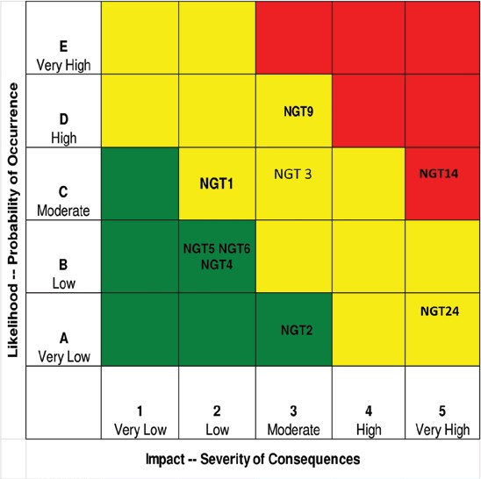
Figure 1. The risk matrix.
Also, always remember that these assessments are estimates. Furthermore, they are often quite subjective; therefore, transparency is vital – each score should be accompanied by a description of the estimation method, assumptions, and so forth. These should all go into that same database.
It is useful if these assessments of likelihood and impact can be expressed as distributions, rather than just as point estimates. If nothing else, expressing these assessments as distributions expresses the uncertainty in those assessments. When there is uncertainty, it is always better to make that uncertainty visible, rather than to hide it.
Step e: Create Mitigation and Exploitation Plans
For each risk, we next develop approaches (for some risks, we might in fact develop more than one such approach) for how we could decrease the likelihood of that risk coming to pass. We also, for each risk, develop approaches (again, perhaps more than one) for decreasing the impact of that risk, in case it does come to pass.
Think of the example we discussed above the risk of our house burning down. We had multiple approaches for lessening the likelihood of occurrence (e.g. trimming foliage, replacing the roof with non‐flammable materials, and so forth) and a separate set of approaches for lessening the impact if, in fact, something (despite taking the steps intended to lessen the likelihood) caused the house to burn down (e.g. purchasing a policy of fire insurance, etc.). For each entry on the risk register, we now create separate lists of mitigation, one list about how we will lessen the likelihood and a separate list about how we will lessen the impact. The lists of mitigation approaches will naturally be longer and more involved for risks considered serious (e.g. either high likelihood or high impact) than for risks considered minor (e.g. low likelihood and low impact).
As in our house example, these may well proceed in multiple steps of mitigation. Perhaps we decide that – if and when we make a decision that it is time to actually start implementing these mitigation steps – we will start to lessen the likelihood by trimming the trees and other foliage overhanging the house, as the first mitigation measure. If we decide that additional mitigation of likelihood is required, we select screening the attic vents as the next task, in order, and replacing the wood‐shingle roof with non-flammable concrete tiles as the third.
For each such candidate mitigation step, we define: (i) what you will do; (ii) why it will help; (iii) how you measure its effect; (iv) what the resulting position on the risk matrix will be at the end of this step; (v) cost and duration estimates for this step. You also, as described above, place these candidate mitigation steps into a priority sequence: first, second, third, and so forth.
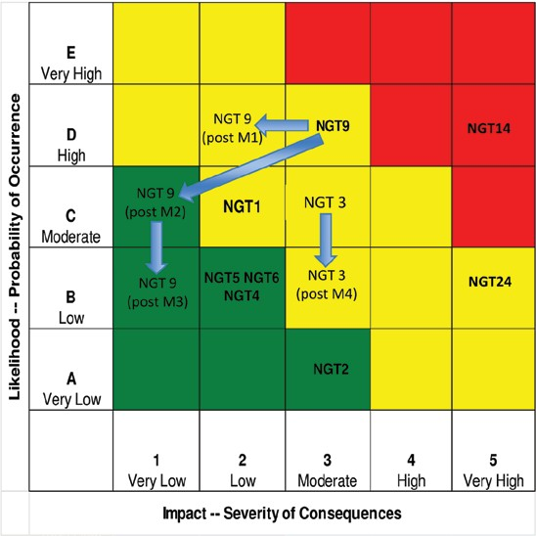
Figure 2. Depiction of the progression of mitigation.
We have four responses that we can make for any identified risk. These are sometimes called the potential dispositions of risk:
- Accept. We can accept the risk and its consequences. In which case, we need under- take no mitigating actions, at least for the present. We always reserve the option of changing our minds at a later date.
- Mitigate. We can mitigate the risk, either in likelihood or impact, or both. This involves assigning people and facilities to the problem and spending money.
- Share. We can share the risk with another party, such as our customer, or one of our subcontractors. This is usually done through a formal contract modification.
- Transfer. We can transfer the risk to another party, such as our customer, one of our subcontractors, or an insurance company. This is also done through a formal contract modification, or through the purchase of insurance.
We must be careful, however, about sharing and transfer; we may have shared or transferred the financial and/or contractual aspects of this risk, but we likely have not been able to transfer the reputational aspects of this risk. If this risk comes to pass, perhaps some other party will bear the financial cost, but the reputation of our company – and of you, as the project manager! – is still likely to be negatively affected. Reputation is very important (the trendy term among consumer‐oriented companies is “brand”), so be aware that one can seldom actually share and transfer reputational risk. People almost always hold the prime contractor and the project manager accountable for failures, even if some responsibility has been formally shared or transferred. Your company may have purchased an insurance policy protecting you financially against the risk that the rocket explodes upon take‐off, and the satellite you just delivered is destroyed, but your reputation may still suffer, causing you to lose future business, making it harder to attract employees, and so forth.
As noted above, the entire risk management process can (and should) be mirrored to create and exploit opportunities (e.g. changes that can improve project outcomes – whether technical, operational, safety, reliability, cost, schedule, etc.). Whereas we assess and attempt to mitigate risks, we assess and attempt to exploit opportunities.
Step f: Create Triggers and Timing Requirements for Those Mitigation Plans
We have now created a set of candidate mitigation plans for each entry on the risk register. But, as noted above, we usually cannot afford either the time or the money to fix all of them. Nor might we wish to spend that money, even if we had it: these are only potential issues, not confirmed issues. Furthermore, we recognize that as we progress with the project, we will uncover new potential risks; we cannot be content with doing this just once at the beginning of the project. We need instead some sort of ongoing activity to assess and manage risk.
We will discuss this ongoing activity in a moment, but we need to set up just two more preparatory steps. The first one is to establish specific triggers – quantitative thresholds – that tell us that it may be time to consider initiating mitigation actions against a specific risk, and estimates of lead time.
To illustrate, let us return to the example of the satellite. We know that its launch weight cannot exceed 1000lb; that is the limit for the weight that the rocket can lift to the correct orbit. We will not design our satellite to be 1000lb, of course; if we did, even a very small overage would be catastrophic for the project. So, we pick some smaller weights – for example, 950lb – as our target design weight. Each month, we ask each of the managers – the person leading the team that is building the structure, building the solar panels, building the batteries, building the processors, building the sensors, building the cable assemblies, building the attitude‐control system, and so forth – to update their own estimate for the predicted weight of their component when they are complete. Each month, we then add all of these weights up to create this month’s estimate for the predicted weight of the satellite when it is complete. As discussed before, we can create a time series out of these numbers, and use that time series to separate signal from noise, and tell us whether an apparent trend up or down in the predicted weight at completion is a real signal or just a random variation.
We may be aiming for 950lb, but perhaps we have decided that if the de-noised pre- diction ever rises to 970lb, we will start some mitigation actions. Perhaps there is a portion of the structure that we are making out of aluminum; we have a mitigation plan that says we can make it out of carbon‐fiber composite instead, and thereby save 30 lb. But making it out of carbon‐fiber composite might cost $300 000 more than making it out of aluminum. Since we have a plan to bring the satellite to completion at 950lb even with the bracket consisting of aluminum, using aluminum is our baseline design, and thereby we hope to save that $300000. But if our de-noised prediction about the weight at completion ever reaches 970lb, we have decided, as a risk mitigation step, that we are going to start the design and fabrication process for the carbon‐fiber composite version of that part. We will not spend all $300000 at once; we are just starting that process. It might be that three months later, we have saved enough weight somewhere else in the design that we can elect to stop the design and fabrication process for the carbon‐fiber composite part, and save whatever money out of the $300 000 we have not yet spent.
We say that having our prediction exceed 970lb is our trigger; if the trigger occurs, we will consider starting one or more of our mitigation actions.
There is a time aspect of the trigger process as well: perhaps we estimate that it will take eight months to design and fabricate that carbon‐fiber version of the part. We therefore would create a dual trigger: exceeding 970 lb would cause us to consider starting a mitigation action, but so would passing the time where only eight months remain before we need that part! Even if we are at 960 lb when we pass the only eight months remaining milestone, we would use that time milestone as a trigger to consider whether we want to start this particular mitigation action. We don’t want to lose the chance to perform a mitigation action just because we run out of time!
Of course, we perform an asymmetric process to look for the triggers and timing associated with our identified opportunities.
Step g: Create a Method to Aggregate All Risk Assessments into a Periodic Overall Project Impact Prediction
A typical engineering project will end up with many items on the risk register. It is tempting to look at just a few risks that you consider the most material, but sometimes the aggregated effect of lots of small risks can result in a big adverse impact. So, we need a method to aggregate the totality of risks into some type of project‐wide assessment.
Such an aggregated assessment should incorporate all of the following:
- The likelihood of occurrence of every risk on the risk register, with their distributions.
- The impact of every risk on the risk register, with their distributions.
- The cost and schedule to implement the mitigating actions (which might be separate actions for decreasing likelihood and decreasing impact!) and their effect on the overall schedule. This can be accomplished by updates to the activity network.
- The tiering/cascading/combining impact on the system and its technical and operational performance. This is usually accomplished through tiered systems performance modeling.
We can use this depiction to allow us to analyze the aggregate impact on various parameters (schedule, cost, weight, and so forth), and thereby make sure that our project is not endangered by the combination of the totality of our risks. Many of the risks may appear small, but when combined, the effect may be serious.
Step h: Create and Use Some Sort of Periodic “Management Rhythm,” Wherein You Periodically Make Decisions About Risk Mitigation and Opportunity Exploitation Actions, Based on the Periodic Assessment
We already noted that we often cannot afford either the time or the money immediately to fix all of the items on our risk register. Nor might we wish to spend that money, even if we had it: these are only potential problems, not confirmed problems. Furthermore, we recognize that as we progress with the project, we will uncover new potential risks. We therefore cannot be content with going through the process of identifying and scoring risks just once at the beginning of the project. We need instead some sort of on‐ going activity to assess and manage risk.
We therefore institute a periodic process (usually monthly) to look at the items on our list of risks. We add or eliminate things from that list, as seems appropriate in light of new data. We look for items on the list that seem to be coming to pass (or any deadlines for a mitigation action decision that are coming up soon), and make a decision if this is the time at which we elect to initiate the planned mitigation actions (which, of course, require people, time, and money to implement). We assess mitigation actions that are already in progress – should we continue them, beef them up, or do we no longer require some particular mitigation action to continue?
We can then take actions:
- Adjust the contents of the risk register
- Adjust the contents of the mitigation plans, exploitation plans, and their associated triggers
- Stop, start, or alter the mitigation and exploitation actions.
Step i: When Risks Actually Occur (Transition from Risks to Issues), Perform a Root‐Cause Analysis
Once a risk has become realized (e.g. transitions from a risk into an issue), it is often appropriate to do a root‐cause analysis. That is, why did it occur? This may help you prevent recurrence of similar problems in the future. Such prevention could save you headaches, and save the project time and money. Furthermore, if your project displays a pattern of having similar problems recur again and again, this will cause your customer and your management to lose confidence in your ability to manage the project.
Note that you may discover that the cause of the problem represented by the risk was different from the mechanism that caused you to identify it as a risk in the first place!
Two Special Types of Risks
The Low‐Likelihood, High‐Impact Event
After you build your risk register and your risk matrix, if there are items that appear in the high‐likelihood/high‐impact portion of the matrix, clearly you must spend time developing and implementing mitigation strategies for those risks. This is a management imperative, but spending time and money to lessen both the likelihood and impact of these events will be supported by both your customers and your management; they will likely insist on such actions, because of their position within the risk matrix.
You will also have a number of items on your risk matrix that have low‐to‐moderate impact, at any level of likelihood. You can use the risk management processes described above, including the periodic risk assessment and the aggregated assessment – both of which are a form of expected‐value analysis (we calculate an expected value by multiplying the likelihood by the impact) – to help you determine when it is appropriate to spend time and money to mitigate these risks.
There remain, however, two other, special types of items in the risk matrix:
- Those items that you have scored as low likelihood but high impact, and
- Those items that you did not yet identify at all!
These two other, special risks are the ones that you really must focus on, because these are the ones that kill projects and kill reputations.
Let’s start with the items that you identified as low‐likelihood, high‐impact. These items can be a trap, luring you and your team into a false sense of complacency; after all, you scored them as unlikely to occur, and their expected value (likelihood times impact) is low, so why devote a lot of time and money to assessing and mitigating them?
The problem is that you may well have underestimated the likelihood of this event. Psychologists say that if an event is rare, we humans tend even further to underestimate its likelihood; if an event is rare, we essentially are wired to believe that it will never occur.
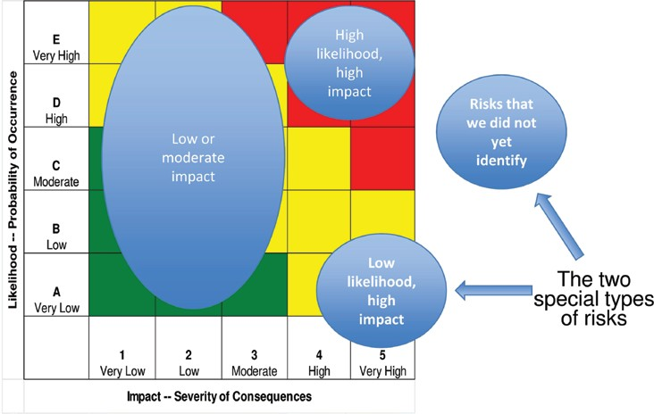
Figure 3. The two special types of risks.
Here the interesting example of this is something called the 100‐year storm. As the name implies, this is a rainstorm of such severity that the weather service estimates that it ought to occur only once every 100 years. In fact, storms of the magnitude identified as 100‐year storms occur far more frequently: about every 10 years. The event is truly rare – occurring only once every 10 years. But even the professional weather forecasters underestimate the likelihood of this rare event, assessing that it will occur only once every 100 years, rather than the correct likelihood of once every 10 years. Note that “once every 100 years” is, for most people, a statement very similar to “never”; few of us live to be 100.
Furthermore, there is the problem caused by the fallacy of the silent evidence: we are more likely to see the good‐news examples than to see the failures. Explorers who die during their exploits don’t write books about their adventures afterward. We, therefore, underestimate the likelihood of these types of events, because we tend not to hear about the relevant occurrences. They, after all, were failures, and people do not usually broadcast their failures. Rare events do occur!
Having now recognized that we might have underestimated the likelihood of the event, we are left with an event that may well occur, but if it occurred, would have a high adverse impact on our project.
If the adverse impact is severe enough, my advice is that you must mitigate the impact, no matter how unlikely you deem its occurrence. Do not handle these types of risks through expected‐value approaches; you will be trapped by our tendency to underestimate the likelihood of rare events. If a rare event can kill one of your employees, you need to spend time and money to mitigate that potential impact.
Another way to think of this is that if the impact is severe enough, you do not need to work very hard to estimate the likelihood. Any estimate that is created of the likelihood of a rare event is likely to be wrong anyway (as noted above, we tend to underestimate the likelihood of rare events), so my approach is not to worry about trying to predict the likelihood very carefully. What you must do instead for these types of risks is to take actions that prevent the impact – if the event happens to occur – from being catastrophic.
Interestingly, this also works for rare events, that if they happened to occur, would have staggeringly good impacts. In engineering projects, my experience is that there are more rare events with really bad impacts than rare events with really good impacts, but rare events with good impacts do occasionally happen; I have had some in my career. The strategy here is if you have identified rare events with potentially game‐changing good impacts, take actions that will if the event happens to occur, maximize the benefit. This is the opportunity side of the risk/opportunity matrix. You do not need to spend a lot of time trying to predict the likelihood; just take actions that will allow you to be ready to benefit.
The Risks That We Have Not Yet Identified
The second special type of risk is the item that you failed to identify and therefore does not appear on the risk register at all. There will always be such items; our systems are too complicated for you and your team to be able to create a complete and perfect risk register during the proposal. So, you must find them as the project progresses, and hopefully before they actually occur. How can you do that?
Build segments of your system and let real users experiment with them. Increase the load on your system until it breaks. Increase the operating temperature beyond the specified limits, both up and down. Subject your components to more shock and vibration than the specified limits. Do these types of things early in the project, and continuously, as a regular practice; that way, you might find the issues early enough that you will still have the time and money to fix them. Don’t wait until the end of the project, during the formal test program, to try to find these problems. Also, don’t succumb to the temptation to interpret away measurements that show failures or unexpected behavior; the entire point is that these measurements might be signals of heretofore‐undiscovered risks to your design or implementation.
Use real measurements on real operations when doing this, not computer models. Your computer models did not predict these risks in the first place – that’s why these items are not yet on the risk register. Running the same models again a few months later is not going to give you a materially different result. Exercising segments of your actual system as they first become available, especially if you push them past their specific limits and find what they do when they fail, will teach you real and important lessons, and can create new and useful insights about your system.
In essence, you must contrive assessments that will cause failures under safe and controlled conditions, so that you can find new things that belong on the risk register that you failed to place their originally.
In other words, we ought to pursue a bifurcated risk management strategy: the ordinary risk management strategy for regular risks, but a completely different strategy for the events that would cause our project or our company to fail, or would harm a person.
We can and ought to use data from past projects to deal with ordinary risks, but we ought not to depend entirely on such past data to deal with those low‐likelihood risks that, if they came to pass, would cause your project to fail or people to be harmed. This is because, since they are by definition rare events, our sample of past data may not include them at all, just because they are rare.
The real world works in a bifurcated manner too. For example, the physics of very small objects (the size of atomic nuclei or smaller) operates according to completely different laws of physics than everything else that is larger. Really and truly different. Scale matters. If the scale of the adverse impact of an event is sufficiently bad, we must deal with that event differently.
The large scale of our engineered systems is itself the source of many of our risks: large numbers of users, large numbers of transactions, large numbers of opinions among the stakeholders, large numbers of interfaces, large numbers of interacting parts, and so forth. Risks associated with large scale are often those that can cause a disaster, so they are among the red flags that should cause you to examine those risks to see which risk management treatment is appropriate. There is an important social aspect to this recommendation. Finding new things to add to the risk register is, in my view, a sign of effective project management, and not a sign of weakness. Your team can do a large portion of this investigation each month as part of the data gathering for the periodic management rhythm. But the precursor need is for you, as the project manager, to create an environment where people feel free to conduct such assessments, and feel that it is safe to find and bring forward such new risks and/or issues.
Your Role in All of This
You must be a personal participant in the risk management process. You probably delegate day‐to‐day operational authority to your project’s chief engineer, but you read the materials, attend the meetings, listen to the discussions, and make the final decisions about what risks to accept and what risks to mitigate, when to spend money on implementing risk mitigation approaches, and so forth.
- Every project entail risk – things that can go wrong.
- Risks may derive from technical and engineering matters, but they may also derive from other matters: contracts, personnel, facilities, and so forth. It is the project manager’s responsibility to identify and mitigate risks. We call this process “risk management.”
- In parallel, one ought also to be looking for opportunities; that is, deviations from the nominal plan that could make the outcomes better (in performance, in cost, in schedule, etc.).
- Risks (and opportunities) must be identified and scored, mitigation plans created (including triggers and timing requirements) and aggregated periodically to an overall risk assessment.
- Decisions to execute (or terminate) specific elements of the risk management plan can then be made.
- This must be done periodically, as part of a “management rhythm,” not just during the proposal phase.
- We must use strong and valid statistics and statistical methods to guide these decisions.
- These must be based on distributions, not just point estimates.
- There are two special categories of risk that must be treated differently.

References:
- Engineering Project Management, Neil G. Siegel, Wiley, 2019
- English for Careers: business, professional and Technical, Leila R. Smith, Roberta Moore, Pearson Education Inc, 2020
- Technical Communication. Process and Product, Sharon J. Gerson, Steven M. Gerson, Pearson Education Inc, 2020

