Mathematics for Science
Lecture 8
Trigonometric equations and solving triangles
Lecturer: Kahenya, N.P

Introduction to Lecture 8
This lecture will introduce trigonometric equations and solving triangles. These concepts are relevant to calculus and solving real-life problems.
Intended learning outcomes
At the end of this lecture you will be able to;
- Solve trigonometric equations.
- Solve triangles.
Further readings
The lecture notes can be complemented with relevant topics from Stewart (2012), Swokowski & Cole (2009), and (Lumen, n.d.).

Basic trigonometric ratios
Consider the right-angled triangle ABC below
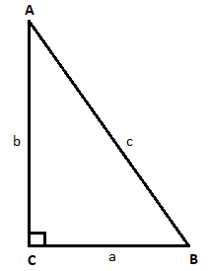
The sine of angle B is the ratio of side b to side c i.e. the opposite side to angle B and the hypotenuse, denoted;
$$Sin B=\frac{Opposite side}{Hypotenuse}=\frac{b}{c}$$

The cosine of angle B is the ratio of side a to side c i.e. the adjacent side to angle B and the hypotenuse denoted;
$$Cos B=\frac{Adjacent side}{Hypotenuse}=\frac{a}{c}$$
The tangent of angle B is the ratio of side b to side a i.e. the opposite side to angle B and the adjacent side to angle B, denoted;
$$\tan{B=\frac{Opposite side}{Adjacent side }=\frac{b}{a}}$$
Reciprocal ratios
The reciprocal of sine is cosecant denoted by csc or cosec e.g. given sin A then its reciprocal is csc A i.e. $\frac{1}{\sin{A}}=cosecant A$.

The reciprocal of cosine is secant denoted by sec e.g. given cos A then its reciprocal is sec A i.e. $\frac{1}{\cos{A}}=\sec{A}$.

The reciprocal of tangent is cotangent denoted by cot e.g. given tan A then its reciprocal is cot A i.e. $\frac{1}{\tan{A}}=\cot{A}$

Example 1: Consider the right-angled triangle below and determine the sine, cosine, and the tangent of angles CAB and ABC (angle ACB is a right-angle).
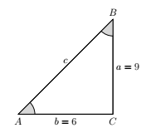
Solution: We apply Pythagoras theorem to find side c i.e.
$c^{2}=9^{2}+6^{2}=81+36=117∴c=\sqrt{117}$ units
Hence; $\tan{A=\frac{9}{6}=1.5}$; $\tan{B=\frac{6}{9}=\frac{2}{3}}$; $Sin A=\frac{9}{\sqrt{117}};Sin B=\frac{6}{\sqrt{117}}$ ; $\cos{A}=\frac{6}{\sqrt{117}};$
$\cos{B=\frac{9}{\sqrt{117}} }$
Remark 1:
$\sin{A=\cos{B and Sin B=\cos{A}}}$ . Angles A and B are complementary angles i.e. their sum is ${90}^{0}$.
Proposition: The sine and cosine of complementary angles are equal i.e. $\sin{α=\cos\left({90}^{0}-α\right)}$ and $\cos{α=\sin{({90}^{0}-α)}}$
Example 1: $sin 46^{0}=cos 44^{0}$

Special angles $\left(0^{0}, 30^{0}, 45^{0}, 60^{0}, and 90^{0}\right)$ and their trigonometric ratios
Example 1: Consider the isosceles triangle ABC below. Angles CAB and ABC are each ${45}^{0}$.
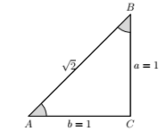
Note that sides $a=b=1 unit$ and by Pythagoras theorem side $c^{2}=1^{2}+1^{2}=2∴c=\sqrt{2}$ units.
Therefore $\sin{{45}^{0}=\frac{1}{\sqrt{2}}};\cos{{45}^{0}=\frac{1}{\sqrt{2}} and\tan{{45}^{0}=1}}$
Example 2: Consider the equilateral triangle ABC of side 2 units below;
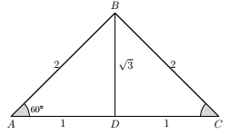
Angle $BAC=A\hat{B}C=A\hat{C}B={60}^{0}$. Line $BD$is a perpendicular bisector of line AC at point D. It also bisects angle $ABC$. Hence angle $ABD=DBC={30}^{0}$. Triangles ADB and CDB are both right-angled triangles.
We can therefore note that;
$$\sin{{60}^{0}=\frac{Opposite side}{Hypotenuse}=\frac{\sqrt{3}}{2}};\cos{{60}^{0}=\frac{Adjacent side}{Hypotenuse}=\frac{1}{2};\tan{{60}^{0}=\frac{Opposite side}{Adjacent side}=\sqrt{3}}}$$
$$\sin{{30}^{0}=\frac{Opposite side}{Hypotenuse}=\frac{1}{2}};\cos{{60}^{0}=\frac{Adjacent side}{Hypotenuse}=\frac{\sqrt{3}}{2};\tan{{60}^{0}=\frac{Opposite side}{Adjacent side}=\frac{1}{\sqrt{3}}}}$$
In summary
 | $$0^{0}$$ | $${30}^{0}$$ | $${45}^{0}$$ | $${60}^{0}$$ | $${90}^{0}$$
Sine | 0 | $$\frac{1}{2}$$ | $$\frac{1}{\sqrt{2}}$$ | $$\frac{\sqrt{3}}{2}$$ | 1
Cosine | 1 | $$\frac{\sqrt{3}}{2}$$ | $$\frac{1}{\sqrt{2}}$$ | $$\frac{1}{2}$$ | 0
Tangent | 0 | $$\frac{1}{\sqrt{3}}$$ | $$1$$ | $$\sqrt{3}$$ | $$∞$$

Positive and negative angles
Positive angles are measured anti-clockwise while negative angles are read clockwise starting from the horizontal axis. Hence $-{90}^{o}={270}^{o};{180}^{o}=-{180}^{o};and {90}^{o}=-{270}^{o}$
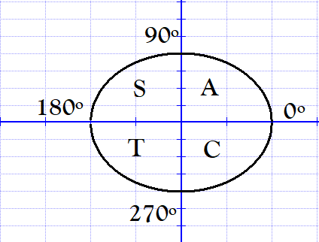
The sine, cosine, and tangent of angles $θ$ where $0^{o}≤θ<{90}^{0}$ are all positive. These angles are in the first quadrant of the circle above. Only the sine is positive in the second quadrant i.e. the sine of angles in the range ${90}^{o}≤θ<{180}^{o}$are positive while the cosine and tangent are negatives. In the 3rd quadrant only the tangent is positive and in the 4th quadrant, only the cosine is positive.

Example 1: Simplify the following;
- $\cos{{30}^{o}\sin{{60}^{o}+\tan{{45}^{0}\sin{{270}^{o}}}}}$
- $3tan{{60}^{o}+4\sin{{30}^{o}\cos{{45}^{o}}}}$
Solution:
- We use the special angles to simplify the expression.
Note that $\sin{{270}^{o}=-\sin{{90}^{o}=-1}}$
Hence our expression becomes;
$$\cos{{30}^{o}\sin{{60}^{o}+\tan{{45}^{0}\sin{{270}^{o}}}}}=\frac{\sqrt{3}}{2}⋅\frac{\sqrt{3}}{2}+1⋅\left(-1\right)=\frac{3}{4}-1=-\frac{1}{4}$$
- $3tan{{60}^{o}+4\sin{{30}^{o}\cos{{45}^{o}}}}=3 ⋅\sqrt{3}+4⋅\frac{1}{2}⋅\frac{1}{\sqrt{2}}=3\sqrt{3}+\frac{2}{\sqrt{2}}=3\sqrt{3}+\sqrt{2}$
Example 2: Given that $\sin{θ}=-\frac{1}{\sqrt{2}}$ determine $θ$ and $\tan{θ}$.
Solution: Since the sine is a negative value, it means that $θ$ is in the 3rd and 4th quadrant.
we know that $\sin{{45}^{o}=\frac{1}{\sqrt{2}}}$ Therefore; in the 3rd quadrant $θ={180}^{o}+{45}^{o}={225}^{o}$ . In the 4th quadrant $θ=-{45}^{0} or {360}^{o}-{45}^{o}={315}^{o}$. Hence $θ=\{{225}^{o}, {315}^{o}\}$.
Therefore; $\tan{{225}^{o}=1 and\tan{{315}^{o}=-1}}$
Example 3: Find all possible values of $θ$ where $0^{o}≤θ≤{360}^{o}$ that satisfy the equation;
$$5\sin{θ\cos{θ=\cos{ θ}}}$$
Solution: The equation can be rewritten as;
$$5\sin{θ\cos{θ-\cos{ θ=0}}}$$
$$\cos{θ (5\sin{θ-1)=0}}$$
$$⇒cos⁡θ=0 or 5sin⁡θ-1=0$$
When $\cos{θ=0, } θ={90}^{o}, {270}^{o}$
When $5\sin{θ-1=0∴\sin{θ=\frac{1}{5}⇒θ=\sin^{-1}\left(\frac{1}{5} \right)≈{11.54}^{o}, {168.46}^{o} }}$

Example 4: Find $θ$ given that $3\sin{θ-\frac{1}{\sin{θ}}=2}$ for $0^{O}≤θ≤{360}^{o}$
Solution: Multiply both sides by $\sin{θ}$to get;
$$3\sin^{2}{θ-1=2\sin{θ⇒3\sin^{2}{θ-2\sin{θ-1=0}}}}$$
$$(3\sin{θ-1)(\sin{θ-1)=0}}$$
$$⇒3\sin{θ-1=0∴\sin{θ=\frac{1}{3}⇒θ≈{19.5}^{o}, {160.5}^{o}}}$$
When $\sin{θ-1=0⇒\sin{θ=1∴θ={90}^{0}}}$
Hence $θ=\left\{{19.5}^{o}, {90}^{o}, {160.5}^{o}\right\}$
Example 5: Given $3\tan{θ+5+2\cot{θ=0}}$ determine $θ$ over $0^{O}≤θ≤{360}^{o}$
Solution: $3\tan{θ+5+2\cot{θ=0}}$ $⇒3\tan{θ+5+\frac{2}{\tan{θ}}=0}$
Multiplying every term by $\tan{θ}$ to get; $3\tan^{2}{θ+5\tan{θ+2=0⋯(i)}}$
Factorize (i) to get; $(3\tan{θ+2)(\tan{θ+1)=0}}$
$$⇒3\tan{θ+2=0∴\tan{θ=-\frac{2}{3}⇒θ≈ {146.3}^{0};{326.3}^{o} }}$$
When $\tan{θ+1=0⇒\tan{θ=-1∴θ=-\frac{π}{4}=-{45}^{0}={315}^{o}}}, {135}^{o}$
Hence $θ=\{{135}^{0}, {146.3}^{o}, {315}^{o}, {326.3}^{o}\}$

Solving triangles
The process of finding the unknown sides and angles of a triangle is called solving the triangle.
To solve a triangle one may apply one or a combination of the following; the sine rule, cosine rule, or the Pythagoras theorem and the trigonometric ratios in case it is a right-angled triangle.
Example 1: Solving the following triangle XYZ given that angle is Z is right-angled and X is ${36}^{o}$ and $z=14 cm$
Solution: Our triangle is as below. Note that the side opposite angle X is labeled x, side opposite angle Y is y, and the side opposite angle Z is side z.
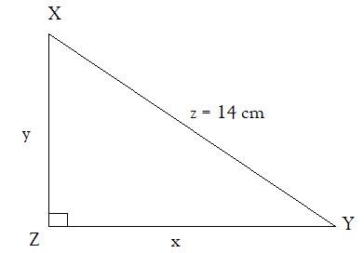
Since the sum of the interior angles of a triangle is ${180}^{o}$ then we have; $X+Y+Z={180}^{o}$
$$⇒Y={180}^{o}-{90}^{0}-{36}^{o}={54}^{o}$$
Again; $\sin{{54}^{o}=\frac{y}{14}⇒y=14\sin{{54}^{o}∴y≈11.33 cm}}$; $\sin{{35}^{o}=\frac{x}{14}⇒x=14\sin{{36}^{o}∴x≈8.22 cm}}$.
Note that after getting the value of side y, we can apply the Pythagoras theorem to find side x i.e. $x^{2}+y^{2}={14}^{2}=>x^{2}=196-128.37∴x=\sqrt{67.63}≈8.22 cm$
Sine Rule
Consider triangle ABC as shown in the two diagrams below.
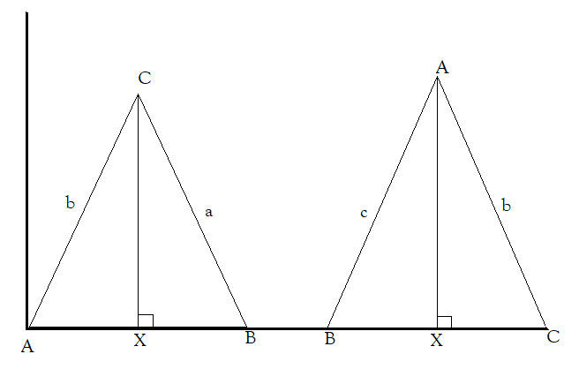
In the first diagram;
$$\sin{A=\frac{CX}{b}⇒CX=b\sin{A}}$$
$$\sin{B=\frac{CX}{a}⇒CX=a\sin{B}}$$
Therefore,
$$CX=a\sin{B=b\sin{A⇒\frac{a}{\sin{A}}=\frac{b}{\sin{B}}⋯(i)}}$$
In the second diagram,;
$$\sin{B=\frac{AX}{c}⇒AX=c\sin{B}}$$
$$\sin{C=\frac{AX}{b}⇒AX=b\sin{C}}$$
Therefore,
$$AX=b\sin{C=c\sin{B⇒\frac{b}{\sin{B}}=\frac{c}{\sin{C}}}}⋯(ii)$$
From equations (i) and (ii) we have;
$$\frac{a}{\sin{A}}=\frac{b}{\sin{B}}=\frac{c}{\sin{C}}-Sine Rule$$
Example 1: Solve the triangle $∠A=52^{o}, ∠B=73^{o}, and c=4.9 cm$
Solution: Our task is to find $∠C$ and sides $a and b$.
$$∠C={180}^{o}-∠A-∠B={180}^{o}-{52}^{o}-{73}^{o}={55}^{0}$$
To get the sides, we apply the sine rule;
$$\frac{a}{\sin{A}}=\frac{c}{\sin{C}}⇒\frac{a}{\sin{{52}^{o}}}=\frac{4.9}{\sin{{55}^{o}}}$$
$$⇒a=\frac{4.9\sin{{52}^{o}}}{\sin{{55}^{o}}}≈4.7 cm$$
Next we find side $b$
$$\frac{b}{\sin{B}}=\frac{c}{\sin{C}}⇒\frac{4.9}{\sin{{55}^{o}}}=\frac{b}{\sin{{73}^{o}}}$$
$$∴b= \frac{4.9\sin{{73}^{o}}}{\sin{{55}^{o}}}≈5.7 cm$$

Cosine rule
Consider triangle ABC below:
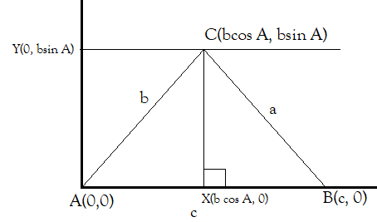
The distance $AB=c∴B is the point (c, 0)$
$$cos A=\frac{AX}{b}⇒AX=b\cos{A∴X is the point (bcos A, 0)}$$
$$\sin{A=\frac{CX}{b}⇒CX=b\sin{A∴Y is the point (0, b\sin{ A)}}}$$
Hence $C is the point (b\cos{A, b\sin{A)}}$.
Recall the distance formula:
That is the distance $d$ between any two points $\left(x_{1},y_{1}\right) and \left(x_{2}, y_{2}\right)$ on the xy- plane is given by;
$$d=\sqrt{{\left(x_{2}-x_{1}\right)}^{2}+{\left(y_{2}-y_{1}\right)}^{2} }$$
$$⇒d^{2}={\left(x_{2}-x_{1}\right)}^{2}+{\left(y_{2}-y_{1}\right)}^{2}$$
From the triangle ABC above; $a^{2}={\left(bcos A-c\right)}^{2}+{\left(bsin A-0\right)}^{2}$
$$a^{2}=b^{2}\cos^{2}{A-2bcCosA+c^{2}+b^{2}\sin^{2}{A}}$$
$$a^{2}=b^{2}(\cos^{2}{A+\sin^{2}{A)-2bcCosA}}+c^{2}$$
$$a^{2}=b^{2}+c^{2}-2bcCosA-Cosine Rule$$
It can also be shown that $b^{2}=a^{2}+c^{2}-2acCosB$ by placing B at the origin.
Similarly, placing C at the origin we shall get $c^{2}=a^{2}+b^{2}-2abCosC$.
This rule is appropriate when solving a triangle with all the three sides given and/or a triangle given two sides and the included angle.
Example 1: Solve triangle PQR with $p=6 cm, q=8 cm, and r=5 cm$
Solution: $p^{2}=q^{2}+r^{2}-2qrCos P⇒\cos{P=\frac{q^{2}+r^{2}-p^{2}}{2qr}}=\frac{64+25-36}{2⋅8⋅5}=\frac{53}{80}$
$$∴P=cos^{-1}\left(\frac{53}{80}\right)≈{48.5}^{o}$$
$$q^{2}=p^{2}+r^{2}-2prCos Q⇒\cos{Q=}\frac{p^{2}+r^{2}-q^{2}}{2pr}=\frac{36+25-64}{2⋅6⋅5}=\frac{-3}{60}=-0.05$$
$$∴Q=\cos^{-1}\left(-0.05\right)≈{92.9}^{o}$$
Finally; $∠R={180}^{0}-{48.5}^{o}-{92.9}^{o}={38.6}^{o}$
Example 2: Triangle ABC is such that $∠A={65}^{o}, b=15 cm, c=22 cm$. Solve the triangle
Solution: Our task is to find $∠B, ∠C, and side a$. We apply the cosine rule to first find side $a$ i.e.
$$a^{2}=b^{2}+c^{2}-2bcCosA$$
$$⇒a^{2}={15}^{2}+{22}^{2}-2⋅15⋅22 Cos {65}^{o}≈569.54∴a=\sqrt{569.54}≈23.9 cm$$
To get angles B and C one can also use the sine rule.
$$\cos{B=\frac{a^{2}+c^{2}-b^{2}}{2ac}}=\frac{569.54+484-225}{2⋅23.9⋅22}≈0.788∴B=\cos^{-1}\left(0.788\right)≈{38}^{o}$$
Hence $∠C={180}^{o}-{38}^{o}-{65}^{o}=77$
Example 8: Helicopter and a jet left port P at 0900hrs. The helicopter flew at 120 knots on course ${028}^{o}$ while the jet flew at 315 knots on course ${114}^{o}$. Assume the course is straight, then find how far apart are the two craft at 1100hrs.
Solution: We can first draw a rough sketch of the positions of the two crafts after 2 hours of leaving the Port P.
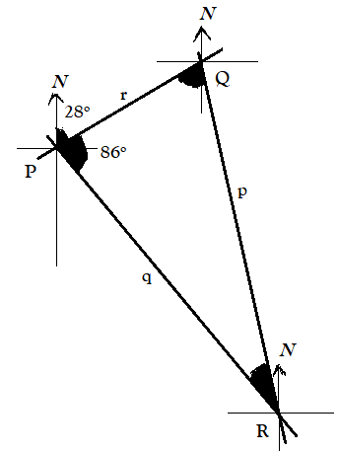
After 2 hours:
The helicopter will be at point Q, distance $r=120×2=240 nm$ from P.
The jet will be at point R, distance $q=315×2=360 nm$ from P.
How far apart are the two crafts i.e. what is distance $p$?
We apply cosine rule i.e.
$p^{2}=q^{2}+r^{2}-2⋅q⋅r⋅cos P={120}^{2}+{360}^{2}-2×120×360\cos{{86}^{0}}$
$$p^{2}≈137973.04⇒p≈371.45 nm$$
Exercise: Find the bearing of the jet from the helicopter, and the bearing of the helicopter from the jet.
Exercise
- Solve the following equations for $0^{o}≤θ≤{360}^{o}$

- $\sin{θ=-1}$
- $\tan{3θ=3.08}$
- $\cos{θ=\sin{4θ}}$
- $3\sin{θ=\csc{θ}}$
- $4\cos^{2}{θ+5cosθ+1=0}$
- $\tan^{2}{θ-3\sec{θ+3=0}}$
- $\sin^{2}\left(3θ+{10}^{o}\right)=0.6$
- $2\cot^{2}{θ-5\cot{θ+2=0 }}$

- Simplify the following trigonometric expressions

- $\cos{{30}^{o}-5\sin{{60}^{o}}}$
- $\tan{{60}^{o}+3\sin{{60}^{2}-4\cos{{45}^{o}}}}$
- $\sin{{45}^{o}+2\cos{{45}^{o}}}$
- $\sin{{270}^{o}\cos{{225}^{o}+\tan{{210}^{o}\tan{{30}^{o}}}}}$
- $cosec {60}^{o}\sec{{30}^{o}-\cot{{60}^{o}\tan{{30}^{o}}}}$
- $1+\frac{3}{\sec{{60}^{o}}}$

- Solve the following triangles

- $∠A={53}^{o}, ∠B={67}^{o}, b=5.4 cm$
- $∠B={40}^{o}, ∠C={73}^{o}, a=55 cm$
- $∠B={38}^{o}, a=5.4 cm, b=7.6 cm$
- $a=7 cm, b=8 cm, c=5 cm$
- $∠A={125}^{o}, b=8 cm, c=5.5 cm$
- $∠C={142}^{o}, a=37.2 cm, b=23 cm$

- ABCD is a rhombus of side 15 cm and angle $DAB={30}^{o}$. E is a point on AB such that $AE=10$ cm. Calculate the length of DE and EC.
- An Antenna VC of length 5 metres is fixed on top of a vertical pole BC. Two wires AC and AV are attached such that they make angles ${60}^{o}$ and ${70}^{o}$ with the horizontal ground, respectively. Calculate the height of the pole.
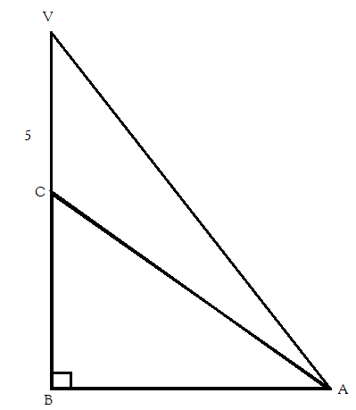

Bibliography
Lumen. (n.d.). Solving Trigonometric Equations. https://courses.lumenlearning.com/precalctwo/chapter/solving-trigonometric-equations/
Stewart, J. (2012). Calculus (7th ed.). BROOKS/COLE Cengage Learning.
Swokowski, E., & Cole, J. A. (2009). Algebra and Trigonometry with Analytical Geometry. BROOKS/COLE Cengage Learning.

