Mathematics for Science
Lecture 3
Conic Sections and their application: Circles and Parabolas
Lecturer: Kahenya, N.P

Introduction to lecture 3
This lecture will introduce the conic sections and in particular circles and parabolas. The application of circles to various structures in the real world is almost obvious. Parabolic shape is applied in such areas as designing satellites disks, spotlights reflectors among many other applications (CUEMATH, n.d.).
Intended learning outcomes
At the end of this lecture you will be able to;
- Define conic sections.
- Solve problems involving equations of circles and parabolas.
References
These lecture notes should be complemented with relevant topics in (Kahenya, 2017; Murray & Robert, 2009; Stewart, 2012).

Definition 1: (Distance Formula)
Suppose $P(x_{1},y_{1})$and $Q(x_{2},y_{2})$ are two points on the $xy$- plane. Then the distance between P and Q denoted $d(P,Q)$ is given by;
$$d\left(P,Q\right)=\sqrt{{\left(x_{2}-x_{1}\right)}^{2}+{\left(y_{2}-y_{1}\right)}^{2}}$$
Example 1: Find the distance between the points; $A(4,-10)$ and $B(6, 6)$
Solution: $d\left(A,B\right)=\sqrt{(x_{2}-x_{1})^{2}+(y_{2}-y_{1})^{2}}=\sqrt{(6-4)^{2}+(6--10)^{2})}$
$$=\sqrt{4+256}=\sqrt{260}≃16.12$$
Definition 2: (Mid-Point Formula)
The midpoint of the line segment AB with endpoints having coordinates $X(x_{1},y_{1})$ and $Y(x_{2},y_{2})$ is given by; $\left(\frac{x_{1}+x_{2}}{2},\frac{y_{1}+y_{2}}{2}\right)$

Example 1: Determine the midpoint of $\overline{AB}$ if $A(-3,14)$ and $B(5,-6)$
Solution: The midpoint $M$of $\overline{AB}$ is; $M\left(\frac{x_{1}+x_{2}}{2},\frac{y_{1}+y_{2}}{2}\right)=\left(\frac{-3+5}{2},\frac{14+-6}{2}\right)=\left(1,4\right)$
Definition 2: (Conic sections)
Conic sections circles, ellipses, parabolas, and hyperbola are graphs that results from the intersections of a plane and a right circular cone.
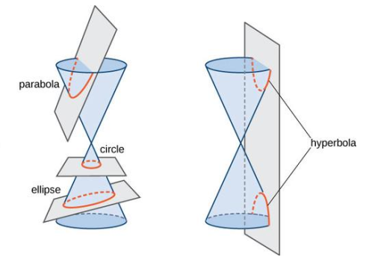
Source: (Lumen, n.d.)

Definition 3: (General quadratic equation)
The general quadratic equation with two variables $x$ and $y$ is of the form;
$$ax^{2}+bxy+cy^{2}+dx+ey+f=0$$
where $a,b,c,d,e,and f$ are real constants, and $a,b, and c$ not all zero.
Definition 4: (Conic sections)
Conic sections are graphs of quadratic equation that are dependent on the value of the discriminant $\left(b^{2}-4ac\right).$
Definition 5: (Circle)
A circle is a locus or a path of a set of all points $(x,y)$ in a plane that are equidistant from a fixed point. The fixed point $0$ is the centre of the circle and the distance is its radius $r.$
Definition 6: (Circle)
A circle is the graph of the general quadratic equation, $ax^{2}+bxy+cy^{2}+dx+ey+f=0$ when the discriminant $b^{2}-4ac<0$ with $b=0 and a=c$. However the graph may also be the degenerate cases i.e. either a point or non-existent.

Example 1: Consider the equation $x^{2}+y^{2}-8x+14y+29=0$ then we have;
$$a=1, b=0,c=1, d=-8, e=14, f=29$$
The discriminant ${(b}^{2}-4ac)=0-4⋅1⋅1=-4<0$. Since the discriminant is less than 0 and $b=0, a=c=1$ then the equation is that of a circle.

Equation of a circle centre the origin
The standard equation of a circle radius $r$ and with centre the origin $(0,0)$ and a point $(x,y)$ is given as $x^{2}+y^{2}=r^{2}$
Example 1: Write the equation of a circle, centre the origin and radius 5 units.
Solution: The equation is $x^{2}+y^{2}=25$

Example 2: Write the equation of a circle with centre the origin and passing though point $P(3,6)$.
Solution: The standard equation is $x^{2}+y^{2}=r^{2}$. We need first find the value of $r$
Using the distance formula i.e. the distance between two points say $P\left(x_{1},y_{1}\right)$ and $Q(x_{2},y_{2})$ given as;
$$d\left(P,Q\right)=\sqrt{{\left(x_{2}-x_{1}\right)}^{2}+{\left(y_{2}-y_{1}\right)}^{2}}$$
Hence the distance from the point (3,6) and the origin i.e. the radius is
$$r=\sqrt{3^{2}+6^{2}}=\sqrt{45}=3\sqrt{5} units$$
Therefore the equation of the circle is;
$$x^{2}+y^{2}=45$$
Example 3: Write the equation of a circle centre the origin and passing through point $(-5,7)$.
Solution: Our $x=-5$and $y=7$. The equation of the circle radius $r$, centre the origin and passing through point (x, y) is $x^{2}+y^{2}=r^{2}$. Therefore we have $r^{2}={\left(-5\right)}^{2}+7^{2}=25+49=74$
The equation is;
$$x^{2}+y^{2}=74$$

Equation of a circle centre (a, b)
The standard equation of a circle radius r and centre $(a,b)$ and a point $(x,y)$ on it, is given by;
$${\left(x-a\right)}^{2}+{\left(y-b\right)}^{2}=r^{2}$$
Expanding the above equation give us the general equation of circle i.e.
$$x^{2}-2ax+a^{2}+y^{2}-2yb+b^{2}-r^{2}=0$$
Note that we can rewrite the above equation into the general quadratic equation as follows;
$$x^{2}+y^{2}-2ax-2by+\left(a^{2}+b^{2}-r^{2}\right)=0$$
Which is of the form;
$$Ax^{2}+Bxy+Cy^{2}+Dx+Ey+F=0$$
with $A=1, B=0,C=1, D=-2a, E=-2b, and F=a^{2}+b^{2}-r^{2}$

Example 1: Write the equation of a circle centre $(-2,5)$ and radius 7 units.
Solution: Note that given the standard equation
$${\left(x-a\right)}^{2}+{\left(y-b\right)}^{2}=r^{2}$$
Then our $a=-2, b=5, and r=7$
Therefore our standard equation of this circle is;
$${\left(x+2\right)}^{2}+{\left(y-5\right)}^{2}=49$$
We can expand the equation to get the general equation of the circle i.e.
$$x^{2}+2x+4+y^{2}-10y+25=49$$
Further simplification gives us;
$$x^{2}+y^{2}+2x-10y-20=0$$

Example 2: Write the standard and general equation of a circle centre $(-5,9)$ and radius 5 units.
Solution: The standard equation is ${\left(x+5\right)}^{2}+{\left(y-9\right)}^{2}=25$
Expanding the above we get;
$$x^{2}+10x+25+y^{2}-18y+81=25$$
Simplifying further we get;
$x^{2}+y^{2}+10x-18y+81=0$ – General equation

Example 3: Determine the standard and general equations of a circle with a diameter d whose end points are $A(3, -2)$ and $B(6, 2)$.
Solution: The standard equation requires one to have the centre (a, b) and the radius r.
In our case the centre is the midpoint of the diameter, and the radius is half the diameter.
The length of the diameter is
$$d\left(A,B\right)=\sqrt{{\left(6-3\right)}^{2}+{\left(2+2\right)}^{2}}=\sqrt{\left(9+16\right)}=5 units$$
Therefore the radius $r=2.5 units$
The centre of the circle is the midpoint of the diameter i.e. $\left(\frac{3+6}{2},\frac{-2+2}{2} \right)=\left(4.5, 0\right)$
Finally the standard equation of the circle is; ${\left(x-\frac{9}{2}\right)}^{2}+y^{2}=6.25$
Expanding the standard equation we get; $4x^{2}-36x+81+y^{2}-6.25=0$
Simplifying the above we get the general equation of the circle i.e.
$$4x^{2}+y^{2}-36x+74.75=0$$

Example 4: Given the equation $4x^{2}+y^{2}-52x+10y+145=0$, determine the centre and radius of the circle.
Solution: We need to rewrite the equation in standard form i.e. ${\left(x-a\right)}^{2}+{\left(y-b\right)}^{2}=r^{2}$
We can rearrange the general equation as follows;
$$4(x^{2}-13x+k_{1})+{(y}^{2}+10y+k_{2})=-145+{4k}_{1}+k_{2}⋯(i)$$
We need to complete the two squares on the LHS (for both x and y). We have added $k_{1}and k_{2}$ to the RHS to balance the equation.
Recall from Basic mathematics given $x^{2}+bx+k$ is a perfect square then $k={\left(\frac{b}{2}\right)}^{2}$
$$∴k_{1}={\left(\frac{b}{2}\right)}^{2}={\left(\frac{-13}{2}\right)}^{2}$$
$$=>k_{1}={\left(\frac{-13}{2}\right)}^{2}=\frac{169}{4}$$
Note that
$$x^{2}-13x+k_{1}=x^{2}-13x+{\left(\frac{-13}{2}\right)}^{2}={\left(x-\frac{13}{2}\right)}^{2}$$

Next we complete the square for $y$: ${(y}^{2}+10y+k_{2})$
$$k_{2}={\left(\frac{10}{2}\right)}^{2}$$
$$⇒y^{2}+10y+k_{2}=y^{2}+10y+{\left(\frac{10}{2}\right)}^{2}={\left(y+5\right)}^{2}$$
Equation (i) becomes;
$${\left(x-\frac{13}{2}\right)}^{2}+{\left(y+5\right)}^{2}=-145+169+25$$
$${\left(x-\frac{13}{2}\right)}^{2}+{\left(y+5\right)}^{2}=49$$
Therefore the centre of the circle is the point $(\frac{13}{2}, -5)$ and the radius is 7 units.

Circle Passing Through Three Given Points
Given a circle centre $(-a,-b)$ and radius r then we have the standard equation;
$${\left(x+a\right)}^{2}+{\left(y+b\right)}^{2}=r^{2}$$
Expanding this equation we get $x^{2}+y^{2}+2ax+2by+\left(a^{2}+b^{2}-r^{2}\right)=0⋯(i)$
Suppose we let $2a=D, 2b=E, \left(a^{2}+b^{2}-r^{2}\right)=F$ then our equation (i) becomes;
$$x^{2}+y^{2}+Dx+Ey+F=0⋯(ii)$$
Equation (ii) can be used to determine the equation of a circle that passes through three given points.

Example 1: Write the general equation a circle passing through points $\left(2, 1\right), \left(-2, -3\right), (-6, 1)$.
Solution: Consider the equation $x^{2}+y^{2}+Dx+Ey+F=0$ we can replace x and y for the three points to get;
$$2^{2}+1+2D+E+F=0$$
$$⇒2D+E+F=-5⋯\left(i\right)$$
$${\left(-2\right)}^{2}+{\left(-3\right)}^{2}-2D-3E+F=0$$
$$⇒2D+3E-F=13⋯(ii)$$
$${\left(-6\right)}^{2}+{\left(1\right)}^{2}-6D+E+F=0$$
$$⇒6D-E-F=37⋯(iii)$$

We next solve the three equations simultaneously to get the values of D, E, and F
From (i) $E+F=-5-2D⋯*$
From (iii) $E+F=6D-37⋯**$
From equations $(*)$ and $\left(**\right)$ we get $-5-2D=6D-37⇒8D=32∴D=4$
Again from (i) we have $E+F=-13$ and from (ii) $8+3E-F=13$
Replacing F with $(-E-13)$ in $(8+3E-F=13)$ to get;
$$8+3E-\left(-E-13\right)=13$$
$$3E+E=13-21$$
$$4E=-8∴E=-2$$
From (i) $F=-13-E=-13+2=-11$
Therefore equation $x^{2}+y^{2}+Dx+Ey+F=0$ becomes;
$$x^{2}+y^{2}+4x-2y-11=0$$
Definition 1: (Parabola)
A parabola is a path of all points $(x,y)$ on a plane each of which is equidistant from a fixed point, the focus F, and a fixed line, the directrix D.
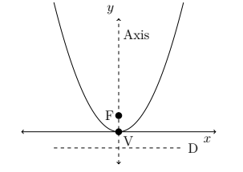
Source: (Kahenya, 2017)

Remark 1: The above parabola is called a central parabola whose vertex V is the origin with the axis passing through the focus F and the vertex V.

Remark 2: The distance from the focus F to the vertex V is the same as the distance from the directrix D to the vertex V, denoted $|p|$. Therefore the focus F is the point $(0,p)$.

Definition 2: (Parabola)
Given the quadratic equation with two variables $x$ and $y$ of the form;
$$ax^{2}+bxy+cy^{2}+dx+ey+f=0$$
if $b^{2}-4ac=0$ the graph is either a parabola or the degenerate cases i.e. two parallel lines or coincident lines, or non-existent.
Definition 3: The equation of the central parabola above with the line of symmetry as $x=0$, directrix $y=-p$ and the focus $(0, p)$ is given by;
$$x^{2}=4py$$
Definition 4: The equation of a central parabola with the axis as the x-axis, the focus at point $(p,0)$, and the directrix $x=-p$ is given by
$$y^{2}=4px$$
Definition 5: The equation of a parabola with vertex at point $(h,k)$ and with its axis and directrix parallel to the y-axis and x-axis respectively is given by
$${\left(x-h\right)}^{2}=4p(y-k)$$
The focus is the point $\left(h, k+p\right)$ , the directrix is the line $y=k-p$, and the axis is the line $x=h$

Example 1: Find the vertex, focus, directrix, and the axis of the parabola $y=\frac{1}{12}x^{2}$
Solution: The parabola is of the form $x^{2}=4py$
We can rewrite it as $x^{2}=12y=>4p=12∴p=3$
This is a central parabola with the vertex at the origin (0, 0) and the focus at (0, 3) while the directrix is the line $y=-3$. The line of symmetry is the $x=0$ (y – axis).

Example 2: Determine the vertex, focus, directrix, and axis of the parabola with equation
$$x^{2}-12x+18y-18=0$$
Solution: we need to write the general equation in the standard form i.e.
$${\left(x-h\right)}^{2}=4p(y-k)$$
$$x^{2}-12x=18-18y$$
We add a k to both sides to complete the square on the LHS i.e.
$$x^{2}-12x+k=18-18y+k$$
But $k={\left(-\frac{12}{2}\right)}^{2}={\left(-6\right)}^{2}$.
Therefore we have; $x^{2}-12x+{\left(-6\right)}^{2}=18-18y+{\left(-6\right)}^{2}$
$${\left(x-6\right)}^{2}=54-18y$$
$${\left(x-6\right)}^{2}=-18\left(y-3\right)⋯(i)$$
$$=> -18=4p∴p=\frac{-18}{4}=-4.5$$
Equation becomes; ${\left(x-6\right)}^{2}=4⋅\left(-4.5\right)\left(y-3\right)$
Given ${\left(x-h\right)}^{2}=4p\left(y-k\right)$ the focus is the point $\left(h, k+p\right)$ , vertex (h,k); the directrix is the line $y=k-p$, and the axis is the line $x=h$. i.e. our vertex is (6, 3); focus is $\left(6,3-4.5\right)=(6, -1.5)$; directrix is $y=3+4.5=7.5$ and the axis is the $x=6$
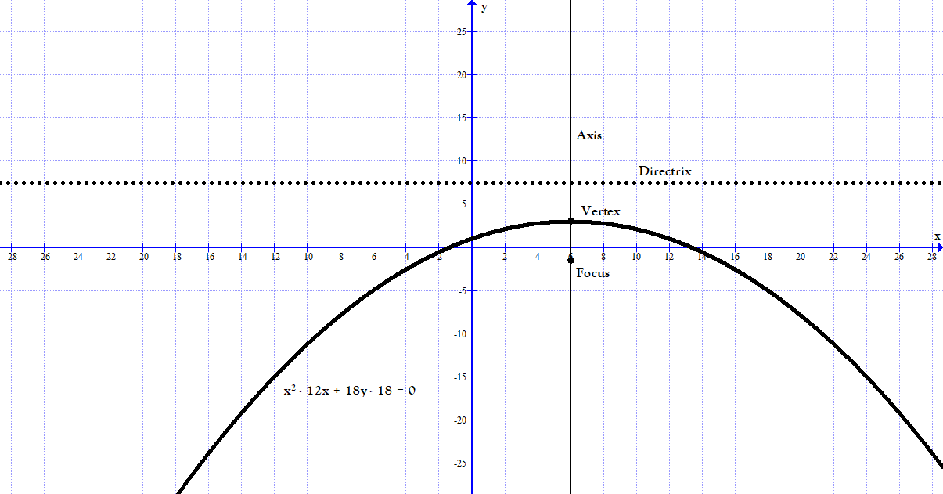

Example 3: Find the standard and the general equations of the parabola with vertex (4, 6) and focus (4, 9)
Solution: Since the x-coordinate of the focus and the vertex is the same then the standard equation for such parabola is; ${\left(x-h\right)}^{2}=4p(y-k)$
Note that our $\left(h,k\right)=(4,6)$. The distance of the focus from the vertex $\left|p\right|=3$
$$=>{\left(x-4\right)}^{2}=4⋅3(y-6)$$
$${\left(x-4\right)}^{2}=12\left(y-6\right)-Standard equation$$
Expanding the above we get; $x^{2}-8x+16=12y-72$
$$x^{2}-8x-12y+88=0-General equation$$Example 4: Find the standard and general equations of the parabola with focus (4, 5) and directrix $x=-4$
Solution: This is a parabola of the form ${\left(y-k\right)}^{2}=4p(x-h)$ since the directrix is parallel to the y-axis, with focus (h, k). The distance from the directrix to the focus is $4-\left(-4\right)=8$
The distance from the directrix to the focus is $2\left|p\right|=8∴p=4$
Thus we have; ${\left(y-5\right)}^{2}=16\left(x-4\right)-Standard equation$
The general equation is; $y^{2}-10y+25=16x-64⇒y^{2}-10y-16x+89=0$

Exercises
- Determine the equation of a circle centre the origin and with the given radius

- 5 units
- 11 units
- 7 units
- 13 units

- Determine the standard and the general equations of the circle with given centre and radius respectively

- (2, 5), 9 units
- (-3, -7), 7 units
- (-2, 6), 3.5 units
- (7, -1), 12 units

- Write the general equation of a circle given the endpoints of its diameter

- (2, 4) and (-3, -1)
- (-1, 5) and (3,7)
- (2, 7) and (-1, -4)
- (5, 3) and (11, 7)

- Determine the centre and radius of the circles
- $x^{2}+y^{2}-10x+8y+25=0$
- $x^{2}+y^{2}+16x-6y+48=0$
- $4x^{2}+4y^{2}+28x-44y+134=0$
- $16x^{2}+9y^{2}-120x-24y+192=0$
- Determine the equation of the circle passing through the points

- $\left(0, -2\right), \left(2,0\right), and (-2,0)$
- $\left(-1, -1\right), \left(-2, 0\right), and (0.6, -1.8)$
- $\left(1, -11\right), \left(-2.6, -9.8\right), and (-5, -5)$
- $\left(-0.5,-1.5\right), \left(1.6, -1.15\right), and (3.0, 0.25)$

- Write the equation of the parabola given the following

- Vertex (0, 0) and focus (3, 0)
- Vertex (0, 0) and focus (-2, 0)
- Focus (3, 5) and directrix $y=1$
- Focus (-2, -1) and directrix $x=2$

- Find the standard equation of the parabolas below, and hence find the vertex, directrix, axis, and the focus

- $y^{2}-8y-12x+76=0$
- $y^{2}-14y-14x+7=0$
- $4x^{2}-20x-22y+91=0$
- $9x^{2}-24x-60y+406=0$

References
CUEMATH. (n.d.). Conics in Real Life. Retrieved March 23, 2022, from https://www.cuemath.com/learn/mathematics/conics-in-real-life/#P004
Kahenya, P. (2017). Foundation Maths. LAP Lambert Academic Publishers.
Lumen. (n.d.). Introduction to Conic Sections. N.D. Retrieved March 23, 2022, from https://courses.lumenlearning.com/boundless-algebra/chapter/introduction-to-conic-sections/
Murray, S., & Robert, M. (2009). College Algebra. McGraw-Hill.
Stewart, J. (2012). Calculus (7th ed.). BROOKS/COLE Cengage Learning.

