CONSUMER BEHAVIOR

WEEK 3

CONSUMER MOTIVATION
Dr. Wanjiku Kinyanjui

CONSUMER MOTIVATION
Motivation is the driving force within individuals that impels them to action. This driving force is produced by a state of tension which exists as the result of an unfulfilled need. The specific goals they select and the patterns of action they undertake to fulfill these needs are the results of individual thinking and learning. Motivation is a state of need-induced tension that drives the individual to engage in behavior that he believes will satisfy the need and thus reduce the tension.

Motivation Process Model

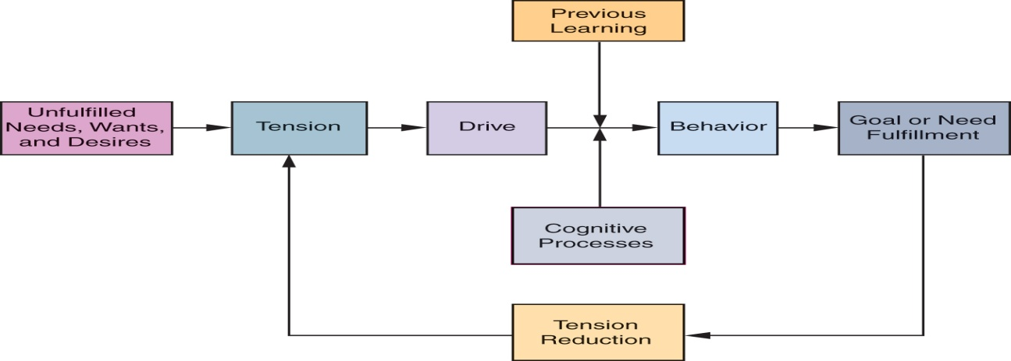
(Schiffman & Wisenbilt, 2020)
The diagram shows how unfulfilled needs create psychological tension and drives that impel people to act. The basis of marketing is identifying and satisfying needs. Marketers do not create needs, although in many instances they make consumers more keenly aware of unfelt or undeveloped needs. Therefore, rather than concentrating on the items they create and sell, marketers must concentrate on the requirements their products fulfill and since the needs of consumers do not change, the manner in how they satisfy needs, including the products they buy, change over time. This sometimes occurs frequently as new and better products that satisfy their needs are launched.

Dynamics of Motivation
Motivation is a highly dynamic construct that is constantly changing in reaction to life experiences. Needs and goals change and grow in response to an individual’s physical condition, environment, interactions and experiences. Need driven human activity never ceases because:
- Many needs are never fully satisfied
- New and higher order needs emerge
- People who achieve their goals set new and higher goals for themselves

Goal selection is a function of success or failure. Individuals who achieve their goals are more confident of their ability to reach higher goals. Expectations are based on past experiences. Effect on marketing strategy implementation: Advertisements should not promise more than the product will deliver, should be reasonably attainable
Products and services are often evaluated by the size and direction of the gap between consumer expectations and objective performance. When an individual can’t attain a specific goal or type that he anticipates will satisfy certain needs, behaviour may be directed to a substitute goal. Substitute goal may not be as satisfactory as the primary goal but may be sufficient to dispel uncomfortable tension.

Arousal motives
The arousal of any particular set of needs at a specific moment in time may be caused by internal stimuli found in the individual’s physiological condition, emotional and cognitive processes or by stimuli in the outside environment
- Physiological arousal –bodily need- hunger, cold –are involuntary- cause tension until they are satisfied. These physiological cues are involuntary, they arouse related needs that cause uncomfortable tensions until they are satisfied.
- Emotional arousal – dormant needs that arise when one is unoccupied and cause tension. When someone is bored may start to daydream and imagine themselves in all sorts of desirable situations. These thoughts tend to arouse dormant needs which may produce uncomfortable tensions that drive them into goal oriented behavior.
- Cognitive arousal – cognitive awareness of needs can be caused by random thoughts. E.g when one sees an ad that reminds them of home they may yearn to speak to their parents.
- Environmental arousal – The set of needs an individual experiences at a particular time are often triggered by specific cues. Without these cues, the need may remain dormant/latent

Types of motives
Rational motives – rationality assumes that consumers behave rationally by carefully considering all alternatives and choosing those that give them the greatest utility; Consumers select goals based on totally objective criteria (price, weight, size)
Emotional motives imply selection of goals according to personal or subjective criteria (pride, fear, affection, status). Assumes that the subjective /emotional criteria may not maximize utility.
Motives can be positive or negative.
- Positive motivation is a driving force towards some object or condition e.g a person may be impelled to start exercising in order to look attractive which is a positive outcome.
  - Needs, wants, desires
  - A positive goal is one toward which behavior is directed – referred to as an approach object
- Negative motivation is a driving force way from some object. A person may be impelled to start exercising in order to avoid health problems which is a negative outcome
  - Fears, aversions
  - A negative goal is one away from which behavior is directed – referred to as an avoidance object

Needs
Needs are circumstances or things that are wanted or required, and therefore direct the motivational forces. Unfulfilled needs form motivational desires that impel consumers to purchase goods and services. Desired outcomes create tensions which consumers strive to relieve, both consciously and subconsciously, by forming purchase-related goals and subsequent behavior that they anticipate will fulfill their needs
Every individual has needs.
- Primary (Innate) needs are physiological (biogenic)
  - water, food, air, clothing, shelter
  - needed to sustain biological life
- Secondary (acquired) needs are learned in response to our culture or environment
  - self esteem, prestige, affection, power
  - are generally psychological (psychogenic)
  - result from individuals subjective psychological state and from relationships with others
The majority of a person's wants are often latent. Any demand that is arousing at a certain time may be brought on by biological inputs, emotional or cognitive processes,or outside environmental stressors. A drop in blood sugar or stomach contractions cause physiological arousal, which makes people feel hungry. Shivering is a sign that the body temperature is dropping, alerting the person to the need for warmth. The majority of these physiological cues are uncontrollable, but they elicit needs that result in unpleasant tensions until they are met. For instance, a cold individual might increase the temperature in his bedroom while also remembering to get a warm jumper to wear about the home.
Types and systems of needs

- Abraham Maslow’s Hierarchy of needs

Everyone has the same set of needs but individuals differ in their priority ranking of these needs. Maslows theory of hierachy of needs identifies five basic levels of human needs. Individuals seek to satisfy lower level needs before higher level needs emerge. Higher order needs become the driving force behind human behavior as lower level needs are satisfied
The lowest level of need the individual experiences serves to motivate his behavior. When this level is satisfied, a new need emerges.

- Level 1: Physiological needs –required to sustain biological life- primary, biogenic needs are dominant when they are chronologically unsatisfied
- Level 2: Safety & security needs – order, stability, protection, control, familiarity over ones life and environment: savings accounts, insurance policies, education – towards satisfying this need
- Level 3: Social needs – love, affection, belonging, acceptance. Seek warm human relationships
The social needs in Maslow’s hierarchy include love, acceptance, and belonging. At this level, the need for emotional relationships drives human behavior. Some of the things that satisfy this need include: Friendships, Romantic attachments, Family relationships, Social groups
Community groups, Churches and religious organizations
In order to avoid loneliness, depression, and anxiety, it is important for people to feel loved and accepted by others. Personal relationships with friends, family, and lovers play an important role, as does involvement in groups—such as religious groups, sports teams, book clubs, and other group activities.
- Level 4: Egoistic needs – self acceptance, self esteem, success, reputation, status
At this level, it becomes increasingly important to gain the respect and appreciation of others. People have a need to accomplish things, then have their efforts recognized. In addition to the need for feelings of accomplishment and prestige, esteem needs include such things as self-esteem and personal worth.
People need to sense that they are valued by others and feel that they are making a contribution to the world. Participation in professional activities, academic accomplishments, athletic or team participation, and personal hobbies can all play a role in fulfilling the esteem needs.
People who are able to satisfy esteem needs by achieving good self-esteem and the recognition of others tend to feel confident in their abilities.3 Conversely, those who lack self-esteem and the respect of others can develop feelings of inferiority.
- Level 5: Need for Self Actualization – individuals desire to fulfill his potential – to become everything he is capable of becoming

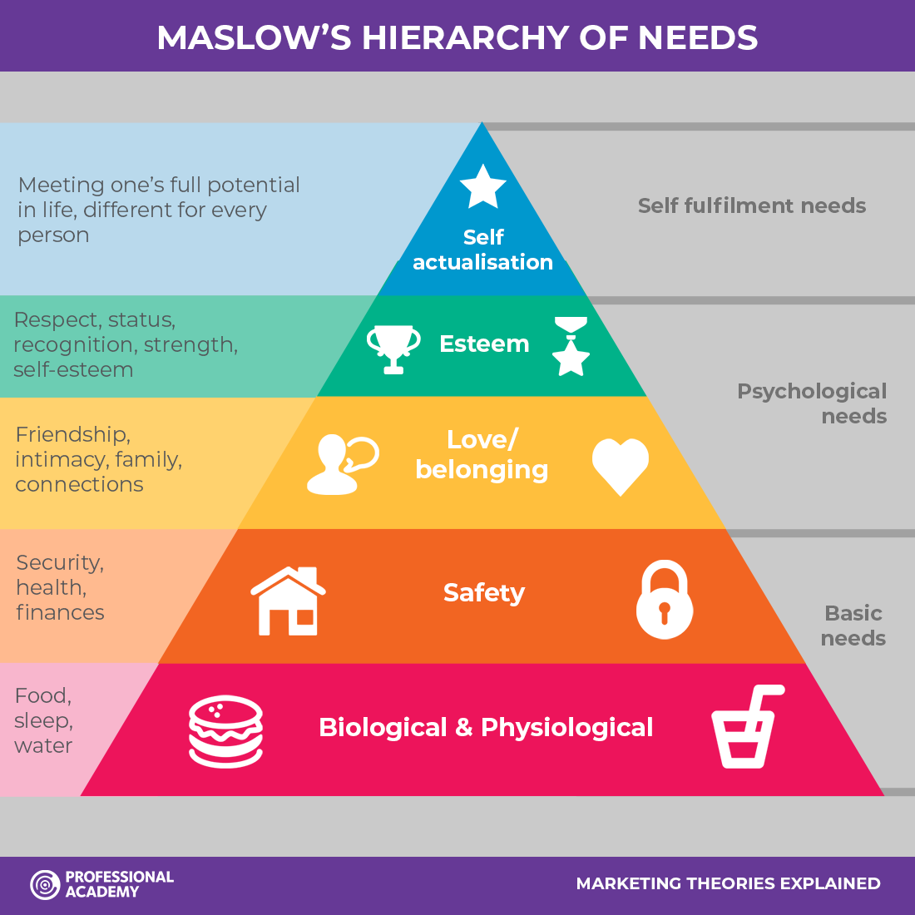

Benefits of Maslow’s Hierarchy
- Maslow’s hierarchy offers a useful framework for marketers trying to develop appropriate advertising appeals for their products.
- Segmentation & promotional application -Enables marketers to focus their advertising appeals on a need level that is likely to be shared by a large segment of target audience
- Hierarchy is used as a basis for segmentation with specific appeals directed to one or more need-segment levels.
- Facilitates product positioning and repositioning – different appeals for the same product can be based on different needs as defined on this framework.

- Henry Murray’s 28 psychogenic needs
According to Murray, all people have these psychogenic needs, but each individual tends to have a certain level of each need. ﻿ Each person's unique levels of needs play a role in shaping their individual personality.
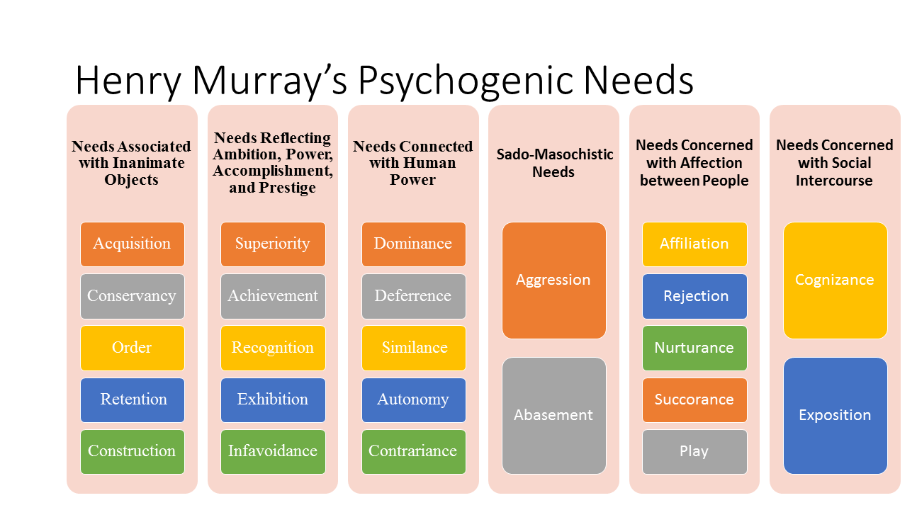
Source: Shiffman, Kanuk & Wisenblit (2010)

- Trio of needs
McClelland's Human Motivation Theory states that every person has one of three main driving motivators: the needs for achievement, affiliation, or power. These motivators are not inherent; we develop them through our culture and life experiences.
Achievers like to solve problems and achieve goals. Those with a strong need for affiliation don't like to stand out or take risk, and they value relationships above anything else. Those with a strong power motivator like to control others and be in charge.
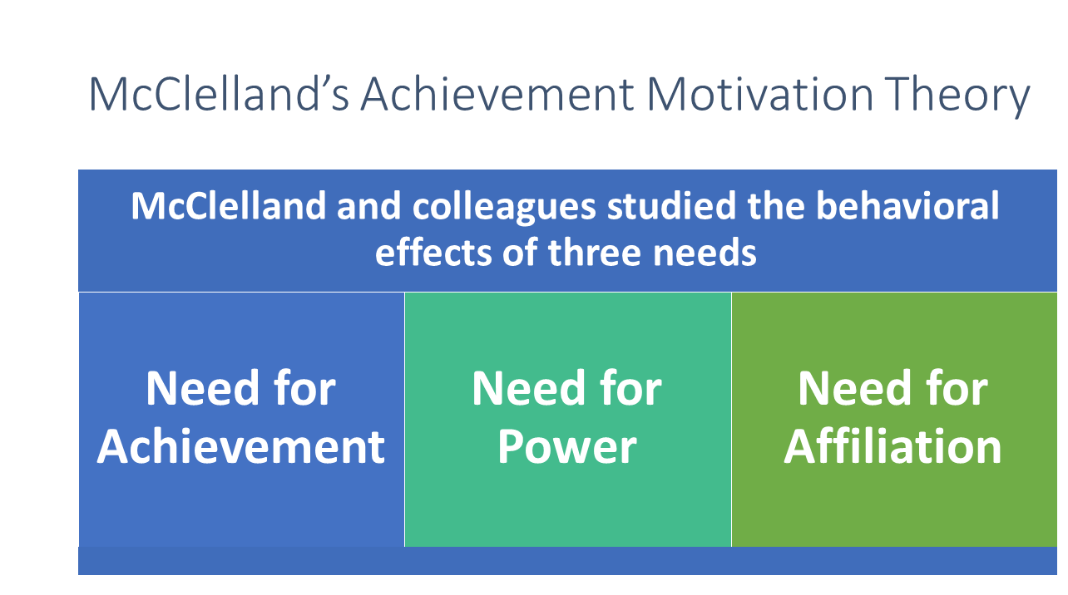
Source: Shiffman, Kanuk & Wisenblit (2010)

Goals
Goals are the sought after results of motivated behavior.
Generic goals – general class or category of goals that consumers see as a way to fulfill their needs.
Product specific goals – the specifically branded product or service that consumers select for goal fulfillment
Individuals set goals on the basis of their personal values and they select means that they believe will help them achieve their desired goals. E.g an individual may start a blog to encourage comments from others
For any given need, there are many different and appropriate goals. The goals selected by individuals depend on their personal experiences, physical capacity, prevailing cultural norms and values and the goals accessibility in the physical and social environment. An individual’s own perception of her/himself influences the specific goals selected. A product that is perceived as matching a consumers self image has a greater probability of being selected.
People that succeed in their endeavors frequently set new, more challenging objectives for themselves. They elevate their objectives since achieving earlier, smaller goals give them more confidence that they can accomplish larger ones. Conversely, people who don't succeed sometimes have smaller ambitions. For marketers, the impacts of success and failure on goal selection have strategic ramifications. Goals should be attainable in a reasonable amount of time, and marketing should only make promises that their products can actually keep.

The extent and direction of the discrepancy between consumer expectations and actual performance is frequently used to evaluate products and services. Therefore, even a decent product won't be repurchased if it falls short of the inflated expectations established by too optimistic advertisements. This can lead to frustration, a feeling that results from failure to achieve a goals.
Everyone has felt the frustration that comes with failing to reach a goal at some point or another. A personal hurdle (such as a lack of physical or financial resources) or an impediment in the physical or social environment (such as a storm that delays a long-awaited vacation) may stand in the way of achieving a goal. Whatever the reason, people respond to frustrating situations differently. Some people are able to deal by finding a way around the barrier or, if that doesn't work, by choosing a different objective. Others are less forgiving and may see failure as something they are personally responsible for. Such individuals will probably develop a defense mechanism to shield their egos against thoughts of inferiority.

Defense mechanisms

Failure/ inability to achieve goals often results in feelings of frustration. The barrier preventing attainment of goals may be personal (limited finances or physically) or social environment.
Products may represent creative responses to the concept of frustration e.g consumer may feel frustrated by having to throw away fresh unconsumed produce just a few days after purchase. People who cannot cope with frustration often mentally redefine their frustrating situations in order to protect their self image and self esteem. E.g a person may want to go on holiday but she cannot afford a coping individual may select a less expensive destination for holiday but a person who cannot cope may get angry at their boss for not paying them enough money to afford the vacation.

Defense mechanisms are used to protect people’s egos from feelings of failure when they do not attain their goals.

- Aggression-individuals may resort to aggressive behavior in attempting to protect their self esteem. e.g a tennis player may slam his racket on the ground after losing or consumer may boycott some products or stores.
- Rationalization-people may solve frustration by inventing reasons for being unable to attain their goals e.g. not having enough time to read
- Regression-an individual may react in childish or immature way e.g a customer attending a sale may see something they like and as they are just about to pick it someone else picks it as well hence they start fighting for it and may even damage it so that the other shopper doesn’t get it.
- Withdrawal-frustration may be resolved by simply withdrawing from the situation. E.g an individual who doesn’t get a promotion may decide to go use his skills elsewhere so he quits.
- Projection-an individual may redefine a frustrating situation by projecting blame for his own or her own failures and inabilities on other objects or persons.
- Repression-an individual can avoid tension arising from the frustration by repressing the unsatisfied needs. They may force the need out of their conscious awareness.
- Daydreaming- Fantasizing enables the individual to attain imaginary gratification of unfulfilled needs. A person who is shy and lonely, for example, may daydream about a romantic love affair

References
Berntson, G. G., & Cacioppo, J. T. (2008). The neuroevolution of motivation. In J. Y. Shah & W. L. Gardner (Eds.), Handbook of motivation science (pp. 188–200). New York: Guilford Publications, Inc.

Gargasz (2010); http://www.gargasz.info/maslow_hierarchy/, (Accessed Date: 10.10.2022)

Schiffman L.G & Wisenblit J.L (2019) Consumer Behavior, 12th ed, Pearson, New York
Schiffman, L.G, Kanuk,L.L., &Wisenblit,J.,(2010)Consumer Behavior, 10th ed, Pearson Prentice Hall.

Review Questions
- Discuss the statement- marketers don’t create needs: needs preexist marketers
- Specify both innate and acquired needs that would be useful in developing promotional strategies for:
- A new version of the iphone
- Sunglasses that can be customized online
- Consumers have both innate and acquired needs. Give examples of each kind of need and show how the same purchase can serve to fulfill either or both kinds of needs

