CONSUMER BEHAVIOUR
WEEK 9

ADVERTISING & CONSUMER BEHAVIOR
By
Dr. Wanjiku Kinyanjui

Introduction to Advertising

Advertising is a technique and practice used to bring products, services, opinions, or causes to public notice for the purpose of persuading the public to respond in a certain way toward what is advertised.
According to Kotler –
Advertising is any paid form of non-personal presentation & promotion of ideas, goods, or services by an identified sponsor.

According to the Advertising Association of the UK –
Advertising is any communication, usually paid-for, specifically intended to inform and/or influence one or more people.

It is a process of developing a paid communication message intended to inform people about something or to influence them to buy, try, or do something.

Importance of Advertising: To The Customers
- Convenience: Targeted informative advertisements make the customer’s decision-making process easier as they get to know what suits their requirements and budget.
- Awareness: Advertising educates the customers about different products available in the market and their features. This knowledge helps customers compare different products and choose the best product for them.
- Better Quality: Only brands advertise themselves and their products. There are no advertisements for unbranded products. This ensures better customer quality and a good business model as no brand wants to waste money on false advertising.

Think of advertisements that have stuck /remained in your head for a very long time. What makes them so memorable? Is it the product itself, or is it the techniques used to produce the ad? Advertising appeals are the persuasive pressures that stimulate a person to buy a product or service by speaking to an individual's needs, interests, or wants.
The goal of an ad is to persuade customers, and advertising appeals provide just the right hook to allow persuasion to occur. Advertising appeals are designed to create a positive image and mindset about those who use the product or service, and are a major factor of consideration for advertisers. Companies put a lot of effort into their creative advertising strategies and use various types of appeals to influence purchasing decisions. (Advertising Appeals: Types & Examples, 2016)

Musical Appeals
Music can help to capture the attention of a listener because music is often linked to emotions, experiences, and memories, grabbing the attention of those not previously engaged. The use of musical appeals allows for a connection between the product or service and a catchy jingle or piece of music.
Since these musical memories are often stored in the long-term recall areas of the brain, many consumers remember the jingles for extended periods of time. The selection of music can involve an already familiar tune or can involve the creation of an original composition specifically for the ad. (Advertising Appeals: Types & Examples, 2016)

Sexual Appeals
Nudity and other sexual approaches are common and are often employed using various methods. By using subliminal techniques, the advertisement attempts to affect a viewer subconsciously. For example, an advertisement may use sexual cues or icons in order to affect the viewer's subconscious, nudity or partial nudity are often used to promote the sale of items such as perfume, cologne, or even clothing. (Advertising Appeals: Types & Examples, 2016)
Other techniques include overt sexuality, which is often used in ads for products that are sexually-oriented by nature, sexual suggestiveness, and sensuality. It should be noted that while sexually-oriented ads do attract attention, there tends to be a lower level of brand recall than with other appeals.

Humor Appeals
Humor is a proven appeal type for grabbing attention and keeping it. When consumers find something humorous, it has value because is causes them to watch, laugh and, most importantly, remember.
By capturing the viewer's attention, humor appeals cut through advertising clutter and allow for enhanced recall and improved moods; consumers who are happy associate the good mood with the product and service.
However, humorous ads can be tricky to design because those that aren't received well result in only the ad being remembered, rather than the product or brand. (Advertising Appeals: Types & Examples, 2016)

Fear Appeals
Fear appeals are widely used because they simply work. Fear can increase a viewer's interest in an advertisement and can heighten persuasiveness, causing consumers to remember these ads more so than upbeat, warm ads.
Fear appeals fit particularly well with certain types of goods and services, particularly those products that can eliminate threats or provide a sense of personal security. For example, fear is often used in insurance company ads, focusing on the consequences of an untimely death. Or, a mouthwash ad can invoke a fear of bad breath. (Advertising Appeals: Types & Examples, 2016)

Rational Appeals
Rational appeals place emphasis on facts, details, and product benefits. The goal is moving from product awareness and knowledge to liking, product preference, conviction for the product and, finally, purchase. By transmitting basic product information, a rational appeal provides product knowledge. In order to promote liking and preference, a rational appeal provides logical reasons as to why a particular brand or service is superior to another. (Advertising Appeals: Types & Examples, 2016).

New Methods of Advertising
Mobile Advertising
Marketers listen to the interactions, or social conversations, and use the information gathered to generate more buzz for their products within social networks. Mobile advertising is the communication of products or services to mobile device and smartphone consumers. The mobile advertising spectrum ranges from short message service (SMS) text to interactive advertisements.
The primary reason for the growth of mobile advertising is that more and more people are using smartphones and other mobile internet devices such as tablets and e-readers. Mobile advertising should be distinguished from mobile-advertising campaigns on social networks, which consist of ads that pop up on, for example, Facebook mobile news feeds to its users after marketers have purchased this advertising space from Facebook.

Because mobile advertising is a new medium, it is important to understand how and why consumers use mobile devices and their reactions to such ads. One study discovered that mobile devices provide four types of value to users:
- Monetary Value: The device provides good value for the money that also exceeds the value consumers receive from using non-mobile communication devices.
- Convenience Value: The device saves time and money, improves efficiency, and makes life easier.
- Emotional Value: The user feels good and relaxed when using the device.
- Social Value: The value is being accepted by others and impressing them.

The results in this study indicated that the higher the value consumers receive from mobile devices, the more likely they are to use the devices to purchase products and engage in word-of-mouth about what they bought.
In another study done on the influence of the language and source of text advertisements on attitudes toward and purchase intentions , the researchers found that reputable companies with highly perceived credibility can use entertaining language, but companies with less credibility and inferior reputations should create serious, clear, and concise mobile ads.
Advantages/Benefits of Mobile Ads Use
Mobile marketers are still spending most of their money on search ads. Search advertising is placing online advertisements on webpages that show results from search engine queries.
- Marketers have been creating mobile ads that are fun, pay rewards, and help customers find useful information (e.g., referrals).
- As smartphone screens became larger, marketers began using mobile ads that take over the entire screen.
- Some mobile marketers have been experimenting with inserting ads in places where consumers do not expect to see any, in an effort to overcome consumers’ tuning-out of promotional messages. For example, Facebook and Twitter have slipped ads into the flow of digital conversations. Some models of the Kindle e-reader display messages
- Many advertisers use banner ads on mobile devices’ screens because such ads are cheap, although most recognize that consumers find banners annoying
- Mobile campaigns were more effective in targeting narrower segments, probably because mobile devices are personal and less likely to be shared in the same way as viewing on other devices.

Social Media and Consumer Behavior
Traditional advertising methods have become the talk of the past. As the world has changed, advertisers must use modern ways to advertise their products or services. The biggest and proven medium of advertisement is Social Media. An average person spends 2 hours every day on social media sites. Social media is gaining popularity and booming like never before. As the social media industry is growing at immense speed, every business needs to leverage proper social media channels to take benefit in the best possible way.
Some researchers have pointed out the distinction between browsing and engaging. They identify engaged online readers by not just the amount of time they spend on the page but also the number of movements (i.e., scrolling up or down or moving the cursor) they make while on the page. Some engaged readers collect more content from the main site. They also exhibit better recall of the advertisements that appear next to the informative content. When readers spend five seconds on a site they are less engaged, only half of them could recall an ad on that site. If they spent 15 seconds there, more than 70 percent exhibited recall of the advertisers.
Social media channels offer better engagement because they can form friendships among people with similar lifestyles, needs, and corresponding purchases. Not all users of social networks share the same reasons and participation levels. The primary reasons for engaging in social media are:
1. Sharing information with others: providing and receiving useful information
2. Convenience and entertainment: enjoying content and staying in touch with others
3. Passing time: having free time or believing that everyone else is doing so
4. Interpersonal relations: meeting others with similar interests and backgrounds
5. Promoting one’s self: sharing one’s expertise, hobbies, status, and profession
6. Bonding and social capital: messages exchanged between friends are both a product of the friendship and a means of facilitating and maintaining such friendships

Marketers can use social media to engage customers with their offerings because websites can enhance people’s interactions with the promotional messages through moving images, links to related materials, and customizing viewing options.
There are several types of social media channels:
1. Owned social media are messages sent by marketers to consumers via channels that the marketers control.
2. Paid social media are messages sent via channels that are not owned by the marketers, who pay for using the channels.
3. Earned social media are channels where consumers pass along messages about brands to one another.
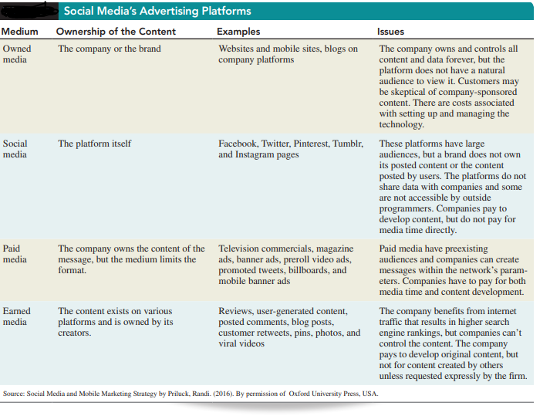
Source: Randi, P (2016 as cited in Schiffman & Wisenblit 2019)

The most widely used platforms to transmit social message are:
1. Branded blogs and microblogging platforms (e.g., Twitter) that encourage interactions among consumers; these messages resemble conversations
2. Social networks such as Facebook and Twitter.
3. Widgets, gaming, and other applications that users can download
4. Mobile phones (discussed in the following section) Most companies use several platforms simultaneously
In order to encourage consumers to make purchases, marketers must engage them with their offerings at every stage of the decision. The table below, describes how prominent companies have used social media to manage customers’ decisions so well that they have developed a trusting and loyal relationship with marketers and brands.
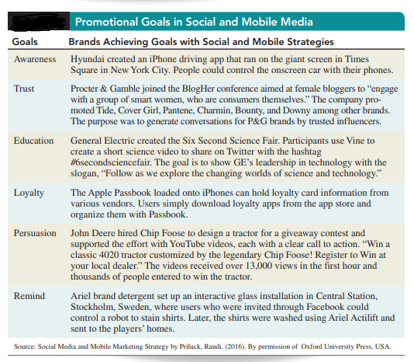
Source: Randi, P (2016 as cited in Schiffman & Wisenblit 2019)

Advertising Scope and Efficacy
Effective advertising is the result of careful and systematic planning. Therefore, advertisers
should use the following steps in designing social media campaigns
1. Define the campaign’s objectives and strategic approaches.
2. Examine the platforms available and determine which ones to use so as to achieve the
objectives.
3. Produce the campaign’s content using internal or external resources.
4. Examine the pricing models for securing access to social media, which, unlike pricing
for advertising space on traditional print and broadcast communication channels, vary
greatly. Then, set the expenditures needed to achieve the campaign objectives.
5. Measure the campaign’s effectiveness.

Gauging influence within Social Networks
An individual’s degree of influence on Twitter is measured by the person’s number of followers, the number of people following the followers, the frequency of updating tweets, and the extent to which his or her tweets are referenced or cited. Twitter also identifies several types of users for instance celebrities have many followers but follow very few, if any. Conversationalists follow about the same number of users as those who follow them. Spammers “collect” users with the intent to push content to as many people as possible.
Google Analytics is a service offered by Google that evaluates the effectiveness of websites and profiles their users by collecting and analyzing the following data:
- Tracking where visitors come from (referrals, search engines, display advertising, pay-per-click networks, email campaigns, and other digital links e.g., clicks within documents
- Customers’ actions after they “land” at the initial page (viewing other pages, downloading files, registering with the site, and other actions)
- Website visitors’ geographic location and their visits’ lengths (also assigns websites’ users into profiles and segments them).
Google Analytics enables marketers to measure the effectiveness of their websites and promotional efforts and, to an extent, predict the impact of planned advertising campaigns on customers’ behavior.
Google Analytics’ e-commerce service tracks sales activities and performance and provides marketers with their sites’ transactions, revenue, and many other commerce-related metrics.
Marketers can also identify pages, links, and promotional efforts that perform poorly and do not achieve the sites’ objectives such as converting visitors to users, generating repeat visits, and getting users to register.

Traditional Media Evolution
Print and electronic media—TV, radio, newspapers, and magazines— were originally all one-way communications. The same promotional messages were sent to the same audiences and receivers could not specify which contents they were interested in and which they would have preferred not to receive. Nevertheless, new means to transmit messages have been fundamentally changing traditional promotional strategies.
TV Advertising
Both the production and broadcast of television ads are very expensive, and, with more and more forms of communications emerging, some major TV advertisers are changing course. The feedback from TV ads has been imprecise and did not enable marketers to effectively determine which ads led to sales and which ones did not. Because TV reaches large and diverse audiences, marketers have been aware that many of their TV commercials reached many consumers that neither had interest in the products advertised nor became customers. Also, more sophisticated recording and time-shifting devices have been allowing viewers to avoid seeing TV commercials altogether.
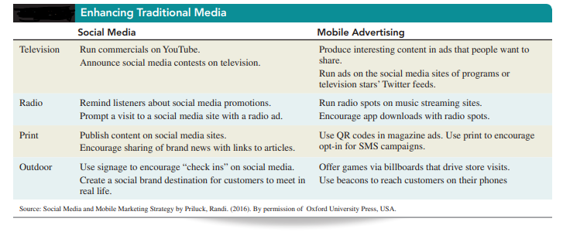
Source: Randi, P (2016 as cited in Schiffman & Wisenblit 2019)

As viewing shifts to the online platform, where people are skipping or blocking ads, advertisers and media companies have experimented with new ad formats. A growing trend is creating interactive ads through Interactive TV (iTV) which combines the broadcasting capabilities of television and the interactivity of the internet. Interactive TV can be delivered to one’s TV, computer, or mobile device in the form of a two-way communication between subscribers and providers of cable or satellite TV. Viewing on iTV is much more engaging, personal, and dynamic than watching one-way TV programs.

Radio Broadcast/Ads
The advantages of radio are its high geographic and demographic audience selectivity, as well as the short lead time needed to produce and place ads. Presently, almost all radio broadcasts, globally, are available online.
In the US, marketers consider radio an effective way to reach the largest age group of its consumers, these are the millennials who tend to listen to radio on their earphones via their cell phones.

Print Media
Newspapers provide access to large audiences and are effective for reaching large audiences. However, when it comes to reaching consumers with particular demographics they are generally inadequate. Newspaper ads can be designed and published quickly, but they have a short life. There is considerable clutter because of the many messages placed therein. Newspapers have experienced accelerating drop in print advertising and forcing publishers to focus more their digital products. Global spending on newspaper print ads is expected to continue declining between 8 and 10 percent a year. The decline is forcing publishers to boost alternative digital-revenue streams quickly to make up for lost revenue, and even reconsider the format of their print products and the types of content they publish. In order to turnaround revenues and remain viable, publishers can consider the following strategies:
1. Phase in digital editions bundled with subscribers’ print additions and develop price structures for digital-only access.
2. Reduce print and home delivery.
3. Market digital editions more aggressively.
4. Develop pricing tiers where subscribers to digital editions would be charged according to the volume of material they access.
Although most magazines and newspapers are still printed on paper, almost all now offer online editions and many are planning to phase out their paper editions. Online, both magazines and newspapers can flourish by offering readers customized editions that are based on the readers’ interests.
Out of Home
Out-of-home media previously called outdoor advertising consist of communications that target consumers in less cluttered environments outside of their homes. This category consists of new promotional tools as well as some older means that were significantly updated with new technology. For instance, captive advertising screens are placed in locations where consumers spend time, such as elevators, cinemas, retail stores, restaurants, bars, fitness clubs, college campuses, and transit. Digital billboards and displays, with interactive capabilities, are placed in transit locations, events, and stores.

References
Advertising Appeals: Types & Examples. (2016, January 11). Retrieved from https://study.com/academy/lesson/advertising-appeals-types-examples.html.

Schiffman L.G & Wisenblit J.L (2019) Consumer Behavior, 12th ed, Pearson, New York

