CONSUMER BEHAVIOR
WEEK 11

THE FAMILY AND CONSUMER BEHAVIOR
BY
DR. WANJIKU KINYANJUI

Learning Objectives
To understand the concept of consumer socialization.
To appreciate how families, make purchase decisions.
To understand the family life cycle and the stages
To comprehend the consumer behavior of nontraditional families and households.

Introduction
Understanding Consumer Socialization
A family is a social unit which consumer behavior analysts often address as an important consumption unit. This is because families make group purchasing decisions and shape the consuming behavior of their members. Families are involved in consumer decisions which involve more than one person. Families make purchase decisions believing that it will maximize the welfare of their members.
A family set up is defined as two or more persons related by blood, marriage, or adoption residing together. There are different types of families. The nuclear family is two parents and at least one child. If the household has at least one grandparent, it is called an extended family. In addition, there is an increasing number of single-parent households. There are changes that have an effect on spending patterns. With more women working, many households have double income. In addition, families are shopping for time-saving products and services since they have less time at home.
Socialization is the process of training people to behave in a way that is acceptable to their society. In the marketing context, the most important role of the family is the socialization of family members, stretching from young children to the adults. This practice includes imparting children with the basic values and modes of behavior that is consistent with their cultures, comprising of moral principles, interpersonal skills, dress code, grooming standards, discipline, manners and speech. It also includes guidance and counsel in the selection of suitable educational and career goals.

The Socialization Process

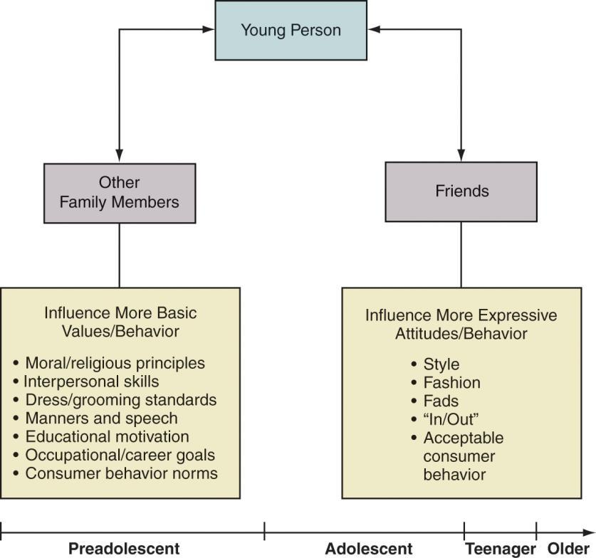
Source: Copyright 2010 Pearson Education, Inc. Publishing as Prentice Hall

Parental Styles and Consumer Socialization
Research has identified four parental styles and lists their respective attitudes toward advertising, consumption, and yielding to children’s buying requests. The four parental styles include: indulgent parents, who are very nurturing and highly permissive during consumer socialization; neglecting parents, who are very permissive and provide their children with little or no nurturing during consumer socialization; authoritative parents, who are very nurturing and also very restrictive with respect to consumer socialization; and authoritarian parents, who are very restrictive and not nurturing during consumer socialization (Schiffman & Wisenblit, 2019).

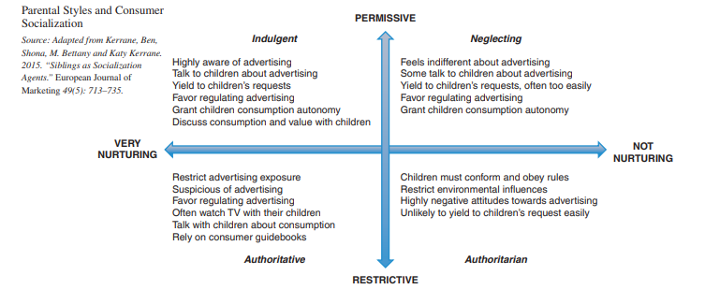
Source: Schiffman & Wisenblit (2019).

Stages of Consumer Socialization: Children Developed as Consumers
Children are not born with the skills of an adult, many cognitive and affective abilities develop only in the first few years of life. These abilities develop in the first 16 to 20 years of a person’s life due to neuro-anatomical changes and increasing life experience. In a common model by Roedder (2008), the psychologist, structured consumer socialization into three phases as shown below:
- Perceptual (3–7 years old), during which children begin to distinguish ads from programs, associate brand names with product categories, and understand the basic script of consumption.
- Analytical (7–11 years), during which children capture the persuasive intent of ads, begin to process functional cues regarding products, and develop purchase influence and negotiation strategies.
- Reflective (11–16 years), when children understand advertising tactics and appeals, become skeptical about ads, understand complex shopping scripts, and become capable of influencing purchases.
Children learn how to function as consumers overtime from as young as 12 months and follow the stages below.
Stage 1: Shopping with Parents and Observing (12–15 months)
• Children notice products that are fun to eat and play with and begin to recall specific ones.
• Parents may buy some items to reward children for good behavior
Stage 2: Shopping with Parents and Making Requests (Age 2–3 years)
• Children begin to connect ads with items in the stores and delight parents with cognitive development.
• They request items by pointing

Stage 3: Shopping with Parents and Making Some Selections (Age 3–7 years)
• Children begin to distinguish ads from programs, associate brand names with product categories, and understand the basic principles of consumption. Children can evaluate products and make decisions about spending, saving, and giving to charity.
Stage 4: Shopping Independently (Age 7–11 years)
• Parents gradually allow children to go to stores or shop online alone or with friends. Children discover the wonders of shopping and deciding among choices. Children understand the persuasive intention of ads
Stage 5: Complex Shopping and Skepticism (Age 11–16 years)
• Pre-teens and teenagers understand advertising tactics and appeals, become skeptical about ads, and understand complex shopping scripts. They can negotiate and are able to influence purchase decisions.
Family decision making roles
Families behave as a unit when it comes to consumer behavior, and many academics have investigated how families make decisions. Marketers pay close attention to how husbands and wives make decisions, how much each family member influences consumption, how children play a part in family decisions, and the various responsibilities that family members may have when it comes to buying, using, and maintaining their homes, goods, and services.

Husband-Wife Decision Making
Marketers have studied each spouse’s influence in consumption and identified four patterns of husband–wife decision-making:
1. Husband-dominated decisions are those where the husband’s influence is greater than the wife’s.
2. Wife-dominated decisions are those where the wife’s influence is greater than the husband’s.
3. Joint decisions are those where the husband’s and wife’s influences are equal.
4. Autonomic decisions are those where either the husband or the wife is the primary or only decision maker.

Children Influence on Decision making
Children now participate more actively in the decision-making process and in what the family purchases. Children are becoming more influential due to families having fewer children (which increases each child's influence), the prevalence of dual-income couples who can afford to give their kids more freedom to choose, and media encouragement for kids to "express themselves." Additionally, single-parent families frequently encourage their kids to be independent and involved in the home. Some tactics that children typically use include:
- Pressure: The child demands, threatens, and tries to intimidate the parents.
- Exchange: The child promises something (e.g., to “be good” or to clean her or his room) in exchange.
- Rational: The child uses a logical arguments and factual evidence.
- Consultation: The child seeks parents’ involvement in the decision.
- Ingratiation: The child tries to get the parent in a good mood first and then make the request

Family Members Roles
Another perspective on family decision-making consists of identifying the roles that members play in buying decisions and consumer behavior.
● Gatekeepers: these include parents who control the information that reaches the family’s children by using the parental control features available on TVs, computers, and other communication devices.
● Influencers: Family member(s) who provide information to other members about a product or service.
● Deciders: Although children might influence the car’s purchase, the parents are the ones with the power to decide which car to buy.
● Buyers: Those who manage the actual purchase. For example, one spouse might manage decorating the home and another buying the family’s transportation.
● Preparers: Transform products for the consumption of the family (mainly foods)
● Users: Uses or consumes the product or service. Particularly, for gifts given from one family member to another, the buyer and user is different.
● Maintainers: in charge of repairs so that products continue to work well.
● Disposers: Carries out the disposal of a product or discontinuation of a service

The family Lifecycle
The family life cycle represents the life stages of a typical family setup. It is a variable that combines various demographic characteristics like marital status, size of family, age of family members and employment status of the head of household. The family life cycle starts with being single and then moves on to marriage. Marriage usually leads to the growth of the family when children arrive, and later on to family contraction, as grown up children leave the household. The cycle ends with the dissolution of the family unit due to the death of one spouse.

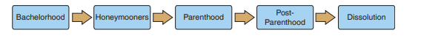
Source: Schiffman & Wisenblit, 2019
The stages are explained as below
Stage I, Bachelorhood, includes single men and women who have moved out of their parents’ home and are living on their own.
Stage II-Honeymooners, occurs immediately after marriage before the arrival of the first child. They often have start-up expenses as they establish a new home.
Stage III, parenthood, occurs with the arrival of the first child. In this stage, people’s financial status often changes.
Stage IV, post-parenthood occurs when the children have left home. This is also called the empty-nest stage and is a time when couples have more time to themselves.
Stage V-Dissolution, occurs with the death of one spouse. Many in this stage will remarry or begin to live a more economical lifestyle.

Nontraditional families
Nontraditional families, are defined as families that do not readily fit into the family life cycle.

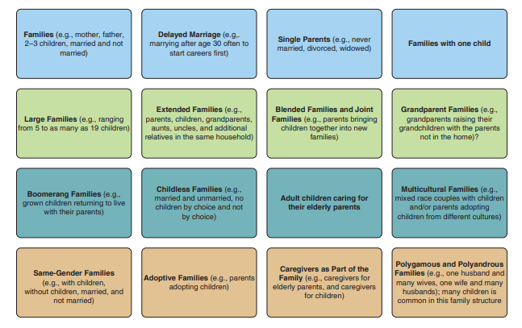
Source: Schiffman &Wisenblit, 2019

References
Roedder J, D. (2008). Stages of consumer socialization: the development of consumer knowledge skills and values from childhood to adolescence. In C. P. Haugtvedt, P. M. Herr, & F. R. Kardes (Eds.), Handbook of consumer psychology (pp. 221–246). New York: Psychology.
Schiffman L.G & Wisenblit J.L (2019) Consumer Behavior, 12th ed, Pearson, New York

