Global Warming 101 - Definition, Facts, Causes and Effects of Global Warming | NRDC

ENERGY, ENVIRONMENT AND SOCIETY

Lecture Notes

Chapter 3
Energy Trends, Global Warming

Lecturer:
Associate Prof. Manchan Tiwari

2022, September

Table of Contents
1. World Energy Scenario 2
1.1. World Energy Consumption 2
1.2. World Electricity Generation 4
1.3. World Oil Consumption/Production Scenario 5
1.4. World Natural Gas Production/Consumption Scenario 10
1.5. World Coal Consumption/Production Scenario 12
1.6. World Nuclear Energy Consumption 13
1.7. World Hydro-Electricity Consumption 13
1.8. World Renewable Energy Production/Consumption Scenario 14
2. Nepal Energy Production/Consumption Scenario 16
2.1. Nepal Electricity Production and Consumption Scenario 18
3. Global Warming 19
3.1. Greenhouse Effect 19
4. References 21

Learning Objectives of the Lecture:
To impart basic knowledge to undergraduate students on the topic of:
- Current Energy Trends, World Energy Scenario
- World Renewable Energy Scenario
- Energy Consumption/Production Scenario of Nepal
- Introduction to Global Warming

World Energy Scenario

World Energy Consumption
The majority of the energy consumed in the world is dominated by non-renewable energy sources mainly oil, natural gas and coal. Nuclear energy, hydro-electricity and renewable energy sources comprises of the remaining energy consumed in the world. Figure 1 shows graphical representation of the world energy consumption data for the year 2021 based on the report published by British Petroleum named Statistical Review of World Energy, 2022.
Figure 1:World Energy Consumption based on Fuel type
Table 1: World Energy Consumption Based on Fuel Type (bp, 2022)
S. No. | Fuel Type | Consumption Value (Exajoules) | % Consumption
1 | Oil | 184.21 | 30.95
2 | Coal | 160.1 | 26.90
3 | Natural Gas | 145.35 | 24.42
4 | Hydro-electricity | 40.26 | 6.76
5 | Renewables | 39.91 | 6.71
6 | Nuclear Energy | 25.31 | 4.25
 | TOTAL | 595.14 | 100.00

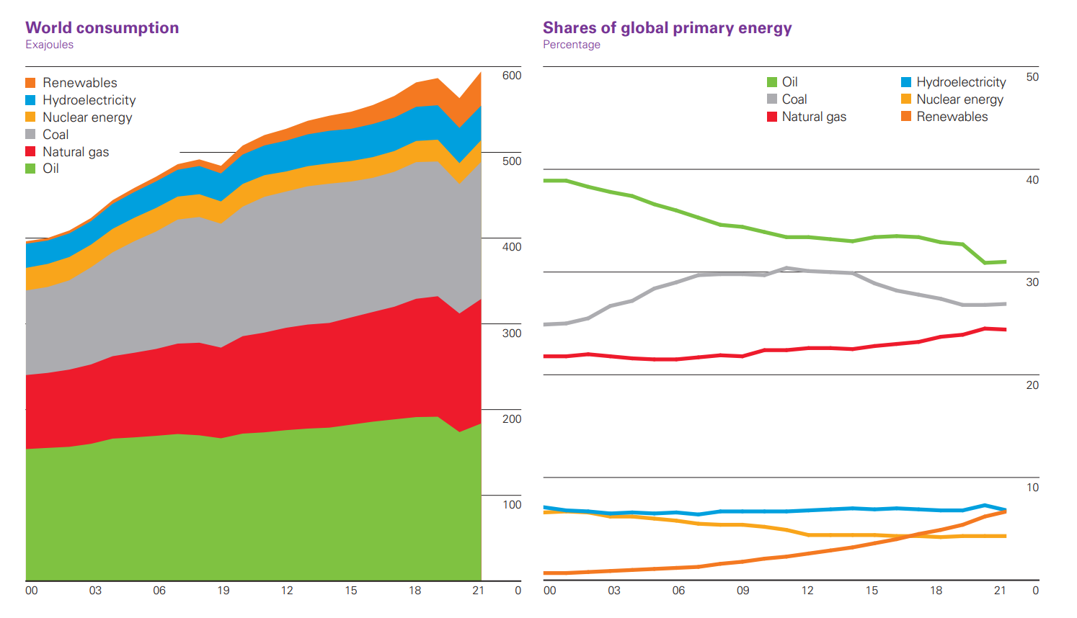
Figure 2: World Energy Consumption Trend (Worldometer, 2022)
While the total amount of energy consumption has been increasing in the recent years, the share of Oil and Coal in the total energy consumption has been decreasing while the contribution of Renewable Energy sources has been increasing in the past decade. The trend in energy consumption scenario as represented in table 2, shows gradual increment in the total energy consumed in the world except for the year 2020 when whole world was largely effected by Covid-19 crisis.
Table 2: World Energy Consumption by Year (bp, 2022)
Figure 3:World Energy Consumption Trendline
Year | Energy Consumed (Exajoules)
2011 | 520.9
2012 | 528.18
2013 | 537.56
2014 | 543.52
2015 | 548.14
2016 | 555.91
2017 | 566.66
2018 | 582.38
2019 | 587.43
2020 | 564.01
2021 | 595.15
World Energy Consumption is dominated by China which alone consumes 23.8% of the energy being consumed in the world as per data for the year 2021 (bp, 2022). China is followed by United States of America (USA) which consumes 16.8% of the world energy consumption. Other countries is majority of energy consumption in the world are India, Russia, Japan, Canada and Germany. The detail data is provided in table 3.
Table 3: World Energy Consumption by Country (bp, 2022)
S. No. | Country | Share of World Energy Consumption
1 | China | 23.80%
2 | United States | 16.80%
3 | Russia | 5.60%
4 | India | 5.20%
5 | Japan | 3.30%
6 | Canada | 2.60%
7 | Germany | 2.40%
8 | South Korea | 2.20%
9 | Brazil | 2.20%
10 | Iran | 2.00%
14 | Others | 33.90%

World Electricity Generation
Table 4: World Electricity Generation According to Fuel Type (bp, 2022)
Fuel Type | 2020 |  | 2021 |  | % Change
Fuel Type | Electricity  Generation  (Terawatt hours) | % of  World Generation | Electricity  Generation  (Terawatt hours) | % of  World Generation | % Change
Coal | 9439.3 | 35.1 | 10244.0 | 36.0 | 8.5
Natural Gas | 6371.7 | 23.7 | 6518.5 | 22.9 | 2.3
Hydro Electric | 4346.0 | 16.2 | 4273.8 | 15.0 | -1.7
Renewables | 3146.6 | 11.7 | 3657.2 | 12.8 | 16.2
Nuclear Energy | 2694.0 | 10.0 | 2800.3 | 9.8 | 3.9
Oil | 661.7 | 2.5 | 720.3 | 2.5 | 8.9
Others | 230.0 | 0.9 | 252.2 | 0.9 | 9.7
As electricity is the most prominent form of secondary energy source, apart from transportation and cooking, electricity is the most widely used form of secondary energy. The major energy source used for production of electricity is Coal. In 2021, 36% of the total electricity produced in the world was produced by utilization of coal as primary energy source. The use of coal is followed by natural gas and hydro-electric power.
Table 5: World Electricity Generation according to Country (bp, 2022)
Country | Electricity Generation (Terawatt hours) | % of World Generation
China | 8534.3 | 30.0
US | 4406.4 | 15.5
India | 1714.8 | 6.0
Russian Federation | 1157.1 | 4.1
Japan | 1019.7 | 3.6
Brazil | 654.4 | 2.3
South Korea | 600.4 | 2.1
Germany | 584.5 | 2.1
France | 547.2 | 1.9
Others | 9247.5 | 32.5

World Oil Consumption/Production Scenario
Major share of oil produced in world as per data of 2021 is contributed by the middle east countries which includes Iran, Iraq, Kuwait, Oman, Qatar, Saudi Arabia, Syria, United Arab Emirates, Yemen and other Middle East Countries. North American countries has also major contribution to the world oil production, mainly United States of America which alone contributes to the 18.45% of the world oil production. Another major contributor country is Saudi Arabia which contributes 12.18% of the world energy production as of 2021 (bp, 2022). CIS countries are Commonwealth of Independent States formed after dissolution of Soviet Union in 1991 which includes countries such as Azerbaijan, Armenia, Belarus, Kazakhstan, Kyrgyzstan, Moldova, Russia, Tajikistan, Turkmenistan, Uzbekistan and Ukraine.

Table 6: World Oil Production by Region in 2021 (bp, 2022)
Region | Oil Production  (thousands of barell per day) | % of World Production
Total Middle East | 28156.00 | 31.3
Total North America | 23942.00 | 26.6
Total CIS | 13829.00 | 15.4
Total Asia Pacific | 7335.00 | 8.2
Total Africa | 7286.00 | 8.1
Total South and Central America | 5909.00 | 6.6
Total Europe | 3420.00 | 3.8

Table 7: Major Contributing Countries to World Oil Production (bp, 2022)
S. No. | Country | Oil Production  (thousands of barell per day) | % of World Production
1 | US | 16585.00 | 18.45
2 | Saudi Arabia | 10954.00 | 12.19
3 | Russian Federation | 10944.00 | 12.18
4 | Canada | 5429.00 | 6.04
5 | Iraq | 4102.00 | 4.56
6 | China | 3994.00 | 4.44
7 | UAE | 3668.00 | 4.08
8 | Iran | 3620.00 | 4.03
9 | Brazil | 2987.00 | 3.32
10 | Kuwait | 2741.00 | 3.05
11 | Norway | 2025.00 | 2.25
12 | Mexico | 1928.00 | 2.15
13 | Qatar | 1746.00 | 1.94
14 | Oman | 971.00 | 1.08
15 | India | 746.00 | 0.83

The oil consumption over the world is dominated by Asia Pacific region where China alone consumes 16.4% of total world consumption in the year 2021 as per data in the “Statistical Review of World Energy” published in 2022. United States of America is the most oil consuming country in the world contributing to 19.9% of total consumption in the world.

Table 6 shows the data regarding the Oil consumption worldwide based on the region.
Table 8: Oil Consumption by Region in 2021 (bp, 2022)
Region | Total Oil Consumption  (thousands barrels 2021) | % of World Consumption
Total Asia Pacific | 35806 | 38.06
Total North America | 22264 | 23.66
Total Europe | 13527 | 14.38
Total Middle East | 8640 | 9.18
Total South and Central America | 5622 | 5.98
Total CIS | 4307 | 4.58
Total Africa | 3922 | 4.17

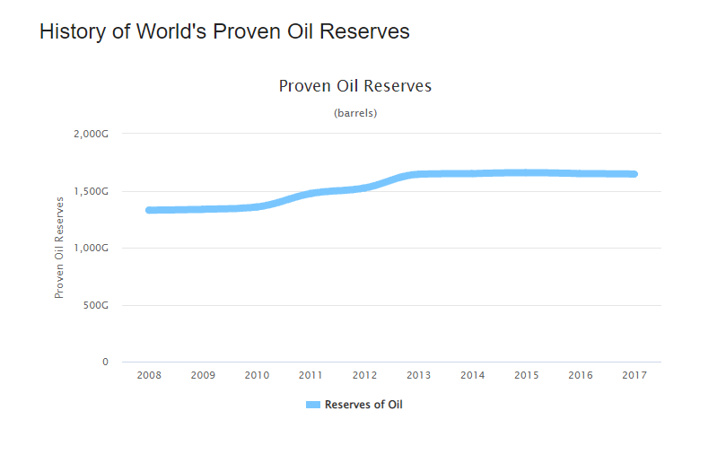
Figure 4: History of World's Proven Oil Reserves (Worldometer, 2022)
The history of world’s proven oil reserves as shown in figure 4 represents that during the early 2010s, new reserves were discovered, while in the recent years the oil reserves in the world has remained at constant which implies that at the rate of the consumption of oil in present context renders the existing reserves at the risk of depletion in upcoming years. According to the data of the year 2021, the current oil reserves will be depleted in 47 years from now (Worldometer, 2022) .
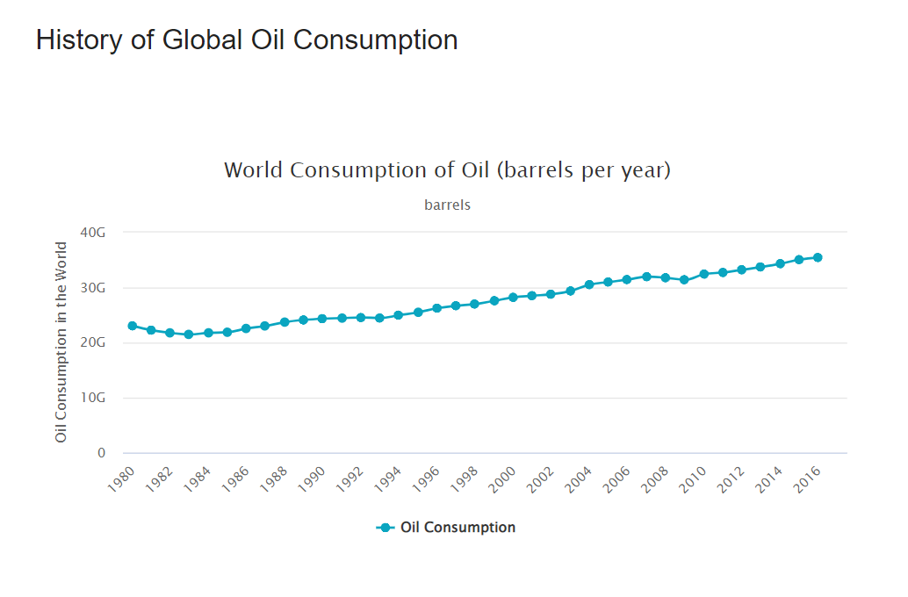
Figure 5: History of Global Oil Consumption (Worldometer, 2022)
The history of global oil consumption as shown in figure 5 shows that the total amount of oil consumed in the world has been gradually increasing while the amount of reserves has remained mostly constant. This can lead to a situation where in future, the supply of oil in the world might not be able to reach the demand.
Table 9: World Share of Oil Reserves (bp, 2022)
Country | World Share of Oil Reserves
Venezuala | 18.20%
Saudi Arabia | 16.20%
Canada | 10.40%
Iran | 9.50%
Iraq | 8.70%
Kuwait | 6.10%
United Arab Emirates | 5.90%
Russia | 4.80%
Libya | 2.90%
Nigeria | 2.20%
United States | 2.10%
Kazakhstan | 1.80%
Qatar | 1.50%
Others | 9.70%
Table 7 shows the world share of oil reserves available according to country. The data shows Venezuala as the country with most prominent share of world oil reserves followed by Saudi Arabia, Canada, Iran, Iraq, Kuwait, UAE along with other countries as the major stockholders in world oil reserves.
Table 10: Percentage Change in Rate of Refining Capacity (bp, 2022)
S. No. | Country | Percentage Growth Rate of Refining Capacity in 2021 | World Share of Refining Capacity in 2021
1 | US | -1.10% | 17.6%
2 | China | 1.80% | 16.7%
3 | Russian Federation | 1.90% | 6.7%
4 | India | 0% | 4.9%
5 | South Korea | 0% | 3.50%
6 | Japan | 0% | 3.20%
7 | Saudi Arabia | 0% | 2.9%
8 | Iran | 1.30% | 2.5%
9 | Brazil | -0.50% | 2.3%
10 | Canada | -5.40% | 1.9%
11 | Mexico | 0% | 1.5%
12 | Kuwait | 78.80% | 1.4%
13 | UAE | 0% | 1.2%
14 | Iraq | 0% | 0.9%
15 | Qatar | 0% | 0.4%
16 | Oman | 0% | 0.3%
17 | Norway | -33.90% | 0.2%

Table 8 shows the percentage change of rate of refining capacity of the countries with most contribution to the world oil production. The most noticeable fact is that the world total refining capacity for the year 2021, the refining rate for the oil has decreased by 0.4%. And between the years 2011 to 2021 the increase in the world refining capacity has been 0.7%.

Figure 6: Year Wise Daily Oil Refining Capacity (bp, 2022)
The year wise daily refining capacity as shown in Figure 6 shows that though initially the oil refining capacity of the world had increased in the later part of the decade, the oil refining capacity has been in the decreasing trend.

World Natural Gas Production/Consumption Scenario
Natural Gas is the second most consumed energy sources in the world. Since 2011 to 2021 its production as well as consumption has been gradually increasing throughout the world. North America and CIS countries combinedly produce around 50% of the world’s total natural gas. Middle East countries and countries in the Asia Pacific region are the other major contributors to the production. Country wise US (23.1%), Russian Federation (17.4%), Iran (6.4%), China (5.2%) along with other countries were the major contributors for the production of natural gas in the year 2021 (bp, 2022).

Figure 7: Natural Gas Production/Consumption in World (bp, 2022)
Table 9 and 10 shows the contribution of different regions to the production and consumption of Natural Gas in the world respectively.
Table 11: Natural Gas Production by Region (bp, 2022)
Region | Gas Production  (Billion Cubic metres) | % of World Production
Total North America | 1135.8 | 28.1
Total CIS | 896 | 22.2
Total Middle East | 714.9 | 17.7
Total Asia Pacific | 669 | 16.6
Total Africa | 257.5 | 6.4
Total Europe | 210.4 | 5.2
Total South and Central America | 153.3 | 3.8

Table 12:Natural Gas Consumption by Region (bp, 2022)
Region | Gas Consumption  (Billion Cubic metres) | % of World Consumption
Total North America | 1034.1 | 25.6
Total Asia Pacific | 918.3 | 22.7
Total CIS | 610.8 | 15.1
Total Middle East | 575.4 | 14.3
Total Europe | 571.1 | 14.1
Total Africa | 164.4 | 4.1
Total South and Central America | 163.3 | 4.0

World Coal Consumption/Production Scenario
As coal is second most used energy source in the world, most countries are dependent on coal for energy production. Table 11 and 12 shows the contribution of different region and countries in the world coal production.
Table 13:Region wise world Coal Production in 2021 (bp, 2022)
Region | Coal Production (in Exajoules) | Percentage of World Production
Total Asia Pacific | 129.5 | 77.3
Total North America | 13.0 | 7.7
Total CIS | 11.4 | 6.8
Total Africa | 6.0 | 3.6
Total Europe | 5.8 | 3.4
Total South and Central America | 1.9 | 1.1
Total Middle East | 0.0 | 0.0

Table 14: Country wise World Coal Production in 2021 (bp, 2022)
Country | Coal Production (in Exajoules) | Percentage of World Production
China | 85.2 | 50.8
Indonesia | 15.2 | 9.0
India | 13.5 | 8.0
Australia | 12.4 | 7.4
US | 11.7 | 7.0
Russian Federation | 9.1 | 5.5
South Africa | 5.6 | 3.3

As shown in the table above, China lead the world production of Coal by a significant margin which is also reflected in the fact that Total Asia Pacific region alone produces 77.3 % of the total world coal production. Consumption wise too, China consumes around 86.2% of the total share of world coal consumption followed by India at 12.5% and US at 6.6%. Table 13 shows the data for country wise world coal consumption.

Table 15: Country wise World Coal Consumption in 2021 (bp, 2022)
Region | Coal Consumption  (in Exajoules) | % of World Consumption
China | 86.2 | 53.8
India | 20.1 | 12.5
US | 10.6 | 6.6
Russian Federation | 3.4 | 2.1
South Africa | 3.5 | 2.2
Japan | 4.8 | 3.0

World Nuclear Energy Consumption
Table 16: Country Wise World Nuclear Energy Consumption in 2021 (bp, 2022)
Country | Energy Consumed (Exajoules) | % of World Consumption
US | 7.4 | 29.24
China | 3.68 | 14.54
France | 3.43 | 13.55
Russian Federation | 2.01 | 7.94
South Korea | 1.43 | 5.65
Others | 3.26 | 12.88
Table 16 shows the country wise data for world nuclear energy consumption. It can be seen from the table that US leads the world consumption of nuclear energy followed by China. The data is for the year 2021.

World Hydro-Electricity Consumption
Table 17: Country Wise Hydro-Electricity Consumption in 2021 (bp, 2022)
Country | Energy Consumed (Exajoules) | % of World Consumption
China | 12.25 | 30.4
Canada | 3.59 | 8.9
Brazil | 3.42 | 8.5
US | 2.43 | 6.0
Russian Federation | 2.02 | 5.0
India | 1.51 | 3.8
Norway | 1.35 | 3.4
As shown in Table 17, China lead the consumption of electricity produced by the means of hydro electric power for the year 2021. Other countries which are prominent in production of hydro-electricity are China, Canada, Brazil followed by Russia, India and Norway.

World Renewable Energy Production/Consumption Scenario
In the recent years the consumption of Renewable Energy as a source of primary energy has been increasing gradually in the world. Table 18 and 19 shows the data regarding renewable energy generation according to country and region.
Table 18: Region Wise World Renewable Energy Generation (2021) (bp, 2022)
Country | Renewable Energy Generation (Terawatt hours) | % of World Generation
Total Asia Pacific | 1690.1 | 46.2
Total Europe | 946.5 | 25.9
Total North America | 714.1 | 19.5
Total South and Central America | 229.3 | 6.3
Total Africa | 49 | 1.3
Total Middle East | 18.5 | 0.5
Total CIS | 9.6 | 0.3

Table 19: Country Wise World Renewable Energy Generation (2021) (bp, 2022)
Country | Renewable Energy Generation (Terawatt hours) | % of World Generation
China | 1152.5 | 31.5
US | 624.5 | 17.1
Germany | 217.6 | 5.9
India | 171.9 | 4.7
Brazil | 144 | 3.9
Japan | 130.3 | 3.6
UK | 116.9 | 3.2
Spain | 95.8 | 2.6
Italy | 71.4 | 2.0
Turkey | 62.7 | 1.7
Australia | 61.3 | 1.7
Canada | 50 | 1.4
South Korea | 40.2 | 1.1
Mexico | 39.7 | 1.1

The table above shows that China leads the production of renewable energy in the world by producing 31.5% of the total world production by itself. This is shown in the fact that Total Asia Pacific region leads the production of renewable energy in the world. US also contributes to the major share of world renewable energy production. The most used types of renewable energy source for production is Wind Energy, followed by Solar Energy. Table 20 shown below shows the renewable energy generation in the world according to the type of renewable energy sources.
Figure 8: World Renewable Energy Generation in 2021
Table 20: World Renewable Energy Generation according to type (bp, 2022)
Renewable Energy Type | Renewable Energy Generation (Terawatt hours) |  | % Growth Rate
Renewable Energy Type | 2020 | 2021 | % Growth Rate
Wind Energy | 1596.4 | 1861.9 | 17%
Solar Energy | 846.2 | 1032.5 | 22.30%
Others | 703.9 | 762.8 | 8.70%
Total | 3146.5 | 3657.2 | 16.50%
The table above shows rapid increase in renewable energy generation in 2021 as compared to 2020. Table 21 shows the country with most installed Solar PV capacity.
Table 21: Installed Solar PV Capacity in 2021 (bp, 2022)
Country | Installed Solar PV Capacity (Gigawatts) | % of World Production
China | 306.4 | 36.3
US | 93.7 | 11.1
Japan | 74.2 | 8.8
Germany | 58.5 | 6.9
India | 49.3 | 5.8
Italy | 22.7 | 2.7

Table 22: Installed Wind Capacity in 2021 (bp, 2022)
Country | Installed Wind Capacity  (Gigawatts) | % of World Production
China | 329 | 39.9
US | 132.7 | 16.1
Germany | 63.8 | 7.7
India | 40.1 | 4.9
Spain | 27.5 | 3.3
UK | 27.1 | 3.3
Brazil | 21.2 | 2.6
France | 18 | 2.2

Table 23: Biofuel Production in World in 2021 (bp, 2022)
Country | Biofuel Production  (Thousand barrels of oil equivalent per day) | % of World Production
US | 643 | 36.8
Brazil | 376 | 21.5
Indonesia | 140 | 8.0
China | 64 | 3.7
Germany | 54 | 3.1
France | 48 | 2.7
Thailand | 40 | 2.3
Netherlands | 38 | 2.2
India | 37 | 2.1

Nepal Energy Production/Consumption Scenario
The energy supply and consumption trend in Nepal as shown in table 24, shows that Nepal has been heavily dependent on Biomass as primary source of energy. The major use of energy source has been on residential sector where fuel wood is primarily used for cooking purpose. Second most used energy source is petroleum products (oil products) which is used in transportation sector in Nepal. Industry and commercial sectors comprises of only low percentage of total energy use in the country. Though hydropower production has been on the rise, its contribution to total energy use is still small compared to biomass and oil products. As Nepal do not have its own oil production, all of the petroleum products have to be imported.
Table 24: Energy Supply and Consumption Trend in Nepal (ADB, 2017)
Particulars | 1990 | 1995 | 2000 | 2005 | 2010 | 2014
Total Primary Energy Supply | 5789 | 6712 | 8108 | 9132 | 10211 | 11690
Coal | 49 | 74 | 258 | 248 | 303 | 484
Oil Products | 244 | 501 | 713 | 724 | 983 | 1359
Natural Gas | 0 | 0 | 0 | 0 | 0 | 0
Hydro | 75 | 100 | 140 | 216 | 276 | 326
Biomass | 5425 | 6039 | 6988 | 7928 | 8592 | 9403
Total Final Energy Consumption | 5761 | 6667 | 8041 | 9050 | 10107 | 11534
Industry | 106 | 161 | 379 | 388 | 449 | 665
Transport | 111 | 203 | 270 | 275 | 637 | 858
Residential | 5465 | 6170 | 7199 | 8128 | 8718 | 9624
Commercial and public services | 43 | 60 | 97 | 165 | 171 | 219
Agriculture/Forestry | 33 | 60 | 75 | 72 | 118 | 151
Non-Energy use | 4 | 7 | 11 | 20 | 10 | 8
Unit: ktoe (kilo tons of oil equivalent)
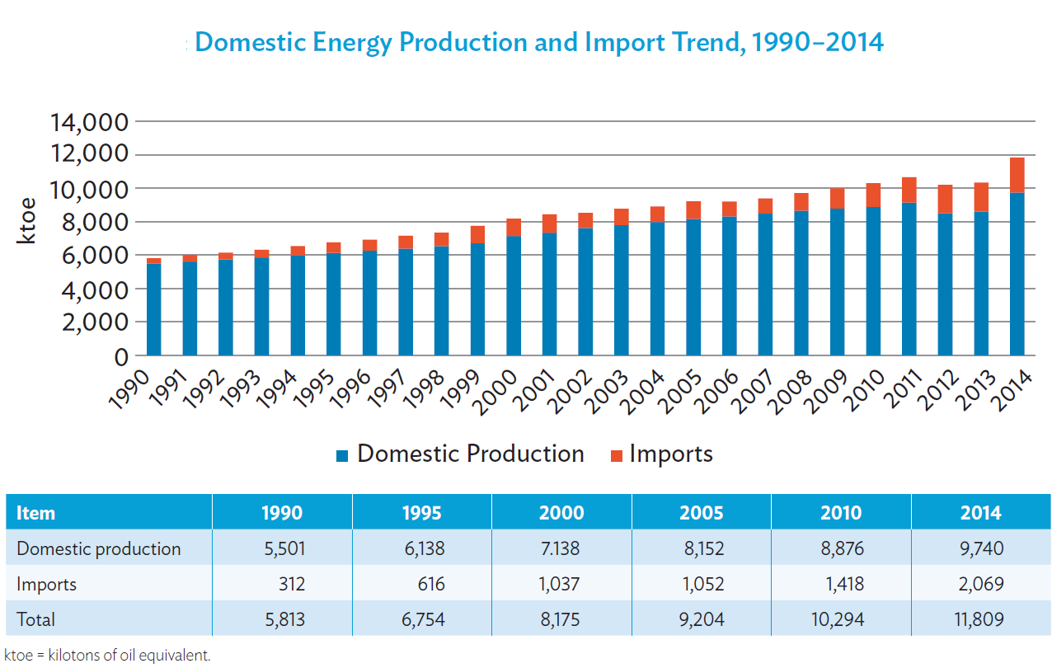
Figure 9 Domestic Energy Production and Import Trend (ADB, 2017)
The energy production and import trend as shown in figure 9 reflects the current scenario in context of energy usage in Nepal. As majority of energy use is biomass, it is produced in Nepal. Whereas majority of commercial fuel (petroleum products) have to be imported which are mainly used in transportation sector.
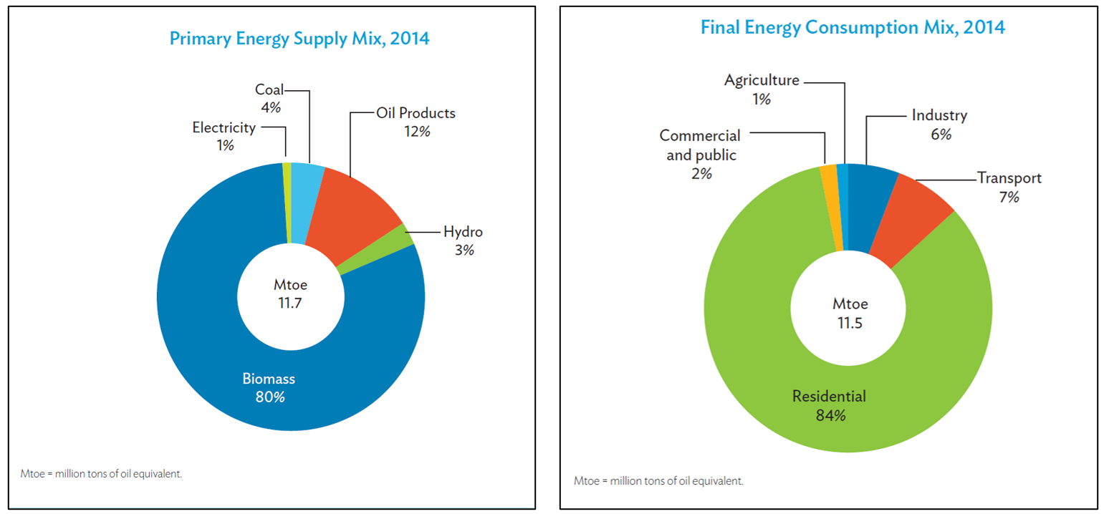
Figure 10: Energy Supply and Consumption Mix 2014 (ADB, 2017)

Nepal Electricity Production and Consumption Scenario
The table 25 below shows the electricity supply and demand capacity of Nepal from year 2011 to 2016. There is considerable gap in the demand and supply which is often bridged to some extent by import of electricity from India. In 2019, the installed capacity was 1127 MW (IHA, 2022). As of 2021, the installed capacity of Nepal is 2190 MW which has exceeded the demand for the first time (Bhusal, 2022).
Table 25:Electricity Demand and Supply in Nepal (ADB, 2017)
Particulars | 2011 | 2012 | 2013 | 2014 | 2015 | 2016
Installed Capacity (MW) | 706 | 719 | 762 | 787 | 787 | 856
Peak Demand (MW) | 946 | 1027 | 1095 | 1201 | 1292 | 1385
Supply Capacity Shortage (MW) | 240 | 308 | 333 | 414 | 505 | 529

Global Warming
Global Warming is the increase of Earth's average surface temperature due to effect of greenhouse gases, such as carbon dioxide emissions from burning fossil fuels or from deforestation, which trap heat that would otherwise escape from Earth. This is a type of greenhouse effect (NRDC, 2022).

Greenhouse Effect
The Earth gets energy from the sun in the form of sunlight. The Earth's surface absorbs some of this energy and heats up. The Earth cools down by giving off a different form of energy, called infrared radiation. But before all this radiation can escape to outer space, greenhouse gases in the atmosphere absorb some of it, which makes the atmosphere warmer. As the atmosphere gets warmer, it makes the Earth's surface warmer, too. The trapping of some of the infrared radiation within the atmosphere keeps the earth’s daily temperature fluctuations within a small and habitable range. This is called greenhouse effect. The greenhouse effect is the process by which radiation from a planet's atmosphere warms the planet's surface to a temperature above what it would be without its atmosphere. The Earth gets energy from the sun in the form of sunlight. The Earth's surface absorbs some of this energy and heats up. The Earth cools down by giving off a different form of energy, called infrared radiation. But before all this radiation can escape to outer space, greenhouse gases in the atmosphere absorb some of it, which makes the atmosphere warmer. As the atmosphere gets warmer, it makes the Earth's surface warmer, too.
The greenhouse gases responsible for the effect are:
- Chlorofluro carbons (CFCs)
- Nitrous Oxide
- Methane
- Carbon dioxide (NRDC, 2022)
Human beings have increased the CO2 concentration in the atmosphere by about thirty percent, which is an extremely significant increase, even on inter-glacial timescales. It is believed that human beings are responsible for this because the increase is almost perfectly correlated with increases in fossil fuel combustion. Combustion of Fossil Fuels, for electricity generation, transportation, and heating, and also the manufacture of cement, all result in the total worldwide emission of about 22 billion tons of carbon dioxide to the atmosphere each year. About a third of this comes from electricity generation, and another third from transportation, and a third from all other sources. This enormous input of CO2 is causing the atmospheric levels of CO2 to rise dramatically which has in turn lead to rising in average temperature of Earth’s surface hence leading to global warming.
Causes of Global Warming
- CO2 emission – From fuels – From powerplants, industries
- Aerosols
- Methane emission from plants and animals (agricultural residues), and from seabeds.
- Deforestation
- Use of chemical fertilizers in agricultural land
- Rise in sea-level
- Some researches also suggest extinction of different species as a reason for global warming
Effects of Global Warming
- Surface and Atmospheric Climate Change
- Changes in Snow, Ice and Frozen Ground
- Oceanic Climate Change and Sea Level
- Extreme Weather conditions
- Changes in intensity, type and frequency of precipitations
- Vegetation shift
- Bird Migrations
- Projected Impacts includes impact on food supply, food security, health related diseases (malaria, diarrhea etc)

References
ADB. (2017). Nepal Energy Sector Assessment, Strategy, and Road Map. Asian Development Bank. doi:http://dx.doi.org/10.22617/TCS178936-2
Bhusal, R. (2022). The Third Pole. Retrieved October 8, 2022, from https://www.thethirdpole.net/en/regional-cooperation/indian-developers-replace-chinese-some-of-nepals-largest-hydropower-projects/#:~:text=Nepal%20added%20710%20MW%20of%20hydropower%20to%20its,creating%2010%2C000%20MW%20of%20installed%20capacity%20by%2020
bp. (2022). bp Statistical Review of World Energy, 71st Edition. British Petroleum.
IHA. (2022). International Hydropower Association. Retrieved October 8, 2022, from https://www.hydropower.org/country-profiles/nepal
NRDC. (2022). Natural Resources Defense Council. Retrieved October 8, 2022, from https://www.nrdc.org/stories/global-warming-101#warming
Worldometer. (2022). Retrieved September 27, 2022, from https://www.worldometers.info

