ENERGY, ENVIRONMENT AND SOCIETY

Lecture Notes

Chapter 4
Energy Sources, Solar Energy

Lecturer:
Associate Prof. Manchan Tiwari

2022, September

Table of Contents
1. Classification of Energy Sources 2
2. Renewable Energy Sources 2
2.1. Solar Energy 2
2.2. Wind Energy 3
2.3. Geothermal Energy 4
2.4. Biomass 4
2.5. Ocean Energy and Tidal Energy 5
3. Advantages of Renewable Energy Sources 5
4. Revision of Heat Transfer Modes 5
5. Solar Radiation 6
5.1. Basic Terminology 6
5.2. Measurement of Solar Radiation 9
6. References 10

Learning Objectives of the Lecture:
To impart basic knowledge to undergraduate students on the topic of:
- Types of Renewable Energy Sources
- Advantages of Renewable Energy Sources
- Solar Energy

Classification of Energy Sources
- Commercial and Non-commercial energy resources
- Renewable and Non-renewable energy resources
- Conventional and Non-conventional energy resources

Renewable Energy Sources
Renewable energy sources are often non-conventional energy sources. The various types of renewable energy sources are
- Solar Energy
- Wind Energy
- Geothermal Energy
- Biomass
- Ocean Energy and Tidal Energy

Solar Energy
Solar energy is continuously incident on the earth in form of electromagnetic radiation at the rate if around 1,7 x 10¹⁷ W (Singal, 2011). If a person would require 10 kW of energy for sustaining life, then a population of 10 billion will require around 10¹¹ which is much less than the solar energy incident on the earth. So, theoretically solar energy is sufficient to fulfill all the energy requirement of the people of earth. However, there are limitations which restrict the actual usage of solar energy such as solar energy is very diffuse, cyclic and often undependable. However, much of the limitations have been addressed by modern energy conversion devices which either convert solar energy to heat or directly generate electricity in reliable manner. Solar energy can be used in following ways:
- Conversion to electricity (Solar PV)
- Conversion to thermal energy (Solar Thermal)
The main applications of solar energy are:

- Heating of buildings
- Cooling of buildings
- AC and refrigeration
- Solar cookers
- Solar water heaters
- Solar air heaters
- Solar water pumping devices
- Building integrated solar photovoltaic
- Community based solar photovoltaic system
- Standalone solar PV power systems
- Solar water heating
- Solar drying of agricultural and animal products
- Solar distillation on a small community scale
- Salt production by evaporation of seawater or inland brines
- Solar engines from water pumping
- Bio conversion and wind energy which are indirect sources of solar energy
- Solar furnace
- Solar electric power generation
- Solar pond
- Steam generation heated by rotating reflectors
- Solar PV cells

Wind Energy
Sunlight has to travel varying distance to reach the surface of the earth depending on its latitude. That is, sunlight reaches perpendicularly at tropical region and becomes more oblique in high latitude region. This results in uneven heating of the earth’s surface which results in tropical region being hotter than the polar regions. This results in variation of atmospheric pressure at different regions which results in movement of air from high pressure to low pressure regions. This phenomenon is the principal cause of Earth’s wind system (Boyle, 2013). This wind energy is dependent mainly on the velocity at which the wind travels and can be harnessed by using different form of wind turbines. The kinetic energy of the wind is governed by simple equation represented as follows:
$$E= \frac{1}{2}×m×V^{2}$$ | 2-1
Where,
- KE = Kinetic energy posses by wind(Joule)
- m = mass of air (kg)
- V = velocity of the wind (m/s)
Generally rotor diameter of 50m and heights of 100m are typical dimensions for a wind turbine which can produce appreciable amount of power (Singal, 2011). The large variability of wind has resulted in unreliable power production in wind energy.

Geothermal Energy
Earth is composed of inner core, outer core, lower mantle, upper mantle and crust. The depth of crust is about 40 kms. The temperature is highest at earth’s core. At the base of the crust the temperature ranges from 200 to 100 degree Celsius. Due to various faults and fractures in earth’s surface (due to earthquakes or surface movement), rain water can seep down such faults for miles. After being heated it can return to the surface as steam or hot water. Geothermal springs can reach temperature of 370 degree Celsius (Singal, 2011). The heat stored beneath the earth’s crust can be used for various purpose such as space heating, electricity generation, cooking and medicinal purposes.

Biomass
Biomass are basically the organic matter derived from various plant and animal sources. Energy derived from such biomass is known as biomass energy. Biomass is also indirect manifestation of solar energy as the solar energy received by the plants converts carbondioxide present in the atmosphere to carbohydrates which forms the basis of much complex molecules. In developing countries, biomass (or in form of biofuels) are the major source of energy. Gaseous and liquid fuels derived from biomass are significant source of power in some countries (Boyle, 2013). However, biomass or biofuels are considered renewable source of energy only when the rate at which they are consumed is less than the rate at which new plants are regrown which is unfortunately, is often not the case (Boyle, 2013). Inefficient combustion of biomass can result in significant amount of green house gases to be released in to atmosphere.

Ocean Energy and Tidal Energy
Gravitation pull of the moon along with little contribution from the Sun results in formation of Ocean tides, which results in the regular rise and fall of water level of the ocean as the Earth rotates. Also, flowing wind blowing over the open sea causes wave which are also significant source of power. These tides and waves in the ocean can be harnessed by various means to generate power. The concept behind harnessing the tidal energy is capturing the rising water during high tide and allowing it to flow back through electricity generating turbines.

Advantages of Renewable Energy Sources
- Renewable in nature and inexhaustible
- No operating cost for fuel
- Are site specific, lesser need for transmission and distribution.
- Renewable energy sources have negligible or no contribution to the pollution and hence are considered as clean energy sources
- Most devices or technology used for conversion of renewable energy sources are simple in nature and can be fabricated easily locally.
- Renewable technology can serve rural areas better with locally available source of renewable energy.

Revision of Heat Transfer Modes
- Conduction
  - Conduction is the mode of heat transfer occurring in within one or more solid object due to the direct physical contact between them, without the appreciable movement of molecules or atoms forming the substance (Koirala, 2019).
- Convection
  - Convection heat transfer occurs within fluid or between solid surface and adjacent liquid or gas, due to the random motion of molecules within the fluid medium.
- Radiation
  - Radiation is the transfer of heat energy in the form of electromagnetic wave from one object to another.

Solar Radiation
Solar radiation is the primary natural energy source of the Earth (other natural sources are: geothermal heat, natural terrestrial radioactivity, cosmic radiation, tidal energy due to gravitational pull). Solar radiation mainly reaches the earth as electromagnetic radiation from the surface of the sun. The radiation is originated due to high temperature of sun which is a result of several nuclear fusion processes occurring in the interior of the sun. The sun is an enormous nuclear fusion reactor, which causes four hydrogen nuclei to fuse together and form helium nucleus. The difference in the mass of helium is 0.7% less than that of four hydrogen nuclei. This difference in mass is expelled in form of energy and radiated from the surface of the Sun (S. Hasan & Sharma, 2009). It radiates energy by virtue of its high surface temperature around 6000 ⁰C. Almost one third of the radiation incident on Earth is simply reflected back.
Even though we perceive solar radiation as white light, in fact it spreads over a wide spectrum of wavelengths, from short-wave infrared to ultraviolet.

Basic Terminology

Solar Constant
The solar constant is the amount of energy received in unit time on a unit area of surface perpendicular to the direction of propagation of the radiation at the mean distance of the earth from the sun. In literature value of 1367 W/m² is given frequently.

Extraterrestrial Radiation
The orbit of the earth around the sun is slightly elliptical with the sun at one of the foci and therefore causes a change of the sun-earth distance throughout the year. Extraterrestrial radiation is the intensity (power) of the sun at the top of the Earth’s atmosphere. It is usually expressed in irradiance units (Watts per square meter) on a plane normal to the sun. It varies throughout the year because of the Earth’s elliptical orbit, which results in the Earth-Sun distance varying during the year in a predictable way. This effect can be represented empirically with the following equations:

Irradiance
Irradiance (I) is defined as the intensity of solar radiation per unit time on a unit surface area of the earth. Its unit is W/m².

Insolation
Insolation is the total energy received from the sun in a day in a unit surface area on the earth. Its unit is Wh/m² per day (watt hour per meter square per day). The average insolation for Nepal can be taken as 4500 to 5500 Wh/m²/day

Peak Sun
Peak sun is the number obtained by division of insolation by 1000 W/m²/day. The unit of Peak Sun is hour (h). In case of solar system design the peak sun is used as the hours of sunshine in the region. In case of Nepal standard value of peak is used as 4.5 to 5.5 hours.

Air Mass
Air mass represents the length of the path the solar radiation has to travel from the earth’s atmosphere to reach the surface. The condition when the sun is directly overhead, the distance through which the sun rays penetrate the atmosphere is shortest and is referred to as Air Mass 1 or AM1.
Air Mass can be calculated by the formula:
$$AM= \sqrt{1+{\left(\frac{s}{h}\right)}^{2}}$$
Where, s is the length of the shadow cast by a vertical post of height h.

Zenith angle
It is the angle made by the ray of light from Sun with the zenith (vertical line). It can also be called as complimentary angle of Sun’s altitude angle.

Solar Azimuth angle
It is the angle made by the projection of Sun’s ray on Earth’s surface with the North direction (Singal, 2011).
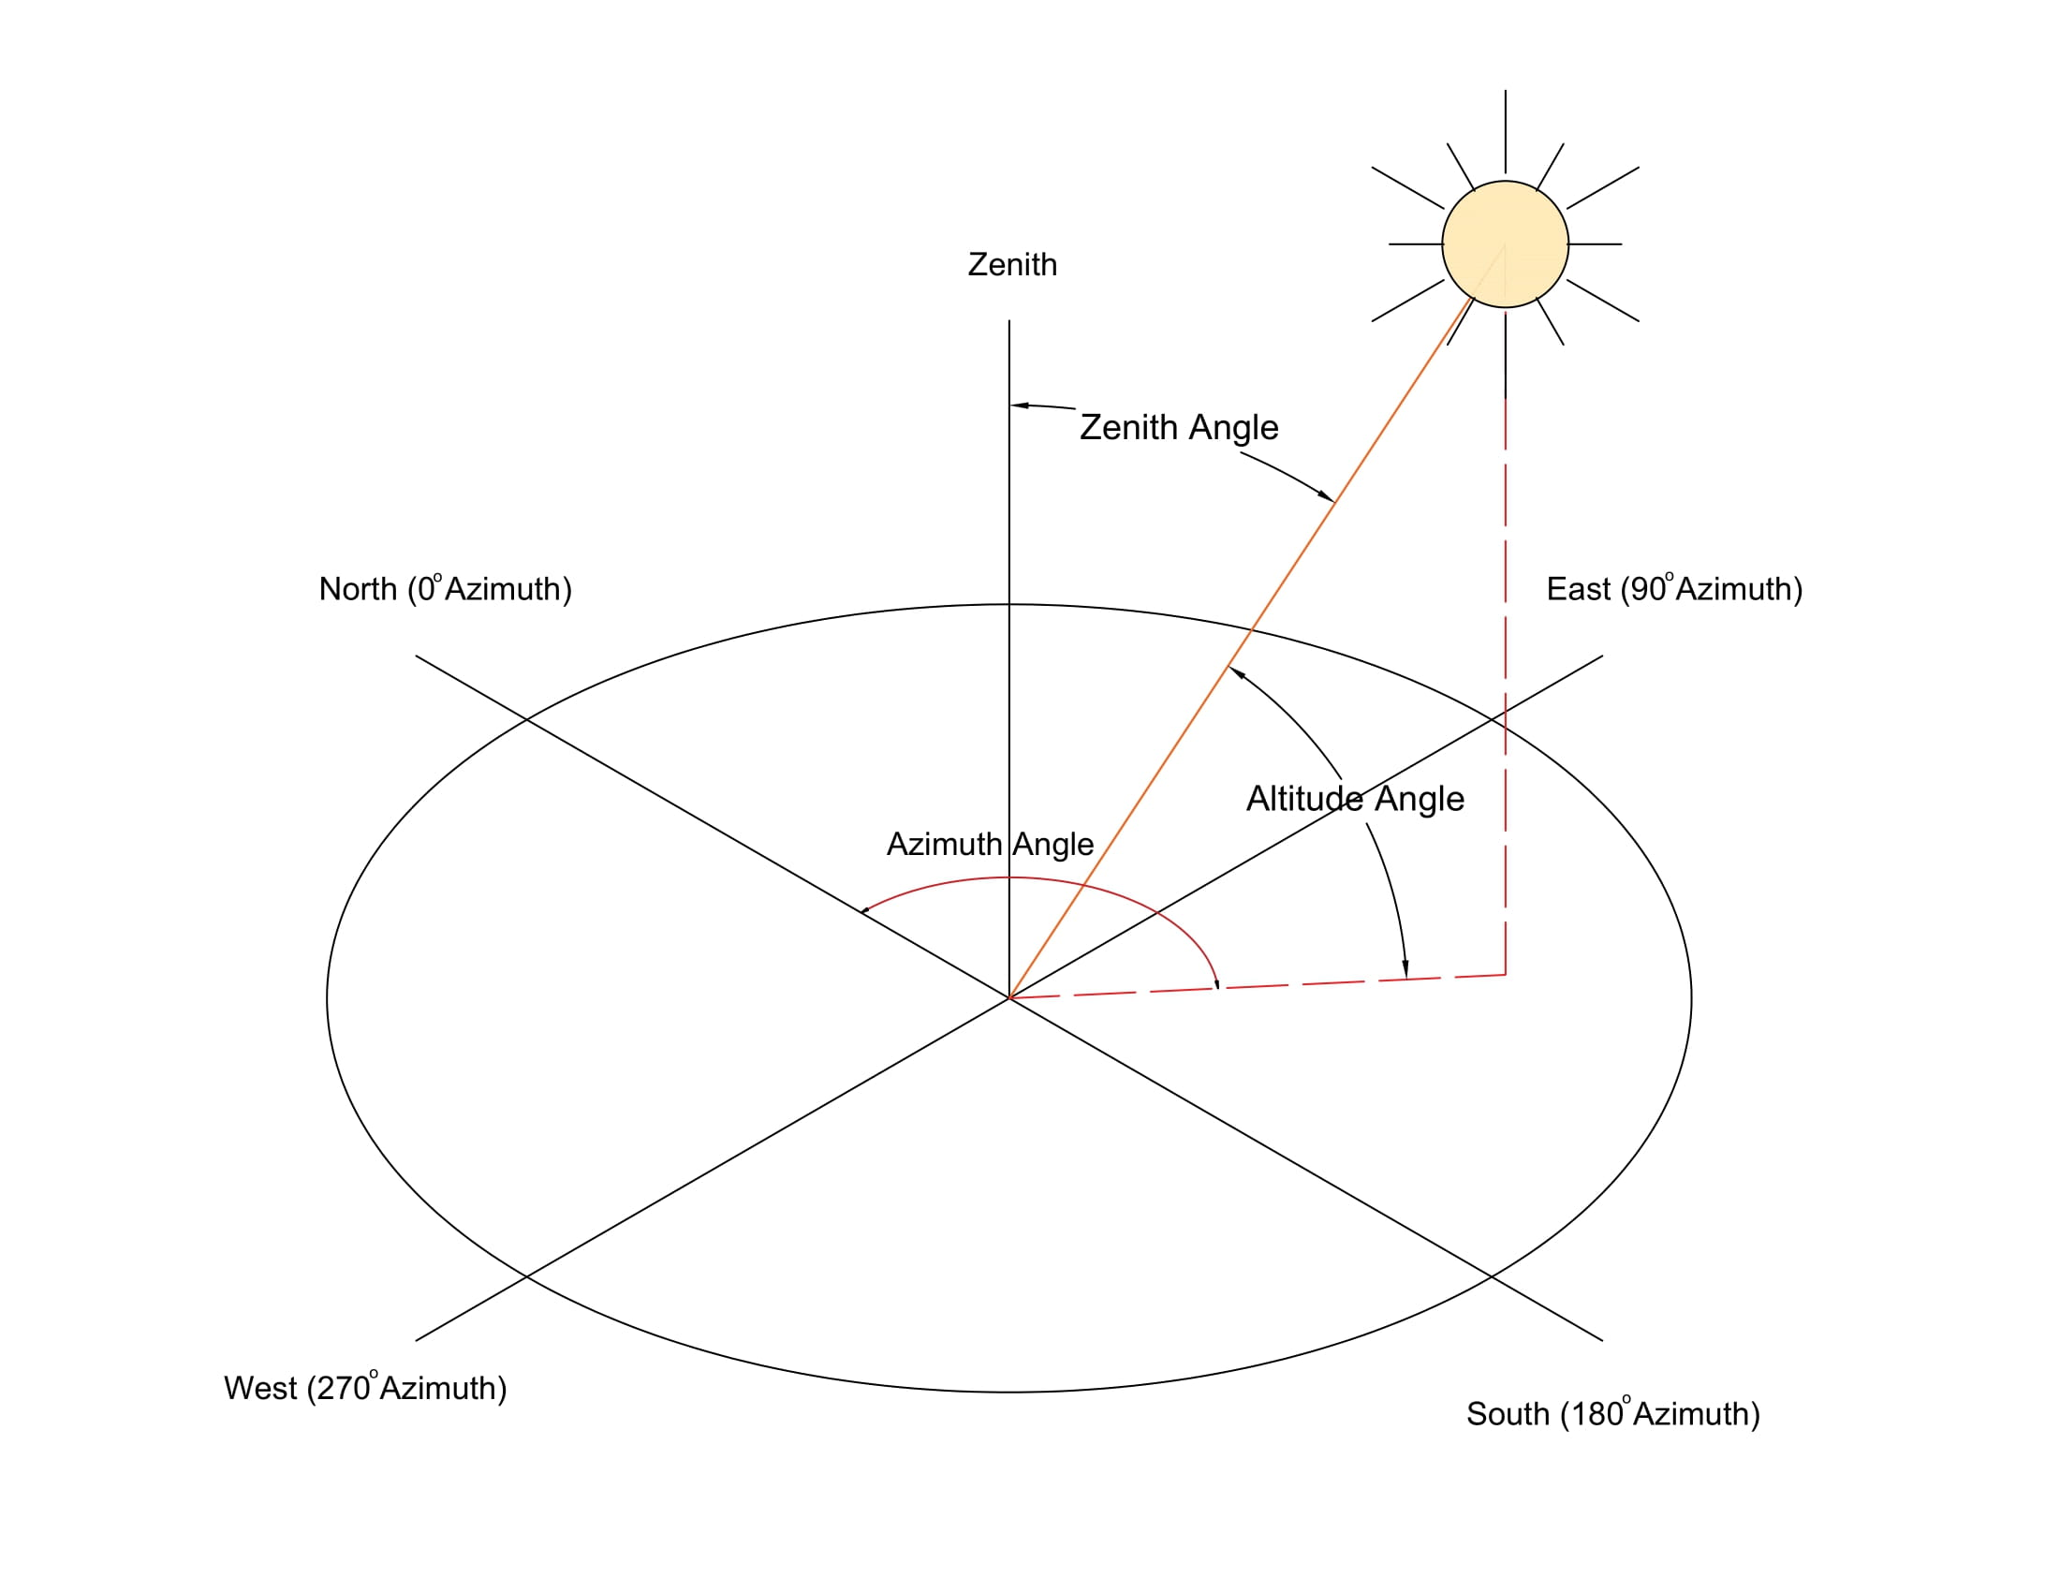
Figure 1: Solar Geometry

Direct and Diffused Solar Radiation
When the sunlight is absorbed, scattered and reflected by various components present in atmosphere, the radiation is called diffused solar radiation. It is caused due to presence of Air molecules, water vapor, clouds, dust, pollutants etc present in atmosphere.
The portion of solar radiation that reaches the earth’s surface without being diffused or is perceived to have reached the surface directly from the Sun, is called direct solar radiation.
The sum of diffused and direct solar radiation is called as global solar radiation.

Measurement of Solar Radiation

Pyrheliometer
It is an instrument for measuring direct solar radiation flux at normal incidence. It is a small telescope like equipment which follows the path of the sun throughout the day.

Pyranometer
It is an instrument used for measuring of direct and diffused irradiance arriving from the whole hemisphere i.e. from the complete sky dome.
A Pyranometer can be used in a tilted position as well, in which case it will also receive the ground reflected radiation.

Pyranometer with shading device
Pyranometer with a shade ring is used to measure diffused solar irradiance.

References
Boyle, G. (2013). Renewable Energy Power For A Sustainable Future (Vol. Third Edition). Oxford: Oxford University Press.
Elprocus. (2022). Retrieved October 9, 2022, from https://www.elprocus.com/what-is-pyranometer-construction-types-applications/
IEA. (2022). Retrieved October 9, 2022, from https://www.iea.org/reports/offshore-wind-outlook-2019
Koirala, D. R. (2019). Principals of Engineering Thermodynamics and Heat Transfer. Kathmandu: Shree Chandeswori Publication Pvt. Ltd. .
S. Hasan, S., & Sharma, D. (2009). Non-Conventional Energy Resources. Delhi: S. K. Kataria and Sons.
Sharma, D., & Hasan, S. (2009). Non-Conventional Energy Sources (Second Edition ed.). Delhi: S.K. Kataria and Sons.
Singal, R. (2011). Non-Conventional Energy Resources (Vol. Third Edition). Delhi: S. K. Kataria and Sons.

