\

ENERGY, ENVIRONMENT AND SOCIETY

Lecture Notes

Chapter 5
Solar Thermal

Lecturer:
Associate Prof. Manchan Tiwari

2022, October

Table of Contents
1. Solar Thermal Systems 5
1.1. Solar Energy Scenario Nepal 5
1.2. Types of Solar Thermal Systems 5
1.2.1. Solar Collector 5
1.2.2. Types of Solar Water Heating System 8
1.2.3. Solar Pond 8
1.2.4. Solar Dryer 10
1.2.5. Solar Cooking System 11
1.2.6. Solar Swimming Pool 11
1.2.7. Solar Still 11
1.2.8. Solar refrigeration 11
1.2.9. Solar Water Pumps 12
2. References 13

Learning Objectives of the Lecture:
To impart basic knowledge to undergraduate students on the topic of:
- Solar thermal energy
- Different types of Solar Thermal Applications
- Working of various Solar Thermal Applications

Solar Thermal Systems
Solar thermal energy (STE) is a technology for harnessing solar energy for thermal energy. The basic purpose of a solar thermal energy system is to collect solar radiation and convert it into useful thermal energy.

Solar Energy Scenario Nepal
- Nepal has a high potential for harnessing solar energy being located in favorable latitude (WECS, 2010).
- The solar insolation in Nepal varies from 3.6 to 6.2 kWh/m2/day and the sunshine is for about 300 days per year (WECS, 2010).
- The monthly daily global solar radiation varies from 120 to 260 w/m² with the annual sun shine duration ranging from 1900 to 2500 hours
- As per report published by Alternative Energy Promotion Centre, Nepal under Solar and Wind Energy Resource Assessment in Nepal (SWERA), the commercial potential of solar power for grid connection is 210hn 80 MW.
- National average sunshine hours of 6.8 hrs per day and average solar insolation of about 4.7 kWh/m2/day, there is a huge potential for solar thermal devices such as Solar water Heaters, Solar Dryers, Solar Cookers.

Types of Solar Thermal Systems

Solar Collector
Solar collector is a device which absorbs the incoming solar radiation, converts it into heat, and transfers this heat to a fluid flowing through the collector. Such converted heat can be used for heating purpose or for the purpose of electricity generation as well. Solar collector can be either flat plate or evacuated tube type (non concentrating type) or concentrating (focusing) type. So, basically the solar collectors can be classified into three types:

Types of Collector
- Flat Plate Collectors
- Evacuated Tube Collectors
- Stationary compound parabolic collectors

Flat Plate Collectors (FPC)
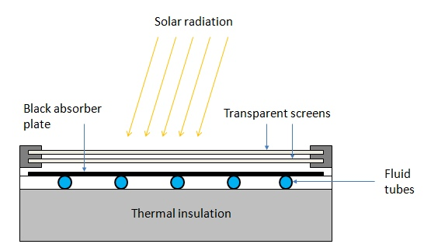
Figure 1 Flat Plate Collector (PennState, 2022)
- Flat plate solar collector consists of an absorber plate, cover glass, insulation, housing and heat transfer fluid tube.
- Absorber plate is generally made of metal to increase the absorption of solar radiation. A large portion of the incident energy is absorbed by the plate and then transferred to the transport medium in the fluid tubes.
- The cover glass or glasses are used to reduce convection and re-radiation losses from the absorber.
- Insulation is used on the back edges of the absorber plate to reduce conduction heat losses.
- The housing holds the absorber with insulation on the back and edges and cover plates.
- The working fluid (water, air) is circulated through the absorber plate to carry the solar energy to its point of use.
- It is used to achieve moderate temperature of up to 100 ⁰C.
- It is used for building heating, industrial process heating.

Evacuated Tube Collectors (ETC)
Evacuated tube collectors comprises of parallel rows of tubes containing water or fluid used for heating. Each tube is made of metal tube surrounded by a larger glass tube. The space between the tube and the glass tube is a vacuum, due to which very little heat is lost from the fluid. The vacuum ensures that there is negligible loss due to conduction or convection, which ensures that the collector can operate at higher temperature that the flat plate collectors. Evacuated tube collectors are used for reduction of losses. ETC can achieve water temperature of up to 250 ⁰C.

Concentrating Collectors
These types of collectors are used for medium and high temperature applications. It is made of a reflecting surface such as reflecting mirror or Fresnel lense which is used in concentrating device such that the solar radiation incident is reflected to a single point and focused on to the absorber. Such concentrator are also rotated through tracking mechanism which helps to track the sun path for increase in the efficiency of the collector. The performance of concentrating collectors is measured by concentration ratio which is the ratio of the aperture area of the concentrator to the area of the absorber. Various types of concentrating collectors are:
- Parabolic Trough Concentrator
  - It is a linear concentrator
  - It has concentration ratio of around 20 to 100
- Parabolic Disc Concentrator
  - It is a point focus concentrator.
  - It has concentration ratio of 100 to 4000 for parabolic and heliostat field concentrator.
  - These are fixed collectors which uses parabolic shaped collectors. The parabolic shaped collectors are made from two sections of a parabola facing each other. These type of collectors can accept incoming radiation over a relatively wide range of angles, by using multiple internal reflections
- Fresnel Lens Concentrator
  - It is capable to achieve temperature as high as 1000 ⁰C. This type of concentrator is se for power generation and process heat supply.

Types of Solar Water Heating System
- Active Solar Water Heating System
- Passive Solar Water Heating SYstem

Active Solar Water Heating System
Active Solar Water Heating System utilizes external power source (pump) to circulate the working fluid to transfer heat from the collector to the desired space.
There are two types of Active Solar Water Heating Systems:

-Direct Circulation Systems
In this system pump circulates the heating fluid (water) through the collectors and in to the home or desired heating space. They work well in climates where the water does not freeze.

Indirect Circulation Systems
In this system pump circulates a non-freezing heat transfer fluid through the collector to a heat exchanger. In the heat exchanger the fluid the heats water which is then circulated into home. This type of system work well in climates prone to freezing temperatures.

Passive Solar Water Heating System
In this system no external power source (pump) is used to circulate the heating fluid or water. Instead, these systems are based on thermos siphon principle.

Thermosiphon System
In thermosiphon system, there is no need for circulating pump and controller. Collector is place below the altitude level of the water tank such that the water flow into the collector due to gravity. When the water in collector gets heating, due to density difference between the hot water in collector and relatively cold water in water tank, the hot water rises up to the tank and consequently the cold water from tank flows to the collector. Due to this the water keeps circulating into the collector and the water temperature is raised. This effect is also called thermo siphon effect.

Solar Pond
In an ordinary pond, water warmed by the sun expands and rises as it becomes less dense. Once, it reaches the surface, the water loses its heat when it comes in contact with the surrounding through convection, or evaporation. Hence, in an ordinary pond, due the loss of heat into the atmosphere, there is no considerable increase in temperature of the water.
Solar pond use a large, salty lake as a kind of flat plate collector. If a lake has salty water at the bottom and fresh water at the top and the water is clear enough, the solar energy is absorbed at the bottom of the pond. The hot and salty water cannot rise as it is heavier than the fresh water at the top. Hence the upper layer acts as insulating blanket to preserve the heat in the bottom layer of the pond. Solar pond is also called as solar salt pond.
A solar pond consists of three main layers
- Top layer near exposed to atmosphere (near ambient temperature) and has low salt content
- Bottom later is hot and has high salt content
- The middle layer between these two layers is a gradient zone which allows the sunlight to pass to the bottom layer but acts as transparent insulator.
A leak proof pond is constructed such that 330 kg of salt per square meter of the pond is added to maintain the gradient. The temperature of the bottom layer can reach around 93 ⁰C (Singal, 2011). Solar ponds are useful in two ways:
Figure 2: Solar Pond
- Due to the temperature difference in the upper most and lower most layer, the temperature difference used to convert the solar thermal energy to useful work
- Solar pond can be used as a thermal storage medium (Singal, 2011)

Applications of Solar Pond
- Industrial process heat applications
- Electrical power generation
- Space heating and cooling
- Water supply (for desalination)
- Fruit and vegetable canning industry (vine fruit drying and for grain drying)

Limitations of Solar Pond
- Solar pond requires large area and sunny climate
- Availability of large amount of water

Solar Dryer
Solar drying is the process of removing moisture from a product to be used in various application as well as to preserve it for a longer period of time. Drying of a product is dependent on temperature, humidity and velocity of air stream and also on the properties of the material to be dried.

Working Principle
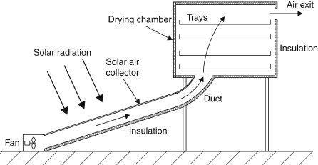
Figure 3: Solar Dryer (Kalogirou, 2014)
Air is drawn through the dryer either by natural convection or by used of fan in some cases. The air is then passed through the collector where it receives heat and the temperature is raised so that the relative humidity is decreased. The warm air can hold more moisture than the cold air, so when the heated air is passed through the drying chamber where, the particulars to be dried are placed, the air withdraws the moisture hence drying the input.

Solar Cooking System
Solar radiation is also used for cooking by either using box type solar cooker or parabolic solar cooker (parabolic solar concentrator). The basic principle of the solar cooker is to concentrate or reflect the solar radiation incident in an area to a single point where the cooking vessel is placed. The solar cooker utilizes direct radiation.

Solar Swimming Pool
Solar thermal energy can also be utilized for heating the swimming pool using various kind of collector as per requirement. Generally, solar swimming pool utilized flat plate or vacuum tube solar collector. The size of the collector depends on several factors such as, size of the pool, climate, desired water temperature, wind conditions, availability of shading in the pool and also the frequency of usage of the pool. Normally, the total area of the solar collector is at least the half of the pool surface area.

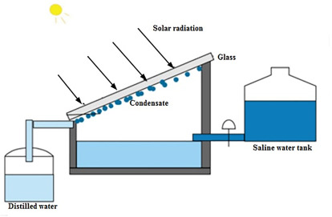
Solar Still
Solar still are the device which uses solar radiation as energy source for purification of liquids for eg. for desalination or distillation of water. In a solar still, impure water is contained in a container outside the collector. In the solar collector, the impure water evaporates and condenses when it strikes the inclined transparent surface that is placed at the top of the collector. The water then condenses and small drops of water is formed which flows into a container where the pure water is collected.
Figure 4: Solar Still (Ren, 2020)

Solar refrigeration
Refrigeration using solar thermal energy from a solar collector is achieved by operation of vapor absorption refrigeration cycle. Such solar refrigeration is feasible and used in rural regions where electric power is not available. Solar refrigeration can be used to store food in such rural areas. In a conventional vapor compression refrigeration system, the input energy is electricity which operates motor to produce cooling effect. In vapor absorption cycle, the input energy is heat, which is used to operate absorber and generator instead of compressor to produce cooling effect in the evaporator. Hence, the heat required for the vapor absorption cycle is supplied by solar collector to produce refrigeration effect.

Solar Water Pumps
Water pumps are the devices which operate when a motor driven by electrical power converts the electrical power to mechanical power which then operates the water pump. In solar water pump operated by thermal energy, organic vapor rankine cycle system with rotary machines or screw expanders or reciprocating engine or spiral expander is used to to provide the mechanical power to the water pump.

References
Boyle, G. (2013). Renewable Energy Power For A Sustainable Future (Vol. Third Edition). Oxford: Oxford University Press.
Kalogirou, S. A. (2014). Solar Energy Engineering Processes and Systems (Second Edition ed.).
Koirala, D. R. (2019). Principals of Engineering Thermodynamics and Heat Transfer. Kathmandu: Shree Chandeswori Publication Pvt. Ltd. .
PennState. (2022). Retrieved October 8, 2022, from Pennsylvania State University: https://www.e-education.psu.edu/eme811/node/685
S. Hasan, S., & Sharma, D. (2009). Non-Conventional Energy Resources. Delhi: S. K. Kataria and Sons.
Sharma, D., & Hasan, S. (2009). Non-Conventional Energy Sources (Second Edition ed.). Delhi: S.K. Kataria and Sons.
Singal, R. (2011). Non-Conventional Energy Resources (Vol. Third Edition). Delhi: S. K. Kataria and Sons.
WECS. (2010). Energy Sector Synopsis Report. Kathmandu, Nepal: Government of Nepal, Water and Energy Commission Secretariat.

