\

ENERGY, ENVIRONMENT AND SOCIETY

Lecture Notes

Chapter 7
Design of Solar PV Rural Systems

Lecturer:
Associate Prof. Manchan Tiwari

2022, October

Table of Contents
1. Steps of Solar pv System Design 2
1.1. Load Assessment and Calculation 2
1.1.1. Accurate load knowledge 3
1.1.2. Load efficiency 3
1.1.3. Load profile throughout the year 3
1.1.4. AC or DC 3
1.1.5. Apparent and real power consideration 3
1.2. Solar Resource Assessment 5
1.3. Survey and Investigation (Site Selection) 6
1.4. System Design 6
1.4.1. Types of Systems 7
1.4.2. Generation System Design 10
2. References 16

Learning Objectives of the Lecture:
To impart basic knowledge to undergraduate students on the topic of:
- Demand assessment and calculation
- Data Collection for Solar Resource assessment
- Basics of survey and investigation for solar PV system
- Aspects of system design
- Basics of array design, battery sizing and charge control sizing

Steps of Solar pv System Design
- Load Assessment and Calculation
- Solar Resource Assessment
- Survey and Investigation
- System Design

Load Assessment and Calculation
The important aspect of designing solar PV system is estimation of energy consumed by the installed load in one day. Accurate calculation of the load is crucial as failure to do so may lead to system failure or high loss of load probability. Generally, initially during the load calculation, a table of daily consumption of electrical energy by various appliances as required to be powered by the solar PV, is prepared. Load refers to electrical energy required er day. Before calculating the system load, there are few important aspects to consider which are
- Accurate Load Knowledge
- Load Efficiency
- Load Profile
- AC or DC Load
- Apparent and Real Power Consideration

Accurate load knowledge
The entire solar PV system design will be based on the size of the load. If the information is inaccurate, the initial cost will be too high or the battery and array/module could be too small and the system will eventually fail.

Load efficiency
Improving load efficiency is the quickest way to reduce PV power system cost. A more efficient load device may even be slightly more expensive than an existing or conventional load device (for example CFL against incandescent lamps).

Load profile throughout the year
It is important to prepare load profile according to season as well as on the basis of daily, weekly, monthly or yearly average, as it reflects the proper fluctuation in available energy, temperature, consumer patterns etc. for the load is useful for rough system sizing, but seasonal variation of the load throughout the year will influence the choice of tilt angle for the array and the final array and battery size. The insolation on a flat surface varies greatly, with the least during the winter and the greatest during the summer. Now if the load demand is small in winter and large in summer, as with air cooling loads or refrigerators or water pumping for irrigation as well as drinking purpose, then tilting the array in optimum angle for summer days will give an insolation profile that best matches the load profile

AC or DC
As far as possible DC loads should be preferred over AC loads to minimize the cost and avoid use of inverters. Use of inverters add the cost, reduces system reliability and introduce power loss.

Apparent and real power consideration
For sizing purpose, the real power in watts consumed in the load is the value needed. For wiring design and inverter choice, the apparent power will be important because the current that will be flowing in the wires into a heavily inductive load will be greater than what would be calculated by just dividing watts by volts. Also, the inverter must be chosen so that it can handle the expected apparent power (or the power factor) of the loads.
The load (or the energy consumed) is generally expressed in Watt-hours (W-h). But for more accurate sizing of the array and battery, sometimes the load is expressed in Ampere-hours (Ah). If Wh is known, Ah can be calculated as :
Ah = Wh / system voltage
For example if a 12V DC operated 10 Watt lamp is turned on for 5 hours, then the total load is:
W-h = 10 W x 5 hours = 50 Wh.
This value expressed in Ah would be 50/12 = 4.17 Ah.
Now if a color television with 60 W power consumption is operated from 220 V AC for 5 hours, then the Wh value would be 60 W x 5 hours = 300 Wh and in Ah it would be 300/220 = 1.36 Ah.
It is very important to accurately determine solar PV system load to correct determination of system size and system electricity generation and losses. As seasonal variation causes variation in energy generation, atmospheric temperature, consumer energy consumption patterns, it is important to consider the load profile according varying seasons. It is essential to plot estimated daily load curve for a 24 hour period of a day in one hourly interval along with consideration for peak load (AEPC , 2022). The table below shows a sample of a demand analysis table
SN | Electricity Uses | Quantity | Watts per Unit | Total Watts | Uses Hours per day | Coincidence Load Factor | Watt hour per day
1 | Households
1.1 | Main Room Light | 4 | 10 | 40 | 5 | 85% | 170
1.2 | TV | 1 | 60 | 60 | 4 | 40% | 96
1.3 | Fan | 2 | 40 | 80 | 8 | 95% | 608
2 | End Uses
2.1 | Hotels and Restaurant | 1 | 500 | 500 | 5 | 100% | 2500
 | TOTAL |  |  | 680 |  |  | 3374

Coincidence load factor is usability or availability of devices (AEPC , 2022). For example coincidence load factor of 85% of main room light in the table above means only 85% of installed main room lights for 5 households shall be used on an average on any particular day. The TV has 40% of the coincidence factor which means that 40% of the households will be using the TV in the community at an instant. Such demand analysis tools should be used for productive end uses as well. These daily load curve should be represented with the help of combined load curve to accurately represent the peak power sizing, storage and energy demand. Regarding the data required for the load table a questionnaire can be developed which can be used to obtain the relevant data. It is desirable to at least survey 10% of the households to obtain the relevant data (AEPC , 2022).
To ensure the project is financially sustainable it is important to ensure the maximum utilization of renewable sources. The primary use of a solar rural system can be to meet the daily household requirement of the community in the rural region; however, the productive and community end uses should be promoted as well for sustainable revenue generation and creation of employment in the community. Due to fluctuating energy production potential of solar energy during the day, it is desirable to use diverse type of end uses to balance the intermittency to optimize the investment cost. The common type of end uses can be communication centers, agro grinding mills, small scale furniture factory, poultry farms, metals and grill workshops, photo studios, tailoring business, health clinics, electronic repair shops, bakeries and other small enterprises. Generally, these end uses are operated during the day due to which no storage devices are required.

Solar Resource Assessment
For accurate estimate of annual energy production, solar resource assessment is essential. Solar resource assessment refers to the analysis of the prospective solar energy production of the site in contention. It is important to measure direct, diffuse and global solar radiation in a site of contention. As per AEpC, the solar mini grid projects which are to be implemented should have global horizontal irradiation value of more than 4 kWh per m² per day.
These data can be obtained either by ground-based measurement stations or by solar models that utilize satellite, atmospheric and meteorological data. There are also solar resources datasets that can be used to get the required data which is represented in table below
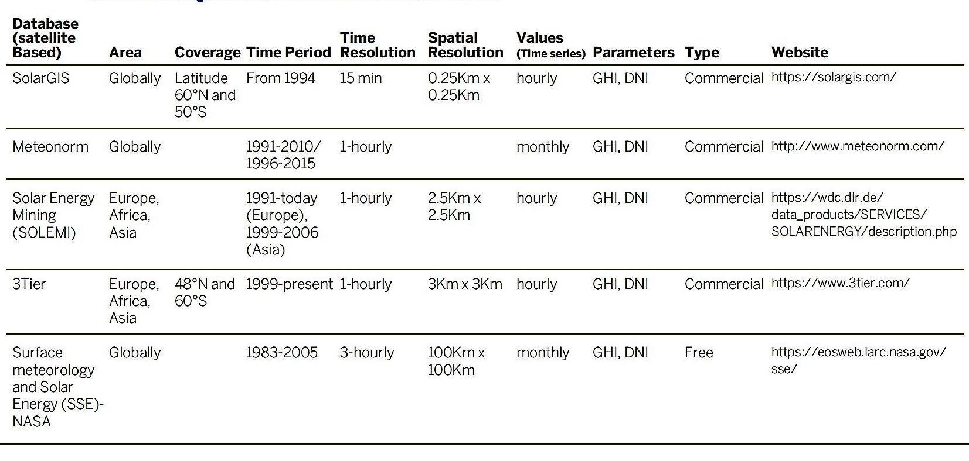
Figure 1: Solar Energy Resource Database (AEPC , 2022)

Survey and Investigation (Site Selection)
Following major parameters are considered for site selection (AEPC , 2022)
- Availability of Solar Resource GHI of more than 4 kWh per m2 per day should be considered
- Shading Shading due to hill, mountains, building, trees, overhead cables should be avoided.
- Availability of land area should have sufficient land area
- Topography and Orientation flat or slope surface with good southern exposure is desirable
- Accessibility should be near from access road
- Geotechnical stable ground is required
- Climatic Characteristics flooding risk, wind speed and risk of snow should be taken in considerations
- Right of Way proper path of transmission and distribution lines should be considered
- Permit and Clearances should follow local land use regulations and should acquire land lease permit or construction permit where ever it is required

System Design
Following important parameters should be considered for design of a solar power systems
- Site location and land area requirement
- Seasonal load profile, daily load profile
- Surge and peak power requirements
- Selection of PV module
- Selection of charge controller
- Array layout with shading analysis
- Selection of inverter
- Inverter and or MPPT controller configuration
- Matching array and grid connected inverter
- Selection of battery storage
- Battery configurations
- Battery selection of battery inverter
- Inverter configurations
- Matching battery storage and battery inverter
- Hybrid system if any
- Power transmission and distribution system components
- Control and monitoring system
(AEPC , 2022)

Types of Systems
- AC Coupled
- DC Coupled
- DC and AC Coupled
- DC AC Coupled with distributed generation

AC Coupled
Separate PV and battery inverters are kept in AC coupled configuration. These two separate inverters connect to one another on the ac side of the system. PV inverter is a standard utility interactive inverter whereas the storage inverter controls battery charging and discharging (AEPC , 2022). This type of systems has improved conversion efficiency as the standard utility interactive inverters are often 97% to 98% efficient.

Figure 2: AC Coupled System (AEPC , 2022)

DC Coupled system
In this kind of system, the pV and battery storage system share a common inverter using three of more interfaces. Two interfaces on the dc side of the converter are used for pV and battery input where as the third interface on the ac side is used as an input for the utility grid. The power supply from pV array is unidirectional where as the power supply from battery and utility interfaces in bidirectional (AEPC , 2022). This type of system results in reduced material and labor cost and are more compact in occupying space as fewer equipment are required.
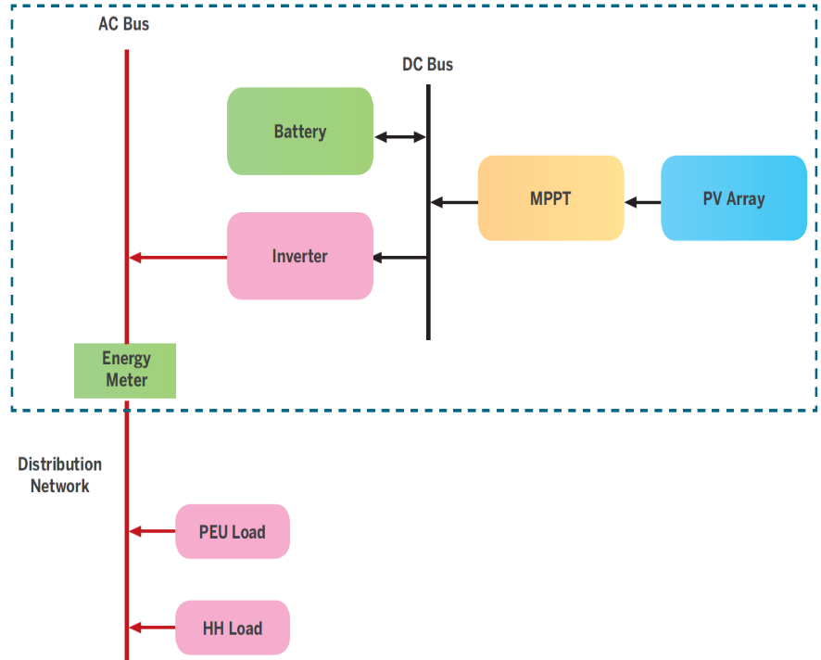
Figure 3: DC Coupled System (AEPC , 2022)

DC and AC coupled system
This type of system uses both the concept of AC and DC coupled system. Here two PV array are used to power AC and DC load separately. This type of system reduces the risk of full drainage of battery.
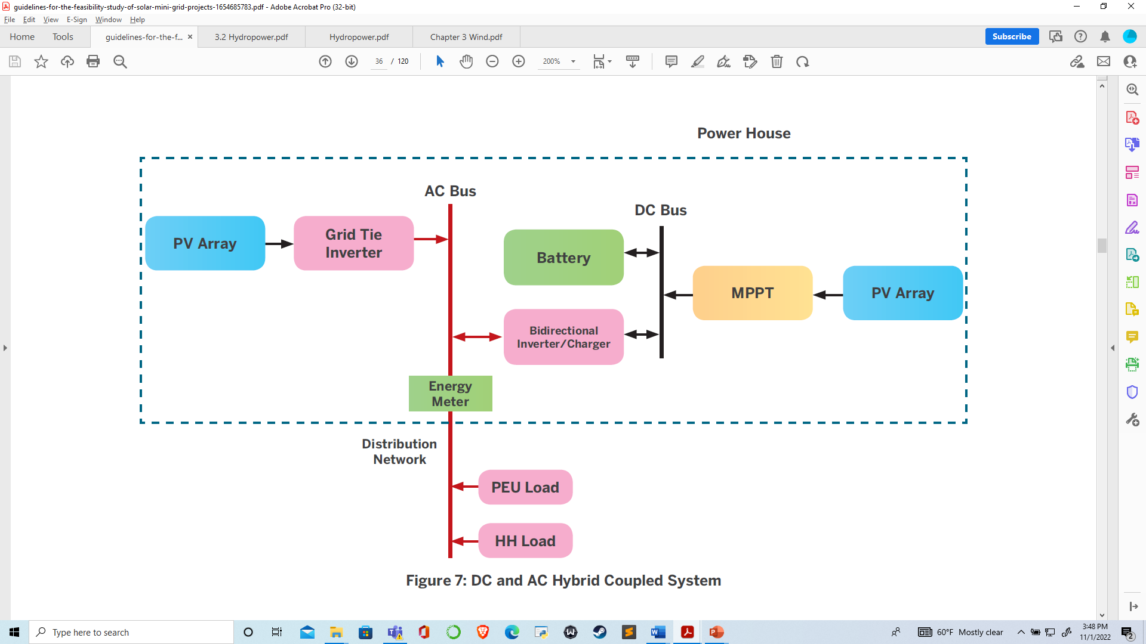
Figure 4: DC and AC coupled system (AEPC , 2022)

DC AC coupled with distributed generation
This kind of system is used where the length of the transmission line is very high and the installation of pV system is not possible at one place. So, certain portion of pV array and grid tie inverted can be place at the far end from the powerhouse and be synchronized to the grid.
Figure 5: DC-AC Coupled system with distributed generation (AEPC , 2022)

Generation System Design

PV Array Sizing
The sizing of PV array is based on the daily energy demand and the available peak sunshine hours. Following equation gives the relation for PV array sizing
$$PV Array Size \left(A\right)=\frac{Daily Energy Demand (Ampere hour)}{Total loss factor×Peak sunshine hours (hour)}$$ | 1-1
In context of Nepal, peak sunshine hours of 4.5 to 5.5 is used. Peak sunshine hour of a particular place is equivalent to the Global Horizontal Irradiation of a particular place. Total loss factor of 0.6 to 0.7 is used. The daily energy demand in Ah is calculated by considering system and array voltage. It is important to consider system voltage to convert the load demand from watt hour to ampere hour. For small home systems, 12 V can be selected as the system voltage, however, for large systems where, AC load is large in the range of few kVA, the DC voltage should be selected in higher range. It should be considered that the PV modules should be selected considering that the designed system will operate below the maximum system voltage of the module. Typically, modules are rated to a maximum system voltage of 600 V DC or 1000 V DC or 1500 V DC. It is also very important to match arrays based on PV inverter voltage. Mismatch may lead to reduction in power production. For, most of the 1500 V DC input inverter, MPPT ranges fall in between 800 to 1300 V.
If a single module cannot deliver the current (here we refer to I_{mp} of the module) calculated, then number of modules have to be connected in parallel to produce the required level of current. The number of modules to be connected in parallel can be found by using the following formula:
• Np = I array / Imp
It is to be noted that Np may not be the whole number. The actual value of Np should always be rounded up to the next highest integer value. The number of module in series can be calculated by finding out effective open circuit voltage at the expected temperature at with the module is supposed to operate in the region. Following relation can be used to calculate the maximum and minimum number of module in series
$$M1=\frac{Inverter\max{input voltage}}{V_{oc cell eff1}}$$ | 1-2
Where
- M1 = maximum number of module in series
$$V_{oc cell eff1}=V_{oc stc}+\left\{γ×\left(T_{cell}-T_{stc}\right)\right\}$$ | 1-3
Where,
- V_{oc cell eff1} = open circuit voltage at effective cell temperature (Volts)
- V_{stc} = open circuit voltage at standard temperature conditions (Volts)
- γ = Voc temperature coefficient (V/⁰C)
- T_{cell} = minimum expected cell temperature at specified temperature in ⁰C
Similarly,
$$M2=\frac{Inverter\max{input voltage}}{V_{oc cell eff2}}$$ | 1-4
Where
- M2 = minimum number of modules in series
$$V_{oc cell eff2}=V_{oc stc}+\left\{γ×\left(T_{cell}-T_{stc}\right)\right\}$$ | 1-5
Where,
- V_{oc cell eff2} = open circuit voltage at effective cell temperature (Volts)
- V_{stc} = open circuit voltage at standard temperature conditions (Volts)
- γ = V_{oc} temperature coefficient (V/⁰C)
- T_{cell} = maximum expected cell temperature at specified temperature in ⁰C

An example below showing maximum number of modules in series
Annual minimum temperature at project site= 10°C
Temperature Coeff. Voc of module = −0.35%/°C
Voc of module= 44 V
Inverter Max input voltage = 1250V
Solution
Temp adjustment factor = -0.35% *(10-25)*44 = 2.31V
(Temp coef. is given in percentage thus have to multiply it by Voc)
Voc cell eff = 44+2.31 = 46.31 V
Maximum no. of modules in series = inverter max input voltage/ Voc cell eff
= 1250/46.31 = 26.99
= 26
(always round down for maximum no. of modules)

An example below showing minimum number of modules in series
Annual maximum temperature of project site =55°C
Temperature Coeff. Vmp = −0.4%/°C
Vmp = 40 V
MPPT mini input voltage= 700V
Solution
Temp adjustment factor = -0.4% *(55-25)*40 = -4.08V
(Temp coef. is given in percentage thus have to multiply it by Vmp)
Vmp cell eff = 40+ (-4.08) = 35.92 V
Minimum no. of modules in series = MPPT mini input voltage/ Vmp cell eff
= 700/35.92 = 19.48
= 20
(always round up for minimum no. of modules)

Battery Sizing
Battery system sizing and selection criteria involve many decisions and trade-offs. Choosing the right battery for a particular PV application depends upon many factors. While no specific battery is appropriate for all PV applications some common sense and a careful review of the battery literature with respect to the particular application requirements will help the system designer to greatly narrow down his choice (Sharma, 2014). Battery size can be calculated as
$$C=\frac{D (Ah)×DOA}{DOD×Eff.}$$ | 1-6
Where,
- C = required capacity of battery bank in ampere hour
- D (Ah) = daily load in Ampere hour
- DOA = Days of autonomy (Generally 1.5 for hybrid and 2 for stand alone systems)
- DOD = Maximum allowable depth of discharge (0.8 for lead acid batteries)
- Eff. = Efficiency of battery system (generally 0.7 to 0.9)
Battery bank voltage selection is often dictated by the load voltage requirements, most often 12 or 24 Volts for small remote stand-alone PV systems. For bigger loads requiring a larger PV array it is sometimes wiser to go to the higher voltages, if possible, in order to reduce the system load current. Lower system currents minimize the size and cost of conductors, fuses and other current handling components of the PV system (Sharma, 2014).

Battery charge and discharge rate (C rate)
A C-rate is a measure of the rate at which a battery is discharged relative to its maximum capacity. In the US battery capacity is typically specified as C20 however in Asia the capacity is given as C10. In Nepal it is typically C10 or C/10 however it could be different depending on where the batteries came from. For a battery with a capacity of 100 Amp-hrs, this equates to a discharge current of 10 Amps at C10 rate.
- C10- Charge and discharge@10Hr
- C20- Charge and discharge@20Hr
- Example: - 100Ah @C10 and C20
- Charging/discharging
  - @C10- 10A for 10 hrs
  - @C20- 5A for 20 hrs
  - Capacity: -
  - 100Ah@C10: - 10A x 12V = 120W
  - 100Ah@C20: - 5A x 12V = 60W

Maximum Power Point Tracking (MPPT)
An MPPT, or maximum power point tracker is an electronic DC to DC converter that optimizes energy output from solar arrays. MPPT keeps tracking maximum power point from the STC (Standard Test Conditions) rating under almost all situations. MPPT controller is usually used in AC coupled systems.
MPPT Size (Watt)=Array Size (Watt)
MPPT is mostly inbuilt in the PV inverter. The PV array side voltage can go up to 250V whereas the output side voltage depends upon the DC input voltage (12V or 24V or 48V) of PV inverter.

Solar Charge Controller
Solar charge controller is also known as MPPT charge controller which is generally in DC coupling systems. It has battery protection as well as MPPT function features inbuilt. It gathers energy from solar arrays and stores it in batteries. In small DC coupled system the charge controller are mostly available without MPPT function, such small scale charge controller comes with pulse width modulation (PWM) for battery protection features. For understanding the charge controller are divided as MPPT and PWM charge controllers.
The current rating of charge controller can be calculated as
Solar Charge Controller (A) = Imp x Np x 1.25
Where,
- Np = total number of modules connected in parallel in the array
- Imp = nominal current of the module
- 1.25 is the safety margin (1.25 for PWM and 1.33 for MPPT)

Inverter Sizing
Battery inverters are sized based on the peak load of the system. To optimize the sizing of battery inverters, only the peak load to the supplied from the battery can be considered.
$$Battery Inverter Size (VA)= \frac{System Peak Load (Watt)}{Efficiency ×Power Factor}$$ | 1-7

Battery inverter efficiency can be taken as 0.85 to 0.95 where as power factor can be taken as 0.8.

References
AEPC . (2022). Guidelines For The Study of Solar Mini Grid Projects. Nepal: Alternative Energy Promotion Centre, The Government of Nepal, Ministry of Energy, Water Resources and Irrigation.
Boyle, G. (2013). Renewable Energy Power For A Sustainable Future (Vol. Third Edition). Oxford: Oxford University Press.
IEA. (2022). Retrieved October 9, 2022, from https://www.iea.org/reports/offshore-wind-outlook-2019
S. Hasan, S., & Sharma, D. (2009). Non-Conventional Energy Resources. Delhi: S. K. Kataria and Sons.
Sharma, P. D. (2014). IOE Lecture Notes, Solar Energy Resources.
Singal, R. (2011). Non-Conventional Energy Resources (Vol. Third Edition). Delhi: S. K. Kataria and Sons.

