\

ENERGY, ENVIRONMENT AND SOCIETY

Lecture Notes

Chapter 9
Micro-Hydro Power Basic Design

Lecturer:
Associate Prof. Manchan Tiwari

2022, November

Learning Objectives of the Lecture:
- Revision of basics required for the lecture
- Basics of Design of Civil Components
- Basics of design of headworks, intake and settling basin
- Basic Design of Penstock

Revision of basics

Bernoulli’s equation
- Pressure energy + kinetic energy + potential energy = constant
- Pressure head + kinetic head + potential head = constant
$$\frac{P}{(ρ×g)}+\frac{v^{2}}{2g}+z=constant$$ | 1-1

Continuity equation
- Density * area * velocity = constant (for a continuous flow)
$ρ×A×v=constant$ | 1-2
Vena contracta is the point in a fluid stream where the diameter of the stream is the least, and fluid velocity is at its maximum, such as in the case of a stream issuing out of a nozzle, (orifice)

Discharge
Theoretical velocity due to head (H)
$$v=\sqrt{2gH_{net}}$$ | 1-3
- Actual velocity = theoretical velocity x coefficient of velocity
- Discharge (Q) = area of vena-contracta x actual velocity
- = coefficient of contraction x area of nozzle x theoretical velocity x coefficient of velocity
- = coefficient of discharge x area x velocity

Hence,
$$Q=c_{d}×A×\sqrt{2gH_{net}}$$ | 1-4

Civil Works

Headworks
A headworks consists of all structural components required for safe withdrawal of desired water from a source river into a canal/conduit. Weir, intake, protection works, desilting basin, forebay etc., are the main structural components. Preference should be given to construct structures like intake, desilting basin and forebay at the source adjacent to the river source and start the penstock right from there so as to minimize cost. Those structures should also be designed using M 25 reinforced concrete.
Indicators of an ideal headworks can be summarized as:
- Withdrawal of desired flows (i.e., Qdiverted and spilling in case of flood).
- Sediment bypass of diversion structure (Continued sediment transportation along the river).
- Debris bypass (Continued debris bypass without any accumulation).
- Hazardous flood bypass with minimum detrimental effects.
- Sediment control at intake by blocking/reducing sediment intake into the system.
- Settling basin control (settling and flushing of finer sediments entered into the system through intakes or open canals).

Diversion Weir
A weir is a structure built across a river to raise the river water and store it for diverting a required flow towards the intake. It is recommended that the weir be 5m to 20m d/s of side intake. This will assure that water is always available and there is no sediment deposition in front of the intake. A narrow river width with boulders is preferable for weir location.
Mini hydropower project weir shall be of permanent (concrete/stone masonry) or semi-permanent (Gabion weir with concrete/plastic core) or even temporary (not recommended). In case a temporary weir shall be constructed, it should be used for diverting maximum flow of 1 m3/sec.

Temporary Weir
Temporary weir is constructed using boulders available at the site, stone masonry in mud mortars placed across a part or all of the river width. It is simple and low cost but it is not possible to divert all of the river flow in dry season by this structure. It is suitable only for the diversion of flows below 1 m3/sec

Side Intake
An intake can be defined as a structure that diverts water from river or other water course to a conveyance system downstream of the intake. Side intake and bottom intake are the common types of river intakes that are used in Nepali hydropower schemes. Conveyance Intake is an intake, which supplies water to a conveyance other than the pressure conduit to the turbine. Power Intake is an intake, which supplies water to the pressure conduit to the turbine. A structure built along a river bank and in front of a canal / conduit end for diverting the required water safely is known as a side intake. Side intakes are simple, less expensive, easy to build and maintain.
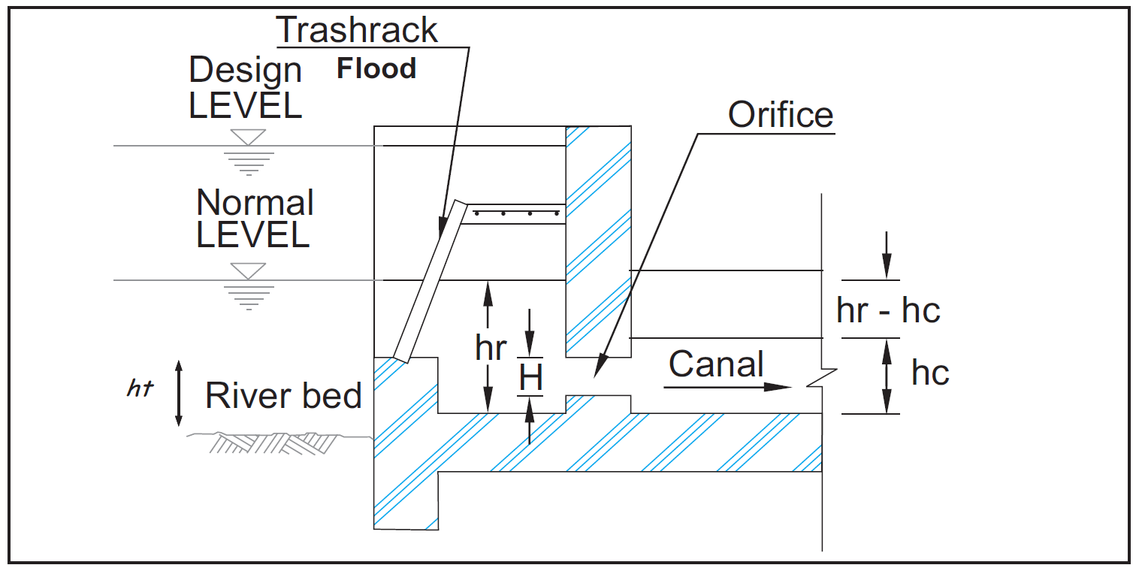
Figure 1: A typical side intake (AEPC, Reference Micro Hydro Standard, 2014)

Settling Basin
Gravel trap and settling basin are the sediment handling structures at headworks. Forebay is the sediment handling structure provided at the end of the headrace system or at the start of the penstock system. A settling basin traps sediment (gravel/sand/silt) from water and settles down in the basin for periodical flushing back to natural rivers. Since sediment is detrimental to civil and mechanical structures and elements, the specific size of specified percentage of sediment has to be trapped, settled, stored and flushed. This can only be achieved by reducing turbulence of the sediment carrying water. The turbulence can be reduced by constructing settling basins along the conveyance system. Since the settling basins are straight and have bigger flow areas, the transit velocity and turbulence are significantly reduced allowing the desired sediments to settle. The sediment thus settled has to be properly flushed back to the natural rivers.
All settling basins should have following components:
- Inlet Zone: An inlet zone upstream of the main settling zone is provided for gradual expansion of cross section from turbulent flow to smooth/laminar flow.
- Settling Zone: A settling zone is the main part of a settling basin for settling, deposition, spilling flushing and trash removal.
- Outlet Zone: An outlet zone facilitates gradual contraction of flow to normal condition.
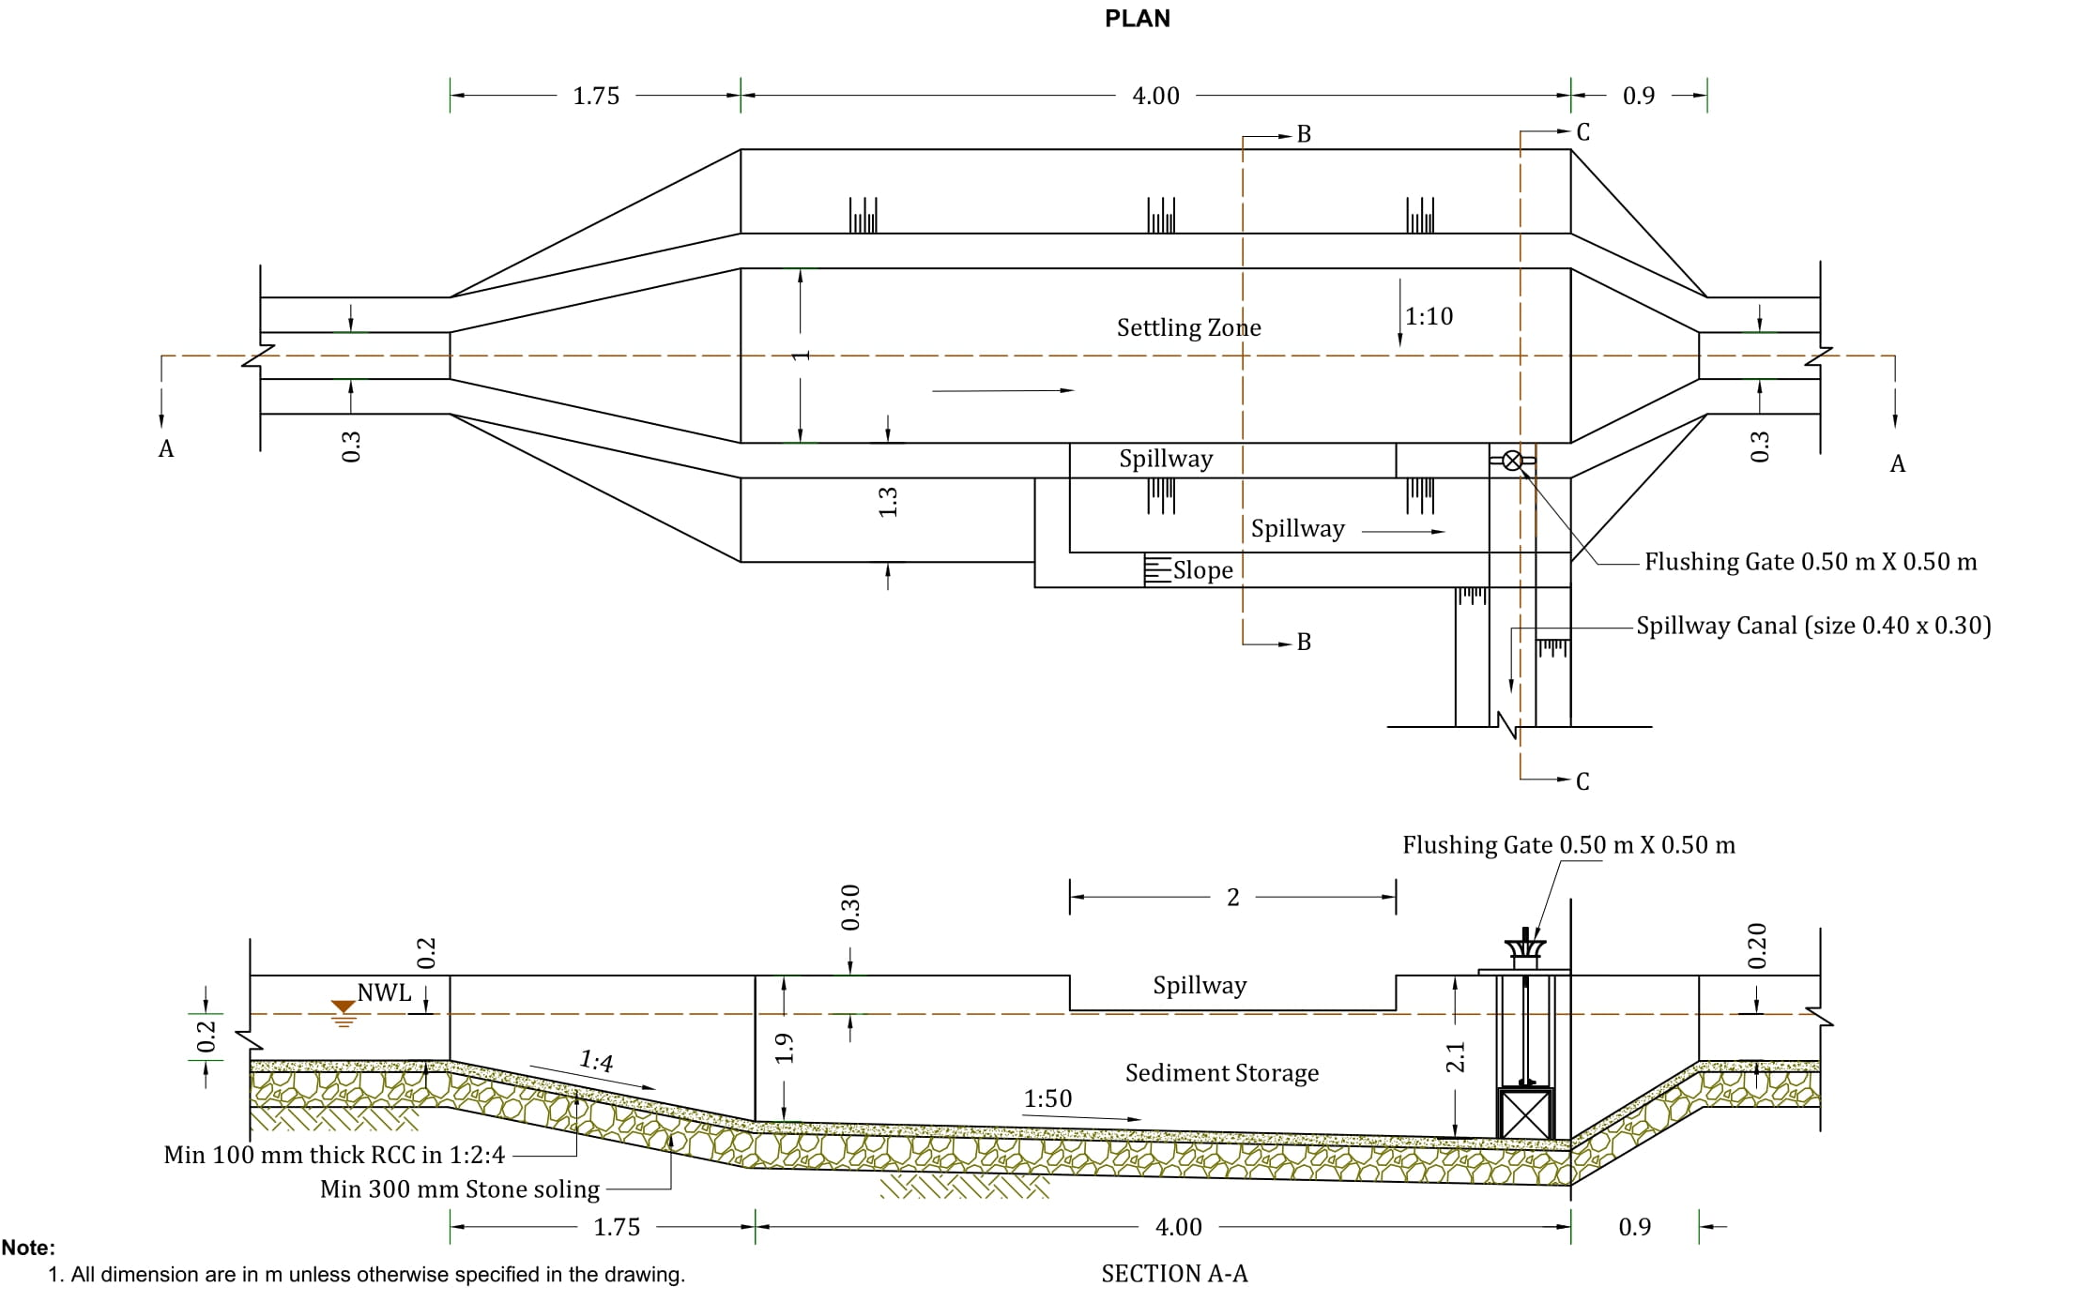
Figure 2: Typical Settling Basin

Canal
Capacity: The canal should be able to carry the design flow with adequate freeboard and escapes to spill excess flow. A canal should generally be designed to carry 110 to 120 % of the design discharge.
- Velocity: Self-cleaning but non erosive (≥ 0.3m/s).
- Unlined canal: In stable ground for Q ≤ 30 l/s
- Lined canal: For higher discharge and unstable ground. Canals with 1:4 stone masonry or concrete are recommended. Care should be taken to minimize seepage loss and hence minimize the subsequent landslides.
- Sufficient spillways and escapes as required.
- Freeboard: Minimum of 300mm or half of water depth.
- Stability and Safety against rock fall, landslide & storm runoff. A catch drain running along the conveyance canal is recommended for mini and small hydropower projects.
- Optimum Canal Geometry: Rectangular or trapezoidal section for lined canal and trapezoidal section for unlined canal are recommended. Unequal settlement of lined trapezoidal canal should be prevented.

Design of Penstock
A penstock is a pipe that conveys the flow of water from forebay to the turbine

Design Aspects

- Safe location/stability
- Proper alignment
- Use of no or fewer bends
- Type/size
- Minimum losses
- Optimization
- Design standards

Design parameters

- Design flow (Q)
- Velocity (V)
- Diameter D
- Thickness (t)
- Gross Head (H_{g})
- Surge Head (Hs)
- Headloss (hL)
- Number of bends
- Expansion joints

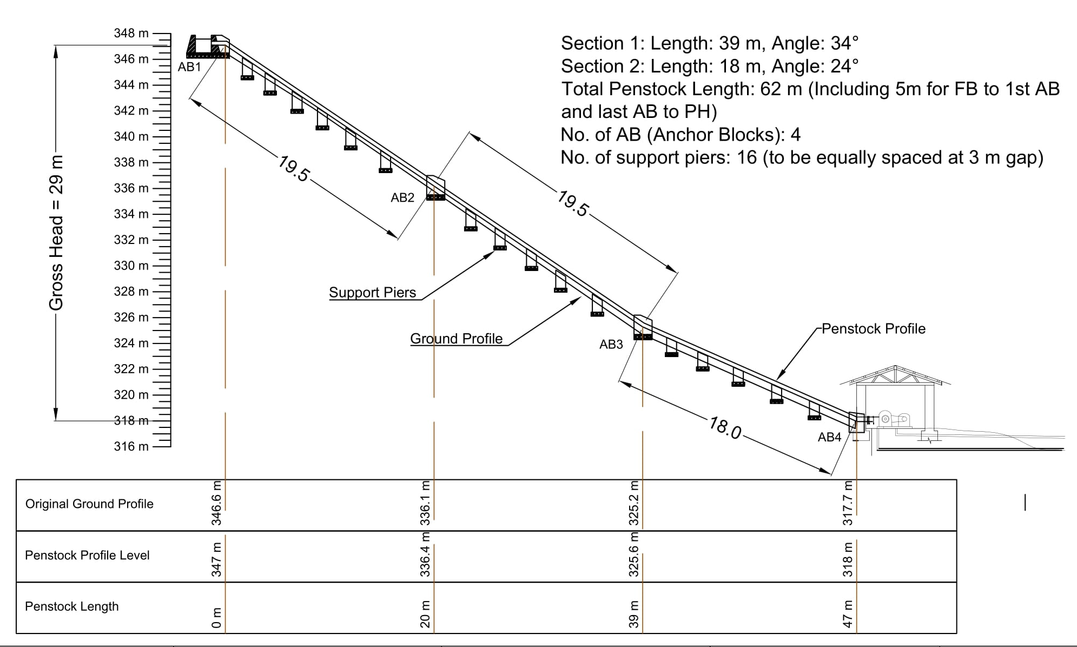
Figure 3:Typical Penstock Alignment Drawing

Penstock Pipe Materials
Materials | Advantages | Disadvantages
Steel | - Widely available  - Can be rolled to any size  - Is available in various thickness  - Easy to join  - Can withstand high pressure | - Heavy, high transport cost  - Rigid, bend need to fabricate as required  - Has corrosion problem  - Costlier
HDPE | - Does not corrode  - Light, easy to transport  - Flexible, accommodates small bends  - Low surge pressure | - Difficult to join  - Available in standard diameter only  - Must be properly buried  - Limited pressure (available upto 10 kgf/cm2)
PVC | - Does not corrode  - Light, easy to transport  - Easy to join (PVC cement and fittings available to join pipes) | - Brittle, can be damaged during transportation  - Larger size diameter not available in Nepal  - Must be properly buried  - Limited pressure (available upto 10 kgf/cm²  - Costlier than mild steel for higher pressure

Sizing of Penstock Pipe

Estimating the diameter
First we can either estimate velocity in the penstock pipe of assume diameter.
The equations used are
$$V=\frac{4Q}{πd^{2}}$$ | 2-1
Where,
- V is the velocity in pipe (m/s)
- Q is the discharge (m3/2)
- d is the internal diameter of the penstock pipe (m)
For rough estimation of penstock diameter
$$d=41×Q^{0.38}$$ | 2-2
Where
- d=internal diameter in mm
- Q= discharge in lps

Calculating head loss
There are two major types of losses in the penstock pipe. One is frictional loss and another is turbulence loss.
Total head loss = frictional head loss + Turbulence head loss

Frictional Head loss
Estimate k/d and [1.2 x (Q/d)]
Where,
- k = roughness value of pipe materials (mm)
- Q = design flow in m3/s
- D = internal diameter of pipe in m
Table 1: k value
Materials | k value
PVC/HDPE | 0.06
Mild-Steel | 0.1 to 0.15

For example,
- If d = 150 mm and Q = 250 lps and k = 0.15 then
- k/d = 0.001
- 1.2 x (Q/d) = 2
- From Moody chart, the friction factor is F = 0.02
Such that,
$$h_{frictional loss }=\frac{FLV^{2}}{2gd}$$ | 2-3
Where,
- F = friction factor
- V = velocity in penstock pipe
- L = length of the penstock pipe

Turbulence Head loss
The relation for turbulence head loss is given by following equation
$$h_{turbulence loss}=\frac{V^{2}}{2g}(K_{1}+K_{2}+K_{3}+K_{4}+…)$$ | 2-4

Where,
- K1, K2, K3…. are the value of headless coefficient for various parts such as entrance, bend, valve, expansion etc.
- The value of K has to be selected from chart
Now we are required to calculate the percentage-based head loss as follows:
$$\% headloss= \frac{h_{headloss}}{h_{gross}}×100$$ | 2-5

If the percentage head loss is more than 5%, then we have to choose the penstock with larger diameter and repeat the calculations.
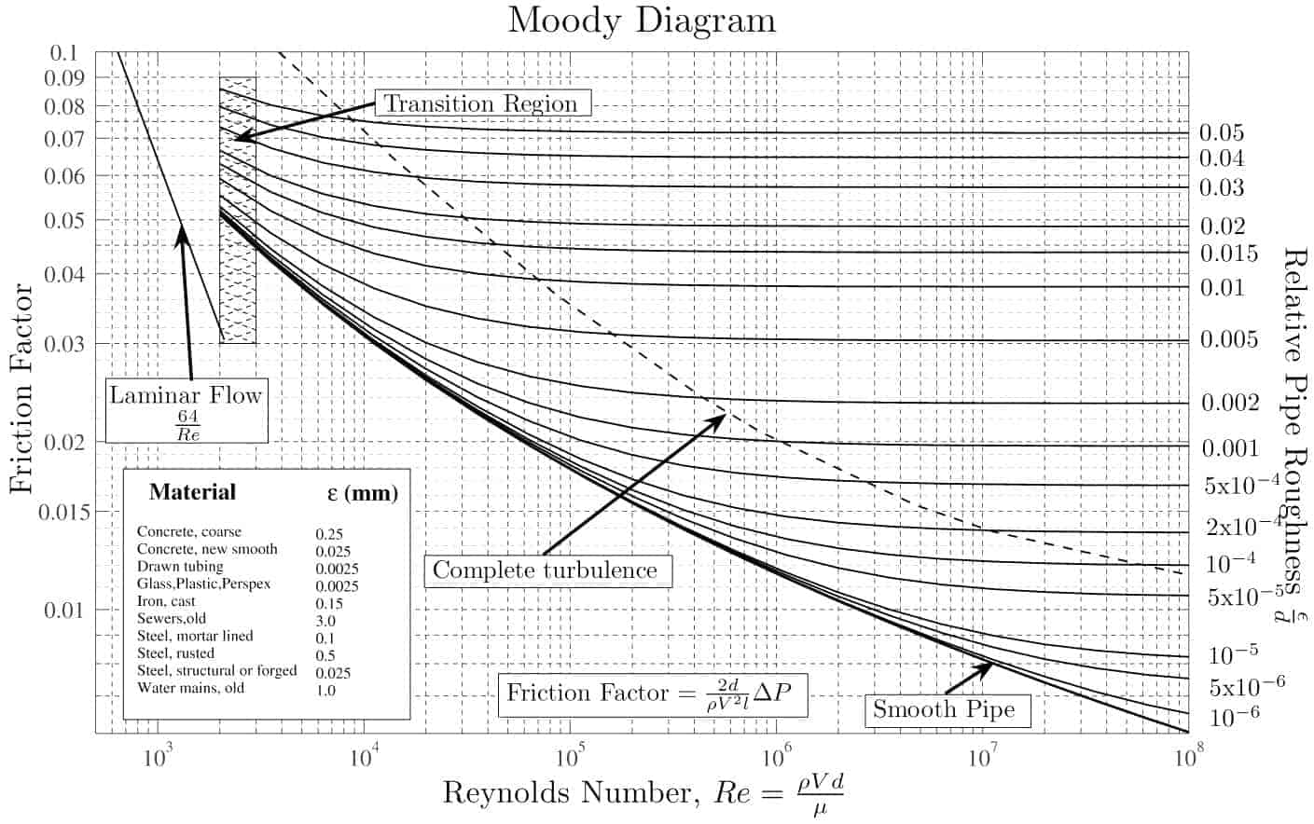
Figure 4: Moody Chart (Thermal Engineering, 2022)

Estimating penstock pipe thickness
The penstock pipe wall thickness must be enough to withstand the maximum water pressure that can occur. In addition to normal pressure, it must be strong enough to withstand the surge pressure as well. Surge pressure occurs when the flow of water in the penstock pipe is suddenly blocked (Harvey, 1993).
Surge pressure head can be calculated as
$$H_{surge}=\frac{a×V}{g}$$ | 2-6
Where,
- a is the pressure wave velocity
- V velocity of water in pipe
- g is gravitational acceleration
The pressure wave velocity can be calculated as
$$a= \sqrt{\frac{\left(K/ρ\right)}{1+\left(\frac{K×d}{E×t}\right)}}$$ | 2-7
Where,
- K is the bulk modulus of water (N/m2)
- d is the diameter of pipe (m)
- E is the young’s modulus of pipe materials (N/m2)
- t = thickness of penstock pipe

Calculating pipe thickness in case of Pelton turbines
- Find the velocity from the chosen value of diameter as in equation 2-1.
- To find the surge head, H_{surge}, we have to assume pipe thickness first.
- The pipe thickness can be assumed as 3 mm minimum and increasing as the head increases.
- Young’s modulus € for the pipe materials has to be known
- Calculate the wave velocity “a” and then surge pressure head using the following equations:
$$a=\frac{1450}{\sqrt{1+\left(\frac{2.1×{10}^{9}×d}{E×t}\right)}}$$ | 2-8

Now, if there is more than one nozzle in the Pelton turbine, that is if the number of nozzle is n then,
$$H_{surge}=\frac{a×V}{g}×\frac{1}{n}$$ | 2-9
Now we have to find the total head which is given by the sum of gross head and surge head.
We also have to check for the critical time by the equation below
$$T_{c}=\frac{2L}{a}$$ | 2-10
Where, Tc is the critical time and L is the length of the penstock pipe in m. The valve closing time (T) should be more than or equal to the twice of the value of the critical time.
$$T≥2T_{C}$$ | 2-11

Now we have to calculate the effective thickness of the pipe (t_{effective}) to check for factor of safety
$$t_{effective}=\frac{t}{F_{welding}×F_{rolling}}-F_{corrosion}$$ | 2-12

Where,
- t is the thickness of pipe
- t_{effective} is the effective thickness of pipe
- F_{welding} is the welding factor = 1.1
- F_{rolling} is the rolling factor = 1.2
- F_{corrosion} is the corrosion factor = 1 to 2 mm
Now based on the effective thickness of the pipe we have to check for the safety factor (Harvey, 1993)
$$SF=\frac{2×σ×t_{effective}}{ρ×g×h_{total}×d}$$ | 2-13
Where
- SF is the safety factor which should be 3.5 or more
- σ is the ultimate tensile strength = 350 x 10⁶ (N/m²) for steel
- ρ is the density of water (1000 kg/m³)
- h_{total} is the total head which is the sum of gross head and surge head
Now, if the calculated value of safety factor is less than 3.5 we have to repeat the calculations with thicker value for t, till the safety factor is equal to or more than 3.5.

References
AEPC. (2014). Guidelines for detail feasibility study of Mini Hydro Projects. Alternative Energy Promotion Centre, Government of Nepal.
AEPC. (2014). Reference Micro Hydro Standard. Alternative Energy Promotion Centre, Government of Nepal.
Boyle, G. (2013). Renewable Energy Power For A Sustainable Future (Vol. Third Edition). Oxford: Oxford University Press.
Harvey, A. (1993). Micro Hydro Design Manual: A guide to small scale power schemes.
S. Hasan, S., & Sharma, D. (2009). Non-Conventional Energy Resources. Delhi: S. K. Kataria and Sons.
Shrestha, A. (2014). IOE Notes of Micro Hydro Power.
Singal, R. (2011). Non-Conventional Energy Resources (Vol. Third Edition). Delhi: S. K. Kataria and Sons.
Thermal Engineering. (2022, November 3). Retrieved from https://www.thermal-engineering.org/wp-content/uploads/2019/05/Moody-chart-min.jpg

