\

ENERGY, ENVIRONMENT AND SOCIETY

Lecture Notes

Chapter 13
Hydrogen Energy and Fuel Cell

Lecturer:
Associate Prof. Manchan Tiwari

2022, November

Learning Objectives of the Lecture:
To impart basic knowledge to undergraduate students on the topic of:
- Basics of hydrogen energy
- Hydrogen production and storage
- Basics of fuel cell
- Types of fuel cell

Hydrogen Introduction
The electrical energy is the most convenient form of energy as it can be easily transported, controlled and converted to other useful forms. However, the major shortcoming of the electrical energy is its inability to be stored in large quantities. To address this shortcoming hydrogen fuel can be phenomenal. Hydrogen fuel can be stored in large quantities but has risk of being highly inflammable and requires special handling methods for safety concerns. Hydrogen is a secondary fuel that requires primary energy sources for production. Hydrogen can be produced from any energy source such as solar or hydro power. Also organic materials such as plants and fossil fuels are also source of hydrogen (Singal, 2011).
Hydrogen can be stored in compressed form in high pressure, It can also be stored in liquid form in low temperatures. Hydrogen form hydrides with various metals which can also be used to store and recover hydrogen as required. Hydrogen has the benefit of having high energy content per unit mass. It can be used as fuel directly in gas turbine or spark ignition engines. It can be used as fuel for transportation of vehicles which also reduces the problem of pollution. Hydrogen can be used in fuel cell to produce electricity. Hence the scope and potential of hydrogen is huge and is increasing at rapid rate in the world.

Hydrogen Production and Storage
Majority of hydrogen being used in world is being used for production of Ammonia. Other major usage of hydrogen has been for purification of fuels such as diesel by removing sulfur from it and for improving low quality “heavy” crude oil.

Advantages of hydrogen

Negligible pollution
The combustion of hydrogen yields only water. However, depending on the flame temperature, traces of nitrogen oxides may also form in negligible amount. Some hydrogen production processes may result in pollution.

Controllability
At normal temperatures, the reaction of hydrogen with oxygen is very slow. Catalysts can be used to control the reaction speed over high range of temperature.

Safety
- Hydrogen is relatively safe compared to its counterpart conventional fuels such as diesel or petrol.
- Being lightest of all gases, it rises and disperses quickly, while liquid fuel forms pools that spread the fire.
- Being small molecule in size, the hydrogen gas can escape easily through cracks hence reducing the risk of being accumulated through leakage in explosive concentrations.
- Due to its low density, a given volume of hydrogen contains small amount of energy compared to natural gas or petroleum, hence possess reduced risks for storage.
- The self-ignition temperature of hydrogen is greater than gasoline, which reduces the risk of accidental fire.
- Hydrogen air mixtures with less than 4.1% fuel will not catch fire, while the flammability limit for gasoline is 1%
- A pure hydrogen flame radiates little energy, allowing firemen to approach much more closely the site of a fire.
- Hydrogen is totally nontoxic.

Production of Hydrogen
Hydrogen production can fall into one of several categories, among which one can list:
- Production of hydrogen in massive amounts at stationary plants as, for instance, in the production of ammonia.
- Production of hydrogen in small amounts by compact on-board plants for use in fuel cell vehicles.
- Production of hydrogen in modest amounts for the food industry and other small consumers.
- Production of hydrogen for use in compact residential or local electricity (and hot water) generation.
At present, approximately 96% of all hydrogen used is produced by chemical means, through the reformation of diverse hydrocarbons, and only 4% is produced by electrolysis of water. In 2019, the largest electrolyzer plant had a capacity of 10 MW, and a 20 MW electrolyzer plant, capable of producing around 3000 tons of hydrogen annually, was under commissioning in Canada by the end of 2020.

Chemical Production of Hydrogen

Metal-Water Hydrogen Production
Small amounts of hydrogen are produced even now by making aluminium chips react with caustic soda (NaOH). This is sometimes the source of the gas used in meteorological balloons.
2Al + 2NaOH + 2H₂O = Na₂Al₂O4 + 3H₂
Aluminium is also used directly for production of hydrogen by decomposition of water
The basic reaction is
2Al + 3H₂O = 3H₂ + Al₂O₃

Large Scale Hydrogen Production
The bulk of the hydrogen produced in the world is made from fossil fuels. Oil, naphtha, and natural gas are still the main materials used. Owing to their growing scarcity, some effort is being made to use the more abundant coal, although the high sulfur content of many coals leads to serious ecological concerns.
Hydrocarbons and alcohols, among other substances, can yield hydrogen when noncatalytically submitted to partial oxidation, steam reforming, or thermal decomposition. These processes lead to a mixture of CO and H2 called syngas.

Partial Oxidation
Partial oxidation is accomplished by reacting a fuel with a restricted amount of oxygen. This process is preferred when raw material is a heavier fraction of petroleum. For lighter ones, steam reforming is used.
CnHm + n/2 O2 = nCO + m/2 H2

Steam Reforming
In steam reforming, the fuel reacts with water that adds its hydrogen to that from the fuel and does not introduce any nitrogen into the reformate. This contrasts with the partial oxidation process. Steam reforming of a generalized hydrocarbon proceeds according to
CnHm + n H20 = nCO + (m+2n)/2 H2
This reaction is also called the carbon-steam reaction.

Thermal Decomposition
Compounds containing hydrogen can be thermally broken down in a process known as thermal decomposition. This process to extract hydrogen is illustrated in the following example.
The thermal decomposition of alcohols can be exemplified by the methanol reactions indicated below:
CH3OH→CO+ 2H2

Hydrogen Purification
Hydrogen derived from electrolysis comes close to being acceptably pure when leaving the electrolyzer. On the other hand, when hydrogen is derived from fossil fuels, it is accompanied by many impurities, including CO2, CO and Nitrogen which must be removed prior to processing. The purification can be done by:
- Desulfurization
- CO2 Removal

Electrolysis
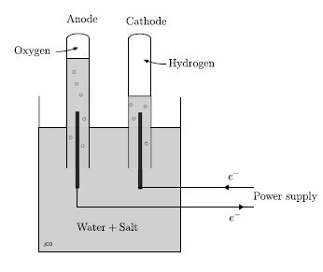
Production of hydrogen by electrolysis is a relatively old art that has found industrial application in the food industry and in other activities which need only a moderate amount of the gas. Hydrogen produced by electrolysis has the advantage of being easily purified, whereas that produced from fossil fuels tends to contain several hard to remove contaminants. For certain applications, an electrolyzer–fuel cell combination constitutes an excellent way to store energy.
One important coming application of electrolyzers is in hydrogen gas stations for refueling of fuel cell vehicles. During the electrolysis of pure water, it is necessary to add a substance that increases the conductivity. It can be salt, an acid or a base. A dilute salt solution is placed in a container in which inverted tubes are placed over two electrodes. These tubes will help collect the hydrogen gas produced.
Figure 1: Electrolysis of Water (Singal, 2011)

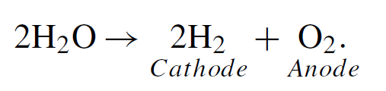

Thermolysis (Direct disassociation)
As water vapour at high temperature dissociates into hydrogen and oxygen, theoretically, using special devices the water could be broken down to produce hydrogen using thermal energy. However, its implementation is difficult.

Photolysis
The technology for using solar light energy to produce hydrogen is well established. One certainly can produce this gas through entirely nonpolluting processes by using photovoltaic converters whose output drives electrolyzers. The main effort here is to develop processes that can accomplish this transformation more economically.

Hydrogen Storage
Hydrogen storage can be done either in following forms

Compressed Gas
Small quantities of hydrogen, as used in chemical laboratories, can be conveniently stored in simple steel pressure cylinders, usually at 150 atm. For fuel cell vehicles (FCVs), compressed hydrogen may be a practical way to carry the necessary fuel. It is certainly the simplest storage system, and it requires no special equipment to retrieve the gas. What is needed are containers with a good Performance Factor.

Cryogenic Hydrogen
Storage of hydrogen by its conversion to liquid form. The density of liquid hydrogen is 71 kg/m3. Hydrogen to be liquefied must be of high purity. Most other gases will freeze during the process and will tend to clog the pipes. If oxygen ice is formed, explosions may result.

Storage of Hydrogen by Adsorption
Adsorption is the process by which a solid holds molecules of a gas or liquid or solute as a thin film. Hydrogen can readily be adsorbed on carbon. The gases are held in place by weak force so that the energy necessary to retrieve the fuel is small

Storage if hydrogen in chemical compounds
The main difficulty encountered in the storage of hydrogen is, as pointed out, the low density of the gas. It is possible to substantially increase the packing density by associating hydrogen with other substances.
The storage and retrieval processes consist then of the synthesis of a hydrogen-rich compound, followed, when the gas is needed, by its dissociation. The chemical compounds can be hydrogen carriers, metal hydrides, formic acid etc.

Hydrogen carriers
One way to store and transport hydrogen is to synthesize a hydrogen rich substance and then, as needed, generate hydrogen by a chemical reforming process.

Scope of Hydrogen fuel
The hydrogen is the fuel for future due to its various advantages such as availability, negligible pollution or harm to environment, good storage properties and ease of conversion to other forms. However, there are areas of research which should be done for hydrogen technology
- Production of hydrogen photoelectrolysis using solar energy.
- Production of hydrogen by blue green algea and by certain bacteria species
- Storage of hydrogen through metal and nonmetal hydrides
- Liquid hydrogen production, storage and utilisation

Fuel Cell
A fuel cell is an electrochemical device that combines hydrogen fuel with oxygen to produce electricity, heat and water. The fuel cell is similar to a battery in that an electrochemical reaction takes place as long as fuel is available. The hydrogen fuel is stored in a pressurized container and oxygen is taken from the air. Because of the absence of a burning process, there are no harmful emissions, and the only byproduct is pure water.
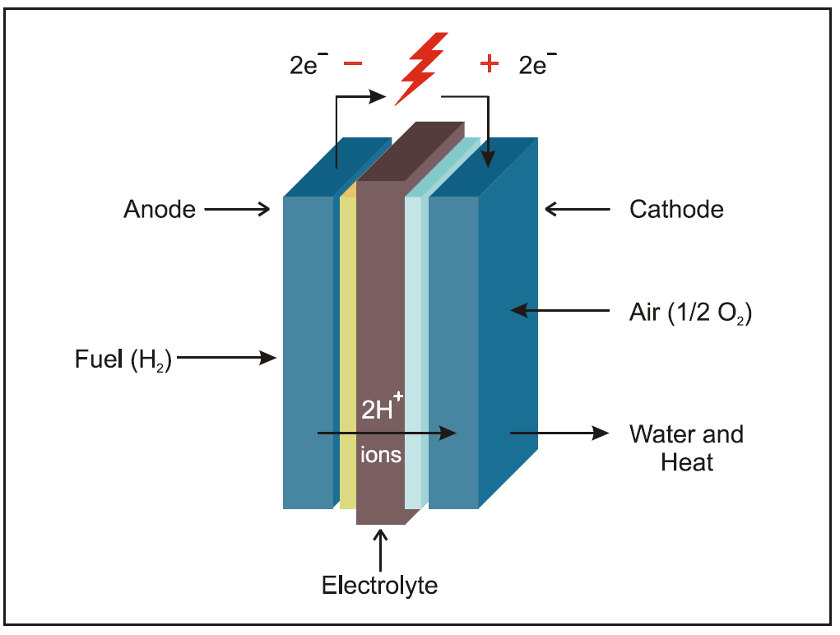
Figure 2: Fuel Cell Operation (Energy Education, 2022)

Working
Fundamentally, a fuel cell is electrolysis in reverse, using two electrodes separated by an electrolyte. The anode (negative electrode) receives the hydrogen and the cathode (positive electrode) collects the oxygen. A catalyst at the anode separates hydrogen into positively charged hydrogen ions and electrons; the oxygen is ionized and migrates across the electrolyte to the anodic compartment, where it combines with hydrogen. A single fuel cell produces 0.6–0.8V under load. To obtain higher voltages, several cells are connected in series
Oxygen enters the fuel cell at the cathode and, in some cell types, it there combines with electrons returning from the electrical circuit and hydrogen ions that have traveled through the electrolyte from the anode. In other cell types the oxygen picks up electrons and then travels through the electrolyte to the anode, where it combines with hydrogen ions.
The electrolyte plays a key role. It must permit only the appropriate ions to pass between the anode and cathode. If free electrons or other substances could travel through the electrolyte, they would disrupt the chemical reaction.

Advantages of Fuel Cell
- Fuel cell operates without pollution when run on pure hydrogen, only by products being pure water and heat.
- Fuel cell systems operate at higher thermodynamic efficiency than heat engines.
- Fuel cell have higher part load efficiency
- Fuel Cell does not need conventional fuels such as oil or gas therefore reducing dependence on fossil fuels.
- Fuel cell demonstrate good load following characteristics that is it reacts instantly to changes in load.
- When used as electrical energy generating device, fuel cell requires fewer energy transformation than those associate with a heat engine
- Fuel cell systems do not require recharging

Disadvantages of Fuel Cell
- Hydrogen is difficult to manufacture and store. Current manufacturing processes are expensive and energy intensive.
- Fuel cell require relatively pure fuel, free of specific contaminants.
- Fuel cells suitable for automotive applications typically require the use of platinum catalyst to promote the power generation reaction. Platinum is a rare and expensive metal.
- Fuel cells must not freeze with water inside.
- Fuel cells that use proton exchange membranes must not dry out during use and must remain moist during storage.
- Fuel cell require complex support and control systems.
- Fuel cell when combined with weight of the fuel are excessively heavy

Types of Fuel Cell

Polymer membrane electrolyte (PEM) fuel cells
Proton exchange membrane (PEM) (or solid polymer) fuel cells use an electrolyte that conducts hydrogen ions (H⁺) from the anode to the cathode. Also referred to as proton exchange membrane fuel cells, polymer electrolyte membrane fuel cells employ porous carbon electrodes containing a platinum catalyst and a solid polymer as the electrolyte.
Polymer electrolyte membrane fuel cells provide high power density and the advantages of low weight and volume compared to other types of fuel cells.
In order for the polymer electrolyte membrane fuel cells to operate, hydrogen, water and oxygen from air are required. Polymer electrolyte membrane fuel cells are typically fueled with pure hydrogen supplied from onboard reformers or storage tanks. PEM fuel cells operate at relatively low temperatures, around 80°C (176°F). Low temperature operation allows them to start quickly (less warm-up time) and results in less wear on system components, resulting in better durability. However, it requires that a noble-metal catalyst (typically platinum) be used to separate the hydrogen's electrons and protons, adding to system cost.

Solid Oxide Fuel Cells
Solid oxide fuel cells (SOFCs) use an electrolyte that conducts oxide ions from the cathode to anode. This is the opposite of most types of fuel cells, which conduct hydrogen ions from the anode to the cathode. The electrolyte used are hard, non-porous ceramic compound.
SOFCs are around 60% efficient at converting fuel to electricity. In applications designed to capture and utilize the system's waste heat (co-generation), overall fuel use efficiencies could top 85%. SOFCs operate at very high temperatures—as high as 1,000°C (1,830°F). Hence, it generates high grade waste heat which can be used for co-generation. High-temperature operation removes the need for precious-metal catalyst, thereby reducing cost. It also allows SOFCs to reform fuels internally, which enables the use of a variety of fuels and reduces the cost associated with adding a reformer to the system. SOFCs are also the most sulfur-resistant fuel cell type; they can tolerate several orders of magnitude more sulfur than other cell types can.

Integrated Gasifier Fuel Cells (IFC)
Lower-temperature fuel cell types such as the proton exchange membrane fuel cell, phosphoric acid fuel cell, and alkaline fuel cell require pure hydrogen as fuel, typically produced from external reforming of natural gas. However, fuels cells operating at high temperature such as the solid oxide fuel cell (SOFC) are not poisoned by carbon monoxide and carbon dioxide, and can use hydrogen with the impurities of carbon monoxide, carbon dioxide, steam, and methane mixtures as fuel.
Gasification process uses coal and biomass as fuel which results in production of syngas which contains mostly hydrogen. Hence, in fuel cell where the impurity of hydrogen does not matter, the syngas can be cleaned and fed directly to the SOFCs, without the added cost and complexity of methane reforming, water gas shifting and hydrogen separation operations which would otherwise be needed to isolate pure hydrogen as fuel.
A power cycle based on gasification of solid fuel and SOFCs is called an Integrated Gasification Fuel Cell (IGFC) cycle

References
Boyle, G. (2013). Renewable Energy Power For A Sustainable Future (Vol. Third Edition). Oxford: Oxford University Press.
Energy Education. (2022). Retrieved November 14, 2022, from https://energyeducation.ca/encyclopedia/Fuel_cell
S. Hasan, S., & Sharma, D. (2009). Non-Conventional Energy Resources. Delhi: S. K. Kataria and Sons.
Singal, R. (2011). Non-Conventional Energy Resources (Vol. Third Edition). Delhi: S. K. Kataria and Sons.

