CORPORATE FINANCE
Week 2: TIME VALUE OF MONEY
Lecturer: Dr. Charity Njoka (PhD)

Lecture Learning Outcomes
At the end of this lesson you will be able to,
- Calculate Present value of lumpsum amounts
- Calculate Present value of annuities
- Calculate the present and future values of annuities
- Determine the amount of savings required to maintain current spending

1.1 Present Value Concept
This concept acknowledges the fact that a dollar losses value with time and as such if it is to be compared with a dollar to be received in Nth year, then the two must be at the same values. This means that an investor’s analytical power is increased by his/her ability to compare cash inflows and outflows separated from each other by time. He/she should be able to work in the reverse direction i.e. from future cash flows to their present values.
Illustration: Money is normally invested to earn interest. If you are offered the choice between $100,000 now and $100,000 at the end of the year, you would naturally take the money now to get a year’s interest. Financial managers make the same point when they say that money in hand today has a time value or when they quote perhaps the most basic financial principle:
One dollar today is worth more than a dollar tomorrow

1.1.1 Present Value of a Lumpsum/Single Amount
A lump-sum payment is an amount paid all at once, as opposed to an amount that is paid in instalments. Usually an investor would wish to know in today’s terms ie current value/ present value of his future receipts.

The process of determining the present value of a payment or a stream of payments that are to be received in future is known as discounting. Hence discounting is the process of determining the present value of a payment or a stream of payments that is to be received in the future. Given the time value of money, a dollar is worth more today than it would be worth tomorrow. In this situation the investor would have to decide at what rate of discount also known as time preference rate, he/she will use to discount the anticipated lumpsum.

Present Value (PV) of a lumpsum is given by $PV=\frac{L}{{(1+r)}^{t}}$
. Where:
PV = Present value
L = Lumpsum
r = Cost of finance or time preference rate
t = given year.

Illustration 1

What is the present value of $1, given the time preference rate of 10%, to be received at the end of year 1;
$PV= \frac{1}{(1+10\%)}$
$PV$ = $\frac{1}{{(1+0.1)}^{1}}$ = 0.909

Also, the present value of a dollar to be received at a given point in time can in addition to using the above formula, be found using the present value tables.
See Table 1 attached at the end of this lecture.

Present value = future value after t periods/(1 + r)t. In this context the interest rate r is known as the discount rate and the present value is often called the discounted value of the future payment. To calculate present value, we discount the future value at the interest r.

PV Table of Lump sum Extract

No. of Years | Interest Rate per Year
No. of Years | 5% | 6% | 7% | 8% | 9% | 10%
1 | 0.952 | 0.943 | 0.935 | 0.926 | 0.917 | 0.909
2 | 0.907 | 0.890 | 0.873 | 0.857 | 0.842 | 0.826
3 | 0.864 | 0.840 | 0.816 | 0.794 | 0.772 | 0.751
4 | 0.823 | 0.792 | 0.763 | 0.735 | 0.708 | 0.683
5 | 0.784 | 0.747 | 0.713 | 0.681 | 0.650 | 0.621
10 | 0.614 | 0.558 | 0.508 | 0.463 | 0.422 | 0.386

Illustration 2
Compute the present value of a $100 cash flow for the following combinations
of discount rates and times:
a) . r = 8 percent. t = 5 years
b) . r = 7 percent. t = 10 years
c) . r = 5 percent. t = 4 years

Solutions
- 100* 0.681= 68.1
- 100* 0.508=50.8
- 100*0.823 = 82.3

1.1.2 Present Value of Annuities
Future value is the value of an asset at a specific date in future. It measures the nominal future sum of money that a given sum of money is ‘worth’ at a specified time in future assuming a certain interest rate/ rate of return. Actually the future value does not include corrections for inflation or other factors that affect the true value of money in future.
An annuity is an equally spaced level stream of cash flows. For example, a 4-year car loan might require 48 equal monthly payments of say $ 1000 per month. Any such sequence of equally spaced, level cash flows is called an annuity.

There are two types of annuities;
- Those that occur at the end of the period and start in the first period (a week, month, year). For example; salaries, dividends etc NB. These are known as Ordinary Annuity
In this course we shall focus on this annuity

- Those that occur at the end of the period but DO NOT start in the first period (a week, month, year). These are known as Delayed Annuity
In this course we shall focus on this annuity

- Those that occur at the beginning of the period (a week, month, year etc). For example, Rent Payments. These are known as Annuity Due

- There is a special annuity known as Perpetuity. This is a stream of level cash payments that never ends. It is an annuity that never ends, in other words lasts forever.

An annuity is a cash flow stream in which the cash flows are regular and happen at regular intervals. To be considered an annuity, the following conditions must be met:
  - The periodic payment must be equal in amount
  - The time period between payments should be constant
  - The interest rate per year remains constant
  - The interest is compounded at the end of each time period

Illustration 2
Mary won a Jackpot in a casino that was to be paid in 10 annual installments of $465,000 each. The interest rate at the time was about 8 percent.

What is the present value of the jackpot?
The present value of these payments is simply the sum of the present values of each payment. But rather than valuing each payment separately, it is much easier to treat the cash payments as a 10-year annuity. We can use the formula to value this annuity and we simply multiply $465,000 by the 10-year annuity factor
We can use the Formula or the PVA table extract. See Table 2 at the end of these lecture notes

Present Value of Annuity Extract
No. of Years | Interest Rate per Year
No. of Years | 5% | 6% | 7% | 8% | 9% | 10%
1 | 0.952 | 0.943 | 0.935 | 0.926 | 0.917 | 0.909
2 | 1.859 | 1.833 | 1.808 | 1.783 | 1.759 | 1.736
3 | 2.723 | 2.673 | 2.624 | 2.577 | 2.531 | 2.487
4 | 3.546 | 3.465 | 3.387 | 3.312 | 3.240 | 3.170
5 | 4.329 | 4.212 | 4.100 | 3.993 | 3.890 | 3.791
10 | 7.722 | 7.360 | 7.024 | 6.710 | 6.418 | 6.145

Summary
How to Value Annuities Cash Flows
Year: 1 2 3 4 5 6 ... Present Value
1. Perpetuity A $1 $1 $1 $1 $1 $1 . . . 1/ r
2. Perpetuity B $1 $1 $1 . . . 1/r(1 + r)³
3. Three-year annuity $1 $1 $1 1/r- 1/ r(1 + r)³

  - Future Value Concept

The future value (FV) is the amount to which an investment will grow after earning interest.
Knowing the future value enables investors to make sound investment decisions based on their anticipated needs. However, external economic factors, such as inflation, can adversely affect the future value of the asset/investment by eroding its value.

Future Value of Lump sum

The future value (FV) is the amount to which an investment will grow after earning interest.

Illustration 1

Suppose you have $100 invested in a bank account and that the banks are currently paying an interest rate of 6 percent per year on deposits. What is your interest after one year?

Solution
Interest = interest rate * initial investment; = 0.06 * $100 = $6, hence the value of your investment will grow to $106 by the end of the year i.e. $100 *$6 = $106

What if you leave this money in the bank for a second year?
Your balance, now $106, will continue to earn interest of 6 percent. So interest in Year 2 = 0.06 *$106 = $6.36. You start the second year with $106 on which you earn interest of $6.36. So by the end of the year the value of your account will grow to $106 + $6.36 = $112.36. In the first year your investment of $100 increases by a factor of 1.06 to $106; in the Second year the $106 again increases by a factor of 1.06 to $112.36. Thus the initial $100 investment grows twice by a factor 1.06: Value of account after 2 years = $100 *1.06 *1.06 = $100 * (0.06)² = $112.36

What if you keep your money invested for a third year?
If you keep your money invested for a third year, your investment multiplies by 1.06 each year for 3 years. By the end of the third year it will total $100 *(1.06)³ = $119.10, If your investment horizon is t years, the original $100 investment will grow to $100 *(1.06)^{t}. For an interest rate of r and a horizon of t years, the future value of your investment will be
Future value of $100 = $100 _ (1 + r)^{t}

Notice in our example that your interest income in the first year is $6 (6 percent of $100), and in the second year it is $6.36 (6 percent of $106). Your income in the second year is higher because you now earn interest on both the original $100 investment and the $6 of interest earned in the previous year. Earning interest on interest is called compounding or compound interest. In contrast, if the bank calculated the interest only on your original investment, you would be paid simple interest.

Future Value of Single Amount Extract

No. of Years | Interest Rate per Year
No. of Years | 5% | 6% | 7% | 8% | 9% | 10%
1 | 1.0500 | 1.0600 | 1.0700 | 1.0800 | 1.0900 | 1.1000
2 | 1.1025 | 1.1236 | 1.1449 | 1.1664 | 1.1881 | 1.2100
3 | 1.1576 | 1.1910 | 1.2250 | 1.2597 | 1.2950 | 1.3310
4 | 1.2155 | 1.2625 | 1.3108 | 1.3605 | 1.4116 | 1.4641
5 | 1.2763 | 1.3382 | 1.3382 | 1.4026 | 1.5386 | 1.6105
10 | 1.6289 | 1.7908 | 1.7908 | 1.9672 | 2.3674 | 2.5937

    - Future Value of Annuity
Annuity is a cash flow stream in which the cash flows are regular and happen at regular intervals. To be considered an annuity, the following conditions must be met:
  - The periodic payment must be equal in amount
  - The time period between payments should be constant
  - The interest rate per year remains constant
  - The interest is compounded at the end of each time period

Illustration 1
You want to buy a car in four years’ time. So you are setting aside $3,000 (in a bank account) at the end of every year in order to buy your dream car. If your savings earn interest of 8 percent a year, how much money will be in your bank account at the end of the four years, assuming that you are not making any withdrawals from the bank?

Your first year’s savings will earn interest for 3 years, the second will earn interest for 2 years, the third will earn interest for 1 year, and the final savings in Year 4 will earn no interest.
The sum of the future values of the four payments is
($3,000 *1.08) ³+ ($3,000 *1.08)² + ($3,000 *1.08)¹ + $3,000 = $13,518

NB: We have used Future value of single amount formula/ Table
This can be calculated using the following formula,
Future value of the annuity can be calculated using the following formula,

Future value of annuity of $1 a year= (1 + r)^{t} – 1
r

The term (1 + r)^{t} – 1
r is known as the compounding factor

Hence the future value of an annuity of $ 3000 for 4 years can be calculated as follows,
$ 3000* (1 + r)^{t – 1}
r

= $ 3000* (1 + 8%)^{3 – 1}
8%
Compounding factors have been calculated for a single unit of currency, e.g $, are shown in Table 4 appearing at the end of this week’s lecture notes.

FV Table of Annuity Extract

No. of Years | Interest Rate per Year
No. of Years | 5% | 6% | 7% | 8% | 9% | 10%
1 | 1.000 | 1.000 | 1.000 | 1.000 | 1.000 | 1.000
2 | 2.050 | 2.060 | 2.070 | 2.080 | 2.090 | 2.100
3 | 3.153 | 3.184 | 3.215 | 3.246 | 3.278 | 3.310
4 | 4.310 | 4.375 | 4.440 | 4.506 | 4.573 | 4.641
5 | 5.526 | 5.637 | 5.751 | 5.867 | 5.985 | 6.105
10 | 12.578 | 13.181 | 13.816 | 14.487 | 15.193 | 15.937

You can see that in the row corresponding to t = 4 and the column corresponding to r = 8%, the future value of an annuity of $1 a year is $4.506. Therefore, the future value of the $3,000 annuity is, $3,000 *4.506 = $13,518.

Illustration 2
For example, consider an investment which promises to pay $100 one year from now, another $100 two years from now, another $100 three years from now and another $100 four years from now. How much will be the future value of the cash streams at the end of year four, given that the interest rate is 10%?

Solution
Formula for future value of ordinary annuity,
$$FVA=A× \left\{\frac{{(1+r)}^{t}-1}{r}\right\}$$

Where,
A - Annuity
FVA – Future value of an annuity
r – Rate of return
t – Number of time periods
$\frac{{(1+r)}^{t}-1}{r}$ – This is the future value interest factor of an annuity (FVIFA)
Solution
Substitute the appropriate numbers
= 100 $× \left\{\frac{{(1+10\%)}^{1}-1}{10\%}\right\}$ +100 $×$ $\left\{\frac{{(1+10\%)}^{2}-1}{10\%}\right\}$ +100 $× \left\{\frac{{(1+10\%)}^{3}-1}{10\%}\right\}$+ 100 $× \left\{\frac{{(1+10\%)}^{4}-1}{10\%}\right\}$
= $ 610.51

We can also use the Future value annuity Table and the answer will be
$ 100 * 6.1051 = $ 610.51

4.1. Present Value and Future Value Compared

- Present value factors are reciprocals of future value factors
- Interest rates and future value are positively related
- Interest rates and present value are negatively related
- Time period and future value are positively related
- Time period and present value are negatively related

PRESENT VALUE AND FUTURE VALUE TABLES
Table 1: Present Value of a Lump sum
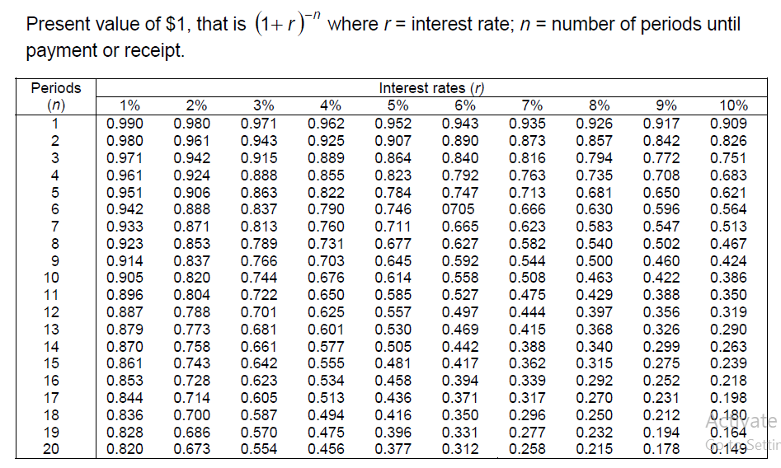
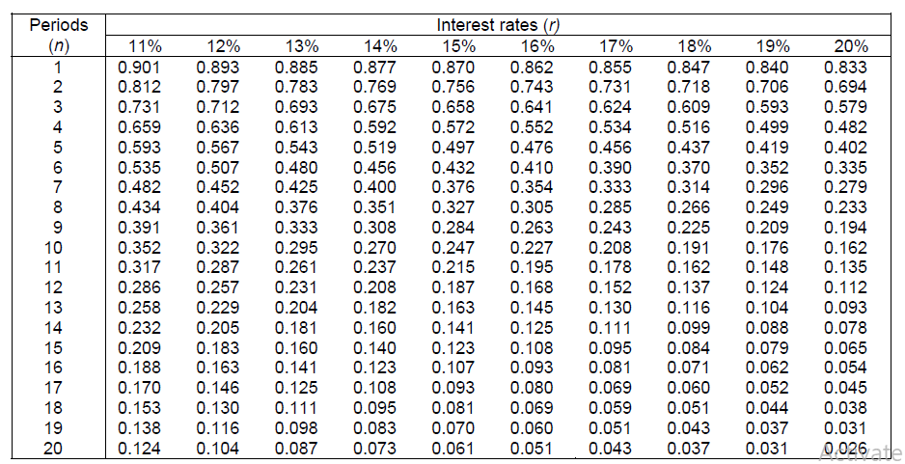
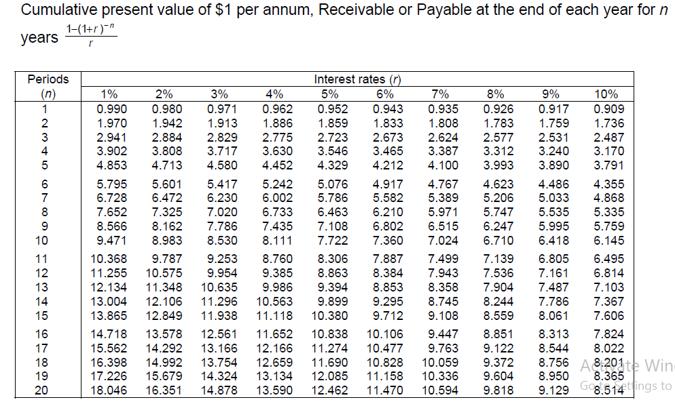
Table 2: Present Value of an Annuity
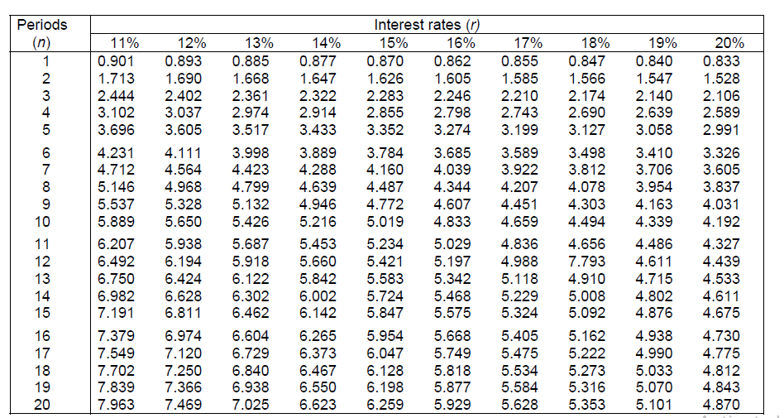

Table 3: Future Value of a Lump sum

$$Formula,FV=PV×{(1+r)}^{n}$$
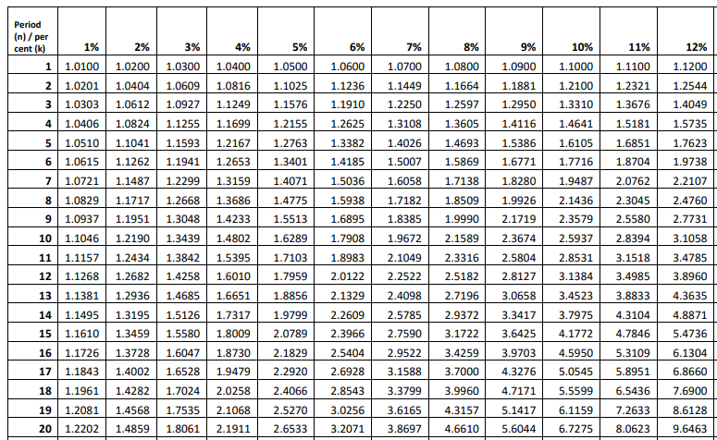

Table 4: Future Value of an Annuity
$$FormulaFVA=A× \left\{\frac{{(1+r)}^{n}-1}{r}\right\}$$

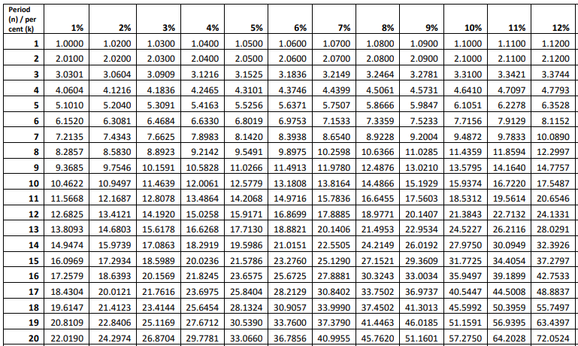

REFERENCES
- CFA level II ,Corporate Finance, Portfolio Management and Equity Module

- Lectures on Corporate Finance, Bassaersts, P, Bernt O, World Scientific publishing Co.pte td, 2006

- Principles of Corporate Finance, Brealey, Myers & Allen, the McGraw-Hill Companies, Inc., 2007.

