CORPORATE FINANCE

WEEK 7: Asset Valuation: Capital Asset Pricing Model-CAPM

Instructor: Dr. Charity Njoka (PhD)

At the end of this lesson you should be able to:
1. Explain the concept of Beta
2. Understand the concept of Capital Market Line (CML)
3. Derive and evaluate asset value using Security Market Line (SML)
4. Understand the concept and state the assumptions of Capital Asset Pricing Model (CAPM)
5. Calculate the required rate of return using CAPM
6. Explain the weaknesses of Capital Asset Pricing Model (CAPM)

  - Introduction
The crux of the current chapter can be summarized as follows: An individual who holds one security should use expected return as the measure of the security’s return. Standard deviation
or variance is the proper measure of the security’s risk. An individual who holds a diversified portfolio cares about the contribution of each security to the expected return and the risk of the portfolio. It turns out that a security’s expected return is the appropriate measure of the security’s contribution to the expected return on the portfolio. However, neither the security’s variance nor the security’s standard deviation is an appropriate measure of a security’s contribution to the risk of a portfolio. The contribution of a security to the risk of a portfolio is best measured by beta.

In our last lesson we looked at portfolio return and risk where we outlined that the risk of a portfolio is influenced by individual risk of assets in the portfolio, the weight of each asset in the portfolio and the relationship of each asset return. In reality, investors hold portfolios that are a mixture of risky and riskless assets, thus the need to determine return of such a portfolio.

2.1 Introduction of a Risk-Free Asset
Adding a risk-free asset to the investment opportunities present on the efficient frontier effectively adds the opportunity to both borrow and lend. Treasury bills (T-bill) is a common risk-free security proxy. Buying a T-bill is loaning money to the government that has issued them. Selling a T-bill signifies effectively borrowing money. Adding risk-free assets integrates investment and financing decisions.

With risk-free asset:
1. Expected return is entirely certain.
2. Standard deviation of return is zero.
3. Covariance with any risky asset or portfolio is always zero, as is the correlation.

3.1 Beta of a Security
The major factor that allowed portfolio theory to develop into capital market theory is the concept of a risk-free asset. Following the development of the Markowitz portfolio model, several authors considered the implications of assuming the existence of a risk-free asset, that is, an asset with zero variance. Such an asset would have zero correlation with all other risky assets and would provide the risk-free rate of return (RFR). It would lie on the vertical axis of a portfolio graph. This assumption allows us to derive a generalized theory of capital asset pricing under conditions of uncertainty from the Markowitz portfolio theory. This theory combined with an optimal portfolio, allows us to measure the risk of individual securities using beta. Beta measures the systematic/undiversifiable risk.

Thus Beta of a security is given by,

ß_{i} = Cov_{(im)}
δ²_{m}
Where,

ß_{i} = Beta of Security i

Cov_{(im)} = Covariance of Asset I and market return

δ²m = Variance of the Market Return

NB: ${Cov}_{im}=\sum_{i}^{N}{\left(R_{ii}-{∈R}_{i}\right)}\left(R_{mi}-{∈R}_{m}\right)$

    - Beta of a portfolio
Beta of a portfolio is not the average of individual securities Betas. It is the weighted average of betas of the individual assets in the portfolio.
Thus B_{p}= W_{a} B_{a} + W_{b}B_{b}

Where, B_{p}= Beta of the portfolio

W_{a}= Weight of Asset A
B_{a} = Beta of the Asset A
W_{b} =Weight of Asset B
B_{b} = Beta of Asset B

Illustration
A company has two investments A and B. 75 % of its investment are in A which has a beta of 1.2 However the balance, 25% of the investments are held in B which is deemed to be 50% riskier in systematic risk terms
Required: Calculate the firm’s portfolio Beta

Solution
B_{p}= W_{a} B_{a} + W_{b}B_{b}
Beta of Asset A= 1.2
Beta of Asset B= 1.2+ 50% * 1.2= 1.8
Bp= 0.75(1.2) + 0.25 (1.8) = 1.35

4.1 Capital Market Line (CML)

The capital market line (CML) represents portfolios that optimally combine risk and return. The CML is a line that is used to show the rates of return, which depends on risk-free rates of return and levels of risk for a specific portfolio. It is a theoretical concept that represents all the portfolios that optimally combine the risk-free rate of return and the market portfolio of risky assets. Under the capital asset pricing model (CAPM), all investors will choose a position on the capital market line, in equilibrium, by borrowing or lending at the risk-free rate, since this maximizes return for a given level of risk.

Formula and Calculation of the Capital Market Line (CML)
Calculating the capital market line is done as follows:
$$R_{p}=r_{f}+(\frac{R_{m}-r_{f}}{σ_{m}})σ_{p}$$
Where:
$R_{p}$= portfolio return
$r_{f}$ = risk free rate
$R_{m}$= market return
$σ_{m}$= standard deviation of market returns
$σ_{p}$= standard deviation of portfolio returns

Graphically Capital Market Line (CML) appears as follows;

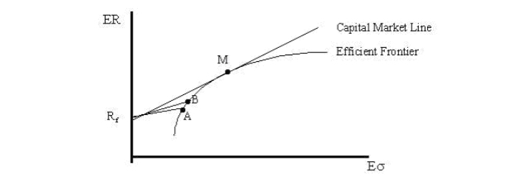

4.1.1 Interpreting Capital Market Line

Introducing risk-free assets creates a set of expected return-risk possibilities that did not exist previously. The new risk-return trade-off is a straight line tangent to the efficient frontier at the market portfolio (point M) with a vertical intercept at the risk-free rate of return, Rf. This line is called the Capital Market Line (CML).
1. The capital allocation line (CAL) is the graph of all possible combinations of the risk-free asset and the risky asset for one investor.
2. The capital market line is the line formed when the risky asset is a market portfolio rather than a single risky asset or portfolio. The market portfolio is a mutual fund or all stocks traded in an exchange (this is sometimes based on a market index,)

The market portfolio of risky securities, M, is the highest point of tangency between the line emanating from Rf and the efficient frontier and is the singular optimal risky portfolio. In equilibrium, all risky assets must be in portfolio M because all investors are assumed to arrive at, and hold, the same risky portfolio.

All assets are included in portfolio M in proportion to their market value. For example, if the market for Google stock was 2 percent of the market value of all risky assets, Google would constitute 2 percent of the market value of portfolio M. Therefore, 2 percent of the market value of each investor's portfolio of risky assets would be Google. Think of portfolio M as a broad market index such as the S&P 500 Index. The market portfolio is, of course, a risky portfolio; its risk is designated σM.
In theory, the market portfolio (M) should include all risky assets worldwide, both financial and real, in their proper proportions. Because the market portfolio includes all risky assets, portfolio M is by definition completely diversified. The market portfolio is the optimal portfolio of risky assets for investors to own, and therefore will form part of the CML. A portfolio that is completely diversified has a correlation with the market of 1.0.

The introduction of the risk-free asset significantly changes the Markowitz efficient set of portfolios. Investors are better off because they have improved investment opportunities.
This new line leads all investors to invest in the same risky portfolio, the market portfolio. That is, all investors make the same investment decision. They can, however, attain their desired risk preferences by adjusting the weight of the market portfolio in their portfolios.
- A strongly risk-averse investor will lend some funds at the risk-free rate and invest the remainder in the market portfolio.
- A less risk-averse investor will borrow some funds at the risk-free rate and invest all the funds in the market portfolio.
Let’s look at the following diagram,

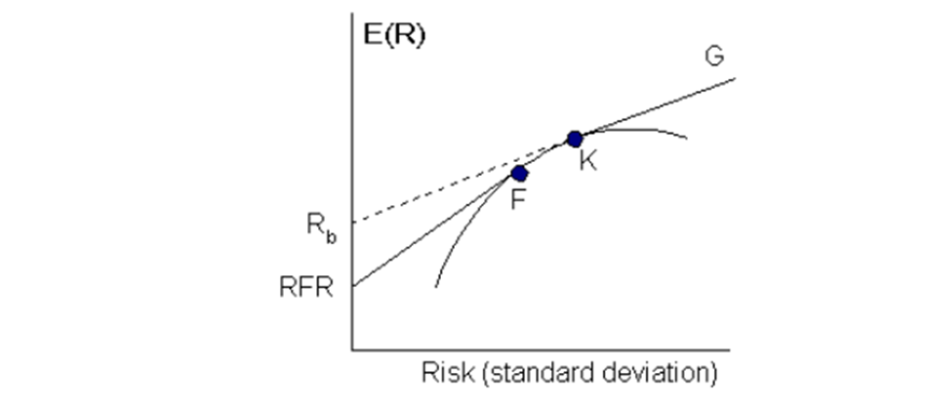

- The segment RFR-F indicates the investment opportunities available when an investor combines risk-free assets (lending at RFR) and portfolio F on the Markowitz efficient frontier. It is NOT possible to extend this line any further if it is assumed that you cannot borrow at this risk-free rate to acquire further units of Portfolio F.
- If you can borrow at Rb, you can use the proceeds to invest in portfolio K to extend the CML along the line segment K-G.
- Therefore, the CML is made up of RFR-F-K-G. This implies that you can either lend or borrow, but the borrowing portfolio is not as profitable as when it was assumed that you could borrow at RFR. Your net return is less, as the slope of the borrowing line (K-G) is below that for RFR-F.

As an investor moves up the CML, the overall portfolio risk and returns increase. Risk-averse investors will select portfolios close to the risk-free asset, preferring low variance to higher returns. Less risk-averse investors will prefer portfolios higher up on the CML, with a higher expected return, but more variance. By borrowing funds at a risk-free rate, they can also invest more than 100% of their investable funds in the risky market portfolio, increasing both the expected return and the risk beyond that offered by the market portfolio.

Illustration one
Suppose the current risk-free rate is 5%, and the expected market return is 18%. The standard deviation of the market portfolio is 10%. Portfolios A and B have standard deviations of 5% and 15% respectively.
Required: Calculate the expected return of each of the assets using the Capital Market Line Formula,
Solution
Calculation of Expected Return of Portfolio A
5% +5%* (18%-5%)/10%
ER(A) = 11.5%
Calculation of Expected Return of Portfolio B
5% +15% (18%-5%)/10%
ER(B) = 24.5%
Portfolios that fall on the capital market line (CML), in theory, optimize the risk/return relationship, thereby maximizing performance. The capital allocation line (CAL) makes up the allotment of risk-free assets and risky portfolios for an investor. CML differs from the more popular efficient frontier in that it includes risk-free investments. The intercept point of CML and efficient frontier would result in the most efficient portfolio, called the tangency portfolio. Mean-variance analysis was pioneered by Harry Markowitz and James Tobin. The efficient frontier of optimal portfolios was identified by Markowitz in 1952, and James Tobin included the risk-free rate to modern portfolio theory in 1958.1 William Sharpe then developed the CAPM in the 1960s, and won a Nobel prize for his work in 1990, along with Markowitz and Merton Miller.

5.1 Capital Asset Pricing Model (CAPM)

There is a concern in Financial Economics on how estimating assets’ returns. There are two main alternatives available for this purpose; the first one is a single factor model (or Capital Asset Pricing Model [CAPM]) by Sharpe (1964) and Lintner (1965) and the second in Arbitrage pricing Theory. CAPM is an economic model that explains stock returns as a function of market return. Markowitz (1952, 1959) states the “mean-variance-model”, which tries to minimize the variance according to a given expected return or maximize the expected return according to a given variance. The Capital Asset Pricing Model (CAPM) actually specifies the relationship between risk and required rate of return on assets when they are held in well-diversified portfolios.

5.1.1 Basic assumptions of CAPM
These assumptions behind the model were developed by Sharpe (1964) and Lintner (1965).

1. Investors are rational and they choose among alternative portfolios on the basis of each portfolio's expected return and standard deviation.
2. Investors are risk averse.
3. Investors maximise the utility of end of period wealth. Thus CAPM is a single period model.
4. Investors have homogeneous expectations with regard to asset return. Thus all investors will perceive the same efficient set.
5. There exist a risk-free asset and all investors can borrow and lend at this rate.
6. All assets are marketable and perfectly divisible.
7. The capital market is efficient and perfect- There no transaction costs (taxes, frictions, and so on).

5.1.2 CAPM Formula
Return of an asset using CAPM is given as follows:
R_{i} = R_{F} + [E(R_{M} - R_{F})]ß

Where R_{i} is required return of security i
R_{F} is the risk free rate of return
E(R_{M}) is the expected market rate of return
ß is Beta.

Note ß_{i} = Cov_{(im)}
δ²_{m}

Where Cov_{(im)} is the covariance between asset i and the market return.
δ²_{m} is the variance of the market return.

Illustration Two

Assume that the risk free rate of return is 8%, the market expected rate of return is 12%. The standard deviation of the market return is 2% while the covariance of return for security A and the market is 2%.

Required: What is the required rate of return on Security A?

Solution
R_{i} = R_{F} + (E(R_{M}) - R_{F})ß
ß = Cov_{(AM)} = 2 = 2 = 0.5
δ_{M}² 2² 4

R_{i} = 8% + (12 - 8)0.5 = 10%

The required rate of return on security A is therefore 10%.
5.1.3 Limitations of CAPM

CAPM has several weaknesses e.g.

a. It is based on some unrealistic assumptions such as:

i. Existence of Risk-free assets
ii. All assets being perfectly divisible and marketable (human capital is not divisible)
iii. Existence of homogeneous expectations about the expected returns
iv. Asset returns are normally distributed.

b. CAPM is a single period model—it looks at the end of the year return.
c. CAPM cannot be empirically tested because we cannot test investors’ expectations.
d. CAPM assumes that a security's required rate of return is based on only one factor (the stock market—beta). However, other factors such as relative sensitivity to inflation and dividend payout, may influence a security's return relative to those of other securities.

The CAPM is the line that connects the risk-free rate of return with the tangency point on the efficient frontier of optimal portfolios that offer the highest expected return for a defined level of risk, or the lowest risk for a given level of expected return.

The portfolios with the best trade-off between expected returns and variance
(risk) lie on this line. The tangency point is the optimal portfolio of risky
assets, known as the market portfolio. Under the assumptions of mean-
variance analysis—that investors seek to maximize their expected return for
a given amount of variance risk, and that there is a risk-free rate of return—
all investors will select portfolios that lie on the CML
The portfolios with the best trade-off between expected returns and variance (risk) lie on this line. The tangency point is the optimal portfolio of risky assets, known as the market portfolio. Under the assumptions of mean-variance analysis—that investors seek to maximize their expected return for a given amount of variance risk, and that there is a risk-free rate of return—all investors will select portfolios that lie on CML. According to Tobin's separation theorem, finding the market portfolio and the best combination of that market portfolio and the risk-free asset are separate problems. Individual investors will either hold just the risk-free asset or some combination of the risk-free asset and the market portfolio, depending on their risk-aversion on the CML

6.1 Security Market Line ( SML)
The relevant risk measure for an individual risky asset is its covariance with the market portfolio (Cov_{i,m}). This is the risk measure for the SML, which describes
the relationship between risk and expected return for all portfolios, whether well-diversified or not, as well as for all securities. The return for the market portfolio should be consistent with its own risk, which is the covariance of the market with itself - or its variance. In equilibrium, all assets and all portfolios of assets should plot on the SML. Any security with an estimated return that plots above the SML is underpriced whereas any security with an estimated return that plots below the SML is overpriced. A superior investor must derive value estimates for assets that are consistently superior to the consensus market evaluation to earn better risk-adjusted rates of return than the average investor.

If we graph ß_{i} and E(R_{i}) then we can observe the following relationship,

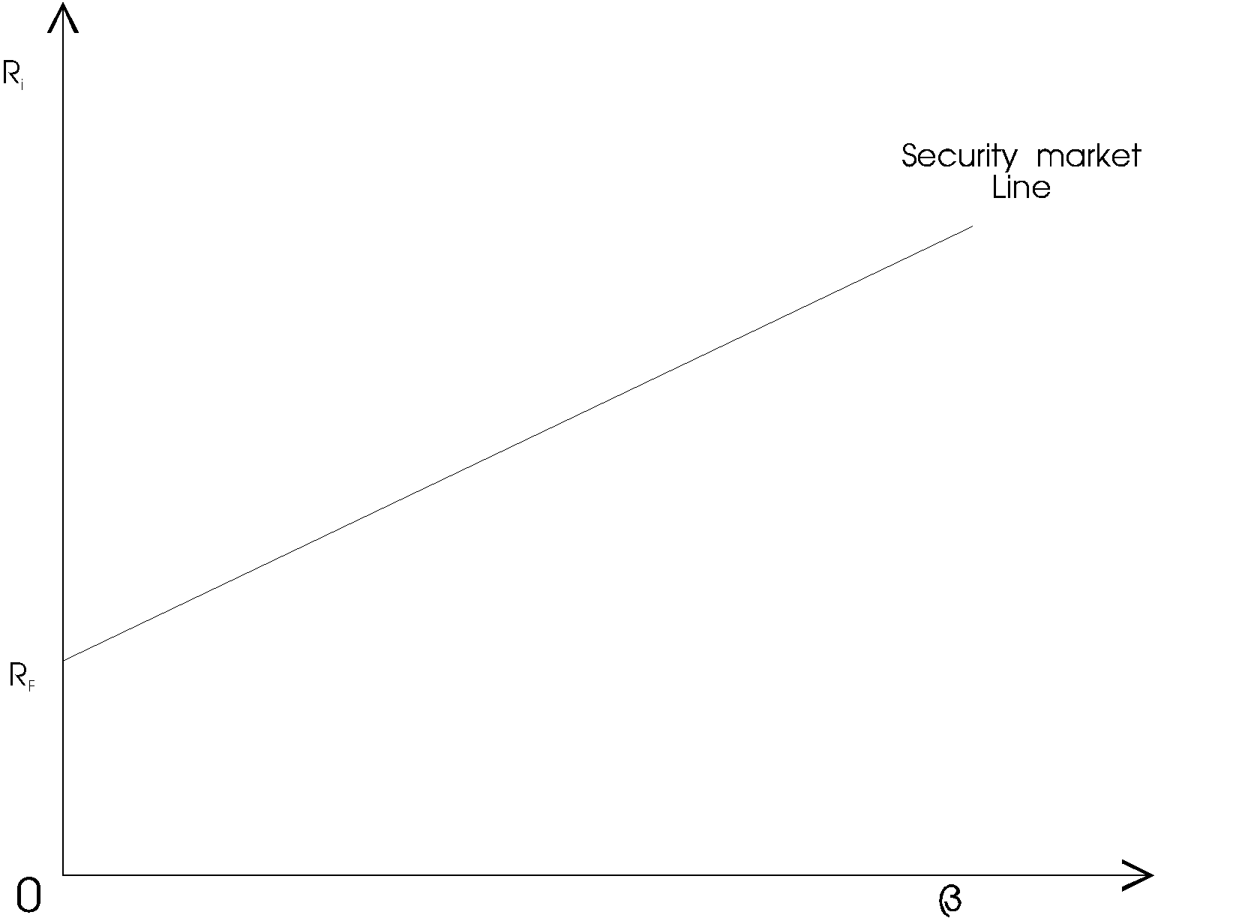

All correctly priced assets will lie on the security market line. Any security off this line will either be overpriced or underpriced ie any security plotted above the SML is interpreted as undervalued. And any security below the line is overvalued.

The security market line therefore shows the pricing of all asset if the market is at equilibrium. It is a measure of the required rate of return if the investor were to undertake a certain amount of risk.

Portfolios that fall on the capital market line (CML), in theory, optimize the
risk/return relationship, thereby maximizing performance. The capital
allocation line (CAL) makes up the allotment of risk-free assets and risky
portfolios for an investo

6.1.1 Capital Market Line vs. Security Market Line Compared

The CML is sometimes confused with the security market line (SML).
The SML is derived from the CML. While the CML shows the rates of return for a specific portfolio, the SML represents the market’s risk and return at a given time, and shows the expected returns of individual assets. And while the measure of risk in the CML is the standard deviation of returns (total risk), the risk measure in the SML is systematic risk or beta.
Securities that are fairly priced will plot on the CML and the SML. Securities that plot above the CML or the SML are generating returns that are too high for the given risk and are underpriced. Securities that plot below CML or the SML are generating returns that are too low for the given risk and are overpriced.

6.1.2 Are CML and Security Market Line (SML) the Same?

The CML is sometimes confused with the security market line (SML). The SML is derived from the CML. While the CML shows the rates of return for a specific portfolio, the SML represents the market’s risk and return at a given time, and shows the expected returns of individual assets. And while the measure of risk in the CML is the standard deviation of returns (total risk), the risk measure in the SML is systematic risk or beta.
6.1.3 Drawbacks of CML
• Presence of friction − CML considers that there is always some friction in the market irrespective of the volume and size.
• Taxes and transaction costs − Taxes and transaction costs are needed to be paid by the investors and these costs can vary from person to person and also in different geographies.
• The difference in investors worldwide − In the practical world, all investors do not have access to all the information required to make a good investment decision

7.1 Summary:
1. The CML is a line that is used to show the rates of return, which depends on risk-free rates of return and levels of risk for a specific portfolio. SML, which is also called a Characteristic Line, is a graphical representation of the market’s risk and return at a given time.
2. While standard deviation is the measure of risk in CML, Beta coefficient determines the risk factors of the SML.
3. While the Capital Market Line graphs define efficient portfolios, the Security Market Line graphs define both efficient and non-efficient portfolios
4. The Capital Market Line is considered to be superior when measuring the risk factors.
5. Where the market portfolio and risk-free assets are determined by the Capital Market Line, all security factors are determined by the SML.

REFERENCES
Analysis of Investments & Management of Portfolios Management of Portfolios 10th Edition

Financial Management: Theory and Practice, Brigham & Ehrhardt, 10th Edition, Cengage Learning, 2002.

Modern Portfolio Theory and Investment Analysis Elton, Gruber, Brown, and Goetzmann, 6th Edition (Wiley):

Principles of Corporate Finance, Brealey, Myers & Allen, 9th Edition The McGraw-Hill Companies, Inc., 2007.

