Python programming language
Week 4. Python operators

Alisher Ismailov
Lecturer
Department of Information technology
Andijan Branch of Tashkent Financial Institute
Email: alisherismailov534@gmail.com

Python dasturlash tili
4-Mavzu. Python operatorlari

Ma’ruzachi: Alisher Ismoilov
Axborot texnologiyalari kafedrasi
Toshkent moliya instituti Andijon filiali
Elektron pochta: alisherismailov534@gmail.com

4-Mavzu. Python operatorlari
Reja:

- Python arifmetik operatorlari
- Belgilash (tayinlash) operatorlari
- Taqqoslash operatorlari
- Mantiqiy operatorlar
- A’zolik operatorlari

Python arifmetik operatorlari
Arifmetik operatorlar umumiy matematik amallarni bajarish uchun raqamli qiymatlar bilan ishlatiladi: Quyida asosiy python dasturlash tili arifmetik amallari keltirilgan:
Operator Nomi Misol
+ Qo‘shuv x + y
- Ayirma x - y
* Ko‘paytiruv x * y
/ Bo‘luv x / y
% Modul x % y
** Koʻrsatkichga koʻtarish x ** y

+ (qo‘shuv) operatoriga misol
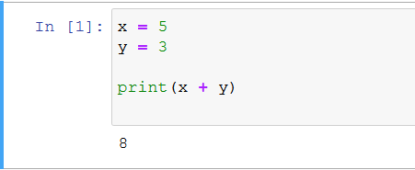

‘-’ (ayirma) operatoriga misol
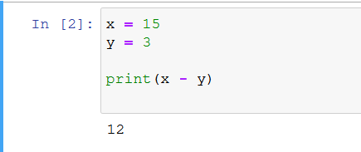

‘*‘ (ko‘paytiruv) operatoriga misol
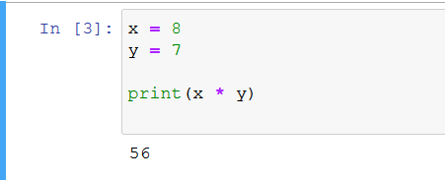

‘/’ (bo‘luv) operatoriga misol
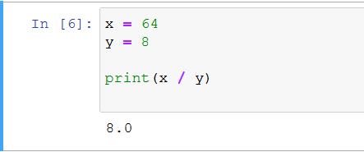

‘%’ (modul) operatoriga misol
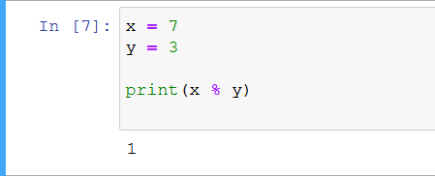

‘**’ (ko‘rsatkichga ko‘tarish) operatori misol
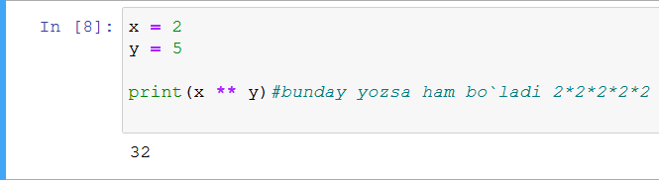

Belgilash (tayinlash) operatorlari
O‘zgaruvchilarga qiymatlarni belgilash uchun tayinlash operatorlari ishlatiladi:
Operator misol bir xil (bu usulda yozilsa ham bir xil natija beradi)
= x = 5 x = 5
+= x += 3 x = x + 3
-= x -= 3 x = x - 3
*= x *= 3 x = x * 3
/= x /= 3 x = x / 3
%= x %= 3 x = x % 3
//= x //= 3 x = x // 3
**= x **= 3 x = x ** 3
&= x &= 3 x = x & 3
|= x |= 3 x = x | 3
^= x ^= 3 x = x ^ 3
>>= x >>= 3 x = x >> 3
<<= x <<= 3 x = x << 3
‘=’ operatoriga misol
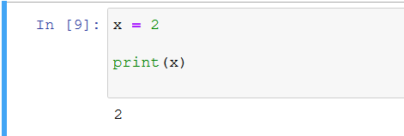

‘+=’ operatoriga misol
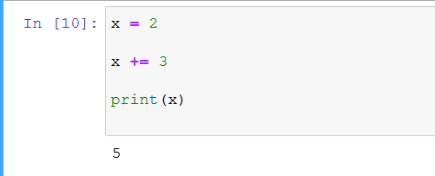

‘-=’ operatoriga misol
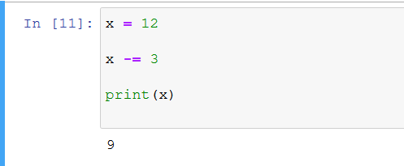

‘*=’ operatoriga misol
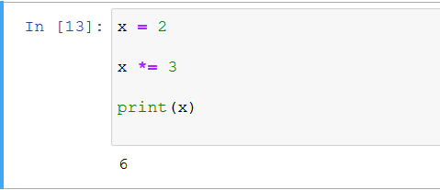

‘/=’ operatoriga misol
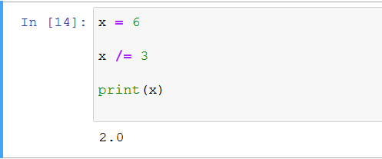

‘%=’ operatoriga misol
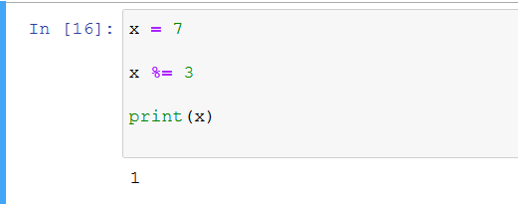

‘//=’ operatoriga misol
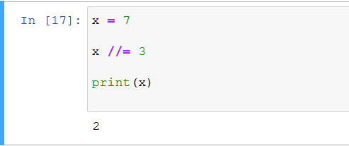

‘**=’ operatoriga misol
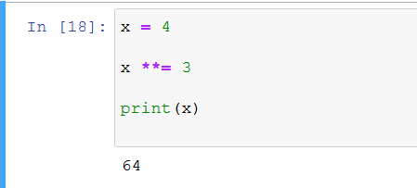

‘&=’ operatoriga misol
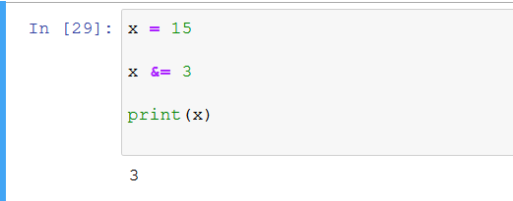

‘|=’ operatoriga misol
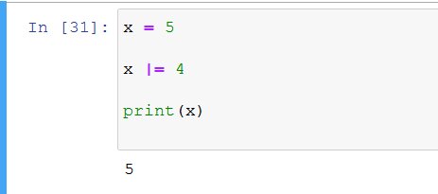

‘^=’ operatoriga misol
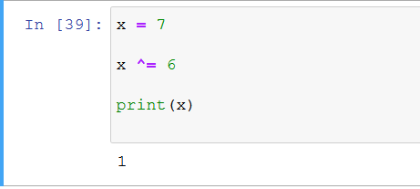

‘>>=’ operatoriga misol
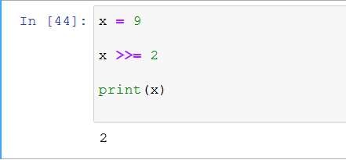

‘<<=’ operatoriga misol
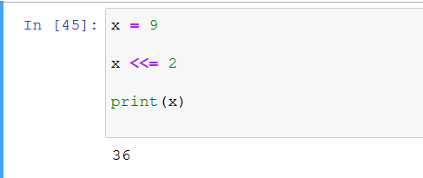

Taqqoslash operatorlari
Taqqoslash operatorlari ikkita qiymatni solishtirish uchun ishlatiladi:
Operator Nomi Misol
== teng x == y
!= teng emas x != y
> katta x > y
< kichik x < y
>= katta yoki teng x >= y
<= kichik yoki teng x <= y
‘==’ (teng) operatoriga misol
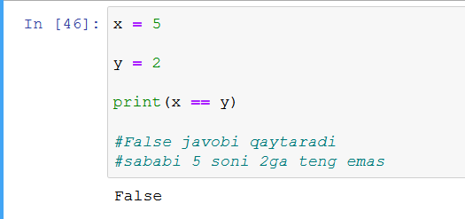

‘!=’ (teng emas) operatori misol
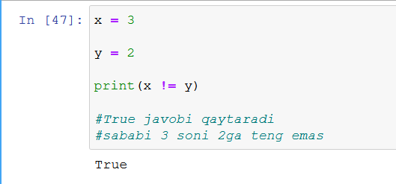

‘>’ (katta) operatoriga misol
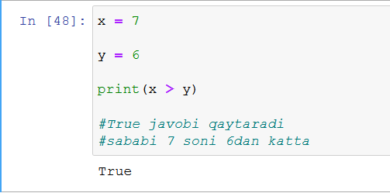

‘<’ (kichik) operatoriga misol
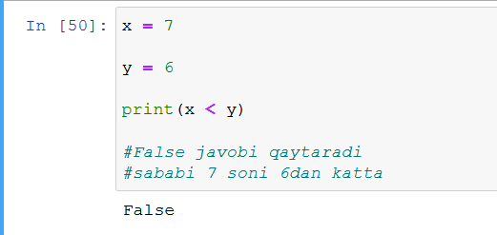

‘>=’ (katta yoki teng) operatoriga misol
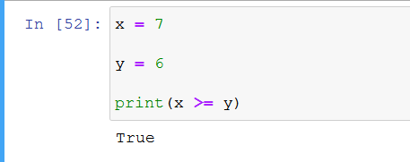

‘<=’ (kichik yoki teng) operatoriga misol
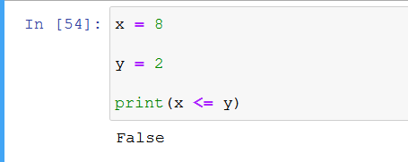

Mantiqiy operatorlar

Mantiqiy operatorlar shartli gaplarni birlashtirish uchun ishlatiladi:

Operator Ta’rifi Misol
and Ikkala holat ham to‘g‘ri bo‘lsa,True qiymatini qaytaradi x < 5 and x < 10
or Agar holatlardan biri to‘g‘ri bo‘lsa, True qiymatini qaytaradi x < 5 or x < 4
not Natijani teskari o‘zgartiring, agar natija to‘g‘ri bo‘lsa, False qiymatini qaytaradi not(x < 5 and x < 10)

‘and’ operatoriga misol
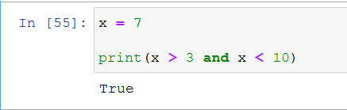

‘or’ operatoriga misol
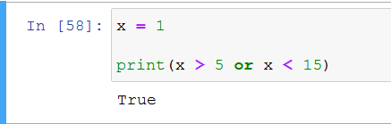

‘not’ operatoriga misol
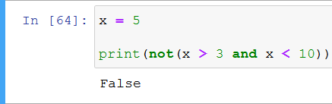

Identifikatsiya operatorlari
Identifikatsiya operatorlari o‘zgaruvchilarni solishtirish uchun ishlatiladi, taqqoslash operatidan farqi identifikatsiya operatorlari, o‘zgaruvchilarni xotira joylashuvi bilan solishtiradi:
Operator Ta’rifi Misol
is Ikkala o‘zgaruvchi ham bir xil obyekt bo‘lsa, True qiymatini qaytaradi x is y
is not Ikkala o‘zgaruvchi ham bir xil obyekt bo‘lmasa, True qiymatini qaytaradi x is not y

‘is’ operatoriga misol
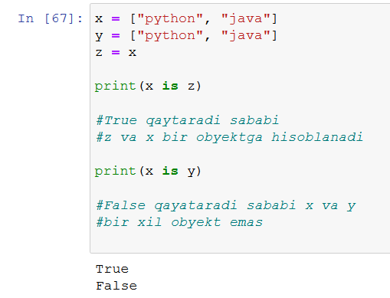

‘is not’ operatoriga misol
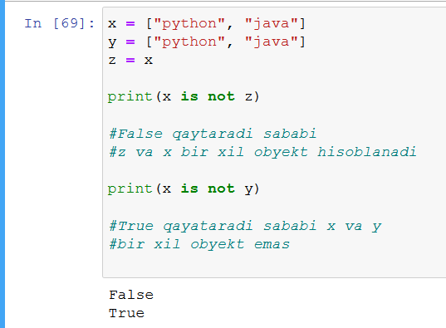

A’zolik operatorlari
O‘zgaruvchida ketma-ketlik mavjudligini tekshirish uchun a’zolik operatorlari ishlatiladi:
Operator Ta’rifi Misol
in Obyektda ko‘rsatilgan qiymatga ega ma’lumot mavjud bo‘lsa, True qiymatini qaytaradi x in y
not in Belgilangan qiymatga ega ma’lumot obyektda mavjud bo‘lmasa, True qiymatini qaytaradi x not in y

‘in’ operatoriga misol
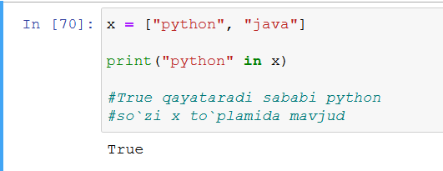

‘not in’ operatoriga misol
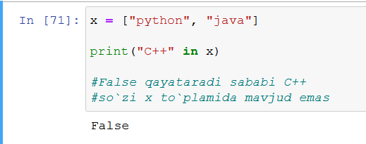

Foydalanilgan adabiyotlar
1. Mastering Object-Oriented Python: Build powerful applications with reusable code using OOP design patterns and Python 3.7, 2nd Edition, Steven F. Lott, Packt Publishing (June 14, 2019)
2. Learning Python, 5th Edition Fifth Edition, Mark Lutz, O'Reilly Media, June 12, 2013
3. Python Programming for Beginners: The Ultimate Guide for Beginners to Learn Python Programming: Crash Course on Python Programming for Beginners, AMZ Publishing, Independently published (July 13, 2021)
4. https://www.python.org/
5. https://www.w3schools.com/
6. https://www.codecademy.com/catalog/language/python
7. https://realpython.com/
8. https://www.anaconda.com/

