BUSINESS FINANCE
LECTURE 3
INTRODUCTION TO THE CONCEPT OF TIME VALUE OF MONEY
Lecturer: Dr. Charity Njoka (PhD)

At the end of this lecture, you should be able to:
- Explain meaning of time value of money and its role in finance.
- Explain the concept of future value and perform compounding calculations.
- Explain the concept of present value and perform discounting calculations.

I.0 INTRODUCTION
A dollar today is worth more than a dollar tomorrow. An individual would thus prefer to receive money now rather than that same amount later. A dollar in one’s possession today is more valuable than a dollar to be received in future because, first, the dollar in hand can be put to immediate productive use, and, secondly, a dollar in hand is free from the uncertainties of future expectations (It is a sure dollar).
Financial values and decisions can be assessed by using either future value (FV) or present value (PV) techniques. These techniques result in the same decisions, but adopt different approaches to the decision.
1.1 Future Value Techniques
The Future Value (FV), or terminal value, is the value at some time in future of a present sum of money, or a series of payments or receipts. In other words the FV refers to the amount of money an investment will grow to over some period of time at some given interest rate
1.2 Present Value Techniques
The Present Value (PV) is the current value of a future amount of money, or a series of future payments or receipts. Present value is just like cash in hand today.
NB: Although FV and PV techniques result in the same decisions, since financial managers make decisions in the present, they tend to rely primarily on PV techniques.
2.0 FUTURE VALUE CONCEPT (COMPOUNDING)
The future value (FV) is the amount to which an investment will grow after earning interest.
Knowing the future value enables investors to make sound investment decisions based on their anticipated needs. However, external economic factors, such as inflation, can adversely affect the future value of the asset/investment by eroding its value.

2.1 Future Value of Single Amount/Lumpsum

The future value (FV) is the amount to which an investment will grow after earning interest.

Illustration 1
Suppose you have $100 invested in a bank account and that the banks are currently paying an interest rate of 6 percent per year on deposits.
- What is your interest after one year? How much money will you have in the bank account at year end?
Solution
Interest = interest rate * initial investment; = 0.06 * $100 = $6, hence the value of your investment will grow to $106 by the end of the year ie $100 *$6 = $106

- What if you leave this money in the bank for a second year? How much money will you have in the bank account at second year?

Solution
Your balance, now $106, will continue to earn interest of 6 percent. So interest in Year 2 = 0.06 *$106 = $6.36. You start the second year with $106 on which you earn interest of $6.36. So by the end of the year the value of your account will grow to $106 + $6.36 = $112.36. In the first year your investment of $100 increases by a factor of 1.06 to $106; in the Second year the $106 again increases by a factor of 1.06 to $112.36. Thus the initial $100 investment grows twice by a factor 1.06: Value of account after 2 years = $100 *1.06 *1.06 = $100 * (0.06)2 = $112.36

- What if you keep your money invested for a third year? How much money will you have in the bank account at third year?
Solution
If you keep your money invested for a third year, your investment multiplies by 1.06 each year for 3 years. By the end of the third year it will total $100 *(1.06)3 = $119.10.

If your investment horizon is t years, the original $100 investment will grow to $100 *(1.06)t.
For an interest rate of r and a horizon of t years, the future value of your investment will be
Future value of $100 = $100 * (1 + r)t

Notice in our example that your interest income in the first year is $6 (6 percent of $100), and in the second year it is $6.36 (6 percent of $106). Your income in the second year is higher because you now earn interest on both the original $100 investment and the $6 of interest earned in the previous year. Earning interest on interest is called compounding or compound interest. In contrast, if the bank calculated the interest only on your original investment, you would be paid simple interest. Future values of a single amount can also be read from future value tables. See TABLE THREE (3) at the end of lecture notes.

For our illustration 1, we can read the FV in the following extract of Future Value of Single Amount Extract

No. of Years | Interest Rate per Year
No. of Years | 5% | 6% | 7% | 8% | 9% | 10%
1 | 1.0500 | 1.0600 | 1.0700 | 1.0800 | 1.0900 | 1.1000
2 | 1.1025 | 1.1236 | 1.1449 | 1.1664 | 1.1881 | 1.2100
3 | 1.1576 | 1.1910 | 1.2250 | 1.2597 | 1.2950 | 1.3310
4 | 1.2155 | 1.2625 | 1.3108 | 1.3605 | 1.4116 | 1.4641
5 | 1.2763 | 1.3382 | 1.3382 | 1.4026 | 1.5386 | 1.6105
10 | 1.6289 | 1.7908 | 1.7908 | 1.9672 | 2.3674 | 2.5937

Summary
The future value (FV), or compound value, of a present amount, Po, is found as follows.
At end of Year 1, FV₁ =P_{o} (1+r) = Po (1+r)¹
At end of Year 2, FV₂ =FV₁ (1+r) = P_{o}(1+r) (1+r) = Po ( 1+r)²
At end of Year 3, FV₃ = FV₂ (1+r) = Po ( 1+r) ( 1+r) (1+r) = Po (1+r)³
A general equation for the future value at end of n periods can therefore be formulated as,
FV_{n} = Po ( 1+r)^{n}

    - Future Value of Annuity
Annuity is a cash flow stream in which the cash flows are regular and happen at regular intervals (a pensioner receiving $100,000 per year for ten years after his retirement). To be considered an annuity, the following conditions must be met:
  - The periodic payment must be equal in amount
  - The time period between payments should be constant
  - The interest rate per year remains constant
  - The interest is compounded at the end of each time period
Types of Annuities
The two basic types of annuities are the ordinary annuity and the annuity due.
- An ordinary annuity is an annuity where the cash flow occurs at the end of each period.
- An annuity due is where cash flows occur at the beginning of each period.

Illustration 1
Paul wants to buy a car in four years’ time, so he setting aside $3,000 (in a bank account) at the end of every year in order to buy your dream car. If the savings earn interest of 8 percent a year, how much money will be in the bank account at the end of the four years, assuming that there are no withdrawals from the bank?
Solution
The first year’s savings will earn interest for 3 years, the second will earn interest for 2 years, the third will earn interest for 1 year, and the final savings in Year 4 will earn no interest.
Hence the sum of the future values of the four payments is
($3,000 *1.08) ³+ ($3,000 *1.08)² + ($3,000 *1.08)¹ + $3,000 = $13,518

Using the formula,
Future value of the annuity can be calculated using the following formula,
Future value of annuity of $1 a year = (1 + r)^{t – 1}
r
Where r= rate of return
t= the number of times money is earning interest

The term (1 + r)^{t} – 1
r is known as the compounding factor

Hence the future value of an annuity of $ 3000 for 4 years can be calculated as follows,
$ 3000* (1 + r)^{t} -1
r
= $ 3000* (1 + 8%)⁴ -1
8% = $13,518

Compounding factors have been calculated for a single unit of currency, e.g $ and are shown in TABLE FOUR (4) appearing at the end of this week’s lecture notes.

FV Table of Annuity Extract

No. of Years | Interest Rate per Year
No. of Years | 5% | 6% | 7% | 8% | 9% | 10%
1 | 1.000 | 1.000 | 1.000 | 1.000 | 1.000 | 1.000
2 | 2.050 | 2.060 | 2.070 | 2.080 | 2.090 | 2.100
3 | 3.153 | 3.184 | 3.215 | 3.246 | 3.278 | 3.310
4 | 4.310 | 4.375 | 4.440 | 4.506 | 4.573 | 4.641
5 | 5.526 | 5.637 | 5.751 | 5.867 | 5.985 | 6.105
10 | 12.578 | 13.181 | 13.816 | 14.487 | 15.193 | 15.937

Here we read the row corresponding to t = 4 and the column corresponding to r = 8%, the future value of an annuity of $1 a year is $4.506. Therefore, the future value of the $3,000 annuity is, $3,000 *4.506 = $13,518.

Illustration 2
Consider an investment which promises to pay $100 one year from now, another $100 two years from now, another $100 three years from now and another $100 four years from now. How much will be the future value of the cash streams at the end of year four, given that the interest rate is 10%?

Solution
Formula for future value of ordinary annuity,
$$FVA=A× \left\{\frac{{(1+r)}^{t}-1}{r}\right\}$$
Where,
  - A - Annuity
  - FVA – Future value of an annuity
  - r – Rate of return
  - t – Number of time periods
  - $\frac{{(1+r)}^{t}-1}{r}$ – This is the future value interest factor of an annuity (FVIFA)
Solution
- Substitute the appropriate numbers = 100 $× \left\{\frac{{(1+10\%)}^{1}-1}{10\%}\right\}$
+100 $×$ $\left\{\frac{{(1+10\%)}^{2}-1}{10\%}\right\}$ +100 $× \left\{\frac{{(1+10\%)}^{3}-1}{10\%}\right\}$+ 100 $× \left\{\frac{{(1+10\%)}^{4}-1}{10\%}\right\}$= $ 610.51

We can also use the Future value annuity TABLE FOUR (4) and the answer will be
$ 100 * 6.1051 = $ 610.51

3.0 PRESENT VALUE CONCEPT (DISCOUNTING)
The process of finding present values is referred to as discounting. It is the inverse of compounding and seeks to answer the question. “If I can earn r % on my money, what is the most I will be willing to pay now for an opportunity to receive FV shillings n periods from now?” The annual rate of return r % is referred to as the discount rate, required rate of return, cost of capital, or opportunity cost. The present value as the name suggests, is the value today of a given future amount. Financial managers make the same point when they say that money in hand today has a time value or when they quote perhaps the most basic financial principle: One dollar today is worth more than a dollar tomorrow

Recall the basic compounding formula for a lump sum/single amount;

FV_{n} = P_{o} (1+r)^{n} Therefore making P the subject

P_{o} = FV_{n}
(1+ r)^{n}

$${PV}_{k,n}=\frac{{FV}_{n}}{{(1+r)}_{n}}={FV}_{n}*\frac{1}{{(1+r)}^{n}}$$

Where: Pv = Present value
FV = Future Value
r = rate of return, cost of finance or time preference rate
t = given year.

3.1 Present Value of a Lumpsum/Single Amount
A lump-sum payment is an amount paid all at once, as opposed to an amount that is paid in instalments. Usually an investor would wish to know in today’s terms ie current value/ present value of his future receipts. The process of determining the present value of a payment or a stream of payments that are to be received in future is known as discounting. Hence discounting is the process of determining the present value of a payment or a stream of payments that is to be received in the future. Given the time value of money, a dollar is worth more today than it would be worth tomorrow. In this situation the investor would have to decide at what rate of discount also known as time preference rate, he/she will use to discount the anticipated lumpsum.

Illustration 1

What is the present value of $1, given the time preference rate of 10%, to be received at the end of year 1; $pv= \frac{1}{(1+10\%)}$

$pv$ = $\frac{1}{{(1+0.1)}^{1}}$ = 0.909

Also, the present value of a dollar to be received at a given point in time can in addition to using the above formula, be found using the present value tables.
See TABLE ONE (1) attached at the end of this lecture.

PV Table of Lumpsum Extract

No. of Years | Interest Rate per Year
No. of Years | 5% | 6% | 7% | 8% | 9% | 10%
1 | 0.952 | 0.943 | 0.935 | 0.926 | 0.917 | 0.909
2 | 0.907 | 0.890 | 0.873 | 0.857 | 0.842 | 0.826
3 | 0.864 | 0.840 | 0.816 | 0.794 | 0.772 | 0.751
4 | 0.823 | 0.792 | 0.763 | 0.735 | 0.708 | 0.683
5 | 0.784 | 0.747 | 0.713 | 0.681 | 0.650 | 0.621
10 | 0.614 | 0.558 | 0.508 | 0.463 | 0.422 | 0.386

Illustration 2

Compute the present value of a $100 cash flow for the following combinations of discount rates and times:
a) . r = 8 percent. t = 5 years
b) . r = 7 percent. t = 10 years
c) . r = 5 percent. t = 4 years

Solutions

- 100* 0.681= 68.1
- 100* 0.508=50.8
- 100*0.823 = 82.3

3.2 Present Value of Annuities
An annuity is an equally spaced level stream of cash flows. For example, a 4-year car loan might require 48 equal monthly payments of say $ 1000 per month. Any such sequence of equally spaced, level cash flows is called an annuity.

There are various types of annuities;
- Those that occur at the end of the period (a week, month, year). For example; salaries, dividends etc NB. These are known as Ordinary Annuity
In this course we shall focus on this annuity

- Those that occur at the beginning of the period (a week, month, year etc). For example, Rent Payments. These are known as Annuity Due
- Those that occur at the end of the period but DO NOT start in the first period (a week, month, year,). These are known as Delayed Annuity

- There is a special annuity known as Perpetuity. This is a stream of level cash payments that never ends. It is an annuity that never ends, in other words lasts forever.

An annuity is a cash flow stream in which the cash flows are regular and happen at regular intervals. To be considered an annuity, the following conditions must be met:
  - The periodic payment must be equal in amount
  - The time period between payments should be constant
  - The interest rate per year remains constant
  - The interest is compounded at the end of each time period

Illustration 2

Mary won a Jackpot in a casino that was to be paid in 10 annual installments of $465,000 each. The interest rate at the time was about 8 percent.
What is the present value of the jackpot?

The present value of these payments is simply the sum of the present values of each payment. But rather than valuing each payment separately, it is much easier to treat the cash payments as a 10-year annuity. We can use the formula to value this annuity and we simply multiply $465,000 by the 10-year annuity factor.

We can use the Formula
PVIFA= $\frac{1-\frac{1}{{(1+r)}^{t}}}{r}$
Where,
PVIFA= Future Value interest factor of Annuity
r= rate of return/ interest
t= number of times
465000*
or the PVA table extract . See TABLE TWO (2) at the end of these lecture notes

Present Value of Annuity Extract

No. of Years | Interest Rate per Year
No. of Years | 5% | 6% | 7% | 8% | 9% | 10%
1 | 0.952 | 0.943 | 0.935 | 0.926 | 0.917 | 0.909
2 | 1.859 | 1.833 | 1.808 | 1.783 | 1.759 | 1.736
3 | 2.723 | 2.673 | 2.624 | 2.577 | 2.531 | 2.487
4 | 3.546 | 3.465 | 3.387 | 3.312 | 3.240 | 3.170
5 | 4.329 | 4.212 | 4.100 | 3.993 | 3.890 | 3.791
10 | 7.722 | 7.360 | 7.024 | 6.710 | 6.418 | 6.145

Using the PVIFA table,
The PVIFA at 8% for 10 periods (PVIFA_{8%,10} periods ) from

465,000* 6.710= $ 3,120,150

SUMMARY
.
- Money has time value.
- A dollar today is more valuable than a dollar a year hence.
- We use rate of interest to express the time value of money.
- Simple Interest may be defined as Interest that is calculated as a simple percentage of the original principal amount.
- Compound interest is calculated on total of previously earned interest and the Original Principal.

- Present value factors are reciprocals of future value factors
- Interest rates and future value are positively related
- Interest rates and present value are negatively related
- Time period and future value are positively related
- Time period and present value are negatively related

TABLE ONE (1)- Present Value of Single Amount/Lumpsum

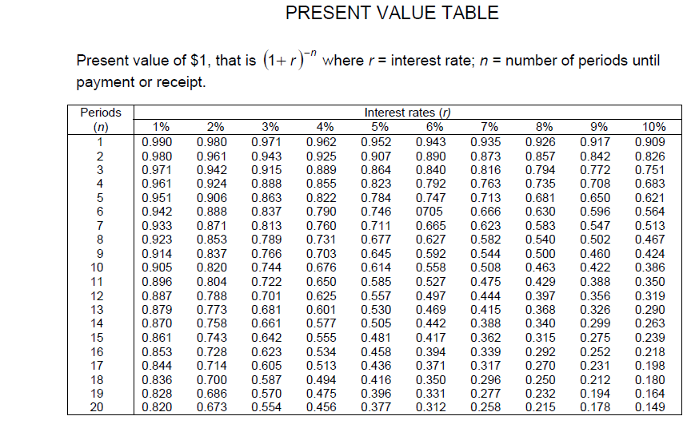

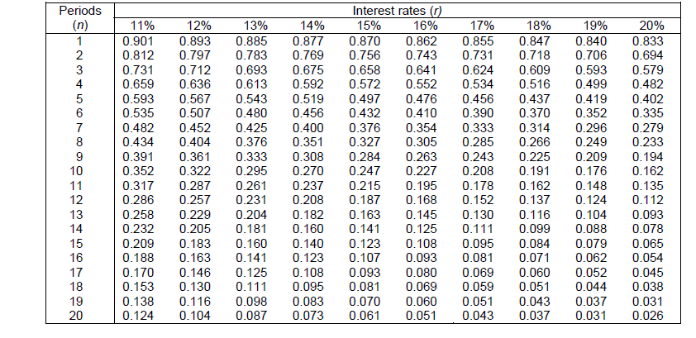

TABLE TWO (2) – Present Value of Annuity

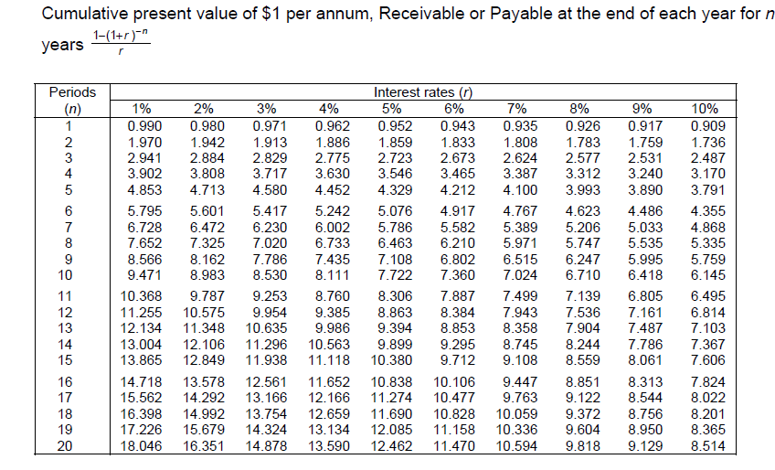
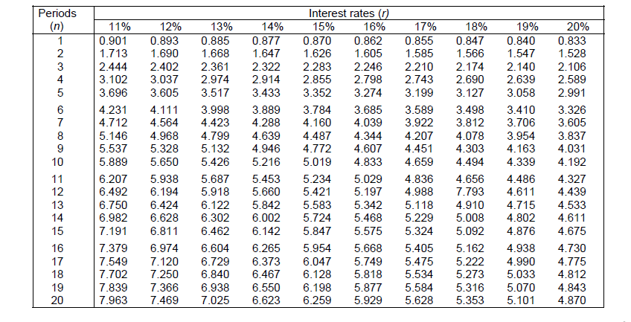

TABLE THREE (3)- Future Value/Compounded of Single Amount/ Lumpsum

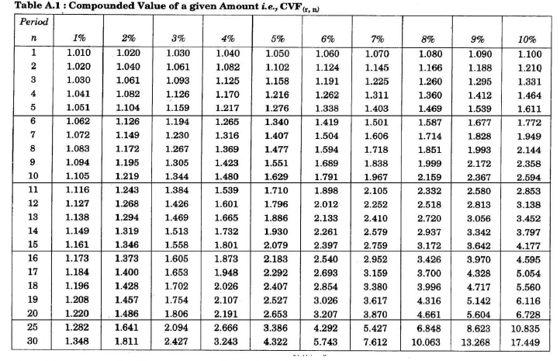
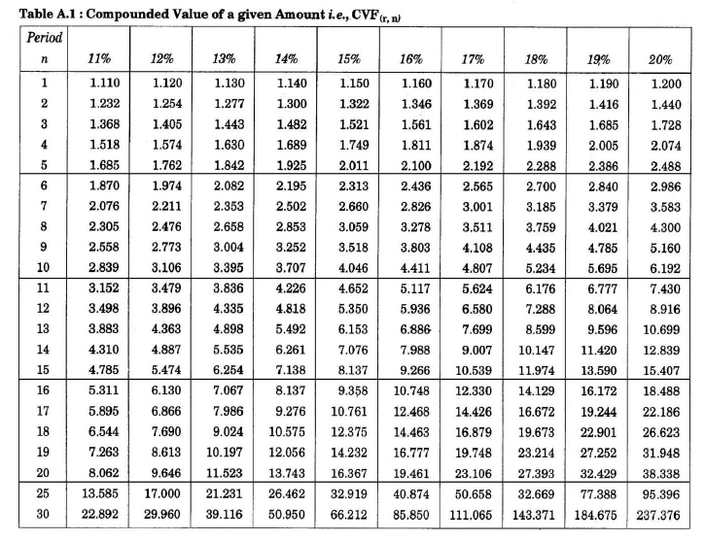

TABLE FOUR (4)- Future Value/Compounded of an Annuity

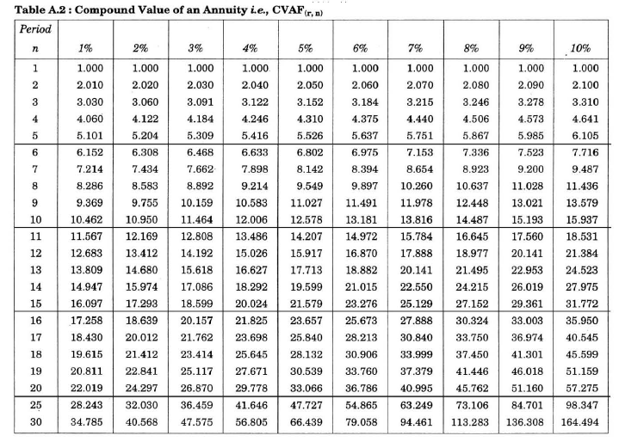
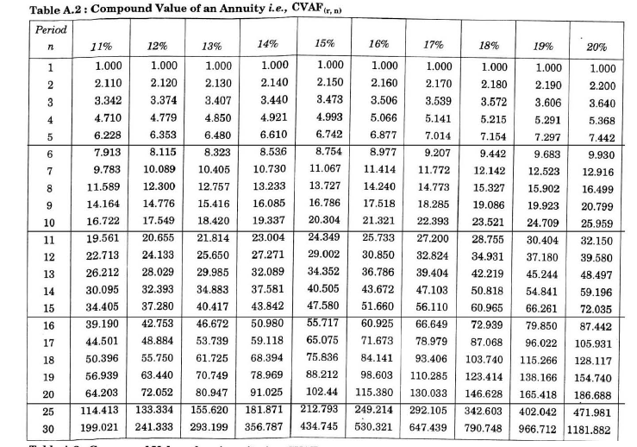

REFERENCES
- Business Finance, Eddie McLaney, Prentice Hall, 11th Edition, 2017
- Fundamentals of Financial Management, Brigham, Eugene F. and Joel F. Houston, Concise 5th Edition, Thomson South-Western, Mason, Ohio, 2006.
- Any other Text book on Business Finance
- Present value and Future Value Tables

