INDUSTRIAL MARKETING
LECTURE 3
CUSTOMER RELATIONSHIP MANAGEMENT
LECTURER: DR. WANJIKU KINYANJUI

Learning Objectives
By the end of this course, the learner should be able to understand:
1. The value of systematically monitoring the customer experience and the central role that business services assume in customer solutions.
2. The roles that service quality, customer satisfaction, and loyalty assume in service market success.
3. Significant factors to consider in formulating a service marketing strategy.
4. The determinants of new service success and failure

Introduction: Customer Experience
Services are fundamentally important to the customer experience that every business-to-business firm provides. Customer experience encompasses every dimension of a company’s offering—product and service features, advertising, ease of use, reliability, the process of becoming a customer, or the way problems are resolved.
Customer experience represents the internal and subjective response a business customer has to any direct or indirect contact with a company. Marketers pay attention to customer touchpoints—those instances where the customer has direct contact with either the product or service itself or with representatives of it by a third party, such as a channel partner. A customer experience map provides a valuable tool for diagnosing key touchpoints or interactions between the company and the customer from the moment contact is made with a potential customer through the maintenance of an ongoing relationship.
As global competition intensifies and product differentiation quickly fades, strategists at leading firms are giving increased attention to services, particularly a solution-centric mindset. Rather than starting with the product, a solution-centered approach begins with an analysis of a customer problem and ends by identifying the products and services required to solve the problem. Rather than transaction based, the focus of the exchange process is interaction based, and value is co-created by the firm together with the customer.

Solution Centered Approach to Business Services
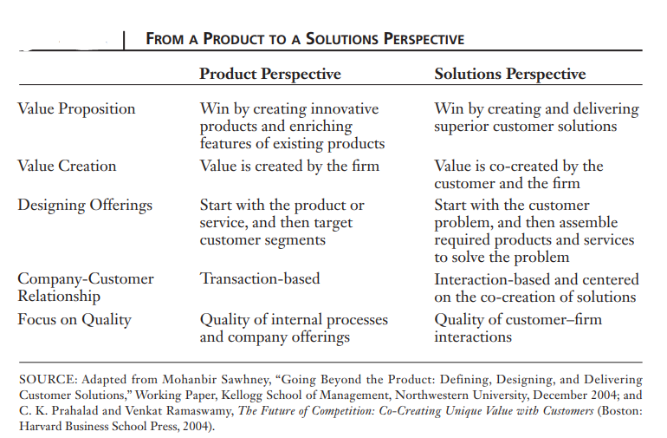

Benefits of Solution Marketing
By shifting from a product to a solutions strategy, business-to-business firms gain two important benefits, namely, new avenues for growth and differentiation. Creating Growth Opportunities Solutions create fresh opportunities for increasing the amount of business or share-of-wallet that a company receives from its customer base. An expanded portfolio of service-intensive offerings makes this possible. Often, services represent a far larger market opportunity than the core product market.
Business services include maintenance and repair support and advisory support. Like supplies services are considered as expense items. The explosive growth of the internet has increased the demand for a range of electronic commerce services such as delivering technical support, customer training and management development programs.
The rapid growth of business services in industrial marketing is governed by four important factors which are explained below.
- Innovations: The innovations in the field of science and technology have contributed for increasing demand in the area of business services. Advancement in computer security systems, computer enabled services, environmental control systems for office and factory buildings are examples for the effect of innovations on business services.
- Out Sourcing: It is a common phenomenon that the present day organizations are getting the services done from outside services provide. In an area where the company is not expertise such as management information functions, HR, Payrolls, Warehousing etc, the trend is towards going for outsourcing these activities. As a result, more and more small and large service providers have entered the business services sector, therefore resulting in the wide opening up of business service sector.
- E-Business: The internet is creating new business opportunities and directing the organizations to do the business in different forms and ways. Services like supply chain management, customer service and support are done through internet .
- Growth of Manufacturing Sector: Despite the decline in the number of manufacturing employees, manufacturing output has continued growing. With this growth the demand for services like information processing, advertising etc, are on an increasing trend.
Services in the industrial market can be grouped into two categories such as Products supported by services and Pure services.
- Products Supported by Services: The services which accompanied the physical product are equally important like the product itself. For example, the consultation services associated with the sale of computers is as important as computer itself. A significant portion of the revenue for an industrial distributor comes from the product support services. An industrial marketer can create a differential advantage for the firm through such product support services.
- Pure Services: A pure service is one which is marketed on their own right not associated with intangible product. A wide range of such pure business services included insurance, consulting, banking, transportation and such allied services. Pure services are very significant from business point of view as they constitute the major portion of the total corporate purchases. With the rise of competition in the professional services industry, the service providers such as accountants, consultants and financial advisers have found it imperative to develop highly focused marketing programs. Such marketing programs enable the service providers to pre establish a relationship with a client, advance its reputation as a leader in the field and strengthen its relationships with existing clients. Services are deeds, process and performances.
There are several basic differences between goods and services. Services are intangible, but products are tangible. Services are consumed at the time of production, but there is a time gap between the production and consumption of products. Services cannot be stored but products can be stored. Services are highly variable but products are highly standardized. The universally recognized difference between goods and services is intangibility. Services are more intangible than manufactured goods and manufactured goods are more tangible than services because services are actions or performance they cannot be seen or touched.
Business services are those market offerings that are intangible dominant. However, few services are totally intangible. Services are generally consumed as they are produced; a critical element in the buyer-seller relationship is the effectiveness of the individual who actually provides the services. The quality of the service output may vary each time it is delivered. Services differ in the amount of equipment and labor that are utilized to provide the service. Services cannot be stored.
Dimensions of Service Quality
Because business services are intangible and non-standardized, buyers tend to have greater difficulty evaluating services than evaluating goods. Because they are unable to depend on consistent service performance and quality, service buyers may perceive more risk.
Customers focus on five dimensions in evaluating service quality: reliability, responsiveness, assurance, empathy, and tangibles. Among these dimensions, reliability—delivery on promises—is the most important to customers. High-quality service performance is also shaped by the way frontline service personnel provide it. To the customer, service quality represents a responsive employee, one who inspires confidence, and one who adapts to the customer’s unique needs or preferences and delivers the service in a professional manner.
Marketing Mix for Business Firms
Meeting the needs of service buyers effectively requires an integrated marketing strategy. First, target segments must be selected, and then a marketing mix must be tailored to the expectations of each segment. The business marketing manager must give special consideration to each of the key elements of the service marketing mix: development of service packages, pricing, promotion, and distribution. In terms of the overall approach that firms develop to interact with their customers, business-to-business service firms are more likely to emphasize relationship strategies as opposed to transactional strategies. Because the transactional mode involves an close relationships, success in marketing business services hinges on the business marketer’s ability to develop close and long-lasting ties with customers— based on buyer-seller dependence.
A s with any marketing situation, development of the marketing mix is contingent on the customer segment to be served. Every facet of the service, as well as the methods for promoting, pricing, and delivering it, hinges on the needs of a reasonably homogeneous group of customers. Since service-quality expectations play such an important role in determining ultimate satisfaction with a service, they can be used to segment business-to-business markets.

References
Zimmerman, A., & Blythe, J. Routledge. (2021). Business to Business Marketing Management: A Global Perspective (4th ed.). https://doi.org/10.4324/9781003164036
Michael D. Hutt, Thomas W. Speh, (2012), Business Marketing Management B2B, 10th Ed. or 11th Ed. South-Western Cengage Learning, ISBN-13: 978-0-324-58167-6
Piyush, Ajbani, L.A, Patole, S., & Sharma, V. (2017), Industrial Marketing: Instructional Material. Y. C. M. Open University, Nashik.

