INDUSTRIAL MARKETING
LECTURE 5
INDUSTRIAL MARKETING PLANNING
LECTURER: DR. WANJIKU KINYANJUI

Learning Objectives
This topic provides a foundation for exploring business marketing strategy on a global scale based on the following objectives:
- To understand the special role of the marketing function in corporate strategy development for b2b planning
- To identify and explain the sources of competitive advantage by exploring the key components of a business for strategic positioning.
- An understanding of converting strategy goals into a tightly integrated customer strategy.

Introduction
To meet the challenges brought on by growing domestic and global competition, business-to-business firms are increasingly recognizing the vital role of the marketing function in developing and implementing successful business strategies. Effective business strategies share numerous common characteristics, while responding to market needs, they exploit the special competencies of the organization, and study environmental trends and competitive behavior.
Market-driven businesses put the needs of the consumer first; they approach strategy from the outside in and exhibit the ability to anticipate market trends before their rivals. In major global firms there are multiple divisions with numerous product lines, products, and brands being used such firms as Johnson & Johnson, Motorola, etc. To secure the survival and expansion of the entire firm, corporate policies set the framework for strategy creation in each business division.

Levels of Strategy
Policies established at the corporate level provide the framework for strategy development in each business division to ensure survival and growth of the entire enterprise. In turn, corporate and divisional policies establish the boundaries within which individual product or market managers develop strategy. There are three major levels of strategy that dominate most large multiproduct organizations: (1) corporate strategy, (2) business-level strategy, and (3) functional strategy.

- Corporate strategy defines the businesses in which a company competes, preferably in a manner that uses resources to convert distinctive competence into competitive advantage. Essential questions at this level include:
- What are our core competencies?
- What businesses are we in?
- What businesses should we be in?
- How should we allocate resources across these businesses to achieve our overall organizational goals and objectives?

At this level of strategy, the role of marketing is to:
- assess market attractiveness and the competitive effectiveness of the firm,
- promote a customer orientation to the various constituencies in management decision making, and
- formulate the firm’s overall value proposition as a reflection of its distinctive competencies
At the corporate level, marketing managers have a critical role to play as advocates, for the customer and for a set of values and beliefs that put the customer first in the firm’s decision making.
- Business-level strategy centers on how a firm competes in a given industry and positions itself against its competitors. The focus of competition is not between companies; rather, it is between their individual business units. A strategic business unit (SBU) is a single business or collection of businesses that has a distinct mission, a responsible manager, and its own competitors and that is relatively independent of other business units. An SBU could be one or more divisions of the industrial firm, a product line within one division, or, on occasion, a single product. Strategic business units may share resources such as a sales force with other business units to achieve economies of scale. An SBU may serve one or many product-market units.
Some questions to reflect on include:
- what have your competitors done?
- In the same period, what have you done to them in the marketplace?
- How might they attack you in the future?
- What are your plans to leapfrog them?

The marketing function contributes to the planning process at this level by providing a detailed and complete analysis of customers and competitors and the firm’s distinctive skills and resources for competing in particular market segments.

- Functional strategy centers on how resources allocated to the various functional areas can be used most efficiently and effectively to support the business-level strategy. The primary focus of marketing strategy at this level is to allocate and coordinate marketing resources and activities to achieve the firm’s objective within a specific product market.
At the functional level planning must be a collaborative effort between all key functional areas. This can help reduce conflict that may occur when the tasks and objectives are unclear or different between the various departments.

Business Model Components
For a strategy to succeed, individuals must understand and share a common definition of a firm’s existing business concept. A business concept or model consists of four major components.
- Customer Interface
- Core Strategy
- Strategic Resources
- Value Network

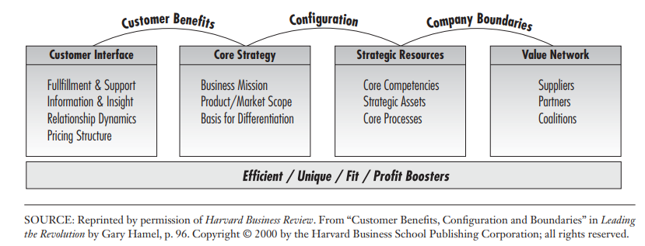

Customer Interface
Customer benefits provide the bridge between the core strategy and the customer interface. Customer benefits link the core strategy directly to the needs of customers. The customer interface includes four elements:
- Fulfillment and support refers to the channels a business marketing firm uses to reach customers and the level of service support it provides.
- Information and insight refers to the knowledge captured from customers and the degree to which this information is used to provide enhanced value to the customer.
- Relationship dynamics refers to the nature of the interaction between the firm and its customers
- Pricing structure. A business concept may offer several pricing choices. For example, a firm can bundle products and services or price them on a menu basis.

Core Strategy
The core strategy determines how the firm chooses to compete. The three elements involved in setting a core strategy include:
- The business mission describes the overall objectives of the strategy, sets a course and direction, and defines a set of performance criteria that are used to measure progress. The business mission must be broad enough to allow for business concept innovation, and it should be distinguished from the mission of competitors in the industry.
- Product /market scope defines where the firm competes. The product markets that constitute the domain of a business can be defined by customer benefits, technologies, customer segments, and channels of distribution.
- Basis for differentiation captures the essence of how a firm competes differently than its rivals

Strategic Resources
A business marketing firm gains a competitive advantage through its superior skills and resources. The firm’s strategic resources include core competencies, strategic assets, and core processes.
- Core competencies are the set of skills, systems, and technologies a company uses to create uniquely high value for customers. The guiding questions for the strategist are: What important benefits do our competencies provide to customers? What do we know or do especially well that is valuable to customers and is transferable to new market opportunities?
- Strategic assets are the more tangible requirements for advantage that enable a firm to exercise its capabilities. Included are brands, customer data, distribution coverage, patents, and other resources that are both rare and valuable. Attention centers on this question: Can we use these strategic assets in a different way to provide new levels of value to existing or prospective customers?
- Core processes are the methodologies and routines companies use to transform competencies, assets, and other inputs into value for customers. For example, drug discovery is a core process at Merck, and delivery fulfillment is a core process at FedEx. Here the strategist considers these questions: Which processes are most competitively unique and create the most customer value? Could we use our process expertise effectively to enter other markets?

The Value Network
The final component of a business concept is the value network that complements and further enriches the firm’s research base. Included here are suppliers, strategic alliance partners, and coalitions.
Concerning the value network, the guiding question for the strategist is:
What market opportunities might become available to us “if we could ‘borrow’ the assets and competencies of other companies and marry them with our own?

Building the Strategic Plan
Successful execution of strategy involves linking strategy to operations, using tools and processes like the balanced scorecard or strategy map. (Kaplan & Norton,2008).
The balanced scorecard converts a strategy goal into concrete objectives, and measures are organized into four different perspectives:
  - Financial perspective
  - Customer perspective
  - Internal business process, and
  - Learning and growth

The balance scorecard tells the story of the strategy, starting with the long-run financial objectives, and then linking them to the sequence of actions that must be taken with financial processes. Then, customers and employees and systems that deliver the desired long-run economic performance.
The diagram below is a representation of the same.
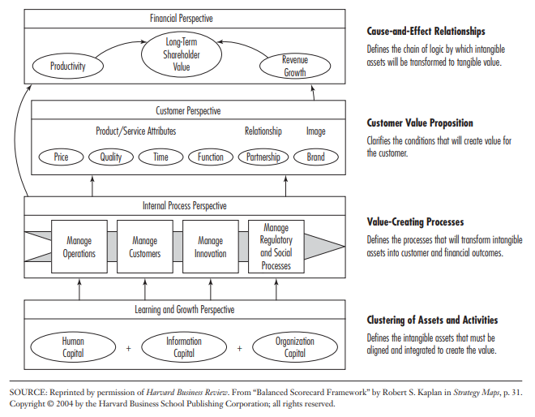
BALANCE SCORE CARD
The balanced scorecard seeks to match financial objectives to a business unit’s growth and life cycle stages.
Three stages of a business are isolated and linked to appropriate financial objectives:
- Growth: Business units that have products and services with significant growth potential and that must commit considerable resources
Financial Objectives: Sales growth rate by segment; percentage of revenue from new product, services, and customers
- Sustain: there are business units, which may be representing the majority of businesses within a firm. They expect to maintain or increase market share from year to year.
Financial Objectives: Share of target customers and accounts; customer and product-line profitability.
- Harvest: Mature business units that warrant only enough investment to maintain production equipment and capabilities.
Financial Objectives: Payback; customer and product-line profitability.

Building a Strategic Map
A strategic map enables an organization to describe and illustrate,
  - its objectives,
  - initiatives and targets
  - the measures used to assess performance (market share/customer surveys)
  - the linkages that are the foundation for strategic direction.

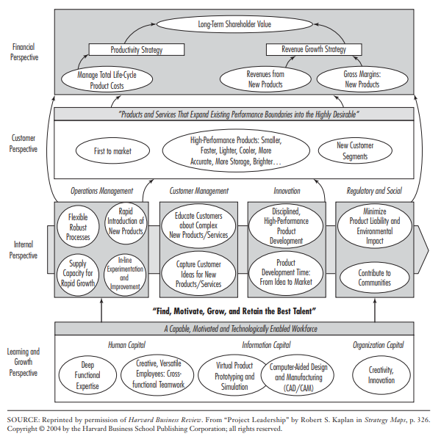

The strategy map template above is for a firm pursuing a product-leadership strategy. Companies emphasize two performance levels in developing a financial strategy—a productivity strategy and a revenue-growth strategy. A value proposition for product leadership should be to have “Products and services that expand existing performance boundaries into the highly desirable.”
A strategic map provides a visual representation of a firm’s critical objectives and the cause-and-effect relationships among them that drive superior organizational performance.

References
Kaplan, R.S. and Norton, D.P. (2004) The Strategy Map: Guide to Aligning Intangible Assets. Strategy & Leadership, 32, 10-17.
http://dx.doi.org/10.1108/10878570410699825
Michael D. Hutt, Thomas W. Speh, (2012), Business Marketing Management B2B, 10th Ed. or 11th Ed. South-Western Cengage Learning, ISBN-13: 978-0-324-58167-6
Nyangon, Joseph & Byrne, John. (2018). Diversifying Electricity Customer Choice: Reving Up the New York Energy Vision for Polycentric Innovation. 10.5772/intechopen.76023.

