INDUSTRIAL MARKETING
LECTURE 9
INDUSTRIAL MARKETING COMMUNICATIONS 2
BY
DR. WANJIKU KINYANJUI

By the end of this topic, you should have understood:
- the role of personal selling in the marketing strategy
- the skills and characteristics of high-performing account managers
- the nature of the sales management function
- managerial tools that can be applied to sales force decision areas.

Introduction
One element of the promotional mix is personal selling, which is the skill of convincing customers or prospects in person during the sales process. Other marketing components, such as product development, price, distribution strategy, advertising, and so forth, should be balanced with the application of personal selling in order to create an efficient marketing system.
Personal selling is the interpersonal part of the promotion mix and can include:
- Face-to-face communication
- Telephone communication
- Video or Web conferencing
The above tasks are done by a sales person. A Salesperson is the link between the company and its customers who assist in producing customer value and company profit by:
- Representing the company to customers
- Representing customers to the company
- Working closely with the marketing teams
Personal selling is the largest budget item in most business to business markets.
Salespeople earn high salaries, and need expensive back-up: company cars, administration assistance, smart phones, expensive computers, and other sales materials.
Allowing for travelling time, preparation time, and so forth, salespeople spend only a fraction of their time actually making sales presentations
Role of the Sales Person
• identify problems that customers have or might have
• establish a dialogue with the potential customer
identify suitable possible customers
• identify solutions that are within the supplying firm’s capabilities
• represent the customer’s views to the supplying company
• ensure a smooth process of supply that meets the customer’s needs;
• solve any after-sales problems that may arise

The Selling Process
Prospecting: The sales step in which a salesperson or company identifies qualified potential customers. Salespeople can ask current customers for referrals and cultivate other referral sources, such as suppliers, dealers, noncompeting salespeople, and online or social media contacts. They can also search for prospects in directories or on the internet and track down leads using the telephone, email, and social media. Or, as a last resort, they can drop in unannounced on various offices (cold calling).
•Pre-approach: The salesperson learns as much as possible about a prospective customer before making a sales call. The salesperson should set call objectives, which may be to qualify the prospect, gather information, or make an immediate sale. Another task is to determine the best approach, which might be a personal visit, a phone call, an email, or a text or tweet.
•Approach: The sales step in which a salesperson meets the customer for the first time. This step involves the salesperson’s appearance, opening lines, and follow-up remarks. The opening lines should be positive to build goodwill from the outset. This opening might be followed by some key questions to learn more about the customer’s needs or by showing a display or sample to attract the buyer’s attention and curiosity.
•Presentation: The sales step in which a salesperson tells the “value story” to the buyer, showing how the company’s offer solves the customer’s problems. The customer-solution approach fits better with today’s relationship marketing focus. The qualities that buyers dislike most in salespeople include being pushy, late, deceitful, unprepared, disorganized, or overly talkative. While on the other side they value: good listening, empathy, honesty, dependability, thoroughness, and follow-through.
•Handling objections: The sales step in which a salesperson seeks out, clarifies, and overcomes any customer objections to buying. The objections can be either logical or psychological, and they are often unspoken.
•Closing: The sales step in which a salesperson asks the customer for an order. Salespeople should know how to recognize closing signals from the buyer, including physical actions, comments, and questions.
•Follow-up: The sales step in which a salesperson follows up after the sale to ensure customer satisfaction and repeat business. This visit would reveal any problems, assure the buyer of the salesperson’s interest, and reduce any buyer concerns that might have arisen since the sale.

Effective management of the industrial sales force is essential for a firm’s success. Sales management requires proper planning, organizing, directing, and controlling of the personal selling efforts. Sales operations must be supervised to identify problem areas and to assess the efficiency, effectiveness, and profitability of personal selling.

The business marketer can organize the sales force by:
- geographical location
- product type
- target market
Large industrial firms that market diverse product lines may use all three.
Many Industrial business marketing firms find that a small proportion of customers account for a major share of the business. These customers have a large purchasing power by virtue of their size, and they are searching for ways to leverage their suppliers’ capabilities to enhance the value they deliver to their own customers. In exchange for a long-term volume commitment, these customers expect the business marketing firm to offer additional value-added services that are not offered to other customers.
- Customer prioritization
Represents the degree to which firms prioritize customers by developing different value propositions for its top-tier versus bottom-tier customers
- Key Accounts
Industrial firms have key account managers and customer teams composed of individuals from other departments like sales, marketing, finance, logistics, and other functional groups.
Key account managers are responsible for several important customers and report to a senior manager in the firm.
  - purchases a significant volume as a percentage of a seller’s total sales
  - involves several organizational members in the purchasing process
  - buys for an organization with geographically dispersed units
  - expects logistical support, inventory management, price discounts, and customized applications

- Type of Relationship
- This involves multiple goals.
- To illustrate, firms may enter into a closer, long-term relationship to lower costs to both partnering firms.
This is done by reducing the seller’s marketing and logistics costs and reducing the buyer’s acquisition and production costs.
d) Coordinated Action
- To effectively deliver more value to an important customer,
  - the interpersonal connections between the buying and selling firms must extend beyond the salesperson and the purchasing manager.
  - frequent interactions between a team of functional experts from both organizations.
The key account manager assumes a lead role in coordinating selling center activities and facilitating these cross-firm communications among functional experts.
e) Selecting Key Accounts
If the industrial firm can have closer and important relationships with a small set of customers, each requiring a large investment, the choice of the key accounts is critical.
  - the profit potential of a customer, measured in terms of incremental sales potential, and
  - the degree to which a customer values the firm’s support services and is willing to pay a premium price for them

Account Management Success

- Building Internal Relationships
High-performing account managers form more cross-functional and cross-unit ties within the organization
A diverse social network provides a manager with access to unique skills and knowledge.
Account managers with ties to a number of distinct knowledge pools in the organization can draw on a large array of skills, knowledge, and resources—thereby enhancing their customer responsiveness
- Forging Relationships (Customer Organization)
Being centrally involved in a customer organization’s buying system improves an account manager’s ability to understand the customer’s requirements and business goals.
C. Managing the Customer Engagement Process
By developing a network of relationships both within the firm and within the customer organization, an account manager is ideally equipped to manage the customer engagement process. Through these connections account managers receive vital information about emerging customer opportunities, customer requirements and solutions, and competitive challenges
d. Aligning and Crafting
A successful client engagement hinges on both customer knowledge and competitive intelligence.
High performers know more about client goals and the drivers of client profitability than low performers.
When creating a customer solution, a salesperson must act as a broker to gather an ad-hoc team of experts and coordinate the efforts of people who may not have met before.
With this knowledge managers’ align the capabilities of the firm to the goals of the customer.
High-performing account managers develop sound competitive intelligence and use this knowledge to outmaneuver their rivals in a particular client engagement.
e. Enhanced Internal Reputation
By building a strong network of relationships within both the firm and the customers firm, high-performing account relate well with colleagues better able to diagnose customer requirements, mobilize internal experts, and design the activities that are required to outsmart the rivals and create the desired customer solution.
Successful sales force administration involves recruiting and selecting salespersons, then training, motivating, supervising, evaluating, and controlling them. The industrial firm should foster an organizational climate that encourages the development of a successful sales force.
The recruiting process presents numerous trade-offs for the business marketer. Should the company seek experienced salespersons, or should it hire and train inexperienced individuals? The answer depends on the specific situation. It varies with the size of the firm, the nature of the selling task, the firm’s training capability, and its market experience
Industrial firms need to prepare new salespersons adequately by designing a proper training program. Periodic training is required to sharpen the skills of experienced salespersons, especially when the firm’s environment is changing rapidly.
Changes in business marketing strategy (such as, new products, new market segments) require corresponding changes in personal selling styles
Supervision and Motivation
The sales force must be directed in a way that is consistent with the company’s policies and marketing objectives. Critical supervisory tasks are continued training, counseling, assistance and activities that help sales personnel plan and execute their work. Supervision also sets sales performance standards, fulfills company policy and integrates the sales force with higher organizational levels
Socialization
Salespersons are likely to be anxious and frustrated when they are uncertain about the expectations of role partners or feel that role partners (for example, customers, superiors) are making incompatible and impossible demands.
An effective approach for reducing role ambiguity among new salespeople is training and socialization to offer sufficient information about role expectations and minimize potential confusion about performance requirements.
Evaluation and Control
A constant sales management responsibility is to monitor and control the industrial sales force at all levels whether national or regional level.
- To determine whether objectives are being attained
- to identify problems
- recommend corrective action
- keep the sales organization in tune with changing competitive and market conditions.

Models for Industrial Sales Force Management
- The size of the sales force is used to determine the level of selling effort that the business marketer can use.
- The selling effort is then organized by designating sales districts and sales territories.
- Allocation decisions determine how the selling effort is to be assigned to customers, prospects, and products
- Territory sales response
The level of sales in a particular territory can be influenced by:
  - Environmental factors (e.g., health of economy, technology)
  - Competition (e.g., number of competitive salespersons)
  - Company marketing strategy and tactics
  - Sales force organization, policies, and procedures
  - Field sales manager characteristics
  - Salesperson characteristics
  - Territory characteristics (e.g., potential)
  - Individual customer factors
- Sales Resource Opportunity Grid
A sales resource opportunity grid can be used to classify the business-to-business firm’s portfolio of Planning and Control Unit (PCU).
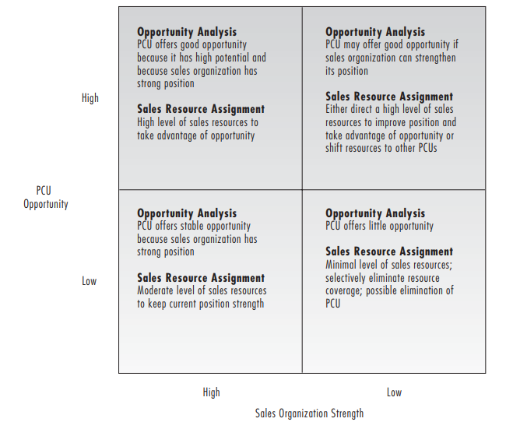
(Hutt & Speh,2012)

Conclusion
In industrial marketing, personal selling is a significant influence that drives demand.
- With the enormous resources dedicated to personal selling and the quickly rising expense of in-person sales calls, the business marketer needs to closely oversee this function and make the most of existing technology in order to maximize sales force productivity. In order to profitably service large customers with complex purchasing requirements, a growing number of business-to-business companies are also building a key account sales force, regardless of the structure of their sales staff.
The sales organization must be appropriately structured: hiring and selection, training, supervision, assessment, and control are all part of the continuous process of managing a sales team.

References
Michael D. Hutt, Thomas W. Speh, (2012), Business Marketing Management B2B, 10th Ed. or 11th Ed. South-Western Cengage Learning
Zimmerman, A., & Blythe, J. (2021). Business to Business Marketing Management: A Global Perspective (4th ed.). New York: Routledge

