Lecture Notes
BUILDING SERVICES III
Chapter 2
Psychrometric Chart, Ventilation Standards
Lecturer: Assoc. Prof. Manchan Tiwari
9-17-2023

Learning Objective of the Lecture:
- Basics of Psychrometric Chart
- Psychrometric Processes
- Ventilation Basics
- Types of Ventilation
- Ventilation Techniques

Revision of Basic Concepts
Humidity: It is the measure of quantity of water vapor present in atmosphere.
Absolute Humidity: It is the ratio of total mass of water vapor present in given volume or mass of air. Its unit is gm/m³ or gm/kg
Specific Humidity: It is the ratio of mass of water vapor to the total mass of moist air.
Relative Humidity: It is the ratio of amount of moisture in the air at a particular temperature to the maximum moisture air can withstand at the same temperature.
Humidity Ratio: It is the ratio of the mass of water vapor to the mass of dry air contained in a sample of air.
Specific Volume is the ratio of unit volume of dry air per unit weight of dry air.
Dry Bulb Temperature: It is the temperature measured by a regular thermometer.
Wet Bulb Temperature: It is the temperature measured by a regular thermometer when the bulb of the thermometer is wrapped in a moist cloth.
Dew Point: It is the temperature at which condensation begins when air with relative humidity below 100% is cooled.
Enthalpy: It is equivalent to the total heat content of a system. The enthalpy of atmospheric air is the sum of the enthalpy of dry air and the enthalpy of water vapor present in it. This is equal to sensible heat of dry air and sensible as well as latent heat of the water vapor (Pita, 2002).

Some Basic Terminologies

Heat
It is basically the measure of thermal energy. Thermodynamically heat is defined at the energy flow between system and surrounding due to the virtue of temperature difference. Its SI unit is Joule. Quanity of heat is also measure din British thermal units (Btu). Btu is defined as the amount of heat required to heat 0.45 kg of water from 15.3 ⁰C to 15.8 ⁰C.
Unit conversion
- 1 Btu = 1055 joules (J)
- 1 Btu = 0.293 watt-hour (W-hr)
- 1 Btu = 252 calories (C)
- 1 watt-hour (W-hr) = 3.413 Btu

Temperature
It refers to the quantification of the average kinetic energy of atoms and molecules within a substance at the microscopic level.. Temperature is typically quantified using units like degrees Celsius (°C), degrees Fahrenheit (°F), or the Kelvin (K) scale, particularly in scientific applications. Conversion of units of temperature is done according to below:
°C = (°F -32)/1.8
°K = °C + 273

Mass density (ρ)
It is the ratio of mass per unit volume of a substance. Its unit is kg/m³

Specific Heat
Specific Heat of a substance is defined as the amount of heat required to raise the temperature of 1 kg of mass of the substance through 1 °C. Its unit is kJ/kg K. It can also be understood as the property of a substance which indicates how slow its temperature rises when it is heated. For example, if heat is applied at the same rate, then the temperature of water will rise slower as compared with iron as water has higher specific heat than iron.
Air at general room conditions has specific heat of 1.012 kJ/kg K while Plaster has the specific heat of 0.84 kJ/kg K, which signifies that the temperature of air will rise less as compared with plaster when same amount of heat is absorbed by both.

Table 1: Specific Heat of Some Substance (Joseph B Wujek, 2010)
Product | Specific Heat (kJ/kg K)
Water (20 ⁰C) | 4.15
Cast Iron | 0.460
Aluminium | 0.912
Copper | 0.389
Gold | 0.13
Brick | 0.92
Marble | 0.88
Wood | 2.3 to 2.7

Sensible and Latent Heating
Sensible heat is the thermal energy associated with changing a substance's temperature, and this change in temperature is directly proportional to the added or removed heat. This phenomenon, known as sensible heating, is observable through the sense of touch. Sensible heating doesn't apply during state changes like solid to liquid or liquid to gas. These transitions, known as phase changes, involve the storage or release of heat and can occur when heat is added or removed from a substance.
Latent heat is the heat associated with a substance's phase transition without affecting its temperature. This "hidden" heat is absorbed or released when a material changes phase, such as from liquid water to water vapor, without any temperature change. In the example of heating water, as it boils and transitions to vapor, the heat added is latent heat, and the water's temperature remains constant during this phase change.
Latent heat of vaporization is the heat which is needed for a substance to change from liquid to gas and is released when it changes back from gas to liquid. In water, this heat is about 970 Btu/lb.
Latent heat of fusion is involved when a substance transitions from liquid to solid, as with water turning into ice, releasing 144 Btu/lb, and the same amount is absorbed when ice returns to a liquid state.

Power
Power is the rate of energy per unit time. Its SI unit is J/s or Watt (W). Btu/hr is also used as unit of power.
- 1 W = 3.413 Btu/hr
- 1 hp = 745.7 W
- 1 hp = 2544.3 Btu/hr

Psychrometrics
Psychrometrics is the study of the thermodynamic properties of gas-water vapor mixtures when temperature and pressure is varied. It is essential in HVAC system design for analyzing conditions involving moist air, indoors and during ventilation, relying on an understanding of air and water vapor within air.
Atmospheric air, which is the air found in the atmosphere, is a mixture of different gases, including nitrogen (75.47%), oxygen (23.2%), Carbon dioxide (0.046%) water vapor, and contaminants like dust and pollen. In contrast, the typical composition of gases exhaled by a seated individual is approximately: oxygen 16.5%, carbon dioxide 4.0%, nitrogen and argon 79.5%, along with minor trace gases. (Joseph B Wujek, 2010)
Dry air is devoid of water vapor and serves as a reference in psychrometrics, while moist air contains varying amounts of water vapor, present to some degree in all atmospheric air. Saturated air holds the maximum moisture it can at a given temperature, and water vapor in air becomes superheated steam at low pressure and temperature, typically appearing clear unless tiny water droplets cause foggy conditions. Due to the variability in atmospheric air, the terms dry air and moist air are mostly used in psychrometrics.
Heating, ventilation, and air conditioning systems are typically rated using standard air conditions, as outlined in Table 2. However, it's important to note that when air experiences conditions different from the standard, such as variations in temperature and pressure, these factors significantly impact air density:
- Lower air pressure leads to reduced air density, while higher air pressure increases it.
- When air temperature drops, air density also decreases, and conversely, higher temperatures result in greater air density.
Changes in the density of dry air are directly proportional to alterations in specific heat and specific heat capacity. These variations necessitate adjustments by designers to account for real-world conditions, a consideration particularly crucial in building HVAC systems.

Table 2: Standard Air Conditions (Joseph B Wujek, 2010)
Air Property | Value for Standards Conditions in SI Units
Absolute Pressure | 101.325 kPa
Temperature | 21.1 ⁰C
Mass Density | 1.189 kg/m³
Specific Heat | 1.195 kJ/m³

Psychrometric Chart
The chart or graph which represents the properties of the atmospheric air is known as psychrometric chart. It represents the variation in value of various psychrometric variables. The value of any two variable can be used to determine the state of the air, which also can be used to determine the values of other associated properties.
The dry bulb temperature scale is situated at the chart's base, denoting consistent dry bulb temperatures through vertical lines.
The wet bulb temperature scale is found along the upper curved section of the chart, with right-sloping lines indicating equivalent wet bulb temperatures.
The dew point temperature scale is also positioned on the same curved section as the wet bulb temperature scale, with horizontal lines extending from this area indicating equal dew point temperatures.
The relative humidity scale is depicted by curved lines that sweep from the lower left to the upper right of the psychrometric chart. The 100% relative humidity (saturation) line follows the upper curve and aligns with both the wet bulb and dew point temperature scales. The 0% relative humidity line runs along the chart's base. The 50% relative humidity line is determined by connecting points at various dry bulb temperatures, representing the humidity ratio when the air holds half of its maximum water content. These points are positioned midway between the 100% and 0% lines at a specific dry bulb temperature.
The humidity ratio or specific humidity is located on the chart's right side, with horizontally extending lines indicating constant moisture levels.
The specific volume scale is represented by diagonal lines that run from left to right.
The enthalpy scale is usually situated near the upper curved section of the chart, and its lines slope to the right, somewhat resembling the wet bulb temperature lines. However, they do not precisely correspond to the wet bulb temperature lines.
Heat exchange in moist air can be categorized into two terms: sensible heating and latent heating. Sensible heating and cooling are related solely to changes in dry bulb temperature, with no addition or removal of moisture. On the other hand, humidification and dehumidification entail the introduction or removal of moisture, thus involving latent heat. Latent heat represents the energy needed to alter the phase of a substance, in this instance, transforming water vapor in moist air. Evaporative cooling, for instance, boosts the latent heat of the air through water evaporation, resulting in a decrease in sensible heat (a drop in the air's dry bulb temperature). The wet bulb temperature represents the lowest temperature at which air can theoretically be cooled through the evaporation of water.
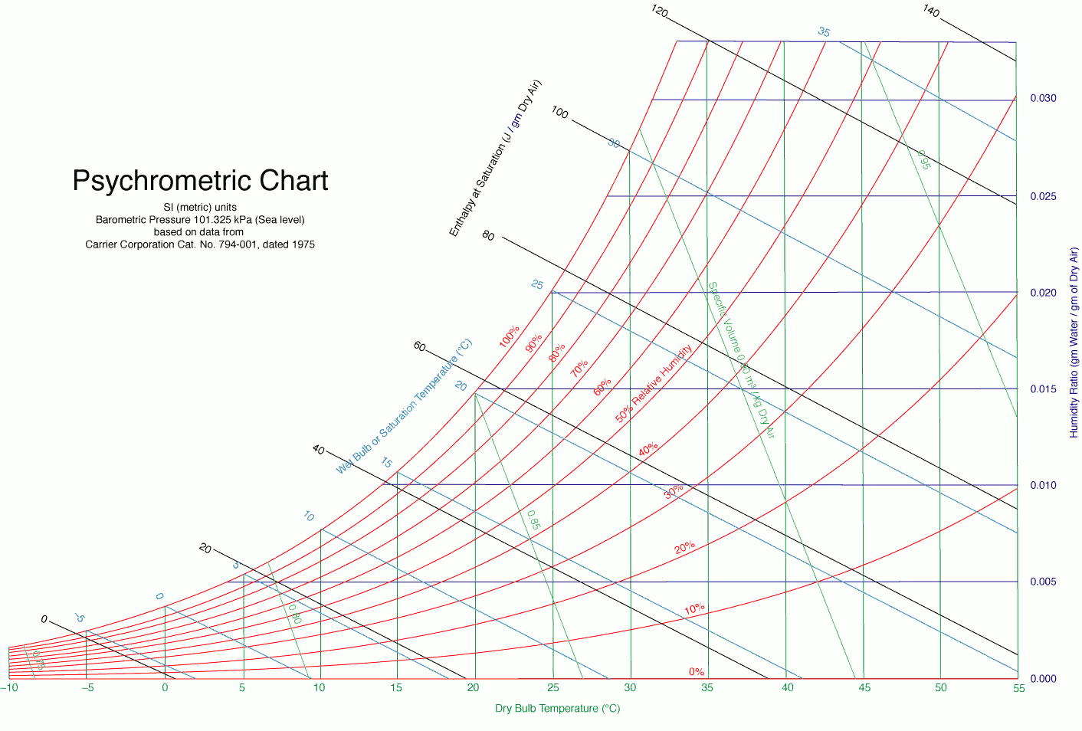
Figure 1: Psychrometric Chart (Ogawa, 2012)

Psychrometric Processes
The change of property of the air by an air conditioning equipment can be represented in the psychrometric chart. These changes are known as Psychrometric processes. Some common psychrometric processes are:
- Sensible heating
- Sensible cooling
- Cooling and dehumidification
- Heating and humidification
- Evaporative cooling
- Dessiccant Dehumidification

Sensible Heating:
In the sensible heating process, heat is introduced into the air without altering its moisture content. This commonly occurs during tasks like heating buildings in winter. On a psychrometric chart, you can observe this as a horizontal shift to the right along the specific humidity line. This results in an increase in dry bulb and wet bulb temperatures, as well as enthalpy, while specific volume and relative humidity decrease. Since no moisture is added or removed, there is no change in humidity ratio and dew point temperature (Joseph B Wujek, 2010).

Sensible Cooling:
Sensible cooling entails the removal of heat from air without affecting its humidity ratio, often seen when cooling indoor air in buildings. This leads to decreases in dry bulb and wet bulb temperatures and enthalpy. It also causes an increase in specific volume and relative humidity. Similar to sensible heating, no alteration occurs in humidity ratio and dew point temperature. On a psychrometric chart, this process is represented by a horizontal shift to the left along the specific humidity line (Joseph B Wujek, 2010).

Cooling and Dehumidification:
The cooling and dehumidification process involves lowering both the dry bulb temperature and the humidity ratio of the moist air. On a psychrometric chart, this process is illustrated by diagonal movement down and to the left.

Heating and Humidification:
Heating and humidification refer to the simultaneous increase of both the dry bulb temperature and humidity ratio of the air, as seen when human respiration adds both sensible heat and moisture to the surrounding air. On a psychrometric chart, this process is depicted by diagonal movement up and to the right.

Evaporative Cooling:
Evaporative cooling transforms sensible heat in the air into latent heat within the added vapor. This results in cooler and more humid air, along with drier surrounding surfaces. Consequently, the process of evaporative cooling is sometimes referred to as "drying." On a psychrometric chart, this process is visualized as diagonal movement up and to the left along the wet bulb temperature line.

Desiccant Dehumidification:
Desiccant dehumidification involves the utilization of chemical or physical absorption to remove water vapor from the air. On a psychrometric chart, this process is represented by diagonal movement down and to the left.

Ventilation
Fresh air supply is required from outside region to the indoor space to maintain the thermal comfort. Ventilation can be natural as well as mechanical. Various factors govern the quantity of fresh air required in a region or space. Ventilation can specifically be defined as the process which fulfills the following requirements:
- Supply fresh air for breathing, typically at a rate of 0.1 to 0.2 liters per second per person.
- Maintain the correct oxygen level in the air, which is approximately 21%.
- Regulate carbon dioxide levels to stay below 0.1%. Concentrations exceeding 2% are dangerous as carbon dioxide can be lethal.
- Manage humidity within a range of 30% to 70%.
- Eliminate excess heat generated by machinery, individuals, lighting, etc.
- Eliminate odors, smoke, dust, and other airborne contaminants (Fred Hall, 2007).
Alleviate stagnation and create a feeling of freshness through air movement ranging from 0.15 to 0.5 meters per second.
In case of Nepal, not much text regarding the guidelines of ventilation is found. In Building design code formulated by government of Nepal, following requirement for ventilation is mentioned:
Each basement shall be separately ventilated. Vents with cross sectional areas not less 2.5% of the floor area spread preferably around the perimeter of the basement shall be provided through stall boards, pavement light or through shafts [in case of double basements]. Each basement above 200sq.m shall have minimum of one each system of air inlets and smoke outlet served through mechanical system. Additional vent system shall be provided for every 200sq.m of plinth area there on (GoN, 2015).
However, there are various ventilation requirements which can be followed and should be considered as well.

Types of Ventilation
Some of the ventilation techniques are:
Natural Ventilation: Suitable for mild coastal climates, this approach allows internal air conditions to vary with external weather. It involves features like central heating, shading blinds, passive solar architecture, and limited cooling through chilled-water beams or panels, but it doesn't provide ventilation air.
Assisted Natural Ventilation: An extension of natural ventilation, it incorporates mechanically operated louvers and exhaust fans to enhance air control. In hot, dry climates, outside air may be cooled with water spray evaporative coolers. The incoming outdoor air can be slightly cooled before being used for temperature control.
Mechanical Ventilation (Outside Air Only): Primarily used in moderate climates, like the UK, where little cooling is needed. It employs air-to-air heat exchangers or recuperative heat wheels to transfer heat between incoming and outgoing air streams, improving energy efficiency and temperature control.
Mechanical Ventilation (Recirculated Room Air): Maximizes energy savings by recirculating conditioned room air. Outside air dampers are modulated to control zone temperature without relying on mechanical refrigeration for as long as possible. When refrigeration is necessary, outside and exhaust air dampers are partially open to maximize recirculated room air use. Various ducted air-conditioning systems are employed (Chadderton, 2007).
Use of mechanical or natural ventilation can be done based on following:
Natural inlet and outlet: This combination relies on features like openable windows, air bricks, and chimneys for air exchange, with up to about 3 air changes per hour possible. The effectiveness depends on factors like wind direction, stack effect from rising warm air, and openings around doors and windows.
Natural inlet, mechanical outlet: In this setup, natural means are used for fresh air intake, while mechanical systems like extract fans remove air contaminated with heat, fumes, or odors. It's suitable for various spaces, but there's no filtration of incoming impurities, and heating may be needed in winter.
Mechanical inlet, natural outlet: This configuration involves blowing heated air into the building using mechanical systems, and air exits through openings and air bricks. It's suitable for spaces like offices, factories, and large halls.
Mechanical inlet and outlet: This approach assumes full mechanical control of air movement, particularly when natural ventilation openings are insufficient. It's used to handle high air flow rates without causing drafts or architectural disruption. In sealed environments, a complete air-conditioning system is employed (Chadderton, 2007).

References
Chadderton, D. V. (2007). Building Services Engineering (5th Edition ed.). New York: Taylor and Francis Group.
Fred Hall, R. G. (2007). Building Services Handbook (4th Edition ed.). Oxford, Burlington: Elsevier Limited.
Joseph B Wujek, F. R. (2010). Mechanical and Electrical Systems in Architecture, Engineering and Construction (5th Edition ed.). New Jersey: Pearson Education Inc.
Ogawa, A. (2012, May 2). Wikimedia Commons. Retrieved September 17, 2023, from https://upload.wikimedia.org/wikipedia/commons/1/1c/Psychrometric_chart.png
Pita, E. G. (2002). Air Conditioning Principles and Systems; An Energy Approach (4th Edition ed.). New York: Prentice Hall, Ohio.

