Lecture Notes
BUILDING SERVICES III
Chapter 3
HVAC Design, Components and Types of HVAC Systems
Lecturer: Assoc. Prof. Manchan Tiwari
10-3-2023

Learning Objective of the Lecture:
- Components of HVAC Systems
- Basis of classification of HVAC Systems

Working Principle of Vapor Compression Refrigeration System
The basic components of a air conditioning system working in the principle of vapor compression are:
- Compressor
- Condenser
- Expansion Valve
- Evaporator
Compressor: Low pressure vapor (refrigerant) enters the compressor and is compressed to high pressure vapor while raising its enthalpy and temperature. The high-pressure vapor then enters the compressor.
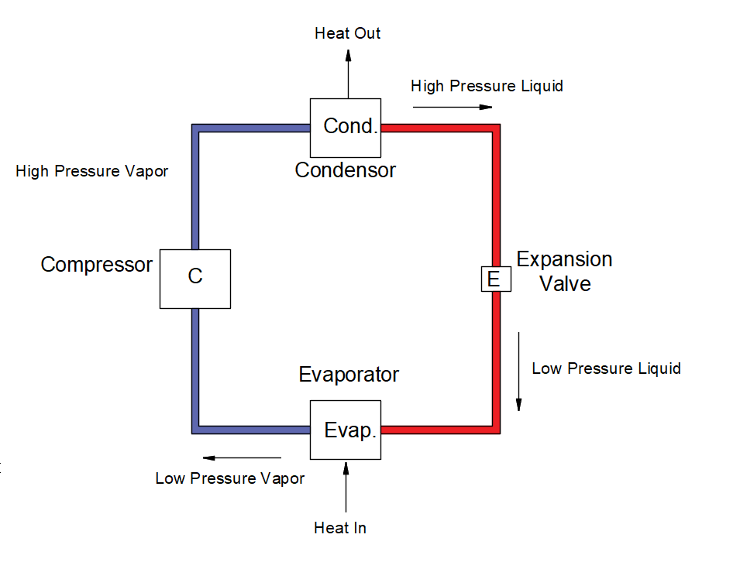
Figure 1: Layout of Air Conditioning System
Condenser: As the high-pressure vapor enter the condenser at relative high temperature, it is cooled to high pressure liquid at the condenser. The cooling at the condenser can be done by either air or liquid which enter the compressor and gets heated while cooling the high-pressure vapor.
Expansion Valve: At expansion valve the high-pressure liquid enters and is changed to low pressure liquid. As the pressure of the liquid decreases, so does its temperature. So, now the relatively cold low-pressure liquid is ready to get evaporated if it comes in contact with surrounding at temperature higher than that of the low-pressure liquid.
Evaporator: The low-pressure liquid from the exit of the expansion valve enters the evaporator where the heat transfer between the low-pressure refrigerant and surrounding is facilitated. As the surrounding is relatively at the higher temperature, the refrigerant absorbs the heat from the surrounding hence cooling it. The refrigerant itself is converted to low pressure vapor.
These four main components are responsible for working of an air conditioning system based on vapor compression cycle.

HVAC System Introduction
An HVAC system involves the processes that regulate the quality of air within a building, comprising of functions like heating, cooling, humidity control, dehumidification, and air filtration. Although "air conditioning" commonly brings to mind cooling, it's crucial to understand that it involves various air quality adjustments.
Space heating equipment is used to warm the air inside buildings and can take various forms like heat pumps, furnaces, boilers, individual space heaters, or district steam or hot water systems. Conversely, space cooling equipment cools indoor air, utilizing refrigeration (such as room air conditioners), evaporative cooling units, or central cooling systems that circulate chilled water. Humidifiers add moisture to indoor air, while dehumidifiers remove excess moisture.
Chilled water systems cool water centrally and distribute it to different building areas via coils or embedded pipes, mainly in larger buildings. Heating and cooling distribution equipment, such as radiators, baseboards, and fan-coil units, disperse conditioned air and water throughout a building through pipes, ducts, or fans. This equipment also facilitates ventilation.
The choice of heating and cooling systems and equipment depends on factors like local climate, heating/cooling needs, occupant comfort preferences, budget constraints, and energy expenses (Joseph B Wujek, 2010).

Specific Components of HVAC System
In present context all major AC systems work under the principle of vapor compression cycle. The major components of AC systems working under vapor compression cycle are:
- Compressor
- Condenser
- Expansion Valve
- Evaporator
- Ducts
- Fans
- Thermostat
- Other Devices (Insulations, Dampers, Automatic Controls)

Compressor:
It is the central and most important component of an AC system, responsible for changing the low-pressure vapor-form refrigerant to a high-pressure state. Following its exit from the evaporator, the low-pressure refrigerant enters the compressor, where it undergoes a transformation. The compressor increases both the pressure and temperature of the refrigerant while it remains in a liquid state. This compression ensures the refrigerant's proper condensation and circulation throughout the entire cycle. The effectiveness of the refrigeration or air conditioning system hinges entirely upon the compressor's capacity.

Reciprocating compressors:
One of the widely employed types of refrigeration compressors is the reciprocating compressor. It incorporates a piston and cylinder arrangement akin to that found in an automotive engine. The piston's reciprocating movement, driven by external power, compresses the refrigerant within the cylinder. Reciprocating compressors are chosen when there is a need for a higher compression ratio (Sarao, 2020).

Scroll Compressors:
A scroll compressor, commonly referred to as a spiral compressor, is designed to compress air or refrigerant. It is utilized in various residential central heat pump and air conditioning systems, as well as certain automotive air conditioning systems. Scroll compressors are chosen instead of the more conventional rotary or reciprocating compressors.

Screw Compressors:
Comprising interlocking screws for compressing refrigerant, screw compressors can generate high pressure with minimal gas quantity. They demonstrate lower power consumption compared to reciprocating compressors.

Rotary Compressors:
Rotary compressors, with two rotating elements resembling gears, compress refrigerant efficiently. These compressors can pump refrigerant at lower or moderate condensing pressures, finding application in fewer scenarios due to their capacity for handling smaller gas volumes and generating lower pressure. These compressors are suitable for high speeds and are used when the capacity required is small.

Centrifugal Compressor:
Centrifugal compressors consist of an impeller or blower capable of handling large volumes of gas but at relatively lower condensing pressures. The impeller is the rotating part which provides kinetic energy to the fluid which is then converted into static pressure. This type of compressor is mainly suitable when the volume to be compressed is large where as the increase in pressure is relatively less.
- Centrifugal compressors have mainly following advantages:
- Can be directly couple with electric motor or turbines
- Lubrication and maintenance is simple due to absence of reciprocating parts
- Relatively compact and smaller in size when compared with reciprocating compressor
- Free from vibrations (Sarao, 2020)

Condenser:
Condensers are typically heat exchangers. In condensers, high pressure and high-temperature refrigerant are cooled by supplying cooling water or cooling air. This process transforms the high-temperature, high-pressure vapor refrigerant into high-pressure liquid refrigerant. The cooling water/air, in turn, absorbs heat from the vapor and gets heated.

Types of condenser:

Water-cooled condenser:
While slightly more expensive to install, these condensers are more efficient and require regular service and maintenance. They also necessitate a cooling tower to conserve water. Depending on the application, one can choose from tube-in-tube, shell and coil, or shell and tube condensers, typically used in large commercial air-conditioning units.

Air-cooled condenser:
This type, located outside the unit, is easy to install and commonly used in domestic refrigerators, upright freezers, and residential packaged air conditioning units.

Expansion Valve or Throttling Valve:
The expansion valve transforms high-pressure liquid refrigerant into low-pressure liquid refrigerant, maintaining constant pressure inside the evaporator. It controls refrigerant flow into the evaporator, thereby regulating superheat at the evaporator outlet. There are two main types: Constant Pressure Expansion Valve or Automatic Expansion Valve.

Constant Pressure Expansion Valve or Automatic Expansion Valve:
This valve keeps the pressure inside the evaporator constant, irrespective of the load inside the evaporator. It doesn't allow control of refrigerant flow based on load, as its primary function is to maintain constant pressure inside the evaporator.

Capillary tubing:
Capillary tubing, usually made of copper, is commonly used in small refrigerating and air-conditioning systems. Technicians need to be cautious during refrigerant charging to avoid overcharging, leading to excessive high discharge pressures and potential compressor overloading and refrigerant leakages.

Evaporators:
Evaporators, typically heat exchangers, are used in air-conditioning systems to allow refrigerant to evaporate from liquid to gas while absorbing heat. They can also remove water or other liquids from mixtures.

Thermostat:
A thermostat senses the system's temperature, maintaining it near a desired set point by switching heating or cooling devices on or off or regulating the flow of a heat transfer fluid.

Solenoid Valve:
A solenoid valve is an electromechanically operated valve, controlled by an electric current through a solenoid. It is frequently used in fluidics to shut off, release, dose, distribute, or mix fluids.

Pumps:
Pumps are used to move fluids, such as water in and out of the condenser and for operating cooling towers. Centrifugal pumps are commonly used in HVAC systems.

Fans:
Fans facilitate the flow of air for ventilation and in evaporators or air-cooled condensers. They create flow within a fluid, typically air, and can be centrifugal, cross-flow, or axial-flow fans. Centrifugal fans are commonly used in HVAC systems.

Types of Air Conditioning System:
- According to the cooling/heating fluid:
  - All air system
  - All water (hydronic) system
  - All air-water combination system
- According to capacity:
  - Window AC
    - Split AC
  - Packaged AC
  - Central AC
- According to zones:
  - Single zone systems
  - Multi-zone systems
- According to purpose:
  - Comfort air conditioning
  - Industrial air conditioning
- According to season:
  - Winter air conditioning
  - Summer air conditioning
  - Year-round air conditioning

Types of HVAC according to Capacity:

Windows AC:
Window air conditioners are popular and cost-effective. They are installed on the wall, extending 2 feet beyond it, with an open space for dissipating heat and dripping water. They can cool various spaces, and their components are housed in a single box. Rotary compressors make them less noisy and more efficient.
Advantages:
- Easily available and cheaper
- Efficient water drainage
- Efficient heat exchange to the exterior
- Suitable for various room sizes
Disadvantages:
- Blocks the window where installed
- Removal and relocation can be a hassle
- Installation location impacts security and appearance

Split Type AC:
A split air conditioner consists of an indoor unit and an outdoor unit, providing flexibility for zoning and heating/cooling individual rooms. The indoor unit includes the evaporator, cooling coil, and cooling fan, while the outdoor unit houses the compressor, condenser, and expansion valve.
Advantages:
- Versatile and attractive
- Quiet and energy-efficient
Disadvantages:
- Costlier than window AC
- Installation challenges
- Noise concerns

Packaged AC:
A packaged AC system has a self-contained unit with the compressor, condenser, and evaporator located together. It's often used on roofs and provides efficient space utilization, quick installation, and centralized maintenance.
Advantages:
- Available in fixed capacities
- Commonly used in various places
- Space efficiency and quick installation
- Aesthetically pleasing and safe
Disadvantages:
- Vulnerable outside unit

Table 1: Types of AC
Type of Air Conditioner | Capacity Range | Usage | Characteristics
Window Air Conditioners | 0.5 to 2 Tons | Individual rooms or small apartments | Compact, window installation, cost-effective
Split Air Conditioners | 0.5 to 3 Tons | Individual rooms or specific zones | Indoor and outdoor units connected, flexible
Packaged Air Conditioners | Greater than 2 Tons to 10 Tons | Larger spaces or whole-house cooling | All components in a single unit, central air
Central Air Conditioners | Greater than 10 Tons | Entire homes, large offices, or commercial spaces | Ducted system, consistent cooling

References
Anker. (2023, June 15). Anker Solix. Retrieved October 3, 2023, from https://www.anker.com/blogs/home-power-backup/watts-window-ac-use
Chadderton, D. V. (2007). Building Services Engineering (5th Edition ed.). New York: Taylor and Francis Group.
Daikin Global. (2023). Retrieved October 3, 2023, from https://www.daikin.com/products/ac/lineup/split_multi_split
Fred Hall, R. G. (2007). Building Services Handbook (4th Edition ed.). Oxford, Burlington: Elsevier Limited.
GoN. (2015). Nepal National Building Code NBC 206:2015, Architectural Design Requirements. Government of Nepal, Ministry of Urban Development, Department of Urban Development and Building Construction.
Joseph B Wujek, F. R. (2010). Mechanical and Electrical Systems in Architecture, Engineering and Construction (5th Edition ed.). New Jersey: Pearson Education Inc.
Ogawa, A. (2012, May 2). Wikimedia Commons. Retrieved September 17, 2023, from https://upload.wikimedia.org/wikipedia/commons/1/1c/Psychrometric_chart.png
Pita, E. G. (2002). Air Conditioning Principles and Systems; An Energy Approach (4th Edition ed.). New York: Prentice Hall, Ohio.
Sarao, A. S. (2020). Refrigeration and AIr Conditioning. Satya Prakashan.
Sparks, V. (2023, September 21). Angi. Retrieved October 3, 2023, from https://www.angi.com/articles/hvac-system-parts.htm

