Lecture Notes
BUILDING SERVICES III
Chapter 5
Cooling Load Calculations
Lecturer: Assoc. Prof. Manchan Tiwari
10-4-2023

Learning Objective of the Lecture:
- Basics of Heat Transfer
- Cooling Loads
- Types of cooling loads

Basics of Heat Transfer
In regions with cold climates, buildings undergo heat loss as heat moves from their interiors to exteriors. To maintain a comfortably warm indoor environment, heating systems, such as furnaces or boilers, are utilized to replenish the lost heat. An understanding of heat transfer principles is essential for effective design. Heat transfer operates through three primary modes: conduction, convection, and radiation. Conduction and convection involve the movement of molecules, with heated molecules transferring energy to adjacent ones. On the other hand, radiation involves the transmission of energy through electromagnetic waves and doesn't necessitate a medium for propagation. Heat transfer depends on temperature differentials, consistently moving from higher to lower temperatures. The three modes are explained in the context of straightforward, stable, one-dimensional heat flow, where temperature differences remain constant. Numerous material properties, such as thermal conductivities and specific heats, impact heat transfer, introducing complexity to problem-solving (Joseph B Wujek, 2010).

Conduction
Conduction is a fundamental mode of heat transfer that occurs when heat energy moves through a material or between objects in direct physical contact. It is driven by the temperature difference between the two ends of the conducting medium. In materials, particularly solids, conduction takes place through the transfer of kinetic energy between adjacent atoms and molecules. The mechanism of conduction involves energetic particles colliding with less energetic ones, imparting some of their kinetic energy to the latter. This causes the less energetic particles to gain motion, and the process continues down the line. Metals, due to their crystalline structure and free electrons, are excellent conductors of heat. In contrast, insulating materials like rubber or wood are poor conductors as they inhibit the efficient transfer of thermal energy.
The rate of conduction is influenced by various factors, including the thermal conductivity of the material, the cross-sectional area through which heat flows, and the temperature gradient. Engineers and scientists leverage an understanding of conduction to design materials and structures with effective thermal insulation, as well as in the development of heat exchangers and other systems where precise control of temperature is crucial. Overall, conduction is a crucial phenomenon with widespread applications in industries ranging from electronics to construction (Joseph B Wujek, 2010).

Convection
Convection is a mode of heat transfer that occurs in fluids, encompassing both liquids and gases, and is characterized by the movement of the fluid itself. This dynamic process plays a fundamental role in redistributing heat energy within a fluid medium.
The mechanism of convection begins when a region of the fluid is heated, causing its molecules to gain energy and, consequently, expand and become less dense. As the fluid becomes lighter, it rises, creating a circulation pattern. Conversely, in cooler regions, the fluid becomes denser and tends to sink. This cyclical motion establishes a continuous flow, facilitating the transfer of heat.
Natural convection, driven by temperature differences, occurs in everyday scenarios such as the rising of warm air in a room or the circulation of water in a pot being heated. Forced convection involves an external force, like a fan or a pump, which enhances the fluid movement and heat transfer rate.
Convection is vital in various applications, from the Earth's weather systems to the design of heating and cooling systems. Understanding convection is essential for optimizing the efficiency of thermal processes, improving the performance of heat exchangers, and designing effective ventilation systems in buildings and industrial settings (Joseph B Wujek, 2010).

Radiation
Radiation is a fundamental mode of heat transfer that occurs through electromagnetic waves, carrying energy from one place to another without the need for a material medium. Unlike conduction and convection, radiation can operate in a vacuum, making it a crucial mechanism for heat transfer in outer space and various terrestrial applications. The energy emitted or absorbed in radiation is in the form of electromagnetic waves, including infrared radiation, visible light, and ultraviolet radiation.
An everyday example of radiation is the sun, which emits a broad spectrum of electromagnetic radiation. This solar radiation reaches Earth, providing the energy necessary for life and driving weather patterns. Similarly, objects with temperatures above absolute zero emit thermal radiation according to their temperature and emissivity (Joseph B Wujek, 2010). Radiation heat transfer involves the transmission of energy through electromagnetic waves, emitted by all substances above absolute zero. Radiative energy moves at the speed of light unless influenced by external forces. When surfaces at different temperatures are visible to each other, there's an exchange of radiant energy from the hotter to the colder body. Unlike conduction and convection, radiant heat transfer doesn't require a molecular medium and travels efficiently through a vacuum.
Understanding the principles of radiative energy transfer is challenging, especially in the context of building components. Radiative energy is categorized by wavelength, measured in microns or nanometers. Shorter wavelengths, such as ultraviolet, visible light, and infrared, play a crucial role in thermal radiation. While radiation is essential in various applications, simulating its transfer in building components is complex. The study focuses on the key electromagnetic waves—ultraviolet, visible light, and infrared—which are integral to the comprehension of thermal radiation.
Ultraviolet Radiation (UV): Ultraviolet radiation consists of short-wavelength energy, invisible to the human eye. With wavelengths below 0.38 μm (380 nm), UV rays cause sunburn and contribute to the degradation of plastics. They also lead to the discoloration of certain fabrics. UV radiation is energetic and poses potential harm to living tissues.
Visible Light (VL): Visible light encompasses middle wavelengths, ranging from 0.38 μm (380 nm) to 0.75 μm (750 nm). Perceptible to the human eye, VL appears as a spectrum of colors when refracted through a prism. It plays a vital role in human vision and is responsible for the colors we see in the world around us.
Infrared Radiation (IR): Infrared radiation consists of long thermal wavelengths, ranging from 0.75 μm (750 nm) to 1000 μm (1,000,000 nm). Divided into near-infrared (NIR), mid/intermediate-infrared (MIR/IIR), and far-infrared (FIR), IR is emitted by objects based on their temperature. It is essential in various applications, including night vision technology and thermal imaging.

Cooling Load Introduction
Cooling load is a fundamental concept in the field of HVAC (Heating, Ventilation, and Air Conditioning) design, playing a crucial role in determining the capacity and specifications of cooling systems for buildings. It represents the amount of heat that must be removed from a space to maintain a comfortable and desired indoor temperature. Understanding the cooling load is essential for designing an effective and energy-efficient cooling system tailored to the unique characteristics of a building. In the cooling season, the air inside a building acquires heat from various sources, and to maintain the air at a comfortable temperature and humidity level, this heat must be eliminated. The quantity of heat requiring removal is referred to as the cooling load. Determining the cooling load is essential as it serves as the foundation for selecting appropriately sized air conditioning equipment and distribution systems. It is also utilized for energy analysis and conservation assessments (Pita, 2002).
In contrast to heating, where the heat loss from a room corresponds to the heating load, cooling is more intricate. The cooling load, representing the amount of heat that must be extracted, doesn't always align with the heat received at a specific moment. This discrepancy is influenced by the effects of heat storage and time lag. When heat enters a building, only a fraction promptly warms the room air, while the remainder (radiation) heats the building mass—encompassing the roof, walls, floors, and furnishings. This interplay, known as the heat storage effect, results in stored heat taking time to impact the room air, illustrating the time lag effect (Pita, 2002).
The cooling load for a room signifies the rate at which heat needs extraction from the room air to sustain the desired temperature and humidity. The interplay of thermal storage and time lag often causes a disparity between the cooling load and the incoming heat (referred to as instantaneous heat gain). As demonstrated in Figure 6.2, during the period of maximum instantaneous heat gain, typically in the afternoon, the cooling load is lower than the instantaneous heat gain. This is attributed to some heat being stored in the building mass and not immediately affecting the room air. As the day unfolds, the stored heat, along with some of the newly received heat, gradually releases into the room air, causing the cooling load to exceed the instantaneous heat gain.
Factors contributing to the cooling load include external influences such as outdoor temperature, solar radiation, and humidity, as well as internal factors like occupancy, lighting, and equipment. The goal is to accurately assess the total heat gain within a building to dimension the cooling system appropriately.
Engineers and HVAC professionals employ various methodologies, including heat load calculations, simulation software, and energy modeling, to determine the cooling load accurately. This precise assessment ensures that the cooling system is neither undersized, leading to inadequate cooling, nor oversized, resulting in unnecessary energy consumption.
In summary, the concept of cooling load is essential in the design and implementation of efficient HVAC systems, contributing to energy conservation, occupant comfort, and the overall sustainability of buildings.

Types of Cooling Loads Type 1
A convenient classification involves organizing the heat gains into two different sets: sensible and latent heat gains. Sensible heat gains contribute to an elevation in air temperature, whereas latent heat gains result from the introduction of water vapor, consequently increasing humidity.
Hence, in the context of building HVAC (Heating, Ventilation, and Air Conditioning) systems, the cooling load can be categorized into two main types:

Sensible Cooling Load:
Sensible cooling load is the heat gain or loss that causes a change in temperature without a change in state (no phase change). It is associated with the dry bulb temperature and involves the transfer of heat through conduction, convection, and radiation. Sensible cooling load is typically expressed in units of energy per unit of time (e.g., watts or British Thermal Units per hour - BTU/hr).
- Factors contributing to Sensible Cooling Load:
- Solar radiation through windows and walls
- Heat conducted through building envelope (walls, roof, floor)
- Internal heat sources (equipment, appliances, occupants)
- Infiltration of outdoor air

Latent Cooling Load:
Latent cooling load is the heat associated with a change in moisture content (humidity) in the air. It represents the energy required to remove or add moisture to maintain a comfortable indoor humidity level. Latent cooling load is expressed in terms of moisture content (usually pounds or kilograms of water per unit of time).
- Factors contributing to Latent Cooling Load:
- Outdoor air ventilation
- Moisture from occupants (breathing, sweating)
- Infiltration of humid outdoor air
- Process-related moisture (cooking, bathing, washing)
These two types of cooling loads are often considered together in HVAC system design to ensure both temperature and humidity control within a building. The combination of sensible and latent cooling loads gives the total cooling load that the HVAC system must be designed to handle. Efficient HVAC system design takes into account both types of loads to provide optimal comfort and energy efficiency.

Cooling Load Classification Type 2
It is practical to categorize the heat gains into two distinct groups: those originating from external sources outside the room and those generated internally (Pita, 2002). The heat gain components that contribute to the room cooling load consist of the following
- Conduction through exterior walls, roof, and glass
- Conduction through interior partitions, ceilings, and floors
- Solar radiation through glass
- Lighting
- People
- Equipment
- Heat from infiltration of outside air through openings
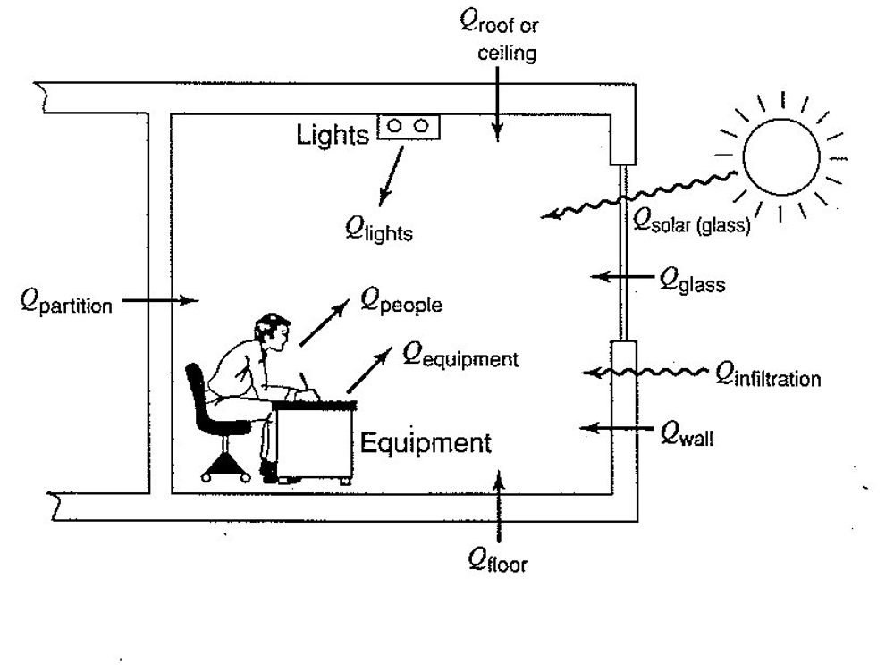
Figure 1: Cooling Load (Pita, 2002)

Conduction through exterior walls, roof, and glass
Concerning conduction through the exterior structure, the cooling loads induced by conduction heat gains through the exterior roof, walls, and glass are determined using the following equation:
Q=U x A x CLTD
where
- Q= cooling load for roof, wall, or glass, BTU/hr
- U = overall heat transfer coefficient for roof, wall, or glass, BTU/hr-ft2-F
- A = area of roof, wall, or glass, ft2
- CLTD = corrected cooling load temperature difference, F (Pita, 2002)
The cooling load temperature difference (CLTD) is not the actual temperature difference between the outdoor and indoor air. It is a modified value that accounts for the heat storage/time lag effects.

Conduction through interior partitions, ceilings, and floors
The heat that flows from interior unconditioned spaces to the conditioned space through partitions, floors, and ceilings can be found from following equation
where
Q = U x A x TD
- Q = heat gain (cooling load) through partition, floor, or ceiling, BTU/hr
- U = overall heat transfer coefficient for partition, floor, or ceiling, BTU/hr-ft2-F
- A = area of partition, floor, or ceiling, ft2
- TD = temperature difference between unconditioned and conditioned space, F (Pita, 2002)
If the temperature of the unconditioned space is unknown, a commonly employed approximation is to assume that it is 5°F lower than the outdoor temperature. Spaces containing heat sources, such as boiler rooms, may have significantly higher temperatures.

Solar Radiation Through Glass
Radiant energy from the sun permeates transparent materials like glass, resulting in a heat gain within the room. This value fluctuates based on factors such as time, orientation, shading, and storage effects. The solar cooling load is determined by the following equation:
Q=SHGF x A x SC x CLF
where
- Q = solar radiation cooling load for glass. BTU/hr
- SHGF = maximum solar heat gain factor, BTU/hr-ft2
- A = area of glass, ft2
- SC = shading coefficient
- CLF = cooling load factor for glass (Pita, 2002)
The maximum solar heat gain factor (SHGF) is the maximum solar heat gain through single clear glass at a given month, orientation, and latitude.
External Shading Effect
Shading from building projections or other objects external to the structure can cast shadows on all or part of the glass. In such scenarios, only indirect radiation reaches the glass from the sky and ground. The Solar Heat Gain Factor (SHGF) values for any shaded glass are equivalent to those of the north side of the building, which also receives solely indirect radiation. To determine the total radiation passing through partially shaded glass, it is essential to identify the proportion of the glass area that is shaded.
Design conditions
Cooling load calculations are typically based on indoor comfort requirements and outdoor conditions derived from historical data, with summer design temperatures typically occurring from June to September in the northern hemisphere. These outdoor conditions are established by considering reasonable maximums and are exceeded for about 35 hours annually. Both Dry Bulb (DB) and simultaneous Wet Bulb (WB) temperatures are provided together for use as design values. It's important to note that occasionally, maximum cooling loads may occur in months other than the summer due to solar radiation, necessitating awareness of design conditions during those periods (Pita, 2002).

Lighting
The equation for determining cooling load due to heat gain from lighting is
Where,
Q=3.4×W× BFX CLF
Q = cooling load from lighting, BTU/hr
W = lighting capacity, watts
BF = ballast factor
CLF = cooling load factor for lighting
The term W denotes the rated capacity of the currently used lights, expressed in watts. In numerous scenarios, all lighting is continuously operational, but if not, the specific amount should be utilized. The value 3.4 facilitates the conversion of watts to BTU/hr. The factor BF accommodates heat losses in the ballast of fluorescent lamps or other special losses, with a typical value of 1.25 for fluorescent lighting. Incandescent lighting, on the other hand, incurs no extra loss, and BF is set at 1.0 (Pita, 2002).
The factor CLF addresses the storage of a portion of the heat gained from lighting. This storage effect depends on factors such as the duration of operation for lights and the cooling system, building construction, lighting fixture type, and ventilation rate. Certain conditions, including the cooling system operating solely during occupied hours, operation for more than 16 hours, or allowing the space temperature to rise during unoccupied hours (temperature swing), prohibit the presence of a storage effect.

People
The heat gain from individuals consists of two components: sensible heat and latent heat produced by perspiration. While some of the sensible heat may be assimilated by the heat storage effect, the latent heat remains unaffected. The formulas for determining cooling loads arising from sensible and latent heat gains from individuals are as follows:
Qs = qs x n x CLF
Qi = qi x n
where
- Qs, Qi sensible and latent heat gains (loads)
- qs, q1= sensible and latent heat gains per person
- n = number of people
- CLF = cooling load factor for people
The rate of heat gain from people depends on their physical activity.

Equipment and Appliances
Heat gain from equipment can sometimes be obtained directly from manufacturer data or nameplate information, considering intermittent usage. Certain equipment produces both sensible and latent heat. The heat generated by motors and the equipment they drive results from converting electrical energy into heat. The proportion of heat transferred to the air-conditioned space depends on whether both the motor and driven load are located in the space or if only one of them is.

Infiltration
Infiltration, the entry of air through cracks around windows or doors, leads to both sensible and latent heat gain within rooms. Most summer air conditioning systems incorporate mechanical ventilation with some outside air, reducing or eliminating infiltration by creating positive air pressure within the building. Ventilation air affects the central cooling equipment but doesn't contribute to the room's load. Many modern buildings have fixed (sealed) windows and, as a result, experience no infiltration loss, except for at entrances.

Peak Room Cooling Load
The room cooling load is the summation of all cooling load components in the room, including roof, walls, glass, solar, people, equipment, and infiltration.
The intensity of external heat gain components varies with the time of day and year due to changes in solar radiation, sun orientation, and outdoor temperatures. As a result, the total room cooling load varies. While peak load times are sometimes evident upon inspection, calculations at different times may be necessary. General guidelines can help in this regard:
- West-facing glass experiences its maximum load in mid-summer during the afternoon.
- East-facing glass has its maximum solar load in early or mid-summer in the morning.
- South-facing glass reaches its maximum solar load in the fall or winter in early afternoon.
- Southwest-facing glass has its peak solar load in the fall during the afternoon.
- Roofs encounter their maximum load in the summer in the afternoon or evening.
- Walls reach their peak load in the summer in the afternoon or evening.
These generalizations assist in approximating peak room load times. For instance, a south-facing room with extensive window area is expected to have a peak load in early afternoon during the fall, not the summer. However, a room with a smaller glass area may experience peak load during a summer afternoon, with wall and glass heat conduction playing a significant role. Determining the exact time and value of the peak load requires a few calculations once the appropriate day and time are identified.

Cooling Coil Load
The cooling coil load means the rate at which heat must be removed by the equipment to produce the desired cooling effect. The cooling coil load is greater than the building load due to following factors:
- Ventilation
- Heat gains to ducts
- Heat produced by the air conditioning system
- Air leakage from ducts

Ventilation
Typically, a certain amount of outdoor air is introduced into a building for health and comfort considerations. The sensible and latent heat content of this air is generally higher than that of the indoor air, making it a component of the cooling load. However, the excess heat is typically extracted by the cooling equipment, specifically the cooling coil, making it part of the cooling coil load rather than the overall building load.
The equations for determining the sensible and latent cooling loads from ventilation air are
where
Q = 1.1 x CFM × TC
Q1 = 0.68 × CFM × (W1 – W2)
- Qs, Q;= sensible and latent cooling loads from ventilation air, BTU/hr
- CFM = air ventilation rate, ft3/min
- TC= temperature change between outdoor and inside air, F
- W1, W2 outdoor and inside humidity ratio
The total heat Q, removed from the ventilation air is Qi-Qs + Qt.

Heat gain due to ducts
As conditioned air travels through ducts, it inevitably absorbs heat from its surroundings. When the duct traverses conditioned areas, this heat gain contributes to a beneficial cooling effect. However, if the ducts pass through spaces without conditioning, it represents a loss of sensible heat, which needs to be considered while calculating the Building Sensible Cooling Load (BSCL). The calculation of this heat gain can be determined using the heat transfer equation:
Q=U X A X TD

Duct system air leakage
Air leakage commonly occurs at joints in duct systems. Regrettably, many systems exhibit unnecessarily high levels of air leakage due to careless installation. However, with meticulous work, duct leakage can be limited to 5% or less of the total Cubic Feet per Minute (CFM). If the ducts are located outside the conditioned space, the impact of leakage must be incorporated into the Building Sensible Cooling Load (BSCL) and Building Latent Cooling Load (BLCL). In cases where air leaks into the conditioned space, it contributes to effective cooling, but caution is needed to ensure that the distributed air reaches the intended location.
Also fan and pump heat generated within the system needs to be considered for cooling loads.
After cooling load is calculated the amount of the air to be supplied to meet the required comfort criteria is determined (Pita, 2002).

References
Chadderton, D. V. (2007). Building Services Engineering (5th Edition ed.). New York: Taylor and Francis Group.
Fred Hall, R. G. (2007). Building Services Handbook (4th Edition ed.). Oxford, Burlington: Elsevier Limited.
GoN. (2015). Nepal National Building Code NBC 206:2015, Architectural Design Requirements. Government of Nepal, Ministry of Urban Development, Department of Urban Development and Building Construction.
Joseph B Wujek, F. R. (2010). Mechanical and Electrical Systems in Architecture, Engineering and Construction (5th Edition ed.). New Jersey: Pearson Education Inc.
Ogawa, A. (2012, May 2). Wikimedia Commons. Retrieved September 17, 2023, from https://upload.wikimedia.org/wikipedia/commons/1/1c/Psychrometric_chart.png
Pita, E. G. (2002). Air Conditioning Principles and Systems; An Energy Approach (4th Edition ed.). New York: Prentice Hall, Ohio.
Sarao, A. S. (2020). Refrigeration and AIr Conditioning. Satya Prakashan.

