Lecture Notes
BUILDING SERVICES III
Chapter 8
Fire Safety Codes, Lifts and Escalators, Construction Equipment
Lecturer: Assoc. Prof. Manchan Tiwari
10-29-2023

Summary of NBC Code 107:1994
The provided text outlines guidelines related to fire safety and building design. Here's a summary:

Fireplaces and Chimneys:
Buildings with kitchens should have fireplaces and chimneys to reduce the risk of accidental fires.
Open hearths are discouraged, and timber construction near fireplaces should be enclosed by suitable materials.

Fire Extinguishers:
Occupants are encouraged to install portable fire extinguishers.
Adequate water storage is recommended for buildings using open hearths or kerosene stoves.

Fire Zones:
Fire zones in urban areas should be demarcated in consultation with municipal authorities, adhering to specified requirements.

General Requirements:
Buildings should be designed to contain fires and prevent their spread to other structures.
Proper access, wide doors, fire escape ways, and open spaces are essential design considerations.

Exit Requirements:
Exits should allow for rapid evacuation and meet size requirements, visibility standards, and absence of obstructions.
The number and width of stairs, fire escapes, and exit doors are specified based on building size and purpose.

Access to a Building:
Building access should comply with zoning requirements and not lead to dead ends or obstruct fire engine passage.

Lightning Arresters/Conductors:
Lightning arresters, connected to an earth rod, should be installed in the highest part of every building to minimize the risk of fire caused by lightning strikes.

Summary of NBC 206:2003

Refuge Area
A refuge area is a specific designated space within a building intended to accommodate occupants during a fire or other emergency when evacuation may be unsafe or unfeasible. Individuals can remain there until the rescue team arrives. These areas are essential in tall buildings exceeding a height of 25 meters, where the standard fire brigade may face limitations in reaching higher levels.

Lift Requirement
High-rise structures (above 8 stories or 25 meters) should have a minimum of two lifts. One of these lifts must be designated as a fire lift, intended for use by firefighters during emergencies for rescue and access.
Fireman's lifts should have a loading capacity of no less than 500kg (equivalent to 8 persons). The lift car for the fire lift must have a floor area of not less than 1.44 square meters. The electric supply for the fire lifts and Hospital lifts shall be on a separate supply line from the supply mains. In case of failure of normal electric supply, it shall automatically trip over to an alternate power source.

Indian standard summary
Each structure must be constructed, furnished, upheld, and operated in a manner that prevents excessive risk to the lives and safety of occupants from fire, smoke, fumes, or panic during the duration required for evacuation (NBCI, 2007).
The guidelines outline the specifications for exits in buildings, emphasizing their critical role in ensuring the safety of occupants during emergencies, particularly fires. Exits can take various forms, including doorways, corridors, internal or external staircases, verandahs, or terraces. Lifts and escalators are explicitly excluded from being considered exits. Maintenance of exits, exit access, and exit discharge without obstructions is highlighted as crucial for their effective use in emergencies.
The provision underscores the necessity for buildings intended for human occupancy to have sufficient exits to facilitate the safe evacuation of occupants during emergencies. Any alterations to buildings must not reduce the number, width, or protection of exits below the required standards. Visibility and clarity are stressed, with exits being mandated to be clearly visible, marked, and equipped with illuminated signs. These signs must be wired to an independent electrical circuit with an alternative power source. Illumination requirements for floor areas covered by exits are specified, with adjustments allowed in certain assembly areas during performances.

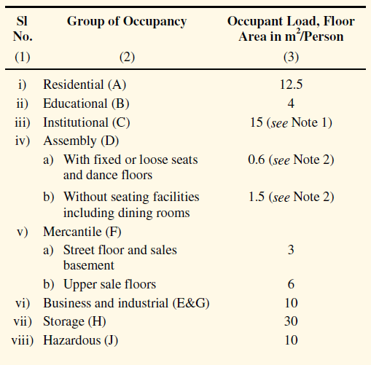
Fire doors with a two-hour fire resistance rating are required at strategic points along escape routes to prevent the upward spread of fire and smoke. Additionally, exits must provide continuous means of egress to the exterior of the building or an open space leading to a street. The arrangement of exits ensures that they can be reached without passing through another occupied unit, enhancing the efficiency of evacuation routes. The provisions aim to establish a comprehensive and standardized framework for the design and maintenance of exits in buildings to safeguard lives during emergencies.
Table 1: Occupants Load (NBCI, 2007)
To ascertain the necessary exits, the count of individuals within a floor space or the occupant load should be calculated using the real number of occupants. However, this count should not fall below the minimum specified in the table.
The standard unit for measuring exit capacity is 500 mm, with an additional half unit counted for a clear width of 250 mm. Clear widths less than 250 mm are not considered for exit width calculations.
Table 2: Occupants per unit exit width (NBCI, 2007)
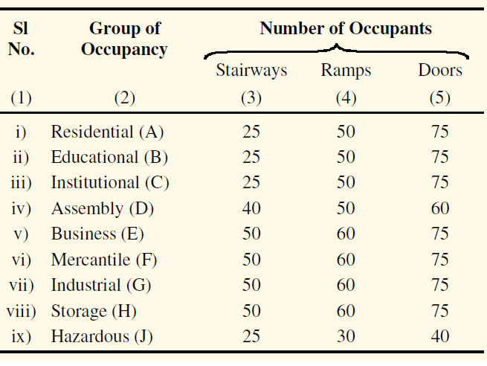
Exits must be positioned to ensure that the travel distance on a floor does not surpass the values as specified in guidelines. In the case of a dead end in a corridor, the travel distance to an exit should not exceed half of the specified distance.

Elevator
Building conveying systems includes various mechanical systems designed to transport occupants and goods within a structure. These systems include elevators, dumbwaiters, escalators, moving ramps, walkways, lifts for people and wheelchairs, and specialized material-handling equipment for business and industrial settings. In large facilities, there may be additional features like monorails and other people movers. These systems play a crucial role in the overall energy consumption of buildings, with estimates suggesting that elevators alone can account for about 5% of a building's total energy usage. Consequently, they contribute significantly to operational costs. Therefore, careful consideration of building conveying systems is essential during the initial design phase, as they are integral to the overall occupant traffic system, which also includes corridors, stairs, and exits.
An elevator serves as a transport mechanism for moving individuals or cargo vertically, typically between different levels of a building. There are two fundamental types of elevator technologies: hydraulic and traction. Table 3 provides a comparison of elevator types and their designed speeds
Table 3: Design speeds for elevators (Joseph B Wujek, 2010)
Type | Residential | Commercial | Speed | m/min
Hydraulic | 6 floors or less | 3 floors or less | Low | 30
Hydraulic | 6 floors or less | 6 floors or less | Low | 45
Traction (Geared) | 18 floors or less | 5 floors or less | Moderate | 60
Traction (Geared) | 18 floors or less | 9 floors or less | Moderate | 105
Traction (Geared) | 18 floors or less | 18 floors or less | Moderate | 135
Traction (Gearless) | Over 18 floors | 15 floors or less | High | 150
Traction (Gearless) | Over 18 floors | 15 to 25 floors | High | 210
Traction (Gearless) | Over 18 floors | Above 25 floors | High | 305

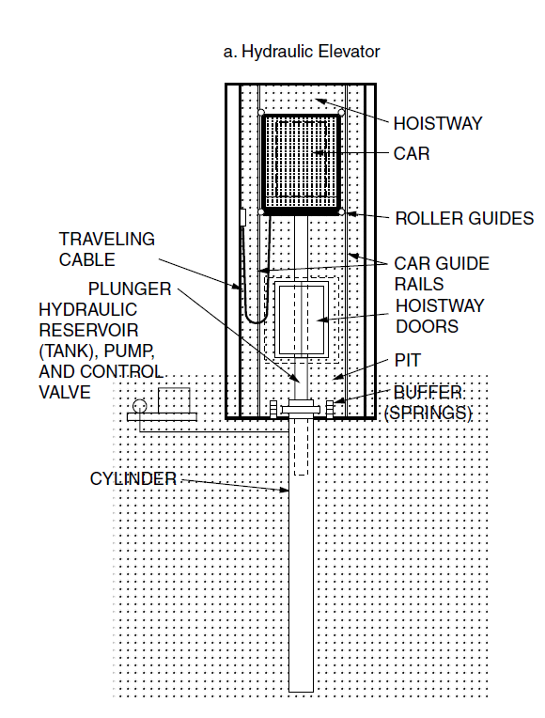
Hydraulic Elevator
Figure 1: Hydraulic lift (Joseph B Wujek, 2010)
Hydraulic elevators operate through a fluid-driven hydraulic jack mechanism, as illustrated in Figure 1. The key components include a hydraulic jack comprising a cylinder and plunger, an electric motor-powered pump that elevates hydraulic fluid pressure, a control valve regulating pressure in the jack, and a fluid reservoir. The process involves the pump pressurizing oil drawn from the reservoir, directing it through the oil line to the jack, thus lifting the elevator car. Conversely, releasing fluid through the control valve and back to the reservoir reduces oil pressure, facilitating the downward movement of the plunger and connected car.
Conventional hydraulic elevators utilize an in-ground hydraulic jack, requiring a deep hole beneath the bottom landing. This hole is drilled and cased before building construction. Telescopic hydraulic elevators, however, incorporate concentric tubes in the plunger, allowing for a shallower hole. Holeless hydraulic elevators feature jacks beside the rails, eliminating the need for holes and permitting dual or single jack configurations with different entrance options.
Roped hydraulic elevators, combine ropes and hydraulic power. They consist of a cantilevered car lifted by ropes passing over a sheave attached to the top of a hydraulic plunger. Single rope configurations lack rear entrances. Each elevator type has distinct advantages, making them suitable for various architectural and operational considerations within buildings.

Traction Elevator
Traction elevators are a type of elevator system characterized by their drive machine, which typically includes an electric motor and a grooved drive sheave. These components work in conjunction with steel cables, referred to as hoisting ropes, to move the elevator car up and down. Traditionally, these systems used a wire rope pattern known as 8x19, featuring eight strands with 19 wires per strand, but modern patterns are now replacing it. The hoisting ropes must precisely match the drive sheave for optimal performance and durability.
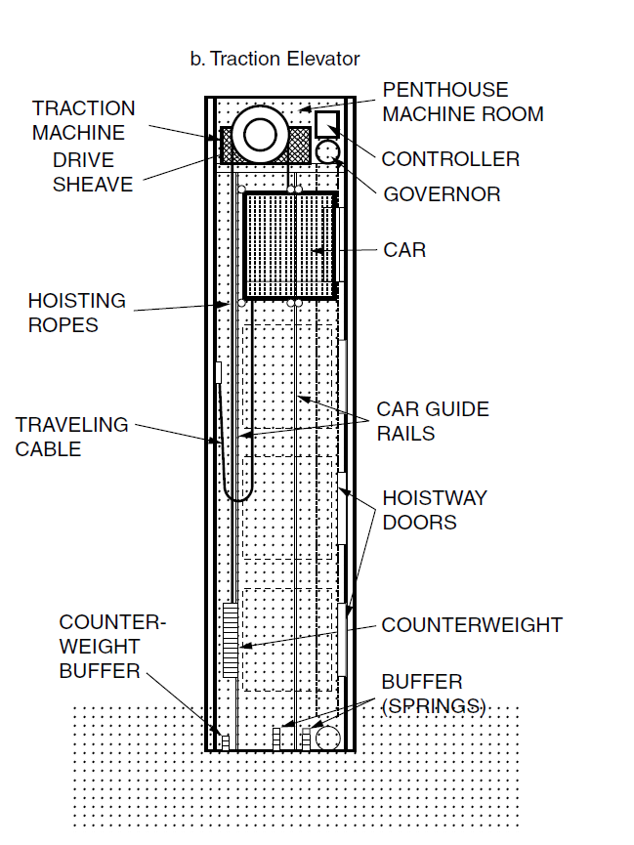
Counterweights are essential components in traction elevators, as they counterbalance the weight of the car, ensuring smooth operation. These counterweights are typically made of steel or iron plates and are designed to equal the dead weight of the car plus 40 to 50% of its load capacity. The friction generated between the hoisting ropes and the drive sheave is harnessed to move the elevator car efficiently.
Figure 2: Traction Elevator (Joseph B Wujek, 2010)
Traction machines, driven by either AC or DC electric motors, play a crucial role in elevator operation. Geared traction machines use low-speed, high-torque motors and a reduction unit to control the movement of elevator cars by rolling steel hoist ropes over a drive sheave. This type is well-suited for lower-speed applications like basements or overhead systems. On the other hand, gearless traction machines employ high-speed, direct-drive electric motors, with the drive sheave directly attached to the motor. They are ideal for high-speed elevator systems and skyscrapers.
A notable innovation in the field is the machine room-less (MRL) elevator, introduced in the mid-1990s. MRL elevators use gearless traction machines, mounted within the hoistway directly above the car, resulting in smaller and more efficient systems. They reduce energy consumption by approximately 50% compared to traditional traction elevators and eliminate the need for a separate machine room, making them an attractive choice for modern buildings, saving floor space, and improving energy efficiency.

Basic Components of Elevators
The basic components of an elevator include:

Elevator Car:
The car is the part of the elevator that passengers or goods occupy during the ride. It typically has doors that open and close for entry and exit. It includes the frame, enclosure, along with car doors. A platform serves as the framework to which the car is mounted, providing a horizontal surface for passengers or cargo.

Counterweight:
The counterweight is used to balance the load of the elevator car, ensuring smooth and energy-efficient operation. The functions of counterweight are:
- Balancing the load: Elevators are designed to transport passengers and cargo, which can vary in weight. The counterweight helps to balance the weight of the elevator car and its occupants. This balance ensures that the elevator operates efficiently and consumes less energy.
- Reducing the workload on the motor: When the counterweight balances the load, it reduces the amount of work the elevator's motor has to do. This efficiency is especially important in tall buildings with heavy loads, as it helps to save energy and reduce wear and tear on the elevator system.
- Safety: Counterweights play a crucial role in elevator safety. If the counterweight system fails, modern elevators are designed to activate safety mechanisms that will bring the elevator to a halt, preventing it from plummeting or moving uncontrollably. This provides an added layer of protection for passengers.
- Smooth and controlled motion: The counterweight helps maintain a controlled and smooth motion for the elevator. It prevents the elevator from accelerating or decelerating too quickly, ensuring a comfortable and safe ride for passengers.

Electric Motor:
The electric motor powers the elevator by driving a system of pulleys or sheaves connected to the elevator's cables. It is responsible for moving the elevator car up and down.

Guide Rails:
Guide rails are vertical or inclined tracks that run along the sides of the elevator shaft. These rails keep the elevator car and the counterweight aligned and prevent them from swaying during movement.

Elevator Cables:
Elevator cables are typically made of strong steel and are attached to the elevator car and counterweight. They are wound around the sheave to lift and lower the car.

Sheave and Pulley System:
The sheave is a large wheel connected to the motor that holds the elevator cables. It works in conjunction with pulleys to transmit power from the motor to the elevator car and counterweight.

Control System:
The control system consists of various electrical and electronic components that manage the operation of the elevator. This includes buttons and indicators inside the elevator car, call buttons on each floor, safety features, and a control panel often located in a machine room.

Safety Mechanisms:
Elevators are equipped with several safety features, including emergency brakes, overspeed governors, and buffers. These components are designed to stop the elevator in case of malfunction or emergencies, ensuring the safety of passengers.

Hoistway or Elevator Shaft:
This is the vertical shaft within a building where the elevator car and counterweight move. The guide rails are attached to the walls of the hoistway, and it contains the mechanical components necessary for the elevator's operation.

Doors and Door Operators:
Elevator cars have doors for entry and exit, and these doors are typically operated by a motorized system. Sensors ensure that the doors open and close safely.

Machine Room (optional):
In some cases, there may be a machine room located adjacent to the elevator shaft. This room houses the motor, control system, and other equipment. In modern designs, machine room-less (MRL) elevators are becoming more common, where these components are integrated into the shaft.

Classification of Elevators
Elevators can be classified into various categories based on different criteria, including their purpose, technology, capacity, and location. Some common classifications of elevators are:
- Passenger Elevators: These are the most common type and are designed for transporting people within buildings. They come in various sizes and capacities.
- Freight Elevators: These elevators are specifically designed for transporting goods and cargo. They typically have higher weight capacities and durable interiors to withstand the movement of heavy loads.
- Hospital/Clinical Elevators: These are designed for use in medical facilities and are equipped to accommodate stretchers and medical equipment.
- Residential Elevators: Installed in homes, these elevators provide accessibility for people with mobility issues or can be used to transport goods between different floors in a house.
- Service Elevators: Typically found in commercial buildings, these elevators are used by maintenance and service personnel for transporting equipment, tools, and supplies.

Elevator Selection Guidelines
Table 4: Standard dimension of passenger elevators (Joseph B Wujek, 2010)
No. of Persons | Capacity (kg) | External Dimensions (mm)
8 | 550 | 1445 * 1200
10 | 680 | 1445 * 1420
11 | 750 | 1445 * 1520
13 | 900 | 1645 * 1520
15 | 1000 | 1645 * 1720
17 | 1150 | 1850 * 1675
20 | 1350 | 1850 * 1905

Table 5: Guideline for Elevator design (Joseph B Wujek, 2010)
Building Type | Guideline
Office Buildings | One elevator per 45000 usable ft2
Office Buildings | Number in a single group should not exceed eight
Office Buildings | No single group should serve more than 16 levels
Office Buildings | A separate service elevator should be considered above 4 floors
Office Buildings | Additional elevators for cafeterias, central supplies etc.
Apartments/Hotels | One elevator for every 60-75 rooms with one additional service e

Escalators
Escalators operate through a sophisticated combination of structural elements and mechanisms, each designed to ensure safe and efficient transportation of individuals within various settings, catering to different traffic demands and spatial considerations. Their construction and engineering enable them to move large volumes of people, matching the requirements of diverse public spaces.
Escalators are motorized moving stairway systems used to transport people in a continuous manner, either in a linear or spiral configuration. Spiral escalators are specifically designed to align with the structure of a building and are utilized in areas where elevators might not be practical or efficient. Typically, 15 to 20 elevators would be needed to match the capacity of an escalator system. They can be situated in the same space as regular stairs and are efficient in moving large crowds without a waiting interval, making them ideal for places like department stores, malls, stadiums, airports, and various public buildings. Factors influencing their design encompass physical requirements, safety concerns, traffic patterns, aesthetics, and the specific location they'll be installed in.
Escalators, while costly and sizable, consist of several fundamental components that facilitate their operation.
- The drive unit, powered by a constant-speed AC electric motor, propels the escalator using a sprocket drive system at both ends to move the steps or pallets.
- These steps, typically made of die-cast aluminum or steel, form the moving platform for passengers and circulate on tracks while staying horizontally aligned.
- The balustrade, featuring handrails, provides safety and support for riders, synchronizing its movement with the steps.
- Structurally, a truss supports the escalator's load and houses the machinery, including the electric motor, drive gears, and chains that connect to each step.
- Escalators, powered by constant-speed AC motors, generally move at 1 to 2 feet per second, with their capacity matching anticipated peak traffic demand.
The maximum incline angle of an escalator is around 30 degrees from the horizontal level. Commercial escalators typically rise up to approximately 60 feet, while transit escalators can reach heights of up to 164 feet.
These systems are designed to transport individuals efficiently. For instance, a 24-inch (600 mm) escalator moving at 1.5 feet (0.45 m) per second can transport roughly 170 individuals within a 5-minute period. They are particularly engineered to accommodate the expected peak traffic demands of their specific environments.

Components of Escalators

Drive Unit:
This is the power mechanism of the escalator, usually comprising an electric motor, decelerator, electromagnetic brake, V belt, sprocket, and various other components. It's responsible for driving the movement of the escalator.

Steps or Pallets:
These are the moving platforms on which passengers stand. Typically made from one-piece, die-cast aluminum or steel, these steps move along tracks, staying horizontally aligned.

Sprocket Drive:
Located at the top and bottom of the escalator, the sprocket drive includes wheels that drive the steps. The top sprocket drives the moving steps, while the bottom sprocket turns the steps.

Balustrade:
This is the enclosing side of the escalator, extending above the steps. It includes components such as skirt panels, interior panels, decks, and handrails. The moving handrail provides support and safety for passengers, synchronized with the movement of the steps.

Truss:
The truss is a structural steel assembly that supports the escalator's load. It's attached to the top and bottom landing platforms and houses the escalator's machinery, including the electric motor, drive gears, and chains that connect to each step.

Electric Motor and Gears:
Located within the truss, the electric motor powers the drive gears. There are drive gears at the top and return gears at the bottom, connected by chains that help move the steps up or down the escalator.

Constant-Speed AC Motor:
The escalator is powered by a constant-speed alternating current motor, moving passengers at a speed typically ranging from 1 to 2 feet (0.3 to 0.6 meters) per second.

Safety Features:
Escalators are equipped with safety features like emergency stop buttons, comb plates to prevent objects from getting trapped in the steps, and various sensors for detecting irregularities or obstructions.

Controllers and Sensors:
These control the speed and direction of the escalator, ensuring safe and efficient operation. Sensors monitor various parameters and help in controlling the escalator's performance.
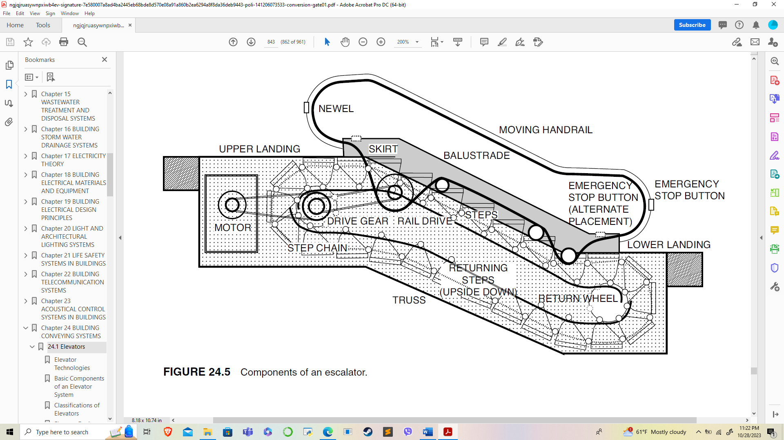
Figure 3: Components of Escalator (Joseph B Wujek, 2010)

Heavy Equipment
Heavy equipment" in construction refers to large, specialized machinery and vehicles designed for various construction tasks. These machines are essential for executing different phases of construction projects, offering the capability to handle demanding and labor-intensive tasks efficiently. They are typically characterized by their size, power, and specialized functionality.
Some of the heavy equipment are:

Excavator:
An excavator is a heavy construction machine equipped with a boom, stick, bucket, and cab on a rotating platform. It's primarily used for digging, trenching, and lifting heavy materials. The versatile arm and bucket allow it to perform a wide range of tasks, from digging trenches to demolishing structures.

Front Loader:
A front loader, also known as a wheel loader, is a powerful vehicle equipped with a large, front-mounted bucket. It's used for loading, carrying, and transferring loose materials, such as soil, gravel, or sand, within construction sites, quarries, or for general earthmoving tasks.

Backhoe Loader:
A backhoe loader combines a loader in the front and an excavator-like arm on the back. This versatile machine is adept at digging, trenching, loading, and lifting materials. It's commonly used in various construction activities, from excavation to landscaping and utility installation.

Forklift Truck:
A forklift truck is a powered industrial truck equipped with fork-like prongs used for lifting and transporting heavy materials. It's widely employed in warehouses, manufacturing facilities, and construction sites for moving pallets, construction materials, and equipment.

Dump Truck:
A dump truck is a heavy-duty vehicle designed for transporting loose materials, such as sand, gravel, or demolition waste. Its bed can be hydraulically raised at the front, allowing the load to be easily deposited at the required location, such as a construction site or disposal area.

Crane:
Cranes are essential lifting machines used for hoisting and moving heavy materials. They come in various types, such as tower cranes, truck-mounted cranes, and crawler cranes. Cranes are crucial in construction for tasks like lifting steel, concrete, and other heavy building materials.

Truck-Mounted Crane:
This type of crane is mounted on a truck chassis, providing mobility and easy transportation to different job sites. It's versatile, offering the advantages of a crane with the mobility of a truck.

Tower Crane:
Tower cranes are tall, fixed to the ground, and commonly used in high-rise construction. They have a vertical mast with a horizontal jib for lifting heavy loads to great heights on construction sites.

Road Rollers:
Road rollers, also known as steamrollers or compactors, are heavy machines equipped with large, heavy rollers. They're used for compacting and flattening surfaces during road construction to ensure a solid, even foundation.

Concrete Pumps:
Concrete pumps are used for transferring liquid concrete by pumping it to the desired location, especially in hard-to-reach or high-rise construction sites. They are vital for efficient and precise concrete placement.

Compactors:
Compactors are heavy machines designed to compress and compact different materials, such as soil, gravel, or asphalt. They ensure stability and density in construction projects, such as roads, building foundations, or landfills.

Graders:
Graders are used in construction for leveling and grading surfaces, such as roads, ensuring they are smooth and even. These machines have a long blade that can be adjusted for different angles to achieve the desired surface contour.

Loaders:
Loaders, also called front-end loaders, are used for loading and transporting materials like dirt, sand, or gravel. They have a front-mounted bucket and are employed in various construction and earthmoving tasks.

References
Chadderton, D. V. (2007). Building Services Engineering (5th Edition ed.). New York: Taylor and Francis Group.
FIREX. (2023). Smoke Alarms Guide. Retrieved October 12, 2023, from https://smokealarmsdetectors.blogspot.com/2012/10/how-smoke-detector-works.html
Fred Hall, R. G. (2007). Building Services Handbook (4th Edition ed.). Oxford, Burlington: Elsevier Limited.
GoN. (2015). Nepal National Building Code NBC 206:2015, Architectural Design Requirements. Government of Nepal, Ministry of Urban Development, Department of Urban Development and Building Construction.
Joseph B Wujek, F. R. (2010). Mechanical and Electrical Systems in Architecture, Engineering and Construction (5th Edition ed.). New Jersey: Pearson Education Inc.
NBCI. (2007). National Building Code of India 2005. Bureau of Indian Standards.
NFPA. (2021). Fire Protection Handbook. National Fire Protection Authority.
Ogawa, A. (2012, May 2). Wikimedia Commons. Retrieved September 17, 2023, from https://upload.wikimedia.org/wikipedia/commons/1/1c/Psychrometric_chart.png
Pita, E. G. (2002). Air Conditioning Principles and Systems; An Energy Approach (4th Edition ed.). New York: Prentice Hall, Ohio.
Sarao, A. S. (2020). Refrigeration and AIr Conditioning. Satya Prakashan.

