Lecture Notes
BUILDING SERVICES III
Chapter 10
Solar PV Systems, Solar Heating Systems
Lecturer: Assoc. Prof. Manchan Tiwari
10-29-2023

Solar Photovoltaics
Solar photovoltaics refers to utilization of solar radiation to generate electrical energy using conversion device such as solar photovoltaic (PV) cell. The amount of electricity or electrical energy generated depends on intensity of solar radiation, size of solar cell, type of semiconductor material and ambient temperature (Sharma & Hasan, 2009). Unlike most of the electricity generation systems, the solar PV cell does not need working fluid such as steam or air, or any mechanical cycle for the conversion of the primary solar energy into electricity. Hence, a photovoltaic system is reliable, simple and convenient without any moving parts (Singal R. , 2011). Solar cell is a basic unit of a photovoltaic system.

Energy in Light (Photon Energy)
The transfer of energy through light occurs in discrete pieces and not continuously. Quantum is the smallest unit of energy and quantum of radiant energy is called a photon (Singal R. , 2011). The energy carried by a photon is proportional to the frequency of the radiation as stated by Planck’s law as shown in equation below.
$$E_{p}=h ×v=h ×\frac{c}{λ}$$ | 1-1
- Where,
  - Ep = Photon energy
  - H = Planck’s constant (6.67 x 10⁻³⁴ J-s)
  - v = frequency of radiation (herz)
  - c = speed of light (2.997925 x 10⁸ m/s)
  - λ = wavelength of radiation (m)
The solar radiation is composed of photons and has energy value equal to its frequency times Planck’s constant. This energy is utilized by solar cell.

Solar Cell
Solar cell is a photovoltaic device, composed of p-n semiconductor junction, which converts the light energy into electrical energy based on the principles of photovoltaic effect. The photovoltaic effect is the creation of voltage or electric current in a material upon exposure to light. The photovoltaic effect can be observed in nature in a variety of materials, but the materials that have shown the best performance in sunlight are the semiconductor. When photons from the sun are absorbed in a semiconductor, they create free electrons with higher energy. Once the electrons are created, there must be an electric field to induce these higher electrons to flow out of the semiconductor to do useful work.

Working of a solar PV cell.
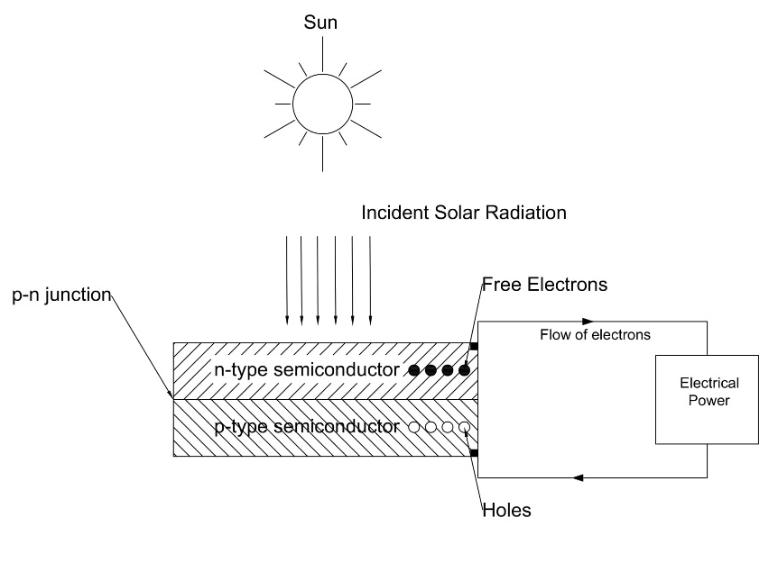
A solar cell consists of P-type semiconductor and n-type semiconductor. Generally, n-type are made from crystalline silicon that has been doped with tiny quantities of impurities (usually phosphorus) such that it possesses a surplus of free electrons. P-type semiconductor are also made from crystalline silicon, but are doped with small amount of impurity (usually boron) which results in deficit of free electrons known are holes. A p-n junction is created by joining the dissimilar semiconductors which sets up electric field in the region. Although, the semiconductors can be made from other elements than silicon, we shall be considering semiconductors based on silicon for the purpose of simplicity.
Figure 1: Working of Solar Cell
Light can be considered as stream of tiny particles of energy, called photons. When the photons from the light fall within the p-n junction, they can transfer their energy to some of the electrons in the material so promoting them to higher energy level. In their excited state the electron becomes free to conduct electric current by moving through the material (Boyle, 2013). Due to the absorbed energy, the free electrons are liberated and when an external circuit is used, it produces the DC current. The DC current is converted into 240 V AC current using an inverter for different applications.
Over 95% of the solar cells produced worldwide are composed of semiconductor material Silicon (Si) (Boyle, 2013). As abundantly found in earth’s crust, silicon has the advantage of being available in sufficient quantities.

Solar Cell
A commercially available solar cell with the dimensions of 15.6 cm x 15.6 cm, the electricity output is more likely rated at 0.5 V with 7 A DC current. It can produce around 3-4 Watts.

Solar Modules and Array
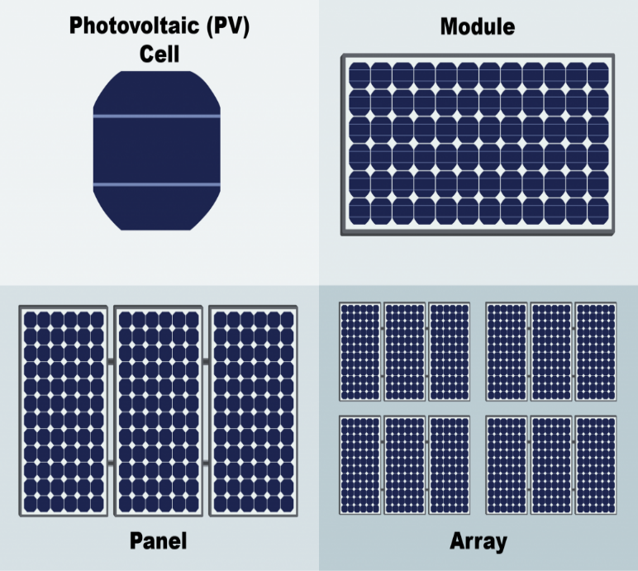
Number of solar cells are combined either in series or parallel to form a solar panel or module to operate at desired voltage and current output. Standard module consists of 36 to 72 solar cells. A P-V module is made of very thin silicon wafer of around 300 micro meter in size. As it is very fragile, the layer of the module is protected from damage by sealing it between layer of toughed glass and layers of EVA (Ethyl Vinyl Acetate (S. Hasan & Sharma, 2009). Below the EVA layer, an insulating sheet is provided , while whole module is attached to an outer frame to provide strength to the module.
Solar Array is a group of similar modules connected in series and parallel to increase the power delivered by the PV system.
- To increase the system voltage maintaining the current, the panel are connected in series connection.
- To further increase the power by increasing the system current, the panel are connected in parallel connection.
Figure 2: Solar Cell, Panel and Array (FSEC, 2022)
As shown in the figure 3, series and parallel connection of various panel of same capacity of 100 Watts and 12 V is shown. When two panels are used the power output is always 200 W, however the difference between series and parallel connection results in the change in output voltage hence varying the system voltage at which power generation takes place. In series connection, two panel results in system voltage of 24 V where as in parallel connection, the output voltage is 12 V. Consequently, the current rating of the system also changes which effects the wire sizing as well. In series connection the current rating is fixed while the voltage rating of the system is increase while in parallel connection, the voltage rating is fixed while the current rating is increased for the system.

Types of Solar Cells

Monocrystalline PV Cell
Monocrystalline solar cells are those made from pure monocrystalline silicon that is, silicon with a single, continuous crystal lattice structure having virtually no defects or impurities. Monocrystalline silicon is produced from polycrystalline silicon in the sophisticated and expensive process. Due to which the monocrystalline cells are highly efficient but expensive. It has appearance of uniform blue color. These modules have efficiency in the range of 15% to 18% and are generally used in medium and large sized plants (Singal R. , 2011).

Polycrystalline PV Cell
Polycrystalline PV cells are easier and cheaper to manufacture than the monocrystalline PV cells, but are less efficient. Polycrystalline silicon essentially consists of small grains of monocrystalline silicon. It has appearance of irregular blue color. It has efficiency in the range of 12% to 14% (Singal R. , 2011).

Amorphous PV Cell
In amorphous silicon (a-Si), the silicon atoms are much less ordered than in the crystalline forms described above. Amorphous silicon cells are cheaper to produce than those made from crystalline silicon. It is also better absorber of light, so thinner (therefore cheaper) films can be used. The manufacturing process operates at lower temperature; hence less energy is required. However, a-Si cells are less efficient. The efficiency achieved is around 5% to 8% (Singal R. , 2011).

Characteristics of Solar Cells

I-V and P-V characteristics at varying Irradiance levels
At constant cell temperature, with the increase in Irradiance, the current produced is increased significantly, whereas the voltage produced is also increased by slight amount. Due to which, the increase in irradiance results in increase in power produced by the solar cell. This is represented in Figure 4.

I-V and P-V characteristics at varying temperature
At constant value of Irradiance incident on the solar cell, with the change in cell temperature, the voltage drop is significant as compared to the increase in current. Increased temperature increases the heat which causes electrical resistance to the flow of electrons. Hence, increase in cell temperature results in decrease in power produced, at constant Irradiance. The figure 5 illustrates the characteristics at varying temperature.

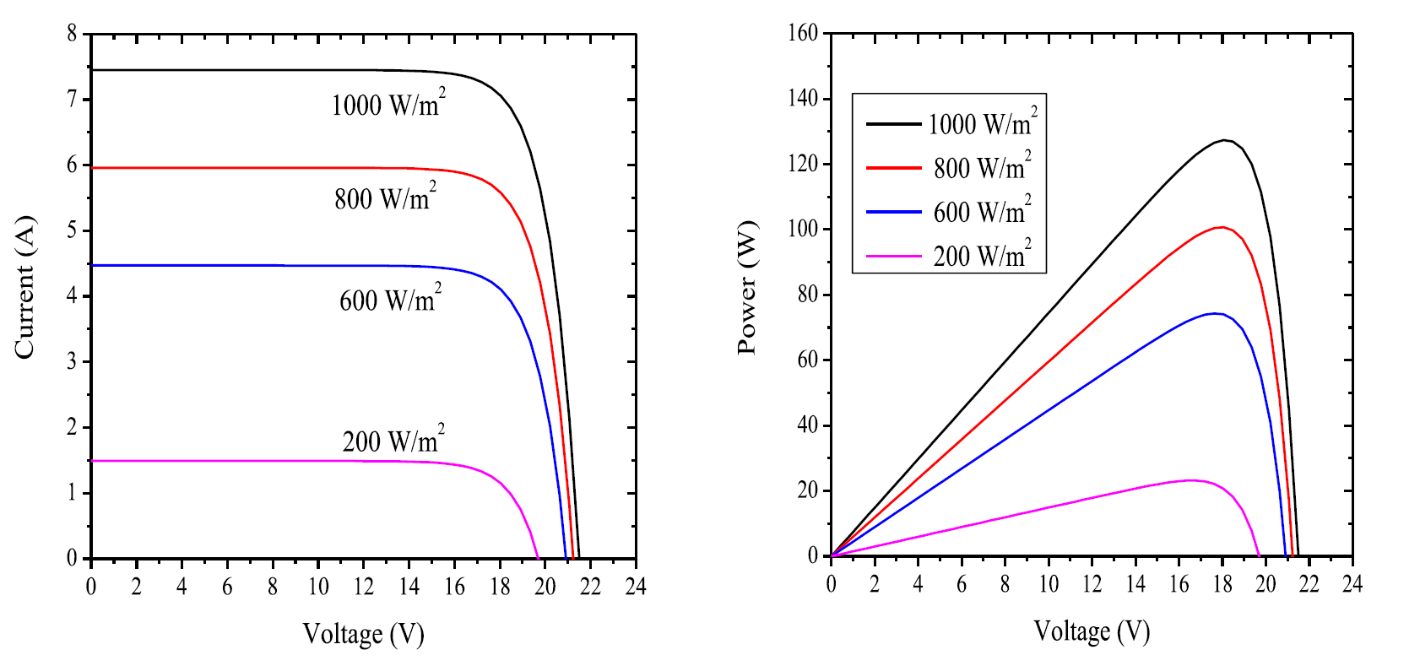
Figure 4: I-V and P-V characteristics at varying Irradiance (Saharia, 2014)
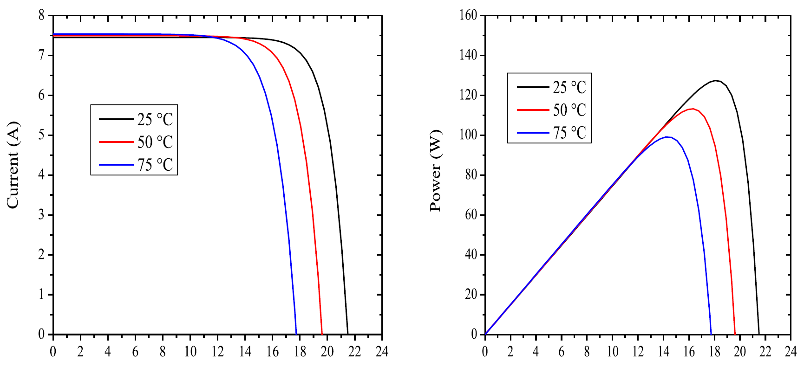
Figure 5: I-V and P-V Characteristics at varying temperature (Saharia, 2014)

Solar PV terminologies
- Open circuit voltage
- Short circuit current
- Voltage at maximum power
- Fill factor
- Efficiency

Open Circuit Voltage (V_{oc})
It is the maximum voltage generated by the cell under given conditions of light and temperature. V_{oc} is the voltage when the load is open circuited, ie. the output current is zero. The output power at this point is again essentially zero.

Short Circuit Current
It is the maximum current (in A or mA) produced by the cell under given conditions of irradiance and surrounding temperature. I_{sc} is the current when the load is short circuited. The output power at this point is zero.

Voltage at Maximum Power (V_{mp})
The voltage that results in maximum power output of a solar cell is called voltage at maximum power. V_{mp} is also called “rated” voltage of the cell

Current at Maximum Power (I_{mp})
The current that results in maximum power output of a solar cell is called current at maximum power. I_{mp} is also called “rated” current of the cell.

Fill Factor (FF)
The fill factor is the ratio of actual maximum power P_{max} to the unattainable but theoretical ideal power that would result from operating at short circuit current and open circuit voltage.
$$FF=\frac{I_{m}×V_{mp}}{I_{sc}×V_{oc}}$$ | 2-1

Total Area Efficiency
It is the ratio of electrical power output (Pmax) to the total light power incident on the entire cell area including frames, interconnects and pattern lines on the surface.
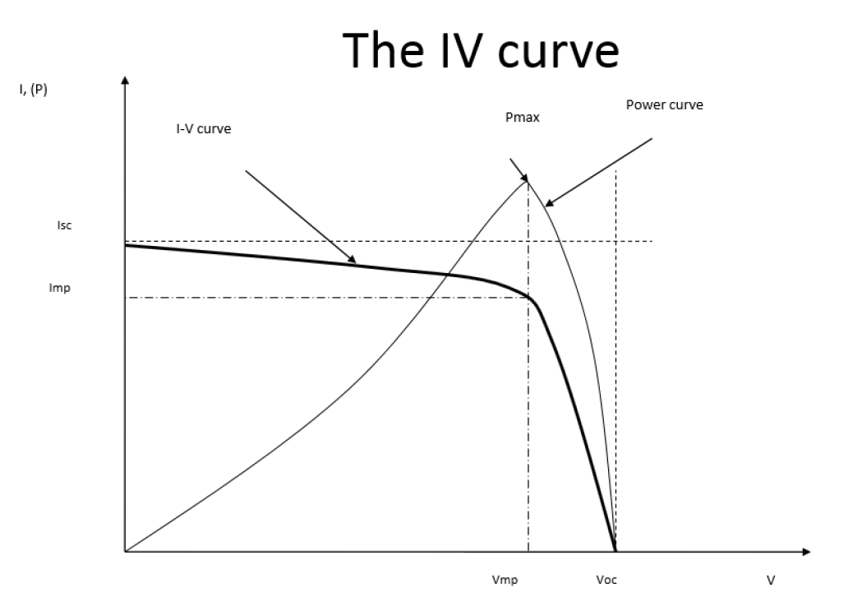
Figure 6: I-V characteristics of typical silicon PV cell under standard test conditions

Factors Effecting Durability of Solar Cells
- Location
- Maintenance
- Soiling
- Environment
- Solar Cell Degradation
- Interconnections Effects of Solar Cell/Module
- Mismatch Effect
- Hot Spot Heating

Solar PV Systems
A typical solar PV system comprises of solar panels/array used to power a given load which can be village load in a community or a specific load for a system such as water pump used for irrigation.
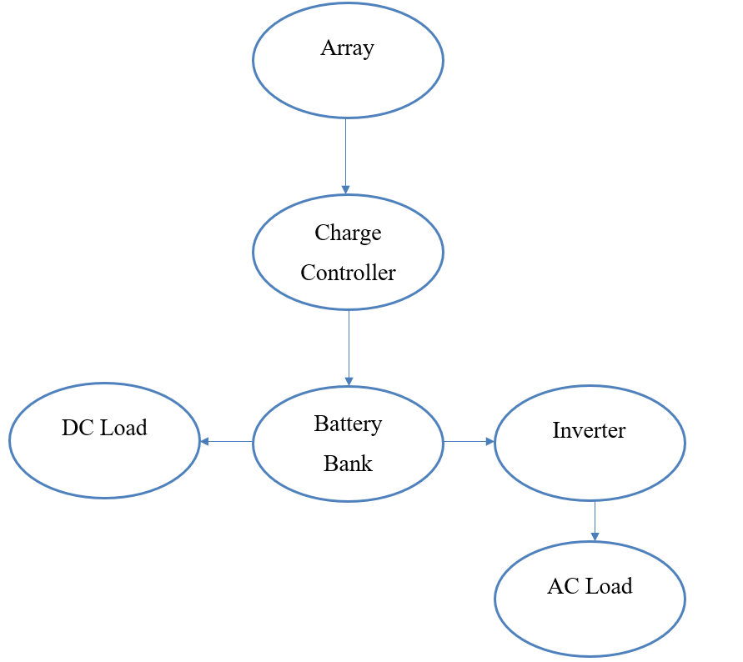
Figure 7: A typical solar PV system
The major components of a typical solar PV system are DC-AC power inverter, battery bank, system and battery controller (charge controller), auxiliary energy sources and sometimes specified electrical load. Some of the types of PV systems are:
- Grid Connected Photovoltaic systems
- Stand Alone Photovoltaic Systems

Grid Connected Photovoltaic Systems
These type of PV systems are interconnected with electric utility grid and operates parallelly. A power conditioning unit is the major component of such system which converts the DC power produced by the PV array into AC power consistent with the requirements of the electric grid.

Stand-Alone Photovoltaic Systems
This type of system operates independent of the electric utility grid and are designated to supply power to specific AC or DC load. A simplest form of stand-alone PV systems is when the power produced from an array is directly used to operate DC load. In such case, due to absence of storage device such as battery, the load can only be operated during sunshine hours. However, many stand-alone PV systems use battery for storage of the power to operate the load outside of sunshine hours (Sharma & Hasan, 2009).

Advantages of Solar PV
- Absence of moving parts
- Direct conversion of light to electricity at room temperatures
- Does not require constant attention and can function on its own
- Low maintenance cost
- No environmental pollution
- Has very long life and is highly reliable
- No cost of fuel
- No starting time required
- Solar PV system can be of varying size, used to operate small load, power a community of produce power in MW for a country.

Limitations of Solar PV
- High initial cost
- Insolation is unreliable due to which storage devices are required
- Requires very large land areas

Solar Thermal Systems
Solar thermal energy (STE) is a technology for harnessing solar energy for thermal energy. The basic purpose of a solar thermal energy system is to collect solar radiation and convert it into useful thermal energy.

Solar Energy Scenario Nepal
- Nepal has a high potential for harnessing solar energy being located in favorable latitude (WECS, 2010).
- The solar insolation in Nepal varies from 3.6 to 6.2 kWh/m2/day and the sunshine is for about 300 days per year (WECS, 2010).
- The monthly daily global solar radiation varies from 120 to 260 w/m² with the annual sun shine duration ranging from 1900 to 2500 hours
- As per report published by Alternative Energy Promotion Centre, Nepal under Solar and Wind Energy Resource Assessment in Nepal (SWERA), the commercial potential of solar power for grid connection is 210hn 80 MW.
- National average sunshine hours of 6.8 hrs per day and average solar insolation of about 4.7 kWh/m2/day, there is a huge potential for solar thermal devices such as Solar water Heaters, Solar Dryers, Solar Cookers.

Types of Solar Thermal Systems

Solar Collector
Solar collector is a device which absorbs the incoming solar radiation, converts it into heat, and transfers this heat to a fluid flowing through the collector. Such converted heat can be used for heating purpose or for the purpose of electricity generation as well. Solar collector can be either flat plate or evacuated tube type (non concentrating type) or concentrating (focusing) type. So, basically the solar collectors can be classified into three types:

Types of Collector
- Flat Plate Collectors
- Evacuated Tube Collectors
- Stationary compound parabolic collectors

Flat Plate Collectors (FPC)
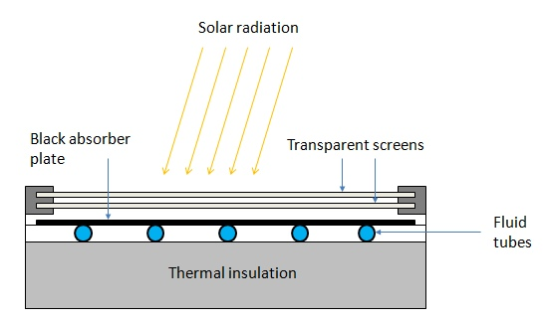
Figure 1 Flat Plate Collector (PennState, 2022)
- Flat plate solar collector consists of an absorber plate, cover glass, insulation, housing and heat transfer fluid tube.
- Absorber plate is generally made of metal to increase the absorption of solar radiation. A large portion of the incident energy is absorbed by the plate and then transferred to the transport medium in the fluid tubes.
- The cover glass or glasses are used to reduce convection and re-radiation losses from the absorber.
- Insulation is used on the back edges of the absorber plate to reduce conduction heat losses.
- The housing holds the absorber with insulation on the back and edges and cover plates.
- The working fluid (water, air) is circulated through the absorber plate to carry the solar energy to its point of use.
- It is used to achieve moderate temperature of up to 100 ⁰C.
- It is used for building heating, industrial process heating.

Evacuated Tube Collectors (ETC)
Evacuated tube collectors comprises of parallel rows of tubes containing water or fluid used for heating. Each tube is made of metal tube surrounded by a larger glass tube. The space between the tube and the glass tube is a vacuum, due to which very little heat is lost from the fluid. The vacuum ensures that there is negligible loss due to conduction or convection, which ensures that the collector can operate at higher temperature that the flat plate collectors. Evacuated tube collectors are used for reduction of losses. ETC can achieve water temperature of up to 250 ⁰C.

Concentrating Collectors
These types of collectors are used for medium and high temperature applications. It is made of a reflecting surface such as reflecting mirror or Fresnel lense which is used in concentrating device such that the solar radiation incident is reflected to a single point and focused on to the absorber. Such concentrator are also rotated through tracking mechanism which helps to track the sun path for increase in the efficiency of the collector. The performance of concentrating collectors is measured by concentration ratio which is the ratio of the aperture area of the concentrator to the area of the absorber. Various types of concentrating collectors are:
- Parabolic Trough Concentrator
  - It is a linear concentrator
  - It has concentration ratio of around 20 to 100
- Parabolic Disc Concentrator
  - It is a point focus concentrator.
  - It has concentration ratio of 100 to 4000 for parabolic and heliostat field concentrator.
  - These are fixed collectors which uses parabolic shaped collectors. The parabolic shaped collectors are made from two sections of a parabola facing each other. These types of collectors can accept incoming radiation over a relatively wide range of angles, by using multiple internal reflections
- Fresnel Lens Concentrator
  - It is capable to achieve temperature as high as 1000 ⁰C. This type of concentrator is used for power generation and process heat supply.

Types of Solar Water Heating System
- Active Solar Water Heating System
- Passive Solar Water Heating SYstem

Active Solar Water Heating System
Active Solar Water Heating System utilizes external power source (pump) to circulate the working fluid to transfer heat from the collector to the desired space.
There are two types of Active Solar Water Heating Systems:

-Direct Circulation Systems
In this system pump circulates the heating fluid (water) through the collectors and in to the home or desired heating space. They work well in climates where the water does not freeze.

Indirect Circulation Systems
In this system pump circulates a non-freezing heat transfer fluid through the collector to a heat exchanger. In the heat exchanger the fluid the heats water which is then circulated into home. This type of system work well in climates prone to freezing temperatures.

Passive Solar Water Heating System
In this system no external power source (pump) is used to circulate the heating fluid or water. Instead, these systems are based on thermos siphon principle.

Thermosiphon System
In thermosiphon system, there is no need for circulating pump and controller. Collector is place below the altitude level of the water tank such that the water flow into the collector due to gravity. When the water in collector gets heating, due to density difference between the hot water in collector and relatively cold water in water tank, the hot water rises up to the tank and consequently the cold water from tank flows to the collector. Due to this the water keeps circulating into the collector and the water temperature is raised. This effect is also called thermo siphon effect.

Solar refrigeration
Refrigeration using solar thermal energy from a solar collector is achieved by operation of vapor absorption refrigeration cycle. Such solar refrigeration is feasible and used in rural regions where electric power is not available. Solar refrigeration can be used to store food in such rural areas. In a conventional vapor compression refrigeration system, the input energy is electricity which operates motor to produce cooling effect. In vapor absorption cycle, the input energy is heat, which is used to operate absorber and generator instead of compressor to produce cooling effect in the evaporator. Hence, the heat required for the vapor absorption cycle is supplied by solar collector to produce refrigeration effect.

Solar Water Pumps
Water pumps are the devices which operate when a motor driven by electrical power converts the electrical power to mechanical power which then operates the water pump. In solar water pump operated by thermal energy, organic vapor Rankine cycle system with rotary machines or screw expanders or reciprocating engine or spiral expander is used to to provide the mechanical power to the water pump.

References
Boyle, G. (2013). Renewable Energy Power For A Sustainable Future (Vol. Third Edition). Oxford: Oxford University Press.
Elprocus. (2022). Retrieved October 9, 2022, from https://www.elprocus.com/what-is-pyranometer-construction-types-applications/
EPEVER. (2019, September 19). Retrieved October 9, 2022, from https://blog.epever.com/what-is-a-series-or-parallel-connection/
FSEC. (2022). Retrieved October 9, 2022, from Florida's Premier Energy Research Center at the University of Central Florida: https://energyresearch.ucf.edu/consumer/solar-technologies/solar-electricity-basics/cells-modules-panels-and-arrays/
IEA. (2022). Retrieved October 9, 2022, from https://www.iea.org/reports/offshore-wind-outlook-2019
Kalogirou, S. A. (2014). Solar Energy Engineering Processes and Systems (Second Edition ed.).
Koirala, D. R. (2019). Principals of Engineering Thermodynamics and Heat Transfer. Kathmandu: Shree Chandeswori Publication Pvt. Ltd. .
PennState. (2022). Retrieved October 8, 2022, from Pennsylvania State University: https://www.e-education.psu.edu/eme811/node/685
Ren, J. (Ed.). (2020). Renewable Energy Driven Future: Technologies, Modelling, Applications, Sustainability and Policies. Academic Press. doi:https://doi.org/10.1016/C2019-0-01298-8
S. Hasan, S., & Sharma, D. (2009). Non-Conventional Energy Resources. Delhi: S. K. Kataria and Sons.
Saharia, B. J. (2014). A comparative study on converter topologies for maximum power point tracking application in photovoltaic generation. Journal of Renewable and Sustainable Energy 6. doi:10.1063/1.4900579
Sharma, D., & Hasan, S. (2009). Non-Conventional Energy Sources (Second Edition ed.). Delhi: S.K. Kataria and Sons.
Singal, R. (2011). Non-Conventional Energy Resources (Vol. Third Edition). Delhi: S. K. Kataria and Sons.
WECS. (2010). Energy Sector Synopsis Report. Kathmandu, Nepal: Government of Nepal, Water and Energy Commission Secretariat.

