Lecture Notes
BUILDING SERVICES III
Chapter 12
Case Study (Renewable Energy Technology incorporated in Buildings)
Lecturer: Assoc. Prof. Manchan Tiwari
11-15-2023

The Pearl Academy Jaipur
The Pearl Academy in India has implemented several passive cooling techniques to create a sustainable and energy-efficient campus. Some of the techniques used in the academy are: (Khan, 2021).
Shading:
The building benefits from a double-skin façade that shields it from the harsh external environment. This design creates a thermal buffer space between the building and its surroundings. The outer skin takes the form of a traditional Rajasthani “jaali,” positioned four feet away from the building. Furthermore, the jaali allows diffused light to enter, reducing direct heat gain. Essentially, the jaali serves the dual purpose of filtering light and air, along with providing privacy. The diffused light brightens studios and classrooms while mitigating direct heat gain, thus regulating internal temperatures.
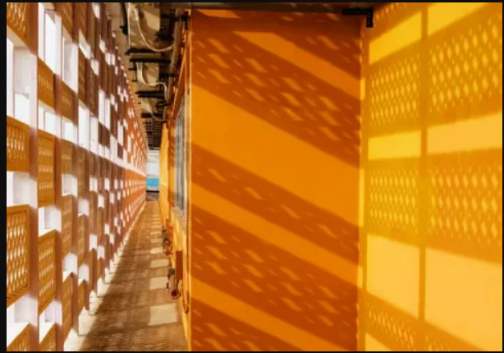
Figure 1: Double Facade in Pearl Academy (Khan, 2021)
Materials:
Locally available materials like stone, glass, and concrete were utilized in the construction, with earthen pots sourced from local potters. Concrete jaalis were also crafted on-site.
Ventilation & Daylighting:
An open-to-sky central courtyard facilitates cross ventilation and unifies the surroundings. Stack ventilation and evaporative cooling techniques contribute to the campus's energy efficiency. The courtyard allows indirect sunlight into classrooms, creating naturally ventilated and lit corridors. For 80% of the operational hours, the campus maintains a comfortable temperature.
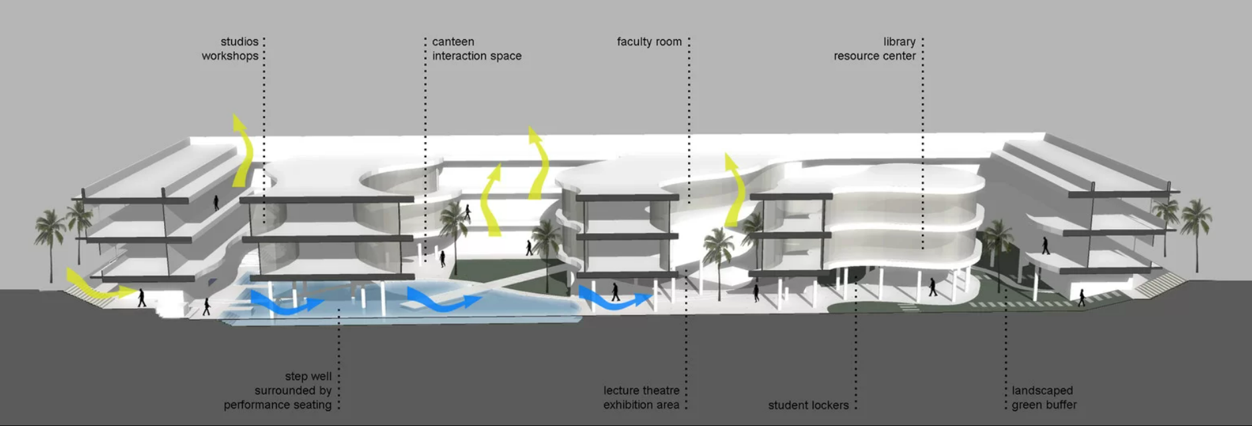
Figure 2: Building Section (Khan, 2021)
The campus, features a single bay design, ensuring natural lighting and cross ventilation. This grid configuration enables daylighting, ventilation, and a flexible partitioning system for future adaptability. Daylight illuminates 90% of the gross floor area.
Insulation:
Traditional earthen pots, used for thermal insulation in India, are employed in the Pearl Academy campus. Placed on the flat roof with a 2.5cm gap in between, these 35cm diameter earthen pots are filled with sand and broken bricks, covered with a thin layer of concrete. The air in the pots acts as insulation for the structure.
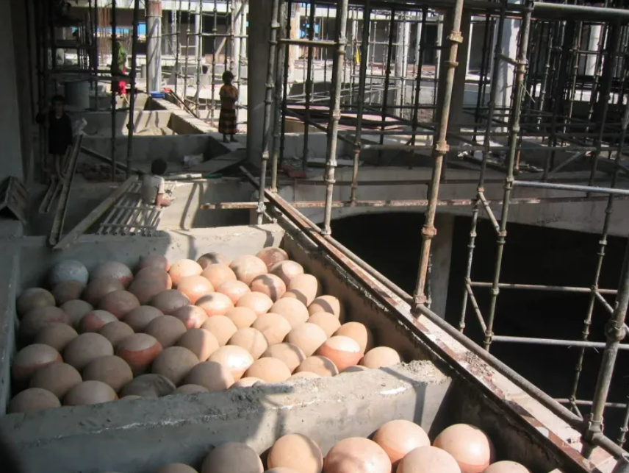
Figure 3: Use of earthern pot for insulation (Khan, 2021)
Landscaping:
30% of the total site area is dedicated to landscaping, creating a thermally comfortable microclimate within the building. A water body, fed by recycled water from the sewage treatment plant, contributes to this microclimate. Green spaces and the water body, mostly shaded, reduce water evaporation and aid in evaporative cooling. During the night, the building dissipates heat to create a thermally comfortable environment. Rainwater harvesting and wastewater recycling through the sewage treatment plant are integral features.
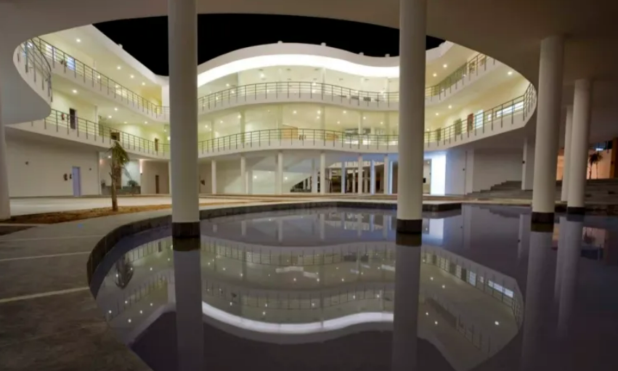
Figure 4: Waterbody in central courtyard (Khan, 2021)
Form Optimization & Orientation:
The building's form is a streamlined rectangle, minimizing exposure to surface area. Classrooms, studios, and offices occupy two stories above in this structure. The thermally banked underbelly features a ramp and serves as a spacious recreation and exhibition area, housing the cafeteria and student spill area. Natural cooling techniques make this area usable throughout the year, even in summers.

Bullit Center
The Bullitt Center, located in the vibrant city of Seattle, stands as a beacon of sustainable innovation and environmental responsibility. Often hailed as one of the world's greenest buildings, this six-story structure redefines the concept of urban architecture by seamlessly blending cutting-edge design with a deep commitment to renewable energy and resource conservation. Completed in 2013, the Bullitt Center has set a remarkable standard for environmentally conscious construction, aiming not only to be energy-efficient but to achieve net-zero energy consumption – a milestone in the realm of sustainable building practices. This iconic facility showcases an array of innovative features, from its massive solar panel array and rainwater harvesting systems to its composting toilets, all working in harmony to create a blueprint for a future where buildings not only coexist with nature but actively contribute to its preservation. The Bullitt Center generates its entire electricity on-site through a rooftop photovoltaic array spanning 14,000 square feet. Diverse water conservation and management methods are implemented within the building, encompassing rainwater harvesting, a green roof, a bioswale for graywater treatment, and the use of composting toilets. Additionally, the building incorporates environmentally friendly elements such as geothermal heating and cooling, the utilization of Forest Stewardship Council–certified wood, and the preference for building materials and finishes devoid of 14 classes of toxic chemicals. As we explore the Bullitt Center, we delve into a paradigm shift towards sustainable urban living, where architectural marvels serve as catalysts for a greener, more ecologically balanced world (Pena, 2014).
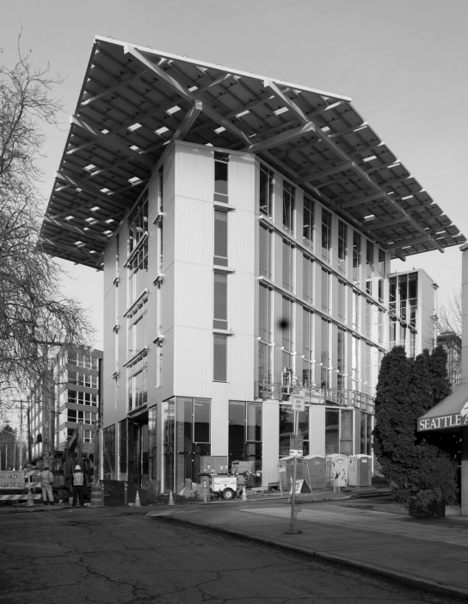
Figure 5: Bullit Center (Pena, 2014)
The Bullitt Center in Seattle is a pioneer in sustainable building design and construction, incorporating a range of renewable energy technologies and innovative features to achieve net-zero energy consumption. Some of the key renewable energy technologies used at the Bullitt Center are (Pena, 2014):

Solar Power:
The Bullitt Center is equipped with a large rooftop solar panel array, harnessing the power of sunlight to generate electricity. The solar panels play a crucial role in meeting the building's energy needs and contribute significantly to its net-zero energy goal.
The Bullitt Center, a paragon of sustainable architecture, showcases an exemplary solar power system that plays a pivotal role in its mission to achieve net-zero energy consumption. Atop the building's roof, an expansive array of solar panels, totaling approximately 575 rooftop modules, captures the abundant Pacific Northwest sunlight, transforming it into a substantial source of clean and renewable energy.
Comprising a photovoltaic (PV) system with an impressive capacity of around 242,000 kilowatt-hours per year, the solar panels generate electricity to power the Bullitt Center's diverse energy needs. The modules are strategically positioned and inclined to optimize sunlight absorption throughout the day, maximizing energy production and efficiency.
The solar power system at the Bullitt Center is seamlessly integrated into the building's design philosophy, adhering to the principles of aesthetic harmony and environmental responsibility. The sleek and modern appearance of the solar panels not only contributes to the building's architectural elegance but also serves as a visible testament to its commitment to sustainable practices.
To further enhance performance, the Bullitt Center's solar power system is equipped with advanced monitoring and control systems. These systems continuously track energy production and consumption patterns, providing real-time data to building operators. This data-driven approach enables precise management of energy resources, allowing for informed decisions on optimizing consumption and further reducing environmental impact.
The solar power system at the Bullitt Center exemplifies a forward-thinking approach to renewable energy integration in urban environments. By harnessing the power of the sun and leveraging cutting-edge technology, the Bullitt Center not only meets its own energy needs sustainably but also sets a shining example for the future of environmentally conscious construction and design.

Geothermal Heating and Cooling:
The building utilizes a geothermal system for heating and cooling. This involves tapping into the stable temperature of the Earth below the surface to regulate the building's interior climate more efficiently. The geothermal system at the Bullitt Center utilizes a series of ground-source heat pumps to tap into the Earth's thermal energy. Vertical boreholes, each extending hundreds of feet into the ground, serve as conduits for heat exchange. During the winter, the system extracts heat from the Earth and transfers it to the building, providing a reliable and efficient source of warmth. Conversely, in the summer, excess heat from the building is transferred back into the ground, ensuring effective cooling without the need for traditional air conditioning.
One of the notable aspects of the Bullitt Center's geothermal system is its integration with the building's radiant heating and cooling distribution system. This system involves circulating water through pipes embedded in the building's structure, using it as a medium to distribute heating or cooling. The geothermal system plays a central role in maintaining the water at an optimal temperature, contributing to the overall energy efficiency of the radiant distribution system.
This geothermal strategy not only reduces the Bullitt Center's reliance on conventional heating and cooling methods but also minimizes its environmental footprint. The closed-loop nature of the system ensures a sustainable, long-term solution for regulating indoor climate, aligning seamlessly with the building's commitment to ecological responsibility.
In embracing geothermal technology, the Bullitt Center showcases the practical application of renewable energy systems in the built environment, setting a precedent for environmentally conscious architecture that prioritizes both comfort and sustainability.

Energy-Efficient Design:
The Bullitt Center incorporates passive design principles to maximize energy efficiency. This includes strategic placement of windows to optimize natural light and ventilation, reducing the need for artificial lighting and mechanical cooling.

Advanced Building Envelope:
The building features an advanced envelope design, including high-performance insulation and energy-efficient windows. This helps in minimizing energy losses and maintaining a comfortable indoor environment with reduced reliance on heating or cooling systems.

Rainwater Harvesting:
Rainwater harvesting systems are employed to collect and store rainwater for non-potable uses within the building, such as flushing toilets and irrigation. This reduces the demand on municipal water supplies.

Composting Toilets:
The Bullitt Center incorporates composting toilets, which contribute to water conservation and the recycling of organic waste. This sustainable waste management system aligns with the building's commitment to minimizing environmental impact.

Natural Ventilation:
The building is designed to promote natural ventilation, allowing fresh air to circulate through the spaces. This not only enhances indoor air quality but also reduces the need for mechanical ventilation systems, further lowering energy consumption.

Net-Zero Energy Strategy:
The Bullitt Center's overarching strategy is to achieve net-zero energy consumption, meaning it produces as much energy as it consumes over the course of a year. This is a holistic approach that considers both energy efficiency measures and renewable energy generation.

Usage of Solar PV System in Buildings
Solar Photovoltaic (PV) systems have emerged as a cornerstone of sustainable energy solutions for buildings, contributing to both environmental conservation and energy independence. These systems harness the power of sunlight and convert it into electricity through the photovoltaic effect, where semiconductor materials generate an electric current when exposed to sunlight.

Solar PV Components in Buildings
Solar PV systems consist of various components that work together to capture sunlight and convert it into electricity for building energy needs. Here's a brief overview of the key components:

Solar Panels (Photovoltaic Modules):
Solar panels are the most visible component and are responsible for converting sunlight into electricity through the photovoltaic effect.
They are typically made of semiconductor materials, such as silicon, and consist of interconnected solar cells.

Inverter:
The inverter is a crucial component that converts the direct current (DC) electricity generated by the solar panels into alternating current (AC), which is used to power most household appliances and is compatible with the building's electrical grid.

Mounting Structure:
The mounting structure supports and positions the solar panels. It can be fixed or tracking, with tracking systems adjusting the panel orientation to maximize sunlight exposure throughout the day.

Charge Controller (Optional):
In off-grid or hybrid systems with energy storage (such as batteries), a charge controller regulates the flow of electricity from the solar panels to the batteries, preventing overcharging.

Batteries (Optional):
In systems designed for energy storage, batteries store excess electricity generated during sunny periods for use during cloudy days or at night, providing a continuous power supply.

Racking and Mounting Systems:
These components secure the solar panels to the roof or ground. Racking systems are designed to withstand environmental factors like wind and snow loads.

Monitoring System:
A monitoring system tracks the performance of the solar PV system, providing real-time data on energy production, system efficiency, and potential issues. This helps optimize the system's operation and identify any maintenance needs.

Electrical Wiring and Connectors:
Wiring and connectors are essential for safely transmitting electricity from the solar panels to the inverter and then to the building's electrical system. They should be appropriately sized and installed to ensure efficiency and safety.

AC/DC Disconnects:
Disconnect switches are installed for safety and maintenance purposes. They allow for the isolation of the solar PV system from the electrical grid or building's electrical system when needed.

Power Meter (Optional):
A power meter may be installed to measure the electricity generated by the solar PV system. This information can be useful for tracking energy savings and system performance.

Key Features of Solar PV systems in Buildings:
Renewable Energy Source: Solar PV systems provide a clean and renewable source of energy, reducing reliance on fossil fuels and minimizing greenhouse gas emissions associated with traditional power generation.

On-Site Power Generation:
By installing solar panels on rooftops or facades, buildings can generate electricity on-site, promoting decentralization of power production and reducing transmission losses.

Grid Interaction:
Buildings with solar PV systems often have the capability to interact with the grid through net metering. Excess energy generated during sunny periods can be fed back into the grid, allowing owners to earn credits or receive compensation.

Reduced Electricity Bills:
Solar PV systems can significantly reduce electricity bills by generating power during peak demand periods, thus offsetting the need to purchase electricity from the grid at higher rates.

Low Operating Costs:
Once installed, solar PV systems have relatively low operating and maintenance costs. Regular cleaning and occasional inspections are typically sufficient to ensure optimal performance.

Integration with Building Design:
Advances in design and technology allow for the seamless integration of solar panels into building structures. Solar canopies, building-integrated photovoltaics (BIPV), and solar shingles are examples of aesthetically pleasing integration methods.

Environmental Benefits:
Solar PV systems contribute to a building's green credentials by reducing its carbon footprint. The electricity generated is emission-free and helps combat climate change.
Energy Independence: Solar PV systems contribute to energy security by diversifying the energy mix and reducing dependence on centralized power sources. This is particularly valuable during grid outages or emergencies.

Solar Thermal Systems for Building Applications:
Solar thermal systems harness the sun's energy to generate heat for various applications within buildings. Unlike solar photovoltaic (PV) systems that convert sunlight into electricity, solar thermal systems focus on capturing and utilizing solar heat directly.
Solar thermal systems harness the sun's energy to produce heat for various applications within buildings. These systems consist of several key components working together to capture, collect, and distribute solar heat efficiently.

Components of Solar Thermal Systems in Buildings
The main components of solar thermal systems in buildings are:

Solar Collectors:
Solar collectors are the primary components that capture and absorb sunlight to generate heat. There are two main types: flat-plate collectors and concentrating collectors. They are typically mounted on rooftops or on the ground, facing the sun.

Heat Transfer Fluid:
A heat transfer fluid, often a liquid or a gas, circulates through the solar collectors and absorbs the heat. This fluid then transfers the collected heat to a heat exchanger.

Heat Exchanger:
The heat exchanger is a device that transfers the thermal energy from the heat transfer fluid to another fluid used within the building, such as water or air. This allows the captured solar heat to be utilized for specific applications.

Pump:
A pump is used to circulate the heat transfer fluid through the solar collectors and the heat exchanger. It ensures a continuous and efficient flow of the fluid, promoting the transfer of heat.

Storage Tank
In solar thermal systems designed for hot water or space heating, a storage tank may be used to store excess heat for later use, providing a consistent supply of hot water or warm air.

Controller:
The controller monitors and regulates the operation of the solar thermal system. It may control the pump, valves, and other components to optimize system efficiency and prevent overheating.

Backup Heating System:
Some solar thermal systems include a backup heating system, such as an electric or gas heater, to supplement solar heat during periods of low sunlight or high demand.

Distribution System:
The distribution system carries the heated fluid or air from the solar thermal system to the areas within the building where it is needed, such as radiators for space heating or pipes for hot water delivery.

Insulation:
Proper insulation is crucial to minimize heat loss during the transportation of the heated fluid from the solar collectors to the point of use. Insulation is often applied to pipes and storage tanks.

Sensors and Control Systems:
Sensors are used to monitor temperature, pressure, and other parameters within the system. Control systems use this data to adjust the operation of various components for optimal performance.

Solar Thermal Application in Buildings
Solar thermal systems can be used in building for various purpose such as:

Space Heating and Cooling:
Solar thermal collectors, such as flat-plate or concentrating collectors, absorb sunlight and convert it into heat. This heat can be used for space heating during colder months. Additionally, absorption chillers can utilize solar heat to provide cooling in warmer climates, contributing to overall HVAC efficiency.

Domestic Hot Water (DHW):
Solar thermal systems are commonly employed to meet a building's hot water demand. Solar collectors heat a fluid (usually water or a heat transfer fluid) that is then circulated to a heat exchanger, transferring the heat to the water used for showers, sinks, and other domestic purposes.

Pool Heating:
Solar thermal technology is also applied to heat swimming pools. Solar collectors capture sunlight and transfer the collected heat to the pool water, reducing the need for conventional heating methods and lowering energy costs.

Process Heat:
In industrial settings, solar thermal systems can be integrated to provide process heat for manufacturing or other industrial processes. This can contribute to reducing the reliance on fossil fuels in industrial operations.

Solar Air Conditioning:
Advanced solar thermal systems can be employed in absorption cooling systems, allowing buildings to be cooled using heat energy from the sun. This is particularly beneficial in regions with high cooling demands and ample sunlight.

Integrated Design:
Solar thermal systems can be integrated into a building's design, either through rooftop installations or building-integrated collectors. This integration not only provides energy but can also contribute to architectural aesthetics.

Environmental Benefits:
By utilizing solar energy for heating purposes, solar thermal systems help reduce the carbon footprint of buildings. They contribute to sustainability goals by decreasing reliance on conventional heating methods that often involve the burning of fossil fuels.

Cost Savings:
While the initial investment for solar thermal systems can be significant, they offer long-term cost savings by reducing energy bills and, in some cases, qualifying for incentives or rebates.

Center for Energy Studies Building: Nepal
Center for Energy Studies Building in Nepal is a component of Pulchowk Campus, Institute of Engineering in Nepal. Its building has used Solar PV system for electricity generation as well as geothermal energy for maintaining thermal comfort in the building.
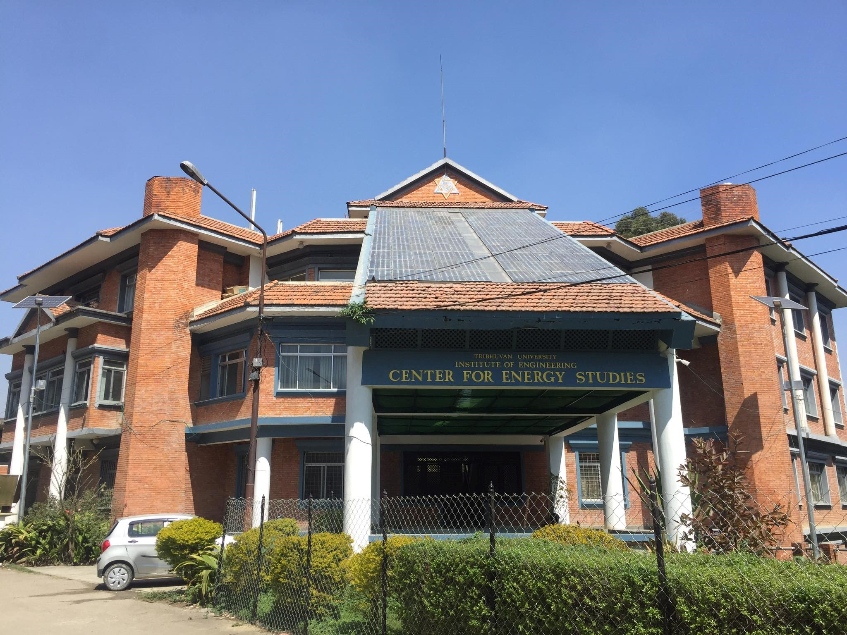
Figure 6: CES Building Nepal
The geothermal system used in CES consists of following components:
A geothermal heating and cooling system for a building typically consists of several key components that work together to harness the Earth's stable temperature for efficient climate control. Here are the primary components used in a geothermal system:

Ground Heat Exchanger (GHX):
This component consists of a series of pipes, typically filled with a heat transfer fluid (usually water mixed with antifreeze), buried in the ground. The GHX is responsible for exchanging heat with the Earth. There are two main types: vertical boreholes and horizontal trenches.

Heat Pump:
The heat pump is a crucial element that transfers heat between the building and the ground. In heating mode, it extracts heat from the ground and transfers it to the building's interior. In cooling mode, it removes heat from the building and transfers it back into the ground.

Distribution System:
The distribution system circulates the heated or cooled fluid from the heat pump to various parts of the building. This can involve a radiant floor system, hydronic (water-based) baseboard heaters, or forced air systems.

Refrigerant Loop (in Heat Pump):
The refrigerant loop is part of the heat pump and is responsible for absorbing and releasing heat. It undergoes a phase change from liquid to gas and back again, facilitating the transfer of heat.

Pump:
Pumps are used to circulate the heat transfer fluid through the ground loop and the building's distribution system. They play a crucial role in maintaining the flow of the working fluid.

Controller/Thermostat:
The controller or thermostat regulates the operation of the geothermal system based on the building's heating or cooling needs. It ensures optimal performance and energy efficiency.
Other components that can be used are:

Backup Heating/Cooling System:
In some cases, a backup heating or cooling system may be integrated to supplement the geothermal system during extreme weather conditions or in case of system maintenance.

Desuperheater:
A desuperheater is an optional component that can be added to some geothermal heat pumps. It utilizes excess heat generated during the cooling cycle to provide supplemental hot water for domestic use.

Ground Heat Exchanger Monitoring System:
Some systems incorporate monitoring systems to assess the performance of the ground heat exchanger over time, ensuring efficiency and identifying potential issues.

References
Alcala, B. J. (1999). Natural Cooling in Hispano-Moslem Residential Architecture: The Case Study of the Court of the Lions and the Court of Comares in the Alahambra (Granada). In S. V. Szokolay (Ed.), PLEA' 99 "Sustaining the Future - Energy, Ecology, Architecture", (pp. 399-406). Brisbane, Australia.
Chadderton, D. V. (2007). Building Services Engineering (5th Edition ed.). New York: Taylor and Francis Group.
Chu, C. (2011). The Pantheon's Passive Systems. Retrieved November 13 2023, from Wordpress: https://cc4jw.wordpress.com/2011/11/10/assignment-4-the-pantheons-passive-systems/
Hui, F. (2023). Beijing Courtyard. Retrieved November 14, 2023, from China Culture: http://en.chinaculture.org/focus/focus/2010expo_en/2010-04/19/content_376827.htm
Joseph B Wujek, F. R. (2010). Mechanical and Electrical Systems in Architecture, Engineering and Construction (5th Edition ed.). New Jersey: Pearson Education Inc.
Khan, A. (2021, July 16). Pearl Academy of Fashion- climate responsive passive habitat. Retrieved November 14, 2023, from Archestudy: https://archestudy.com/pearl-academy-of-fashion-climate-responsive-passive-habitat/
Mariellen. (2018, May 16). Dolat Abad Windcatcher. Retrieved November 14, 2023, from Atlas Obscura: https://www.atlasobscura.com/places/dolat-abad-windcatcher
Moore, D. (1995). The Pantheon. Retrieved November 13, 2023, from Roman Concrete: https://romanconcrete.com/docs/chapt01/chapt01.htm
Pena, R. B. (2014). Living Proof The Bullit Center: High Performance Building Case Study. University of Washington, Center for Integrated Design . Northwest Energy Efficiency Alliance (NEEA). Retrieved from https://bullittcenter.org/wp-content/uploads/2015/08/living-proof-bullitt-center-case-study.pdf
Pita, E. G. (2002). Air Conditioning Principles and Systems; An Energy Approach (4th Edition ed.). New York: Prentice Hall, Ohio.

