Course title: Atomic and Nuclear Physics

Week # 3

Main Topics: Atomic constituents, atomic model & hydrogen spectrum

Lecturer: Jojo Panakal John

Lecture Learning Outcomes:
At the end of the lecture, you will be able to:
- Explain Atomic constituents
- Understand the models of atom
- Explain the spectrum of hydrogen atom
1. Atomic constituents.
Atom is the smallest particle of an element that has the properties characterizing that element. Sir Ernest Rutherford in 1911 found that an atom has a nucleus with positive charge surrounded by negatively charged electrons. This theory of atomic structure was complemented by Niels Bohr in 1913. In Bohr atom model, electrons were arranged in definite energy shells or quantum states. The nucleus contains most of the atom's mass and is composed of protons and neutrons. Size of atoms are roughly some angstroms (Å), which is defined 10⁻¹⁰ meters. Atomic nucleus has protons and neutrons. Proton's charge is equal but opposite to the charge of electron. The number of protons in the nucleus of an atom and the number of electrons in the atomic shells are same for a neutral atom. Neutrons were discovered by Sir James Chadwick. Electrically neutral neutrons have almost the same mass as the proton. Protons, electrons and neutrons have internal structure, made up of quarks.
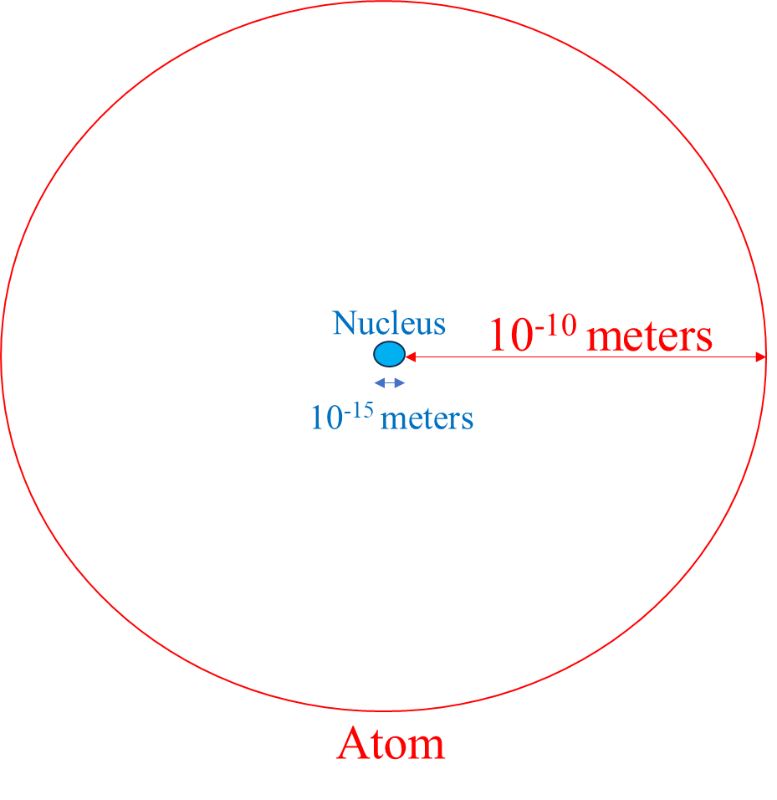
The major characteristic of an atom is its atomic number (z), which is defined as the number of protons in the nucleus. For a neutral atom atomic number equals the number of electrons. The chemical properties of an atom are determined by its atomic number. The total number of nucleons (protons and neutrons) in an atom is the atomic mass number (A). The number of neutrons in an atom is denoted by N. Therefore, mass number of an atom is A = N + Z. Usually an atom is represented as: $O_{8}^{16}$. This represents oxygen with atomic number 8 and atomic mass number 16. All electrons, protons and neutrons are 8 in number.
Atoms with the same atomic number (z) but with different masses (A) are called isotopes. Isotopes have identical chemical properties but have very different nuclear properties. For example, there are three isotopes of hydrogen – ₁H¹(Hydrogen), ₁H² (Deuterium) and ₁H³ (Tritium). Two of these isotopes are stable (not radioactive) but tritium (with one proton and two neutrons) is unstable. Most elements have stable isotopes. Radioactive isotopes can also be created for many elements artificially.
- Alpha-particle scattering and the Rutherford model.
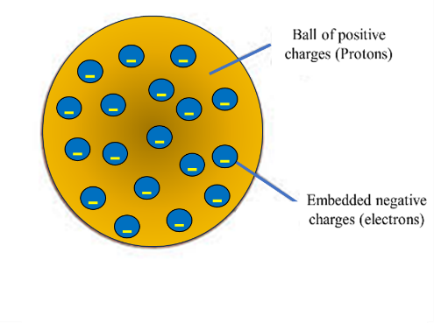
The first model of an atom was proposed by J.J. Thomson in 1989 called the Plum-pudding or watermelon model. He proposed that an atom is made up of a positively charged ball with electrons embedded in it. Atom is neutral since the negative and positive charges are equal in number. In 1911, Ernest Rutherford, performed an experiment to verify the plum-pudding model proposed by J.J. Thomson.
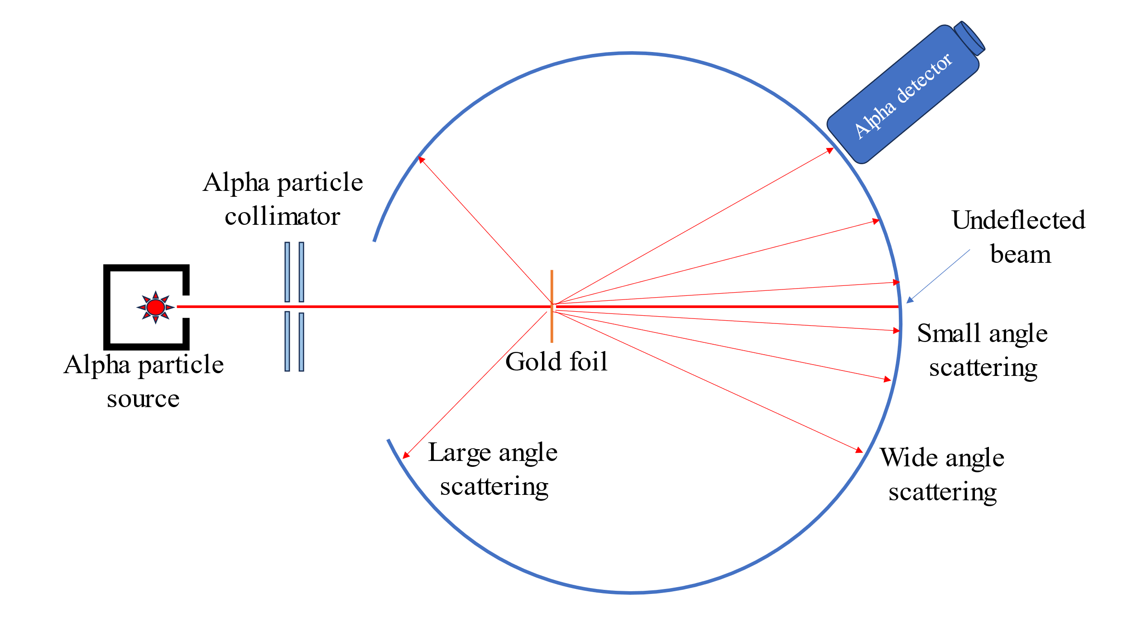
Rutherford took a thin gold foil having a thickness of 2.1×10⁻⁷ m and placed it in the centre of a rotatable detector made of zinc sulfide and a microscope. Then, they directed a beam of 5.5MeV alpha particles emitted from a radioactive source at the foil. Lead bricks collimated these alpha particles. A narrow beam of alpha particles was sent to the gold foil and the scattered particles were studies using the ZnS detector and microscope. ZnS is a scintillator which produces visible light flashes alpha particles fall on it. The light flashes can be seen through the microscope. Bases on plum pudding model, Rutherford expected only small angle scatterings from the gold foil, as the interaction would be purely week electrostatic.
On the contrary, Rutherford found that most of the alpha particles passed through the foil without suffering any collisions. Some particles suffered small angle scattering and a few were found to have very large angle scattering (reflections). These observations led to many arguments and conclusions which laid down the structure of the nuclear model on an atom.
Conclusions from the experiment
- The results of this experiment were not in agreement with the plum-pudding model of the atom as suggested by Thomson.
- Since large number of alpha particles were passed un deflected, he concluded that a good amount of atom is empty.
- For alpha particles to be deflected back, there should be a positively charged region producing large repelling force. Therefore, he concluded that the positive charges of the atom are concentrated in the centre.
- He then suggested the ‘nuclear model of an atom’ wherein the entire positive charge and most of the mass of the atom is concentrated in the nucleus.
- The alpha particles were deflected or scattered through a large angle on coming close to the nucleus. Also, the electrons having negligible mass, do not affect the trajectory of these incident alpha particles.Also, the electrons are moving in orbits around the nucleus similar to the planets and the sun.
- Finally, from his experimental data, Rutherford concluded that the size of the nucleus is between 10⁻¹⁵ and 10⁻¹⁴m.
- Atomic spectra.
When a substance absorbs energy and radiates, it occurs in the form of a spectrum. When atoms and molecules absorb energy from a source, they become excited and re-emit the absorbed energy in a very short period of time (typically in 10⁻⁸s). The spectrum of emitted light is called emission spectrum. Depending on the emitting substance or medium, there can be line, band or continuous spectra. When an atomic system (say hydrogen gas) is the source of spectrum, it will be a line spectrum in which, the emitted specific wave lengths will be seen as coloured lines. For a molecular system (ex. Methane) the emitted spectrum will be broader lines called bands. Thirdly, from a source of hot cloud or an incandescent lamp, there will not be any lines nor bands but a continuous display of colours called continuous spectrum is produced.
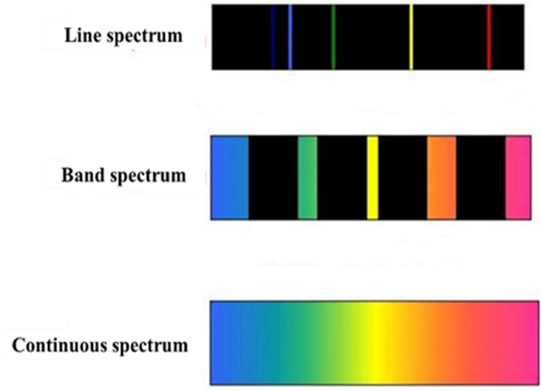
We can classify spectra into two as absorption and emission spectra. Emission spectrum is formed by the wavelengths emitted by a source. On the other hand, an absorption spectrum is formed by the wavelengths of transmitted light through a medium. Many wavelengths will be absorbed by the medium. An emission spectrum has different coloured lines in the spectrum, whereas an absorption spectrum has dark-coloured lines in the spectrum.
Spectrum of electromagnetic radiation produced or absorbed by an electron during transitions between different levels of energy within an atom is called atomic spectrum. The electrons those drop from the higher energy levels to the lower energy levels in an atom release a photon of a specific wavelength, which makes atomic emission spectrum. The energy levels in the atom are unique to each element. Therefore, the wavelength of the light emitted can help to determine which element has produced the light. Collection of all these wavelengths of the atom in a given range of conditions, such as pressure, temperature, etc., is called atomic spectra. Each element generates a unique set of spectral lines. It may have either absorption or emission line spectrum based on the interaction of light with matter.
- Bohr theory and the hydrogen spectrum.
Bohr’s theory
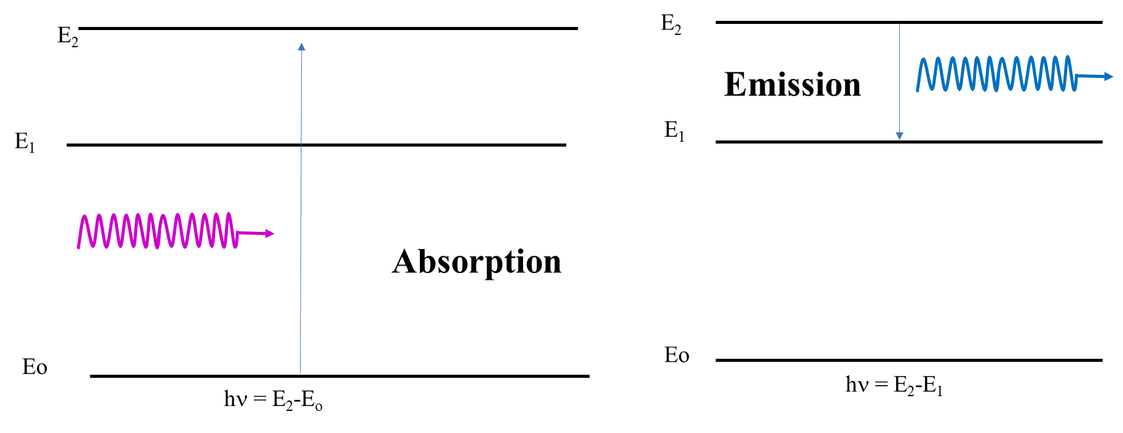
The explanation of the line spectra was first given by Neils Bohr in 1913. Bohr postulated that the energy levels of atoms belong to a discrete set of values E_{n}, rather than a continuum as proposed by classical mechanics. When an atom makes a downward energy transition from a higher energy level E_{m} to a lower energy level E_{n}, it causes the emission of a photon of energy
hν=E_{m}−E_{n}
This is what accounts for the discrete values of frequency ν in emission spectra of atoms. Absorption spectra are correspondingly associated with the annihilation of a photon of the same energy and concomitant excitation of the atom from E_{n} to E_{m}. A schematic representation of the processes of absorption and emission of photons by atoms are shown here. Absorption and emission processes occur at the same set frequencies, as is shown by the two-line spectra.
Hydrogen Spectrum
When an electric current is passed through a glass tube containing hydrogen gas at low pressure the tube gives off a blue light. When this light is passed through a prism or a grating four narrow bands of bright light are observed against a black background.
Niels Bohr proposed a model for the hydrogen atom that explained the spectrum of the hydrogen atom. The Bohr model was based on the following assumptions.
- The electron in a hydrogen atom travels around the nucleus in a circular orbit.
- The energy of the electron in an orbit is proportional to its distance from the nucleus.
- Only a limited number of orbits with certain energies are allowed. In other words, the orbits are quantized.
- The orbits that are allowed are those for which the angular momentum of the electron is an integral multiple of Planck's constant divided by 2π.
- Light is absorbed when an atomic electron excites to a higher energy orbit and emitted when an electron de-excite to a lower energy orbit.
- The energy of the light emitted or absorbed is exactly equal to the difference between the energies of the orbits.

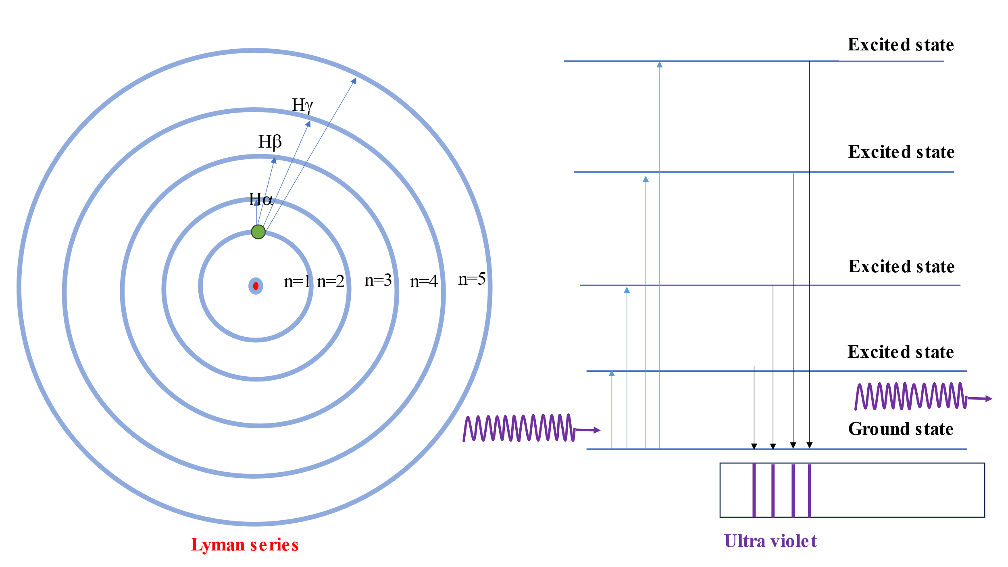
Bohr assumed that there are only a limited number of orbits in which the electron can reside. He based this assumption on the fact that there are only a limited number of lines in the spectrum of the hydrogen atom and these lines were the result of light being emitted or absorbed as an electron moved from one orbit to another in the atom. Bohr restricted the number of orbits on the hydrogen atom by limiting the allowed values of the angular momentum of the electron. An object moving in a circular orbit has an angular momentum equal to its mass (m) times the velocity (v) times the radius of the orbit (r). Bohr assumed that the angular momentum of the electron can take on only certain values, equal to an integer times Planck's constant divided by 2π. That is, angular momentum, L = mvr = n $\frac{h}{2π}$ = nħ (n = 1,2,3,4….)
Bohr then used classical physics to show that the energy of an electron in any one of these orbits is inversely proportional to the square of the integer n.
Rydberg (1890) found that all the lines of the atomic hydrogen spectrum could be fitted to a simple empirical formula:
= $\frac{1}{}$ = R $\left[\frac{1}{{\left(n_{1}\right)}^{2}}-\frac{1}{{\left(n_{2}\right)}^{2}}\right]$
where n = 1,2,3,4……… and n₂ > n₁.
where R is the Rydberg constant =109,677 cm⁻¹ = 1.09×10⁷ m⁻¹. This formula was found to be valid for hydrogen spectral lines in the infrared and ultraviolet regions, in addition to the four lines in the visible region. Bohr proposed a model for the energy levels of a hydrogen atom which agreed with Rydberg's formula for radiative transition frequencies. Inspired by Rutherford's nuclear atom, Bohr suggested a planetary model for the hydrogen atom in which the electron goes around the proton in one of a set of allowed circular orbits.
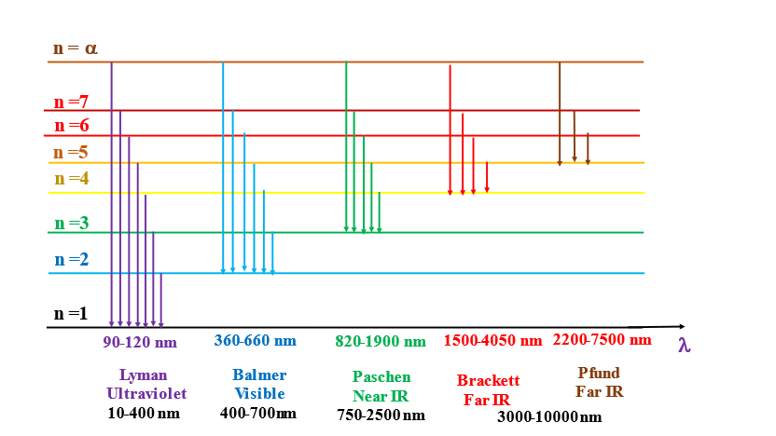
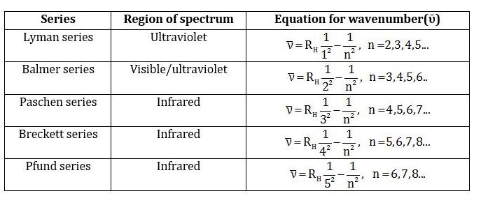

Problem 1 A wavelength of 4.653 μm is observed in a hydrogen spectrum for a transition that ends in the nf =5 level. What was ni for the initial level of the electron?
We have: $\frac{1}{}$ = R $\left[\frac{1}{{\left(n_{1}\right)}^{2}}-\frac{1}{{\left(n_{2}\right)}^{2}}\right]$ where R = 109,677 cm⁻¹.
Wave length, 4.653 μm = 4.653×10⁻⁶ m = 4.653×10⁻⁴ cm
$\frac{{10}^{4}}{4.653}$ = 109,677 cm⁻¹ $\left[\frac{1}{{\left(n_{i}\right)}^{2}}-\frac{1}{{\left(5\right)}^{2}}\right]$ Solving for, n_{i} the nearest integer is 4.
Problem 2. Calculate the wave lengths of first two lines of Balmer series in H spectrum?
We have: $\frac{1}{}$ = R $\left[\frac{1}{{\left(n_{1}\right)}^{2}}-\frac{1}{{\left(n_{2}\right)}^{2}}\right]$ For Balmer series final level is n = 2. Therefore, first line will be $\frac{1}{}$ = R $\left[\frac{1}{{\left(2\right)}^{2}}-\frac{1}{{\left(3\right)}^{2}}\right]$ and second line will be $\frac{1}{}$ = R $\left[\frac{1}{{\left(2\right)}^{2}}-\frac{1}{{\left(4\right)}^{2}}\right]$
be $\frac{1}{}$ = R $\left[\frac{9-4}{36}\right]$ = 109,677 × $\frac{5}{36}$ = 15233 cm⁻¹ or λ = 6.565 x 10⁻⁵ cm = 6565 ºA
$\frac{1}{}$ = R $\left[\frac{16-4}{64}\right]$ = 109,677 × $\frac{12}{64}$ = 20564 cm⁻¹ or λ = 4.863 x 10⁻⁵ cm = 4863 ºA
Problem 3. Calculate the wave length of H_{α} and H_{β} lines of the Lyman series in H spectrum?
For Lyman series, n₁ = 1 and n₂ = 2 for H_{α}
n₁ = 1 and n₂ = 3 for H_{β}
Therefore, Wavelength of H_{α} is given by: $\frac{1}{}$ = R $\left[\frac{1}{{\left(1\right)}^{2}}-\frac{1}{{\left(2\right)}^{2}}\right]$ = R $\left[\frac{3}{4}\right]$
λ = $\frac{4}{3R}$ = $\frac{1.333}{1.09×{10}^{7}}$ = 1.223×10⁻⁷ m = 1223ºA
Wavelength of H_{β} is given by: $\frac{1}{}$ = R $\left[\frac{1}{{\left(1\right)}^{2}}-\frac{1}{{\left(3\right)}^{2}}\right]$ = R $\left[\frac{8}{9}\right]$
λ = $\frac{9}{8R}$ = $\frac{1.125}{1.09×{10}^{7}}$ = 1.125×10⁻⁷ m = 1125ºA
References:

Nuclear Physics: Experimental and Theoretical, 2nd Revised edition by H S Hans. New Academic Science, 2011.

Littlefield, T.A. & Thorley, N., Atomic and Nuclear Physics, 3rd edition, (ELBS and van Nostrand Reinhold Co., 1979).

